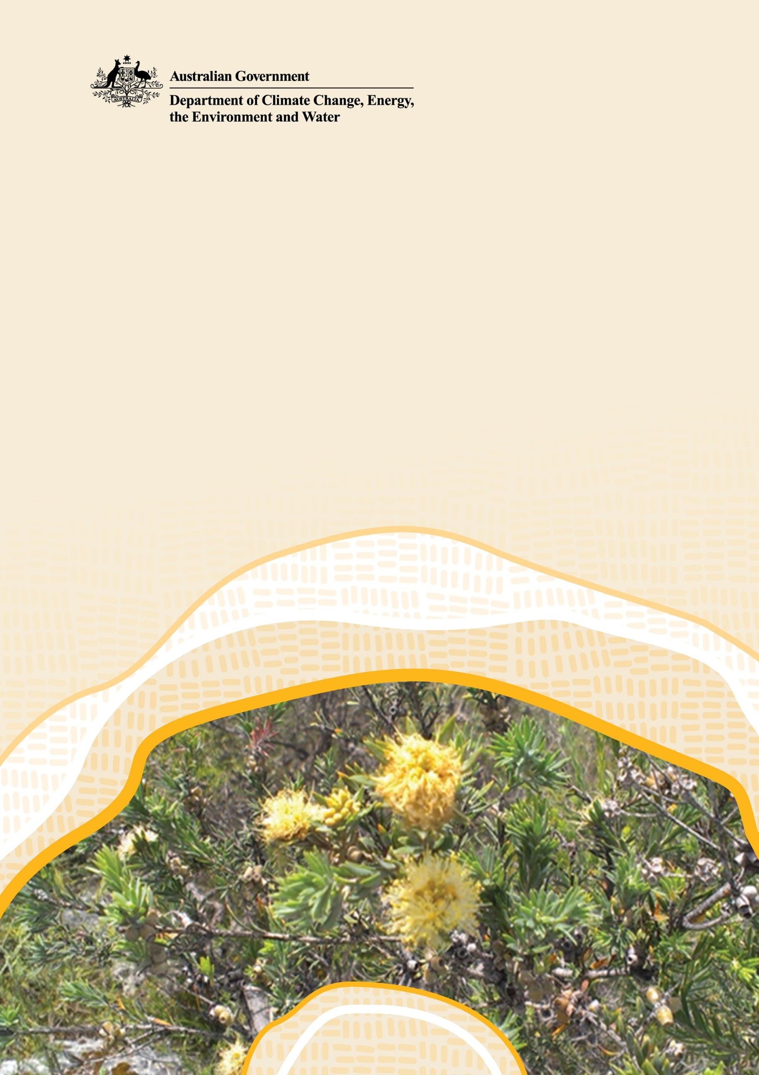Draft National Recovery Plan for *Melaleuca* sp. Wanneroo (G.J. Keighery 16705)

© Commonwealth of Australia 2025

**Ownership of intellectual property rights**

Unless otherwise noted, copyright (and any other intellectual property rights) in this publication is owned by the Commonwealth of Australia (referred to as the Commonwealth).

**Creative Commons licence**

All material in this publication is licensed under a [Creative Commons Attribution 4.0 International Licence](https://creativecommons.org/licenses/by/4.0/legalcode) except content supplied by third parties, logos and the Commonwealth Coat of Arms.

Inquiries about the licence and any use of this document should be submitted via our online contact [form](https://www.dcceew.gov.au/about/contact).



**Cataloguing data**

This publication (and any material sourced from it) should be attributed as: DCCEEW 2025, National Recovery Plan for *Melaleuca* sp. Wanneroo, Department of Climate Change, Energy, the Environment and Water, Canberra. CC BY 4.0.

This publication is available at [dcceew.gov.au/publications](https://www.dcceew.gov.au/about/publications).

Department of Climate Change, Energy, the Environment and Water

GPO Box 3090 Canberra ACT 2601

Telephone 1800 920 528

Web [dcceew.gov.au](http://www.dcceew.gov.au)

**Disclaimer**

The Australian Government acting through the Department of Climate Change, Energy, the Environment and Water has exercised due care and skill in preparing and compiling the information and data in this publication. Notwithstanding, the Department of Climate Change, Energy, the Environment and Water, its employees and advisers disclaim all liability, including liability for negligence and for any loss, damage, injury, expense or cost incurred by any person as a result of accessing, using or relying on any of the information or data in this publication to the maximum extent permitted by law.

**Acknowledgements**

This plan represents the combined efforts of many people, including those who have directly contributed to the content of the plan, those whose site and management action information has been captured, and those who have built the knowledge and understanding on which this plan relies.

**Acknowledgement of Country**

We acknowledge the Traditional Owners of Country throughout Australia and recognise their continuing connection to land, waters and culture. We pay our respects to their Elders past and present.

**Image credits**

Cover page: *Melaleuca* sp. Wanneroo (G.J. Keighery 16705) by Anne Harris and Fiona Felton / Department of Biodiversity, Conservation and Attractions

Contents

1 Executive summary 1

2 Background 2

2.1 Introduction 2

2.2 Conservation status 2

2.3 Cultural significance 2

2.4 Recovery interests 3

3 Species information 4

3.1 Taxonomy 4

3.2 Description 4

3.3 Distribution 5

3.4 Population structure 10

3.5 Habitat 10

3.6 Ecology 11

3.7 Threats 12

4 Recovery planning 17

4.1 Vision 17

4.2 Objectives 17

4.3 Performance criteria 17

4.4 Strategies and recovery actions 18

References 28

Tables

**Table 1.** Melaleuca sp. Wanneroo population and survey information (DBCA 2023) 6

**Table 2.** Risk matrix for *Melaleuca* sp. Wanneroo. 16

**Table 3.** Objective 1. In 2035 all populations are documented, secure, healthy, and resilient: population size, and thequality and connectivity of habitat have increased. 18

**Table 4.** Objective 2. Before 2035 active and effective threat management is in place across all populations. 20

**Table 5.** Objective 3. Knowledge of the species’ biology and occurrence is increased and available to support effective management that maintains and increases populations 24

**Table 6.** Objective 4. Education and community outreach has led to broad support in recovering the species. 27

Figures

**Figure 1.** Photos of *Melaleuca* sp. Wanneroo 5

**Figure 2.** Modelled distribution of Melaleuca sp. Wanneroo 10

# Executive summary

*Melaleuca* sp. Wanneroo (G.J. Keighery 16705) is listed as Endangered under both the WA *Biodiversity Conservation Act* 2016(BC Act) and the Commonwealth *Environment Protection and Biodiversity Conservation Act 1999* (EPBC Act).

The main factors that make the species eligible for listing in the Endangered category are its restricted extent of occurrence (EOO) and area of occupancy (AOO), declines in habitat quality, number of locations, number of mature individuals, and projected population declines of up to 20% in two generations.

The main threat affecting the species is land clearing for mining and urban development. Additional threats are fire regimes that cause declines in biodiversity, and climate change. As the species occurs within peri-urban areas, habitat disturbance is increasing in these areas.

**Vision**

By 2050, the long-term survival of *Melaleuca* sp. Wanneroo in the wild is secured. All populations are documented, secure, healthy, resilient and genetically diverse. Effective management of threats across the range is occurring with communities working together to achieve healthy, connected, and high-quality habitats. Populations are monitored to ensure continued persistence.

**Recovery objectives**

In support of the long-term conservation and recovery *Melaleuca* sp. Wanneroo (G.J. Keighery 16705), the objectives of this plan are as follows:

Objective 1. In 2035 all populations are documented, secure, healthy, and resilient: population size, and the quality and connectivity of habitat have increased

Objective 2. Before 2035 active and effective threat management is in place across all populations

Objective 3. Knowledge of the species’ biology and occurrence is increased and available to support effective management that maintains and increases populations

Objective 4. Education and community outreach has led to broad support in recovering the species.

# Background

## Introduction

Australia is home to over 200 species of *Melaleuca* (Tran et al. 2013), with the greatest diversity occurring in Western Australia. *Melaleuca* sp. Wanneroo (G.J. Keighery 16705), hereafter referred to in this recovery plan as *Melaleuca* sp. Wanneroo, was circumscribed in 2007 but is not yet formally described. The species does not have a common name.

*Melaleuca* sp. Wanneroo has a very localised distribution in two areas approximately 35 km north of Perth and 65 km north of Perth in the City of Wanneroo and Shire of Gingin, in a heavily modified region with a long history of clearing for horticulture and mining. The species is restricted to calcareous soils on limestone ridges and outcrops (Spearwood Dune system – Tamala limestone), which have been extensively used in limestone mining.

This National Recovery Plan for *Melaleuca* sp. Wanneroo (G.J. Keighery 16705) is made in accordance with Part 13, Division 5 of the Commonwealth *Environment Protection and Biodiversity Conservation Act 1999* (EPBC Act). This plan considers the conservation requirements of the species across its range and identifies the research and management actions necessary to halt decline and support recovery of *Melaleuca* sp. Wanneroo, so that its chances of long-term survival in nature are maximised.

## Conservation status

Melaleuca sp. Wanneroo is listed in the Endangered category under the *Environment Protection and Biodiversity Conservation Act 1999* (Commonwealth), and the Biodiversity Conservation Act 2016 (Western Australia).

The species also occurs in the nationally listed Ecological Community *Honeymyrtle shrubland on limestone ridges of the Swan Coastal Plain Bioregion*, as well as occurring in the same region as the state listed threatened ecological community *Melaleuca huegelii – Melaleuca systena shrublands on limestone ridges* and priority ecological communities *Northern Spearwood shrubland and woodlands* and *Banksia Woodlands of the Swan Coastal Plain*.

This is the first national recovery plan for *Melaleuca* sp. Wanneroo. Conservation advice for the species was published at the time of its listing under the *Environment Protection and Biodiversity Conservation Act 1999* (EPBC Act).

## Cultural significance

*Melaleuca* sp. Wanneroo occurs on the traditional lands of the Whadjuk and Yued people of the Noongar Nation. Acknowledging First Nations people’s connection to Country and the importance of biodiversity, ‘place’, custom and totemic elements of Country and species, it is likely that the species and/or its habitat has cultural significance.

## Recovery interests

Conservation of *Melaleuca* sp. Wanneroo will involve a range of stakeholders, governments, scientists and First Nations peoples. Groups with interests in the conservation and recovery of the species include but are not limited to the following:

**State government authorities**

WA Department of Biodiversity, Conservation and Attractions (DBCA), WA Department of Mines, Petroleum and Exploration (DMPE), WA Department of Planning, Lands and Heritage (DPLH), WA Water Corporation, Forest Products Commission (FPC), Department of Water and Environmental Regulation (DWER)

**Local government authorities**

City of Wanneroo, Shire of Gingin

**Industry groups**

WA Limestone, Meteor Stone, Cockburn Cement, Adelaide Brighton Cement, Oakford Land Company

**Traditional owners**

Whadjuk Aboriginal Corporation (Whadjuk ILUA), Yued Aboriginal Corporation (Yued ILUA)

**Land managers (community conservation and sustainable agriculture)**

Perth NRM (Swan NRM Region), WA Landcare Network, Urban Bushland Council WA Inc, WA Conservation Council

**Research partners**

WA universities

# 3 Species information

## 3.1 Taxonomy

*Melaleuca* sp. Wanneroo (G.J. Keighery 16705) belongs to the *Melaleuca systena* complex of numerous closely related, very similar species. Although this complex has not yet been revised, *Melaleuca* sp. Wanneroo is recognised as a separate taxon (WA Herbarium 2007). The species is not yet formally described, and it does not have a common name. Further taxonomic work, including genetic analysis, is required to resolve species limits within this complex.

## 3.2 Description

*Melaleuca* sp. Wanneroo is an erect shrub that can grow to 2.5 m in height and 2-3m in width. Older stems have grey furrowed bark with ‘twiggy’ branchlets that break easily. *Melaleuca* sp. Wanneroo produces numerous terminal inflorescences of yellow flowers with branchlets growing out when flowering is finished. *Melaleuca* sp. Wanneroo has leaves that are 15-20 mm long, flat in cross section, 3 mm wide, with a blunt-acute apex, hairy, with oil glands not prominent. Flowering occurs from late November to late December (DEE 2019).

*Melaleuca* sp. Wanneroois distinguished from other closely related species based on the following attributes: *Melaleuca systena* has leaves crowded, 5-7 mm long, triangular in cross section, 1-1.5 mm wide, with an acute tip, hairs at the base and prominent oil glands. *Melaleuca. systena* subsp. Kemerton is a tall shrub to small tree, 3-5 m tall. The leaves are crowded towards ends of branchlets, lamina 9-13 mm long, terete, with a long pungent point, glabrous and lacking oil glands (DPAW 2017).

**Figure 1.** Photos of *Melaleuca* sp. Wanneroo

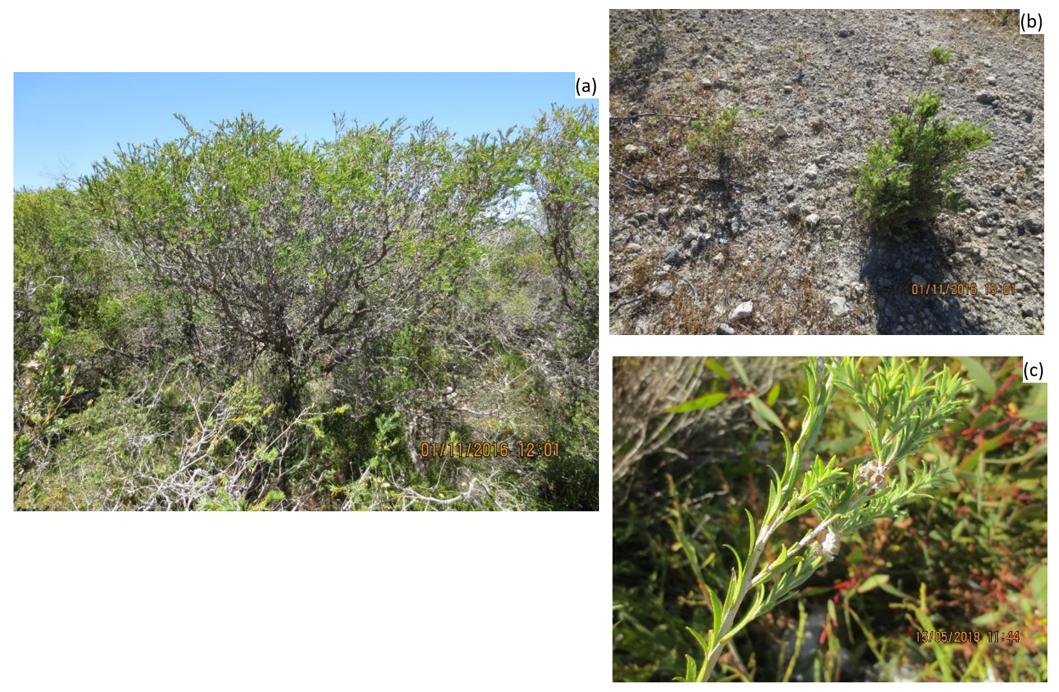

**Notes.** (a) Healthy mature *Melaleuca* sp. Wanneroo shrub, (b) Small juvenile of *Melaleuca* sp. Wanneroo, and (c) *Melaleuca* sp. Wanneroo leaves. (Photos: Anne Harris and Fiona Felton / Department of Biodiversity, Conservation and Attractions).

## 3.3 Distribution

*Melaleuca* sp. Wanneroo is endemic to Western Australia. It is restricted to the Swan Coastal Plain IBRA region in extensively cleared locations within the City of Wanneroo and Shire of Gingin Local Government Areas (LGAs) on Crown land (including Shire Reserve), private land and state forest (Table 1).

The species has a very restricted distribution: it is currently known from five populations at ten locations (DBCA 2023) – see Table 1. Under the EPBC Act, a population is defined as an occurrence of a species in a particular area. The species’ current extent of occurrence (EOO) is 51 km2 and area of occupancy (AOO) is 16 km2.

**Table 1.** Melaleuca sp. Wanneroo population and survey information (DBCA 2023)

| **Population** | **Location (description)** | **Land tenure** | **Land manager** | **Survey information: date of survey and number of mature individuals**  ***() = juveniles***  ***+ = partial survey*** | **Trend (magnitude and timeframe)** | **Site/habitat condition** | **Threats** |
| --- | --- | --- | --- | --- | --- | --- | --- |
| 1 | City of Wanneroo Shire Reserve | Crown Land  Subject to mining lease | City of Wanneroo LGA  Mining company | 08/07/2014 – 50+ | Unknown | Excellent (2014)  Burnt 1966 (prescribed) and 1996 (wildfire) | Habitat loss and fragmentation due to mining  Habitat modification and disturbance due to urbanisation  High severity and high frequency fire |
| 2 | Wattle Ave population | Private Property owned by mining company | Mining company | 2004 – ‘locally common’  07/04/2008 – 100  2018 – 0  *Possibly extinct* | 100% decline from 2008 to 2018 | Site was cleared in 2006 and has since been allowed to re-establish native vegetation.  Burnt 1965 (wildfire) and 1968 (prescribed) | Habitat loss and fragmentation due to mining  Habitat modification and disturbance due to urbanisation  High severity and high frequency fire |
| 3 | 3A West of Hopkins Road, Nowergup | Private Property owned by mining company | Mining company | 28/11/2014 - 500+  01/11/2016 - 1117+ [5 dead]  10/05/2017 - 15+ (recorded as 1000+ on herbarium specimen)  17/01/2019 - 1000+ | Unknown | Excellent  Burnt 1990 (wildfire) | Habitat loss and fragmentation due to mining  Habitat modification and disturbance due to urbanisation  High severity and high frequency fire  Grazing by goats |
| 3B West of Hopkins Road | Crown Land  Subject to mining lease | Department of Planning, Lands and Heritage (DPLH)  Mining company | 1/10/2009 – 40  27/11/2013 -1  *Potentially extinct* | 97% decline from 2009 to 2013 | Poor (2022)  Satellite imagery (2022) shows habitat has been cleared.  Wildfire 1965 & 2015, prescribed burn 1968 | Habitat loss and fragmentation due to mining  Habitat modification and disturbance due to urbanisation  High severity and high frequency fire |
| 3C Hopkins Road East | Crown Land  Subject to mining lease | DPLH  Mining company | 30/09/2009 – 41+  *Potentially extinct* | 100% decline from 2009 to 2022 | Poor (2022)  Satellite imagery (2022) show habitat has been cleared.    Wildfires 1965 & 2015, prescribed burn 1968 | Habitat loss and fragmentation due to mining  Habitat modification and disturbance due to urbanisation  High severity and high frequency fire |
| 3D Crown Reserve, Nowergup | Crown Land  (Sewage treatment plant)  Subject to prospecting licence | WA Water Corporation | 15/05/2018 – 6250+ (extrapolated count) | Unknown | Excellent  Plants were recruiting well after wildfire  Wildfires 1965, 2006 & 2015, prescribed burn 1968 | Habitat modification and disturbance due to urbanisation  High severity and high frequency fire |
| 4 | 4A Wesco Road North | Crown Land (State Forest)  Subject to mining lease | DBCA  Mining company | 26/11/2013 - 46+ | Unknown | Excellent (2013)  Prescribed burns 1966, 1971, 1979, 1984 & 1987, wildfire 2015 | Habitat loss and fragmentation due to mining  Habitat modification and disturbance due to urbanisation  High severity and high frequency fire |
| 4B Island Remnant, Wesco Road North | Crown Land (State Forest)  Subject to mining lease | DBCA  Mining company | 06/12/2013 - 20 | Unknown | Poor; site heavily cleared  Plants growing in ‘island’ of vegetation in the middle of mine pit  Prescribed burns 1966, 1971, 1979, 1984 & 1987. | Habitat loss and fragmentation due to mining  Habitat modification and disturbance due to urbanisation  High severity and high frequency fire |
| 4C Hopkins North, eastern population | Crown Land (State Forest)  Subject to prospecting licence | DBCA  Mining company | 17/01/2019 – 90+ | Unknown | Prescribed burns 1966, 1971, 1979, 1984, 1987, 1995 & 1998, wildfires 1991, 2003 & 2020 | Habitat loss and fragmentation due to mining  Habitat modification and disturbance due to urbanisation  High severity and high frequency fire |
| 5 | South of Wabling Road, | Crown Land (State Forest)  Subject to exploration licence | DBCA  Mining company | 27/11/2017 – 100  20/03/2019 – 27+ | 70% decline from 2017 to 2019 | Prescribed burns 1965, 1968, 1972, 1979, 1985 & 2006. | Habitat loss and fragmentation due to mining  Habitat modification and disturbance due to urbanisation  High severity and high frequency fire |

**Figure 2.** Modelled distribution of Melaleuca sp. Wanneroo

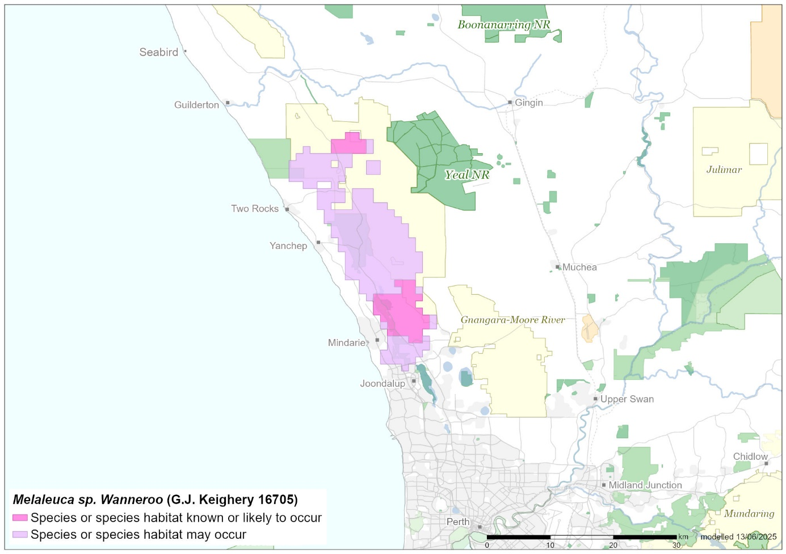

**Source:** Base map Geoscience Australia; species distribution data [Species of National Environmental Significance](http://www.environment.gov.au/science/erin/databases-maps/snes) database.

**Caveat:** The information presented in this map has been provided by a range of groups and agencies. While every effort has been made to ensure accuracy and completeness, no guarantee is given, nor responsibility taken by the Commonwealth for errors or omissions, and the Commonwealth does not accept responsibility in respect of any information or advice given in relation to, or as a consequence of, anything contained herein.

**Species distribution mapping:** The species distribution mapping categories are indicative only and aim to capture (a) the habitat or geographic feature that represents recent observed locations of the species (known to occur) or habitat occurring in close proximity to these locations (likely to occur); and (b) the broad environmental envelope or geographic region that encompasses all areas that could provide habitat for the species (may occur). These presence categories are created using an extensive database of species observations records, national and regional-scale environmental data, environmental modelling techniques and documented scientific research.

## 3.4 Population structure

### Important populations

In 2022, the total population size of the species was estimated to comprise 6640 mature plants. As noted in section 3.3, the species is currently known from ten locations with five populations (DBCA 2023). With such limited occurrences, all locations and all populations are considered important.

## 3.5 Habitat

The species occurs in a warm mediterranean climate which typically has hot, dry summers and mild, wet winters (BOM 2025). The species has highly specific habitat requirements: plants occur on upper slopes of rugged Tamala limestone ridges or areas with a high proportion of Tamala limestone outcropping. Soils are shallow, grey to mossy black or yellow/brown sands, depending on the amount of limestone ‘caprock’ (DEE 2019). Translocation of this species to new or unprotected sites, is not currently considered a viable management action because of its very specific habitat requirements and the lack of secure tenure.

*Melaleuca* sp. Wanneroo can be locally dominant, but it typically co-occurs in dense patches with other *Melaleuca* species, predominantly *M. systena*, when growing on very shallow soils over limestone ‘caprock’ on ridges. Vegetation community descriptions include *M. systena*, *M. huegelii* and/or *M. cardiophylla* within a Closed Tall Shrubland to Shrubland. An Open Low Heath, Sedgeland and/or Herbland may occur at the site, depending upon the level of limestone outcropping (DEE 2019).

Associated species include *Acacia alata* var. *tetrantha*, *A. lasiocarpa, A. rostellifera, A. pulchella, Thomasia triphylla, Leucopogon parviflorus, Grevillea preissii, Banksia sessilis* var*. cygnorum, Xanthorrhoea preissii, Calothamnus quadrifidus, Templetonia retusa, Astroloma microcalyx, Conostylis pauciflora* subsp. *euryrhipis, C. candicans, Tricoryne elatior, Hardenbergia comptoniana, Dianella revoluta, Desmocladus flexuosus, Lepidosperma calcicole*, *Lomandra maritima, Hakea trifurcata, H. prostrata, Opercularia vaginata, Scaevola crassifolia, Persoonia comata, Hypocalymma angustifolium, Hibbertia hypericoides, Podotheca chrysantha, Trymalium ledifolium, Jacksonia calcicola, Eremophila glabra, Banksia dallanneyi, B. nivea* and *Carpobrotus virescens*.

*Eucalyptus petrensis* grows as an overstorey in one population (DEE 2019).The threatened species *Eucalyptus argutifolia*,listed as Vulnerable in WA and nationally, is associated with two populations of *Melaleuca.* sp. Wanneroo and grows approximately 300 m away from a third population.

### Habitat critical to survival

*Melaleuca* sp. Wanneroo is known to occur mostly on Tamala limestone ridge slopes, tops, and outcrops associated with the Spearwood Dune System within the Karrakatta soil unit of the Swan Coastal Plain. Habitat critical to the survival of the species encompasses the area of occupancy (AOO) of all extant populations with habitat as described in Section 3.5, and the surrounding similar habitat, typically characterised by *M. systena* and *B. sessilis* shrublands or heaths on slopes with calcareous soil. All five known populations constitute habitat critical for survival. The definition of this habitat may be further clarified if new populations are found during additional surveys.

Other habitat likely to be critical to the survival of the species includes areas of potentially suitable habitat containing the above landform and vegetation characteristics that occur between known populations, as well as disturbed areas that may contain a remnant seedbank from previously cleared plants. Additionally, areas described as the Critically Endangered Threatened Ecological Community (TEC) *Honeymyrtle shrubland on limestone ridges of the Swan Coastal Plain Bioregion* and also areas of vegetation that contain populations of the threatened flora *E. argutifolia* (Vulnerable) may also constitute habitat critical to the survival of *Melaleuca* sp. Wanneroo.

## 3.6 Ecology

### Life history

There is a paucity of knowledge of the biology of *Melaleuca* sp. Wanneroo.The species flowers from late November to late December (DEE 2019). Specific pollinators of the species have not been identified, but no research has been undertaken. Honeyeaters and moths have been observed to visit the flowers. No research has been carried out on flower, fruit and seed development. Like other *Melaleuca* species,seeds are held on the tree until the trigger for release (presumably at an appropriate fire intensity). Adult plants are killed by fires of a certain intensity and duration (DEE 2019), although fire events catalyse seed release and germination. The age of sexual maturity of *Melaleuca* sp. Wanneroo is unknown. The closely related *Melaleuca systena* will flower in 3-4 years from seed, less than 1 year from cuttings or re-sprouts (DEE 2019). Seeds need approximately 6 months to mature in capsules, which are held on plants for several years. The lifespan of *Melaleuca* sp. Wanneroo is unknown; *M. systena* re-sprouts after fire however it is unknown whether *Melaleuca* sp. Wanneroo also resprouts (DEE 2019). More research is needed in relation to life history and specific ecological and biological requirements (e.g. fire ecology) to better understand growth and habitat requirements in-situ.

## 3.7 Threats

### Historical causes of decline

Land clearing for horticulture was one of the most significant drivers of habitat loss and modification in the Perth region since European settlement in 1829. However, clearing for horticulture may not have had a direct impact on *Melaleuca* sp. Wanneroo as it is generally found on infertile land on limestone ridgelines and rocky outcrops. A study published in 2018 found that accelerating urbanisation was the main driver of clearing and fragmentation on the Swan Coastal Plain and that this pressure was intensifying (DPLH 2018). Concurrent with land use change have been changes in climate. In the 30 years to 2018 in the Perth region, annual rainfall has decreased by 9%, and rainfall has decreased in the autumn and winter months, with winter rainfall being reliable and summer rainfall unreliable. There has been an increase in hot days at Perth Airport with an increase in the average of 19 nights per year above 20 OC between 1959-1988 to 24 nights per year above 20 OC between 1989-2018 (BOM and CSIRO 2019).

### Current known and suspected threatening processes

The most significant threat to *Melaleuca* sp. Wanneroo is extensive past and potential future land clearing for mining (mainly limestone extraction) and infrastructure (road/rail/public utilities) corridors associated with urbanisation. Fire regimes that cause declines in biodiversity (especially high severity and too frequent fire) are also major threats. Climate change (increasing temperatures and declining rainfall) also compounds several threats (e.g. drought and fire) because a drying climate increases the risk of fire. As the species is within peri-urban areas, habitat disturbance due to altered fire regimes, impacts from recreational uses and weed incursions are all generally increasing.

Although listed separately, the threats presented in the remainder of this section often interact, although how such interactions may occur is not always clear. Threats may also impact adult plants differently to younger plants or seedlings.

#### Habitat loss, disturbance and modification

##### Habitat loss and fragmentation due to mining activities

Habitat clearing due to activities from extractive industries is the most significant threat to *Melaleuca* sp. Wanneroo in the short term. Four of the five populations occur within the Basic Raw Material Extraction Area (BRMEA) and these populations are at significant risk of being cleared or subject to other impacts from mining.

Within the BRMEA, extractive industries remove basic raw materials from the ground. Basic raw materials include sand (including silica sand), clay, hard rock, limestone (including metallurgic limestone), gravel, gypsum and other construction and road building materials (DWER 2019). Limestone is extracted in the area where *Melaleuca* sp. Wanneroo occurs. Extractive industries usually have an active point of extraction (e.g. a pit) that may be mobile, following the resource through the landscape, and a processing site (i.e. for stockpiling, lay-down areas, washing, crushing and screening) (DWER 2019). Such operations need roads, offices, workshops and staff amenities (DWER 2019).

The creation of large pits, vehicle movement and lift-off from stockpiles can lead to the physical removal of *Melaleuca* sp. Wanneroo plants and surrounding habitat and can damage those plants and the habitat that may remain. This removal has led to fragmentation and isolation of populations, which can lead to reduction in genetic diversity, seed dispersal and pollinator activity and increase the impact of edge effects. These activities have led to plants at southern sites within the range to be fragmented and isolated within a habitat patch (mine exclusion zone - MEZ) whose ecological function may be compromised. Open-pit limestone extraction has resulted in the removal of several populations of *Melaleuca* sp. Wanneroo, and open pit limestone mining is currently occurring near four of the five known populations.

Dust from the crushing of rock could impact on the plants and surrounding habitat, although how and to what extent that this may be occurring is unknown. Significant wind-borne lime dust has been observed on plants nearest to the open mine pits. Dust on leaves can reduce photosynthesis and the rate of growth of individuals although impacts tend to be highly localised. The range of activities associated with extraction (e.g. the creation of large pits, clearing of vegetation) may also affect hydrology, such as quality, quantity and seasonality of water available to the plants, drainage and replenishment of the water table. Further research is required to clarify the extent of hydrological impacts.

##### Habitat modification and disturbance due to urbanisation

Increasing human populations near natural areas increases the impacts and pressures on them. Pressures on this species include: clearing for transport corridors and infrastructure; road and rail construction and widening, approved and informal trails and tracks for bikes; walking and for four-wheel drive vehicles; increased entry and spread of weeds; increased fire frequency and intensity; rubbish dumping; mowing or ‘tidying up’ native areas; firewood and rock collection; as well as impacts from busy roads once they are in use.

Increased human traffic can lead to impacts from trampling. Domestic rubbish, in particular garden waste, introduces weed seeds into bushland and increases the fire hazard (Luu & English 2005). Perth is expanding northward, and the distribution of *Melaleuca* sp. Wanneroo is in a peri-urban environment currently subject to urban encroachment.

##### Habitat modification due to infestation by fungal diseases

Myrtle rust (*Austropuccinia psidii*) is an invasive rust fungus that infects species from the Myrtaceaefamily, including some *Melaleuca* species. The disease was first detected in NSW in 2010 and is now also present in Victoria, Queensland, Tasmania and the Northern Territory (Tiwi Islands) (DCCEEW 2025a). It has also been detected in the Australian Capital Territory and the northern part of Western Australia (DCCEEW 2025a). The disease is not yet present in southwest WA. A national study has indicated that the climatic suitability of southwest WA for myrtle rust may be limited due to the mismatch between wet periods and temperatures suitable for germination of the fungus (Berthon et al. 2018). However, controlled inoculation of *Melaleuca* sp. Wanneroo in experiments showed that the species has high susceptibility to the disease (Martino et al. 2024).

*Phytophthora multivora*, a pathogen likely originating in South Africa (Tsykun et al. 2022), is widespread in southwest Western Australia (CPSM 2012-2020). This pathogen has consistently been isolated from dead and dying woody plants in the urban and peri-urban environment, where it causes root rot resulting in susceptible plants dying of drought stress. Unlike *P. cinnamomi* and *P. multivora* it is active in calcareous soils (CPSM 2012-2020). It is not known whether *Melaleuca* sp.Wanneroo is susceptible to *P. multivora* but decline and degradation of the vegetation and habitat in which it occurs would impact the species in the long term. The ability of *P. multivora* to survive in alkaline soils has implications for hygiene management, particularly if limestone is used as a road base for surrounding access tracks.

Honey fungi (*Armillaria* spp.) are plant pathogens widespread in southwest WA, where they have a wide host range and cause Armillaria Root Disease (ARD) (DBCA 2025). In healthy, undisturbed native ecosystems, ARD contributes to the death of weakened and stressed trees and shrubs. In can become a particularly aggressive pathogen in disturbed ecosystems (DBCA 2025).

##### Habitat modification due to introduced weeds

Weeds affect recruitment, suppressing early plant growth by competing for soil moisture, nutrients and light. Weeds including rose pelargonium (*Pelargonium capitatum*) and bridal creeper (*Asparagus asparagoides*) occur in the species range. Further weed invasion by these and other species is likely to occur without active management, and many grass weeds may increase the fire hazard due to the easy ignition of high fuel loads which are produced annually, leading to higher risk of too-frequent fire.

#### Fire regimes that cause declines in biodiversity

Fires are a major influence on vegetation composition in a Mediterranean climate, such as that in southwest WA. Many Australian plant species have strategies to persist under certain fire regimes; populations will recover post-fire, given time, suitable conditions and low exposure to threats. However, knowledge gaps relating to the species' fire response and their post-fire persistence, threaten the effective long-term management of Australian vegetation in an increasingly pyric world (Nolan et al. 2021).

The mechanisms by which fire regimes can threaten this species are high frequency fires and high severity fires (DAWE 2022). Field observations have shown that high severity fire kills adults of *Melaleuca* sp. Wanneroo. Recruitment occurs after fire, with two populations impacted by wildfires in spring and autumn showing significant recruitment and large numbers of young plants observed at three and five years post fire. More research is needed regarding the threshold of fire severity that determines viability of adult and juvenile plants. It is highly likely that population regeneration occurs primarily from seed, as no evidence of lignotuber regeneration has been recorded to date. The shallow soils on which the species grows may also mean the seed bank is impacted by high severity fires.

Fires that are too frequent also threaten the species at all known populations, especially in circumstances where intervals between fires are too short to allow seedlings/younger plants to reach maturity and produce sufficient seed to replenish the soil seedbank. High frequency and high severity fires may also facilitate weed invasion in disturbed areas and may lead to increased rabbit numbers, further increasing post-fire grazing of seedlings.

Interactions between fire and other threats are increasingly likely, as climate change increases the frequency and severity of fire weather (DWER 2021). Fire and drought are likely to interact, with drought priming conditions for more severe fires, as happened in 2019–20 (Nolan et al. 2020). Climate change is likely to compound changes to fire regimes and changes to vegetation, such as increases in density, extent and potentially the diversity of annual and highly flammable grass weeds. Other threats that may interact with fire include disease and herbivory. In both cases the added pressure of these threats, before or after fire, may reduce the capacity of a species to recover from the fire impacts, or make the species more susceptible to these threats (DAWE 2022).

#### Climate change

##### Increased likelihood of extreme climate and weather events and changes to water availability and quality

The impacts of climate change are significant in southwest Western Australia, which is characterised by a mediterranean climate of hot, dry summers and cool, wet winters. Rapid change is already occurring, in line with predictions that winter will be 16% drier and up to 20% drier in spring (DWER 2021). In southwest Western Australia, mean annual temperature is projected to increase by 1.1 – 4.0°C by 2090, depending on CO2 emission scenarios (DWER 2021). Under current climate trajectories, the frequency and intensity of extreme events such as wildfire, drought and heatwaves are predicted to increase (CSIRO 2022). Rainfall patterns have also been affected, with lowest annual rainfall records in parts of south-western Australia (CSIRO 2022).

Although the genus *Melaleuca* may have the ability to adapt to climate change with many species tolerant of climatic extremes such as drought and salinity (Tran et al. 2013), the adaptive capacity of *Melaleuca* sp. Wanneroo is unknown. There is no knowledge about the species’ response to heat stress. Significant droughts in coastal southwest WA occurred in 2010, 2019, and from 2023-24 (Swan Coastal District Nature Conservation Team pers. comm 2025), possibly causing additional stress to populations already subject to a range of other threatening processes and likely amplifying their impacts. The current and predicted changes to climate will likely lead to further detrimental hydrological changes to water availability, runoff and the water table, which may be exacerbated by topographic alteration associated with infrastructure and mining activities.

#### Invasive fauna species

The negative impacts of feral herbivores on, for example, vegetation health, plant regeneration, erosion, nutrient cycling, and promotion of weed incursion are well documented. European rabbits (*Oryctolagus cuniculus*) and goats (*Capra hircus*) have been observed feeding on (especially juvenile) *Melaleuca* sp. Wanneroo plants at some populations. Grazing pressure may increase after fire, impeding regrowth, although this has not been studied. Rabbits also modify habitats by digging and increasing nutrients in the soil.

Polyphagous shot-hole borer (PSHB) (*Euwallacea fornicatus*) is a small, tree-boring beetle native to Southeast Asia that was first detected in East Fremantle in August 2021. The species is now established in the Perth region (DAFF 2025). The species tunnels into trunks, stems and branches of trees (DPIRD 2025). The beetle has a symbiotic relationship with a *Fusarium* fungus, which it cultivates inside the tree as a food source for adults and larvae. In susceptible trees, the fungus restricts or prevents the movement of water and nutrients within the tree, causing symptoms in susceptible trees such as Fusarium dieback, structural damage and sometimes tree death (DPIRD 2025). Several *Melaleuca* species in southwest WA are confirmed reproductive hosts for the beetle (DPIRD 2024) and *Melaleuca* sp. Wanneroo may also be susceptible.

### Threat prioritisation

Each of the threats outlined in this recovery plan have been assessed to determine the risk posed to the *Melaleuca* sp. Wanneroo using a risk matrix (see Table 1). The risk matrix considers the likelihood of an incident occurring and the consequences of that incident and uses a qualitative assessment drawing on both peer-reviewed literature and expert opinion.

**Table 2.** Risk matrix for *Melaleuca* sp. Wanneroo.

|  |  |  |  |  |  |
| --- | --- | --- | --- | --- | --- |
| **Consequence (x) / Likelihood (y)** | Not significant | Minor | Moderate | Major | Catastrophic |
| Almost certain |  |  |  | **Very-high risk**  Climate change causing extreme weather and changes to hydrology | **Very-high risk**  Habitat loss and fragmentation |
| Likely |  |  |  | **Very-high risk**  Fire regimes causing decline  Disturbance due to urbanisation |  |
| Possible |  | **Moderate risk**  Grazing by introduced herbivores  Impacts from introduced weeds | **High risk**  Infestation and habitat modification by fungal diseases |  |  |
| Unlikely |  |  |  |  |  |
| Unknown |  |  |  |  |  |

**Risk matrix key**

|  |  |  |  |
| --- | --- | --- | --- |
| **Low risk** | **Moderate risk** | **High risk** | **Very-high risk** |

**Definition of likelihood and consequence categories**

Consequence is a measure of the severity of the impact of the threat on the survival of the species.

* Catastrophic – affecting survival, reproduction or essential movement of individuals in >80% of the population or across >80% of the distribution within the next 3 generations or 10 years, whichever is longer.
* Major – affecting survival, reproduction or essential movement of individuals in 50-80 % of the population or across 50-80% of the distribution within the next 3 generations or 10 years, whichever is longer.
* Moderate – affecting survival, reproduction or essential movement of individuals in 20-50% of the population or across 20-50% of the distribution within the next 3 generations or 10 years, whichever is longer.
* Minor – affecting survival, reproduction or essential movement of individuals in 5-30% of the population or across 5-30% of the distribution within the next 3 generations or 10 years, whichever is longer.
* Not significant – affecting survival, reproduction or essential movement of individuals in <5% of the population or across <5% of the distribution within the next 3 generations or 10 years, whichever is longer.

Likelihood is a measure of how regularly the threat impacts the species.

* Almost certain – >90% chance that threat will have an impact on the species within the next 3 generations or 10 years, whichever is longer.
* Likely – 66-90% chance that threat will have an impact on the species within the next 3 generations or 10 years, whichever is longer.
* Possible – 33-66% chance that threat will have an impact on the species within the next 3 generations or 10 years, whichever is longer.
* Unlikely – <33% chance that threat will have an impact on the species within the next 3 generations or 10 years, whichever is longer.
* Unknown – probability that threat will have an impact on the species within the next 3 generations or 10 years, whichever is longer, could be 0-100%.

# 4 Recovery planning

## 4.1 Vision

By 2050, the long-term survival of *Melaleuca* sp. Wanneroo in the wild is secured. All populations are documented, secure, healthy, resilient and genetically diverse. Effective management of threats across the range is occurring with communities working together to achieve healthy, connected, and high-quality habitats. Populations are monitored to ensure continued persistence.

## 4.2 Objectives

Objective 1. In 2035 all populations are documented, secure, healthy, and resilient: population size, and the quality and connectivity of habitat have increased.

Objective 2. Before 2035 active and effective threat management is in place across all populations.

Objective 3. Knowledge of the species’ biology and occurrence is increased and available to support effective management that maintains and increases populations.

Objective 4. Education and community outreach has led to broad support in recovering the species.

## 4.3 Performance criteria

Effective implementation of this recovery plan will be based on the following:

1. All known populations in 2025 are extant
2. The number of known populations is equal to or greater than in 2025
3. The total population size has been maintained or increased since 2025
4. The total area of occupancy is at least the same as in 2025
5. The number of mature individuals in each population has been maintained or increased since 2025.
6. All known and potential habitat has been surveyed, and all populations identified.
7. All known populations records are surveyed and accurately mapped every 5 years.
8. All populations are in secure tenure or have formal protection measures in place.
9. Knowledge of population genetics, connectivity, recruitment, seedling survivorship, and fire ecology has increased, and this information has been incorporated into management.
10. All populations are actively managed to abate threats.
11. Participation in recovery by Noongar Traditional Custodians has increased.

## 4.4 Strategies and recovery actions

**Table 3. Objective 1. In 2035 all populations are documented, secure, healthy, and resilient: population size, and the quality and connectivity of habitat have increased.**

Protecting all known populations and their habitats from any further land clearing, habitat degradation or fragmentation is the highest priority recovery action.

| **Action number** | **Action** | **Details** | **Target population(s)/ location(s) for recovery action** | **Performance criteria** | **Potential partners** |
| --- | --- | --- | --- | --- | --- |
| 1.1 | Implement good governance arrangements to ensure this recovery plan is implemented, the species conservation status is monitored, and the plan is effectively evaluated. | Acquire baseline population data by conducting detailed field surveys including (a) identification of the area and extent of populations; (b) estimates of the number, size and structure of populations; and (c) inference or estimation of population change. | 1.1 | Implement good governance arrangements to ensure this recovery plan is implemented, the species conservation status is monitored, and the plan is effectively evaluated. | Acquire baseline population data by conducting detailed field surveys including (a) identification of the area and extent of populations; (b) estimates of the number, size and structure of populations; and (c) inference or estimation of population change. |
| 1.2 | Protect species habitat within conservation covenants | Seek opportunities to establish conservation covenants on private land where the species occurs through a Conservation Covenant Program. | 2, 3A | Private landholders have been provided information regarding covenanting opportunities.  The proportion of the species’ habitat that is protected has increased to the extent possible. | Private Landholders  WA Department of Biodiversity, Conservation and Attractions (DBCA)  National Trust of Australia (WA) |
| 1.3 | Establish an *ex-situ* seed collection stored at the WA Threatened Flora Seed Centre | Collect seed from all populations (to capture any genetic variation) for storage and *ex-situ* propagation. Include sites in disturbed areas that may contain a remnant seedbank from previously cleared plants.  Conduct viability and germination testing on stored seed.  Test plant propagation methodologies. | All populations | Seed from allpopulations held in appropriate long-term storage.  Seed viability, germination and propagation are well understood and informing storage under appropriate conditions. | DBCA  WA Threatened Flora Seed Centre |
| 1.4 | Translocation and augmentation | Where the site is protected by a conservation covenant or other conservation agreement, develop and implement an augmentation strategy. Where feasible, establish re-plantings at any location where the species has been cleared. Ensure there is ongoing management of all new plantings, including competition from existing vegetation and mitigating other threats.  Where the site is protected by a conservation covenant, develop and implement a translocation plan. Establish new populations at locations with suitable habitat (where this is feasible). Ensure there is ongoing management of any new populations, including competition from existing vegetation and mitigating other threats. | All locations | Known populations are augmented with new plantings (where this has been feasible).  New populations are established on secure land tenure with appropriate habitat (where this has been feasible). | DBCA  Developers, mining companies and other private landholders  WA Threatened Flora Seed Centre  Kings Park and Botanical Garden  DWER  DPLH  City of Wanneroo LGA  Shire of Gingin LGA  Perth NRM |

**Table 4. Objective 2. Before 2035 active and effective threat management is in place across all populations.**

| **Action number** | **Action** | **Details** | **Target population(s)/ location(s) for recovery action** | **Performance Criteria** | **Potential Partners** |
| --- | --- | --- | --- | --- | --- |
| 2.1 | Protect the species and its habitat from land clearing, degradation or fragmentation. | Provide protections to this species at all stages of zoning and development planning.  Consult with local councils and state authorities to minimise cumulative impacts on this species as part of broader strategic planning and development.  Ensure buffers are implemented around all sites where the species occurs as protection from road, rail, bike/walking trail construction and widening or other infrastructure developments. Any trails formalised/proposed should be designed without any negative impacts to this species.  Retain other native vegetation around and near occurrences of this species, particularly where they are important for connectivity and diversity of habitat, or where they function as buffer zones between this species and any threats or development zones. | All locations | Local councils and state authorities are aware of the species and its requirements.  Knowledge of the species’ distribution and biology is integrated into strategic and land management plans and implemented in all relevant on-ground activities.  Occurrences of the species are protected by buffer zones.  Habitat quality is stable or improving. | Developers, mining companies and other private landholders  State and Commonwealth governments  DPLH  DMPE  DBCA  DWER  WA Water Corporation  City of Wanneroo LGA  Shire of Gingin LGA |
| 2.2 | Develop and implement a fire management plan for the species. | Develop and implement an evidence-based fire management plan that sets an appropriate fire regime for *Melaleuca* sp. Wanneroo, that minimises risks of decline and optimises population persistence for the species, including:  Avoiding successive fire intervals that are shorter than the period required to maintain recovery capacity of resprouting or germinating individuals, and  Ensuring that prevailing fire regime(s) do not disrupt the life cycle of *Melaleuca* sp. Wanneroo, that they support rather than degrade suitable habitat and do not promote invasion of exotic species.  Consult with all fire managers (e.g. DBCA, mining companies) so that the fire management plan is implemented across all populations regardless of land tenure.  Fire management authorities and land management agencies should use suitable maps and install field markers to avoid damage to *Melaleuca* sp. Wanneroo and ensure fire planning personnel are trained to understand fire impacts on the species. | All locations | Appropriate fire management is implemented across the species’ range. | Department of Fire and Emergency Services  DBCA  Private landholders and managers  City of Wanneroo LGA  Shire of Gingin LGA |
| 2.3 | Control pest and invasive weed species. | Monitor the populations for evidence of feral or domestic animal or weed impacts.  Active management of invasive pests and weeds is in place for all populations, employing biological control solutions where appropriate (e.g. bridal creeper).  Implement the threat abatement plans for European rabbits (DEE 2016) and unmanaged goats (DEWHA 2008, DCCEEW 2023), especially after fire events to protect germinant and juvenile plants.  Fence population sites to protect the habitat from grazing from goats and rabbits.  Identify if the Polyphagous shot-hole borer (*Euwallacea fornicatus*) is in the species habitat, and if it is impacting on the species control it using appropriate methods.  Maintain state biosecurity arrangements to exclude new invasive weeds. | All locations | All pests and weed species are eliminated or managed so they are not impacting on the survival of the species. | DPIRD  DBCA  Private landholders and managers  City of Wanneroo LGA  Shire of Gingin LGA  Land managers (community conservation and sustainable agriculture)  Perth NRM |
| 2.4 | Identify and control Myrtle Rust *Austropuccinia psidii*, and *Phytophthora* dieback *Phytophthora* spp. | Maintain soil and plant hygiene when undertaking any work such as fire management, plantings, and weeding management.  Limit visitor access to paths and install hygiene stations where necessary.  Survey sites for myrtle rust and phytophthora and implement control measures if identified.  If identified follow guidelines in the *Threat abatement plan for disease in natural ecosystems caused by Phytophthora cinnamomi* (DCCEEW 2025b) and the *Myrtle Rust in Australia National Action Plan* (DCCEEW 2025a).  Maintain state quarantine and biosecurity arrangements to exclude new invasive pathogens and diseases. | All locations | All populations are regularly monitored for Myrtle rust, *Phytophthora* and other invasive pathogens and diseases.  All known and potential populations and habitat are free of Myrtle rust and *Phytophthora*. | DPIRD  DBCA  City of Wanneroo LGA  Shire of Gingin LGA |
| 2.5 | Identify any potential impacts of climate change on *Melaleuca* sp. Wanneroo and identify actions to minimise these impacts. | Model the projected impact of climate change on the species’ ecology, distribution, and habitat.  Set up long term monitoring sites occupied by *Melaleuca* sp. Wanneroo.  Resurvey long term monitoring plots at suitable intervals to assess change in vegetation composition and population demographics over time.  Identify appropriate mitigation measures and develop an action-orientated implementation strategy.  Use modelling results for targeted engagement of land managers for implementation of mitigation actions.  Identify areas of suitable and/or refuge habitat within the distribution where new populations of the species may be established.  Investigate options for maintaining in situ persistence as the climate changes, for example by minimising other population pressures, enhancing resilience and promoting recruitment or supplementing existing populations. | All locations | Climate change impacts on this species are understood  The species can adapt to climate change  Climate change is having a minimal impact on the species and its habitat. | DBCA  DPLH  DMPE  Private landholders and managers  Research institutions  Land managers (community conservation and sustainable agriculture)  DWER |
| 2.6 | Protect and restore hydrology. | Consider/minimise any water extraction from infrastructure or mining activities.  Prevent, reduce and/or mitigate land uses in proximity to populations that are likely to alter the flow of surface water and/or draw down groundwater.  Where populations of the species occur, identify areas within local catchments for rehabilitation, such as mining holes, to reinstate natural hydrological flows and revegetate affected areas.  Use sediment barriers and other erosion control measures to minimise erosion and sediment runoff during any disturbance activities. | All locations | The hydrology across the species distribution is managed to promote conservation of the species and its habitat. | WA Water Corporation  Developers, mining companies and other private landholders |

**Table 5. Objective 3. Knowledge of the species’ biology and occurrence is increased and available to support effective management that maintains and increases populations**

Undertaking regular monitoring of known populations to determine baseline data is a critical priority to inform recovery actions.

| **Action number** | **Action** | **Details** | **Target population(s)/ location(s) for recovery action** | **Performance Criteria** | **Potential Partners** |
| --- | --- | --- | --- | --- | --- |
| 3.1 | Resolve the taxonomy and assign scientific and common names to raise the profile of the species and enhance community engagement. | Undertake taxonomic work, including genetics, to resolve all species in the *Melaleuca systena* complex.  Formally describe *Melaleuca* sp. Wanneroo.  Create an engaging common name for *Melaleuca* sp. Wanneroo. | N/A | Species description, diagnosis and suggested common name published in a peer-reviewed journal.  Scientific and common names are used in all outreach and education activities. | DBCA  Kings Park and Botanical Garden  Australian Network for Plant Conservation |
| 3.2 | Establish/maintain a monitoring program for all known locations/populations. | To obtain accurate population numbers, distribution and to discern trends in conservation status, maintain a monitoring program for all known locations/populations.  Establish and maintain a monitoring program for any new location/population that is discovered.  Repeat surveys on a regular basis to maintain accurate information on the status of all populations of the species.  Monitor and record habitat condition in areas with populations to provide information on changes in habitat suitability in relation to fire frequency, rainfall decline, and drought frequency and duration.  Assess effectiveness of management interventions | All locations | Population size, distribution and any trends are accurately documented over time and across all suitable habitats.  Trends in population size and distribution are used to adaptively manage the species. | DBCA  Whadjuk Aboriginal Corporation  Yued Aboriginal Corporation  DPLH  DMPE  Private landholders and managers  Land managers (community conservation and sustainable agriculture)  Citizen scientists  DWER |
| 3.3 | Mapping and surveys for new populations/locations, and any locations suitable for *ex-situ* plantings. | Map the geology, soils and vegetation within the Swan Coastal Plain Bioregion, identifying locations with potentially suitable habitat for this species.  Identify and map sites with suitable habitat and then survey for new populations. The initial focus should be within the species’ EOO. Conduct surveys at appropriate times of the year (i.e. during flowering) to maximise likelihood of discovering the species.  Identify and survey sites with suitable geology, soils and habitat that can potentially support new populations created from *ex-situ* cultivated plants. | All locations | Surveys and mapping of suitable geology, soils and habitat are completed.  Any new populations are identified and mapped.  Any sites suitable for *ex-situ* plantings are identified and mapped.  Habitat critical for survival is fully understood (and quantified) across the species’ entire range. | DBCA  Whadjuk Aboriginal Corporation  Yued Aboriginal Corporation  Land managers (community conservation and sustainable agriculture) |
| 3.4 | Identify, research and fill knowledge gaps, particularly in relation to key biological processes to inform effective management. | Research the species’ requirements for calcareous soils and dependence on limestone geology.  Clarify hydrological features of the habitat and requirements of the species.  Investigate pollination ecology. Understand seed viability, germination requirements reproductive status, longevity, fecundity, and frequency and size of recruitment events. | All locations | Improved understanding of the species biology informs on-ground management actions and in situ and ex situ conservation measures.  Habitat critical for survival is fully understood (and quantified) across the species’ entire range. | DBCA  Research partners  Citizen scientists |
| 3.5 | Research to understand the impacts of threats more fully on this species. | Investigate the species’ response to heat stress.  Study the adaptive capacity of this species to understand resilience to climate change scenarios.  Investigate how climate change may impact local hydrology and species survival.  Investigate how topographic alteration is affecting water availability, runoff and the water table for the species.  Investigate any impact of lime dust on the viability of plants and surrounding habitat. | All locations | How climate change may directly and indirectly impact the species is well understood.  Improved understanding of how the impacts on the species is informing on-ground management. | DBCA  Research partners  Citizen scientists |
| 3.6 | Undertake research into the species’ fire requirements. | Determine optimal fire interval and use this to set timing of and approaches to fire management activities.  Clarify understanding of fire-recruitment dynamics and ecology, including juvenile period, time required to produce an adequate pre-fire serotinous seedbank, age ranges at peak reproduction, duration of seed retention on plants, post-fire seedling dynamics and plant longevity. | All locations | Improved understanding of fire ecology requirements to inform on-ground management actions. | DBCA  Research partners |
| 3.7 | Understand population genetics to support effective management. | Undertake genetic sampling from each population.  Undertake population genetic analysis to understand population genetic diversity, structure connectivity and minimum viable population size. | All populations | Genetic characteristics of all populations are well understood.  Genetic data acquired and informing on-ground management actions. | DBCA  Research partners |

**Table 6. Objective 4. Education and community outreach has led to broad support in recovering the species.**

| **Action number** | **Action** | **Details** | **Target population(s)/ location(s) for recovery action** | **Performance Criteria** | **Potential Partners** |
| --- | --- | --- | --- | --- | --- |
| 4.1 | Undertake education and community outreach. | Develop and implement a communication strategy that promotes the conservation of this species and its habitat.  Develop site-specific interpretive material (such as a fact sheet that includes locations, population numbers, population structure, threats, seed collection sites) and distribute to relevant land managers, consultants and community groups.  Develop strategies with Industry groups to protect populations from inappropriate management activities and maintenance programs.  Develop strategies with Local and State authorities to protect populations from inappropriate management activities and maintenance programs.  Support engagement of Traditional Owners in conservation actions, including the development and implementation of Indigenous fire management and other survey, monitoring and management actions. | All locations | Regular and targeted communication occurs with key stakeholders.  All key stakeholders are aware of the species and its requirements.  Local community groups are participating in public outreach and recovery actions.  Members of the local community are participating in conservation actions. | DBCA  Developers, mining companies and other private landholders  Land managers (community conservation and sustainable agriculture)  Perth NRM  DWER  DMPE  Whadjuk Aboriginal Corporation  Yued Aboriginal Corporation  City of Wanneroo LGA  Shire of Gingin LGA |

# References

Berthon K, Esperon-Rodriguez M, Beaumont L J, Carnegie A J, and Leishman M R (2018) Assessment and prioritisation of plant species at risk from myrtle rust (*Austropuccinia psidii*) under current and future climates in Australia. *Biological Conservation* 218, 154-162.  Accessed: 27 June 2025 Available at: <https://doi.org/10.1016/j.biocon.2017.11.035>

BOM (2025) [Climate Classification Maps. Bureau of Meteorology](https://www.bom.gov.au/climate/maps/averages/climate-classification/). Accessed: 23 June 2025.

BOM and CSIRO (Bureau of Meteorology and Commonwealth Scientific and Industrial Research Organisation) (2019) [Regional Weather and Climate Guide](https://www.bom.gov.au/climate/climate-guides/guides/031-Perth-WA-Climate-Guide.pdf). A Climate Guide for Agriculture, Perth, WA.

CPSM (Centre for Phytophthora Science and Management School) (2012-2020). [*Phytophthora multivora*; an emerging pathogen](https://www.cpsm-phytophthora.org/news-emerging-pathogen.php). Murdoch University, Western Australia. Accessed: 27 June 2025.

CSIRO (Commonwealth Scientific and Industrial Research Organisation) (2022) [State of the Climate 2022: Australia's changing climate](https://www.csiro.au/en/research/environmental-impacts/climate-change/State-of-the-Climate/Previous/State-of-the-Climate-2022/Australias-Changing-Climate/).

DAFF (Department of Agriculture, Fisheries and Forestry)(2025) [Polyphagous shot-hole borer (*Euwallacea fornicatus*)](https://www.outbreak.gov.au/current-outbreaks/polyphagous-shot-hole-borer). Outbreak: animal and plant pests and diseases. Accessed: 25 June 2025.

DAWE (Department of Agriculture, Water and the Environment) (2022) [Fire regimes that cause declines in biodiversity](https://www.environment.gov.au/cgi-bin/sprat/public/publicshowkeythreat.pl?id=33): Advice to the Minister for the Environment from the Threatened Species Scientific Committee on amendments to the List of Key Threatening Processes under the *Environment Protection and Biodiversity Conservation Act 1999*. Accessed: 30 June 2025.

DBCA (2023) Threatened Species Scientific Committee Evaluation of the nomination of *Melaleuca* sp. Wanneroo (G.J. Keighery 16705). Department of Biodiversity, Conservation and Attractions, Perth.

DBCA (2025) [Armillaria root disease: a disease of native plants caused by a native fungus](https://www.dbca.wa.gov.au/management/threat-management/plant-diseases/armillaria-root-disease). Department of Biodiversity, Conservation and Attractions. Accessed: 23 June 2025.

DCCEEW (Department of Climate Change, Energy, the Environment and Water) (2023) [Draft threat abatement plan for competition and land degradation by unmanaged goats](https://www.dcceew.gov.au/environment/biodiversity/threatened/threat-abatement-plans/drafts-open). Accessed: 17 September 2025.

DCCEEW (Department of Climate Change, Energy, the Environment and Water) (2025a) [Myrtle rust (*Austropuccinia psidii*)](https://www.dcceew.gov.au/environment/invasive-species/diseases-fungi-and-parasites/myrtle-rust). Accessed: 30 June 2025.

DCCEEW (Department of Climate Change, Energy, the Environment and Water) (2025b) [Threat abatement plan for disease in natural ecosystems caused by *Phytophthora cinnamomi*](https://www.dcceew.gov.au/environment/biodiversity/threatened/publications/threat-abatement-plan-disease-natural-ecosystems-caused-phytophthora-cinnamomi) Accessed: 30 June 2025.

DEE (2016) Threat abatement plan for competition and land degradation by rabbits. Department of the Environment and Energy, Canberra.

DEE (Department of the Environment and Energy) (2019) [Conservation Advice for *Melaleuca* sp. Wanneroo (G.J. Keighery 16705)](https://www.environment.gov.au/cgi-bin/sprat/public/publicspecies.pl?taxon_id=89456). Canberra. Accessed: 13 August 2025.

DEWHA (2008) Threat abatement plan for competition and land degradation by unmanaged goats, Department of the Environment, Water, Heritage and the Arts, Canberra.

DPAW (2017) Threatened Species Nomination for *Melaleuca* sp. Wanneroo (G.J. Keighery 16705), Department of Parks and Wildlife, Perth.

DPLH (Department of Planning, Lands and Heritage) (2018) [Perth and Peel 3.5million](mailto:Perth%20and%20Peel@3.5million). Accessed: 30 June 2025.

DPIRD (Department of Primary Industries and Regional Development) (2024) [Western Australian *Euwallacea fornicatus*, Polyphagous Shot-Hole Borer (PSHB) Host List](https://www.dpird.wa.gov.au/pshb). Accessed: 27 June 2025.

DPIRD (Department of Primary Industries and Regional Development) (2025) [Polyphagous Shot-Hole Borer](https://www.wa.gov.au/organisation/department-of-primary-industries-and-regional-development/polyphagous-shot-hole-borer). Accessed: 2 July 2025.

DWER (Department of Water and Environmental Regulation) (2021) [Western Australian climate projections: summary](https://www.wa.gov.au/government/publications/western-australian-climate-projections-summary). Accessed: 2 July 2025.

DWER (Department of Water and Environmental Regulation) (2019) [Water quality protection note no. 15: Basic raw materials extraction](https://www.wa.gov.au/system/files/2022-06/WQPN-15-Basic-raw-materials-extraction.pdf). Accessed: 2 July 2025.

Luu R and English V (2005) [*Melaleuca huegelii* – *Melaleuca systena* shrublands of limestone ridges (Swan Coastal Plain Community type 26a - Gibson *et al*. 1994) Interim Recovery Plan 2004–2009](https://library.dbca.wa.gov.au/static/Journals/080548/080548-193.pdf). Interim Recovery Plan No 193. Accessed: 2 July 2025.

Martino AM, Park RF and Tobias PA (2024) Threatened and Priority listed *Melaleuca* species from Western Australia display high susceptibility to *Austropuccinia psidii* in controlled inoculations. *Australasian Plant Pathology* 53: 253–260. <https://doi.org/10.1007/s13313-024-00974-8>

Nolan RH, Boer MM, Collins L, Resco de Dios V, Clarke H, Jenkins M, Kenny B, Bradstock RA (2020) Causes and consequences of eastern Australia's 2019-20 season of mega-fires. Global Change Biology 26(3): 1039-1041. <https://researchers.westernsydney.edu.au/en/publications/causes-and-consequences-of-eastern-australias-2019-20-season-of-m>.

Nolan RH, Collins L, Leigh A, Ooi MK, Curran TJ, Fairman TA and Bradstock R (2021) Limits to post‐fire vegetation recovery under climate change. *Plant, cell & environment*. 44(11): 3471-3489.

Pratt S (2015) City of Joondalup/City of Wanneroo Then and Now, City of Joondalup.

Tran DB, Dargusch P, Moss P and TV Hoang (2013) An assessment of potential responses of *Melaleuca* genus to global climate change. Mitigation and Adaptation Strategies for Global Change 18: 851–867. <https://link.springer.com/article/10.1007/s11027-012-9394-2>.

Tsykun T, Prospero S, Schoebel CN, Rea A and Burgess TI (2022) Global invasion history of the emerging plant pathogen Phytophthora multivora. BMC Genomics 23: 153.

Western Australian Herbarium (2007) FloraBase: the Western Australian Flora. Accessed: 2 July 2025 Available at: [Florabase-the Western Australian flora](https://biodiversity.org.au/nsl/services/rest/instance/apni/664258).