
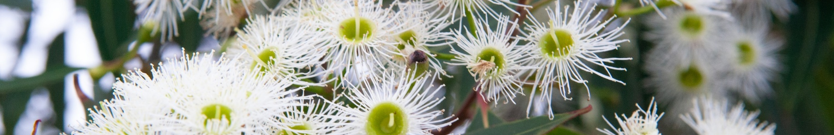
Enhancing Native Vegetation method - proposed design
The department is consulting on the proposed design of an Enhancing Native Vegetation (ENV) method under the Nature Repair Market. To view the consultation document and to make a submission, visit https://consult.dcceew.gov.au/env-methods-nature-repair-market. The consultation closes at 10:00PM AEDT Tuesday 4 November 2025.

The Nature Repair Market
The Nature Repair Market is a legislated voluntary national biodiversity market. It is designed to increase investment in nature and deliver high integrity biodiversity outcomes. Under the market, land managers undertake projects that result in verifiable and measurable biodiversity outcomes.
Methods set out how Nature Repair Market projects must be carried out. These are legislative instruments made under the Nature Repair Act 2023 (the Act). They must be consistent with the relevant requirements of the Act and the Biodiversity Assessment Instrument. This ensures methods are evidence-based, informed by science and that they set requirements to assess and describe project outcomes in a consistent and comparable way.

Summary of requirements for the proposed ENV method
The proposed ENV method would enable projects that:
- restore native vegetation through revegetation and facilitated regeneration
- enhance the ecosystem condition of remnant vegetation to support biodiversity and/or
- maintain the ecosystem condition of good-quality remnant vegetation.
The broad scope of the ENV method allows flexibility in project design. This reduces transaction costs for project proponents by avoiding the need to register separate projects under different methods. It also makes the market more accessible to potential participants. This flexibility for landholders and project proponents is important as ecosystems with different condition states are often found on single properties.
The method also supports participation of Aboriginal people and Torres Strait Islanders through culturally informed project design. This allows for the use of Indigenous knowledge and values in project implementation and design. It also allows the inclusion of culturally significant entities as a focus of the biodiversity outcome.
Eligible regions
Projects could take place in the modified landscapes of eastern, southern and south-western Australia. These regions have been cleared in the past or degraded by a variety of land uses and pressures, such as pests and weeds. Restoring, enhancing and maintaining the native vegetation in these regions is a conservation priority. This is because they contain high concentrations of threatened species and ecological communities.
Eligible projects
Project starting ecosystem condition states could range from highly degraded to intact. Restoring, enhancing and maintaining their native vegetation helps biodiversity by improving the habitat’s extent and condition as well as improving the connectivity of the landscape.
The method would focus primarily on terrestrial habitats. Land under seas or inland waters would not be included.
Project requirements
The ENV method would set requirements for how a project is to be implemented.
For example, project proponents would need to identify restoration target states for major vegetation groups at the project site. They would also need to measure the changes in the ecosystem condition as a result of the project.
In addition to ecosystem condition, the method would include the following variable biodiversity project characteristics:
- culturally significant entities (optional)
- ability to support threatened species (optional)
- commitment to protection (optional).
These characteristics are used to describe project biodiversity, and improvements to it, in a consistent and comparable way.
This information provides the evidence the Clean Energy Regulator needs to issue a biodiversity certificate. Biodiversity certificates are only issued for a genuine environmental benefit that would be unlikely to have occurred if the project did not take place.
The method would set requirements relating to the permanence period. This is the time for which the project must be monitored and protected. A permanence period of between 25 and 100 years is being considered for this method.
Project activities
Project activities could include:
- enhanced grazing control
- enhanced weed control
- enhanced pest control
- infill planting
- revegetation through environmental planting
- facilitated regeneration.
The project activities selected for each activity area must be recommended by a suitably qualified person. Complementary activities could include the use of fire as an eligible activity.

More information
The department leads the development of methods in collaboration with technical experts. We also consult interested stakeholders on the design of the method.
The Minister for the Environment formally makes methods for the Nature Repair Market. The Nature Repair Committee advises the Minister on the integrity of methods after undertaking public consultation to inform their advice.
The Committee’s consultation on a final proposed ENV method is expected to take place in the first half of 2026.
Learn more
- ENV method consultation page
- Nature Repair Market - DCCEEW
- Email naturerepairmarketmethods@dcceew.gov.au if you have any queries on the method.
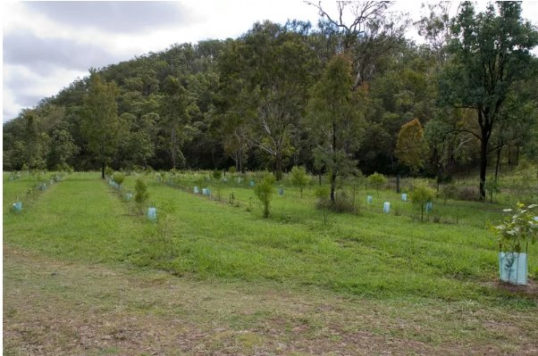

Credit: Lyle Radford ©DCCEEW

Acknowledgement of Country
We acknowledge the Traditional Custodians of Australia and their continuing connection to land and sea, waters, environment and community. We pay our respects to the Traditional Custodians of the lands we live and work on, their culture, and their Elders past and present.
© Commonwealth of Australia 2024
Unless otherwise noted, copyright (and any other intellectual property rights) in this publication is owned by the Commonwealth of Australia (referred to as the Commonwealth).
All material in this publication is licensed under a Creative Commons Attribution 4.0 International Licence except content supplied by third parties, logos and the Commonwealth Coat of Arms.
The Australian Government acting through the Department of Climate Change, Energy, the Environment and Water has exercised due care and skill in preparing and compiling the information and data in this publication. Notwithstanding, the Department of Climate Change, Energy, the Environment and Water, its employees and advisers disclaim all liability, including liability for negligence and for any loss, damage, injury, expense or cost incurred by any person as a result of accessing, using or relying on any of the information or data in this publication to the maximum extent permitted by law.

