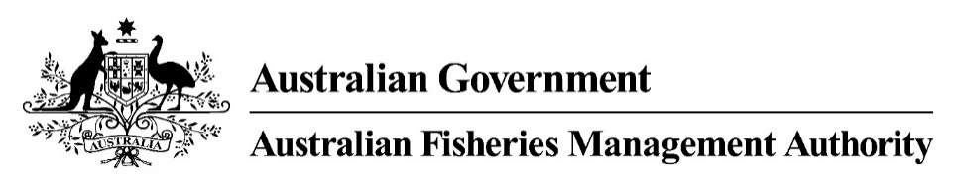

Application for assessment of the Commonwealth Southern Squid Jig Fishery for approval under the Environment Protection and Biodiversity Conservation Act 1999
Contents
Introduction 4
The fishery 4
Description of the fishery 4
Fishing methods and gear 5
Target and byproduct species 5
Value of the fishery 6
Management regime 6
Description of the management regime 6
Consultation processes 8
Performance against objectives, performance indicators and performance measures 8
Controlling the level of harvest 9
Harvest strategy 9
Recovery strategies for overfished stocks 11
Enforcement of the management arrangements 12
Mitigating impacts on the wider ecosystem 13
National policies, plans and strategies 14
Changes since the previous assessment 14
Monitoring and data collection 16
Data collection, data validation and data monitoring programs 16
Stock assessments 17
Key target and byproduct species 17
Indicator species 18
Distribution and spatial structure of key stocks 19
Estimates of total removals 19
Bycatch 20
Bycatch composition 20
Risk assessment on the effects of fishing on bycatch 20
Bycatch mitigation measures 20
Indicator bycatch species 20
Management actions 20
Protected species and threatened ecological communities 21
Fishery impacts on protected species and communities 21
Mitigating risks to protected species 21
CITES-listed species 21
Ecosystem 21
Ecosystem management actions 21
Management responses 22
Marine bioregional plans 22
Research 23
COMRAC – FRDC 23
Progress against current Conditions 24
References 24
Appended Data Tables 26
APPENDIX 1 – Retained catch data (target and byproduct species) 26
APPENDIX 2 – Discarded catch data (target and non-target species) 27
*Where no discarded weight or no. of animals is recorded this indicates species caught but not landed in the vessel 27
** Anecdotal information from Industry suggests that it is highly unlikely that commercial scallop could be caught on squid boats with computerised gear (which is majority of the fleet) as the computer stops the line/jigs before they touch the seabed floor. 27
APPENDIX 3 – Protected species interaction data 28
APPENDIX 4 – Fishing effort 29

Introduction
This submission meets the requirements for assessment of the Commonwealth Southern Squid Jig Fishery (SSJF) under [Part 13 and/or Part 13A of] the Environment Protection and Biodiversity Conservation Act 1999 (Cth) (EPBC Act).
This submission has been produced to enable the Department of Climate Change, Energy, the Environment and Water (DCCEEW) to assess the SSJF management arrangements against the Guidelines for the Ecologically Sustainable Management of Fisheries – 2nd Edition and the requirements set out in relevant sections of the EPBC Act.

The fishery

Description of the fishery
The SSJF is a low impact, single method, single species fishery. It encompasses Commonwealth waters from Sandy Cape on Fraser Island (latitude 24°30'S), to the South Australian/Western Australian border (longitude 129°00'E), including Commonwealth waters adjacent to NSW, Victoria, South Australia and Tasmania.
The majority of fishing effort and catch occurs between Queenscliff and Portland, off the Victorian coastline, and south of Kangaroo Island off the South Australian coast and around Tasmania. Most catch is taken between January and June each year, with the highest catches concentrated in March and April. The major landing ports are located in Portland (Victoria), Queenscliff (Victoria) and Triabunna (Tasmania).
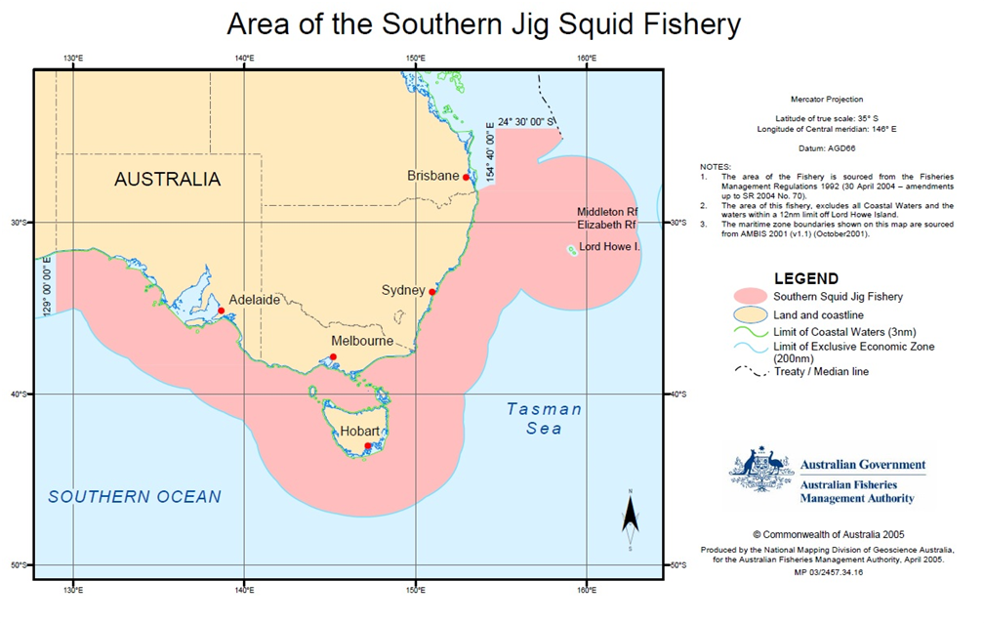
Figure 1. Area of the Southern Squid Jig Fishery

Fishing methods and gear
Squid in the SSJF is targeted using automatic jigging machines with 20 to 25 jigs attached to each line (see Figure 2). Squid jig vessels traditionally operate at night in continental shelf waters at depths ranging from 60 to 160 meters.
Squid jigging vessels have overhead lights which illuminate the water and attract squid, which then gather in the shaded area under the boat. The squid are caught using barbless lures on monofilament fishing lines which are jigged up and down in the water by machines. The jigs used are cylindrically in shape and spaced approximately 1 metre apart. Instead of normal fishing hooks, each jig contains multiple tiers of closely spaced spikes, which face towards the top of the jig. When squid try to attack the jig, they become tangled around the vertically facing spikes.
Each jigging machine has a roller which extends out from the side of the boat, allowing the line to be lowered into the water column away from the edge of the boat, and be jigged up and down without causing abrasion to the line. Barbless lures are used so that as lures are recovered over the end rollers, squid fall off into the boat. This assists in reducing the handling time required to individually remove squid from the lures.
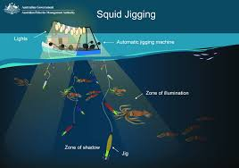
Figure 2. Diagram of squid jigging vessel setup, showing jigging machines, overhead lights, and barbless lures.
Source: ‘Methods and gear’ AFMA Website

Target and byproduct species
The primary species targeted in the Southern Squid Jig Fishery (SSJF) is Gould’s squid (Nototodarus gouldi), also known as arrow squid. This species is also commonly caught as bycatch in the South East Trawl and Great Australian Bight Trawl fisheries. There is limited information on the population dynamics and biology of Gould’s squid, however they are known to be highly fecund, complete their life cycle within 12 months, and reproduce throughout the year. Recruitment is variable, possibly due to environmental factors.
Byproduct species primarily consist of other squid species, including southern calamari (Sepioteuthis australis), big-fin reef squid (Sepioteuthis lessoniana), and southern ocean arrow squid (Nototodarus sloanii). Appendix 1 provides data on landed catches in the SSJF over the past five years.

Value of the fishery
There have been no recent surveys of the Southern Squid Jig Fishery (SSJF) to estimate Net Economic Returns (NER). Indicators such as catch, Gross Value of Production (GVP), and Catch Per Unit Effort (CPUE) show high variability, which may reflect fluctuations in squid stock and availability. This aligns with the challenges of consistently locating squid and the increasing costs of fishing. The relatively long delay in economic returns suggests that NER is likely low.
Most vessels in the SSJF lack onboard refrigeration or processing capabilities. While the catch is chilled at sea, it must be brought back to port each morning for processing or freezing, which limits the volume of squid that can be harvested per trip. The squid is sold in Melbourne after being processed into tubes. Domestic demand for squid is generally strong, leaving little room for export. This is evident in Australia’s status as a net importer of squid. Additionally, infrastructure constraints hinder export opportunities, despite some interest from international buyers.
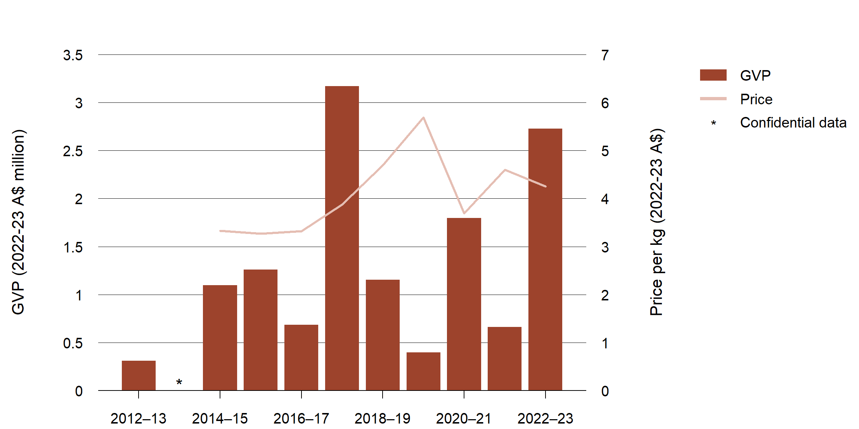
GVP Gross value of production.
Note: ‘Real’ indicates that value has been adjusted for inflation.
Figure 3. Southern Squid Fishery – real GVP and average unit prices, 2012-13 to 2022-2023
Source: ABARES 2024

Management regime

Description of the management regime
The SSJF is managed through a combination of input and output controls as prescribed in the:
- Fisheries Management Act 1991 (the Act) and associated amendments and temporary orders;
- the Southern Squid Jig Fishery Management Plan 2005 and associated amendments, directions and determinations;
- the SSJF Harvest Strategy developed in accordance with the Commonwealth Fisheries Harvest Strategy Policy 2018; and
- conditions on gear SFRs.
A copy of the 2025 SSJF gear SFR concession conditions can be found on the AFMA website (‘Services for Fishers’ – ‘Concession Holders’ – ‘Southern Squid Jig Fishery’)
The Management Plan outlines management arrangements for the SSJF. The SSJF is managed by input controls with a Total Allowable Effort (TAE) determined each year. The Management Plan specifies effort controls based on a set number of standard squid jigging machines allocated to a gear SFR. The objectives of the Management Plan are to:
- manage the SSJF efficiently and cost-effectively
- exercise the precautionary principle regarding the impact of fishing activities on non-target species and the long-term sustainability of the marine environment
- ensure accountability to the fishing industry and Australian community in the management of the SSJF
- achieve government targets for cost recovery
- maximise economic efficiency in the exploitation of the resources of the SSJF
- achieve the best use of the living resources of the Australian Fishing Zone (AFZ).
Access to the SSJF is provided through gear SFRs allocated by AFMA under the Management Plan. Gear SFRs authorise the use of a certain number of squid jigging machines during the year. A boat must be nominated to an SFR in order to operate in the fishery.
The number of standard squid jigging machines allocated to a gear SFR for a fishing year is calculated by dividing the TAE for the fishing year by the total number of gear SFRs at the start of the fishing year. As of August 2025, there were 33 SFR holders and a total of 4,800 SFR units held in the fishery.
Current quota ownership and unit holdings can be found on the AFMA website at: https://www.afma.gov.au/commercial-fishers/resources/concession-holders-and-sfr-conditions.
Operators typically nominate SFRs to their boats in lots of 100. The TAE is shared equally across all 4,800 SFRs. For example, the 2025 TAE for the SSJF is set at 550 standard squid jigging machines which require fishers to hold 8.73 SFRs per standard jig machine, as per Table 1.
Table 1. TAE and gear SFR conversion factors for the 2025 fishing year
 | TAE | Number of gear SFRs | Conversion factor (TAE/SFR)
Standard squid jig machines | 550 | 4,800 | 8.72727

SFRs are fully tradeable, allowing operators to increase or decrease the number of squid jigging machines they can use on their vessel.
Along with conditions on gear SFRs, the Management Plan details concession holders’ obligations when fishing in the area of the fishery. Copies of the Management Plan are available from the Commonwealth of Australia Law (ComLaw) website at: www.comlaw.gov.au/Details/F2012C00161.

Consultation processes
The SSJF undertake a consultation process with the Squid Resource Assessment Group (SquidRAG) and the South East Management Advisory Committee (SEMAC). Members of these groups provide a range of perspectives involving representatives for Industry, economics, conservation groups, state and territory governments, recreational and scientific fields.
SquidRAG provides advice and recommendations to the SEMAC, AFMA management, the AFMA Commission and the AFMA Research Committee (ARC) on the status of the Gould’s squid stock, the impact of squid jigging on the marine environment and the type of information needed for stock assessments. They also evaluate the impact over time of the SSJF Harvest Strategy, stock depletion and recovery rates, confidence levels for fishery assessments and risk to the success of fishery objectives. Compliance and economic factors affecting the fishery are also evaluated and reported on by this group.
SEMAC is the overarching committee that provides management advice to AFMA on the Southern and Eastern Scalefish and Shark Fishery; Small Pelagic Fishery; and the SSJF. Specifically, SEMAC provides management advice to the AFMA Commission and AFMA management on the scientific and economic status of fish stocks, sub-stocks, species (target and non-target) and the impacts of fishing on the marine environment. SEMAC provides a forum where management issues relating to fisheries are discussed and possible solutions developed.
The AFMA Commission is the final decision-making body within the agency providing final outcomes for domestic fisheries management and foreign compliance.
RAG and MAC meetings are not open for public invitation, however the minutes of the meetings including the agenda and outcomes are published online on the AFMA website.

Performance against objectives, performance indicators and performance measures
AFMA’s performance measurement is a multi-faceted process that involves clear objectives, relevant performance indicators, and measurable performance measures. Some of these measures are mandated by fisheries legislation, including annual reporting requirements.
Strategic objectives and performance measures are broadly defined in the Fisheries Management Act 1991. The SSJF Management Plan contains fishery-specific objectives, performance measures, and performance criteria.
Management actions to achieve these objectives are identified in the risk management strategy and harvest strategy for this fishery. The Commonwealth Fisheries Harvest Strategy Policy and Guidelines provide the basis for developing the harvest strategy for this fishery, which includes objectives, harvest control rules, reference/trigger point, performance measures, and decision rules.
Key information from these strategy documents is contained in the management arrangements booklet.
AFMA’s ecological risk management framework uses a hierarchical approach to assess the sources of risk, their consequences, and likelihood of occurrence. The approach is used to assess the risks of fishing to target and non-target species, protected species, habitats and communities.
AFMA’s performance is regularly monitored throughout the year, reviewed annually through the various RAGs and MACs, and reported through catch reports, surveys, annual stock assessments and in the AFMA annual report. Periodic reviews of the harvest strategy itself are also conducted as required. These reports provide a transparent overview of AFMA’s activities and their impacts on fisheries. The information contained in these reports is used by stakeholders, including industry, government and the public, to assess the effectiveness of AFMA’s management and to inform future decisions.
Independent assessments are performed every year by the Australian Bureau of Agricultural and Resource Economics and Sciences (ABARES), the yearly reports provide an independent evaluation of the biological and economic status of fish stocks managed solely or jointly by the Australian Government. The most recent report and outcomes can be seen here.

Controlling the level of harvest
There is no Total Allowable Catch (TAC) or catch quota for the SSJF. A TAC is unable to be determined as there is insufficient scientific information available to set biological reference points. Harvest levels in the SSJF are therefore controlled primarily by managing fishing effort; including restricting how much gear (effort) can be used in the area of the fishery and type of gear that can be used.
Prior to the start of the SSJF fishing year (1 January each year), the AFMA Commission determines the TAE as the total number of jig machines that can operate in the fishery. In setting the TAE, the AFMA Commission considers advice from SquidRAG and SEMAC. Statutory Fishing Right (SFR) owners are notified of the TAE prior to the commencement of each SSJF Fishing Year. For the 2025 fishing year, the TAE is 550 standard squid jigging machines.
All catches are monitored and managed in accordance with the SSJF Harvest Strategy using within-season monitoring against catch and effort triggers informed by historical catch and effort levels. In the event that catch and effort exceed the triggers, advice will be provided by SquidRAG on an appropriate management response (i.e. the need for a stock assessment or a review of management arrangements).

Harvest strategy
The SSJF is subject to management arrangements specified in the Southern Squid Jig Fishery Harvest Strategy 2022 (the Harvest Strategy). The Harvest Strategy specifies processes for monitoring and conducting assessments of the biological and economic conditions of the fishery. The Harvest Strategy covers the SSJF as well as sectors of the SESSF and other fisheries that may take Gould’s squid in the Australian Fishing Zone.
The SSJF Harvest Strategy uses a system of within-season monitoring against catch triggers for the SSJF and the Commonwealth Trawl Sector (CTS) and Great Australian Bight Trawl Sector (GABTS) of Southern and Eastern Scalefish and Shark Fishery (SESSF). The triggers are categorised as combined (trawl sectors and SSJF) and then individual triggers for the SSJF and the trawl sectors, as follows:
Annual Combined trigger (all methods)
- Intermediate trigger – 4,000 tonnes
- Limit trigger – 6,000 tonnes
SSJF triggers (jig only)
- Lower catch and effort trigger (end of year) - 360 t (total catch by SSJF) and/or 213 days (total days fished by SSJF
- SSJF intermediate trigger – 3,000 tonnes
- SSJF limit trigger – 5,000 tonnes
Combined trawl trigger (all trawl methods)
- Limit trigger – 2,000 tonnes
The combined intermediate catch trigger (4,000 tonnes) equates to half the highest historic annual catch by squid fishing boats off southern Australia. There is also an additional effort trigger of 30 ‘standard boats’ (defined as a boat carrying 10 standard squid jigging machines) operating in the fishery.
If the lower catch and effort trigger is reached, a review of the available catch and effort data is required to ensure there are no risks associated with the increase in catch or effort. If any sustainability concerns are identified a management response will be considered which may include effort limits or investing in additional analysis.
If any of the above triggers are reached, a SquidRAG meeting must be held and a depletion analysis undertaken to estimate the impact of fishing in that year.
At the intermediate catch triggers – 3,000 tonnes for the SSJF or 4,000 tonnes for the SSJF and trawl sectors combined – if no impact is detected, then fishing can continue until the limit trigger is reached. If there is evidence of an impact to the stock, then a review of the sustainability of the fishery, and potentially a review of the triggers, is required.
At the limit catch triggers – 5,000 tonnes for SSJF or 6,000 tonnes for the SSJF and trawl sectors combined – fishing should cease, and if no impact is detected, then fishing can continue provided additional real-time monitoring is implemented. If there is evidence of an impact on the stock, then the triggers should be revised and catch and effort in the fishery should not increase the following year unless the depletion analysis demonstrates it is sustainable to do so.
Table 2. Harvest strategy control rules for Gould’s squid.
Fishery | Trigger | Control rule: management response if trigger exceeded
Jig fishery | 360 t or 213 days (total days fished by SSJF | Fishing continues. A review of the available catch and effort data is required to ensure there are no risks associated with the increase in catch or effort. If any sustainability concerns are identified a management response will be considered which may include effort limits or investing in additional analysis.
Jig fishery | 3000 tonne catch or 30 active vessels | Fishing continues. Requires a depletion analysis and increased investment in fishery monitoring and biological data collection. If there is no indication of impact (depletion) fishing may continue to the next trigger limit.
Jig fishery | 5000 tonne catch or 45 active vessels | Further catches are suspended pending another depletion analysis. If there is no indication of depletion a further, higher trigger may be considered. If there is impact, catch or effort may be capped. Fishing beyond this trigger will require more rapid real-time monitoring of the fishery.
Combined trawl sector | 2000 tonne catch | Fishing continues. Decision rules require depletion analyses equivalent to those required for the jig fishery rules. Catch limits may be set depending on the outcome of the analyses.
Combined jig fishery and trawl sector | 4000 tonne catch | The combined jig and trawl catch triggers the decision rules at this level are equivalent to those applying to the 3000 tonne intermediate jig catch trigger however assessment would involve depletion analysis for both fisheries.
Combined jig fishery and trawl sector | 6000 tonne catch | Decision rules are equivalent to the 5000 tonne jig catch trigger however assessment will involve depletion analysis using data for both fisheries and any changes to catch triggers will require agreement from both the SSJF and the SESSF resource assessment groups.

Recovery strategies for overfished stocks
Southern squid is currently not considered overfished and is below the limit catch triggers defined in the harvest strategy. As such, no formal recovery strategy is required.
However, proactive management measures are implemented to ensure the stock remains at sustainable levels. These include:
- A harvest strategy with in-season monitoring against catch triggers and decision rules.
- Adaptive management that allows for timely adjustments to catch limits if indicators suggest a risk of depletion.
These measures are designed to prevent the need for recovery strategies by maintaining stock health and sustainability.

Enforcement of the management arrangements
AFMA’s National Compliance and Enforcement Program is ultimately designed to maintain the integrity of fisheries management arrangements and protect Australia’s fishing resources. AFMA seeks to achieve a level of compliance consistent with its legislative objectives by maximising voluntary compliance and creating effective deterrents to non-compliance.
The main functions of the compliance program include:
- ensuring compliance with AFMA’s domestic fisheries management measures;
- ensuring licensed boats comply with fishing conditions within the AFZ;
- ensuring that there are no unlicensed foreign boats operating in the AFZ;
- managing port access for foreign boats; and
- surveillance and apprehension of foreign boats fishing illegally in the AFZ.
The National Compliance and Enforcement Program is conducted via the use of a risk based approach, which enables AFMA’s resources to be targeted to the areas where they are most needed and where they will prove most effective. It involves a series of steps to identify and assess non-compliance risks and the apply appropriate enforcement actions to mitigate these risks.
A risk-based compliance and enforcement assessment is undertaken on a biennial basis. The assessment is informed by compliance intelligence, including information via Crimfish. Priority risks are identified for ongoing investigation including quota invasion, failure to report interaction/retention of protected or prohibited species and misreporting or mishandling of bycatch and discards.
In addition to the risk treatment model, it is essential that AFMA maintains a general deterrence program. By maintaining a presence across Australia’s ports (and at sea), AFMA discourages those members of the fishing community who do not wish to comply with the rules and regulations. It also reassures those who are complying that non-compliant activity is likely to be detected. Further AFMA officers can assist those wishing to comply (but not knowing how) by providing advice and/or instructions on operator’s responsibilities.
Vessel Monitoring System (VMS) monitoring
VMS systems provide AFMA with information on fishing effort and the position, speed, and direction of vessels.
Under the Fisheries Management Regulations 2019 it is a concession holders’ responsibility to ensure that any boat nominated to their concession is fitted with a VMS of a category specified in the register of AFMA approved units. AFMA requires the VMS unit to be switched on at all times that the boat is nominated to a Commonwealth concession, including when in port or engaged in State fishing. The concession holder must ensure VMS is reporting correctly before going out to sea for the first time and that no interference occurs with the correct operation of the VMS unit. On becoming aware of a problem with the VMS functioning, the concession holder must advise AFMA as soon as practicable.
If the VMS is not operating or is malfunctioning, the boat must remain in port until the VMS is inspected, repaired if necessary and AFMA received confirmation from an authorised technician. Depending on the circumstances, and in accordance with its enforcement decision principles as outlined in the National Compliance and Enforcement Policy, if a nominated boat’s VMS unit stops reporting, AFMA may require the boat to immediately return to, and/or remain in port until such a time as AFMA is satisfied that problems with the VMS unit have been rectified.
Independent Monitoring
Random in-port and at-sea inspections may be carried out on active boats in the fishery during the year including the use of on-board observers. A fishing operator must carry an AFMA observer upon request by AFMA. The role of an observer is to collect independent, accurate and reliable data on Commonwealth fishing operations, catches and interactions with the environment by the boat and its fishing gear.

Mitigating impacts on the wider ecosystem
An ecological risk assessment of the SSJF was conducted in 2007 in alignment with AFMA’s ecologically sustainable development (ESD) objectives. This is an ecosystem-based approach by managing the effects of fisheries on the marine environment. AFMA utilises an ecological risk management (ERM) framework and the ecological risk assessment for the effects of fishing (ERAEF) to inform management decisions consistent with its objectives and the Commonwealth fisheries harvest strategy policy and guidelines, the Commonwealth fisheries bycatch policy, and the EPBC act assessment and reporting obligations (Figure 4).

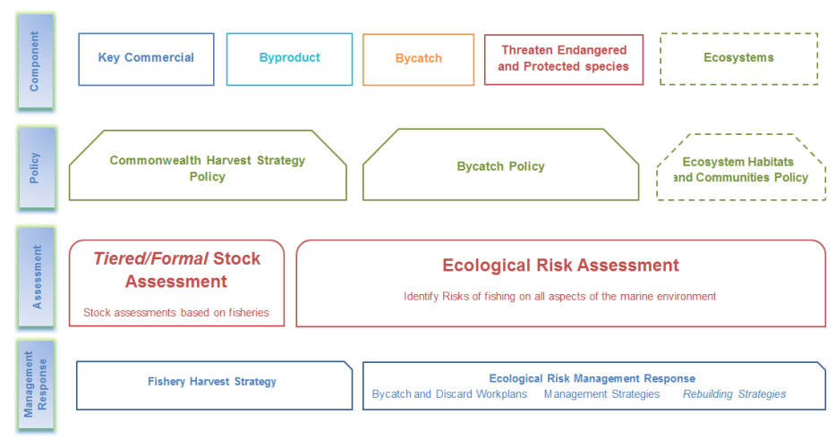
Figure 4. AFMA’s ecosystem based fisheries management framework.
The fishery's ERA takes into consideration the possible effects of fishing on the following five elements of the marine environment - target, byproduct, bycatch/discards, protected species, and the habitats and communities in which those species occur.
The impacts of the SSJF on the ecosystem are considered minimal. Due to the highly selective nature of squid jigging, there is normally no bycatch or interactions with protected species. There is no damage to the sea floor as the fishing gear does not come into contact with the bottom. No significant threats were identified in the SSJF based on a Level 1 Ecological Risk Assessment in 2007 and an Ecological Risk Management report in 2009. A copy of the ecological risk assessment and ecological risk mitigation strategy are available at Ecological risk management strategies | Australian Fisheries Management Authority.

National policies, plans and strategies
There are a number of National and Commonwealth plans, policies and strategies relevant to the SSJF that aim to mitigate impacts to target and non-target species, and to the marine environment in which the fishery operates.
Key National and Commonwealth plans, policies and strategies relevant to the SSJF include:
- Commonwealth Bycatch Policy and Guidelines
- Commonwealth Harvest Strategy Policy and Guidelines
- Threat abatement plan for the impacts of marine debris on the vertebrate wildlife of Australia’s coast and oceans
- National Policy on Fisheries Bycatch
- Environment Protection and Biodiversity Conservation Act 1999
Requirements are met via several avenues including implementation of the SSJF Harvest Strategy, Research Statement, Bycatch and Discarding Workplans, Management Strategies and integration into fisheries legislation to ensure enforceability and compliance.

Changes since the previous assessment
Fishing Methods and Gear
Recent reports presented at the October 2024 SquidRAG meeting indicate a shift in fishing practices. Industry representatives have noted that the majority of fishing is now conducted under anchor, targeting hard bottom reef areas at greater depths—down to 160 meters, compared to the previous average of around 90 meters. Additionally, while fishing was predominantly undertaken at night in previous seasons, operators have more recently adopted a mixed schedule, fishing during both day and night.
Management Arrangements
A review of the current Harvest Strategy was undertaken throughout 2020 and 2021, as part of this review, AFMA sought advice from SquidRAG and SEMAC. While it was recognised that the trigger and decision rules should be reviewed, there was insufficient data available to undertake a depletion analysis and support an evaluation of the current Harvest Strategy catch triggers (current catch triggers).
To support a more holistic review of the current catch triggers, AFMA, with advice from SquidRAG, have undertaken a review of the data needs in the fishery and developed the draft SSJF Data and Monitoring Strategy 2022. The data collected is expected to support a more thorough review of the Harvest Strategy in the future.
As an interim approach, the draft Harvest Strategy was amended to include a lower catch and effort trigger (end-of-year) based on more recent catch and effort data. This approach formalises the review already undertaken by SquidRAG each year as part of the Total Allowable Effort setting process and ensures a consistent and transparent approach.
In 2022 the draft Harvest Strategy was reviewed once more by SquidRAG, including the additional lower catch and effort trigger, before being reviewed and endorsed by SEMAC and finally the commission where it was adopted. It has been implemented since the beginning of the 2023 fishing season.
The ABARES report ‘Analyses to support the review of the Southern Squid Jig Fishery harvest strategy’ which was presented at SquidRAG27 and informed the updated 2022 SSJF Harvest Strategy is available on the ABARES website.
Further information on the SSJF Harvest Strategy can be found on the AFMA website (‘Fisheries management’ – ‘Fisheries’ – ‘Southern Squid Jig Fishery’).

Research And Monitoring
ABARES has finalised the project ‘CPUE standardisation for Gould’s squid caught in the Commonwealth Trawl Sector and Southern Squid Jig Fishery’. The aim of this project was to investigate approaches to standardise CPUE and assess the utility of nominal and standardised CPUE indicators to support the review and implementation of a revised SSJF Harvest Strategy. A key outcome of the study was that data availability, particularly deficiencies in logbook data, significantly affected the ability to conduct reliable CPUE standardisations. The report identifies existing data gaps regarding logbooks and provides recommendations for improvement of data. AFMA have commenced work with ABARES to implement priority recommendations.

Climate Adaptation Program
AFMA’s Climate Adaptation Program is implementing a range of measures to incorporate climate change information and risks into decision making frameworks, to ensure that management of Commonwealth fisheries is adaptive to the impacts of climate change.
The Climate Risk Framework (CRF) is currently being trialled across a number of AFMA-managed fisheries. The Framework details a risk assessment process designed to integrate with existing management frameworks to respond to climate change impacts. The Framework employs a four-step process designed to:
- Evaluate the overall risk to a species, integrating climate change impacts with the stock's biological status, using the best available information;
- Evaluate whether current science, management, or industry adaptation strategies offer adequately responsive measures for the full spectrum of climate change impacts, both positive and negative;
- Determine the residual risk to a species; and
- Where necessary, recommend to the AFMA Commission any supplementary measures needed to respond to climate change impacts.
AFMA established a Working Group to support the trial implementation of the CRF and provide strategic advice to the AFMA Commission and AFMA Management on the development, coordination and implementation of the CRF across Commonwealth fisheries.
A range of fishery climate and ecosystem status reports are available on the AFMA website that provide information on expected impacts of climate change on AFMA-managed fisheries. Of particular relevance is the Climate & Ecosystem Status Report for the Southern Squid Jig Fishery (September 2023), which offers insights into environmental trends and their implications for squid populations and fishery operations. The report is available at: Southern Squid Jig Fishery Climate Report."
Electronic Logbooks
In July 2022, AFMA mandated the use of logbooks or electronic logbooks (elogs) across Commonwealth fisheries. There is no longer an exemption for a concession holder that has fished less than 50 days in the current or previous fishing season.

Monitoring and data collection

Data collection, data validation and data monitoring programs
The monitoring program for the SSJF includes information collected through daily catch and effort logbooks and catch disposal records (CDRs). An overview of the monitoring program is provided below. This information can be verified against multiple sources including independent studies, vessel monitoring systems and on board scientific observers.
Logbooks
All concession holders in the SSJF are required to complete paper and/or electronic logbooks. Squid jig operations must complete the Squid Jigging Daily Fishing Log (SQ05). Logbooks provide for the recording of information on the vessel, operator, gear, location, time and catch for each fishing operation. Information on bycatch species, interactions with ETP species and other trip observations including discard rates are also collected. Accurate data from logbooks allow AFMA to monitor bycatch and discards in the fishery and respond to any emerging issues.
Electronic logbooks (eLogs)
E-logs are used across all commonwealth fisheries and AFMA encourages operators in the SSJF to use electronic CDR’s for the completion and transmission of logbook returns. They have been mandatory for operators in other sectors to promote more accurate and timely data. E-logs must be submitted prior to the boat docking.
Catch disposal records (CDRs)
Catch Disposal Records (CDRs) provide a means to verify information recorded in the daily fishing logbooks and provides accurate weights for each species landed.
Operators in the SSJF are not required to land their catch to licensed Fish Receiver Permit Holders, like most Commonwealth fisheries, instead the catch must be accurately weighed at the point of unload and a CDR is completed before it is transported.
Electronic CDRs
Electronic CDRs (eCDRs) were trialled in the 2022 fishing season and remain voluntary in the SSJF.
Vessel Monitoring Systems
Vessel Monitoring Systems (VMS) provide AFMA with near real time information to effectively monitor the movements of all Commonwealth endorsed fishing boats. Each VMS unit routinely produces positional reports which contain information including the boat’s current location, course and speed; for the purpose of domestic compliance, fisheries management and research.
Observer Program and port sampling
Observer programs provide fisheries managers, research organisations, environmental agencies, industry and the wider community with independent, reliable, verified and accurate information on the fishing catch, effort and practice of Commonwealth boats. Data is collected by scientifically trained observers, either on-board the boats or in port when product is landed. An observer program can be used to verify logbook information; determine levels of interactions with ETP species; quantify levels of bycatch and status of discards and educate operators.
There is no formal observer program in the fishery however concession holders may be required to carry an observer if there is a need identified by AFMA or SquidRAG.
Crew collected data program
Crew collected data provides a cost effective alternative to an observer program, with data collected on-board by crew. Unlike the observer program, crew collected data is not independent and verified but can provide information on the fishing catch and effort.
Under a revised Data and Monitoring Strategy AFMA are considering establishing a crew collected data program.
Data management
AFMA oversees the collection of large amounts of fishery data that are collected through methods outlined above. These data sources are collected via systems directly integrated into the AFMA database (e.g. electronic logbooks), via paper forms submitted and manually entered into the database (e.g. ETP interaction forms, observer reports).

Stock assessments

Key target and byproduct species
No formal stock assessment has been undertaken in the SSJF. The Harvest Strategy is underpinned by a simple catch and effort analysis with triggers that will prompt a depletion analysis should enough fishing occur. Stock status is considered annually by ABARES as part of the Fishery Status Reports). These reports have described stocks as ‘not subject to overfishing’ and ‘not overfished’ since 2008, with the previous status being ‘uncertain’ (Table 3). Current knowledge of the southern squid resource is insufficient to allow biomass or suitable proxies for reference points to be estimated.
Table 3. ABARES Fishery Status Report for the Southern Squid Jig Fishery – biological status
Stock | Fishing mortality 2023 | Biomass 2023 | Fishing mortality 2024 | Biomass 2024 | Comments
Gould’s squid (Nototodarus gouldi) | Not subject to overfishing | Not overfished | Not subject to overfishing | Not overfished | Relative stability in catch rates may indicate relative stability in availability and biomass.

The Harvest Strategy uses a system of catch triggers to monitor the need for a formal assessment (Refer to Table 2). Due to relatively low effort in the last few years, these triggers have far exceeded the catch and effort in the fishery.
Table 4. TAEs* and reported catches for fishing seasons 2020-2024
 | 2020 |  | 2021 |  | 2022 |  | 2023 |  | 2024
Stock | TAE | Catch (t) | TAE | Catch (t) | TAE | Catch (t) | TAE | Catch (t) | TAE | Catch (t)
Gould’s squid | 550 | 62.92 | 550 | 525.83 | 550 | 106.68 | 550 | 640.97 | 550 | 770.38
*TAE are represented by the number of standard jigging machines allowed to be used.
There are currently no concerns with respect to the squid resource in Commonwealth waters. The reduced effort in the SSJF is due to market forces rather than the availability of squid. Despite being considered to have been only lightly fished in recent years, the highly variable pattern of Gould’s squid abundance across years and localities has underpinned the rationale for a precautionary approach specified in the Harvest Strategy.
In addition, trawl bycatch of Gould’s squid has been relatively consistent over the years indicating that squid stocks are stable (Table 5).
Table 5 Bycatch of Gould’s Squid in the CTS
Year | 2020 | 2021 | 2022 | 2023 | 2024
Gould’s squid (Nototodarus gouldi) Tonnes (t) | 357.4 | 405 | 204 | 221 | 211

Indicator species
Currently, there are no formally recognised indicator species associated with the Southern Squid Jig Fishery (SSJF). Meaning that no specific marine organisms have been designated to serve as biological indicators for monitoring the environmental health, ecosystem impacts, or sustainability of fishing activities within this fishery. The absence of indicator species reflects limited ecological data and/or a need for further research to identify species whose population trends or behaviours could reliably signal changes in ecosystem condition or fishing pressure. Establishing indicator species may enhance the fishery’s environmental monitoring and support more adaptive management practices.

Distribution and spatial structure of key stocks
The majority of squid catches by the SSJF are reported off the coast of Portland, Victoria, and Triabunna, Tasmania, with total catch and catch per unit effort showing considerable variability between years. Cross jurisdictional management arrangements in the SSJF operate in the form of Offshore Constitutional Settlement (OCS) arrangements. OCS arrangements have been negotiated with South Australia and Victoria for squid resources in inshore waters to be managed by the Commonwealth. An OCS arrangement with Queensland gives the Commonwealth management of squid in areas from approximately 80 nm of the Queensland coast to the edge of the AFZ from the NSW/Queensland border to Sandy Cape, Fraser Island. There is no OCS arrangement with Tasmania however, the state continues to participate as an invited participant on the SquidRAG and SEMAC consultation processes to ensure that inshore squid resource management interests are represented and that management approaches remain aligned across jurisdictions.

Estimates of total removals
Total catches for the SSJF have historically shown considerable variability between years and have consistently been significantly below the intermediate and limit catch triggers set out in the Harvest Strategy. Trawl bycatch of Gould’s squid has been relatively consistent over the last five years (between 200 and 400 tonnes). (Refer to Table 5. Bycatch of Gould’s Squid in the CTS).
Commercial catch data of Gould’s squid in the SSJF and CTS since 2016 are detailed below in Table 6.
Table 6. Catch of Gould’s squid by calendar year (CDR Data, 2016-2025).
 | SSJF (t) | Trawl sectors of the SESSF (t)
2016 | 384 | 542
2017 | 213 | 569
2018 | 811 | 784
2019 | 248 | 425
2020 | 67 | 357
2021 | 530 | 405
2022 | 146 | 204
2023 | 692 | 220
2024 | 782 | 211
2025 | 470* | 90*
* Catch as of September 2025 (2025 fishing season is open from January to 31 December 2025).
Appendices 2 provide data on discards in the SSJF from the last 5 years.
Discarded catch data in the SSJF from the last five years (target and non target) is provided at Appendices 2.

Bycatch

Bycatch composition
Bycatch in the SSJF is very low due to the targeted nature of the fishing operations. Byproduct has historically comprised red ocean squid (Ommastrephes bartrami), the Southern Ocean arrow squid (Todarodes filippovae) and southern calamari (Sepioteuthis australis). Other potential bycatch species occasionally encountered in the fishery include gummy shark, school shark, mako shark, barracouta, cuttlefish and octopus. These species are typically released at the rollers prior to boarding and are not retained.
For further detail, refer to discarded catch data (target and non-target species) from 2020–2025 in Appendix 2.

Risk assessment on the effects of fishing on bycatch
Ecological risk assessments are used to identify which species, habitats or communities are at risk from the effects of fishing. The ecological risk assessment of the fishery, completed in 2006, did not identify any threats to the environment from jig fishing (Furlani et al 2007). The subsequent ecological risk management assessment (AFMA 2009) supported this outcome, with none of the 216 ETP species identified as occurring within the area of the SSJF being assessed as at high risk from the effect of commercial fishing operations.

Bycatch mitigation measures
Throughout 2020, AFMA consulted with the Southern Squid Jig Fishery Resource Assessment Group (SquidRAG) and the South East Management Advisory Committee (SEMAC) on the revised 2021 SSJF Bycatch and Discarding Workplan (the Workplan).
The Workplan replaced the SSJF Bycatch Action Plan 2004, and outlines actions to support evidence based fisheries management decisions in the SSJF. The focus of the Workplan is accurate recording of bycatch and discards to support ongoing management and assessment under AFMA’s Ecological Risk Management framework, which includes undertaking Ecological Risk Assessments.
A copy of the Workplan can be found on the AFMA website (‘Protected Species’ – ‘Reducing Bycatch’ – ‘Bycatch and Discarding Workplans’).

Indicator bycatch species
Currently, no indicator bycatch species are monitored in this fishery and therefore no specific monitoring processes are in place for assessing the effects of fishing on bycatch species.

Management actions
As there are no designated indicator bycatch species monitored for the effects of fishing in the SSJF, there are no associated decision rules or management actions triggered by changes in their status.

Protected species and threatened ecological communities

Fishery impacts on protected species and communities
While there is potential for interactions with seals, dolphins, seabirds and sharks in the SSJF, the risk of interaction is considered low. Research in 2004 investigated the potential for harmful interactions between Australian fur seals and squid-jigging operations and found that there was no evidence of jigging operations having a negative impact on seals (Arnould et al 2003).
There have been no reported interactions with ETP species in the SSJF since 2010.
Protected species interaction reports are produced quarterly and are available from the AFMA website at: Endangered and Threatened Species Reporting | Australian Fisheries Management Authority

Mitigating risks to protected species
The Southern Squid Jig Fishery (SSJF) employs a highly selective jigging method, which results in minimal bycatch and very limited interactions with protected species. Consequently, the ecological risk associated with these interactions is considered low. The 2007 Ecological Risk Assessment (ERA) did not identify any species at risk from commercial fishing operations, and no priority species or groups were flagged for action under the bycatch and discarding workplan.
To further support responsible fishing practices and minimise potential impacts, the SSJF concession conditions include general management arrangements designed to mitigate bycatch risks and ensure appropriate treatment of non-target species. These measures include:
- Bycatch Handling: Operators must handle bycatch species in a way that maximises their chances of survival.
- Bycatch Treatment: Mistreatment of bycatch is strictly prohibited. Mistreatment is defined as any action—or failure to act—that causes, or is likely to cause, death, injury, or distress to bycatch species.
- Finfish Restrictions: Operators must comply with specific limits and prohibitions.
- Catch Reporting: Any interactions with species listed under the Environment Protection and Biodiversity Conservation (EPBC) Act must be reported in the ‘Wildlife and Other Protected Species’ section of the logbook.

CITES-listed species
The fishery does not target or retain any species listed under the Convention on International Trade in Endangered Species of Wild Fauna and Flora (CITES), and therefore no harvest quantities or species-specific management arrangements apply.

Ecosystem

Ecosystem management actions
AFMA monitor the effects fishing activities have on marine species, habitats and communities through ecological risk assessments. The assessment results help to prioritise the management, research, data collection and monitoring needs of the fishery. After the risk assessment is complete, an ecological risk management strategy (ERM) is developed to address how AFMA will manage risks to marine species, habitats and communities identified in the assessment as impacted by commercial fishing operations.
The impacts of the SSJF on the ecosystem are considered minimal. No significant threats were identified in the SSJF based on a Level 1 Ecological Risk Assessment in 2007 and an Ecological Risk Management report in 2009.
Information on catch and ETP interactions are available on the AFMA website at:
- www.afma.gov.au/resources/catch-data/
- www.afma.gov.au/sustainability-environment/protected-species-management/protected-species-interaction-reports/.

Management responses
The Fisheries Management Act 1991 mandates that fishing is conducted in a manner consistent with the principles of ecological sustainable development. The ERA and ERM has been implemented to mitigate the effects of fishing on the marine environment in which the fishery operates.
A range of management actions are in place to ensure fishing operations do not have a significant impact on the marine environment in which the fishery operates. Risks and mitigation measures are addressed in the risk assessment reports for the fishery.

Marine bioregional plans
The area of the fishery encompasses the South-east Marine Region. The south-west Marine region, and the Temperate East Marine Region.
There is no marine bioregional plan for the south-east marine region. However, the South-east marine region profile describes the major ecosystems and processes in the area. Conservation values identified in the region include 8 key ecological features (KEFs). The region also provides foraging and nursery habitat for over 46 EPBC Act-listed species, and a number of protected places including marine reserves, and ecological communities.
The Marine bioregional plan for the temperate east marine region 2012 describes 16 conservation values of regional priority, including marine turtles, grey nurse sharks, white shark, and seabirds. The fishery has in place mitigation measures that have proven effective in minimising interactions with these species. Harvesting of living resources and physical disturbance to seafloor, are described as pressures of concern in the temperate east marine region. Specific measures are in place in the fishery that mitigate the impact of these pressures, including a closure, mandatory use of bycatch reduction devices, and trigger limits.
The Marine bioregional plan for the south-west marine region 2012 identified 23 conservation values of regional priority, including Australian sea lions, white shark, school shark, seabirds and eight KEFs. These KEFs support highly diverse marine life and provide important habitat for a range of commercially important species. Climate change factors (e.g. acidification and water temperature), and impacts caused by marine debris are considered pressures of concern in the region. Extraction of living resources places pressure on Australian sea lions and seabirds by reducing the availability of prey species. A number of species such as orange roughy, and seabirds are prone to bycatch. The marine bioregional plan indicates that these pressures are either not well understood or expected to increase.
There is no clear evidence to suggest any systematic change to species diversity or richness is caused by the fishery.
Given the management measures in place in the fishery, the conservation values identified in these marine regions are not compromised by the fishery. However, the risks and uncertainties identified in this assessment require ongoing monitoring, assessment, and management to ensure that fishing effort does not have a material impact on the food chain or trophic structure in the area of the fishery.

Research

COMRAC – FRDC
Table 7 represents current and recently completed relevant FRDC research projects since the last fishery assessment under the EPBC Act.
Table 7. Commonwealth Research Advisory Committee current and completed research projects.
Research Project | Status | Purpose | Principle Investigator
Trials of oceanographic data collection on commercial fishing vessels in SE Australia | Current | This project intends to instrument the seafood sector’s assets (e.g Trawl Nets, longlines, pots) with fit-for- purpose quality-controlled (QC'd) temperature/pressure sensors to increase the sub-surface temperature data coverage around Australia’s shelf and upper slope regions (0-800m) at low cost. Not only will this assist in the collection of data at relevant spatial and temporal scales for use by fishers, but it will also provide a far more extensive level of QC’d data to oceanographers in near real time (NRT) for evaluation and ingestion into data-assimilating coastal models that will provide improved analysis and forecasts of oceanic conditions. In turn, this will also be of value to the fishing sector when used to standardise stock assessments.  Project Timeframe: 31 Jul 2022 – 30 May 2025 | Fishwell consultanting
Developing a cost-effective stock assessment program for Southern Calamari fisheries | Current | The primary outcome of this project will be to develop an assessment program for Southern Calamari in SA that can be used to assign stock status and provide TACC setting advice to fisheries management.  Overcoming key knowledge gaps and incorporating information on environmental drivers will be a key focus of this project, in order to develop an assessment that accounts for the full complexity of cephalopod population dynamics.  (FRDC Project 2021-118)  Project Timeframe: 24 March 2024 – 27 Feb 2027 | University of Adelaide  Craig J. Noell
Analyses to support the review of the Southern Squid Jig Fishery (SSJF) harvest strategy | Completed  May 2024 | The primary outcome of this project was to investigate modelling approaches and identify the data needed to construct reliable CPUE series for the SSJF and CTS and, investigate if there is sufficient data to conduct a depletion analysis.  The report is available here | Rocio Noriega, Mahdi Parsa, James Woodhams and Rupert Summerson  Research by the Australian Bureau of Agricultural and Resource Economics and Sciences

Progress against current Conditions
There are no conditions or recommendations for this fishery. The fishery continues to be well managed and is considered to have a low ecological impact. Ecological risks are regularly reviewed and reassessed when required.

References
AFMA (2022) Southern Squid Jig Fishery Harvest Strategy 2022.
AFMA (2009) Ecological Risk Management report for the Southern Squid Jig Fishery.
AFMA (2025) Southern Squid Jig Fishery Management Arrangements Booklet – Season 2025. December 2024.
Arnould J, Trinder DM, McKinley CP (2003) Interactions between fur seals and a squid jig fishery in southern Australia. Marine and Freshwater Research, 54:8, 979-984.
Furlani D, Ling S, Hobday A, Dowdney J, Bulman C, Sporcic M, Fuller M (2007) Ecological Risk Assessment for the effects of fishing: Southern Squid Jig Sub-fishery. Report for AFMA, Canberra.
Green CP (2011) Influence of environmental factors on population structure of arrow squid Nototodarus gouldi: implications for stock assessment. Thesis. University of Tasmania, Hobart.
McKinna D, Wall C, Brown R, Lonie K, Jaensch M (2011) Improving the efficiency of southern squid jig fisheries. FRDC Final Report #2009/221, pp. 97.
Keller K, Noriega R and Curtotti R (2024) Chapter 12: Southern Squid Jig Fishery. ABARES Fishery Status Reports 2024. October 2024. 309-315p.
Southern Squid Jig Fishery Management Plan 2005 (2012) Federal Register of Legislative Instruments F2012C00161. Prepared 23 February 2012.
Virtue P, Green C, Pethybridge H, Moltschaniwskyj N, Wotherspoon S, Jackson G (2011) Arrow squid: stock variability, fishing techniques, trophic linkages – facing the challenges. FRDC Final Report #2006/12, pp.207.

Appended Data Tables

APPENDIX 1 – Retained catch data (target and byproduct species)
Table 8. SSJF Reported logbook catch 2020-2025
Year | Standard Name | Scientific Name | CAAB | Retained weight (kg)
2020 | Gould's Squid | Nototodarus gouldi | 23636004 | 62924
2020 | Gummy Shark | Mustelus antarcticus | 37017001 | 29
2020 | School Shark | Galeorhinus galeus | 37017008 | 9
2020 | Swallowtail | Centroberyx lineatus | 37258005 | 224
2021 | Gould's Squid | Nototodarus gouldi | 23636004 | 525829
2022 | Commercial Scallop | Pecten fumatus | 23270007 | 640
2022 | Gould's Squid | Nototodarus gouldi | 23636004 | 106675
2022 | Southern Ocean Arrow Squid | Todarodes filippovae | 23636011 | 32580
2023 | Commercial Scallop | Pecten fumatus | 23270007 | 1216
2023 | Gould's Squid | Nototodarus gouldi | 23636004 | 640974
2024 | Gould's Squid | Nototodarus gouldi | 23636004 | 770384
2025 | Gould's Squid | Nototodarus gouldi | 23636004 | 423348
2025 | Southern Bluefin Tuna | Thunnus maccoyii | 37441004 | 27995

APPENDIX 2 – Discarded catch data (target and non-target species)
Table 9. SSJF Discarded catch by Logbook 2020-2025
Year | Standard Name | Scientific Name | CAAB | *Discarded weight (kg) | *Discarded No.
2020 | Gould's Squid | Nototodarus gouldi | 23636004
2020 | Gummy Shark | Mustelus antarcticus | 37017001
2020 | Port Jackson Shark | Heterodontus portusjacksoni | 37007001 | 2 | 4
2020 | School Shark | Galeorhinus galeus | 37017008
2020 | Swallowtail | Centroberyx lineatus | 37258005
2021 | Gould's Squid | Nototodarus gouldi | 23636004
2022 | *Commercial Scallop | Pecten fumatus | 23270007
2022 | Gould's Squid | Nototodarus gouldi | 23636004
2022 | Southern Ocean Arrow Squid | Todarodes filippovae | 23636011
2023 | *Commercial Scallop | Pecten fumatus | 23270007
2023 | Gould's Squid | Nototodarus gouldi | 23636004
2024 | Gould's Squid | Nototodarus gouldi | 23636004
2025 | Banded Morwong | Cheilodactylus spectabilis | 37377006 | 1 | 1
2025 | Barracouta | Thyrsites atun | 37439001 | 20 | 32
2025 | Gould's Squid | Nototodarus gouldi | 23636004
2025 | Southern Bluefin Tuna | Thunnus maccoyii | 37441004

*Where no discarded weight or no. of animals is recorded this indicates species caught but not landed in the vessel

** Anecdotal information from Industry suggests that it is highly unlikely that commercial scallop could be caught on squid boats with computerised gear (which is majority of the fleet) as the computer stops the line/jigs before they touch the seabed floor.

APPENDIX 3 – Protected species interaction data
This includes all species protected under Part 13 of the EPBC Act, including all Listed Marine, Listed Migratory, Eligible Listed Threatened Species, and whales and other cetaceans.
Copies of protected species lists are available at: https://www.dcceew.gov.au/environment/epbc/our-role/approved-lists.
Note: There is no list of whales and cetaceans - all whales and cetaceans are protected under Part 13 of the EPBC Act.
An interaction is any physical contact between a species and a fishing operation and includes all catch, and any discards or releases. Collisions (that is, an animal that makes contact with the fishing operation but is not caught) are also considered to be interactions. Interactions must be recorded and reported even if the animal does not require physical contact for release and regardless of whether any other catch is recorded.
Where possible report interactions by number of each species for each fishing method/gear type. Where information is available on whether the animal was injured, killed, or released alive, please include this for consideration.
Where interactions have not been identified to species-level, please provide advice in the relevant sections of the report on how impacts on individual species are monitored and managed.
There have been no reported interactions with ETP species in the SSJF in the last 10 years.

APPENDIX 4 – Fishing effort
Table 10. Fishing effort within the SSJF
Year | 2020 | 2021 | 2022 | 2023 | 2024 | 2025*
No. of active boats | 5 | 8 | 6 | 8 | 10 | 7
No. of boat days | 183 | 325 | 148 | 405 | 526 | 366
* Effort as of September 2025 (2025 fishing season is open from January to 31 December 2025).

