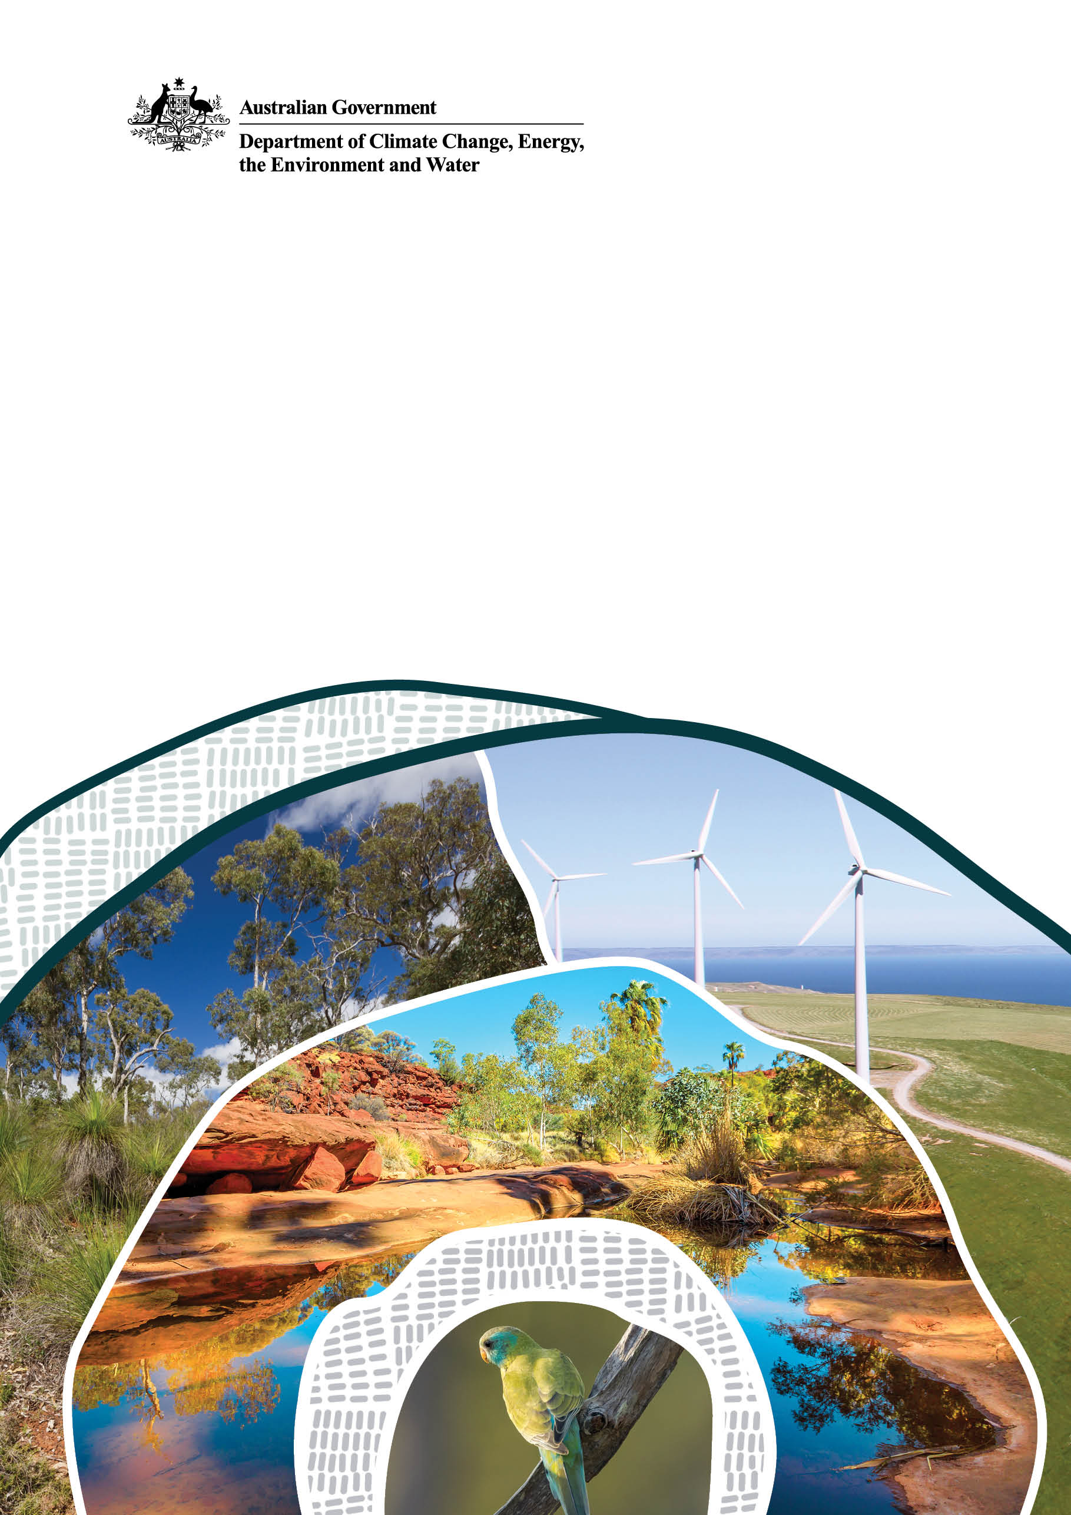
OFFICIAL Sensitive
DRAFT FOR DISCUSSION: NOT OFFICIAL GOVERNMENT POLICY/LEGISLATION

DRAFT Policy Position: National Environmental Standard for Matters of National Environmental Significance

This document provides an overview of the proposed policy positions for a National Environmental Standard for Matters of National Environmental Significance associated with reforms of the Environment Protection and Biodiversity Conservation Act 1999 (the EPBC Act).

Background
The Samuel Review (Review) recommended the development of National Environmental Standards (Standards) that would form the centrepiece of national environmental law reforms.
In response, the Government has committed to amend the Environment Protection and Biodiversity Conservation Act 1999 (EPBC Act) to include new provisions to enable the Minister to make, implement and review Standards.
Standards will support the operation of a reformed EPBC Act by setting expectations for regulated activities and uplifting the quality and consistency of decision-making.
The Review found that under the current EPBC Act decision-making requirements are not focused on outcomes for Matters of National Environmental Significance (MNES) and allow considerable discretion by the Minister. The Review recommended development of a Standard for MNES that:
- Assists the community and business to access clear and consistent rules in order to know what to expect from decision-making.
- Provides flexibility by outlining clear outcomes but not dictating how these should be achieved.
- Places in one location all legislative requirements, including consideration of statutory documents, guidelines and policies.
- Includes unacceptable impact criteria that set rules the Minister could not be inconsistent with when making a decision, unless in rare exceptions.
Note c) and d) have not been included in the MNES Standard as:
- Unacceptable impact criteria have been placed into the primary legislation.
- Duplicating existing EPBC Act requirements, as well as non-legislative guidelines and policies, into Standards could create complexity and should be minimised.
The Standard for Matters of National Environmental Significance (MNES Standard) will operate alongside existing requirements under the EPBC Act or proposed under the reforms, including:
- Unacceptable impacts must be avoided (reforms).
- Legislated requirement to consider whether proponents have taken appropriate measures to avoid, mitigate or repair significant impacts (reforms).
- Compensation for residual significant impacts and deliver a net gain (reforms).
- Subordinate instruments, such as recovery plans and conservation advices.
- Other standards (e.g., the Environmental Offsets Standard).
- Alignment with Australian Radiation Protection and Nuclear Safety Agency (ARPANSA) national codes.
- Consistency with international conventions and agreements (e.g., Bonn Convention).

An MNES Standard was developed under the previous term of Government and was last consulted on in March 2024. However, the MNES Standard has changed substantially from the March consultation version for the following reasons:
- Alignment with provisions already covered in the EPBC Act – removal of duplication, including consistency with international agreements, alignment with external party codes (ARPANSA), and consideration of relevant legislative instruments.
- Removed former ‘net positive’ requirements and inserting ‘net gain’ into legislation.
- Insertion of outcomes and principles for avoidance, mitigation and repair.
The MNES Standard will be made by the Minister as a legislative instrument through the new proposed standards-making power under the EPBC Act.
This standard is in the first tranche of standards to be developed as it addresses what must be done to protect, conserve and enhance (if necessary) EPBC Act protected matters through the regulatory process. It is being developed alongside the amendments to the primary legislation of the EPBC Act to provide confidence in what will be delivered to inform outcomes and protect MNES through the proposed reforms. The Standard would be made after the required statutory consultation and as a legislative instrument once the amended provisions have commenced.
Further detail on the proposed legislative settings for MNES, including the proposed changes to the EPBC Act, the proposed settings in EPBC Regulations, and content for policy and guidance is provided at Attachment A.

Proposed application of the MNES Standard
This Standard is intended to cover all MNES, in addition to other matters protected by Part 3 of the EPBC Act (protected matters).
It is proposed that the Minister will only be able to approve an action if satisfied that doing so is not inconsistent with any prescribed National Environmental Standard. The only exception is in the rare circumstance of the action being in the national interest, where an inconsistency with a National Environmental Standard is reasonably necessary for an action to deliver an outcome in the national interest.
For actions approved under Part 9, the MNES Standard will apply to the Minister’s decision whether or not to approve an action, and what conditions to attach to an approval. This is the point at which the Minister must be satisfied that their decision to approve the action is not inconsistent with the standard. This decision will be based on a range of factors, including the finalised assessment documentation, design of the action, and any proposed conditions of the approval.
Actions assessed under assessment bilateral agreements will benefit from a streamlined process and prescribed Standards will apply to decisions under Part 9 as described above.
Actions, or classes of actions, approved by state or territory decision-makers under approval bilateral agreements may also only be approved if the Minister is satisfied that doing so is not inconsistent with any prescribed Standard.

For landscape-scale approaches, the MNES Standard will apply to the class of actions (as a whole). The Minister will have regard to whether:
- a decision to approve the class of actions (including to make a guidance bioregional plan or a bioregional plan) is not inconsistent with the Standard, and
- the class of actions will appropriately avoid, mitigate or repair damage to a protected matter.
For accreditation of state and territory processes under bilateral agreements, the Minister must be satisfied that:
- the accredited process is not inconsistent with the Standard, and
- for approval bilateral agreements - the approval decisions made under the accredited process will not be inconsistent with the Standard.
In addition, the MNES Standard will:
- Support primary legislation as a statutory instrument – to set legally enforceable outcomes but also retain the flexibility to respond to new approaches to conservation or emerging threats.
- Complement the suite of other/future Standards supporting the operation of the EPBC Act.
- Be subject to a non-regression clause in the EPBC Act so that overall protections of the environment are not diminished over time.

Anticipated use of the Standard by Proponents
This Standard will apply to actions seeking approval under the EPBC Act, once they have been determined to have a significant impact on a protected matter. It will not directly apply to decisions relating to the referral process and the controlled action decision.
However, in practice it is anticipated that Proponents will use the Standard as a guide when designing their actions or classes of actions. Applying the Standard will support proponents to meet EPBC Act requirements should actions be determined to be controlled actions which require assessment and approval under the EPBC Act.
For bioregional plans, the Standard will also guide the Commonwealth and, where relevant, a partner state or territory government, to develop the bioregional plan. For the purposes of this document, the term ‘proponents’ includes governments working on the development of bioregional plans.

Figure 1: Expected use of the MNES Standard by different stakeholders

 | Community | Proponents | Minister
Scoping / planning | Reflects community expectations for the conservation and enhancement of protected matters. | Provides guidance on required objectives and outcomes for Protected Matters through a set of clear & consistent principles; including early expectation setting on what is required if actions have significant impacts on protected matters. | -
Submission | Supports community to make informed comment on outcomes for protected matters through the development application process and bioregional plan development process. | Supports proponents to develop robust submissions for consideration by the Minister, including an early emphasis on avoiding and minimising likely impacts to protected matters. | -
Assessment |  | Supports proponents to develop robust assessment documentation that considers all impacts to protected matters, further mitigates significant impacts to protected matters, identifies opportunities for restoration, and provides a net gain for protected matters where residual significant impacts are expected. | Supports quality and consistent assessments to ensure decisions are not inconsistent with the Standard. This includes consideration of the Objective, Outcomes and Principles of each Standard.
Approval | - | Supports greater certainty for what is required to progress to an approval or to the making of a bioregional plan. | Provides a consistent framework for decision-making.  Minister’s decision must not be inconsistent with the Standard.
Post approval | - | Supports design of efficient and effective monitoring, evaluation and reporting activities to meet conditions of approval or bioregional plan. | Supports regulatory assurance processes through defining outcomes for protected matters and principles to achieve these. These are built into ongoing monitoring, evaluation and reporting activities as conditions of approval or conditions under a bioregional plan.

Key elements of the MNES Standard
There are three key elements of the MNES Standard: Objective, Outcomes and Principles (Figure 2).
- Objective: outlines the overall aim of the Standard and provides clear linkages to the Objects of the EPBC Act
- Outcomes: are specific results that, when implemented, the Standard aims to achieve
- Principles: are requirements that need to be applied to achieve the Outcomes and effectively promote the Objectives of the Standard and, as a result, the Objects of the EPBC Act.

In addition, the Standard will include key definitions for terms not defined in the EPBC Act.
Figure 2: Key elements of the MNES Standard
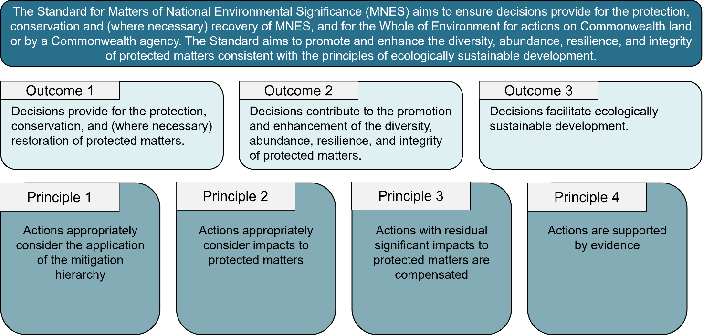

MNES Standard Objectives

Summary of intent
The EPBC Act will require that a Standard must specify one or more outcomes or objectives. The Objective of a Standard, including the MNES Standard, will relate directly to the objects of the EPBC Act and will explain the purpose and goal of all requirements in the Standard.
These objectives align with the outcomes from the Review for each MNES and are consistent with Australia’s obligations under international agreements for MNES. They have been elevated into the objectives to form the overarching aim of the MNES Standard.

These objectives set out the overarching aims that guide a proposed action or class of actions (referred to hence forth collectively as actions). They define what the MNES Standard is trying to achieve for combined actions, providing a foundation for planning, assessment, and decision-making. These high-level intentions ensure that all actions align with the broader purpose of the MNES Standard.

The objectives have been developed to provide direction, while balancing ambition with achievability through the regulatory system. They set the desired aims and have been framed to ensure they remain realistic and capable of being used to achieve positive results. This balance ensures the objectives both inspire long-term vision and guide practical management.

Key elements of these objectives for the protected matters are to protect, conserve, and restore.
- Protect refers to keeping a protected matter safe from harm, damage or exploitation.
- Conserve relates to wise management for the future prevention of permanent loss and promotes sustainable use.
- Restore relates to repairing, rehabilitating or reinstating damage, degraded or lost conditions of or for the protected matter.

Content for the Standard [Policy]
The Standard for Matters of National Environmental Significance (MNES) aims to ensure decisions provide for the protection, conservation, restoration, (where necessary) recovery and (where relevant) sustainable management of all MNES, in addition to other matters protected by Part 3 of the EPBC Act (protected matters).
The Standard aims to promote and enhance the diversity, abundance, resilience, and integrity of protected matters consistent with the principles of ecologically sustainable development. This includes the following Objectives:

For Threatened Species
- Habitat, including critical habitat of the listed threatened species where the habitat is irreplaceable and necessary for a threatened species to remain viable in the wild, is protected, conserved and restored to support the survival and recovery of the threatened species.
- Protection and recovery actions support the viability of threatened species in the wild.

For Ecological Communities
- Habitat, including critical habitat of the listed ecological community where the habitat is irreplaceable and necessary for an ecological community to remain viable in the wild, is protected, conserved and restored to support the survival and recovery of the ecological community.
- Protection and recovery actions support the viability of ecological communities in the wild.

For Migratory Species
- Habitat, including critical habitat of the listed migratory species where the habitat is irreplaceable and necessary for a migratory species to remain viable in the wild, is protected, conserved and restored to support the survival and recovery of the migratory species.
- Protection and recovery actions support the viability of migratory species in the wild.

For Wetlands of International Importance (Ramsar Wetlands)
- The ecological character of the Ramsar wetland is maintained protected, conserved and (where it is in decline) restored.

For National Heritage Places
- The National Heritage values of the place are protected, conserved and (where necessary) rehabilitated.
- Indigenous Heritage values of a National Heritage place are treated in a manner respectful of Indigenous traditions and beliefs.

For World Heritage Properties
- The World Heritage values of a World Heritage property, are protected, conserved and (where necessary) rehabilitated in a manner consistent with Australia’s obligations under the World Heritage Convention.

For Great Barrier Reef Marine Park
- The environment, biodiversity and heritage values of the Great Barrier Reef Marine Park, and its individual components, are protected, conserved and (where necessary) restored.

For Commonwealth Marine Areas
- The environment affected, or part thereof, are protected, restored (where necessary) and sustainably managed.

For Protection of Water Resources from Unconventional Gas and Coal Mining Development
- The function and integrity of the water resource are protected and conserved, including the:
  - ecological components, functions and processes of the water resource necessary to support sites of regional and national ecological significance, and
  - reliability and supply of water to support critical human water needs.

For Protection of the Environment from Radiological Exposure Actions
- The environment affected, or part thereof, is protected, restored and sustainably managed.
- Human health is protected from radiological exposure.
- The environment, including biological diversity, and the health of natural ecosystems is protected from impacts of radiological exposure.

For actions taken on Commonwealth land or on Commonwealth Heritage places overseas and actions taken by the Commonwealth
- The environment affected, or part thereof, is protected, restored and sustainably managed.

MNES Standard Outcomes

Summary of intent

Outcomes for protected matters outline what is to be achieved through the application of the Standard to individual decisions made under the EPBC Act.

Considering impacts from ecologically sustainable development alone cannot protect and enhance protected matters. Rather, it is one part of a broader framework aimed to protect, repair and improve the environment.

The MNES Standard must be able to achieve Outcomes through the decisions it applies to. The Outcomes therefore reflect the role of the EPBC Act in delivering Outcomes for protected matters. The Outcomes aim to promote the Standard’s Objectives and the broader Objects of the EPBC Act.

Promoting the Standard’s Objectives means that any decision or action should actively support, advance or further the purpose and goals set out in the Objects of the Act.

While no single action is expected to achieve outcomes entirely, each action is expected to contribute to them by applying the principles in this Standard.

Content for the Standard [Policy]

Through the demonstrated application of the Principles outlined in this Standard, the following Outcomes for protected matters will be facilitated through decision-making:
- Decisions provide for the protection, conservation, and (where necessary) recovery of protected matters.
- Decisions contribute to the promotion and enhancement of the diversity, abundance, resilience, and integrity of protected matters.
- Decisions facilitate ecologically sustainable development.

MNES Standard Principles

Summary of intent

Principles outline what needs to be demonstrated through the application of the MNES Standard to facilitate the realisation of Outcomes for protected matters to effectively promote the Objective of the MNES Standard. Four Principles have been identified for this Standard and are outlined below.

The Principles in the MNES Standards will detail how the Standard will operate in practice. Policy and guidance will explain how to demonstrate that the Principles have been met.

The MNES Standard uses the term ‘action’, as opposed to ‘decision’, as the Standard sets the onus of the Principles in the standards onto the proponent rather than the decision maker. The Minister is required to make decisions ‘not inconsistent with’ Standards. The proponent needs to show they have incorporated the Principles into the submission so the Minister can be supported (have the evidence) to make a decision that

is not inconsistent with the Standard.

Content of the Standard [Policy]
The following Principles will be applied through the implementation of the MNES Standard to facilitate the realisation of Outcomes for protected matters and promote the Objective of this Standard:
- Actions appropriately consider the application of the mitigation hierarchy.
- Actions appropriately consider impacts to protected matters.
- Actions with residual significant impacts to protected matters are compensated.
- Actions are supported by evidence.

Definitions

Mitigation hierarchy: is a framework designed to minimise adverse significant impacts of actions on protected matters. The four sequential steps include avoid, mitigate, repair, and offset.

Compensated: when a residual compensation liability has been acquitted through the delivery of an offset.
Residual compensation liability: is the amount of compensation required to compensate for residual significant impacts to an impacted protected matter.

Offset: measures to compensate to a gain for residual significant impacts to protected matters. Offsets can be achieved through an offset activity or restoration contribution charge [as defined in the Environmental Offsets Standard].

Application of the Principles

Principle 1: Actions appropriately consider the application of the mitigation hierarchy.

Policy intent

The mitigation hierarchy is a framework designed to help proponents limit, as far as reasonably possible, the adverse impacts of development on protected matters (Figure 3). It is a four-step approach that can be used when planning and implementing actions to provide a systematic approach to the consideration, protection, and enhancement of protected matters.
Figure 3: Mitigation hierarchy
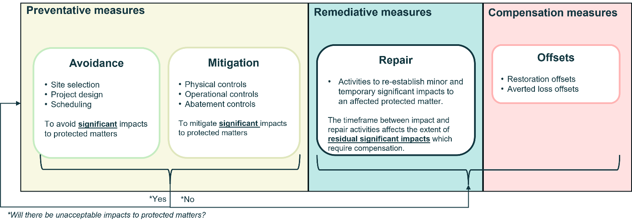

As part of the proposed EPBC Act reforms, the Minister will be required to consider whether residual significant impacts have been appropriately minimised before deciding to attach compensation conditions to an approval. Proponents are expected to appropriately consider the mitigation hierarchy when planning an action, with the primary aim of reducing impacts on protected matters.
Unacceptable impact criteria will be defined for each protected matter, reflecting the unique characteristics and international or constitutional underpinnings of each.
The Minister will not be able to approve an action that has, will have, or is likely to have an unacceptable impact, unless the project meets specific national interest criteria. ​
Project proponents must avoid all unacceptable impacts on protected matters. ​
Compensatory measures (i.e. offsets) cannot be used to make an unacceptable impact acceptable.
The application of the mitigation hierarchy will support the assessment of actions that do not have unacceptable impacts. Through the mitigation hierarchy the Minister can assess whether an action’s significant impact is residual and thus acceptable.

Content of the Standard [Policy]

In applying the mitigation hierarchy:
- All appropriate efforts should be made to identify protected matters and likely impacts (further detail on impacts is provided at Principle 2).
- Preventative measures (avoidance, mitigation) are applied as a priority, and before remediative measures (repair), which then inform compensatory measures (offset), where appropriate.
- Impacts to protected matters, where avoidable, are avoided.
- Significant impacts to protected matters, where unable to be avoided, are mitigated.
- Following the application of preventative measures, degradation or damage affecting protected matters, is repaired as soon as possible and as close to original condition as possible.
- Residual significant impacts to protected matters are offset only as a last resort and offsets cannot make an unacceptable impact acceptable (Principle 3).

Definitions

Avoid: demonstrated measures taken to anticipate and prevent adverse significant impacts to protected matters.

Feasible: [as per dictionary meaning] – For guidance: that which is possible and likely to be achieved.

Mitigate: demonstrated process of identifying and implementing measures to reduce significant impacts to protected matters. A proponent can directly reduce significant impacts on protected matters through addressing the scale, duration, timing, location and intensity of impacts that cannot be completely avoided.

Mitigation measures generally form the basis of management plans and monitoring for an action to reduce, prevent, control, and react to adverse impacts throughout the lifespan of an action and are an active decision to do something to reduce the severity or likelihood of significantly impacting a protected matter.

Repair: demonstrated effort to lessen the duration, seriousness and/or extent of temporary significant impacts to protected matters through remedial actions, following impacts of an action at the impact site that cannot be completely avoided or mitigated. Repair may be a viable option where:
- Damage is minimal, temporary and/or occurs over a short timeframe.
- Repair can be done in a timely manner (as relevant to the protected matter) to reduce the likelihood or severity of significant impacts.
- Repair activities are feasible in the long term for the protected matter.

Repair activities focus on the significantly impacted protected matters and involve on-site works with specific goals for re-establishment of habitat, values or functioning to reduce residual significant impacts.

Rehabilitation activities, including progressive rehabilitation, at the conclusion of an action, or stages of the action, (e.g., a mine or site closure plan) are not considered to be Repair.

Intended application through the Regulations
The Principle that actions appropriately consider the application of the mitigation hierarchy will apply to all EPBC Act decisions outlined in this policy paper.

Where required, the Regulations will be updated to outline the information needed to demonstrate that the mitigation hierarchy has been appropriately applied. For example, submissions for relevant decisions will need to describe and demonstrate:
- Effective and appropriate methods used to identify protected matters and to understand likely impacts of the action.
- Planning and design measures undertaken to avoid (or minimise) any relevant significant impacts on protected matters from a proposed action.
- Effective and appropriate safeguards and mitigation measures to lessen any relevant significant impacts of the action.
- Effective and appropriate ongoing management, monitoring and response measures to prevent further harm to protected matters, with reference to relevant statutory and policy documents.
- Effective and appropriate repair and rehabilitation to minimise impacts to protected matters, with reference to relevant statutory and planning documents.
- A consolidated list of mitigation, repair, offset and monitoring measures proposed, including:
  - those to be taken by the proponent and other agencies, including state, territory or local governments, and
  - the name of the agency responsible for endorsing or approving each measure.
- The cost of the mitigation, and where relevant, repair and rehabilitation measures.
- Any other requirements for approval or conditions that apply, or that the proponent reasonably believes are likely to apply, to the proposed action.
- An outline of an environmental management plan setting out the framework for continuing management, including mitigation, repair/rehabilitation and monitoring, including any provisions for independent environmental auditing.

In practice, this is expected to be demonstrated through a detailed discussion (including on considered alternatives to the proposal) in a proponent’s submission / assessment documentation (Figure 4).

Figure 4: Mitigation hierarchy - iterative design
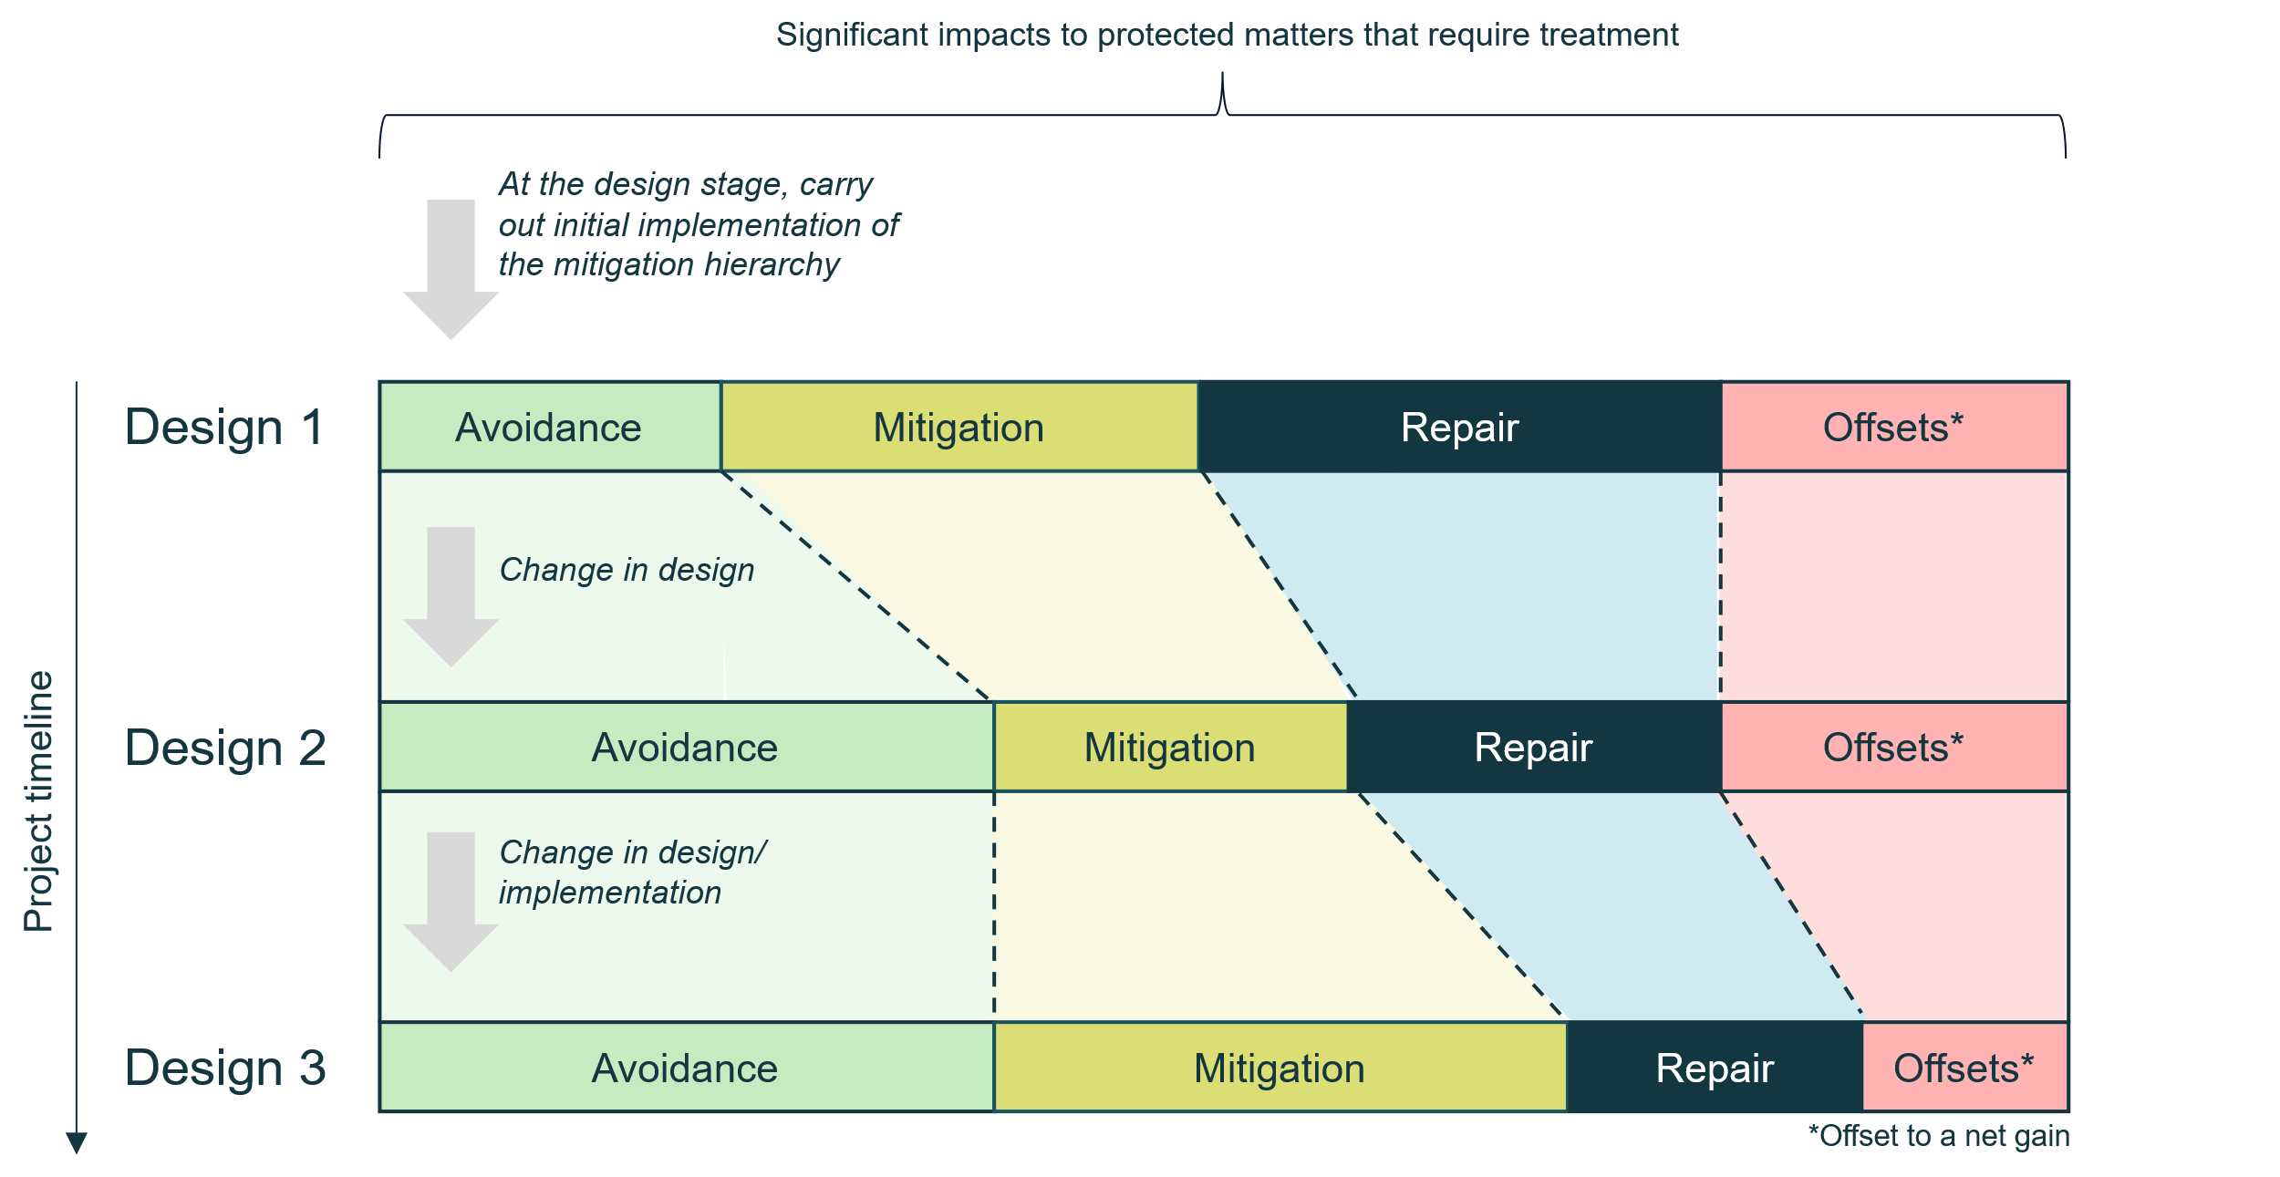

Definitions in policy and guidance
It is proposed that considerations for whether a proposed measure in the mitigation hierarchy is feasible will be further guided by policy and will consider whether a measure can be reasonably implemented in practice, considering a combination of technical, ecological, financial, legal, and social criteria, to ensure it can genuinely reduce environmental impacts.

Principle 2: Actions appropriately consider impacts to protected matters.

Policy intent

Appropriate consideration of impacts to protected matters through EPBC Act planning, assessment and approval processes is fundamental to assessing the full range of impacts of a proposal to protected matters.

The EPBC Act already requires consideration of direct, indirect (including facilitated) impacts to protected matters. In practice, this incorporates compounding impacts (e.g., the combined impacts of light, noise, habitat clearance to breeding success of endangered species as a result of a controlled action).

Considering the impacts of multiple actions is most effective when done at the landscape scale through bioregional planning or strategic assessments as it enables the strategic consideration of multiple actions over time, including those approved and anticipated in the future. Consideration of context at the landscape scale ensures the bringing together of appropriate knowledge, resources, and stakeholder engagement to fully understand and adequately protect protected matters.

Considering the broader context of a protected matter means understanding past, present and reasonably foreseeable events, circumstance or threats affecting the protected matter. This consideration will enable a Minister to understand the current and likely future status of a protected matter and enable them to understand the compounding effect of the proposed impacts of an action.

These impacts are relevant to consider when deciding how to apply the mitigation hierarchy (Principle 1), and what residual significant impacts require to be compensated (Principle 3).

Content of the Standard [Policy]

For an action or class of actions (including to make a guidance bioregional plan or a bioregional plan):
        - adverse impacts to protected matters are appropriately considered.
        - the nature, extent or seriousness of an impact on a protected matter appropriately considers the context in which the impact might occur.

Definitions

Impact: As per the definition in the EPBC Act [Refer Attachment B for EPBC Act definition].

Context: the circumstances that form the setting for a protected matter, so impacts can be understood with high certainty. The context includes for example:
- the unique context of a protected matter, including the past, present and reasonably foreseeable future events, circumstances and threats affecting the protected matter.
- the interaction of different stressors, for example, the combined impacts of light, noise, and habitat clearance to breeding success of endangered species as a result of an action or a class of actions.
- The context may also, depending on the particular matter being considered include the following:
  - individually minor, but collectively significant, actions taking place over a period of time.
  - the amplified or combined adverse impacts that occur when multiple impacts overlap, interact, or accumulate, to the point that they are considered significant impacts.

Intended application through the Regulations
The Principle that actions appropriately consider impacts to protected matter will apply to all EPBC Act decisions outlined in this policy paper.

In addition, for a class of actions considered through a landscape scale approach (e.g. strategic assessments and bioregional plans), the context of relevant impacts will need to be considered.

Definitions in policy and guidance

It is proposed that definitions for impact, including when and how impacts will be considered, may be further expanded in policy (e.g., in significant impact guidelines). This may include the following definitions:

Direct impact: impacts of an action taken by a person. It is events or circumstances which do not have an intervening event or action but are caused, in a proximate sense, by carrying out the particular action itself.
Indirect impact: (as defined in the EPBC Act) an impact that is not a direct result of the primary action, but which could reasonably be predicted to follow on from the action (later in time or farther away or off-site). They include:
- ‘downstream’ or ‘downwind’ impacts (e.g. impacts on wetlands or ocean reefs from sediment, fertilisers or chemicals which are washed or discharged into river systems),
- ‘upstream impacts’ such as impacts associated with the extraction of raw materials and other inputs which are used to undertake the action (e.g. offsite impacts associated with, for example, acquiring materials for the action, such extraction elsewhere of landfill material associated with a marina development).
- ‘facilitated impacts’ which result from further actions (including actions by third parties) which are made possible or facilitated by the action. For example, the construction of a dam for irrigation water facilitates the use of that water by irrigators with associated impacts. Likewise, the construction of basic infrastructure in a previously undeveloped area may, in certain circumstances, facilitate the urban or commercial development of that area.

Principle 3: Actions with residual significant impacts to protected matters are compensated.

Policy intent
Actions which will, or are likely to, result in one or more residual significant impacts to protected matters will need to be compensated. Offsets will be required to result in a net gain, relative to an agreed baseline; reflecting what would occur in the absence of the development activity. The net gain principle will be set out in the proposed Offset Standard.

Including a Principle that all actions with a residual significant impact to EPBC Act protected matters are compensated sets out the requirement for development of the subsequent enabling Standard.

Content of the Standard [Policy]
The required compensation for residual significant impacts to protected matters will be understood:
- once likely impacts from the impacting action are known,
- where impacts are assessed as significant,
- where impacts are not unacceptable, and
- following appropriate consideration of the application of the mitigation hierarchy (Principle 1).
As a result, compensation for residual significant impacts is a last resort once all subsequent steps in the mitigation hierarchy have been exhausted.

All residual significant impacts to protected matters are required to be compensated for.

Definitions

Residual significant impacts: as defined in the EPBC Act [refer Attachment B for proposed definition].

Intended application through the Regulations
The principle that actions with residual significant impacts to protected matters are compensated will apply to all EPBC Act decisions outlined in this policy paper.
The Regulations will specify which protected matters are not compensable.

Principle 4: Actions are supported by evidence.

Policy intent
Assessment of the impact of actions needs to be supported by scientifically sound, legally defensible, transparent, and adaptive data and information. This ultimately supports decision-making and reduces uncertainty, strengthens trust, and ensures that environmental, social, and economic outcomes are genuinely balanced.
It is intended that this Principle applies to all elements of a proposed action (e.g., planning, design and assessment of associated impacts).
Actions being supported by evidence means:
- Credibility and transparency – actions are backed by robust data, effective monitoring, and expert analysis. Transparent evidence builds public trust and helps secure a proponent’s ‘social licence to operate.’
- Accuracy in predicting impacts – information is forward-looking in estimating how a development may affect protected matters, and evidence improves the accuracy of predictions. In addition, contextual information about a species, including information on past, present and reasonably foreseeable future events, circumstances and threats affecting the protected matter, all of which form the unique context of a protected matter.
- Informed application of the mitigation hierarchy – evidence can be used to judge if avoidance, mitigation, repair and offsets are feasible and likely to be effective.
- Legal and policy compliance – when ‘best available science or data’ relevant to the protected matter is used, it provides the legal justification for approval, conditions, or refusals. This in turn increases certainty.
- Risk management and precaution – an appropriate level of evidence is provided, which is proportional to the risk and likelihood or consequence, to qualify risks and supports decision makers to apply the precautionary principle where knowledge gaps exist.
- Balancing competing interests – evidence provides a common reference point for balancing competing interests (environmental, social and economic).
- Adaptive management and monitoring – post-approval, evidence from monitoring programs enable adaptive management.

This Principle also sets out for development of the subsequent enabling Standards.

A proposed First Nations Standard would stipulate all dynamics related to engagement specifically with First Nations People. The term ‘engagement’ has not been defined here, as in this case, the term relates to specific engagement with First Nations people, which is proposed to be defined in a future Standard.

A proposed Data and Information Standard would improve the integrity of data and information collected and used in planning, assessment and approvals processes and to inform environmental decisions by setting data principles and controls.

Content of the Standard [Policy]

Actions are supported by evidence:
- Appropriate and suitable data and information.
- Effective and genuine engagement with and contribution of knowledge from First Nations people.
- Effective consultation and consideration of outcomes.

Definitions

Data and information: facts and details, and the meaning derived from them enabling interpretation related to their effective use. Together, they form the foundation for knowledge, decision-making, and understanding.

Consultation: the process of seeking, sharing and considering information, views and feedback from parties to support actions and decisions.

Effective: [as per dictionary meaning] – For guidance: producing the desired or intended result; successful.

Intended application through the Regulations

The Principle of actions are supported by evidence will apply to all EPBC Act decisions outlined in this policy paper.

Attachment A: Legislative settings for the MNES Standard

Reformed EPBC Act
Proposed EPBC Act reforms will enable the Minister, by legislative instrument, to make National Environmental Standards for the purposes of the EPBC Act. A National Environmental Standard must specify outcomes or objectives, and parameters, processes or outcomes for achieving the outcomes or objectives.
A number of proposed changes to the EPBC Act are relevant to the MNES Standard.
Approval only if not inconsistent with the MNES Standard
It is proposed that the Minister will only be able to approve an action or class of actions (as a whole) if satisfied that doing so is not inconsistent with any National Environmental Standard. The only exception is in the rare circumstance of the action being in the national interest.
The Minister will also only be able to make a bioregional plan if satisfied that it would not result in, or be likely to result in, an unacceptable impact.
Approval only if no unacceptable impacts
It is proposed that the Minister will only be able to approve an action or class of actions (as a whole), make a bioregional plan if satisfied that it will not have, or be likely to have, an unacceptable impact on a protected matter. The only exception to the Minister not being able to approve unacceptable impacts is in the rare circumstance of the action being in the national interest.
Appropriate consideration of the mitigation hierarchy
Mitigation hierarchy considerations are proposed to be included within the EPBC Act. The intention is that the Minister will be required to consider whether residual significant impacts have been appropriately minimised before considering conditions requiring an offset activity or offset contribution charge.
In setting a condition to compensate, the Minister will be required consider whether the proponent has taken appropriate measures to avoid, mitigate and/or repair the significant impact to which the proposed condition relates, including through the location or design of the project. When considering whether appropriate measures have been considered, the Minister will be able to have regard to the action, and the significant impacts the action has, will have, or is likely to have, on protected matters, as a whole.
These requirements will also apply before the Minister sets compensation conditions for a strategic assessment approval of a class of actions.
Equivalent requirements will apply to the inclusion of bioregional restoration measures in bioregional plans.
Addition of conditions
The EPBC Act currently allows for conditions to be added if the Minister considers it necessary or convenient for protecting, or for repairing or mitigating damage to, an EPBC Act protected matter for which the approval has effect.
The proposed amendments extend the Minister’s power to attach conditions to an approval to specifically include a condition to compensate for any damage to a protected matter (refer above to considerations for appropriate consideration of the mitigation hierarchy).

Ability to make Regulations
The Minister will be able to make EPBC Regulations to outline the application of the Standard to relevant EPBC Act decisions. Relevant to the MNES Standard, this is expected to include, but not limited to:
- Prescribe which EPBC Act decisions the Standard applies to,
- Prescribe the ways in which the Standard is to be applied by the Minister,
The Minister will also be able to make Regulations relating to things covered by the MNES Standard (e.g., the mitigation hierarchy). National environmental standards must be applied in making decisions specified by the Regulations. In making decisions specified by the Regulations, there are three different ways in which the MNES Standard could apply:
- The Minister must be satisfied that the decision is not inconsistent with the Standard;
- The Minister must have regard to the Standard;
- Any other ways in which the standard is to be applied.

Unacceptable impacts to MNES
Reforms of the EPBC Act include defining in legislation what would constitute an unacceptable impact for each protected matter. Unacceptable impact is the extreme end of a ‘significant impact’, these impacts must be avoided, and compensatory measures (i.e., offsets) cannot be used to make an unacceptable impact acceptable.
Criteria for unacceptable impacts to MNES have not been included in the Standard as they will be placed in the primary legislation.

Policy and guidance
Guidance and policy will provide detail on the mitigation hierarchy (Figure 3) and how to avoid, mitigate, repair and offset impacts that would otherwise result in the Standard not being met. This will include guidance for proponents on what would be needed to demonstrate each step of the mitigation hierarchy has been applied. This is expected to be demonstrated in practice through a detailed discussion on considered alternatives to the proposal (Figure 4).

Attachment B: Expanded definitions

The following definitions are currently included, or are proposed to be included, in the EPBC Act.

Impact:
- An event or circumstance is an impact of an action taken by a person if:
- the event or circumstance is a direct consequence of the action; or
- for an event or circumstance that is an indirect consequence of the action – subject to subsection (2), the action is a substantial cause of that event or circumstance.
- For the purposes of paragraph (1)(b), if:
  - a person (the primary person) takes an action (the primary action); and
  - as a consequence of the primary action, another person (the secondary person) takes another action (the secondary action); and
  - the secondary action is not taken at the direction or request of the primary person; and
  - an event or circumstance is a consequence of the secondary action;

then that event or circumstance is an impact of the primary action only if:
- the primary action facilitates, to a major extent, the secondary action; and
- the secondary action is:
  - within the contemplation of the primary person; or
  - a reasonably foreseeable consequence of the primary action; and
- the event or circumstance is:
  - within the contemplation of the primary person; or
  - a reasonably foreseeable consequence of the secondary action.

Residual significant impact of an action:
- An impact that an action will have or is likely to have on a matter protected by a provision of Part 3 is a residual significant impact on the matter if all of the following apply:
  - the impact is significant;
  - the impact will not be avoided, mitigated or repaired in the course of taking the action;
  - the impact will not be avoided, mitigated or repaired in the course of complying with conditions to be attached to the approval of the taking of the actions.

Residual significant impact of a class of actions
- An impact that a class of actions as a whole will have or is likely to have on a matter protected by a provision of Part 3 is a residual significant impact on the matter if all of the following apply:
  - the impact is significant;
  - the impact will not be avoided, mitigated or repaired in the course of taking the actions in the class;
  - the impact will not be avoided, mitigated or repaired in the course of complying with conditions to be attached to the approval of the taking of the class of actions.

