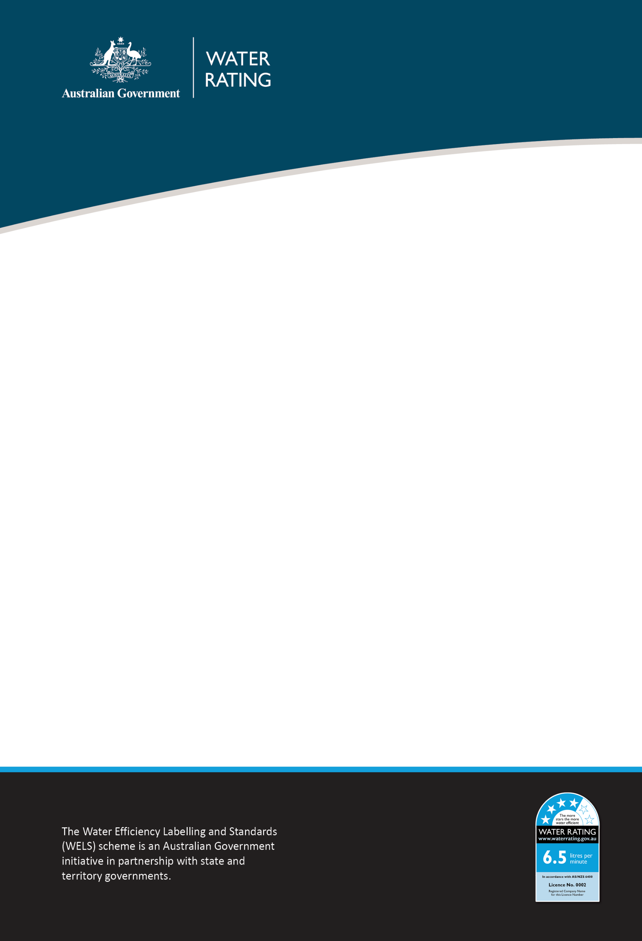

WELS (Registration Fees) Amendment Determination 2026
Legislative amendment summary

2026-27 Budget Decision
As part of the 2026-27 Budget, the Australian Government decided that funding for the Water Efficiency Labelling and Standards (WELS) scheme would transition to full cost recovery. The Budget decision also included the implementation of an indexation strategy, the recovery of indirect scheme costs and changes to fees associated with minor product registrations.
Product registration fee increases will be phased in over four years from 15 September 2026 to reduce impact on businesses, with the Australian Government partially funding operating costs through to 2028-29.
To implement the decision, the Water Efficiency Labelling and Standards (Registration Fees) Determination 2013 (WELS (Registration Fees) Determination) must be amended. This will be achieved through the Water Efficiency Labelling and Standards (Registration Fees) Amendment Determination 2026 (Amendment Determination).

Background
The current WELS fee structure has remained unchanged since it was introduced in 2013, with governments partially funding the WELS scheme for 20 years.
While the original intent was for industry to contribute 80 per cent of scheme funding, government contributions have covered closer to 50 per cent of operating costs in recent years. This level of funding is unsustainable and inconsistent with Australian Government charging policy. Increases to scheme fees are required to restore sustainable funding for the ongoing functions of the WELS Regulator.
Of the approximately 450 businesses that register products under the WELS scheme, the majority register fewer than 40 products, and around 25 per cent of businesses register between one and five products. The impacts are expected to be modest for most businesses, with one in four seeing a total annual increase of $320 and the majority facing an annual increase of less than $1,740 in the 2026 charging year (15 September 2026–14 September 2027).

Legislative amendments
The Amendment Determination is the legislative instrument that will give legal effect to the required changes by amending the WELS (Registration Fees) Determination. Details on each proposed item within Schedule 1 of the Amendment Determination is provided below.
Item 1 of the Amendment Determination
Item 1 will amend section 4 of the WELS (Registration Fees) Determination by removing the definition of “corresponding State-Territory law”. The definition is no longer required because this term will be removed through amendments to sections 5(2)(a)–(c) (see Items 2–4).
Item 2 of the Amendment Determination
Item 2 will repeal section 5(2)(a) of the WELS (Registration Fees) Determination to remove a redundant reference to circumstances in which no fee is payable under a corresponding State-Territory law. This is a historical reference and no longer needed, as the only fee payable for the registration of a WELS product is to the Australian Government Regulator designated under the Water Efficiency Labelling and Standards Act 2005 (WELS Act).
The amendment will also insert a new section 5(2)(a) which provides that the fee for each charging year is set out in Schedule 1 (i.e. the WELS fee table) of the WELS (Registration Fees) Determination (also see Item 8). The term ‘charging year’ is already defined in section 4 of the WELS (Registration Fee) Determination.
Item 3 of the Amendment Determination
Item 3 will repeal section 5(2)(b) of the WELS (Registration Fees) Determination and replace it with a new section.
Consistent with Item 2, this amendment will remove the current section 5(2)(b), which contains a redundant reference to circumstances in which a fee is payable for the registration of a WELS product under a corresponding State-Territory law. As noted above, the only fee payable is to the Australian Government Regulator designated under the WELS Act.
The new section 5(2)(b) will introduce an indexation mechanism which will apply from the 15 September 2030–14 September 2031 charging year onwards. The indexation mechanism will not apply prior to this period, as it will already be incorporated into the fees for 2026 to 2029 (set out in Schedule 1 of the WELS (Registration Fees) Determination).
Item 4 of the Amendment Determination
Item 4 will remove section 5(2)(c) of the WELS (Registration Fees) Determination.
Consistent with Item 2, this amendment will remove a redundant reference to circumstances in which a fee is payable for the registration of a WELS product under a corresponding State-Territory law. As noted in Item 2, the only fee currently payable for the registration of WELS products is to the Australian Government Regulator designated under the WELS Act.
Item 5 of the Amendment Determination
Item 5 will amend section 5(3)(a) of the WELS (Registration Fees) Determination to change how fees are calculated for registration applications that include minor products, or a mix of minor and non-minor products.
A minor product is defined as a product sold in volumes of fewer than 100 units within a 12-month period.
Under the current WELS (Registration Fees) Determination, minor products are converted into an equivalent number of non-minor products for fee calculation purposes. This is done by dividing the total number of minor products by a specified conversion factor (currently 15) and rounding the result up to the nearest whole number. The resulting figure is then added to the number of non-minor products (if any) to determine the total number of products used to calculate the fee. Once the number of products has been calculated, the fee set out in Schedule 1 applies to the relevant number of products.
Although this discounted approach is intended to support innovation and niche markets, it does not fully reflect the regulatory effort required to assess minor products and to verify sales volumes. Around 13 per cent of WELS organisations currently register minor products.
The current approach is shown below (for applications including only minor products):
- 1 minor product
1 ÷ 15 = 0.07 → rounded up to 1 product.
If this is the first product registration for a business, the Tier 1 fee applies.
- 100 minor products
100 ÷ 15 = 6.67 → rounded up to 7 products.
If these are the first product registrations for a business, the Tier 2 fee applies.
Item 5 will amend section 5(3)(a) by reducing the conversion factor from 15 to 5. This will mean that fewer minor products are required to equal one non-minor product for fee calculation purposes. In practical terms, this means that fewer minor products fall within a given fee tier.
The impact of amending the conversion factor is shown below (using the same examples):
- 1 minor product
1 ÷ 5 = 0.2 → rounded up to 1 product.
If this is the first product registration for a business, the Tier 1 fee applies.
- 100 minor products
100 ÷ 5 = 20 products → no rounding required.
If these are the first product registrations for a business, the Tier 3 fee applies.
Businesses registering 25 or fewer minor products will remain within Tier 1 and will not move to a higher fee tier. Tier 1 allows registration of up to 5 non-minor products.
Item 6 of the Amendment Determination
Item 6 will remove section 5(5) of the WELS (Registration Fees) Determination. Section 5(5) relates to a provision that expired on 14 September 2015 and is therefore redundant and can be removed.
Item 7 of the Amendment Determination
Item 7 will insert a new section (section 6) into the WELS (Registration Fees) Determination. This section will set out the indexation method referred to in Item 3 (section 5(2)(b)).
The indexation method will apply at the beginning of each charging year (commencing on 15 September), from the year 2030. Indexation will only apply from 2030 because indexation will already be incorporated into the fee structure for the 2026 to 2029 charging years (see Item 8).
Under the indexation method to be set out in section 6, fees for each new charging year will be adjusted by multiplying the previous year’s fee by an indexation factor. This factor reflects changes in both the Consumer Price Index (CPI) and the Wage Price Index (WPI, weighted to reflect the cost structure of the WELS scheme.
Approximately 15% of WELS scheme costs relate to supplier inputs (influenced by CPI), while 85% relate to labour costs (influenced by WPI). Accordingly, the indexation factor will be calculated by:
- Taking the percentage change in CPI number between the December quarter immediately preceding the charging year (the reference quarter) and the December quarter before that (the base quarter), and weighting this change by 15%; and
- Taking the percentage change in WPI number over the same period and weighting this change by 85%.
These weighted values will then be combined to produce the indexation factor.
Example – 2030 charging year (15 September 2030–14 September 2031):
- The CPI number for the December quarter 2029 is divided by the CPI number for the December quarter 2028 to determine the annual CPI change, which is then weighted at 15%.
- The WPI number for the December quarter 2029 is divided by the WPI number for the December quarter 2028 to determine the annual WPI change, which is then weighted at 85%.
- The two weighted figures are added together to produce the indexation factor. This indexation factor is then multiplied by the fees for the 2029 charging year to determine the revised fees for the 2030 charging year.
Finally, section 6 will provide that indexed fees are to be rounded to the nearest multiple of $10 (either up or down) for administrative simplicity.
Item 8 of the Amendment Determination
Item 8 will amend Schedule 1 of the WELS (Registration Fees) Determination to prescribe fees for WELS product registration for the following four charging years:
- 15 September 2026–14 September 2027
- 15 September 2027–14 September 2028
- 15 September 2028–14 September 2029
- 15 September 2029–14 September 2030.
The effect of this is to progressively phase in fee increases. The Australian Government will continue to partially fund the scheme during the transition period, contributing 26 per cent of total funding in 2026-27, 15 per cent in 2027-28 and 8 per cent in 2028-29, based on predicted fee recovery amounts.
Full cost recovery would be achieved in the 2029 charging year.
From 15 September 2030, annual indexation fee adjustments will be made in accordance with section 6 of the WELS (Registration Fees) Determination (see Item 7).
The scheme will retain its existing tiered fee structure to minimise change impact. Fees will not be averaged across the four-year transition period to avoid unnecessary increases in the 2026 and 2027 charging years.

