 | If the person completing this form is representing a small business (i.e. a business having less than 20 employees), please provide an estimate of the time taken to complete this form.
Please include:
– the time taken spent reading the instructions, working on the questions and obtaining the information; and
– the time spent by all employees in collecting and providing this information.
Hours | 2 | Minutes | 0

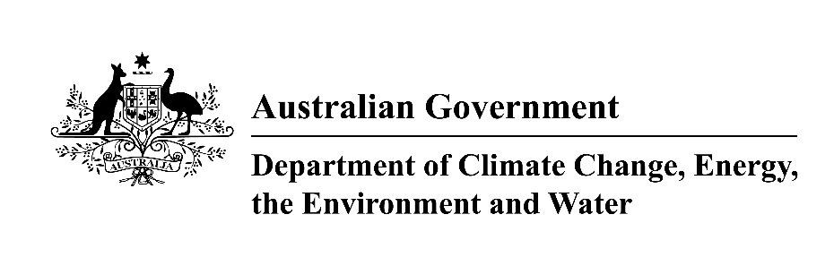
Environment Protection and Biodiversity Conservation Act 1999.
General Permit Application for:
• Threatened species and ecological communities (section 201)
• Migratory species (section 216)
• Whales and dolphins (section 238)
• Listed marine species (section 258)

Purpose of this form
This form is for an activity which will affect any species or ecological community listed under the EPBC Act in the above categories where that activity is within a Commonwealth Area, and for whale/dolphins where the activity is within the waters of the Australian Whale Sanctuary, or internationally.
Complete this form in addition to either Supplementary Form A, B or C described in question 1 on the next page. Please return it, along with the relevant Supplementary Form to the Department of Climate Change, Energy, the Environment and Water.
Note that it is a requirement of the Environment Protection and Biodiversity Conservation Act 1999 that details of this application (which may include the applicant's name) and any supplementary forms (A, B or C) be provided to persons or bodies registered with the Department of Climate Change, Energy, the Environment and Water under section 266A of the Act, for the purposes inviting submissions from those persons or bodies regarding permit applications.
Do not use this form for permits in:
• The Great Barrier Reef Marine Park. These permits are available at:
https://www2.gbrmpa.gov.au/online-services/permits-online
• A Commonwealth park or reserve (e.g. Kakadu National Park). These permits are available at:
https://www.dcceew.gov.au/parks-heritage/national-parks/parks-australia/permits-licences-and-leases
Additional information
Further information is also available by contacting the Department by email: EPBC.Permits@dcceew.gov.au.
Incomplete information
Applications that are incomplete or contain insufficient information cannot be assessed. Delays will occur whilst further information is sought from the applicant.
If you need more space
If there is insufficient space on this form to fully address any of the questions please attach additional pages and list these attachments at question 10.

1 Which of the following best describes the purpose of this application?
Research on whales/dolphins | ⇒ | You will also need to complete Supplementary Form A for Whales and Dolphins (cetaceans).  Now go to 2
To conduct an activity  that will have an  incidental impact on whales/dolphins  E.g. whales and dolphins  are not the purpose of the activity but they will be indirectly affected | ⇒ | You will also need to complete Supplementary Form A for Whales and Dolphins (cetaceans).  Now go to 2
Whale and Dolphin watching | ⇒ | You will also need to complete Supplementary Form B for Whale and Dolphin Watching.  Now go to 2
To kill, injure, take,  trade, keep or move a listed species or  ecological community  in Commonwealth areas | ⇒ | You will also need to complete Supplementary Form C  Listed species / ecological community, listed migratory species or listed marine species.  Now go to 2
Import/export of whale/dolphin parts  or products | ⇒ | Please contact the Wildlife Trade Section on (02) 6274 1111.
2 Period of permit requested
Permits are usually not issued for more than 5 years.
Start date: 01/02/2026 | End date: 01/02/2027
3 The permit holder can be a group such as a business, company, or corporation?
Is the proposed permit holder a group?
No ⇒ Go to next question
Yes⇒ Give details below
Group Name
South Australian Sardine Industry Association
Street address:

Postal address:

Telephone No.:
Fax No.:
Email address:

4 Is the proposed permit holder an individual?
No ⇒ Go to next question
Yes⇒ Give details below of each individual to whom the permit would be issued. If insufficient space, attach a separate list.
Now go to 5

5 Applicant details (if different from proposed permit holder(s)
Name:
Residential address:
Postal address:
Telephone No.:
Fax No.:
Email address:
6 Give the relevant qualifications and experience of all people who will carry out the activities. If insufficient space, attach a list.
1 | Name: Claire Webber
1 | Qualifications and Experience  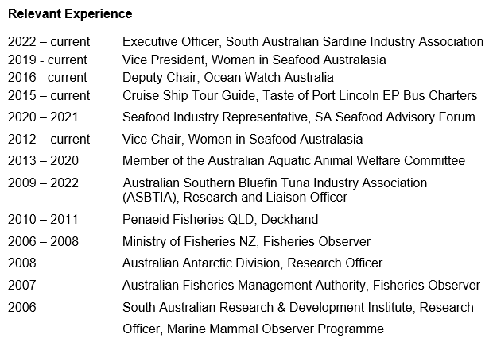  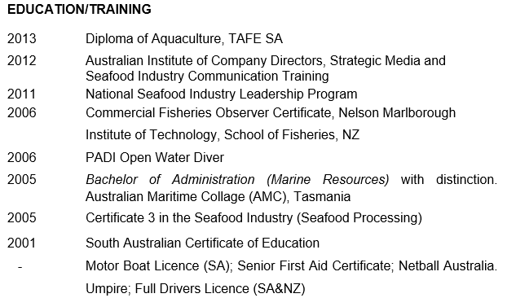

2 | Names: Table of List of Skippers and Vessels  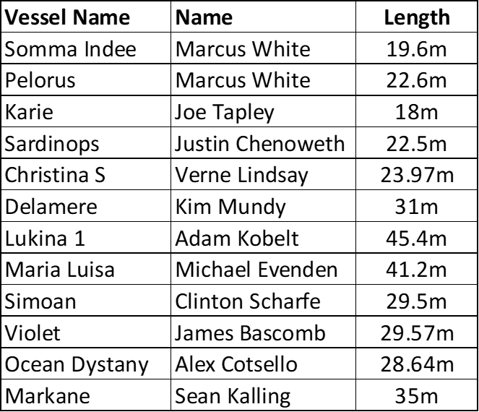
2 | Qualifications and experience:  Skippers in the South Australian Sardine Fishery have a diverse range of AMSA, maritime safety, and trade-related qualifications. Skippers have between 6 and 35 years of sea time, with extensive operational experience in purse-seine fishing for sardines. Skippers and crew are practiced in cetacean sighting, with thorough observation for dolphins undertaken whenever the net is set.  For the 2026 season, all skippers will receive refresher training on:  - DDD deployment options and discussion on vessel-specific procedures  - Limitations of acoustic propagation under different environmental conditions  - Night-time wildlife detection using spotlights and sound  - Updated 2025 Wildlife Interactions Code of Practice (CoP), and  - DDD permit conditions, including 500-m whale exclusion distances and the requirement to remove DDDs immediately if whales are detected.  This will ensure all skippers meet the required competencies to safely deploy the devices and comply with all mitigation, monitoring and reporting requirements.
7 Have you applied for or obtained any other approvals, permits or licences relating to this activity under Commonwealth, State or Territory legislation?

No ⇒ Go to next question
Yes ⇒ Attach copies
8 Have you previously held a permit from the Australian Government to conduct this activity?
No ⇒ Go to next question
Yes ⇒ Give details below
Permit number Date permit expired
2023-0012 | 01/02/2026
9 Offences
A proposed permit holder is taken to have been convicted of an offence if, within 5 years before the application is made, the proposed permit holder:
• has been charged with, and found guilty of, the offence but discharged without conviction; or
• has not been found guilty of the offence, but a court has taken the offence into account in passing sentence on the proposed permit holder for another offence.
Section 6 of the Crimes Act 1914 deals with being an accessory after the fact. Sections 7 and 7A and subsection 86(1) of the Crimes Act 1914 and sections 11.1, 11.4 and 11.5 of the Criminal Code deal with attempts to commit offences, inciting to or urging the commission of offences by other people and, conspiracy to commit offences.
Part VIIC of the Crimes Act 1914 includes provisions that, in certain circumstances, relieve persons from the requirement to disclose spent convictions and require persons aware of such convictions to disregard them.
Has the proposed permit holder been convicted of, or subject to
proceedings for an offence under any of the following?

a. offences under the EBPC Act or Regulations
b. a law of the Commonwealth or a State or Territory about the protection, conservation or management of native species or ecological communities;
c. section 6, 7 or 7A, or subsection 86(1), of the Crimes Act 1914 (Commonwealth) or sections 11.1. 11.4 or 11.5 of the Criminal Code Act 1995 (Commonwealth) in relation to an offence under a law mentioned in (a) or (b) above; or
d. a provision of a law of a State or Territory that is equivalent to a provision mentioned in (c) above.
No
Yes ⇒ Attach details

10 Attachments
Indicate below which documents are attached.
Additional permit holders
See question 4
Additional qualifications details
See question 6
Copies of other approvals/permits
See question 7
Details of offences
See question 9
Other supporting documentation
List all additional documents below

Titles of all attached documents (include the document title,
the specific section(s) and the page number(s) on which the information appears)

- 2025 Sardine Industry Code of Practice

11 Declaration
I declare that the information contained in this application Is correct to the best of my knowledge.
Signature of applicant
Name of person signing
Claire Frances Webber
Date
28/11/2025

