Application for assessment of the Northern Territory Coastal Line Fishery for approval under the Environment Protection and Biodiversity Conservation Act 1999
Contents
Introduction 3
The Coastal Line Fishery 3
Description of the fishery 3
Fishing methods and gear 4
Target and byproduct species 4
Value of the fishery 4
Management regime 5
Description of the management regime 5
Consultation processes 5
Controlling the level of harvest 5
Commercial sector 5
Recreational sector 6
Fishing Tourism sector 7
Aboriginal Traditional sector 7
Management zones 1
Management regions 1
Management areas 1
Commercial catch limits for management areas 2
Harvest strategy 3
Performance against objectives, performance indicators and performance measures 3
Recovery strategies for overfished stocks 4
Enforcement of the management arrangements 4
Mitigating impacts on the wider ecosystem 4
Changes since the previous assessment 5
Monitoring and data collection 5
Data collection, data validation and data monitoring programs 5
Logbooks 5
Recreational fishing surveys 5
Independent monitoring 6
Vessel monitoring System 6
Stock Assessments 6
Key target species 6
Distribution and spatial structure of key stocks 7
Estimates of total removals 7
Total retained catch of target species 7
Total retained catch of target species taken in other fisheries 8
Total retained catch of by-product species 8
Total catch by other sectors 9
Bycatch 9
Bycatch composition 9
Risk assessment on the effects of fishing on bycatch 11
Bycatch mitigation measures 11
Protected species and threatened ecological communities 11
Fishery impacts on protected species and communities 11
Mitigating risks to protected species and communities 11
Ecosystem 12
Ecosystem management actions 12
Research 12
Recovery plan – research and monitoring 12
Other research activities 12
Progress against current Conditions 1
References 1

Introduction
This submission meets the requirements for the assessment of the Northern Territory Coastal Line Fishery (CLF) under the Environment Protection and Biodiversity Conservation Act 1999 (Cth) (the EPBC Act).
This submission has been produced to enable the Department of Climate Change, Energy, the Environment and Water (DCCEEW) to assess the Coastal Line Fishery management arrangements against the Guidelines for the Ecologically Sustainable Management of Fisheries – 2nd Edition and the requirements set out in relevant sections of the EPBC Act.

The Coastal Line Fishery

Description of the fishery
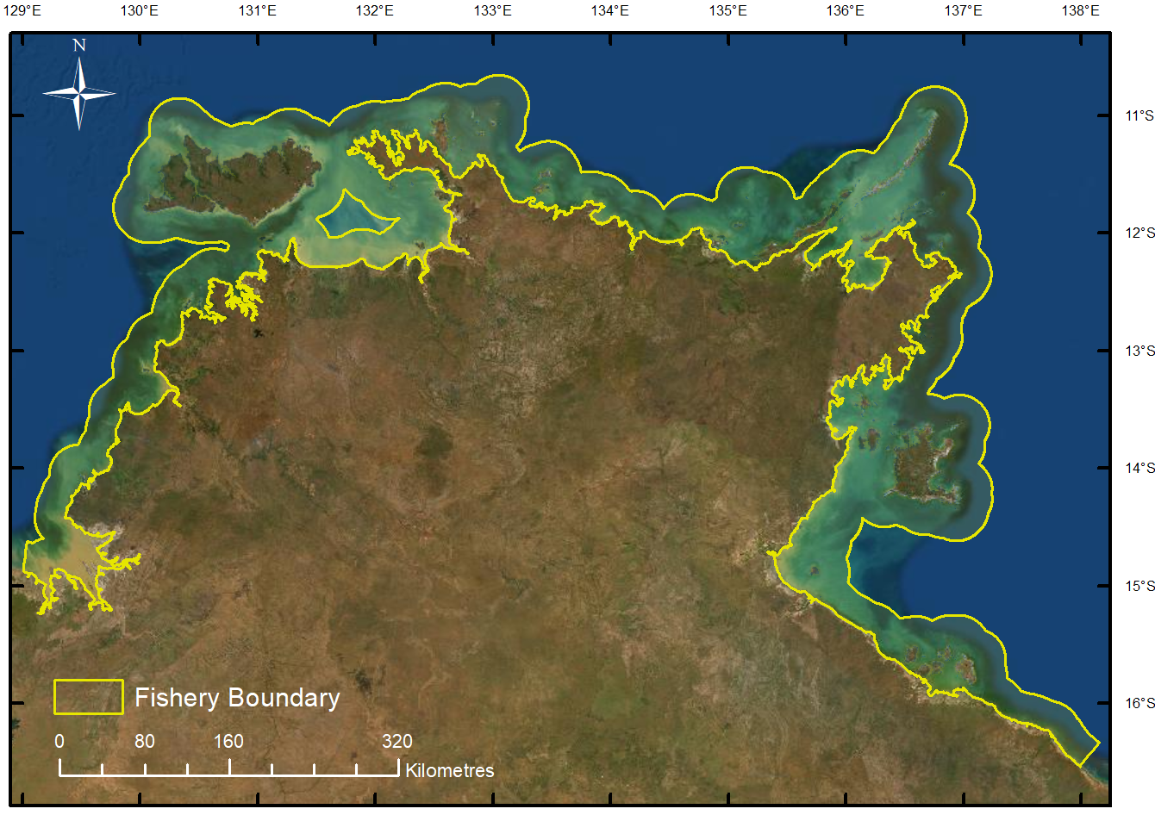
The CLF is a multi-sector fishery that spans the entire Northern Territory coastline, from the high-water mark to 15 nm from the low water mark (Figure 1), which fishes for coastal reef fish using predominately hook and line methods. The fishery includes commercial, recreational, fishing tourism and Aboriginal traditional sectors. The fishery catches a wide range of coastal reef fish such as Black Jewfish, Golden Snapper, Grass Emperor, Coral Trout, cods and red snappers.
Figure 1. Spatial extent of the Coastal Line Fishery.

Fishing methods and gear
The principal fishing method used by all fishing sectors in the CLF is hook and line. This involves the use of weighted hand or reel lines (generally with baits or jigs). Hand lines are the simplest form of fishing; they consist of one or more baited hooks attached to a line, which is retrieved by hand. Hand lines are also the most common traditional fishing method used by Aboriginal fishers. Hand reels can be attached to a rod (rod and line) or mounted on the side of a vessel. Recreational fishers and tourism clients mainly use rods and lines, while hand reels mounted to vessels (commonly known as deck winches) are used by commercial fishers. Reels are used to deploy and retrieve the line and are usually fitted with a drag system (a ‘brake’ system, which is designed to create resistance in the reel as the fish takes out line). Commercial fishers can also use drop lines that may contain up to 40 hooks. The hook and line methods employed in the CLF do not include fishing from a vessel that is under way and making way (e.g. fishing methods that involve trolling). Note the commercial sector uses significantly larger hooks than the other sectors when targeting Black Jewfish. The hook size selects away from smaller Jewfish and many of the other coastal reef species. Other fishing methods are available but are not as frequently used, such as the ability for commercial fishers to use a maximum of 5 fish traps in the Eastern Zone only and utilise a gaff, cast net and scoop net to assist fishing operations.

Target and byproduct species
The broad range of species harvested across all sectors and the proportion of individual species caught vary significantly between sectors depending on the economic or social value of each species respectively. Herein species are classified as primary, secondary, or tertiary species for assessment and management purposes:
- Primary species are the two species targeted by most fishing sectors (Black Jewfish and Golden Snapper).
- Secondary species are reef fish species that comprise more than five percent of both the recreational and fishing tourism reef fish catch by weight (Grass Emperor and Stripey Snapper)
- Tertiary species include all remaining reef fish species with vulnerable biological characteristics that place them at a greater risk of becoming overfished (Tuskfish, Coral Trout, Red Emperor, Mangrove Jack, cod/groupers, red snappers).
Black Jewfish and Golden Snapper are the primary species targeted by most fishing sectors, but more than 40 different species of fish are harvested across all sectors. Note the commercial sector predominately targets Black Jewfish (approx. 95.6% of catch) and the setting of a limited commercial TACC ensures that Golden Snapper is managed as an incidental by-product for this sector (approx. 1.5% of catch).
Under the Fisheries Regulations 1992 (Fisheries Regulations), a CLF licensee must not take Barramundi, King Threadfin, Spanish Mackerel or mud crabs (each a no-take species) under the licence. In addition, interactions with marine protected species under the EPBC Act must be reported in logbooks by commercial fishing operators.

Value of the fishery
Economic characteristics of the fishery are able to be determined for the commercial sector using market returns provided to the Fisheries Division from Coastal Line Fishery licences. Limited data is available to accurately describe the economic characteristics of the recreational, fishing tourism and Aboriginal traditional sectors in the Coastal Line Fishery. The estimated annual Gross Value Product of the Coastal Line Fishery for the past three years is provided in Table 1.
Table 1. Estimated Gross Value Product (GVP) of the Coastal Line Fishery from 2022-23 to 2024-25.
Financial Year | GVP ($/million)
2022-23 | $1.985
2023-24 | $3.816
2024-25 | $2.321

Management regime

Description of the management regime
The management of the Coastal Line Fishery is undertaken in strict accordance with the requirements of the Northern Territory Fisheries Act 1988 (the Act) and Fisheries Regulations 1992. Coastal Line Fishery operations performed under licences must also conform to conditions of the licence that are established under the authorisation of the Act.
Annual operational management is guided by the Coastal Line Fishery Harvest Strategy which was implemented 1 July 2023. More information on the harvest strategy is available at
https://industry.nt.gov.au/__data/assets/pdf_file/0017/1252610/coastal-line-fishery-harvest-strategy.pdf

Consultation processes
NT Fisheries undertakes consultation processes with stakeholders when developing policy or amending management relevant to the Fishery. Depending on the activity, this is typically achieved through either an established advisory group process involving experts from fishing sectors (commercial, recreational and traditional fishing) or targeted specialist working groups.

Controlling the level of harvest

Commercial sector
The commercial sector of the CLF is managed using a combination of input and output-based management controls. The management controls differ between the two zones of the fishery; the Western Zone and Eastern Zone. The primary management control used to limit catch in the Western Zone is an Individual Transferable Quota (ITQ) system. In the Eastern Zone, where there is significantly less fishing effort, the commercial sector is primarily managed through input based controls such as gear restrictions and limited entry controls. A summary of the commercial management controls is provided in the table below (Table 2).

Table 2. Management controls for the commercial sector in both zones of the Coastal Line Fishery.
Management controls | Western Zone | Eastern Zone
Limited Entry | 49 licences (7-8 active)  Minimum quota holdings | 49 licences (1-2 active)
Individual Transferable quota (ITQ) | 145 tonnes Black Jewfish  4.5 tonnes Golden Snapper | -
Permitted gear | Vertical line (1-5 hooks)  Cast nets (bait only)  Scoop net and gaff  Drop line (6-40 hooks)* | Vertical line (1-5 hooks)  Cast nets (bait only)  Scoop net and gaff  Drop line (6-40 hooks)*  Fish trap (5 per licence)*
Catch and effort data | Statutory logbooks | Statutory logbooks
Pre-departure notice (includes prior landing) | 1-12 hours prior to undocking, specifies time and location of departure point and landing | -
Catch disposal record | Within 1 day of unloading (electronic scales) | -
Prohibited species | Barramundi, King Threadfin, Spanish Mackerel and Mud Crab | Barramundi, King Threadfin, Spanish Mackerel and Mud Crab
Catch restrictions | Shark (500 kg per trip) | Shark (500 kg per trip)
Closed areas | Reef Fish Protection Areas | -
*permitted for use between 2nm and 15nm only

Recreational sector
Recreational fishers are managed through a combination of input and output management controls. The controls include spatial and temporal closures (e.g. temporary Reef Fish Protection Areas), gear restrictions, size limits, personal possession limits, and vessel limits. Recreational fishers cannot sell or barter their catch. A summary of the recreational controls that relate to the taking of reef fish species in the NT is provided in the table below (Table 3).

Table 3. Management controls for the recreational sector of the Coastal Line Fishery.
Management controls
Permitted gear (that relates to reef fishing) | Vertical line  Scoop net and gaff  Cast nets |  | Spear-gun and hand spear  Float Line  Troll line
General personal possession limit | 15 fish per person
Personal possession limits. * At-risk species, vessel limits apply | 2 Black Jewfish*  3 Golden Snapper*  3 Mangrove Jack*  5 Tricky Snapper (Grass Emperor)*  5 Stripey Snapper (Spanish Flag)*  5 Cod (all species)* |  | 5 Russell’s Snapper*  5 Tuskfish*  5 Coral Trout*  5 Red Emperor*  3 Sharks  5 for all other fish species not subject to specific individual limits
Vessel limits | Vessels with 4 or less people on board, each person can take their personal possession limit  Vessels with 5 to 7 people on board can take a maximum of 4 times the personal possession limit of ‘at-risk’ species  Vessels with 8 or more people on board can take a maximum of 8 times the personal possession limit of designated ‘at risk’ species
Size limits | Mangrove Jack, 35 cm minimum length  Cod and groper, 120 cm maximum length
Reporting | Recreational fishing surveys
Closed areas | Reef Fish Protection Areas

Fishing Tourism sector
Fishing Tour Operators are managed using the same input and output management controls as recreational fishers (Table 3). However, fishing tour operators (FTO) must have a licence to take clients fishing in the Northern Territory. There is no cap on the number of FTO licences that may be granted in the NT, but targeted reef or bottom fishing in the Western Zone is restricted to licences granted before 2015 (approx. 130 licences). None of the catch, or product from the catch, can be sold or bartered. FTOs are also required to submit daily logbook returns every month.

Aboriginal Traditional sector
Aboriginal fishers are entitled to use the resources of an area of land or water in a traditional manner. This entitlement does not extend to engaging in commercial fishing activities without a licence. Commercial engagement by the Aboriginal sector is encouraged through the purchase of a commercial licence, or through the Aboriginal Coastal Licence (ACL) program, which was established to give Aboriginal people living in remote areas an opportunity to participate in small-scale fishing enterprises for community benefit and as a ‘stepping stone’ for entry into larger scale commercial fishing business.

Management zones
The CLF is managed as two separate zones that establish management of the commercial and fishing tourism sectors. The Western Zone extends from the Western Australia border to Vashon Head on Cobourg Peninsula at the point of latitude 11° 07.516' south, longitude 131°59.650' east. The Eastern Zone extends east from Vashon Head to the Queensland border (Figure 2).
Access to the Western Zone is restricted for CLF and Fishing Tour Operator (FTO) licences. CLF licences must hold individual transferrable quota (ITQ) to fish in the Western Zone. CLF Licences that do not have access must purchase quota in order to gain access to the fishery in the Western Zone. FTO licences that existed prior to the fishery restructure in 2015 (approx. 130 FTO licences) have access to reef fish resources in the Western Zone but all new licences are restricted, and do not have the ability to target reef fish in the Western Zone.

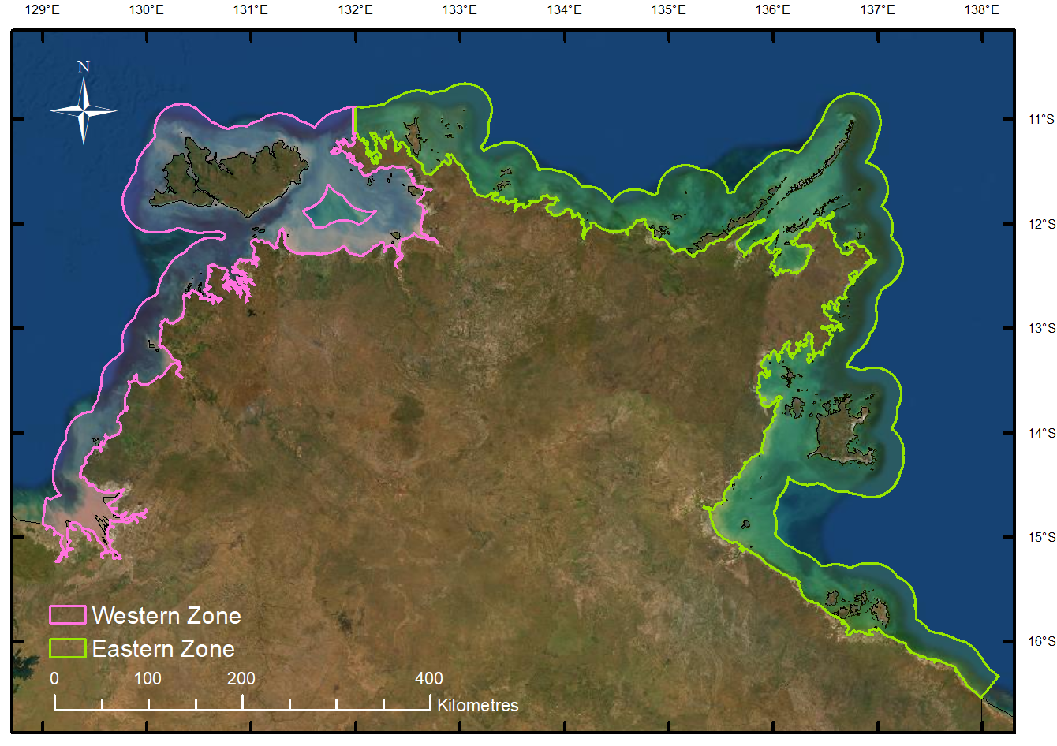
Figure 2. Management zones of the Coastal Line Fishery.

Management regions
The stock structure of the primary species occurs at a finer scale than the management zones currently in place and risk-based management at an appropriate biological scale is necessary. Management regions have been established within the management zones, and future risk assessments will be conducted at this scale, to ensure the decision rules of the Harvest Strategy are applied at an appropriate spatial scale (Figure 3). The management regions were developed using current knowledge of the primary species stock structures (Saunder’s et al 2017) and exposure to fishing pressure. The management regions monitored in the Harvest Strategy are listed below:
- Western Region – Western Australia Border to Cape Ford
- Greater Darwin Region – Cape Ford to Vashon Head
- Arnhem Region – Vashon head to the Wessel Islands
- Northern Gulf Region – Wessel Islands to the Roper River
- Southern Gulf Region – Roper River to the Queensland Border
Access to discrete areas within the management regions by sectors may be limited by the decision rules of the Harvest Strategy should performance indicators breach defined trigger or limit reference points.

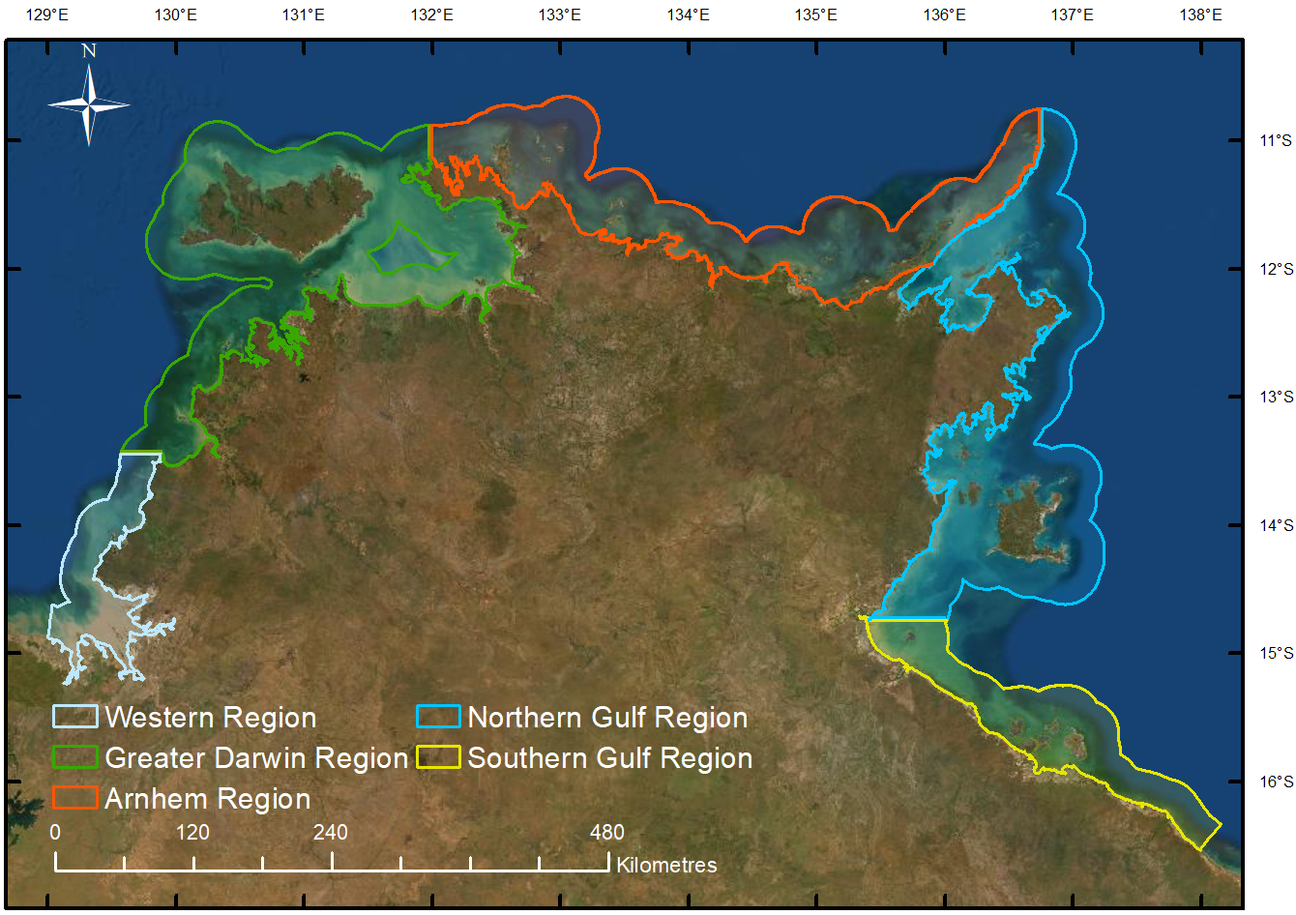
Figure 3. Management regions of the Coastal Line Fishery.

Management areas
Inside the Greater Darwin Region, management areas have been established to improve management of Black Jewfish aggregations (Figure 4). These aggregations are separated by sufficient distance with negligible mixing between aggregations that indicate they are likely to be separate stocks highly reliant of self-recruitment at time scales relevant to fisheries management (Saunders et al., 2017). Independent management of the aggregations is necessary to minimise the risk of overfishing and any associated displaced fishing effort within the broader ITQ management system for the Western Zone.
The management areas for Black Jewfish in the Greater Darwin Region include Channel Point, Mitchell Point and Point Stuart (shown as A, B and C respectively in Figure 4). Access to these areas for recreational, commercial and fishing tourism sectors is dependent on the performance of commercial catch rates inside these areas, in accordance with the decision rules of the harvest strategy.
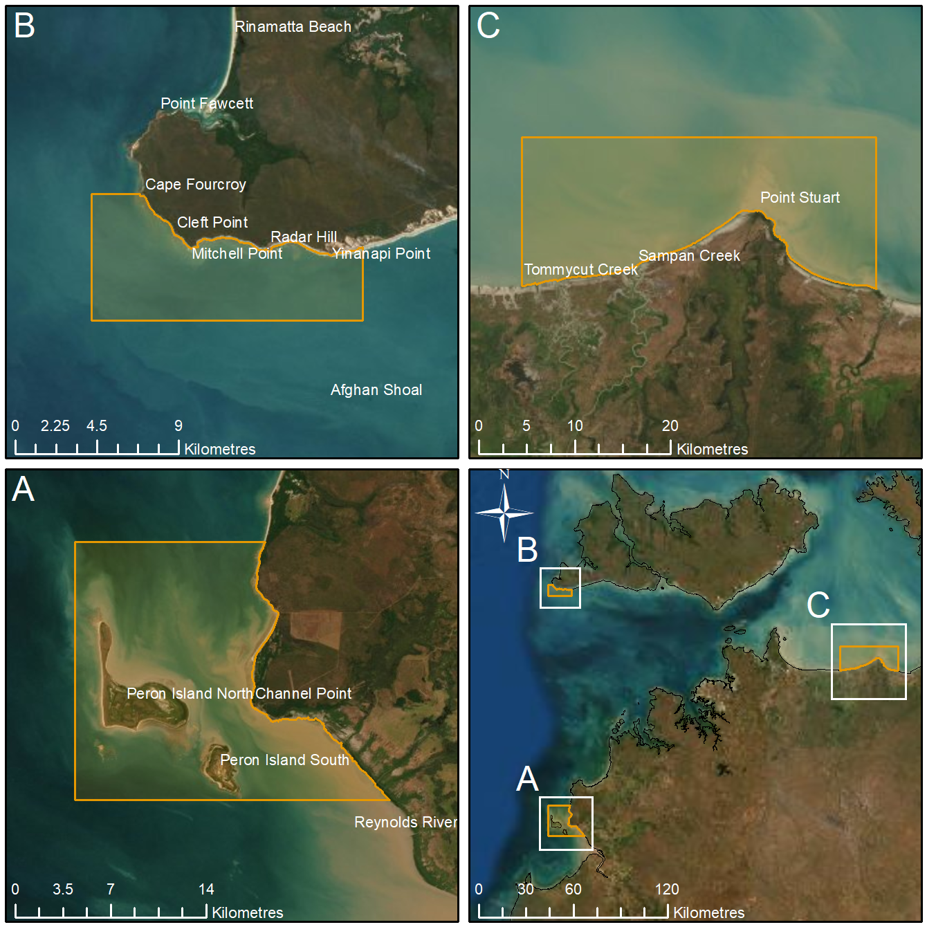
Figure 4. Map of the aggregation areas identified as priorities for management of Black Jewfish.

Commercial catch limits for management areas
The catch limits specify the total amount (in weight) of Black Jewfish that can be sustainability taken each year by CLF licences inside the management areas within the Greater Darwin Region. The catch limits distribute the allowable catch for CLF licences in the Western Zone among known Black Jewfish aggregations and reduces the fishing pressure that could previously be exerted on individual aggregations.
The catch limits were modelled using a Schaeffer surplus production model adapted from Martell and Froese (2013) by Haddon et al (2019). This conservative model utilises a time-series of catch and randomly selected pairs of parameters for growth (r) and carrying capacity or unfished biomass (K) to predict plausible stock reduction trajectories consistent with known catches. Model outputs include a range of values for r and K in addition to a corresponding range of maximum sustainable yields (MSY) from which quantiles are drawn and the median MSY is estimated. The quantiles represent an upper and lower bound of plausible MSY values (e.g. the 5% quantile is the lower bound and 95% quantile the upper bound) for which 90% of the model MSY values estimated are contained within. Henceforth, the 50% quantile is the median (middle value or most frequent result). Note the model outputs are based on commercial catch and are not to be used as an indicative MSY incorporating all fishing sectors.
The catch limits for Black Jewfish in each management area are equivalent to their respective MSY 95% quantile (Table 4). The MSY quantiles for each of the aggregation management areas will be reviewed every five years and coincide with the review of the Framework. Five years is considered an appropriate timeframe to allow for additional data to influence the model outputs.
Table 4. Coastal Line Fishery licence catch limits for Black Jewfish inside each management area.
Management area | Black Jewfish catch limit
Channel Point | 86t
Mitchell Point | 32t
Point Stuart | 25t
TOTAL | 143t

Harvest strategy
The NT Coastal Line Fishery Harvest Strategy (the Harvest Strategy) was developed in line with national guidelines and the NT Harvest Strategy Policy. The Harvest Strategy was implemented 1 July 2023 and specifies long-term fishery goals, operational objectives, and performance indicators with associated reference points and decision rules.

Performance against objectives, performance indicators and performance measures
All parts of the fishery are managed in accordance with Coastal Line Fishery Harvest Strategy. The harvest strategy includes reference points against which the fishery’s performance is monitored and managed. If any of the reference points are met, then pre-defined actions must be undertaken, these triggers and responses are detailed in the decision rules.
The Harvest Strategy assessment has been completed for the 2024-25 fishing year with the following key outcomes:
- Golden Snapper spawning stock biomass is below the limit reference point and classified as depleted in the Greater Darwin Region (Curin-Osorio et al. 2025).
- Black Jewfish spawning stock biomass is below the trigger reference point and classified as sustainable in the Greater Darwin Region (Smart et al. 2025).
- Commercial CPUE of Black Jewfish inside the Channel Point Management Area has resulted in a closure being implemented for the commercial and tourism sectors until 28 February 2026.

Recovery strategies for overfished stocks
A recovery plan is being developed in collaboration with key stakeholders to reduce fishing pressure and rebuild Golden Snapper stocks in the Greater Darwin Region to target biomass levels.
Black Jewfish is not considered in scope for this work for the following reasons:
- Stocks are sustainable, are above the Limit Reference Point and are under active management through the Harvest Strategy.
- Issues with the stock are based on localised depletion risk and current management actions under the Harvest Strategy provide mechanisms to address that risk under an agreed approach.
- Management of the critical decline of Golden Snapper will have corollary benefits to Black Jewfish that are likely to add management benefits without requiring further approaches under an explicit Black Jewfish Recovery Plan.
The Department has held five Sector-Based Working-Group meetings to gain sector specific input, and the Coastal Line Fishery Advisory Group has been re-established to review the plan more collaboratively. The draft recovery plan will be publicly released for consultation and is expected to be implemented in mid-2026.
A review of the Harvest Strategy is scheduled to commence following implementation of the recovery plan for Golden Snapper to ensure that it is operating as intended and remains appropriate for managing the operational use of resources in the CLF.

Enforcement of the management arrangements
The Fisheries Compliance Unit of NT Fisheries, Department of Agriculture and Fisheries, is responsible for ensuring the management controls are adhered by commercial licence holders, recreational and fishing tour operators.
Compliance activities for the fishery are prioritised using compliance risk assessments. Compliance risks are assessed on a variety of factors including the current levels of non-compliance being observed or reported and the impact that this activity may have on the sustainability of the target species or the ecosystem.
Vessel Monitoring Systems (VMS) are required on all commercial vessels. Commercial fishers are required to notify the Fisheries Compliance Unit of their landing details prior to landing and have a number of reporting and monitoring requirements under a licence.

Mitigating impacts on the wider ecosystem
The principles of Ecologically Sustainable Development (ESD) are the basis of fisheries and aquatic resource management in the Northern Territory (NT). The Act, describes ESD as “the use, conservation, development and enhancement of the community’s resources so that ecological processes, on which life depends, are maintained and the total quality of life, now and in the future, can be increased”.
The Coastal Line Fishery Ecological Risk Assessment (ERA) was undertaken in 2018 to help ensure that management for the CLF is both effective and efficient in the context of achieving Ecological Sustainable Development (ESD) outcomes. In addition to meeting the statutory requirements of the Act and national environmental legislation, this approach provides the fishing industry and key stakeholders with an ongoing opportunity to contribute to fisheries management outcomes.
In undertaking the ERA subject matter experts and key fishery stakeholders considered the range of potential consequences of an issue, activity, or event, how likely those consequences are to occur, and assigned a risk rating. It is important to note that the ERA was based on the existing management arrangements at the time of assessment. The outcomes of the ERA formed the basis for a comprehensive fishery review undertaken between 2018 and 2023, which resulted in development of the management arrangements contained in the Harvest Strategy.
The ERA can be located at https://dpir.nt.gov.au/__data/assets/pdf_file/0007/619405/NTCLF-ecological-risk-assessment-052018.pdf

Changes since the previous assessment
Commercial Harvest Portions were implemented upon the request of industry to assist licence holders manage access to catch limits at Black Jewfish management areas in 2023. Harvest Portions are monitored by the Department and ensure that catch limits are not exceeded by individual licences.
Electronic Monitoring (EM) has been introduced for commercial vessels as an alternative arrangement to on-board human observers.

Monitoring and data collection

Data collection, data validation and data monitoring programs
There are several existing monitoring programs used to collect and validate data in the CLF. These include statutory logbooks, recreational fishing surveys, independent monitoring programs and vessel monitoring systems (VMS). Future monitoring will be undertaken in accordance with the Monitoring and Research Plan contained in the CLF Harvest Strategy.

Logbooks
All CLF commercial fishers and Fishing Tour Operators (FTOs) are required to complete logbooks that include daily details of catch and effort recorded while fishing. This information is critical to undertake stock assessments to determine sustainable levels of catch for each target species. The information is also used to calculate catch per unit of effort (CPUE). CPUE is recognised by managers and industry as a measure of relative abundance that is well-understood. CPUE is used as a performance indicator for Black Jewfish aggregations in the Harvest Strategy.

Recreational fishing surveys
Recreational fishing surveys have been conducted at varying intervals for the past two decades and include NT wide surveys undertaken in 1995, 2001, 2009-10 and 2018-19 and smaller scale surveys of resident anglers within the greater Darwin area undertaken in 2014, 2015, 2016, 2017, 2021, 2022 and 2025. Recreational fishing surveys provide estimates of recreational catch and effort and is used to inform stock assessments for key species across multiple fisheries, particularly for Golden Snapper where recreational account for the majority of harvest.

Independent monitoring
Independent monitoring is currently undertaken using human observers and electronic monitoring (cameras). Information from independent monitoring is used to assess and validate logbook reported catch and effort data and collect biological information to inform stock assessments.
On board observer trips are conducted on FTO and CLF licenced fishing operations. An annual average of 17 observer trips are conducted on FTO vessels. The use of onboard observers on CLF licences has declined due to Work Health Safety constraints on small fishing vessels, with electronic monitoring increasingly used as an alternative.
Electronic Monitoring (EM) has been introduced to the commercial sector as an alternative data validation to human on-board observers in 2024. Since its introduction 10 electronic monitoring trips have been conducted in the CLF with 100% review of the footage by the Department.

Vessel monitoring System
A key monitoring and compliance tool for commercial CLF operations is the Vessel Monitoring System (VMS). All CLF vessels are required to use an approved vessel tracking unit and comply with the installation and maintenance standard when configuring, installing and maintaining a VMS. Further information about VMS in NT Fisheries is available at: https://industry.nt.gov.au/publications/fisheries-publications.

Stock Assessments

Key target species
Updated stock assessments have recently been completed for both Golden Snapper and Black Jewfish using the Stock Synthesis model. Golden Snapper in the Greater Darwin Region have been classified as depleted and Black Jewfish as sustainable (Curin-Osorio et al, 2025; Smart et al, 2025). The full stock assessment report for both Golden Snapper and Black Jewfish can be found on the Department website here https://nt.gov.au/marine/reef-fishing-management#golden-snapper-stock-assessment.
The target species of Black Jewfish and Golden Snapper were assessed under the most recent Status of Australian Fish Stocks report. The results of these assessments are summarised in the table below (Table 5). More information on the stock status of target species is available at https://www.fish.gov.au/
Table 5. Status of Australian Fish Stocks outcomes for CLF target species.
Species | Region | Status
Black Jewfish | Darwin Region | Sustainable
Black Jewfish | Regional Northern Territory | Sustainable
Black Jewfish | Gulf of Carpentaria | Undefined
Golden Snapper | Darwin Region | Depleted
Golden Snapper | Regional Northern Territory | Sustainable
Golden Snapper | Gulf of Carpentaria | Sustainable

Distribution and spatial structure of key stocks
Black Jewfish is a widespread Indo-Pacific species found across northern Australia from Exmouth Gulf, Western Australia to the east coast of Queensland. The biology (Phelan 2002, 2008, Randall et al. 2023) and stock structure (Phelan 2008, Saunders et al 2017, Porter et al. 2023) of Black Jewfish within 150 km of Darwin, NT, is understood, with health and physiology negatively linked to wet season freshwater flow (Randall et al. 2025) and diet strongly marine-based (Randall et al. 2023).
Golden Snapper is broadly distributed across the Indo-West Pacific and occurs across northern Australia from Kimberley region in Western Australia, around the north of the continent to the southern Great Barrier Reef (around Rockhampton) (Travers et al 2009). The biology of Golden Snapper and aspects of its life history is relatively well understood (Allen 1985, Cappo et al 2013, Kiso and Mahyam, 2003, Tanaka et al. 2011). The stock structure of Golden Snapper within the area surrounding Darwin is likely to be at scale of tens of kilometres although the boundaries are unclear (Saunders et al 2017).
Clear differences in stock structures both Black Jewfish and Golden Snapper were also found between inshore and offshore stocks, indicating there are significant geomorphic barriers. It is unknown whether these barriers are driven by currents or lack of suitable settlement habitat existing between inshore and offshore sites (Saunders et al., 2017).
In meeting the reporting requirements of Condition 5 of the WTO, the incidental commercial catch of Golden Snapper by the commercial sector has remained relatively consistent over the past three years, with catch distribution primarily attributed to the Black Jewfish Management Areas at Channel Point, Point Stuart and Mitchell Point. Additional catches have also been reported outside the Mitchell Point aggregation area, the Tiwi Islands, and in waters adjacent to Point Stuart. The average annual commercial catch (including discards) of Golden Snapper over the past three years is summarised in Table 6, showing catches within the high recreational fishing effort area (defined as the coastal area within approximately 50 km of major boat ramps in the Greater Darwin Region), as well as the remainder of the Western Zone and the Eastern Zone.
Table 6. Commercial catch (including discards) of Golden Snapper (in kilograms) by area in the CLF.
Area | 2022-2023 | 2023-2024 | 2024-2025
Western Zone (high recreational fishing effort area) | 5 | 92 | 34
Western Zone (remaining area) | 1135 | 1202 | 2951
Eastern Zone | 567 | 0 | 0

Estimates of total removals

Total retained catch of target species
The total retained commercial catch, in kilograms, of Black Jewfish and Golden Snapper in the CLF between 2022-23 and 2024-25 is provided in Table 7.
Table 7. Commercial retained catch of target species (in kilograms) in the CLF.
Species (common name) | 2022-2023 | 2023-2024 | 2024-2025
Black Jewfish | 119,000 | 101,502 | 110,482
Golden Snapper | 1,703 | 1199 | 2,176

Total retained catch of target species taken in other fisheries
The total retained catch, in kilograms, of Black Jewfish and Golden Snapper in other managed fisheries between 2022-23 and 2024-25 is provided in Table 8.
Table 8. Commercial retained catch of target species (in kilograms) in other NT managed commercial fisheries between 2022-23 and 2024-25.
Year | Species | Barramundi Fishery | Coastal Net Fishery | Offshore Net and Line Fishery | Demersal Fishery | Timor Reef Fishery | Aboriginal Coastal licences | TOTAL
2022-23 | Black Jewfish | 2,458 | 20 | 143 | 61,300 | 189 | 2 | 64,163
2022-23 | Golden Snapper | 0 | 0 | 461 | 35,900 | 110 | 148 | 36,619
2023-24 | Black Jewfish | 638 | 0 | 14 | 35,399 | 105 | 16 | 36,172
2023-24 | Golden Snapper | 0 | 0 | 228 | 34,976 | 7 | 123 | 35,334
2024-25 | Black Jewfish | 242 | 0 | 0 | 38,443 | 0 | 13 | 38,698
2024-25 | Golden Snapper | 0 | 0 | 284 | 35,335 | 22 | 46 | 35,687

Total retained catch of by-product species
The total retained catch, in kilograms, of by-product species taken by the commercial sector in the CLF between 2022-23 and 2024-25 is provided in Table 9.
Table 9: Commercial retained catch of by-product and by-catch species (in kilograms) in the CLF.
Species (common name) | 2022-2023 | 2023-2024 | 2024-2025
Blackspot rock cod | 0 | 0 | 28
Blacktip Reef Sharks | 0 | 442 | 503
Blacktip sharks | 0 | 331 | 184
Blue Threadfin | 215 | 498 | 311
Catfishes | 30 | 14 | 4
Cod – Marine | 495 | 76 | 10
Coral Trout | 31 | 0 | 0
Crimson Snapper | 24 | 0 | 0
Goldspotted Rock Cod | 3 | 299 | 798
Grass Emperor | 249 | 10 | 12
Indonesian Snapper | 14 | 17 | 43
King Threadfin | 35 | 0 | 0
Mangrove Jack | 2.5 | 0 | 0
Moses Snapper | 0 | 0 | 2
Rankin Cod | 30 | 0 | 0
Red Emperor | 69 | 0 | 0
Rockcods | 161 | 185 | 14
Saddletail Snapper | 39 | 0 | 87
Shark (general) | 131 | 34 | 0
Snappers (Tropical) | 38 | 0 | 10
Spangled Emperor | 0 | 0 | 0
Stripey Snapper | 27 | 0 | 6
Trevally | 30 | 3 | 78
Yellowspotted Rock Cod | 0 | 16 | 345

Total catch by other sectors
The total estimated catch (individuals) of target species by the recreational sector and the total reported catch (individuals) by the fishing tourism sector of the CLF between 2021 and 2024 is provided in Table 10.
Table 10: Black Jewfish and Golden Snapper catch (individuals) by the recreational and FTO sectors of the CLF. Recreational fishing surveys were not undertaken in the greater Darwin area in 2023 and 2024.
Year | Species | Recreational fishers | Fishing Tour Operator licences
2021 | Black Jewfish | 9,185 | 5,406
2021 | Golden Snapper | 47,315 | 11,304
2022 | Black Jewfish | 5,212 | 4,359
2022 | Golden Snapper | 47,009 | 13,589
2023 | Black Jewfish | - | 3,831
2023 | Golden Snapper | - | 13,393
2024 | Black Jewfish | - | 3,848
2024 | Golden Snapper | - | 13,564

Bycatch

Bycatch composition
The bycatch composition (discards) from commercial CLF licences between 2022-23 and 2024-25 is provided in Table 11.

Table 11: Commercial bycatch species (in kilograms) in the CLF.
Species (common name) | 2022-2023 | 2023-2024 | 2024-2025
Australian Blackspot Shark | 0 | 5 | 0
Australian Sharpnose Shark | 0 | 228 | 0
Barracuda (Striped Seapike) | 16 | 0 | 2
Batfish | 0 | 0 | 1
Black Jewfish | 294 | 173 | 493
Blackspotted Rockcod | 0 | 0 | 2
Blacktip Reef Shark | 0 | 260 | 2,476
Blue Salmon | 219 | 39 | 237
Catfish | 30 | 986 | 2,329
Cod - General | 995 | 568 | 722
Coral Trout | 30 | 0 | 0
Creek Whaler | 0 | 0 | 90
Golden Snapper | 19 | 95 | 809
Goldspotted Rockcod | 0 | 0 | 62
Grass Emperor | 249 | 0 | 0
Great Hammerhead | 0 | 0 | 500
Grey Reef Shark | 0 | 147 | 37
Hammerhead Shark | 0 | 550 | 0
Indonesian Snapper | 0 | 0 | 11
Lemon Shark | 0 | 250 | 0
Mangrove Jack | 2 | 0 | 0
Milk Shark | 0 | 743 | 537
Mixed Fish | 40 | 0 | 0
Queenfish | 0 | 5 | 14
Rankin Cod | 31 | 0 | 0
Red Snapper | 108 | 56 | 0
Rock Cod | 160 | 1 | 8
Saddletail Snapper | 39 | 0 | 17
Scalloped Hammerhead | 0 | 0 | 120
Shark-General | 131 | 593 | 113
Spanish Flag | 27 | 0 | 0
Stingrays - undifferentiated | 0 | 100 | 100
Stripey Snapper | 0 | 0 | 2
Tawny Shark | 0 | 1,331 | 68
Tiger Shark | 0 | 2,250 | 3,937
Trevally – General | 30 | 0 | 0
Trevally-Golden | 0 | 0 | 6
Winghead Shark | 0 | 0 | 8

Risk assessment on the effects of fishing on bycatch
The impact of the CLF (all sectors) on both bycatch and low retained species was determined as low in the 2018 ERA.

Bycatch mitigation measures
Due to the predominant hook and line fishing methods used in the fishery, there are no specific bycatch mitigation measures used in the commercial CLF. Bycatch is inherently regulated by input controls that constrain the number of lines and hooks able to be used by commercial operators. Although not regulated, commercial operators fish with larger hook sizes to reduce catches of smaller and unwanted species while targeting Black Jewfish.
A performance indicator in the Harvest Strategy aims to maintain a negligible or low risk to populations of bycatch species in the CLF. This is monitored through conducting an ERA every five years and implementing associated decision rules if the performance indicator falls below a reference point.

Protected species and threatened ecological communities

Fishery impacts on protected species and communities
Interactions with Threatened, Endangered and Protected Species (TEPS) are reported on commercial logbooks and monitored through Electronic Monitoring coverage and the previous on-board human observer program. There have been minimal TEPS interactions reported in the commercial sector due to the high selectivity of using line caught methods in the CLF. The reported TEPS species between 2022-23 and 2024-25 are provided in Table 12.
Table 12. Number of interactions with Threatened, Endangered and Protected Species from 2022-23 to 2023-24 in the CLF.
Species (common name) | 2022-2023 | 2023-2024 | 2024-2025
Northern River Shark | 0 | 7 released alive | 0
Speartooth Shark | 0 | 1 released alive | 0
Grey Nurse Shark | 0 | 1 released alive | 0
Seasnake - undifferentiated | 0 | 0 | 1 released alive

The reported interactions with Northern River Sharks in 2023/2024 are from an area where Northern River Sharks have never been previously reported. These interactions are outside Northern River Sharks known range (Department of Climate Change, Energy, the Environment and Water, 2021). This suggests it may be a reporting misidentification.

Mitigating risks to protected species and communities
Due to the predominant hook and line fishing methods used in the fishery, there are no specific protected species mitigation measures used in the commercial CLF. Interactions with TEPS is inherently regulated by input controls that constrain the number of lines and hooks able to be used by commercial operators. Although not regulated, commercial operators fish with larger hook sizes to reduce catches of smaller and unwanted species while targeting Black Jewfish.
A performance indicator in the Harvest Strategy aims to maintain a negligible or low risk to populations of TEPS in the CLF. This is monitored through conducting an ERA every five years and implementing associated decision rules if the performance indicator falls below a reference point.

Ecosystem

Ecosystem management actions
General environmental impacts of the Coastal Line Fishery, including impacts on trophic structure, habitat disturbance and the broader environment (air and water quality) were determined as low and negligible in the 2018 ERA.
A Performance Indicator has been implemented in the Harvest Strategy to maintain a negligible or low risk to habitat structure and function, and to ecological processes. This Performance Indicator is scheduled to be reviewed every five years through the process of conducting an ERA where environmental impacts will be reviewed based on updated information. The Harvest Strategy outlines if a trigger reference point is reached, implementing management actions aligned with the decision rules will be required.

Research

Recovery plan – research and monitoring
A detailed research and monitoring plan will be developed to support the recovery plan for Golden Snapper. The research and monitoring plan will be designed to monitor the recovery of Golden Snapper and determine the effectiveness of management arrangements introduced by the recovery plan. Existing monitoring programs will be refined and modified where necessary, and new targeted research initiatives will be identified to address key data gaps and uncertainties affecting the management of Golden Snapper in the NT.

Other research activities
Foundational research to develop a high-quality whole-genome sequence for Black Jewfish has recently commenced. This represents an important first step in establishing the core genomic resources needed to support future scientific and management work. Once completed, the genome will provide a flexible platform that can support a wide range of potential future applications, such as improved understanding of population relationships, the development of genetic markers for monitoring, and more detailed assessments of diversity and structure if required. Establishing this genomic foundation provides strategic value by ensuring that key resources are in place to support evidence-based management over the long term.
Since the establishment of the RFPA’s abundance and diversity surveys have been undertaken inside and outside the areas using Baited Remote Underwater Video stations (BRUVs). A recent analysis of the BRUVs data found that the two target species (Golden Snapper and Black Jewfish) were 2.8 times more abundant within RFPA’s when compared to nearby areas opened to fishing (Figure 5). The analysis also found that there was greater diversity within RFPAs.
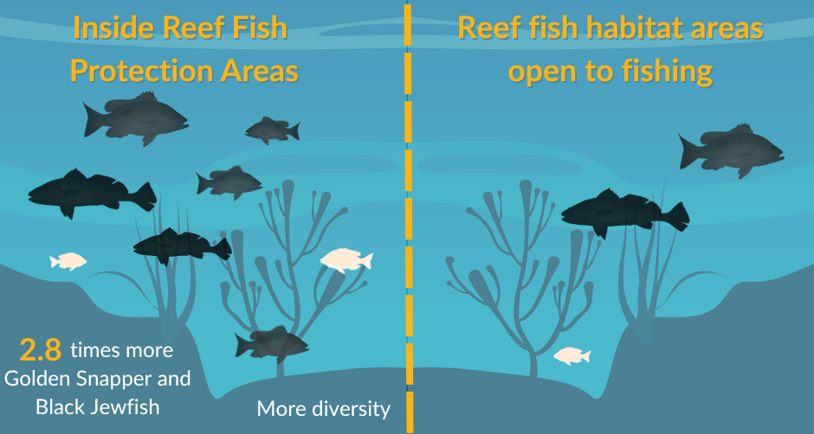
Figure 5: Analysis of reef fish surveys in RFPA’s found that target species were 2.8 times more abundant within protected areas when compared to nearby areas open to fishing. Fish diversity was also higher in areas closed to fishing.

Progress against current Conditions
Note, following machinery of government changes in 2024, the Northern Territory Department of Agriculture and Fisheries (DAF) is responsible for the management of the Coastal Line Fishery.
RECOMMENDATIONS FOR THE NORTHERN TERRITORY COASTAL LINE FISHERY | PROGRESS AGAINST THE RECOMMENDATION AS OF DECEMBER 2025
Condition 1: Operation of the Northern Territory Coastal Line Fishery must be carried out in accordance with management arrangements in force under the Northern Territory of Australia Fisheries Act 1988 (NT) and the Northern Territory of Australia Fisheries Regulations 1992 (NT). | The CLF continues to be managed in in accordance with the relevant legislation contained in the NT Fisheries Act 1988 and NT Fisheries Regulations 1993.
Condition 2: The Northern Territory Department of Industry, Tourism and Trade must inform the Department of Climate Change, Energy, the Environment and Water of any intended material changes to the Northern Territory Coastal Line Fishery management arrangements that may affect the assessment against which Environment Protection and Biodiversity Conservation Act 1999 decisions are made. | DAF continues to inform the Department of any intended material changes to the CLF.
Condition 3: The Northern Territory Department of Industry, Tourism and Trade must inform the Department of Climate Change, Energy, the Environment and Water of any intended changes to fisheries legislation that may affect the legislative instruments relevant to this approval. | DAF continues to inform the Department of any intended legislative changes that would impact the management of the CLF.
Condition 4: The Northern Territory Department of Industry, Tourism and Trade must produce and present reports on the Northern Territory Coastal Line Fishery to the Department of Climate Change, Energy, the Environment and Water by 30 June annually, as per Appendix B of the Guidelines for the Ecologically Sustainable Management of Fisheries – 2nd Edition. The first report is due 30 June 2024. | DAF continues to report annually against the WTO conditions as per Appendix B of the guidelines for the Ecologically Sustainable Management of Fisheries – 2nd edition.
Condition 5:  a) The Northern Territory Department of Agriculture and Fisheries must monitor the commercial catch of golden snapper by Northern Territory Coastal Line Fishery licences, including discards, on a spatial basis.  b) If the catch (including discards) of golden snapper under commercial licences from the overfished reef complexes adjacent to Darwin (designated as the high recreational fishing effort area) exceeds 1125 kilograms within a licensing year:  i. the Northern Territory Department of Agriculture and Fisheries must prohibit commercial fishing within the high recreational effort area for the remainder of that licensing year; and  ii. the Northern Territory Department of Agriculture and Fisheries must notify the Department of Climate Change, Energy, the Environment and Water of:  a) the date on which catch exceeded 1125 kilograms within that licensing year  b) the implementation of management arrangements to prohibit fishing in the high recreational effort area.  c) The Northern Territory Department of Agriculture and Fisheries must include in its annual reports to the Department of Climate Change, Energy, the Environment and Water information on the spatial distribution of golden snapper catches by Northern Territory Coastal Line Fishery licences. | DAF continues to monitor the commercial catch (including discards) of Golden Snapper in the CLF. Information regarding the spatial distribution of commercial Golden Snapper catch is provided in this WTO application (see Distribution and spatial structure of key stocks). Due to confidentially constraints, locational catch data is unable to be provided in this application. Should DCCEEW require this data, then DAF will undertake the necessary process to disclose the data under the NT Fisheries Act 1988.

References
Coleman APM (1998) Fishcount: A Survey of Recreational Fishing in the Northern Territory. NT Department of Primary Industry and Fisheries.
Curin-Osorio, S., Randall, J. and Usher, M (2025) Stock assessment of Golden Snapper (Lutjanus johnii) in the Greater Darwin Region, Northern Territory, with data to December 2024. Northern Territory Government. https://nt.gov.au/__data/assets/pdf_file/0011/1574354/golden-snapper-stock-assessment-2024.pdf
Fletcher, W. R. J. (2015) Review and refinement of an existing qualitative risk assessment method for application within an ecosystem-based management framework. ICES Journal of Maine Science, 72(3), 1043-1056.
Haddon M, Burch P, Dowling N, Little R (2019) Reducing the Number of Un-defined Species in Future Status of Australian Fish Stocks Reports: Phase Two - training in the assessment of data-poor stocks. CSIRO Oceans and Atmosphere and Fisheries Research Development Corporation, Hobart
Henry, G. W. and Lyle, J. M. (Eds.) (2003) The National Recreational and Indigenous Fishing Survey. FRDC Project No. 99/158. NSW Fisheries Final Report Series.
Martell, S. and Froese, R. (2013) A simple method for estimating MSY from catch and resilience. Fish and Fisheries, 14: 504-514. https://doi.org/10.1111/j.1467-2979.2012.00485.x
Matthews S, Penny S, Steffe A (2019a) A survey of recreational fishing in the greater Darwin area 2014. Northern Territory Government, 120, Darwin.
Matthews S, Penny S, Steffe A (2019b) A survey of recreational fishing in the greater Darwin area 2015. Northern Territory Government, 121, Darwin.
NTG (2018) NT Coastal Line Fishery Ecological Risk Assessment. Northern Territory Government, Darwin. https://dpir.nt.gov.au/__data/assets/pdf_file/0007/619405/NTCLF-ecological-risk-assessment-052018.pdf
Porter, M., Barton, D., Hearndon, M., Randall, J., Crook, D. and Shamsi, S. (2023) Relationships between local variability in parasite communities of the black-spotted croaker (Protonibea diacanthus) (Teleostei: Sciaenidae) and host population structure and seasonality. Scientific Reports, 13.
Randall, J., Saunders, t., Barton, D., Porter, M., King, A., Kaestli, M., Gibb, K., Adair, B., Wedd, D., Roberts, B., Kopf, K and Crook, D. (2023) Biology of Black jewfish (Protonibea diacanthus) in the Northern Territory: information to support stock assessment. Fisheries Research and Development Corporation.
Randall, J., Schilling, H., Adair, B., Wedd, D., King, A., Saunders, T., and Crook, D. (2025) Associations between body condition and seasonal freshwater outflow in a coastal marine fish (Protonibea diacanthus) in the wet-dry tropics of northern Australia. Fisheries Research, 285.
Saunders T, Barton D, Crook D, Ovenden J, Newman S, Saunders R, Taillebois L, Taylor J, Travers M, Dudgeon C, Maher S, Welch D (2017) Optimising the management of topical reef fish through the development of Indigenous scientific capability, Fishery Report No. 117.
Smart, J., Randall, J., Roberts, B. and Pazhayamadom, D. (2025) Stock assessment of Black Jewfish(Protonibea diacanthus) in the Northern Territory 2023/24. Northern Territory Government. https://nt.gov.au/__data/assets/pdf_file/0004/1574356/black-jewfish-stock-assessment-2024.pdf
Standards Australia (2018) AS/NZS iso 31000:2009 Risk management-principles and guidelines. Joint technical committee OB-007, Risk Management. Council of Standards Australia and Standards New Zealand. https://policy.deakin.edu.au/download.php?id=214&version=3&associated
Walters C, Martell S, Korman J (2006) A stochastic approach to stock reduction analysis. Canadian Journal of Fisheries and Aquatic Sciences 63: 212–223.
West LD, Lyle JM, Matthews SR, Stark KE, Steffe AS (2012) Survey of Recreational Fishing in the Northern Territory, 2009­–10. Northern Territory Government, Australia.
Zhou S, Griffiths S (2008) Sustainability Assessment for Fishing Effects (SAFE): A new quantitative ecological risk assessment method and its application to elasmobranch bycatch in an Australian trawl fishery. Fisheries Research 91: 56–68.
Zhou S, Griffiths S, Miller M (2009) Sustainability assessment for fishing effects (SAFE) on highly diverse and data-limited fish bycatch in a tropical prawn trawl fishery. Marine and Freshwater Research 60: 563–570.
Zhou S, Smith A, Fuller M (2011) Quantitative ecological risk assessment for fishing effects on diverse data-poor non-target species in a multi-sector and multi-gear fishery. Fisheries Research 112: 168–178
Department of Climate Change, Energy, the Environment and Water. (2021). Conservation advice for Glyphis sp. C (Northern River shark). Australian Government.

