Australian Collision Risk Framework

DRAFT Collision Likelihood Score (CLS) Tool User Guide
This guide is meant to guide the user to use the Collision Likelihood Score online tool. The Collision Likelihood Score is a structured, qualitative assessment of collision likelihood risk using ranked criteria. CLS combines species activity, flight height, seasonal exposure, and collision history to generate transparent risk ratings. CLS is appropriate when data are insufficient for a CRM, during early project stages, or when collision risk is clearly very low or very high.

Steps to using the tool

Enter values
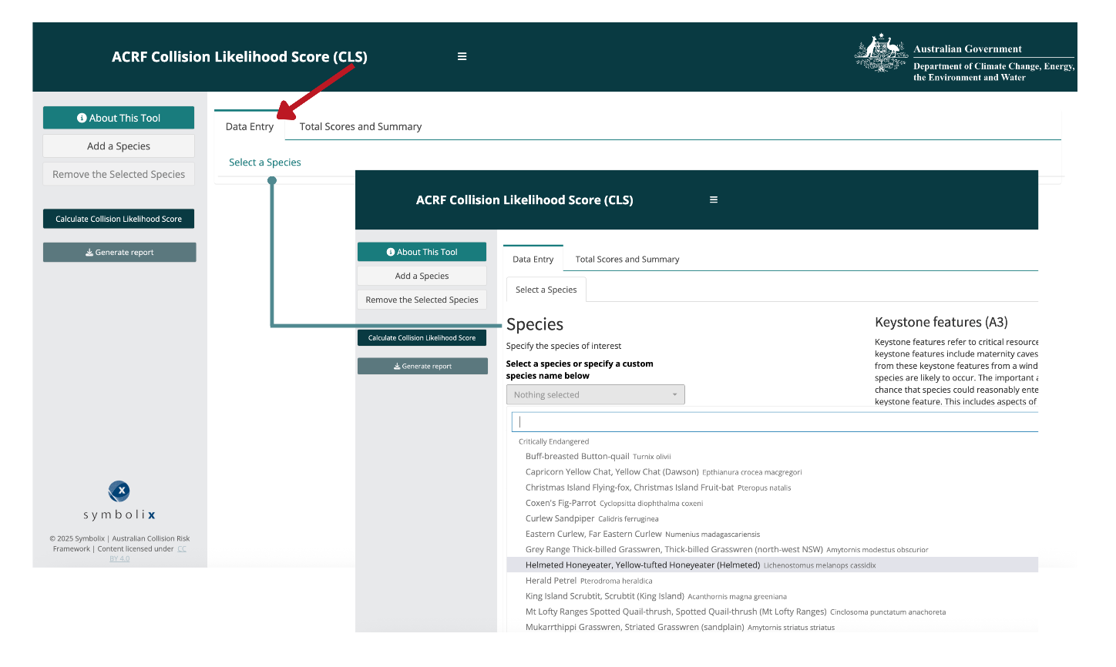

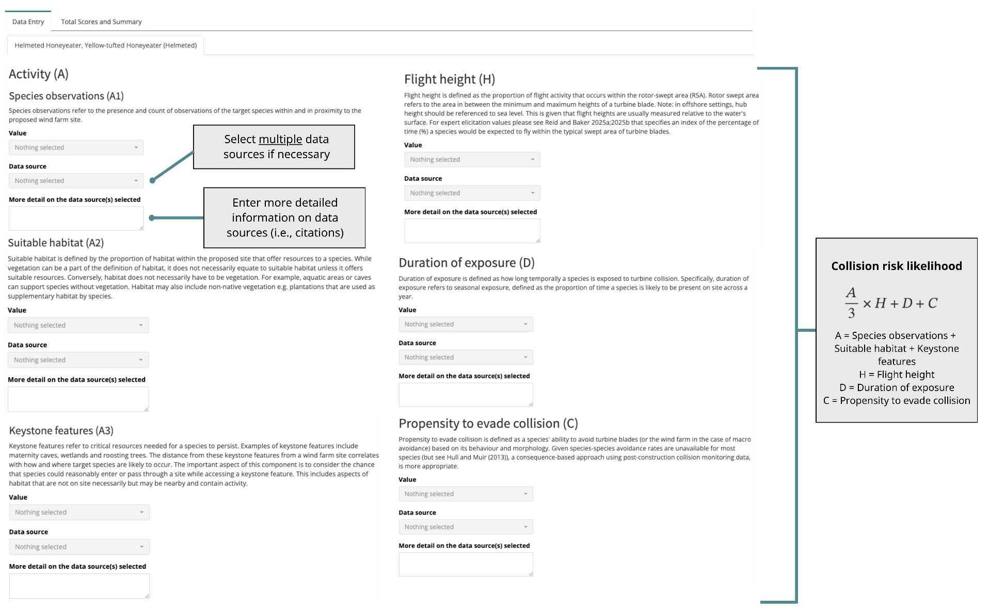

2. Total Scores Summary
Once all relevant information is filled in, click the Calculate Collision Likelihood Score button then select the Total Scores Summary tab. This tab provides more information about the equation used for collision risk likelihood and an expanded version for transparency.
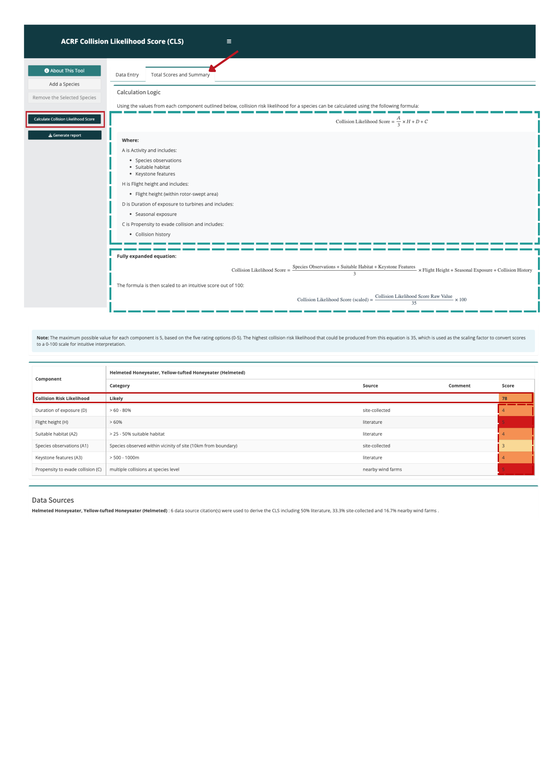
This tab also provides a risk table showing the individual scoring for each component of the equation (out of 5) which are added up to calculate an overall Collision Risk Likelihood score at the bottom (out of 100). Data sources are also included on the bottom.

3. Interpretation:
The colours in the Results table provide a measure of likelihood based on the CLS. The mapping between the score and colour is shown below. Within each risk metric the colour represents the range of possible scores, so the user can see at a glance which metrics are driving the collision risk profile. Note that these are qualitative scores - a score of 90 doesn’t mean a 90% chance. To score highly represents a higher level of risk across multiple categories.
While the CLS cannot provide a single quantitative measure of the number of collisions predicted, it provides a standardised measure for comparing relative risk between species, sites, different avoidance actions, and mitigation strategies.
Collision likelihood score (scaled) | Risk rating
>90 | Very likely
>60-90 | Likely
>40-60 | Possible
>10-40 | Unlikely
≤10 | Very unlikely

3. Generate Report
The final step is to generate a report which will provide a downloadable html that includes all the information that was input for that species and a summary table of the collision risk likelihood estimation, and which data sources were used to derive the estimates.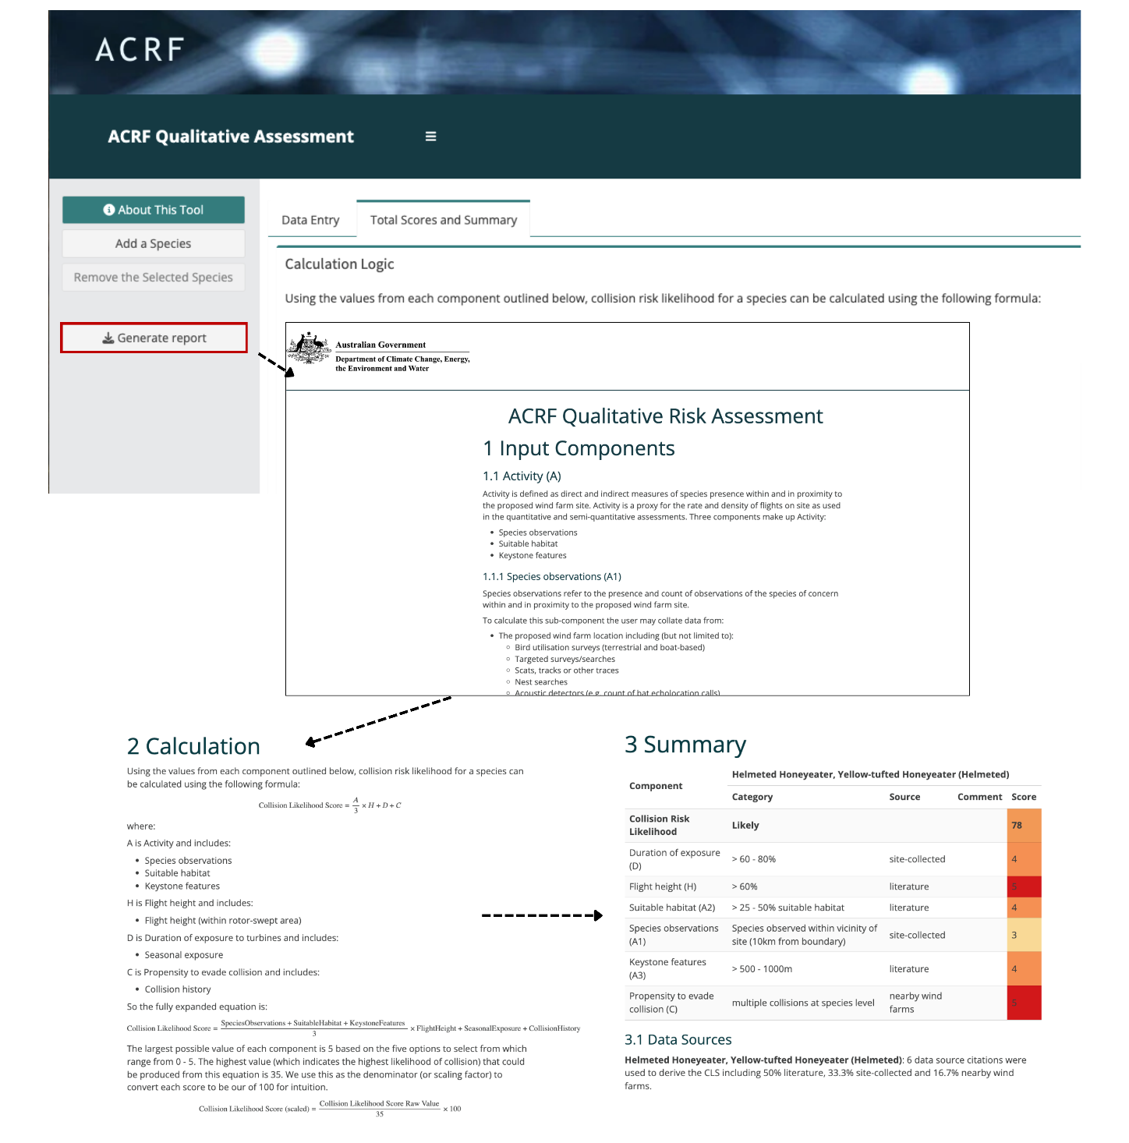

4. Additional species
You can add additional species at any time using the Add a Species button. Fill in the information for that species then click Calculate Collision Likelihood Score to update the values in the Total Scores and Summary tab. You can also click Generate report to re-download the report with the new species.
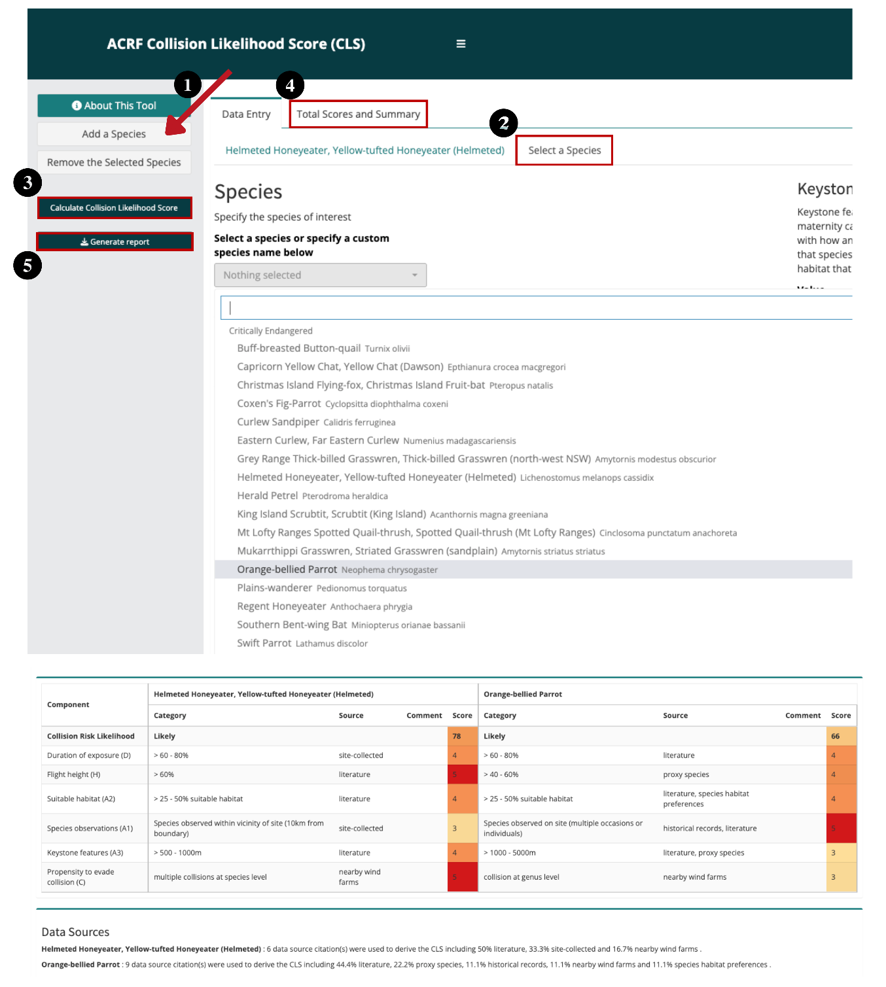

5. Remove species
You can also delete species using the Remove the Selected Species button. Select the tab of the species you want to remove, click the Remove the Selected Species button, and click the Calculate Collision Likelihood Score button to update. Finally, click Generate report to download the updated report.

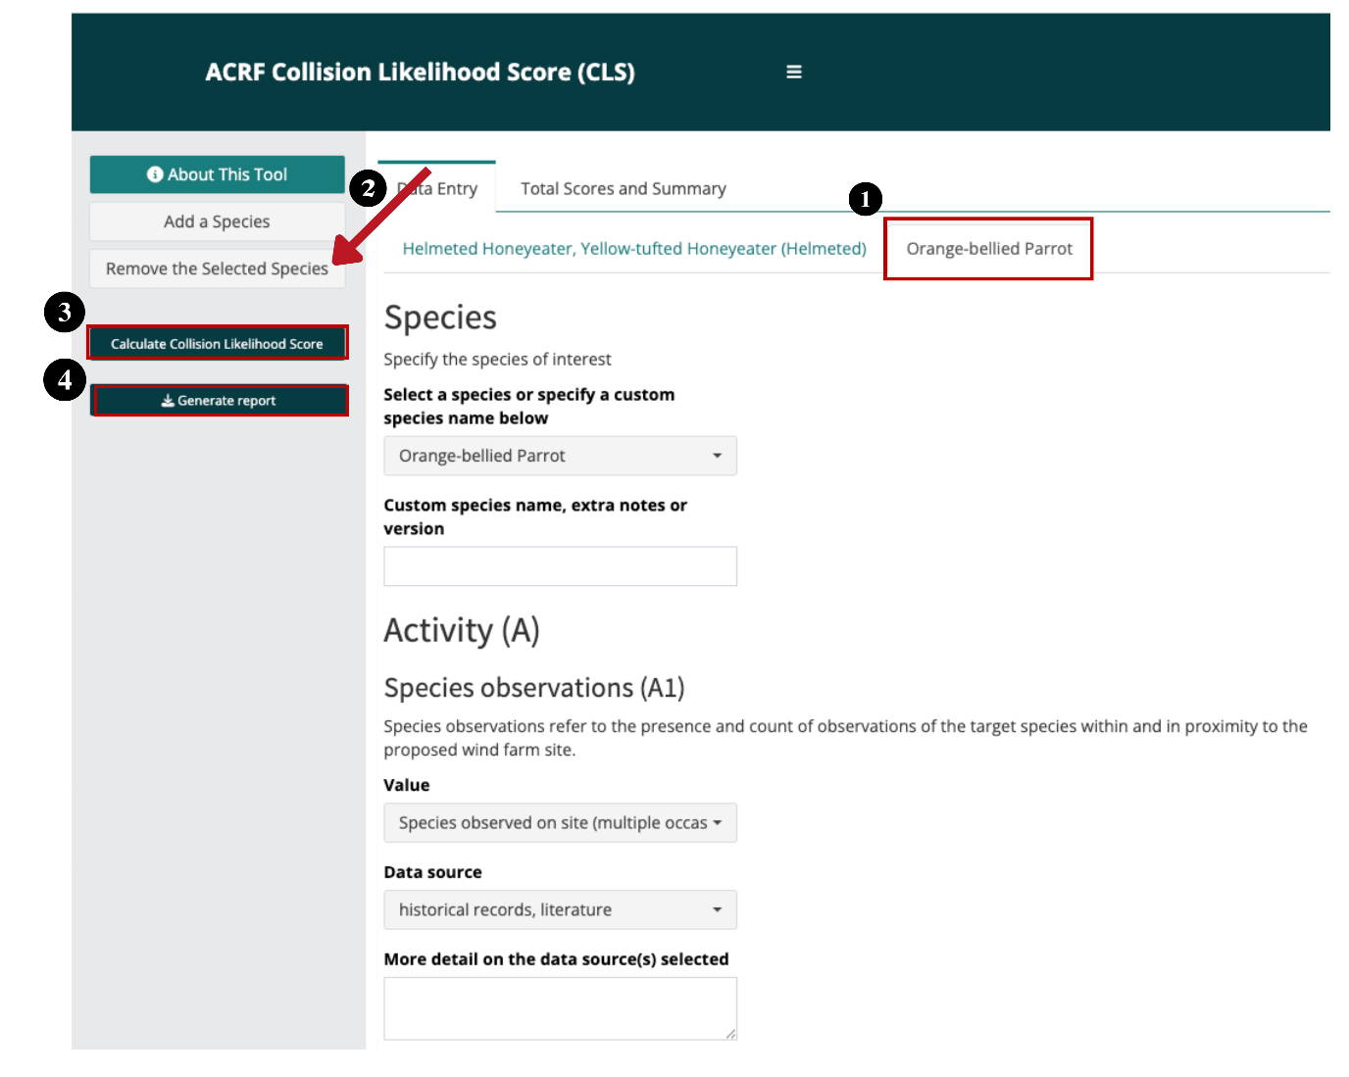

Citation  Potter, Ashley, Thompson, Eliza, Stark, Elizabeth. 2026. “Australian Collision Risk Framework: Collision Likelihood Score (CLS) Tool User Guide. Department of Climate Change, Energy, the Environment and Water. CC-BY 4.0.”  Last Updated: 26 February 2026  Copyright Once published, this work is licensed under a Creative Commons Attribution 4.0 International License. | Contributors Cover image by JosepMonter via canva.com  Funding  This work is funded by the Australian Government as part of the Renewables Environmental Research Initiative (RERI). The RERI is funded by the Department of Climate Change, Energy, the Environment and Water

