Australian Collision Risk Framework

DRAFT Collision Risk Model (CRM) Tool User Guide
This guide provides step-by-step instructions for using the ACRF CRM tool, including data inputs, summary statistics, and interpretation of results. A Collision Risk Model is a quantitative model that uses numerical survey data to estimate the long-term average number of bird or bat collisions per year. CRM works best when flight activity (flights per area per time) can be measured or reliably modelled and should ideally include uncertainty (confidence intervals).

Prerequisites
The ACRF CRM tool is a simplified version of the {collision} R package (Stark et. al. 2026), which is one of the recommended open-source CRM packages available for use. Although it is designed to enable self-assessment during site data collection there are a number of analysis tasks required prior to using the tool.

Note on data collection
Note the CRM tool assumes specific data has been collected on-site using point-transect or line-transect methodology. There are a number of current projects under the Renewables Environmental Research Initiative (RERI) that will provide detailed advice on survey methods and data standards. For the purpose of CRM, the minimum data set includes;
- Survey data - date, duration in minutes, and location information for each point survey or transect count
- Observation data - each observation should be linked to a survey and include at minimum:
  - Species name
  - Height at first observation (Note: If using binned data, ensure height bins are as small as practicable and refer to species-specific protocol recommendations)
  - Distance from observer / right-angle distance from line transect of species (or flock) at first observation. (Note: We advise against truncating in the field. If distances are binned, bins should be kept as small as practicable and align with specific survey protocol recommendations)
  - Number of individuals in the observation
- Flight path data (optional) - if flight path data is to be collected it should be recorded from the start to the end of the flight observation. Note the ACRF CRM online tool does not account for spatial variation across sites, but we note this option for completeness.

Analysis to prepare inputs
Before using the CRM online tool, you must have completed the following analyses:
- Encounter Rate (observed movements per minute): Calculated bird encounter rate per minute of active survey (individual movements recorded per min) with standard error. The encounter rate will be used to calculate a distance corrected flight flux.
- Distance Sampling Analysis (effective detection width in metres): The CRM tool requires an estimate of the effective detection radius/area. This requires analysis to correct for imperfect detection as the distance from the observer increases. The standard approach to generate this value is by fitting a detection function (Miller et. al. 2019; Buckland et. al. 2001) to calculate Effective Detection Radius (EDR - for onshore point-based surveys) or Effect Strip Width (ESW - for transect surveys from boats or planes) with standard error using bootstrap methods. (e.g. {Distance} R package (Miller et. al. 2019) or consult a statistician)

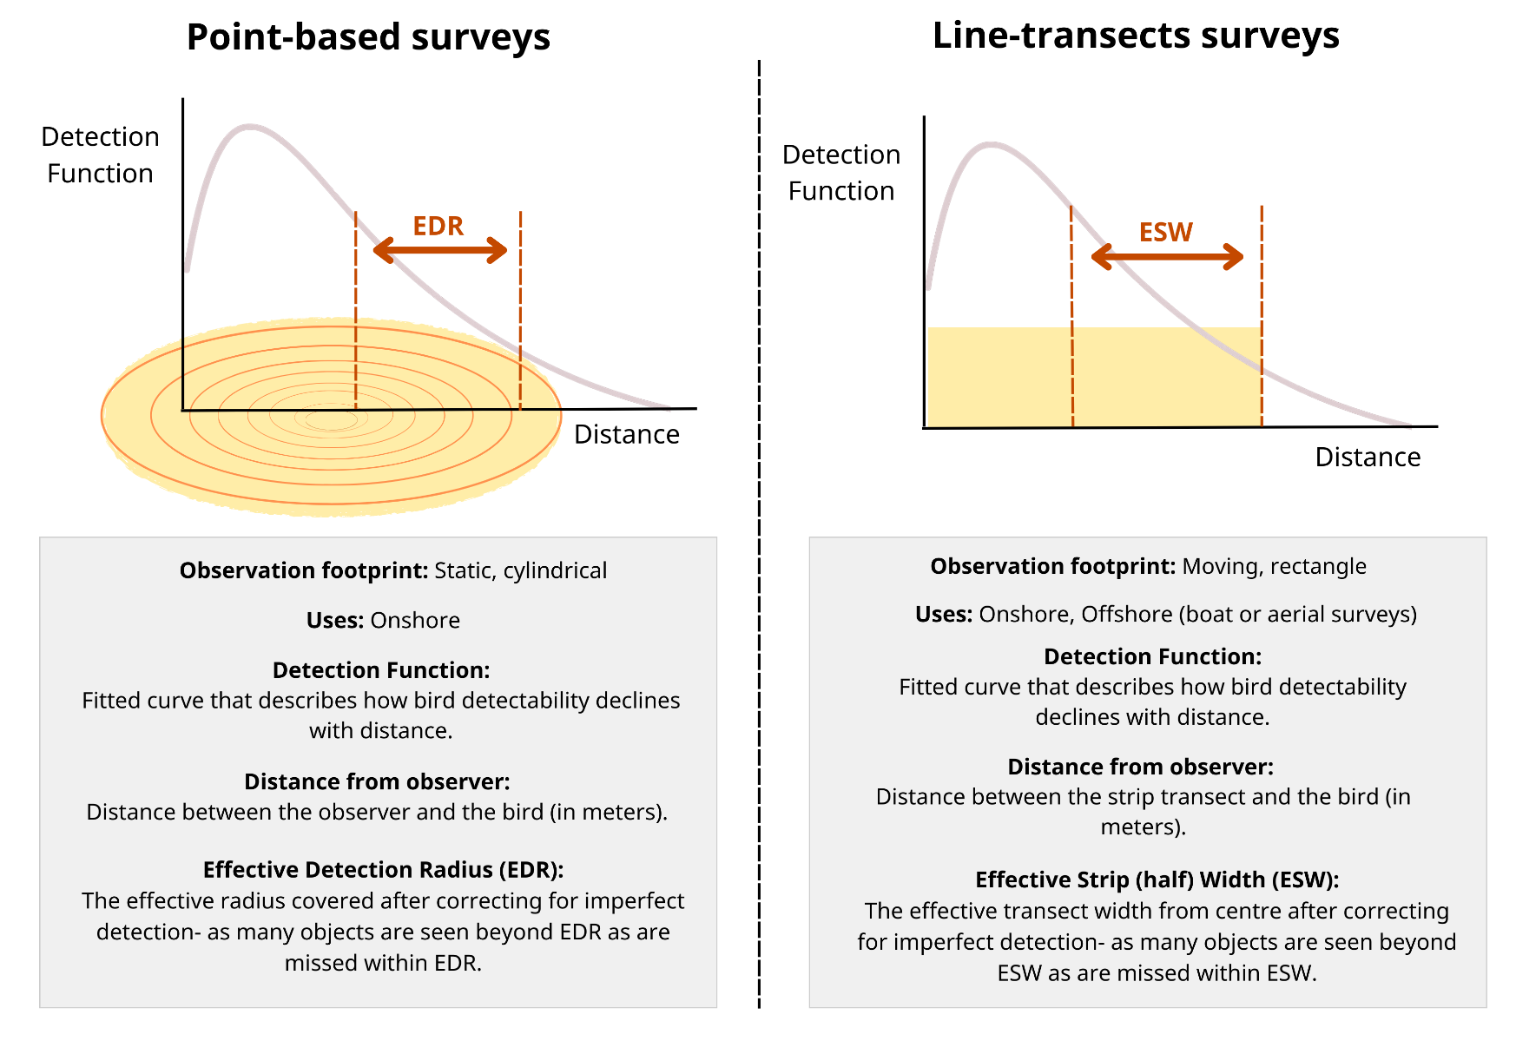
- Flight Height Analysis: Fit a distribution to the flight height survey observations and use this to extract
  - Mean flight height in metres with standard error from survey observations.
  - Proportion of flights (from 0 to 1) below and within rotor swept with standard error.

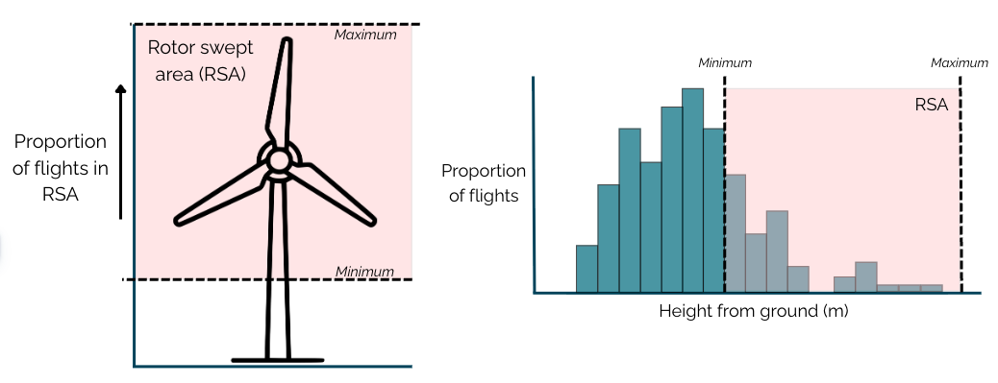

Steps to using the tool

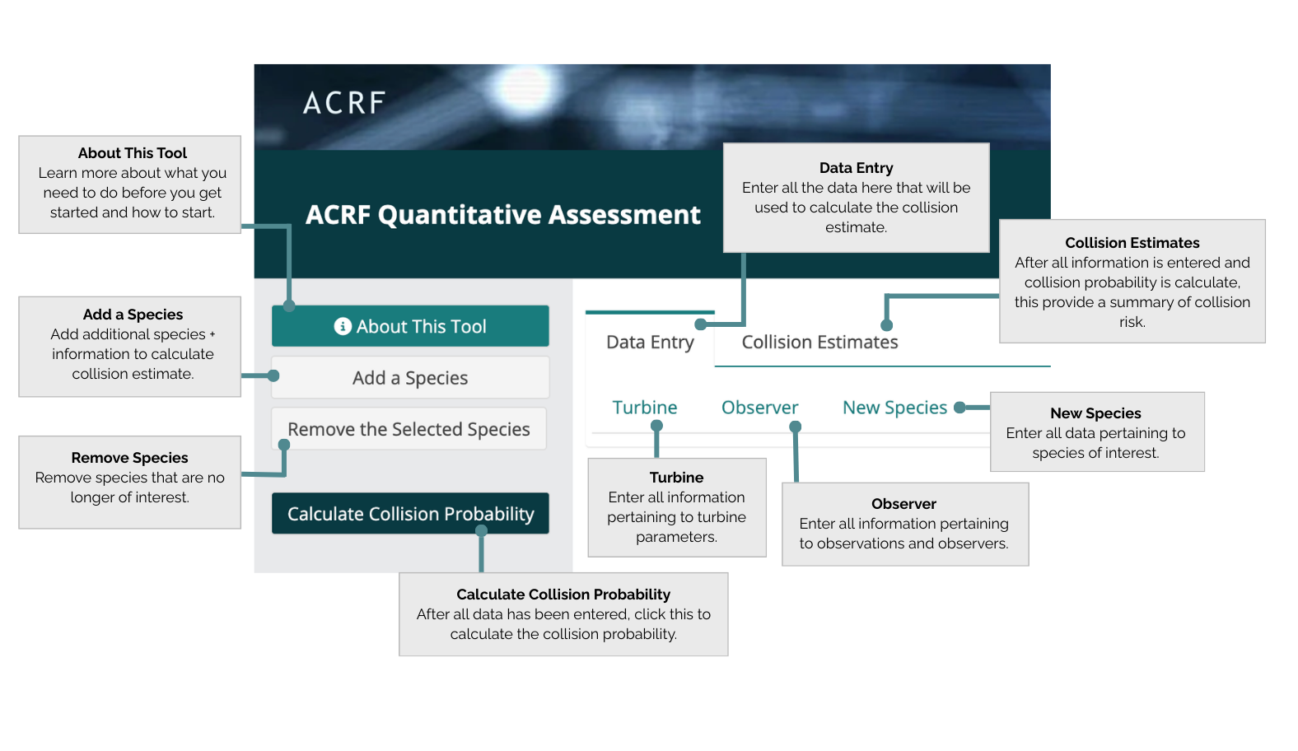
Access the CRM tool from here.
The data entry tab includes three areas of inputs required
- Turbine specifications
- Observer collected data, including the encounter rate, effective distances and height data
- Species are added by selecting “Add a species” from the right and entering species data on the “New Species” tab
- If you add a species in error, it can be removed using the “Remove the Selected Species” button
- Help is provided for each input. Click on the ‘?’ icon to access information about each input
- When all data is entered the “Calculate Collision Probability” runs the model and the results can be accessed and downloaded from the “Collision Estimates” tab.

1. Turbines
Under the Data Entry tab select Turbine tab. Download the template for turbines and fill in the information. Upload the template which will fill the cells. Alternatively, enter the data manually in the cells. By default, the application calculates the likelihood of collision for one turbine. Adjust “Number of Turbines” for whole wind farm estimates.
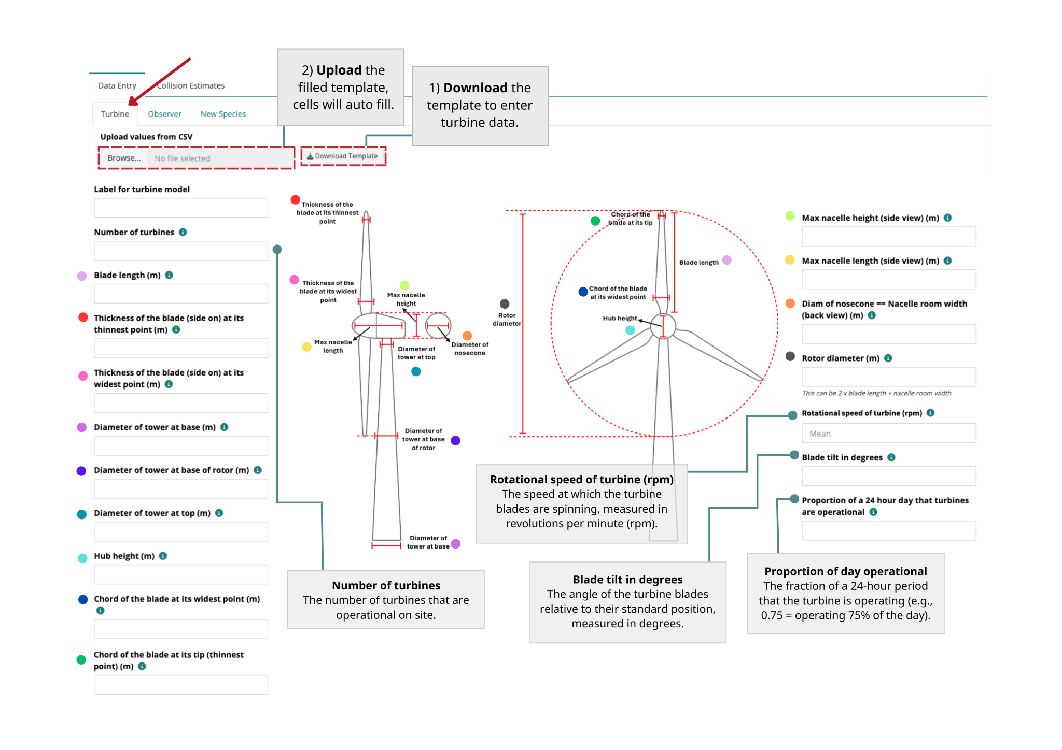

2. Observations
Click the Observer tab. Download the template for observations and fill in the information. Upload the template which will fill-in the cells. Alternatively, enter the data manually in the cells.
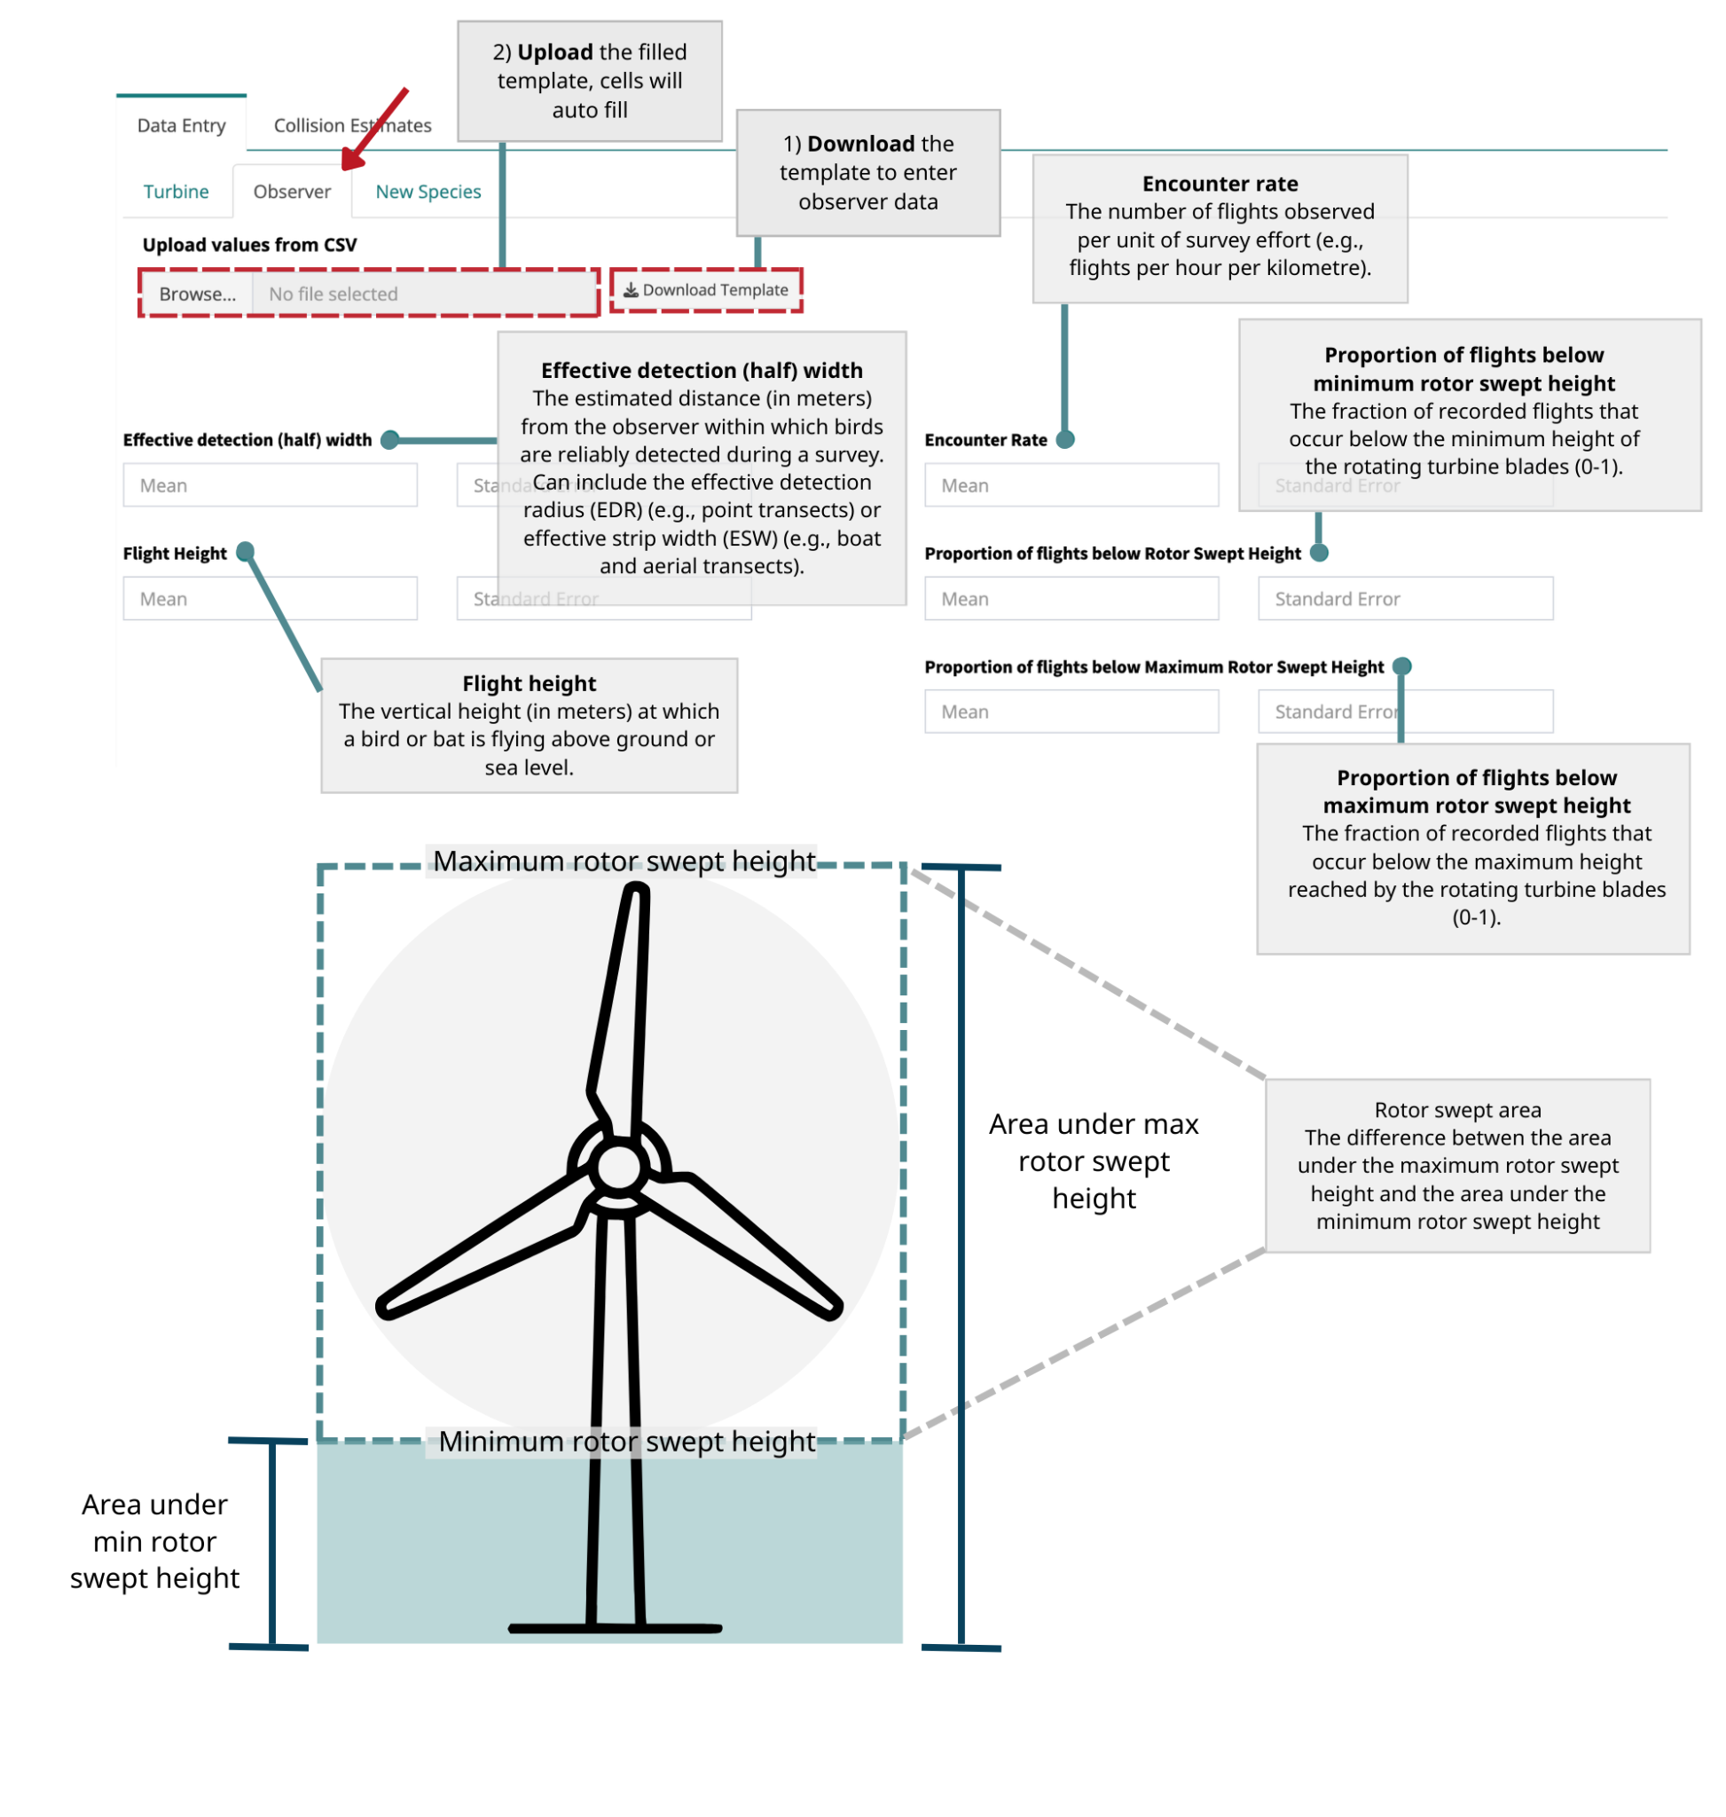

3. Species
Click the New Species tab. Download the template for species and fill in the information. Upload the template which will fill-in the cells. Alternatively, enter the data manually in the cells.

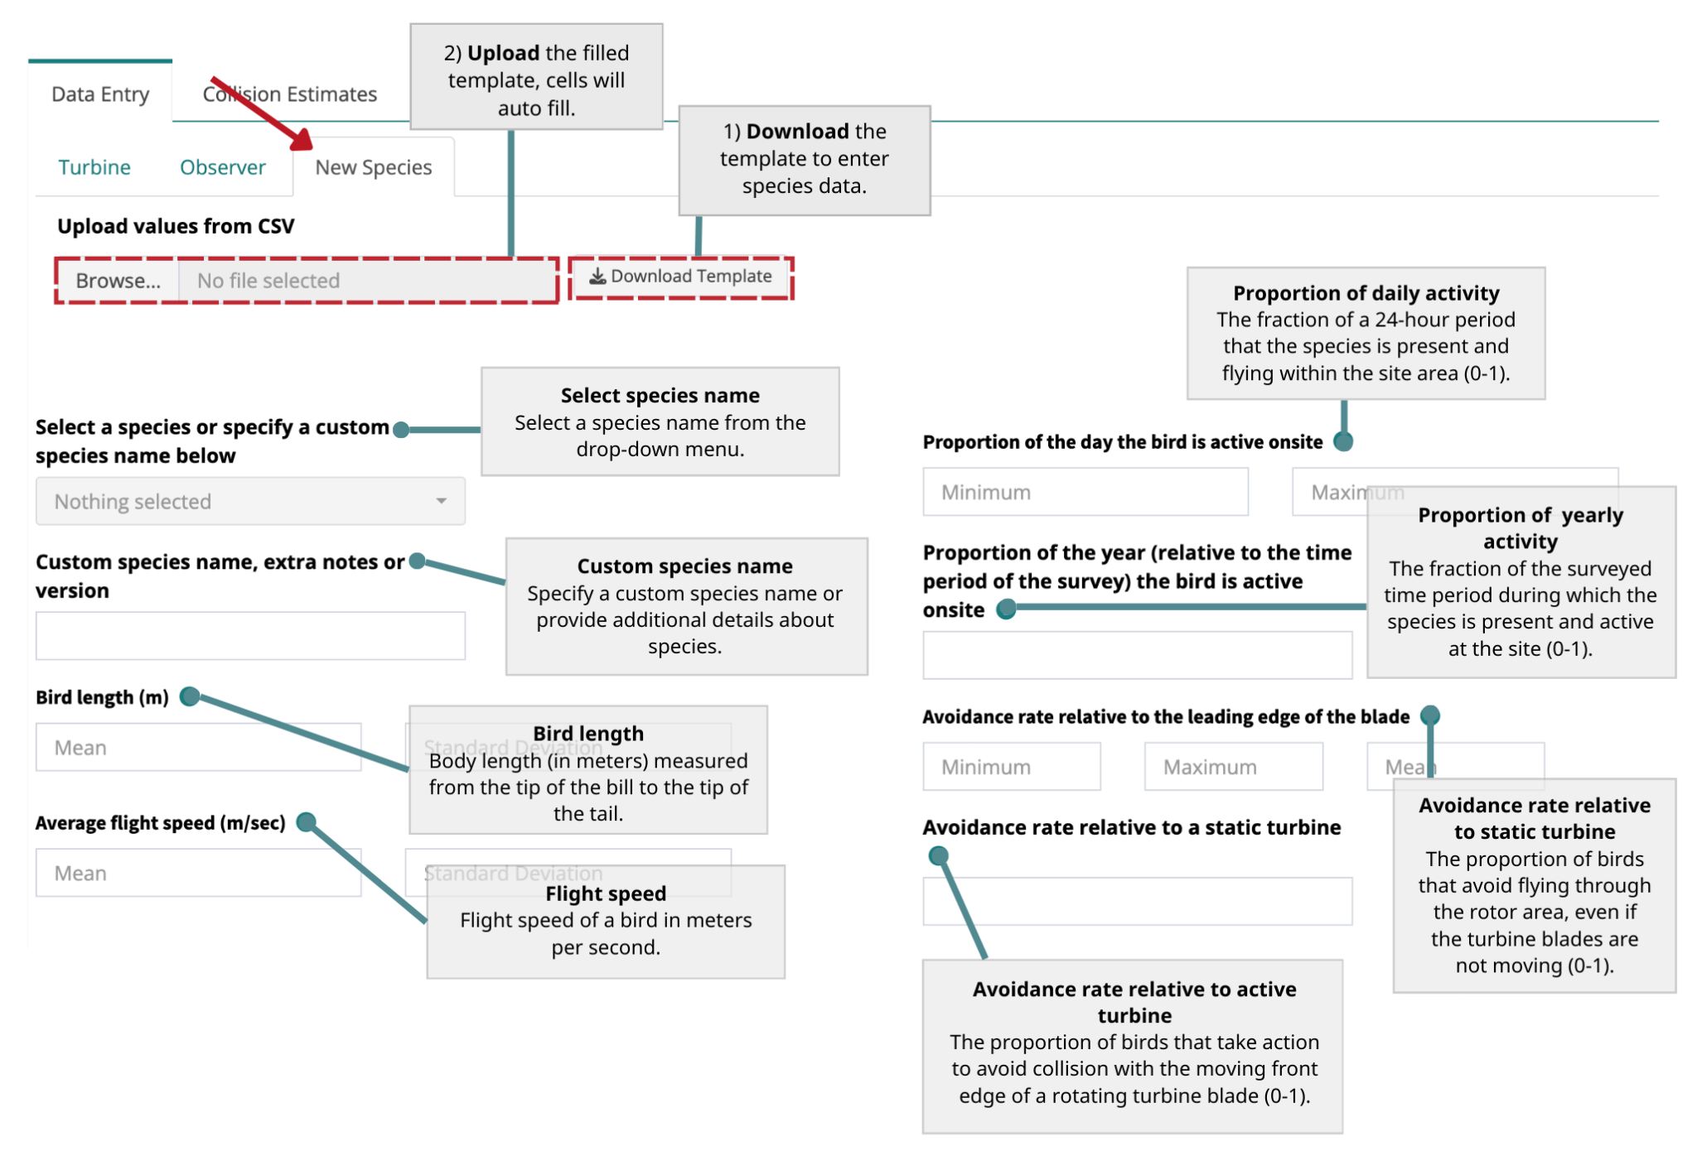

4. Calculate Collision Probability
After all information is filled out in the Turbine, Observer, and New Species tabs, click the Calculate Collision Probability button. Once that has finished running, click on the Collision Estimates tab. You will get one of two messages: Confirmation or Warning. Depending on which one you get you either need to re-check the data provided or proceed to the Collision Estimates tab.
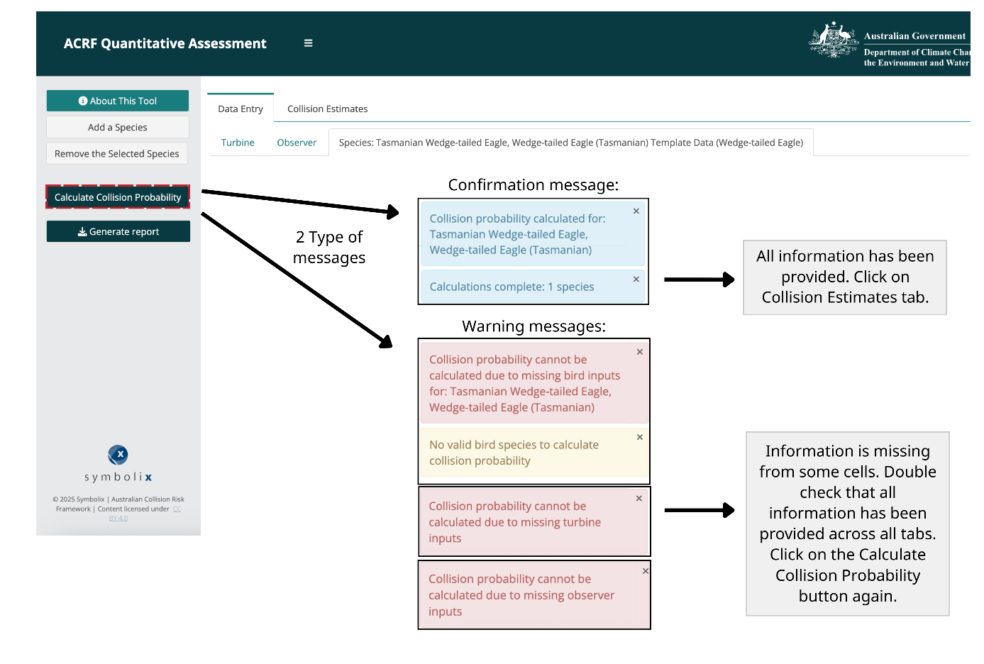

5. Review Collision Estimates
The Collision Estimates tab contains your summary statistics for collision risk, including your mean and median annual collision estimates per turbine as well as a collision distribution by species (blue histogram).
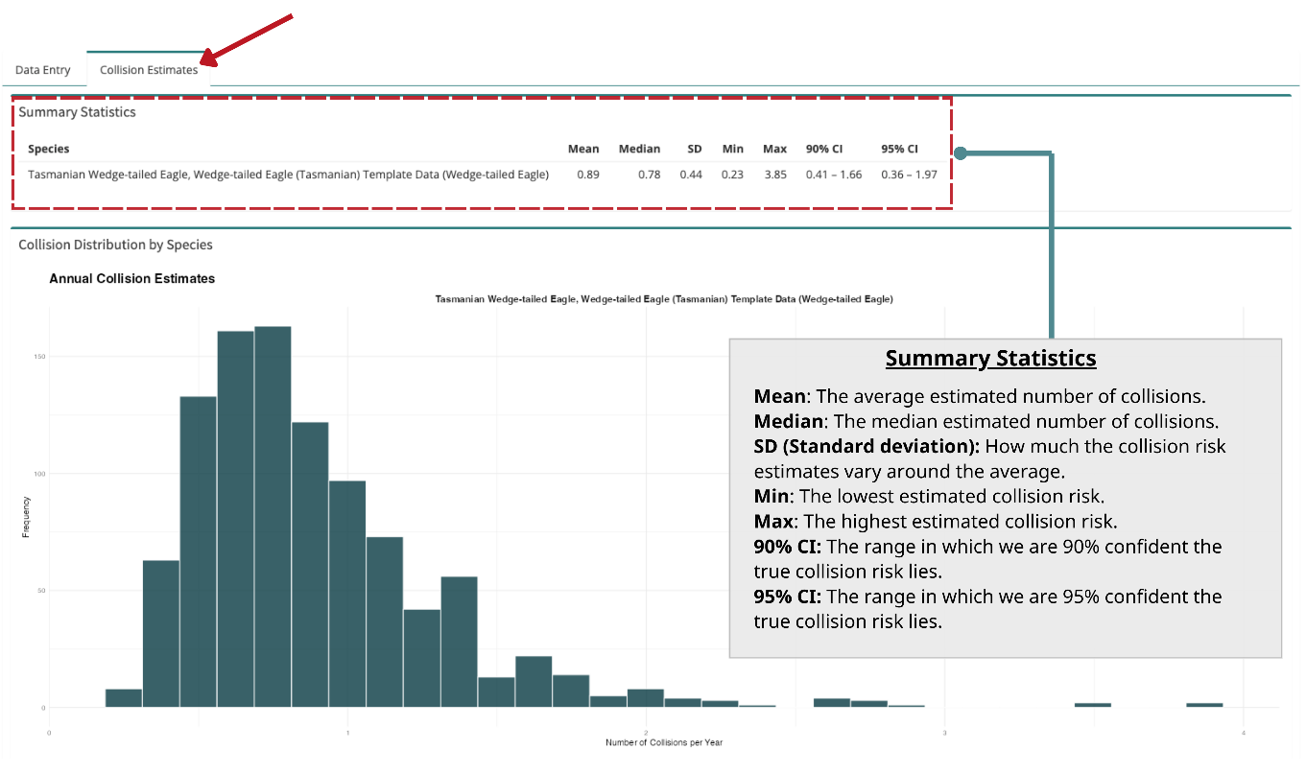
6. Interpret Results
For the results above, we could say that turbine model X has a median estimated risk of 0.78 Wedge-tailed Eagles collisions per annum [0.36, 1.97] 95% confidence interval per turbine. These results were estimated for a single turbine. Note these numbers are entirely fictional and for the purpose of demonstrating the application only.

7. Generate report
After you’ve clicked Calculate Collision Probability, you can download an html of the report by clicking the Generate report button. The report will provide all the inputs from each parameter and the estimated collision results.

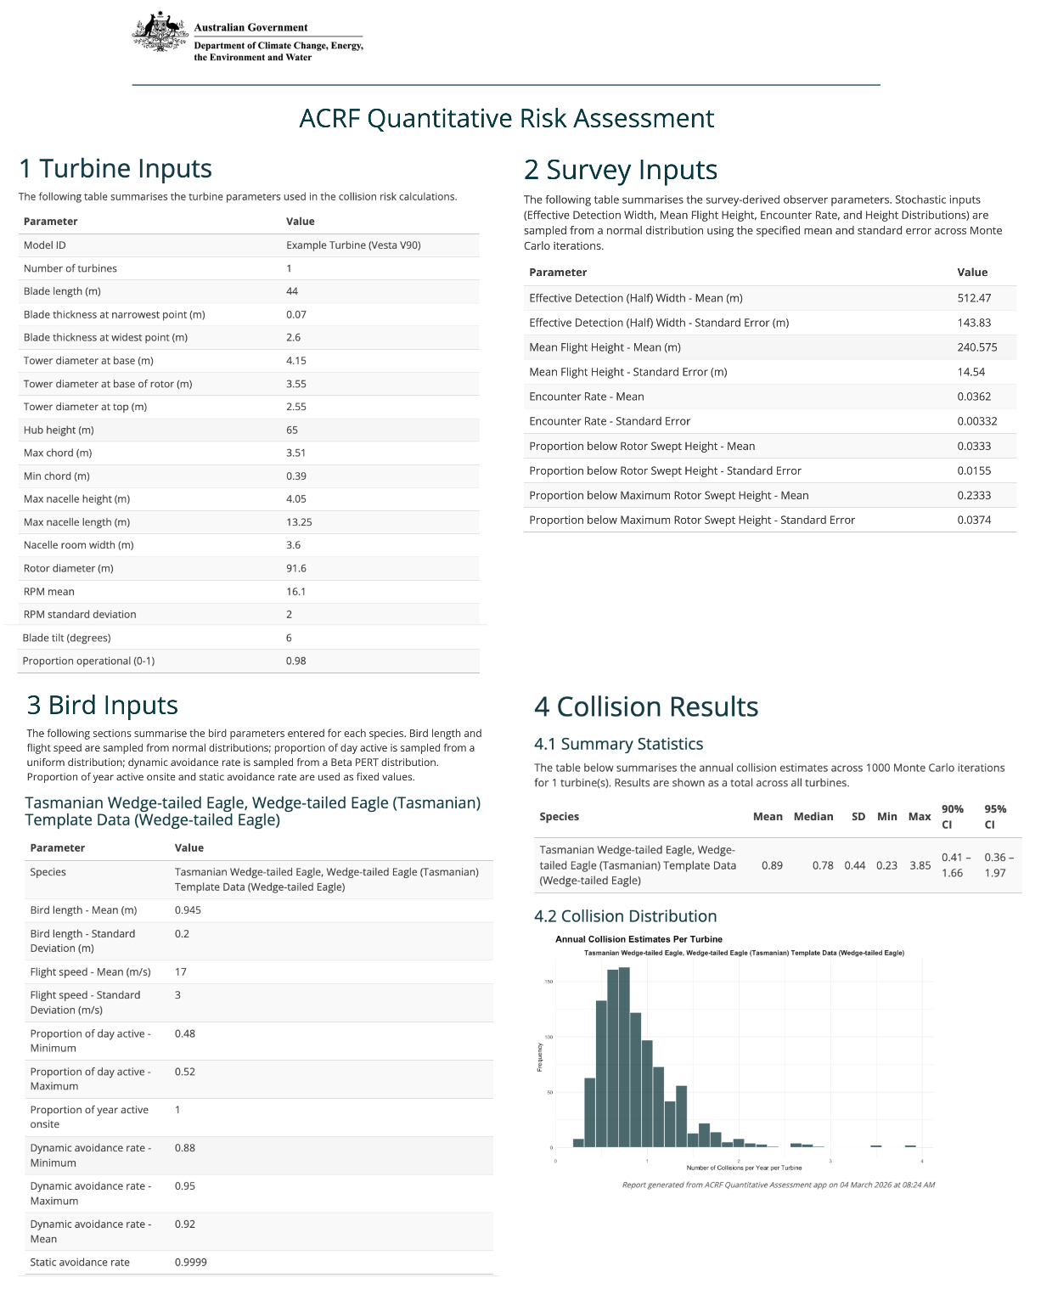

8. Adding / adjusting components and updating the report

Adding multiple species
You can add additional species at any time using the Add a Species button. Once data for new species is imputed, click on the Calculate Collision Probability button, which will update the Collision Estimates tab to include estimates for both species. Finally, click the Generate report button to generate an updated report.

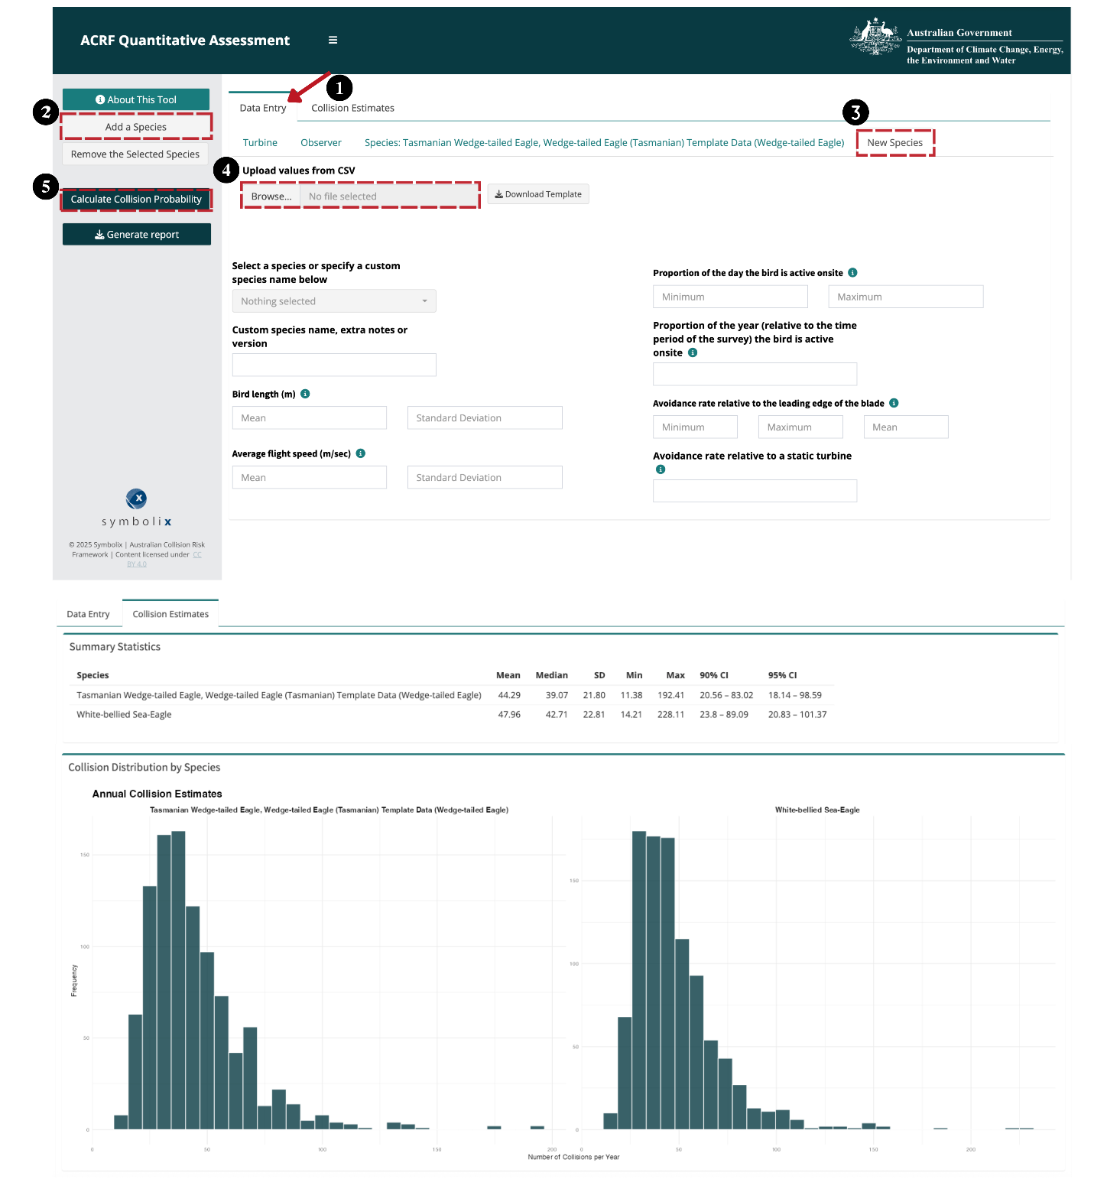

Adding different turbine specifications
You can add different turbine specifications to see how it changes the collision estimate. Navigate back to the Turbine tab. Adjust any of the turbine parameters and click the Calculate Collision Probability button. This will update the estimate in the Collision Estimate tab. Finally, click the Generate report button to generate an updated report.

Removing species
You can also delete species using the Remove Selected Species button. Select the tab of the species you want to remove, click the Remove the Selected Species button, and click the Calculate Collision Probability to update the Collision Estimates tab. Finally, click the Generate report button to generate an updated report.

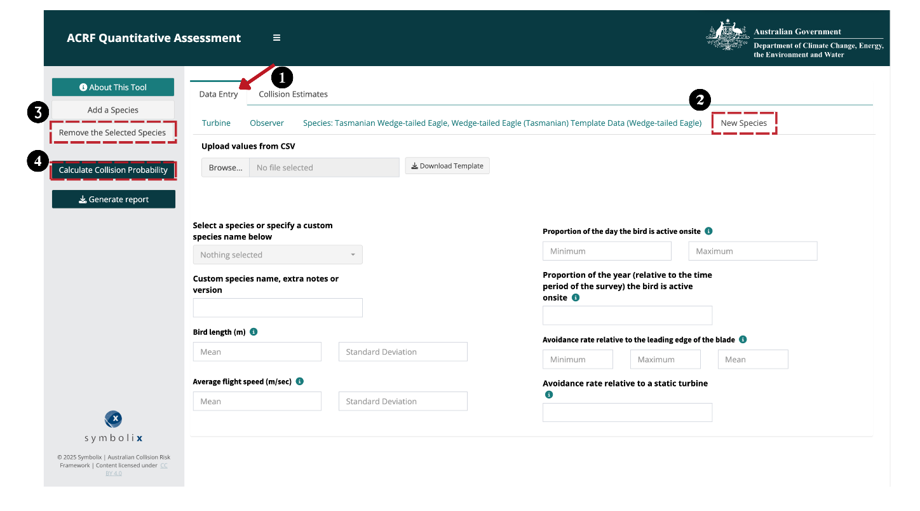

References
Buckland, S.T., Anderson, D.R., Burnham, K.P., Laake, J.L., Borchers, D.L. and Thomas, L. 2001. Introduction to Distance Sampling: Estimating Abundance of Biological Populations. Oxford University Press, Oxford, UK.
Miller, D. L., Rexstad, E., Thomas, L., Marshall, L., & Laake, J. L. (2019). Distance Sampling in R. Journal of Statistical Software, 89(1), 1–28. DOI: 10.18637/jss.v089.i01
Stark, Elizabeth, Muir, Stuart, Yandell, Peggy (2026). collision: Per-turbine stochastic Collision Risk Model for predicting avian collision with onshore and offshore wind turbines. R package version 1.0.4, <https://github.com/SymbolixAU/collision>.

Citation  Potter, Ashley, Stark, Elizabeth, Thompson, Eliza. 2026. “Australian Collision Risk Framework: Collision Risk Model (CRM) Tool User Guide. Department of Climate Change, Energy, the Environment and Water. CC-BY 4.0.”  Last Updated: 4 March 2026  Copyright Once published, this work is licensed under a Creative Commons Attribution 4.0 International Licence. | Contributors Cover image by Elaine Alex via Unsplash  Funding  This work is funded by the Australian Government as part of the Renewables Environmental Research Initiative (RERI). The RERI is funded by the Department of Climate Change, Energy, the Environment and Water

