Australian Collision Risk Framework
Guidance for estimating collision likelihood for onshore and offshore wind farms
DRAFT Guidance document and user guide

Version: 1.0 For industry consultation
Date: 2 March 2026

Citation
Stark, Elizabeth, Thompson, Eliza. 2026. “Australian Collision Risk Framework: Overview and user guide”. V1.0. Department of Climate Change, Energy, the Environment and Water, Canberra, 2026. CC BY 4.0.

Version
This document is correct as at 2 March 2026. The canonical version of this information is maintained and updated at www.acrf-uat.symbolix.com.au

Contributors
This work incorporates inputs and peer review provided by 2rog, ResearchEcology Lab at Monash University, EcoAerial, and Western EcoSystem Technologies Inc (WEST).

Funding
This work is funded by the Australian Government as part of the Renewables Environmental Research Initiative (RERI). The RERI is funded by the Department of Climate Change, Energy, the Environment and Water (DCCEEW).

Acknowledgement
This document was substantially compiled on the traditional lands of the Wurundjeri and Boon Wurrung peoples (Kulin Nation) but is drawn from inputs sourced from various Aboriginal and Torres Strait Islander lands. We acknowledge and pay respects to the traditional custodians of this land and hope to act justly in respect to their connection to land, sea and sky Country.
Main cover photographs: Ken Griffiths, Tom Fisk and CraigRJD via canva.com. Stages

Copyright  Once published, this work is licensed under a Creative Commons Attribution 4.0 International Licence.  This document has been produced for the Australian Government DCCEEW, who may reproduce this document as required in other formats. | 

Table of contents
Table of contents 3
List of figures and tables 3
Executive summary 3
Purpose 4
Methods 4
Scope and limitations 4
How to use this document 5
Glossary of terms 5
Acronyms 6
Definitions 6
Context and overview 7
Regulatory context 7
Core principles 8
Introduction to collision prediction 8
Statistical model or qualitative assessment? 9
What leads to bird and bat collisions? 9
When to consider collision likelihood? 10
Australian Collision Risk Assessment Framework 11
Stage 1: Site identification 12
Context 13
Objective and scope 13
Activities 14
Checklist 15
Resources and further information 15
Tools 15
Third party resources 15
Stage 2: Site investigation planning 16
Context 17
Objective and scope 17
Activities 17
Identify collision assessment pathway 18
Survey program design 19
Checklist 20
Resources and further information 20
Guidance information 20
Tools 20
Stage 3: Self-assessment (during surveys) 20
Context 21
Objective and scope 21
Activities 22
Preliminary collision likelihood prediction 22
Review and refine survey program 24
Checklist 24
Resources and further information 24
Tools 25
Third party resources 25
Stage 4: Final assessment 25
Context 26
Objective and scope 26
Activities 27
Finalise collision risk assessment 27
Overall environmental impact assessment 27
Document evidence base 27
Checklist 27
Resources and further information 28
Stage 5: Post-construction 28
Context 29
Objective and scope 29
Activities 30
Checklist 30
References 30

List of figures and tables

Figure 1 | Conceptual framework for evaluating collision likelihood for birds and bats with wind turbines | 8
Figure 2 | Key stages of project development and Australian Collision Risk Framework resources for each stage | 10
Figure 3 | Species Traits Viewer - overview tab | 13
Figure 4 | Decision tree for choosing a collision assessment pathway | 16
Table 1 | Example data inputs that are suitable as evidence for each of the collision risk categories | 17

Executive summary

Purpose
This document provides an overview and user guide for the Australian Collision Risk Framework for onshore and offshore wind farms (ACRF). The ACRF was developed with funding provided through the Australian Government’s Renewables Environmental Research Initiative (RERI).
The purpose of the ACRF is to provide a standardised, transparent and robust methodology for undertaking and evaluating collision risk assessments for species listed under the Environment Protection and Biodiversity Conservation Act 1999 (EPBC Act).
The objectives of the ACRF are:
- Provide a standardised and transparent Collision Risk Modelling (CRM) approach for consistent application by proponents and regulators in the assessment of onshore and offshore wind developments under the EPBC Act.
- Assist users in identifying circumstances where CRM is not appropriate, and outline alternative, standardised, and transparent collision risk assessment methods consistent with best practice and EPBC Act requirements.
- Specify the evidence requirements for collision risk assessments to support robust EPBC decisions and establish standardised guidelines for streamlined and effective communication of results by proponents.
This ACRF provides guidance, but it is not mandatory. There may be circumstances where proponents decide to take an alternative approach to this guidance, such as to account for new scientific information or emerging best practice. This should be well-documented and justified in their assessment documentation.
The ACRF provides clear expectations upfront to help proponents and ecological consultants prepare adequate referral information, in turn enabling efficient assessment by regulators, with reduced likelihood of requests for further information.

Methods
Research was undertaken to collate and review international guidance standards, collision risk modelling literature, current Australian collision risk assessment practices, and species-specific collision risk traits (Stark and Thompson 2026). The research outcomes are provided in the companion report, Australian Collision Risk Framework: Review of current practice and species data (Stark and Thompson 2026a)
In addition to this research, the authors engaged with related RERI projects, core delivery partners, and expert reviewers, including specialists in species ecology, EPBC Act assessment process, and international impact assessment. Consultation with DCCEEW and State and Territory regulators occurred throughout the research and framework development process.
Feedback and input were sought from formal peer review by statistical and ecological experts, presentations at Australian and International conferences, and a RERI forum hosted by the Environment Institute of Australia and New Zealand (Canberra 2025).

Scope and limitations
The ACRF provides guidance specific to the prediction of collision likelihood of bird and bat species at Australian onshore and offshore wind farms. The ACRF specifically relates to listed threatened, migratory and marine overfly species in the EBPC Act. However, the ACRF is designed to be applicable in a more general environment impact assessment context and to be complementary to the range of Australian State and Territory guidance available.
The ACRF assists users in assessing the likelihood that birds and/or bats will collide with wind turbines. Importantly it does not address the population consequences of loss from collision. To complete an impact assessment users will need to combine the outcome of this process with the likelihood of other threatening processes and the consequences of these.

How to use this document
This document details the Australian Collision Risk Framework and is a user guide for proponents, regulators and consultants who need to include a consideration of collision likelihood in their wind project planning. The canonical version of this information with links to supporting documents and self-assessment tools can be found at the related website.
This document is aimed at a broad audience and is designed to be accessible to wind farm developers, impact assessment experts, ecologists, statisticians, and regulators. The Australian Collision Risk Framework is staged to align with key points in project development. Additional information is linked to throughout the document, including specific web tools to assist with self-assessment of collision likelihood.
The first two sections of this document provide Context and overview, followed by an Introduction to collision prediction. The remaining sections describe each stage of the Australian Collision Risk Assessment Framework. Each stage contains a description of the Context, and Objectives and scope of that stage. The Activities section outlines the key tasks that need to be conducted, and the Checklist summarises the key outputs of that stage. Related resources are provided within each stage and a full reference list at the end of this document.
This document provides a full overview of the ACRF. The website can be used to navigate through specific sections, and to access the related technical documents and self-assessment tools.

Glossary of terms

Acronyms
ACRF | Australian Collision Risk Framework for onshore and offshore wind farms
BBMP | Bird and Bat Management Plan
CLS | Collision Likelihood Score
CRA | Collision Risk Assessment
CRM | Collision Risk Model
DCCEEW | Australian Government Department of Climate Change, Energy, the Environment and Water
EPBC Act | Environment Protection and Biodiversity Conservation Act 1999
MNES | Matters of National Environmental Significance
OEI Act | Offshore Electricity Infrastructure Act 2021
RERI | Renewables Environmental Research Initiative

Definitions
Avoidance behaviour | The propensity for a volant species to avoid collision. In the context of the ACRF we refer specifically to the avoidance behaviour of birds and bats with wind turbine infrastructure, both static and the moving turbine blade. Avoidance behaviour can occur at a combination of scales; macro-avoidance is the avoidance of the entire facility footprint; meso-avoidance is the changing of flight paths within a facility to avoid individual turbines; micro avoidance is changed flight patterns to minimise risk when passing close to or within a turbine footprint (e.g. by flying higher or lower).
Collision Likelihood Score | A structured, qualitative assessment of collision likelihood risk using ranked criteria. CLS combines species activity, flight height, seasonal exposure, and collision history to generate transparent risk ratings. CLS is appropriate when data are insufficient for a CRM, during early project stages, or when collision risk is clearly very low or very high.
Collision Risk Assessment | A multi-step process that assesses the likelihood and consequence of wind turbine collisions for bird and bat species. The CRA is designed to identify species at risk, inform the mitigation hierarchy and to support regulatory approval of onshore and offshore wind farm developments.
Collision Risk Model | A quantitative model that uses numerical survey data to estimate the long-term average number of bird or bat collisions per year. CRM works best when flight activity (flights per area per time) can be measured or reliably modelled, and should ideally include uncertainty (confidence intervals).
Daily activity | Timing and length of flight behaviour on a daily scale. Most species fall into one of three categories; nocturnal, diurnal, or crepuscular.
Exposure | Refers to the state where the target species could be involved in a turbine collision, i.e. “in harm’s way”. The number and duration of flights exposed to collision is directly related to the likelihood of collision.
Flight height distribution | The range of heights at which a particular species flies, usually used in reference to the rotor-swept area of a turbine.
Mitigation Hierarchy | A staged framework for managing environmental risks where avoidance of the risk is the primary objective, then minimisation, repair, then offsetting.
Propensity to evade collision | A species’ ability to avoid turbine blades (or the wind farm in the case of macro avoidance) based on its behaviour and morphology
Rate and density of flights | Exposure to collision relates to a combination of the number of animals in flight, the number of flights made by those animals in a given time (flight rate) and the number of flight movements to cross through a given area of vertical space (flight density). Collision likelihood is directly related to the flux (flights through a given area in a given time), requiring an understanding of the rate and density of flights.
Risk category | A broad set of factors that contribute to an increase in the likelihood of a collision, e.g. exposure to turbine airspace, duration of exposure, ability to avoid.
Risk criteria | A specific type of data that provides information about the risk of collision. Criteria can be quantitative (e.g. flight height distribution) or qualitative (e.g. foraging strategy).
Risk metric | A specific value or score that can be calculated and entered into a CRM or CLS, e.g. proportion of flights at Rotor Swept Height (quantitative) or a score from 1-5 based on an estimate of frequency of flights at rotor swept height.
Rotor swept height | The vertical height space at which turbine blades rotate.
Seasonal patterns | Proportion of time a target species is likely to be present on proposed wind farm site across a year
Spatial use patterns | Proportion of time a target species is likely to be at a given location during its time on the wind farm site
Species morphology | The outward appearance of a species. For the purposes of collision risk assessment, we are specifically interested in size measures (length, wingspan, etc), mass and flight speed.
Species manoeuvrability | The natural ability for a volant species to rapidly change flight trajectory, height, speed etc.
Turbine airspace | The column of vertical space spanning ground to maximum rotor swept height, and diameter equal to the rotor diameter, centred on the turbine tower. The likelihood of collision is much greater within rotor swept height; for that reason, some models ignore the area below minimum rotor swept height, others calculate it.

Context and overview

Regulatory context
Collision likelihood is one piece of the complex suite of environmental impacts proponents must address when seeking approval for wind energy proposals under the Environment Protection and Biodiversity Conservation Act 1999 Act (EPBC Act), the Offshore Electricity Infrastructure Act 2021 (OEI Act) and relevant state or territory legislation.
Commonwealth approvals requiring assessment of collision risk are administered under the EPBC Act. Under the EPBC Act proponents must identify any Matters of National Environmental Significance (MNES) that may be significantly impacted by a proposed action, collect relevant data and undertake a self-assessment prior to referring the proposal to the Department of Climate Change, Energy, the Environment and Water (DCCEEW). If the proposal is determined to be a controlled action, it proceeds through a formal assessment process to inform the approval decision and any conditions that may be applied. This process requires transparent documentation of residual risk (after accounting for avoidance and mitigation measures) to relevant regional populations (onshore proposals) or to the ‘whole-of-environment’ (Commonwealth waters, offshore).
The statistical and ecological complexity of quantifying collision risk, and lack of clear guidance to date, leads to delays, and sometimes sub-optimal environmental outcomes.
As turbine collision is only one of several potential impacts associated with wind farm operation, the Australian Collision Risk Framework (ACRF) is designed to be used within a broader ecological impact assessment. The ACRF is sufficiently flexible to allow its principles and processes to be adapted to varying site complexities, species sensitivities, and the diverse characteristics of onshore and offshore environments in Australia, while still meeting regulatory requirements.
This guidance outlines the principles, processes, methods and supporting resources for assessing collision likelihood, from initial site investigation through to referral and assessment under the EPBC Act. It is designed to be accessible to proponents, regulators, project managers, ecologists and technical analysts. Additional technical documentation and web tools are available and referenced throughout.
While the ACRF is primarily aligned with the EPBC Act, it adopts a standard tiered risk assessment approach and applies the mitigation hierarchy to support informed decisions about impact avoidance and minimisation. Accordingly, the ACRF can also be applied in the context of other environmental impact assessment legislation.

Core principles
The core principles that underpin the Australian Collision Risk Framework are:
- Quantification where feasible
Where feasible and appropriate (see section ‘Identify collision assessment pathway’) the goal should be to estimate a quantified range of expected average annual collisions. Where quantification is not feasible, a standardised, evidence based qualitative assessment should be undertaken. Quantification may not be possible where:
  - The species population is unlikely to be susceptible to collision (generally limited to common species and some marine flyover species); or
  - Insufficient data are available to inform a CRM.
- Site-based and species-informed assessment
All projects should utilise a site-based approach with site investigations required for any assessment. A fully quantitative CRM will require a survey program specifically designed with regard to site characteristics and the species at risk.
- Lifecycle integration
Collision risk considerations should be integrated throughout the entire project lifecycle, from site selection and design through to operation and post-construction monitoring to provide optimal environmental outcomes.
- Decision-focused risk assessment
Collision risk assessment should not only estimate predicted annual collisions and their implications for affected species, but also inform avoidance through project siting and design, and determine whether post-construction mitigation measures are required (e.g. curtailment) are required.

Introduction to collision prediction
The field of Collision Risk Models (CRM) is over 40 years old and there are a diverse range of published models, applications and adaptations available (Cook et al. 2025). However, CRM have specific data requirements that often are not available, or cannot reasonably be collected at the site level, even with a multi-year survey program.
The research underpinning this guidance found no widely adopted standards for collision assessment when CRM is not feasible (Stark and Thompson 2026) . The Australian Collision Risk Framework provides advice for designing and implementing quantitative CRM and a standard procedure for qualitative Collision Likelihood Score (CLS) using a multi-criteria approach.

Statistical model or qualitative assessment?

Collision Risk Models (CRM) are characterised by having quantitative (i.e. numeric, statistically derived) inputs and outputting an estimate of the long-term average rate of collisions each year. It is strongly preferable that the confidence interval on that average is also reported by using a model that considers the uncertainty in the inputs (a “stochastic” CRM).
CRM requires more data collection and analysis than non-quantitative risk assessment methods. It is most applicable for species for which flight activity (flights per area per time period) can be measured through on-site surveys or inferred through a combination of surveys and statistical modelling.
CRM are important tools for generating inputs into population viability models (Smales 2017) and provide a clear quantitative base for setting mitigation strategies and understanding cumulative impacts. But the data required is only currently available, or measurable, for a subset of species. For these and for others where the collision likelihood is very low (or very high), a qualitative model might be more appropriate.

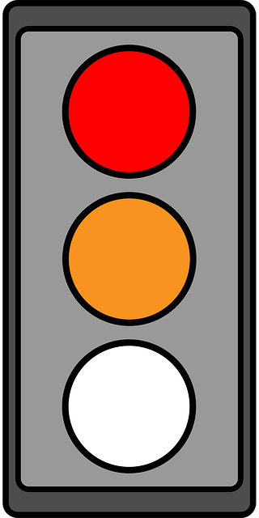
Collision Likelihood Score (CLS) is used in this document to describe a structured multi-criteria assessment of collision. This approach uses similar risk criteria to the CRM, but the metrics are ranked on an ordinal (e.g. 1-5) scale.
The major limitation of these models is the lack of a numeric output; which in turn limits the applicability of the output to population viability analysis, or a cumulative assessment.
CLS is valid when there are barriers to collating the data needed for a CRM, for early impact assessment, and for when the overall collision likelihood is so low (or so high) that the higher precision of a CRM will not change the outcome of the impact assessment (International Organization for Standardization 2018).

What leads to bird and bat collisions?
As with any risk assessment process, having a single prediction for the rate of collisions is of limited use (no matter how precise). Ideally, methods for collision prediction should provide insight into the criteria that increase collision likelihood for a given site and species. This then informs decisions about which actions can provide avoidance, mitigation and remediation of the risk.
To collide with a turbine, a bird or bat must be onsite and active, flying at the turbine location, flying at height, must fail to avoid, and must have an element of bad luck. That is, there must be a series of failure points where the collision is not avoided. The most common approach to risk likelihood analysis is to measure (or assign a score) to each contributing failure point.
To provide a unified framework for collision likelihood prediction that incorporates quantitative models and qualitative assessments, we need a common language for the risk categories and metrics used. The collision risk models available in peer review literature vary in nomenclature and modelling processes, though there are commonalities. Even if the model used is not one of those mentioned in this document, the reporting of the methods, evidence base and results should include the risk categories in Figure 1.
The conceptual model applied to bird and bat collision risk is summarised in Figure 1, to provide standardised definitions for communicating each risk category and criteria. In order to predict the number of collisions we need to estimate the rate of exposure to the turbine, the duration of that exposure and the physical and behavioural ability to avoid collision, once exposed. When assessing and reporting on collision likelihood we recommend addressing each risk criteria and metric in Figure 1.
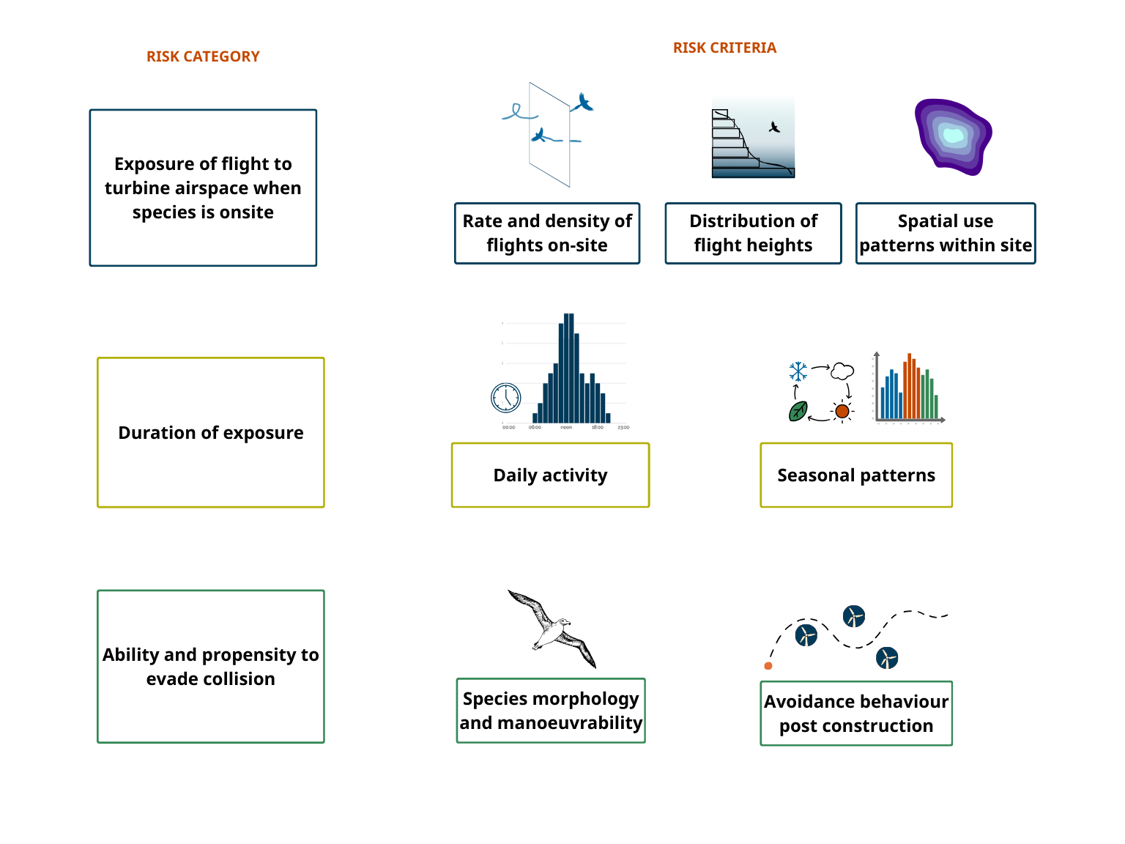
Figure 1: Conceptual framework for evaluating collision likelihood for birds and bats with wind turbines.

For a given species and site, we may be able to collect only some of the information in Figure 1 or have significant data deficiencies that cannot be overcome through site-specific field studies. At that point, a qualitative collision risk assessment may be necessary. In some cases, a hybrid CRM is possible by using a CRM with a combination of field measured inputs and literature, model, or expert derived ranges for others.
Technical guidance is provided as support to this framework for readers needing to choose a collision prediction pathway, as well as additional information on designing onshore (Thompson et al. 2026b) and offshore (Thompson et al. 2026a) survey programs to inform the evidence base for each of the metrics above.

When to consider collision likelihood?
Wind energy impact assessment guidelines worldwide are consistent in recommending early consideration of environmental constraints, at the initial project siting stage (Stark and Thompson 2026). Likewise, we recommend early consideration of collision likelihood, starting with a tiered approach to refine and quantify the likelihood throughout planning and impact assessment.
Collision risk is one of many environmental and social constraints that must be managed, but the specific data required and lack of existing information for many species means it can be a very complex constraint if attempting to quantify it after field studies have been completed.
An early assessment of collision likelihood can additionally contribute to constraints mapping for project placement. Within a site, quantifying the high use spatial regions before final turbine layouts are confirmed allows for collision to be avoided and this avoidance to be clearly demonstrated using consistent language and nomenclature.

Australian Collision Risk Assessment Framework
The Australian Collision Risk Framework (ACRF) includes five stages of collision risk assessment, from initial site identification to post-construction monitoring (Figure 2). These stages provide a structured, evidence-based approach to understanding, predicting, and managing collision risk, and are designed to be applied alongside the assessment process under the EPBC Act.

Stage 1: Site identification – Identify potential collision risks, site constraints, and species presence to inform project feasibility and early design decisions.
Stage 2: Site investigation planning – Design survey programs and data collection to support robust collision risk prediction.
Stage 3: Self-assessment (during surveys) – Evaluate emerging survey data, determine the appropriate assessment pathway, and confirm whether quantitative modelling is feasible.
Stage 4: Final assessment – Provide a transparent, evidence-based evaluation of predicted collision risk to support impact assessment, residual risk determination, and mitigation planning.
Stage 5: Post-construction – Validate predicted impacts through monitoring and support adaptive management to reduce realised collision risk over the life of the project.

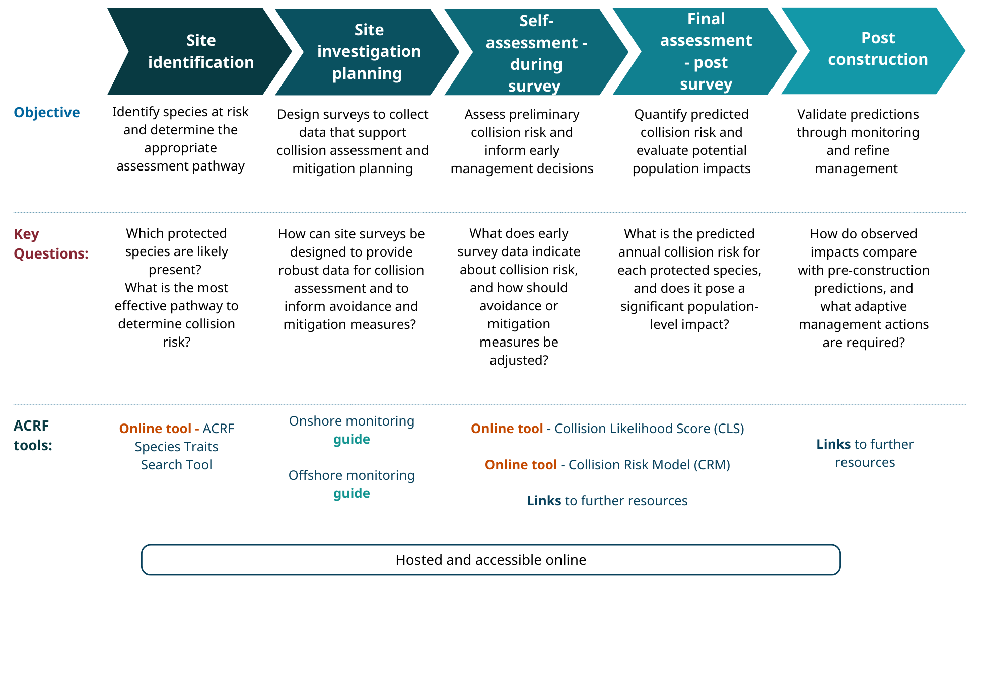
Figure 2: Key stages of project development and Australian Collision Risk Framework resources for each stage

Stage 1: Site identification

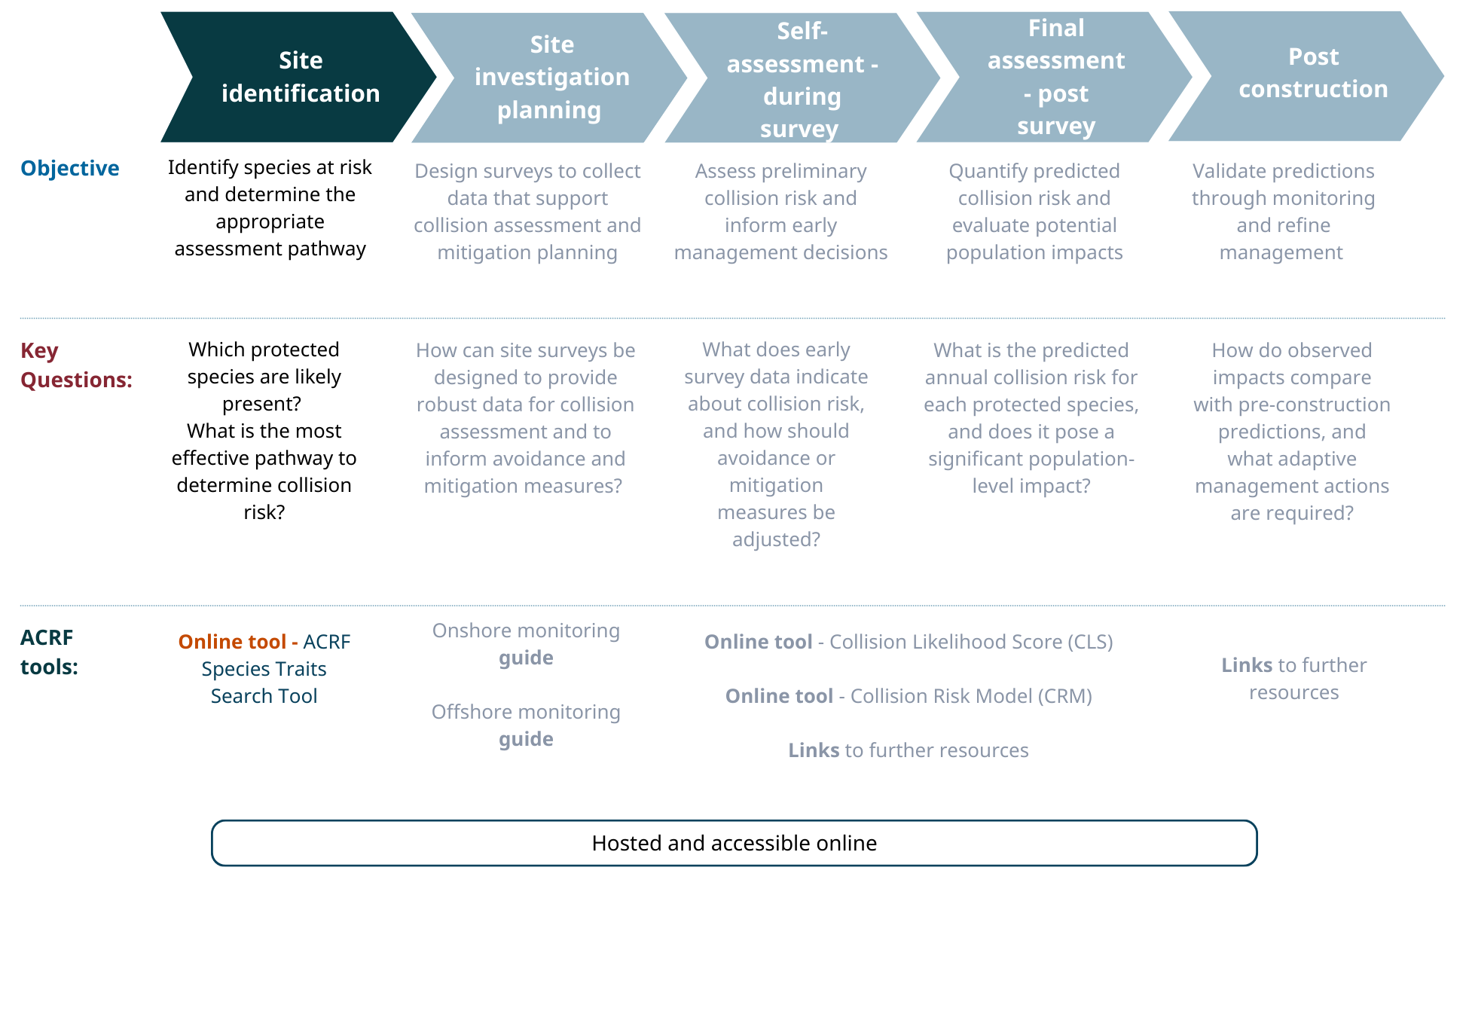Context
Initial site identification involves constraints mapping to prioritise and confirm potential wind farm development sites. At this stage, proponents and their consultants should identify which species listed under the EPBC Act may occur within the project area and consider their susceptibility to collision risk through a desktop assessment.
Using the ACRF species traits database and guidance materials, proponents can identify species potentially vulnerable to collision, knowledge gaps, and gather the information needed to inform a robust and proportionate survey program.
At this stage, identifying species that may be exposed to collision informs whether detailed assessment is needed and shapes the scope and design of subsequent surveys. Without a clear understanding of which species may be affected and their susceptibility to collision, proponents risk collecting insufficient, misdirected, or inadequate data for later stages of assessment.

Objective and scope
Key questions: Which species are likely to be exposed to collision at this site? Is the site likely to present a high collision risk to species listed under the EPBC Act, or involve a complex mix of species with varying susceptibility?
At this stage, the objective is not to quantify collision likelihood, but to determine whether collision risk is likely to be a significant consideration in site selection and project design. This early desktop assessment ensures that survey programs and assessment pathways are proportionate and appropriately designed before substantial resources are committed. It also enables collision risk to be incorporated into site prioritisation and feasibility decisions.
Spatial scope: Regional and inter-site development prioritisation
Key activities:
- Collate relevant species lists and site information. Identify Matters of National Environmental Significance through a Protected Matters Search and equivalent state-based tools.
- Assess species-specific collision likelihood traits and identify data gaps to be addressed through future surveys.
- Integrate collision risk considerations into initial site layout and placement decisions and document how design choices contribute to the avoidance of identified risks.
Relationship to the EPBC Act assessment process: Pre-referral stage

Activities
As input to this stage proponents should review regional species occurrence records, undertake initial site visits, and interrogate relevant databases to identify species and environmental habitats within the site and surrounding region. Tools such as the Protected Matters Search and other EPBC Act resources should be used to identify listed, migratory and marine species that may occur in the area. Information on foraging habitat, nesting locations, breeding colonies, and other key ecological features should also be compiled.
Once the species assemblage and site context have been characterised, the available information relevant to collision criteria should be reviewed for each species of concern (onsite or regionally present).
- The ACRF Species Traits Search Tool (Figure 3) allows you to select EPBC Act listed, migratory and marine species.
- For each species, a summary report provides available information on collision risk exposure (e.g. flight height and spatial use), exposure duration (e.g. daily and seasonal activity), and relevant behavioural and morphological characteristics. A downloadable dataset is available for all selected species.
- Collision likelihood criteria and associated data gaps for listed species should be assessed and documented.
- This information should be combined with an assessment of species susceptibility to provide an initial, qualitative collision risk appraisal.
- The outputs should inform:
  - Development site prioritisation;
  - Identification of the number and type of species potentially at risk of collision; and
  - Definition of the data gaps that would need to be addressed through site-based studies, including clear survey objectives.

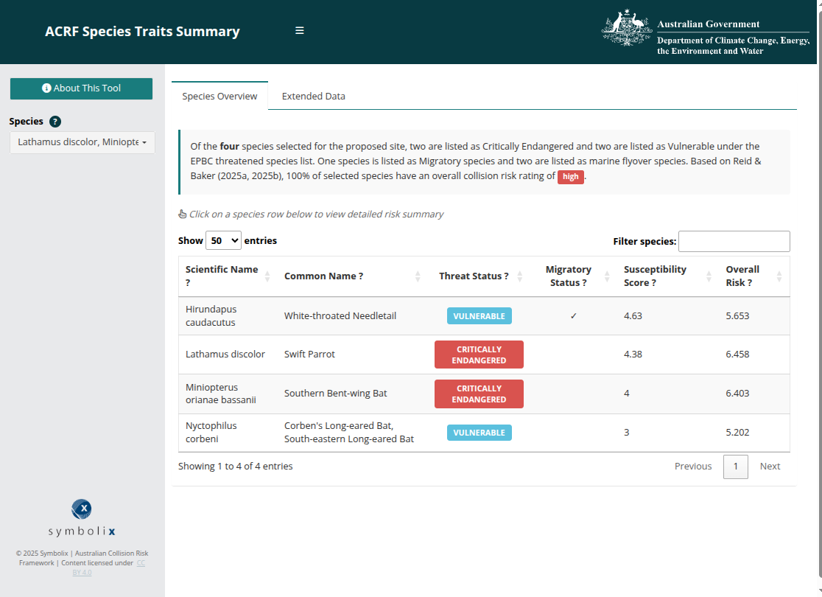
Figure 3: Species Traits Viewer - overview tab

Checklist
The outputs of this stage should include:
- A documented species list categorised by collision risk criteria, identifying traits that may increase risk for each species.
- Identification of key data gaps and species requiring targeted on-site investigation.
- Preliminary survey design objectives based on target species and risk pathways.
- A desktop assessment report suitable for informing referral decisions under the EPBC Act.

Resources and further information

Tools
Species Traits Search Tool – An interactive database providing standardised collision risk trait data for EPBC Act-listed, migratory, and marine flyover species. Users can search by species name to access morphological data (for CRM inputs), flight behaviour characteristics, and temporal activity patterns. The tool also identifies known information gaps.
Collision Likelihood Score (CLS) - A web-based tool that enables users to undertake a structured qualitative collision likelihood assessment. The tool applies standardised criteria to support consistent evaluation of potential collision risks.

Third party resources
Information on the broader commonwealth impact assessment process
- EPBC Act publications and resources: https://www.dcceew.gov.au/environment/epbc/publications
- Protected matters search tool: https://www.dcceew.gov.au/environment/epbc/protected-matters-search-tool
- Updated Guidance on offshore renewables environmental approvals: https://www.oir.gov.au/blog/updated-guidance-offshore-renewables-environmental-approvals
Species sensitivity mapping and assessment of collision population impacts:
- AVISTEP: https://avistep.birdlife.org/
- Reid K. and Baker, B. 2025 Impacts on birds and bats from onshore wind farms in Australia: https://www.dcceew.gov.au/epbc/publications/impacts-birds-bats-onshore-wind-farms-australia
- Reid K. and Baker, B. 2025 Impacts on birds and bats from offshore wind farms in Australia: https://www.dcceew.gov.au/epbc/publications/impacts-birds-offshore-wind-farms-australia

Stage 2: Site investigation planning

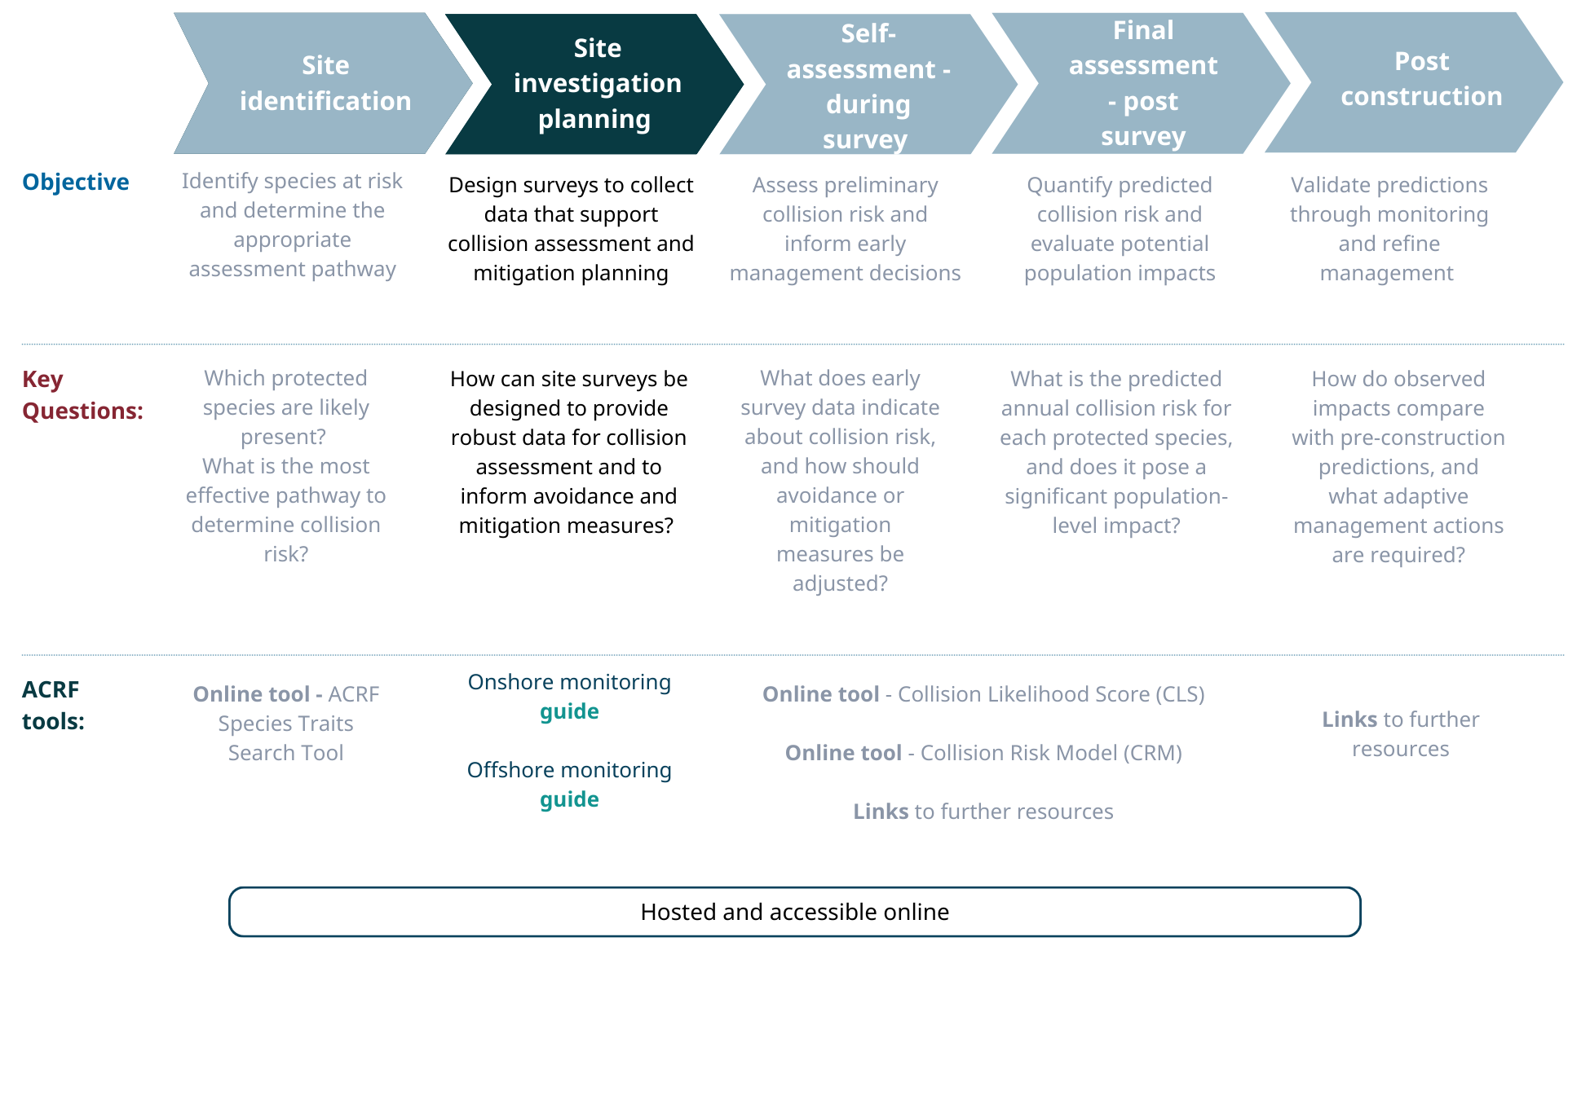Context
Site investigation planning translates the preliminary collision risk assessment into a targeted and proportionate survey program. Early selection of the appropriate assessment pathway is critical, as different methods require specific data types and collection approaches.
This stage results in a detailed survey design that efficiently generates the data required to support the chosen assessment method, while also identifying early opportunities for collision risk avoidance and mitigation.

Objective and scope
Key questions: How can site data collection be optimised to generate the information required for the selected collision risk assessment pathway and to inform avoidance and mitigation measures?
Spatial scope: Site and immediate surroundings
Key activities:
- Confirm the appropriate collision risk assessment pathway.
- Design a comprehensive and proportionate survey program aligned with assessment requirements.
- Apply relevant guidance and checklists to determine optimal survey placement, methodology, duration, and timing.
Relationship to the EPBC Act assessment process: Pre-referral stage and preparation of referral documentation under the EPBC Act.

Activities

Identify collision assessment pathway
If the initial site identification stage indicates the presence of sensitive species at risk of collision, it may be valuable to consult a collision risk expert at this stage to review options and optimise the study design. Several guiding principles can help determine the most appropriate collision assessment approach for a given site:
- Quantitative (Collision Risk Model - CRM): Applied when sufficient data exist from site surveys and existing literature to generate numerical inputs with quantifiable uncertainty.
- Qualitative (Collision Likelihood Score - CLS): Applied where data limitations prevent robust numerical modelling (for example, when no technology can robustly count microbat flights at rotor swept height). A qualitative assessment can still provide evidence-based evaluation of collision risk.
Of the risk criteria shown in Figure 1 (Exposure to turbine airspace, duration of exposure, species’ ability to avoid turbines) the factor that most strongly influences overall collision numbers is the rate and density of flights on-site. This is also generally the most technically challenging metric to measure accurately. Figure 4 presents a decision tree to guide the selection of the appropriate collision assessment pathway based on available data.
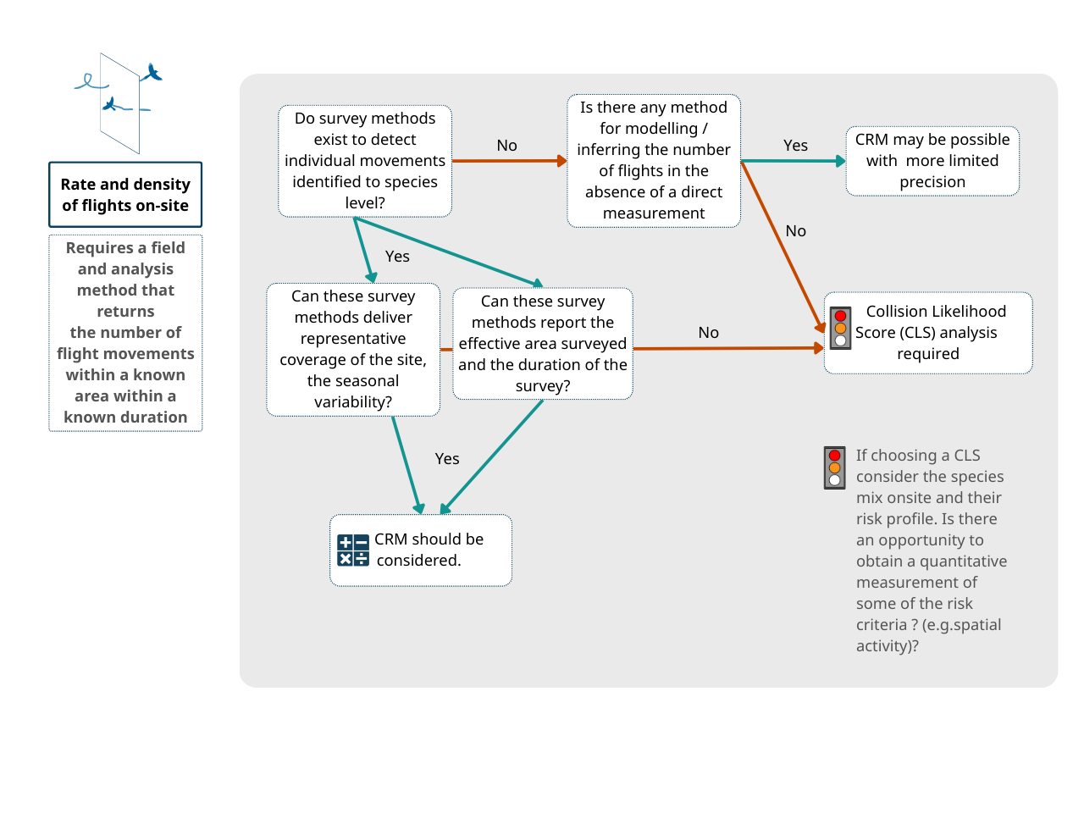Figure 4: Decision tree for choosing a collision assessment pathway

Explaining Figure 4: Examples
- Insectivorous bats - No field technology currently exists that can record individual flights at the species level. Acoustic recorders can identify species but cannot track individual flight paths, while thermal cameras and radar can observe flight paths but cannot identify species. Without additional research or development (which may be undertaken depending on site and species sensitivity), it is not possible to predict the number of collisions.
  - Although a final quantitative prediction is not possible, acoustic surveys can provide useful information for some components. For example, detectors placed along vegetation gradients can indicate relative bat activity near habitat features, informing buffer design. This requires careful consideration of the species mix and site-specific habitat.
- Diurnal birds – Most species can be observed using standard visual methods, allowing collision risk modelling.
  - For very rare or cryptic species, it may still be impossible to quantify flight activity with sufficient precision to support a CRM. This can only be determined after a field survey program, which will inform whether a quantitative (CRM) or qualitative (CLS) assessment is appropriate.

Survey program design
The decision tree above is the first step in understanding if CRM is feasible for a given species and site. The final survey program should consider the availability of existing literature, and feasibility of collecting site-based data to inform the measurement of each of the required risk metrics. Table 1 provides recommended evidence required for each of the collision risk categories.
Survey program design should consider the evidence requirements and the ability to collect them, including consideration of available technologies, site accessibility, existing information sources and the broader ecological data collection requirements for impact assessment.
Table 1: Example data inputs that are suitable as evidence for each of the collision risk categories
Risk category | Risk metric | Qualitative (CRM) inputs | Qualitative (CLS) inputs
Exposure of flight to turbine airspace when species is onsite | Rate and density of flights on-site | Measurement of Movements per area in a fixed time via formal surveys with the ability to  - Observe individual movements  - Species-level identification of bird / bat | Presence / absence of species in multi-season site survey  Historical and regional records  Species distribution maps
 | Distribution of flight heights | Direct site measurement of flight heights  Literature values flight height distributions | Literature values for flight height classes  Foraging strategy (e.g. canopy, open air)
 | Spatial use patterns within site | Direct flight path recording  Flight activity within different habitats (to inform spatial models)  Other model based on ecological assumption (e.g. ‘flat’ distribution of activity, or activity centred on keystone feature) | Quality and extent of suitable habitat onsite  Distance to keystone features (e.g. roost sites, nest sites)
Duration of exposure | Daily activity | Site-based records  Literature values | Species activity type (diurnal, nocturnal etc)
Duration of exposure | Seasonal patterns | Site-based records representative of the whole period of on-site activity | Recorded seasonal activity from public observation repositories
Ability and propensity to evade collision | Species morphology and manoeuvrability | Literature values, particularly length and flight speed | Existence of similar species in post-construction fatality data
Ability and propensity to evade collision | Behavioural avoidance behaviour | Existing literature values for avoidance rates for similar species.

Checklist
The outputs of this stage should include:
- Clear documentation of the reasoning for a chosen collision assessment pathway
- Survey program design documentation including consideration of the risk categories and criteria, and
  - explanation on which survey method(s) selected
  - reasoning of which risk categories/metrics are possible with said method/s
- Development of a data and analysis plan to ensure the data collected is suitable for generating required metrics.
- Consider engaging with Commonwealth and/or State regulatory agencies at this early stage to ensure the program is in line with any other requirements
- Consider review of the program design and data analysis plan to identify issues and limitations early.

Resources and further information

Guidance information
The related Onshore Survey Guide (Thompson et al. 2026b) and Offshore Survey Guidance (Thompson et al. 2026a) provide more information on the ability of different technologies to collect the evidence required for predicting collisions. Refer to these to review and select appropriate data collection methods.

Tools
Onshore monitoring guide is a short reference document and checklist for proponents and consultants designing site-based studies for land-based wind farm sites.
Offshore monitoring guide is a short reference document and checklist for proponents and consultants designing site-based studies for offshore-based wind farm sites.

Stage 3: Self-assessment (during surveys)

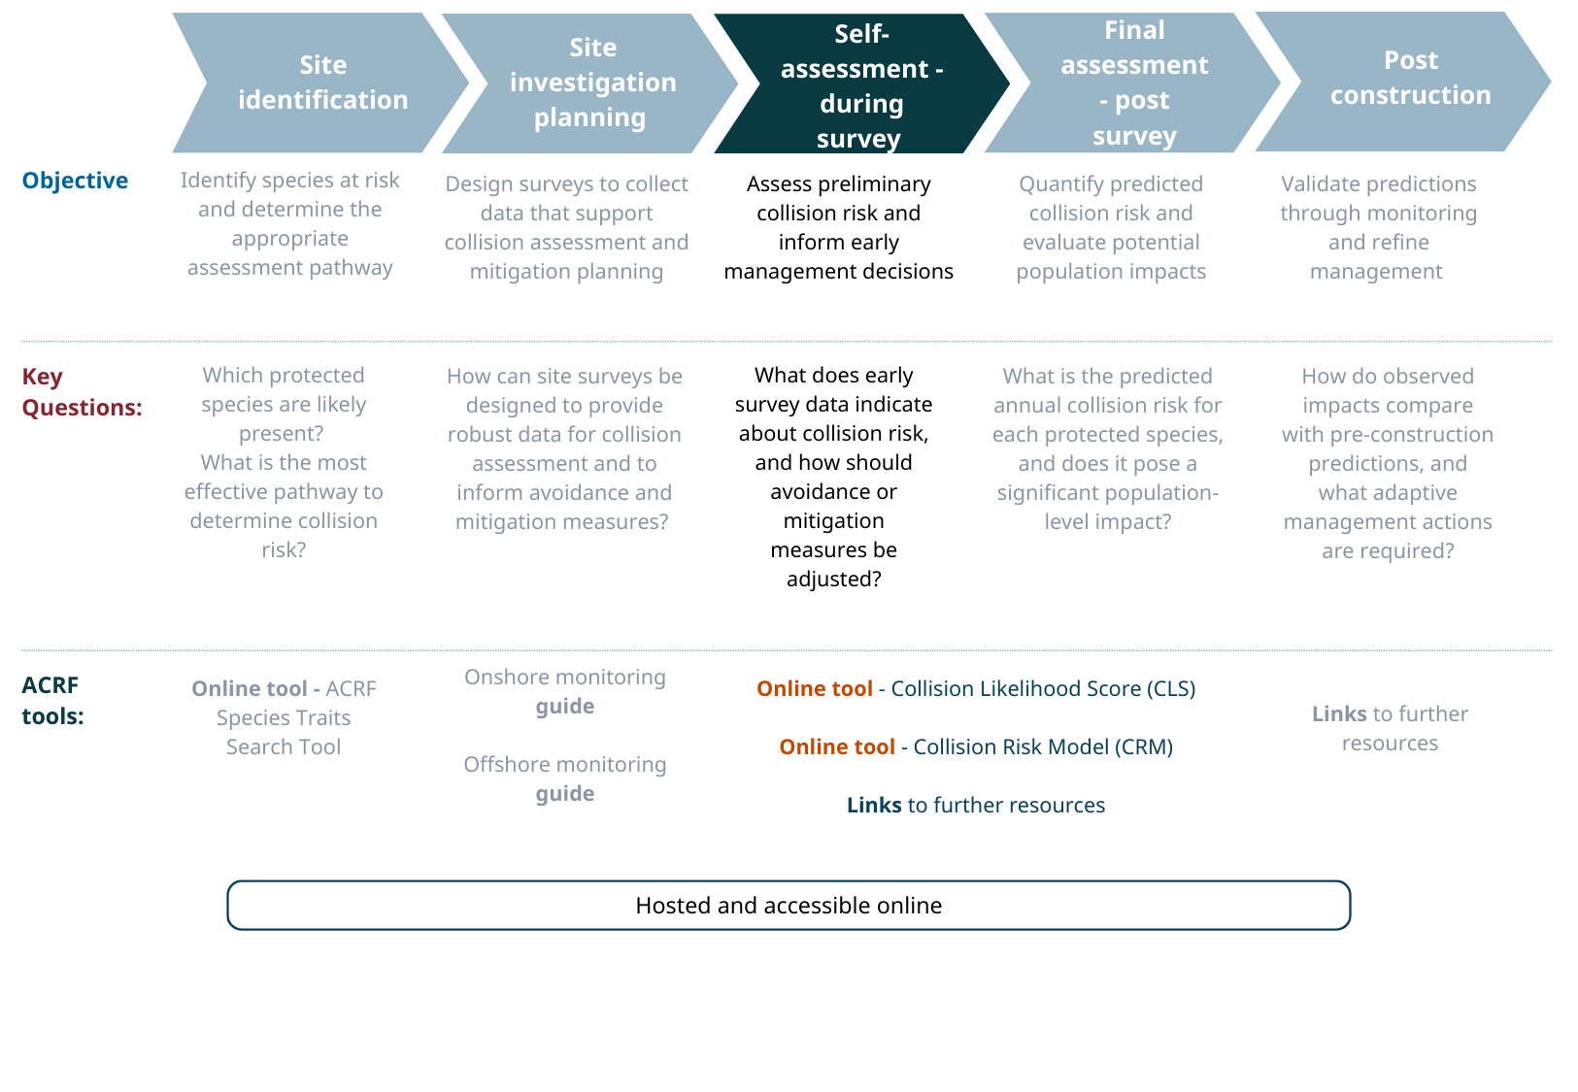

Context
At this stage of project development, detailed on-site studies and initial environmental impact assessments are typically underway. EPBC Act referral preparation, finalisation of turbine layouts, and landowner agreements may also be in progress. At this stage of the ACRF the primary objective is to obtain an early evaluation of collision likelihood and identify specific risk criteria (e.g. spatial patterns) that require avoidance or mitigation.
The ACRF's self-assessment tools generate qualitative or semi-quantitative estimates of collision likelihood, highlighting spatial and temporal risk patterns. Early use of these tools enables proactive risk management through adaptive project planning, rather than documenting impacts after designs are finalised.
Early collision likelihood assessment is critical because it transforms survey data into actionable risk information while project design remains flexible. Identification of spatial or temporal risk hotspots can guide turbine placement, layout adjustments, or operational mitigation strategies before infrastructure commitments are made. This approach supports the mitigation hierarchy by prioritising avoidance and minimisation over offsetting unavoidable impacts.

Objective and scope
Key questions: What does the emerging data indicate about collision risk, and how can this information inform project design and mitigation strategies? Are there remaining data gaps that must be addressed before finalising the site investigations?
Spatial scope: Site and immediate surroundings
Key activities:
- Conduct a preliminary qualitative or semi-quantitative collision likelihood assessment.
- Review the selected collision risk assessment pathway and refine the survey program if needed based on emerging data.
- Draft an adaptive management strategy to monitor and minimise collision risk post-construction.
Relationship to the EPBC Act assessment process: Supports referral preparation and contributes to the referral decision under the EPBC Act.

Activities

Preliminary collision likelihood prediction
The ACRF provides web-based self-assessment tools to support both qualitative and quantitative collision risk evaluation:
- Collision Likelihood Score Tool
- Collision Risk Model Self Assessment Tool

These tools have been peer reviewed and are designed to provide general self-assessed collision estimates. The notes below offer an overview but please refer to the Tool webpage for further scientific information and detailed user guides.

Collision Likelihood Score (CLS)
The ACRF provides an interactive, multi-criteria tool that generates consistent ‘scores’ for each risk criterion. In this way species and sites can be compared and structured information is available on the key risk drivers (spatial, height, temporal) to use when planning site management. The methodology was developed in response to a review of Australian practices (Stark and Thompson 2026), where qualitative approaches varied widely and no standard method existed. Recent risk frameworks are more suited for regional assessment, and include both likelihood and species sensitivity (Reid and Baker 2025b; 2025a; BirdLife International and BirdLife Australia 2025).
The tool applies the following formula:
SpeciesRiskLikelihood = [(A/3) × H] + D + C
Where
- A = Species observations + Habitat amount + Keystone features
- H = Flight height
- D = Duration of exposure
- C = Propensity to evade collision
Scores for each metric are assigned on a scale of one to five, with dropdown selectors to document supporting evidence.

Collision Risk Model (CRM)
The ACRF includes a self-assessment tool based on a simplified version of the recently developed and peer reviewed {collision} package (Stark et al. 2026). This CRM is built upon the same risk categories and criteria used throughout the ACRF.
The web tool (version 1) is based on point count (onshore visual counts) and line transect (boat and aerial) inputs. Inputs include:
- Encounter rate (bird movements per hour observed)
- Effective detection radius (radius surveyed, ideally estimated using distance sampling analysis (Buckland et al. 2001) OR Effective strip width (width surveyed, ideally estimated using distance sampling analysis (Buckland et al. 2001)
- Mean flight height and proportion of flight distribution below, and at rotor swept height
- Species-specific data
  - Body length
  - Flight speed
  - Proportion of day active
  - Proportion of year active
  - Estimated avoidance rate
- Turbine specifications - tower and rotor dimensions
- Inputs can be entered as ranges, either mean and standard error, or an estimate of the minimum, maximum and mean value. The web tool returns an estimate of the annual collision rate for the site.
The full {collision} R package supports per-turbine (spatial) modelling and alternative time frames. The {collision} package is open-source (GPL-3 licence). The ACRF website provides a simplified version of the CRM without spatial modelling and assuming standard statistical distributions for key inputs. We recommend use of the ACRF CRM tool for early self-assessment. For complex risk environments we recommend a site-specific CRM model be run using the {collision} package or one of the alternatives below.

Hybrid analysis
In many cases some information can be sourced via survey, but other inputs require qualitative assessment. In this case it may be possible to use the quantitative CRM tool but with larger input ranges (reflecting uncertainty) or with some inputs sourced via qualitative methods (e.g. expert elicitation). This will be less certain than quantitative CRM but still support scenario modelling and risk management.
Alternatively, the qualitative assessment might be used for the overall site risk rating, but some criteria might be analysed through quantitative modelling because of the importance of these criteria to overall collision risk.
For example, above-canopy insectivorous bat species are often recorded within and on the edges of vegetation patches. Although CRM is not currently possible for these bats, you might undertake a targeted acoustic study, placing recorders on a gradient from vegetation to inform turbine free buffers. This could be input into a quantitative analysis of the spatial site used to quantify, in turn, the relative change in collision likelihood from turbine micro-siting. An overall risk assessment would then be done using the CLS tool. The complete risk assessment would be informed by the combination of qualitative (CLS) and quantitative (spatial gradient modelling) analysis.

Alternative collision risk model options
The CRM tool provided within the ACRF website is suitable for self-assessments and/or collision risk assessments in less sensitive risk settings (e.g. if the overall likelihood and sensitivity of collision is low then a larger statistical error on the CRM is less likely to change the overall risk assessment outcome.
However, in more sensitive assessments, and/or where there are specific complexities (e.g. seasonal or spatial patterns) it is advised to consider applying a more complete and flexible CRM by directly using one of the open-source, peer reviewed packages available.
Following a review of current practice in Australia and existing models we recommend one of the following for ensuring analysis follows peer-review methods and current best practices.
These options are recommended as they relate to the most common field methods used in Australia and are broadly applicable to a range of species. Other bespoke models that rely on specific species information or specialist data collection (Goyert et al. 2024; New et al. 2015) are not generally suggested.

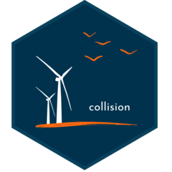 | An open-source R package designed for onshore and offshore use. The {collision} R package builds on the physical models from (Smales et al. 2013) but extends these to develop a model that incorporates input uncertainty (i.e. a stochastic model) and also provides a per-turbine collision risk, allowing for analysts to incorporate spatial modelling to derive risks for turbines and groups of turbines.  A simplified (non-spatial) version of the {collision} CRM is provided in the ACRF resources as a web app.
 | The {stochLAB} R package (Caneco et al. 2022) is an adaptation of the R code developed by (Masden Elizabeth 2015) which, in itself, was an adaptation to incorporate variability in the avian collision risk model developed by (Band 2012). Specifically designed for use by marine ornithologists in the UK offshore wind industry, the package itself relies on generic inputs that can be applied for other marine environments.
Other options | https://www.collisionrisk.org/ is the website of the international collision risk model working group. It provides up to date advice and resources for collision risk modelling best practice.

Review and refine survey program
Review the outputs of the initial collision risk assessment and evaluate the precision and reliability of the results. Consider whether the current level of certainty is sufficient to inform an assessment of potential significant impacts from collision, and whether this is likely to be achieved by completion of the planned data collection.
If the results are unlikely to provide adequate confidence, consider additional measures to reduce uncertainty. These may include supplementary data collection, expanded analytical approaches, formal expert elicitation, or data pooling with other comparable sites.

Checklist
At the end of this stage there should be a clear understanding and initial estimate of the collision likelihood for the proposed wind farm. This includes:
- Validation of the selected collision assessment pathway, including:
  - a review of the precision and reliability of interim qualitative or quantitative outputs, and
  - identification of any additional data required to support referral or assessment.
- Interim collision likelihood estimates or qualitative risk scores, presented by species.
- Preliminary assessment of potential impacts on regional populations, informed by the collision likelihood assessment outputs.
- Spatial risk mapping (where relevant), identifying areas of high activity or vulnerability for species expected to exhibit spatial risk patterns.
- Documented assessment methodology, including a clear statement of assumptions, uncertainties, and data limitations.

Resources and further information

Tools
ACRF Species Traits Search Tool – An interactive database providing standardised collision risk trait data for EPBC Act-listed, migratory, and marine flyover species. Users can search by species name to access morphological data (for CRM inputs), flight behaviour characteristics, and temporal activity patterns. The tool also identifies known information gaps.
Collision Likelihood Score (CLS) Tool - A web app for conducting qualitative collision likelihood assessments, providing users with an interactive tool to evaluate potential collision risks based on standardised criteria. Note this tool is designed for use after sufficient site-based data is collected but may be informative at an early stage to explore possible outcomes prior to survey design.
- CLS methodology document presents the theoretical foundations and structure of the CLS. This document also includes three case studies covering terrestrial and marine birds, and echolocating bats.
- CLS Tool User Guide is a step-by-step guide to using the CLS online tool.
Collision Risk Model (CRM) Self Assessment - A simplified, non-spatial, self-assessment tool for quantitative collision risk modelling. The app is based on an open source, peer reviewed R package for more modelling flexibility.
- CRM Tool User Guide is a step-by-step guide to using the CRM self-assessment online tool.
- For more information on the methodology, code and use of the model underpinning the CRM Tool, see the github repository.

Third party resources
- https://www.collisionrisk.org/ Home page of the international collision risk model working group
- The {stochLAB} R package is the most up-to-date implementation of the frequently used stochastic 'Band' Model (Band 2012; Madsen 2015 and was specifically designed for use by marine ornithologists in the UK offshore wind industry, the package itself relies on generic inputs that can be applied for other marine environments.

Stage 4: Final assessment
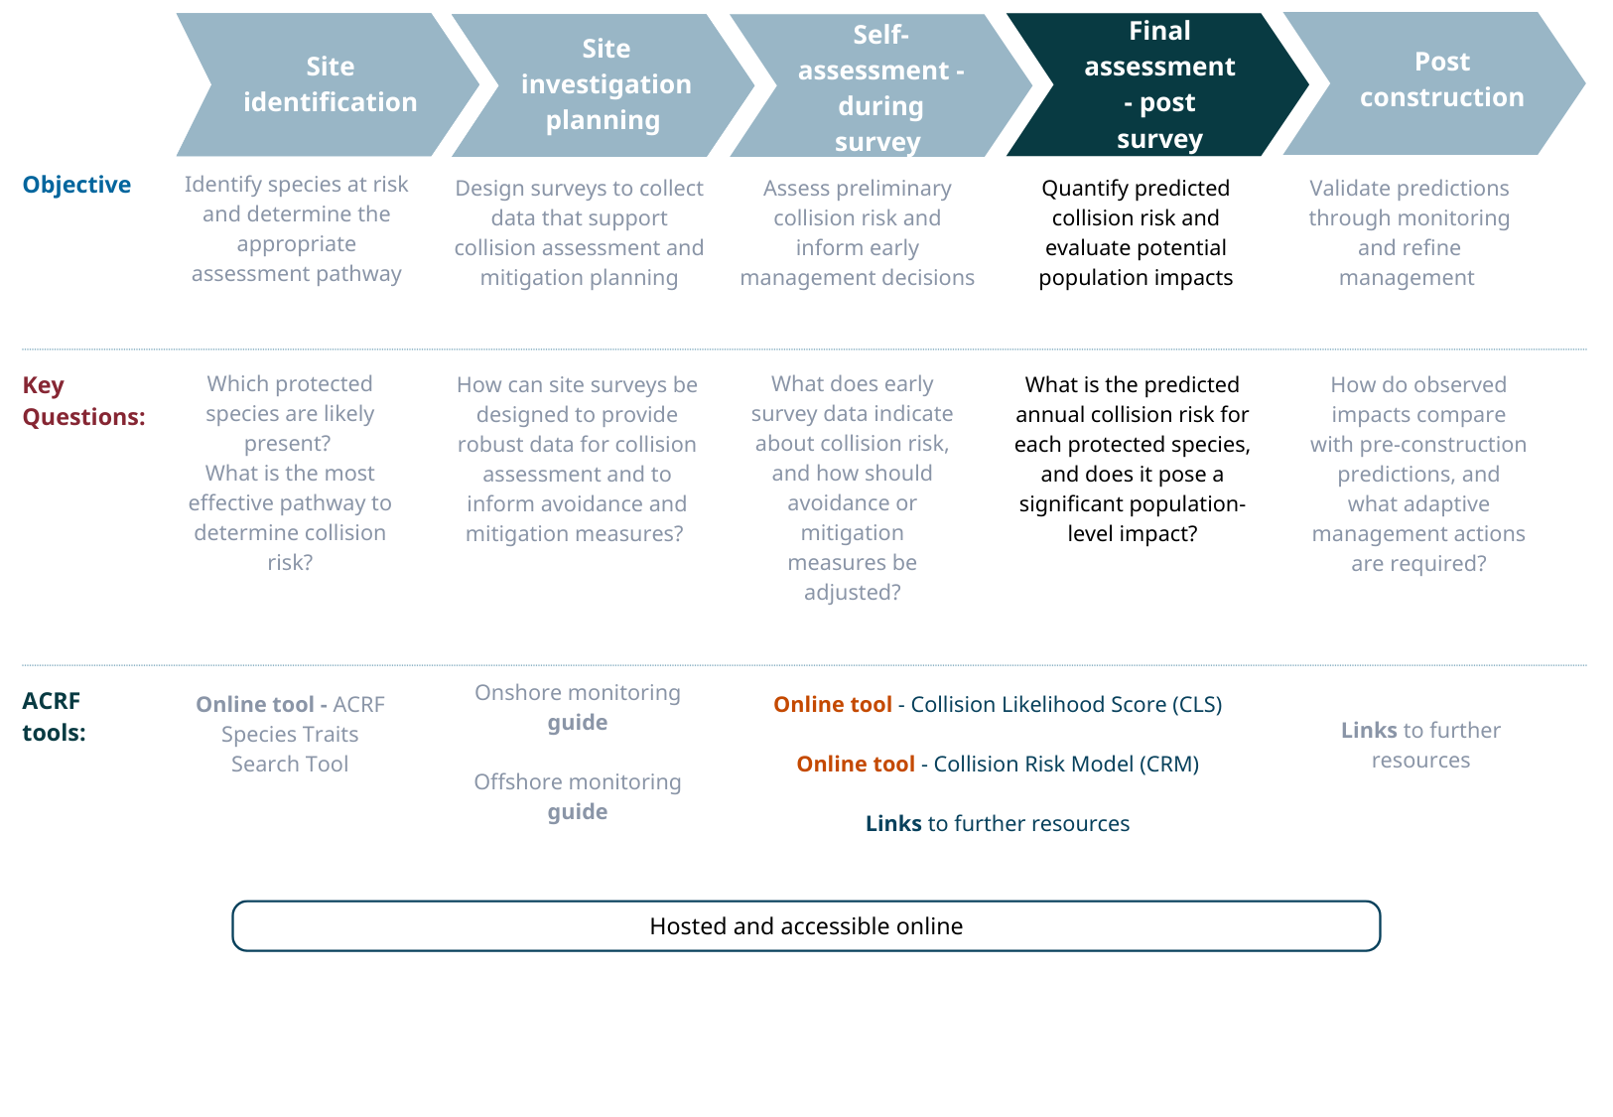

Context
At this stage, final assessment documentation is being prepared for the Commonwealth and/or State regulators. For less complex proposals, this may involve preparation of referral documentation.
The ACRF Final assessment provides the comprehensive collision risk analysis required to support regulatory decision-making. It synthesises the complete survey dataset into robust and transparent predictions, enabling evaluation of potential significant impacts and informing final project decisions.
ACRF Stage 4 consolidates the information and analysis undertaken in previous stages to finalise the population impact assessment. Decisions made throughout project development to avoid and minimise collision risk should be clearly documented and communicated, consistent with the risk categories and criteria established in Stage 1. Survey data collected in Stage 2, and project refinements informed by the preliminary collision assessment in Stage 3 (including turbine siting, curtailment options, and other mitigation measures), are integrated into the final assessment.

Objective and scope
Key questions: What is the predicted collision risk for the project as designed, and are the proposed avoidance, mitigation, and management measures sufficient to address potential significant impacts?
Spatial scope: Site and immediate surroundings (and any broader area relevant to population-level impact assessment).

Key activities:
- Finalise the collision risk assessment using the complete survey dataset and confirmed project design.
- Assess population-level impacts, incorporating avoidance, minimisation, and operational mitigation measures.
- Integrate collision risk findings into the broader environmental impact assessment and development application.
- Document results, assumptions, uncertainties, and supporting evidence using consistent and standardised risk terminology.
Relationship to the EPBC Act assessment process: Referral/Assessment stage (e.g. Preliminary Documentation, Public Environment Report (PER), or Environmental Impact Statement (EIS)).

Activities
At this stage, the collision likelihood assessment provides the definitive evaluation of potential significant impacts that informs regulatory approval decisions and the setting of conditions. The assessment must be robust, transparent, and capable of independent review, with clear documentation of methodology, data quality, assumptions, uncertainty, and the manner in which predictions have informed avoidance and mitigation measures. Regulatory confidence in the assessment directly influences approval timelines and conditions.

Finalise collision risk assessment
Refer to Stage 3 for detailed information on the available tools for predicting collisions and alternative modelling options.

Overall environmental impact assessment
Predicted collision numbers (or qualitative collision risk scores) must be considered in the context of potential impacts on the regional population of each Matter of National Environmental Significance identified as at risk of turbine collision.
While detailed population impact assessment is beyond the scope of the ACRF, proponents should refer to relevant population viability analyses and broader research initiatives that address species-specific population dynamics and cumulative impacts.

Document evidence base
For each documented collision prediction, the assessment report should include a tabulated summary of the collision risk criteria applied, the evidence used to inform each criterion, and any targeted or supplementary studies undertaken (e.g. spatial analyses, roost dispersal surveys, or species-specific investigations).
The ACRF web tools provide downloadable reports summarising model inputs and outputs. These summaries should be incorporated into the assessment documentation together with detailed descriptions of survey and analytic methods (e.g. distance sampling, field observation protocols, statistical modelling approaches).
Transparent reporting of model inputs, assumptions, uncertainty ranges, and outputs supports independent review, facilitates assessment of cumulative impacts over time, and strengthens regulatory confidence in the evidence base underpinning the impact assessment.

Checklist
The outputs of this stage should include:
- Final species-specific prediction of residual collision risk, incorporating all avoidance and minimisation measures.
- Documented uncertainty ranges for quantitative models, or structured and transparent risk characterisations for qualitative assessments.
- Tabulated model inputs, evidence sources, references, and methodological descriptions, aligned with each risk criterion identified in Figure 1 and Table 1.
- A final impact assessment, integrating collision likelihood and consequence to determine overall population-level impact.

Resources and further information
See Stage3: Resources and further information

Stage 5: Post-construction
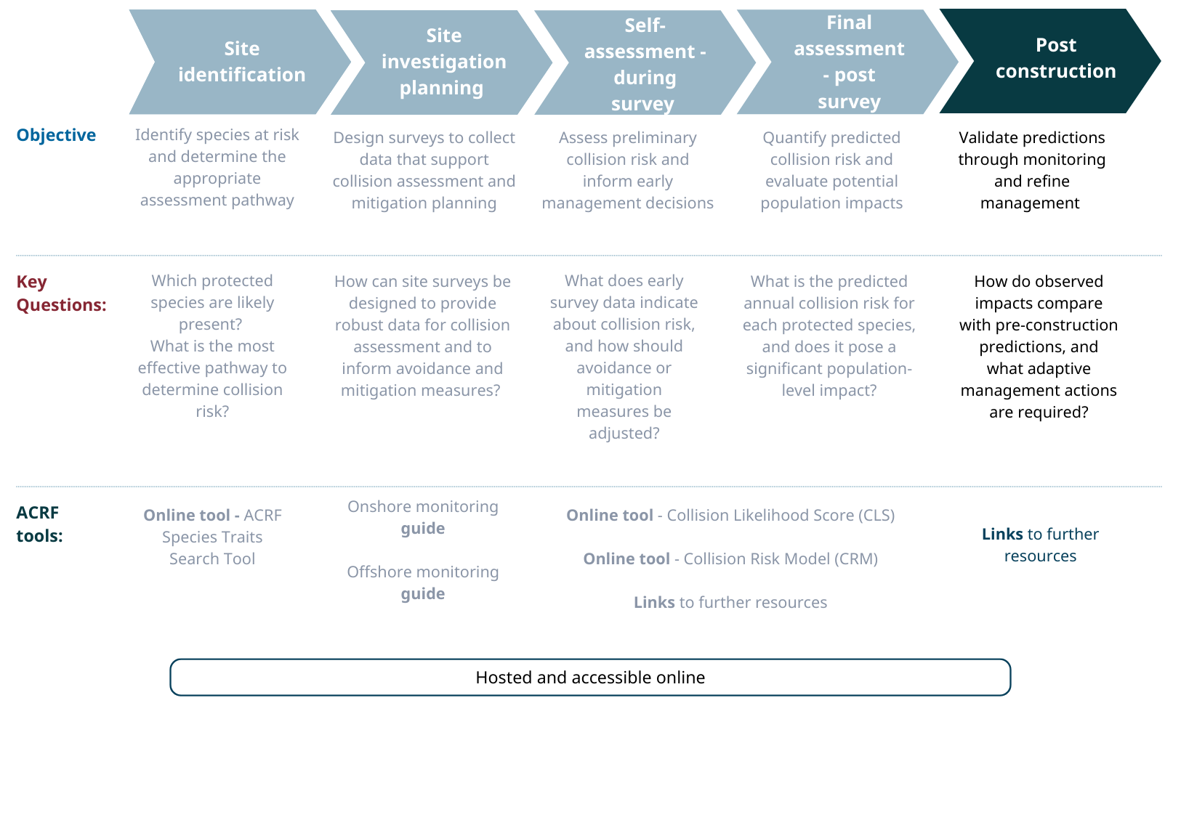

Context
Post-construction application of collision risk prediction using CRM or CLS is not required.
However, post-construction fatality monitoring, including systematic carcass searches and corrected mortality estimates, validates pre-construction collision predictions. It also demonstrates compliance with approval conditions and supports adaptive management if impacts exceed expectations.
This stage provides guidance on best practice monitoring protocols and validation methods. These allow actual collision rates to be compared with predictions, highlight whether mitigation measures need adjustment, and contribute empirical data to improve future assessments.
By closing the feedback loop between prediction and observation, post-construction monitoring ensures that collision risk assessment remains evidence-based and continuously improves over time.

Objective and scope
Key questions: Are actual collision rates consistent with predictions? Are avoidance and mitigation measures effectively minimising impacts?
Spatial scope: Project site
Key activities:
- Implement post-construction fatality monitoring in accordance with the approved management plan.
- Compare observed collision rates with pre-construction predictions to validate models and inform adaptive management.
Relationship to the EPBC Act assessment process: post-approval compliance, monitoring, and adaptive management.

Activities
Post-construction monitoring validates pre-construction collision predictions, tracks actual impacts, and informs adaptive management responses where required. This stage closes the feedback loop, improving prediction accuracy for future assessments and ensuring compliance with approval conditions.
The exact activities required at this stage will be dependent on the Project’s Approval Conditions as synthesised into the Bird and Bat Management Plan (BBMP).
For onshore wind farms, post-construction fatality monitoring is typically required during the first few years of operation to ensure that the actual collision rates align with pre-construction predictions. BBMPs should include a summary of the pre-construction collision risk assessment, including predicted likelihood and consequence, as well as CRM outputs or qualitative CLSs. This information should guide adaptive management triggers within the BBMP. Annual environmental reporting should compare observed mortalities by species with the pre-construction collision predictions.
In some cases, such as offshore wind projects or inaccessible locations, effective post-construction fatality monitoring may be impractical. In these situations, alternative studies can be conducted to increase confidence in specific collision risk criteria. Examples include targeted camera studies to observe bird and bat behaviour near turbines, or GPS tracking to better understand migration routes and flight heights.

Checklist
The annual outcomes of operational monitoring are:
- Annual reporting that compares post-construction mortality rates (where available) with pre- construction collision risk predictions.
- Targeted studies addressing key collision risk criteria or remaining data gaps. In remote or inaccessible sites, these studies may provide greater long-term benefit than direct fatality monitoring.

References

Band, Bill. 2012. Using a Collision Risk Model to Assess Bird Collision Risks for Offshore Windfarms. Prepared for The Crown Estate as part of the Strategic Ornithological Support Services programme, project SOSS02. https://www.bto.org/sites/default/files/u28/downloads/Projects/Final_Report_SOSS02_Band1ModelGuidance.pdf.
BirdLife International and BirdLife Australia. 2025. Avistep Australia: Calculating Sensitivity of Seabirds to Collision with Offshore Wind Energy Development. https://avistep.birdlife.org/.
Buckland, S., D. Anderson, K. Burnham, J. Laake, D. Borchers, and L. Thomas. 2001. Introduction to Distance Sampling: Estimating Abundance of Biological Populations. In Oxford University Press, vol. xv. https://doi.org/10.1093/oso/9780198506492.001.0001.
Caneco, Bruno, Grant R. W. Humphries, Aonghais Cook, and Elizabeth Masden. 2022. “Estimating Bird Collisions at Offshore Windfarms with {stochLAB}.” https://marinescotlandscience.github.io/stochLAB/.
Cook, Aonghai., Eldina Salkanovic, Elizabeth Masden, Hsiu Eik Lee, and Alexander Holm Kiilerich. 2025. “A Critical Appraisal of 40 Years of Avian Collision Risk Modelling: How Have We Got Here and Where Do We Go Next?” Environmental Impact Assessment Review 110 (January): 107717. https://doi.org/10.1016/j.eiar.2024.107717.
Goyert, Holly, Evan Adams, Andrew Gilbert, et al. 2024. SCRAM 2: Transparent Modeling of Collision Risk for Three Federally Listed Bird Species in Relation to Offshore Wind Energy Development. Report No.: BOEM 2024-057. U.S. Department of the Interior, Bureau of Ocean Energy Management. https://espis.boem.gov/Final%20Reports/BOEM_2024-057.pdf.
International Organization for Standardization. 2018. “Risk Management — Guidelines (ISO 31000:2018).” ISO. https://www.iso.org/standard/65694.html.
Masden Elizabeth. 2015. Developing an Avian Collision Risk Model to Incorporate Variability and Uncertainty: Scottish Marine and Freshwater Science Vol 6 No 14. https://doi.org/10.7489/1659-1.
New, Leslie, Emily Bjerre, Brian Millsap, Mark C. Otto, and Michael C. Runge. 2015. “A Collision Risk Model to Predict Avian Fatalities at Wind Facilities: An Example Using Golden Eagles, Aquila Chrysaetos.” PLOS ONE 10 (7): e0130978. https://doi.org/10.1371/journal.pone.0130978.
Reid, Keith, and G Barry Baker. 2025a. Impacts on Birds and Bats from Onshore Wind Farms in Australia: An Ecological Risk Assessment. Department of Climate Change, Energy, the Environment and Water.
Reid, Keith, and G Barry Baker. 2025b. Impacts on Birds from Offshore Wind Farms in Australia: An Ecological Risk Assessment. Department of Climate Change, Energy, the Environment and Water.
Smales, Ian. 2017. “Modelling Collision Risk and Populations.” In Wildlife and Wind Farms, Onshore: Monitoring and Mitigation, edited by Martin Perrow, vol. 2. Conservation Handbooks. Pelagic Publishing. https://doi.org/10.2307/jj.29010219.
Smales, Ian, Stuart Muir, Charles Meredith, and Robert Baird. 2013. “A Description of the Biosis Model to Assess Risk of Bird Collisions with Wind Turbines.” Wildlife Society Bulletin 37 (1): 59–65. https://doi.org/10.1002/wsb.257.
Stark, Elizabeth, Stuart Muir, and Peggy Yandell (2026). collision: Per-turbine stochastic Collision Risk Model for predicting avian collision with onshore and offshore wind turbines. R package. version 1.0.4, <https://github.com/SymbolixAU/collision>.
Stark, Elizabeth, and Eliza Thompson. 2026. “Australian Collision Risk Framework: Review of current practice and species data. Department of Climate Change, Energy, the Environment and Water, Canberra, 2026. CC BY 4.0.
Thompson, Eliza, Ashley Potter, and Elizabeth Stark. 2026a. “Australian Collision Risk Framework: Offshore Survey Guide.” Department of Climate Change, Energy, the Environment and Climate Action.
Thompson, Eliza, Ashley Potter, and Elizabeth Stark. 2026b. “Australian Collision Risk Framework: Onshore Survey Guide.” Department of Climate Change, Energy, the Environment and Climate Action.

