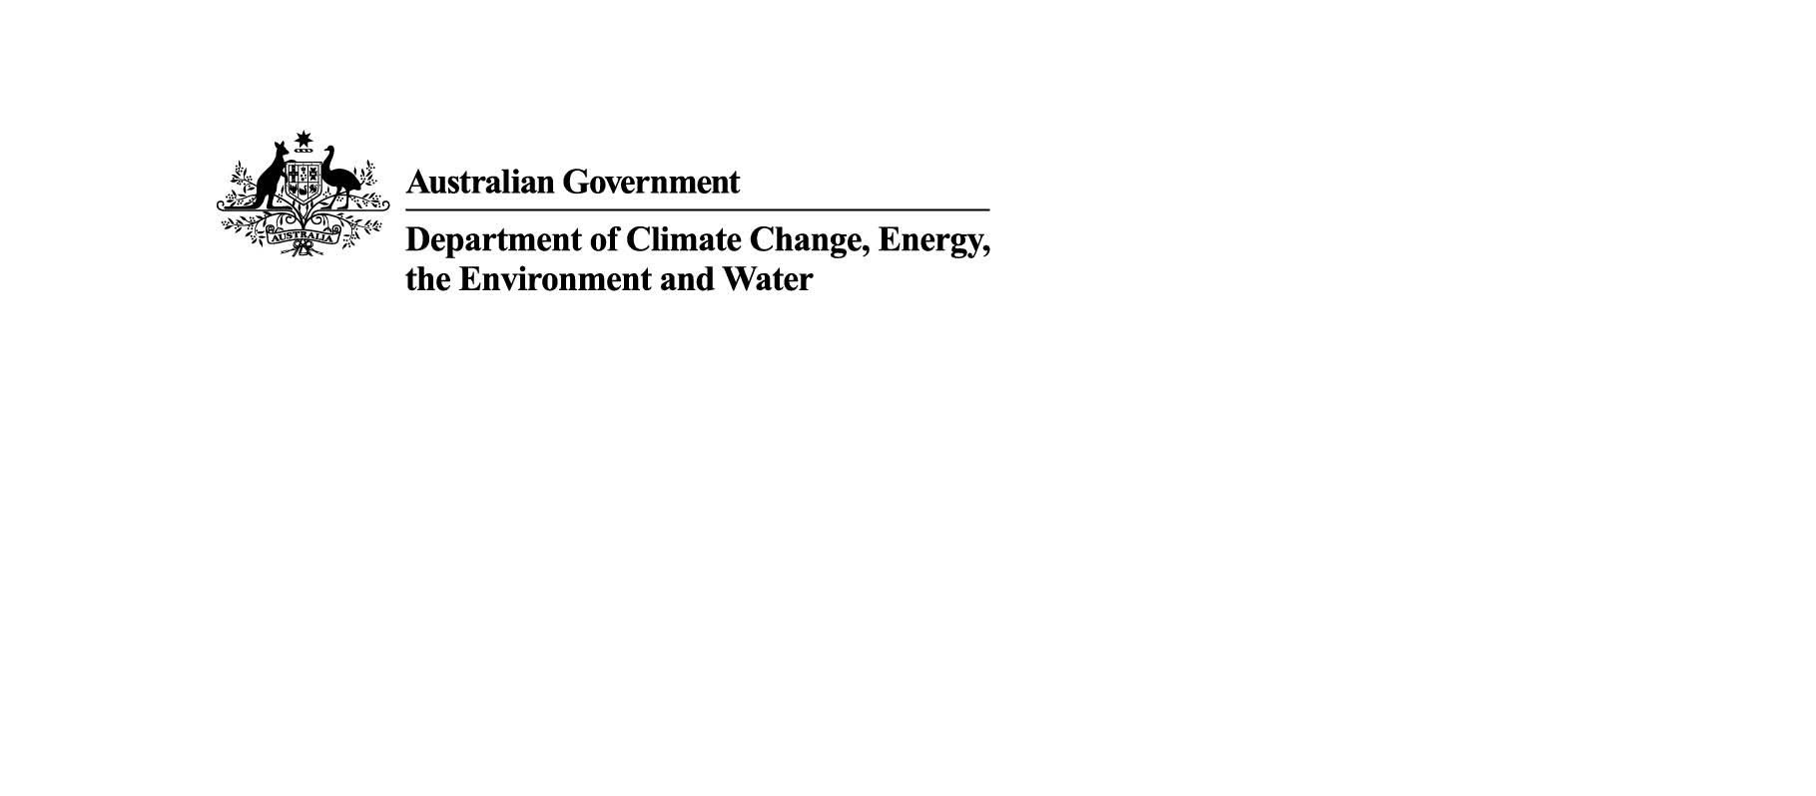
Environment Protection Reforms: Setting up for success
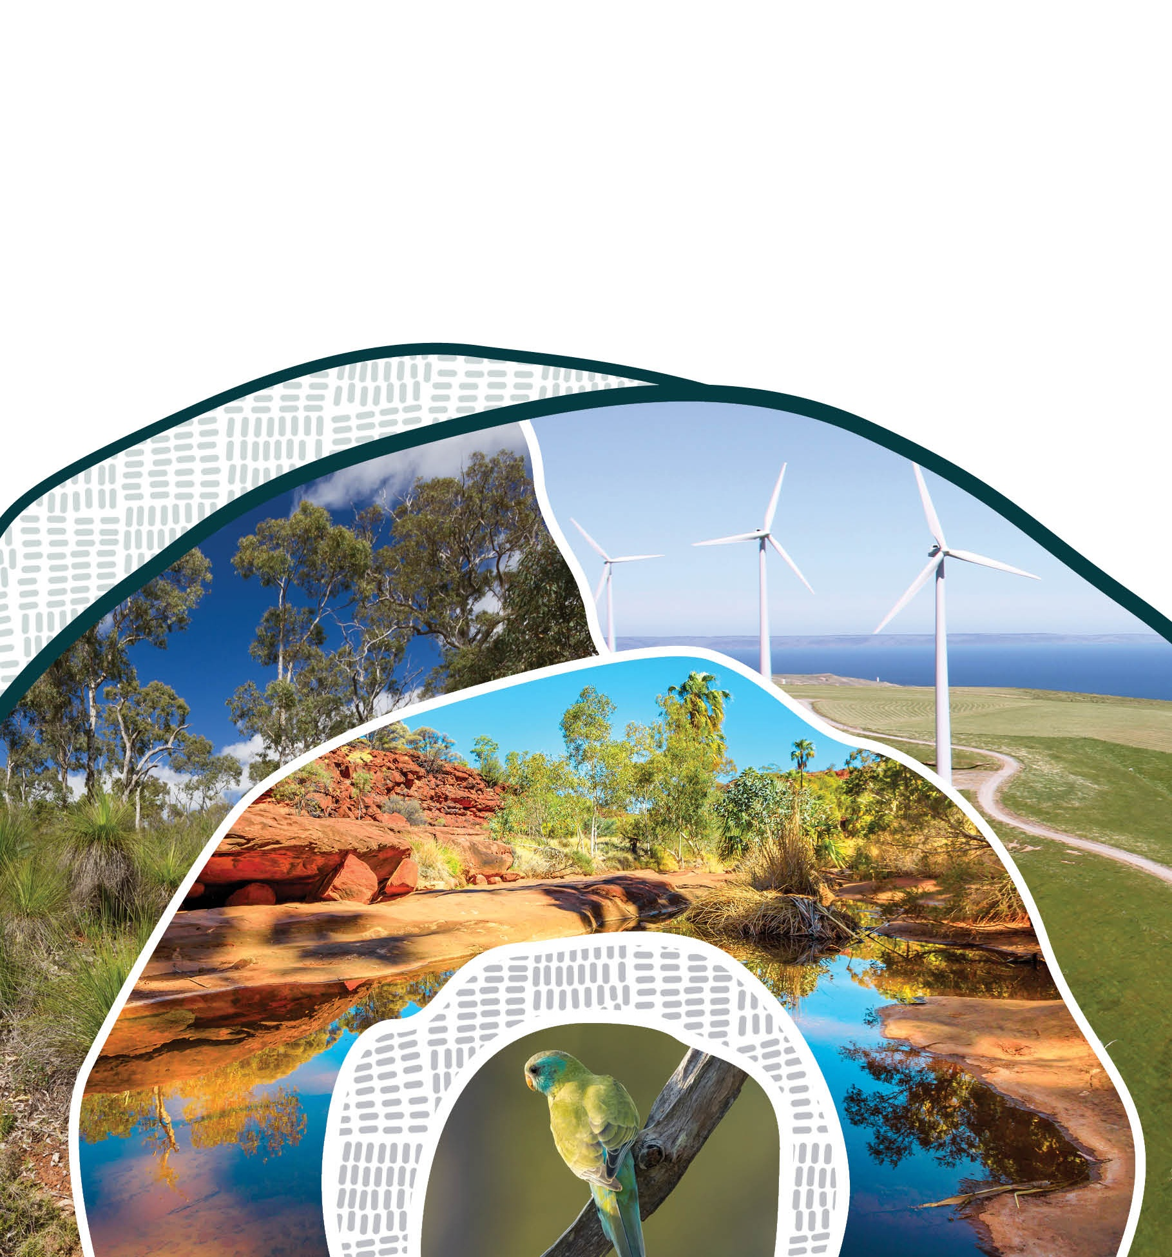
Overview
May 2026
© Commonwealth of Australia 2026
Ownership of intellectual property rights
Unless otherwise noted, copyright (and any other intellectual property rights) in this publication is owned by the Commonwealth of Australia (referred to as the Commonwealth).
Creative Commons licence
All material in this publication is licensed under a Creative Commons Attribution 4.0 International Licence except content supplied by third parties, logos and the Commonwealth Coat of Arms.
Inquiries about the licence and any use of this document should be submitted via our online contact form.

Cataloguing data
This publication (and any material sourced from it) should be attributed as: DCCEEW 2026, Environment Protection Reforms Consultation Paper: Tranche 2 Overview, Department of Climate Change, Energy, the Environment and Water, Canberra, February. CC BY 4.0.
This publication is available at https://consult.dcceew.gov.au/environment-protection-reform-consultation-subordinate-legislation
Department of Climate Change, Energy, the Environment and Water
GPO Box 3090 Canberra ACT 2601
Telephone 1800 920 528
Web dcceew.gov.au
Disclaimer
The Australian Government acting through the Department of Climate Change, Energy, the Environment and Water has exercised due care and skill in preparing and compiling the information and data in this publication. Notwithstanding, the Department of Climate Change, Energy, the Environment and Water, its employees and advisers disclaim all liability, including liability for negligence and for any loss, damage, injury, expense or cost incurred by any person as a result of accessing, using or relying on any of the information or data in this publication to the maximum extent permitted by law.
Acknowledgement of Country
We acknowledge the Traditional Owners of Country throughout Australia and recognise their continuing connection to land, waters and culture. We pay our respects to their Elders past and present.

Contents
1 Introduction 4
2 Environment Protection Reforms 4
3 Stages of implementation 5
3.1 Laying the foundations for the reforms and transition (from 1 December 2025) 6
3.2 More flexible, transparent processes and certainty (February 2026) 6
3.3 Setting up for success (1 July 2026) 7
3.4 National Environmental Standards made to guide decision-making 8
3.5 Faster, simpler assessments and approvals (by 1 December 2026) 9
4 Next steps 9
Attachment A: Items to be proclaimed on 1 July 2026 11

Introduction
The department is consulting on the settings for the next stage of supporting laws under Australia’s environment protection reforms.
This stage includes legislation that is needed to set up for a successful transition to the new environment protection regime. It is discussed across four consultation papers:
Overview
The environment protection reforms are commencing in stages. We are consulting on the reforms that are proposed to commence from 1 July 2026.
Consultation Paper 1: A smooth transition to the National EPA
The National EPA starts on 1 July 2026. We are consulting on supporting regulations and rules, and early commencement of new powers, to support its effective operation.
Consultation Paper 2: More certainty for projects and environment protection
The new laws passed in November 2025 include changes to give more certainty to projects about how the laws apply. We are proposing to bring forward the start date of some provisions to 1 July 2026, and to set out some extra details in regulations to support this.
Consultation Paper 3: Reducing duplication
The reforms make it easier for the Minister to recognise state, territory and Commonwealth regulators where their processes meet EPBC Act requirements. They also set new environmental tests. We are proposing to bring forward the start date of these changes to 1 July 2026 along with supporting regulations.
This consultation covers new or updated Rules, Regulations and commencement of reforms passed in 2025 that we propose would come into effect on 1 July 2026 under the three components above.

Environment Protection Reforms
The Australian Government is implementing major reforms that strengthen national environmental protection and modernise how environmental laws are administered. The Australian Government’s Environment Protection Reform Bills were passed by the Australian Parliament on Friday 28 November 2025.
These reforms respond to the overall decline of the natural environment, support important national priorities like renewable energy, housing and critical minerals, and aim to rebuild the trust of the Australian community.
Once fully implemented, the reforms will deliver:
- stronger environmental protection and restoration
- more efficient and robust project assessments
- greater accountability and transparency in decision making.
The reform package includes:
- changes to the Environment Protection and Biodiversity Conservation Act 1999 (EPBC Act) and consequential changes to other environmental laws and frameworks such as the Airports Act 1996, Offshore Petroleum and Greenhouse Gas Storage Act 2006 and Nature Repair Act 2023 required to implement the reforms
- the National Environmental Protection Agency Act 2025 to establish an independent National EPA
- the Environment Information Australia Act 2025 to establish a new Statutory Office – the Head of Environment Information Australia (EIA)
- four new Charging Imposition Acts, and
- transitional arrangements required to prevent disruption to existing operations when the reformed laws come into effect.
Some parts of the new laws have already commenced, while others will continue to be rolled out in stages. To put these new laws into practice, we need to make Rules and Regulations that provide further detail and operationalise the changes. The Government can also proclaim an earlier start to some parts of the new laws, that otherwise would not come into effect until 1 December 2026.
Alongside the legislative reforms, the department is getting all the arrangements in place to support transition to the reformed regulatory system. This includes updating guidance material, systems and training on national environmental laws, and establishing the new governance arrangements for the National EPA and EIA. In addition, work on bioregional plans continues and discussions are underway with States and Territories to further streamline decision-making under the new laws.

Stages of implementation
The Environment Protection Reforms are being rolled out in stages. This allows proponents and the Government to prepare for new arrangements and for consultation on detailed settings. This will help to ensure there is a smooth transition to reforms which deliver outcomes for the environment and industry.
- Laying the foundations for the reforms and transition (commenced on Royal Assent – 1 December 2025)
- More flexible, transparent processes and certainty (February 2026)
- Setting up for success (1 July 2026)
This is the focus of this consultation paper, which includes:
  - Establishing the new National EPA
  - More certainty for projects and environment protection
  - Reducing duplication
- National Environmental Standards made to guide decision-making (from mid-2026)
- Faster, simpler assessments and approvals (by 1 December 2026)

Laying the foundations for the reforms and transition (from 1 December 2025)
The first reforms commenced on 1 December 2026 when the Bills received Royal Assent from the Governor-General.
They lay important foundations for the reforms and ensure a smooth transition, including:
- the power for the Minister to make National Environmental Standards
- tightening ‘continuing use’ exemptions to clarify when actions must be assessed and remove the risk of a spike in land clearing activity in the lead-up to commencement of the majority of the reforms
- power for the Minister to make Rules to apply any transitional arrangements.

More flexible, transparent processes and certainty (February 2026)
These reforms were brought forward to commence on 20 February 2026. They did not require any subordinate legislation to implement or changes in proponent behaviour, so could be done quickly.
Some of these make decision-making processes by the Minister more flexible, transparent and informed by expert advice, including:
- the power for the Minister to make a national interest exemption without an action being referred, and to impose conditions on a national interest exemption
- expanding the role of the Indigenous Advisory Committee to include providing the Minister with advice on threatened species listing and National Environmental Standards.
Others increase flexibility and certainty for proponents, including:
- allowing proponents to withdraw outdated proposals and surrender unused approvals
- allowing proponents to request variations to strategic assessments, or to surrender, revoke or reinstate a strategic assessment
- reducing legal uncertainty for proponents by allowing them to request reconsideration of a ‘Not Controlled Action – Particular Manner’ (NCA-PM) decision.

Setting up for success (1 July 2026)
This will establish the National EPA as an independent regulator responsible for enforcing national environmental laws. The statutory head of EIA will also commence on 1 July 2026.
The National EPA Act will commence operation on 1 July 2026 with a Chief Executive Officer (CEO) appointed to make compliance, enforcement, permit and licensing decisions, and to provide advice and assurance, including over bilateral agreements and regional plans under the EPBC Act. These regulatory decision-making powers and functions are vested in the CEO by the reforms passed by Parliament in December 2025 in the Environment Protection Reform Act 2025 (EPR Act).
The National EPA will also have other regulatory powers and functions under delegation from the Minister for the Environment and the Secretary of the Department of Climate Change Energy, the Environment and Water (DCCEEW). These will include being lead decision-maker for referral, assessment and approval decisions under the EPBC Act from 1 July 2026, and an ongoing operational role in the administration of bilateral agreements with states and territories. The Minister will retain decisions on the making, variation, suspension, and revocation of accredited arrangements. These are prevented by law from being delegated.
We need to update existing regulations and rules to support the National EPA to operate effectively from day one. We are also proposing to start some other parts of the reforms early. This stage is the focus of this consultation paper. This stage will:
- enable a smooth transition to the National EPA, by commencing new compliance, enforcement and transparency arrangements and updating regulations and rules to match their new functions. Consultation Paper 1 covers new powers and penalties, new audit arrangements, rules to ensure transparency of National EPA decisions and compliance outcomes and consequential updates to rules and regulations to recognise the National EPA.
- provide more certainty for proponents and better environment protection by bringing forward commencement of Rulings, Protection Statements, and the Unacceptable Impact definition to support current negotiations for bilateral and accredited agreements. Consultation Paper 2 covers protection statements, rulings, definition of unacceptable impacts, minor or preparatory works, reconsiderations, lapsing not controlled actions, and other minor changes for Wildlife Trade, Ramsar, Heritage, Part 13, and Publishing Requirements.
- put arrangements in place so the Minister can recognise other regulation that delivers on requirements under the EPBC Act, to reduce duplication while maintaining environmental protections. Consultation Paper 3 covers bilateral agreements, Commonwealth accreditation, NOPSEMA declaration and greenhouse gas emission reporting.
Specific items in the Environment Protection Reform Act 2025 (EPR Act) that are proposed for early commencement on 1 July 2026 are listed in Attachment A.

National Environmental Standards made to guide decision-making
Standards are intended to provide clarity around how to meet the requirements for approval under the EPBC Act and ensure that important environmental outcomes are met.
Standards will apply to both individual projects and to accredited arrangements and landscape-scale approaches including:
- accredited arrangements with Commonwealth agencies such as the National Offshore Petroleum Safety and Environmental Management Authority (NOPSEMA)
- bilateral agreements with states and territories
- strategic assessments
- bioregional plans.
The first Standards made will be for:
- Matters of National Environmental Significance
- Environmental Offsets
- Community Engagement
- First Nations Engagement
- Data and Information.
While the first National Environmental Standards will be made as legislative instruments in mid-2026, they will not be applied to decision-making until the relevant provisions for individual projects, accredited arrangements or landscape-scale approaches commence.
This will provide proponents with enough lead time to understand how to comply with the Standards before they come into force.
It will also provide states and territories with an opportunity to understand the standards and determine how to apply them in their own jurisdictions, so that negotiations on bilateral agreements, strategic assessments or bioregional plans can proceed with more certainty.

Faster, simpler assessments and approvals (by 1 December 2026)
The remainder of the reforms will start by 1 December 2026. This is when proponents will have access to the new approval pathways and tests under the EPBC Act.
These are the most complex aspects of the reforms and require the most lead time to develop the supporting EPBC Regulations for consultation and develop guidance for implementation. They include:
- settings for streamlined assessment pathway and other assessment pathway improvements, strategic assessments and bioregional plans
- requirements that the Standards must be met for an action to be approved
- establishing the Restoration Contributions Holder scheme (RCH), so proponents can make restoration contributions to acquit their offset liability
- applying a ‘net gain’ test to ensure offsets more than compensate for any environmental damage that cannot be avoided, mitigated or repaired
- the power for the Minister to approve an action (excluding fossil fuel actions) that is in the national interest even if it does not meet the standards
We are working to bring forward commencement earlier than 1 December. This will give proponents earlier access to the assessment pathways and the key requirements for approval under the EPBC Act. We will consult on the detailed settings for these parts of the reforms later in 2026.
We are also working with states and territories and commonwealth entities to transition and improve streamlining arrangements, including bilateral agreements.

Next steps
The department is inviting feedback from stakeholders on the proposals in this consultation paper by 21 May 2026. We have included guiding questions within the Have Your Say platform. For the elements of the reform you are interested in, we would like to understand whether you support the proposals, support them in part, or do not support them. We would also welcome a summary of why you do or do not support the proposal, including any changes you would suggest.
Note that given the primary legislation (Acts) have passed the Parliament, we are not seeking feedback on the content of that primary legislation. Regulations and rules must align with that primary legislation.
The department will consider the feedback and consider whether to change the proposed arrangements. The Minister for the Environment will consider the draft Regulations, Rules and Proclamations that will implement these changes. There is a different process for making each type of instrument:
- Regulations: If the Minister and the Executive Council agrees to the amendments, the Governor General will make new or updated Regulation instruments that will take effect on 1 July 2026. These will be tabled in the Australian Parliament as a disallowable instrument.
- Rules: If the Minister agrees to the amendments, they will make the new or updated rule instruments that will take effect on 1 July 2026. These will be tabled in the Australian Parliament as a disallowable instrument.
Proclamation: If the Minister and the Executive Council agrees to the proclamation of the items in the EPR Act listed in Attachment A, the Governor General will proclaim the instrument that will take effect on 1 July 2026.

Attachment A: Items to be proclaimed on 1 July 2026
The following items of the Environment Protection Reform Act 2025 are proposed for early commencement on 1 July 2026:
- item 2A
- items 78 to 114
- items 115A to 115G
- items 116 to 152
- item 155
- items 158 to 160
- item 163
- items 165 to 169A
- items 174 to 177
- items 179 to 186
- item 188
- item 191 (to the extent it adds section 84A)
- item 195
- item 201
- item 216
- item 253
- item 294
- item 305
- item 323 (to the extent it inserts Division 1 of Part 12B)
- items 324 to 431
- item 446
- items 475 to 552
- items 567 and 568
- item 572
- items 585 and 586
- items 587A and 588
- item 589 (to the extent it inserts the definition of accredited)
- item 590
- item 591 (to the extent it inserts the definitions of alternate pathway, approved form, audited person and auditor)
- items 592 and 593
- item 596 (to the extent it inserts the definition of CEO’s environment law provision)
- item 604 (to the extent it inserts the definition of compliance audit)
- items 606 and 607
- item 608 (to the extent it inserts the definitions of designated environmental instrument and designated international agreement)
- items 609 to 611
- item 612 (to the extent it inserts the definitions of environmental exemption, environmental order, environment law provision, environment protection order, greenhouse gas and greenhouse gas emissions information)
- item 614 (to the extent it inserts the definitions of irreplaceable, management or authorisation framework, marine park order, marine park permission, NOPSEMA and NOPSEMA management or authorisation framework)
- item 616 (to the extent it inserts the definitions of passes the net gain test, protection statement, registered auditor, registered critical habitat, relevant person, residual significant impact, ROKAMBA, scope 1 greenhouse gas emission, scope 2 greenhouse gas emission and seriously impair);
- item 617
- item 618 (to the extent it inserts the definitions of subject to, unacceptable impacts and viability)
- items 628 to 635
- items 637A to 637C
- items 638 to 674.

