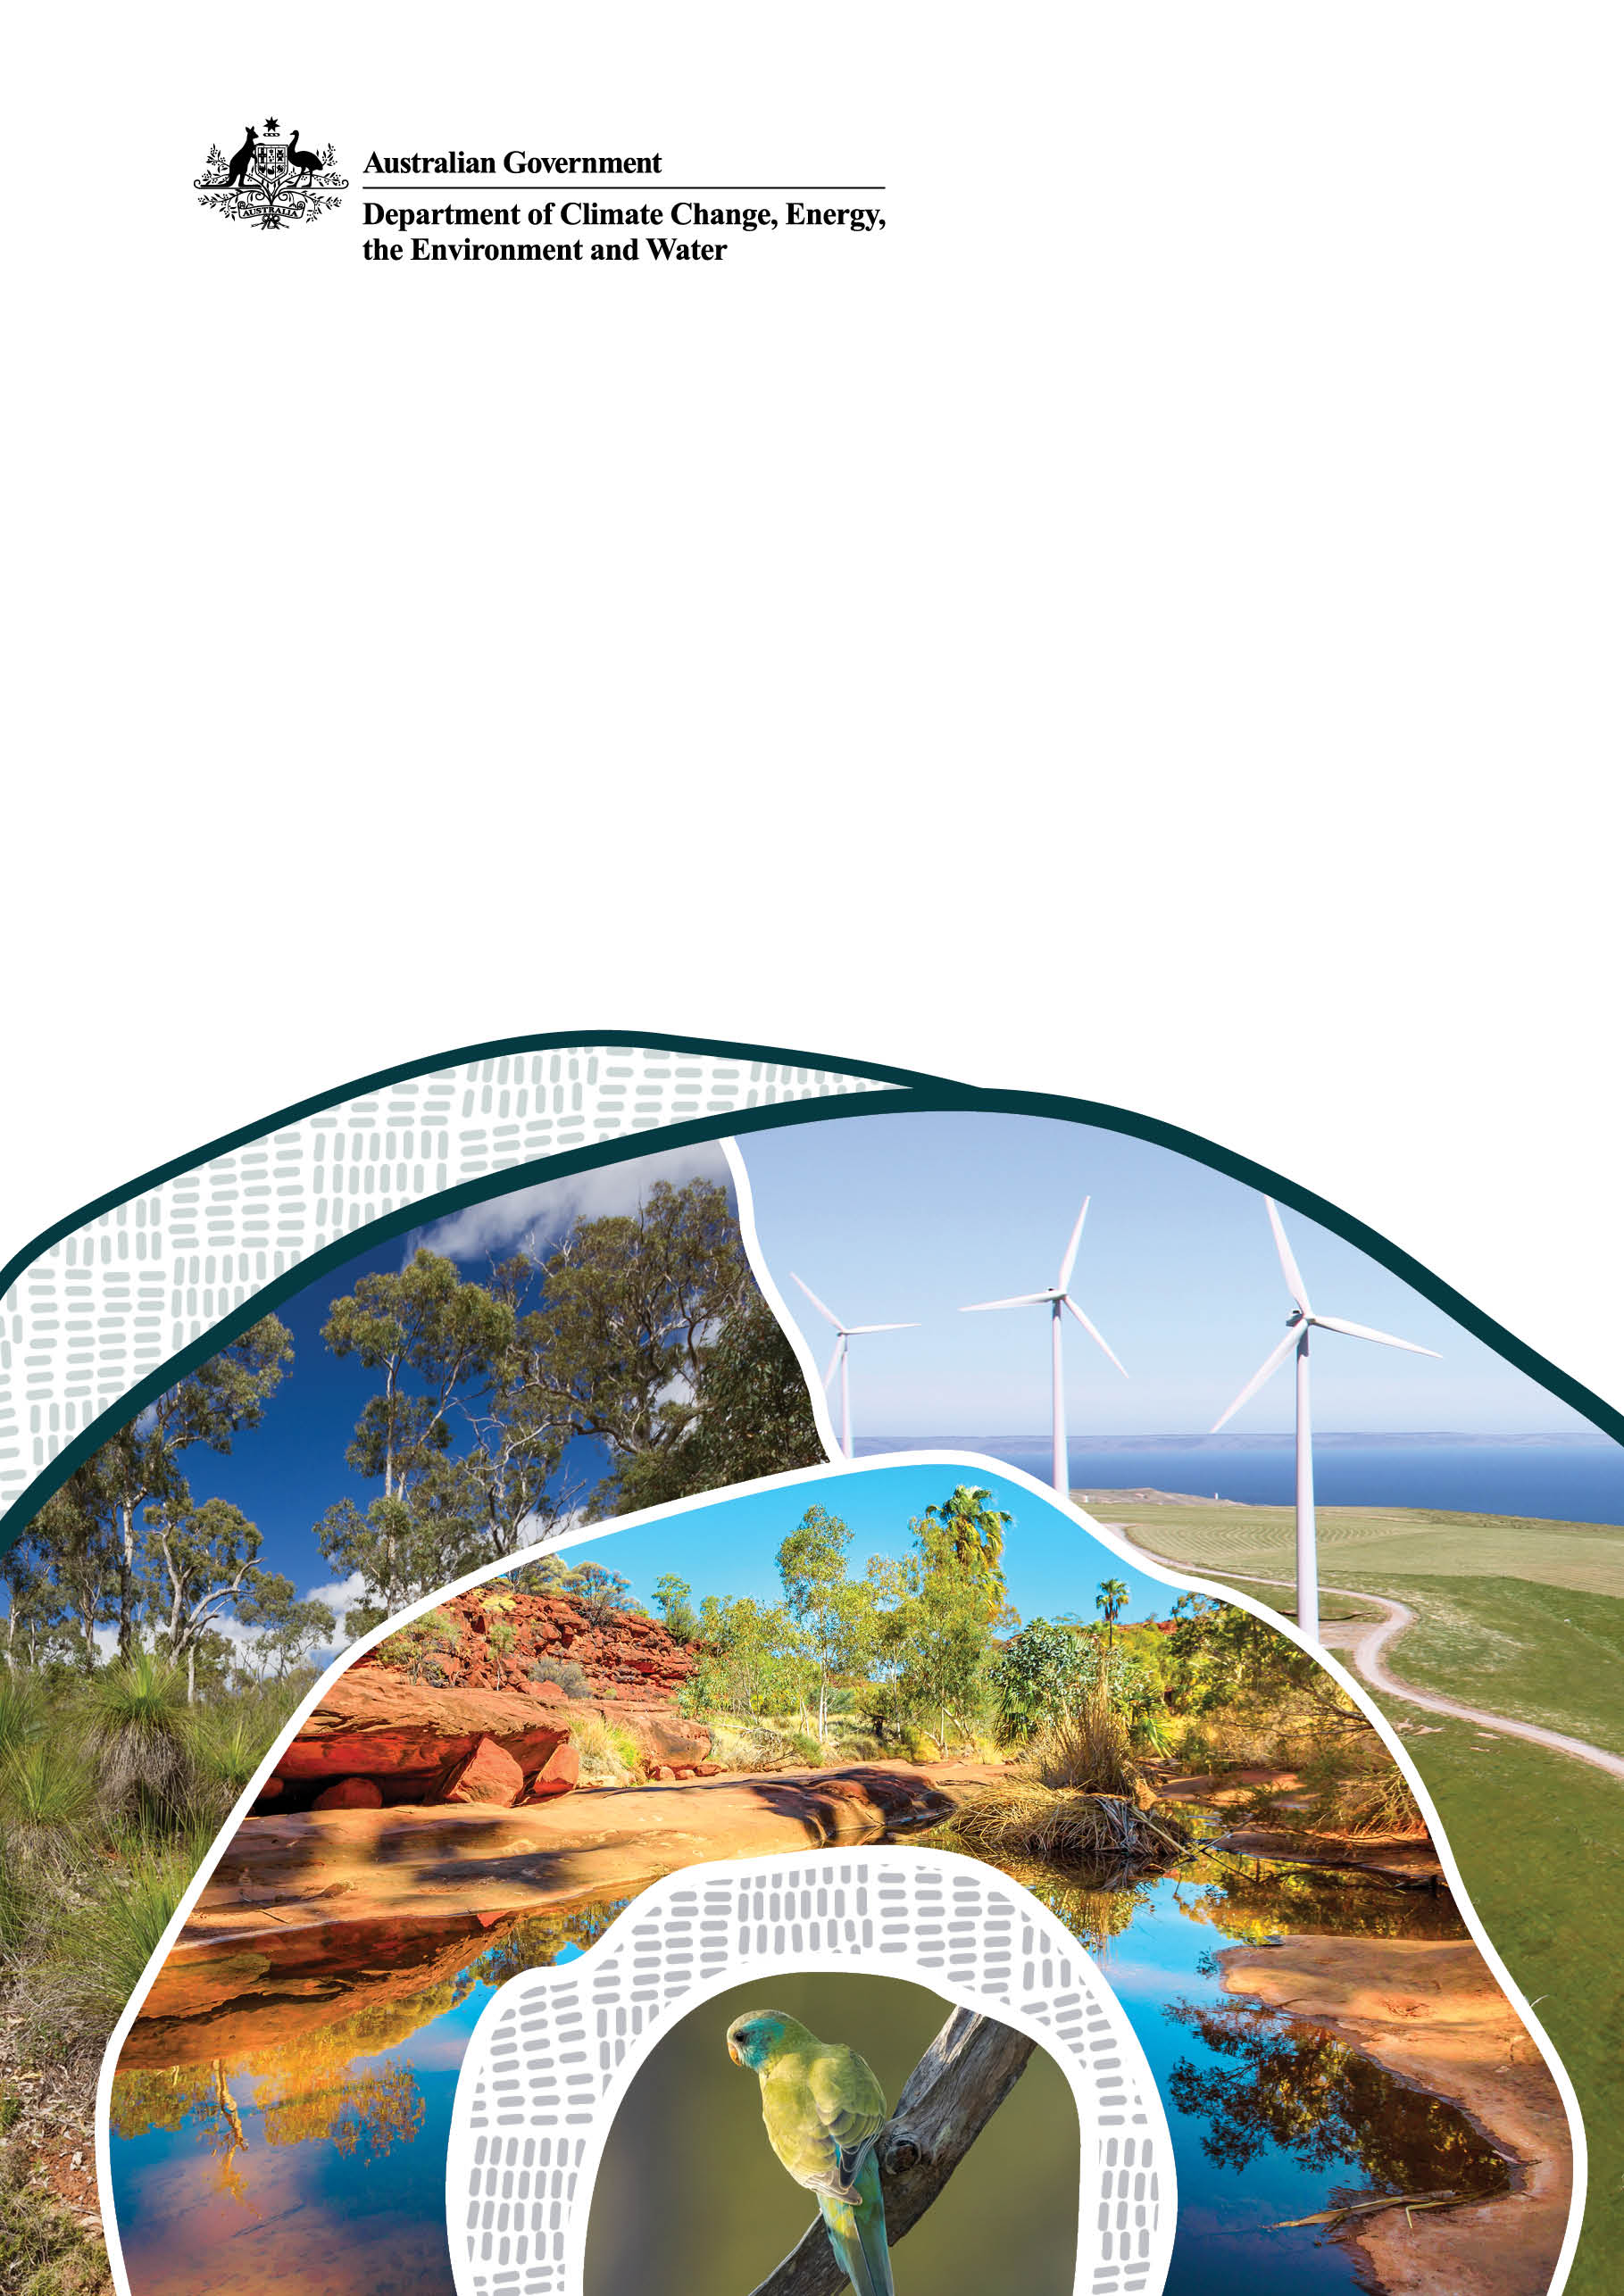
Consultation on the Climate Active program
July 2026
Consultation paper
Department of Climate Change, Energy, the Environment and Water (DCCEEW)
© Commonwealth of Australia 2026
Ownership of intellectual property rights
Unless otherwise noted, copyright (and any other intellectual property rights) in this publication is owned by the Commonwealth of Australia (referred to as the Commonwealth).
Creative Commons licence
All material in this publication is licensed under a Creative Commons Attribution 4.0 International Licence except content supplied by third parties, logos and the Commonwealth Coat of Arms.
Inquiries about the licence and any use of this document should be submitted via our online contact form.

Cataloguing data
This publication (and any material sourced from it) should be attributed as: DCCEEW 2026, Consultation on the Climate Active program, Department of Climate Change, Energy, the Environment and Water, Canberra, February. CC BY 4.0.
This publication is available at https://consult.dcceew.gov.au
Department of Climate Change, Energy, the Environment and Water
GPO Box 3090 Canberra ACT 2601
Telephone 1800 920 528
Web dcceew.gov.au
Disclaimer
The Australian Government acting through the Department of Climate Change, Energy, the Environment and Water has exercised due care and skill in preparing and compiling the information and data in this publication. Notwithstanding, the Department of Climate Change, Energy, the Environment and Water, its employees and advisers disclaim all liability, including liability for negligence and for any loss, damage, injury, expense or cost incurred by any person as a result of accessing, using or relying on any of the information or data in this publication to the maximum extent permitted by law.
Acknowledgement of Country
We acknowledge the Traditional Owners of Country throughout Australia and recognise their continuing connection to land, waters and culture. We pay our respects to their Elders past and present.

Executive summary
The Australian Government has made the decision to close the Climate Active program and cease voluntary certification of businesses’ climate claims through this program.
This decision responds to changes in government policy since Climate Active was established, including the evolution of mandatory climate-related disclosure regimes.
This discussion paper invites formal feedback on whether the government should either:
- Close the Climate Active program.
- Close the Climate Active program but the Department of Climate Change, Energy, the Environment and Water (the department) retain some voluntary standards and select guidance.
These options were developed following public consultation in 2023 and ongoing consultation with key Climate Active stakeholders including industry groups, Commonwealth agencies, state government agencies and non-government organisations.
The department is seeking to understand potential impacts on Climate Active participants and Australian businesses from these proposed changes.
Your feedback will help inform the final decision on the program and transitional arrangements to support Climate Active participants.
It is anticipated that a final decision on the program will be announced before the end of 2026.

How to make a submission
To have your say on the proposed path forward: read the consultation paper, take our survey and provide a written submission via the department’s Have Your Say platform. Emailed submissions cannot be accepted.
Please email the department at climate.active@dcceew.gov.au if you are unable to upload your submission.

Overview

Background to the Climate Active program
Since 2010, Climate Active (formerly the National Carbon Offset Standard) has helped set a benchmark in Australia’s voluntary carbon market. The program has provided standards for Australian entities to measure, reduce, offset and disclose their emissions. It has also certified entities that meet these standards. Certified entities have been able to use Climate Active trade marks to publicly promote their achievements.
The program has supported hundreds of organisations, products and services to understand and reduce their emissions. This includes net emissions reductions of over 25 million tonnes of CO2-e (carbon dioxide equivalent) (across scope 1, 2 and 3 emissions).
The program has also supported carbon projects and renewable electricity generation in Australia.
- Over 2.6 million Australian Carbon Credit Units (ACCUs), from over 60 projects, have been voluntarily surrendered by Climate Active participants.
- Almost 2 million large-scale generation certificates (LGCs), from over 160 renewable energy power stations, have been voluntarily surrendered by Climate Active participants.
- Climate Active participants (excluding building-related certifications) have purchased and surrendered more than 55.1 million carbon offsets to compensate for residual emissions since 2010.
In 2023, we consulted on proposed changes to the Climate Active program to help shape its future direction. The feedback informed consideration of the Climate Active program reforms, and we would like to thank all who made submissions.

The need for change
Climate Active’s operating context has changed significantly in recent years. Action on climate change by Australian businesses is now a core imperative. This is driven by increasingly sharp risks to profitability, growing public expectations for clear and accountable climate action, and a clear government response to reflect those significant changes and Australia’s commitment to internationally aligned emissions reduction.
Emissions reduction and climate-related disclosures by Australian businesses are increasingly driven by domestic legislation, community expectations, and international guidance. While many responsible entities in Australia wish to reduce their emissions, it is more appropriate for this progress to be guided by modernised legislative and regulatory frameworks, the government’s Net Zero Plan and associated sector plans, and domestic policies; with regulators responsible for monitoring and investigating climate and sustainability claims.

Energy and climate change reforms
The Australian Government is taking strong action on climate change, having delivered significant reforms and a Net Zero plan over the past 4 years.
- In 2022, the Australian Government legislated an emissions reduction target of 43% below 2005 levels by 2030 and net zero by 2050, representing a more than 60% improvement of the preceding 26–28% target.
- In 2023, the Australian Government reformed the Safeguard Mechanism to ensure that covered facilities contribute to meeting Australia's legislated targets.
- In September 2025, the Australian Government announced a 2035 emissions reduction target of 62–70% below 2005 levels. As part of the target, the government released a Net Zero Plan and 6 sector emissions reduction plans to outline the path to net zero across the economy.
- From 2025, the government also required large entities to undertake mandatory climate-related financial risk disclosures under changes to the Corporations Act 2001 (Cth). Small and medium-sized businesses often form part of larger companies' supply chains, and may be asked for information to assist the larger entity in meeting their reporting obligations.
The Australian Government has made the decision to close the Climate Active program and cease voluntary certification of businesses’ climate claims through this program.
This decision responds to changes in government policy since Climate Active was established, including the evolution of mandatory climate-related disclosure regimes.
The impact of reform and investment
- Australia’s emissions over the year to December 2025 dropped by 9.7 million tonnes. This represented a 2.1% reduction, one of the fastest rates outside of the COVID period.
- Australia continues to track well towards its target of 43% below 2005 levels by 2030 and has set out its Net Zero Plan to deliver on its 2035 and 2050 targets.
- Over 22 gigawatts of variable renewable generation capacity have been installed since May 2022, an increase of over 60%. In 2025, renewables made up nearly 43% of electricity generation across Australia’s 2 largest electricity grids and over 50% in the fourth quarter of 2025.
- Large and small-scale storage have expanded rapidly, with over 450,000 cheaper home batteries installed since 1 July 2025 delivering over 12 gigawatt hours of new capacity. The Capacity Investment Scheme and Rewiring the Nation are helping to deliver the large-scale generation and storage we need to decarbonise our grids.
- In April 2026, the Clean Energy Regulator (CER) released data from the reformed Safeguard Mechanism showing it is already working to reduce emissions, with onsite emissions down 5.8 million tonnes across the first 2 years and net emissions down 12.7%. Electric vehicles (EVs) have grown from less than 4 per cent of new light vehicle sales in 2022 to more than 20 per cent in the first four months of 2026, supported by our New Vehicle Efficiency Standards and Electric Car Discount.
- The Australian Government has recapitalised the Australian Renewable Energy Agency and Clean Energy Finance Corporation, and the Future Made in Australia agenda is ensuring Australia can capture the benefits of the global shift to net zero.

Addressing integrity concerns
The Australian Government is aware of concerns about the Climate Active program’s perceived integrity issues and recognises the rising expectations from stakeholders and communities.
- Australian businesses are increasingly implementing climate and sustainability programs and publicly communicating their actions to consumers and investors. In turn, there has been a rise in unclear and potentially misleading environmental marketing claims that has led the Australian Competition and Consumer Commission (ACCC) and the Australian Securities and Investments Commission (ASIC) to investigate sustainability claims as a compliance priority.
- The ACCC is currently scoping further guidance for businesses who wish to make emissions related claims. This builds upon guidance issued in 2023 which explains the obligations under the Australian Consumer Law that businesses must comply with when making environmental and sustainability claims.
- There is an increasing number of climate change litigation cases, both in Australia and internationally, including legal challenges against the marketing of ‘carbon neutral’ products.
  - Public support for the term ‘carbon neutral’ has declined, especially where entities mainly rely on carbon offsets rather than direct emissions reductions to support their ‘carbon neutral’ claims.
  - Public, investor and consumer expectations have shifted to prioritise direct emissions reduction from businesses that engage in voluntary climate action.
- International guidance on voluntary climate action has both expanded and matured and the current program settings of Climate Active are no longer in line with international best practice.

Ceasing certification
The Australian Government has made the decision to cease certification of voluntary climate claims through the Climate Active program.
This means that, through a properly managed transition, the department will discontinue:
- certification of organisations’ climate claims
- trade marks, including for Climate Active and its network
- use of the term ‘carbon neutral’ for voluntary claims
- the register of consultants.
The decision to move away from Climate Active voluntary certification recognises the strong progress the government has made over the past 4 years in rolling out climate change policies and programs that support decarbonisation across the economy.
It also considers the changing operating context of business decarbonisation, including:
- rising stakeholder expectations
- public demand for sustainable practices and direct decarbonisation
- shifting corporate priorities to address climate change
- reconsideration of the role for governments in supporting voluntary climate action
- the changed legislative and regulatory environment for disclosure and environmental and sustainability claims.

Certification of businesses’ voluntary climate claims will cease
In closing the Climate Active program, the department will support currently certified organisations through the transition away from certification over a 12- to 18-month period. Entities will have the option to seek certification under other schemes, including through international programs and government schemes.

Trade marks will be discontinued
After certification ends, entities will no longer be able to advertise their Climate Active certification or use the Climate Active trade mark or network member mark, as there will be no certification pathway against most of the standards.
Products manufactured and packaged with a printed Climate Active trade mark or network member mark prior to Climate Active ceasing certification can be sold until supplies are exhausted. They will not need to be repackaged or recalled.

Use of ‘carbon neutral’ will cease
Use of the term ‘carbon neutral’ for voluntary claims will cease. The department recognises that the term ‘carbon neutral’ has become increasingly contested. Community expectations and developments in international guidance point to a growing preference for language which emphasises direct emissions reduction. The ACCC will continue to investigate environmental and sustainability claims and take compliance or enforcement action when required.

The register of consultants will be discontinued
With the decision to cease certification, Climate Active will close the register of consultants who have assisted Climate Active participants to measure, reduce and offset their emissions. The government recognises the important role registered consultants have played in supporting Australian businesses with their sustainability reporting. But as certification winds down, there will no longer be a pathway that requires consultants to be formally registered.
Consultants may continue to help entities who choose to engage with preparing their carbon inventories and undertaking third-party verifications, either to support the mandatory climate related risk disclosure framework, or to meet the relevant requirements of international schemes. Note that the department will no longer be responsible for, or involved with, reviewing inventories.

The path forward – options for future program direction
This section outlines the 2 proposed options for the future of the Climate Active program. The proposed changes under each option are also set out in a summary table in Appendix A: Overview of proposed changes.
Option 1: Close the Climate Active program.
Option 2: Close the Climate Active program but the department retains some voluntary standards and select guidance.
Under both proposed options, certification of businesses voluntary climate claims through Climate Active will cease and the department will not review or monitor any claims.
We are seeking feedback from Australian businesses and stakeholders to understand the potential impacts from these proposed options. We especially encourage responses from Climate Active participants and registered consultants.

Option 1: Close the program
In closing the Climate Active program, the first proposed option is to cease certification of climate claims, and the department would no longer provide voluntary standards or guidance materials.
This option acknowledges that with the increased range of emissions reduction policies in place, the introduction of mandatory disclosure for large companies, and rapidly expanding and maturing international guidance on voluntary climate action, it will no longer be necessary for the Australian Government to certify voluntary climate action.
Your feedback on this option and the potential impacts to your business or organisation will help inform transitional arrangements.

Building sector certification
The department is working with its delivery partners, the Green Building Council of Australia (GBCA) and National Australian Built Environment Rating System (NABERS), to determine the path forward for building certification.
The department currently maintains the relevant Climate Active standard for buildings, which GBCA and NABERS administer. In a closure scenario, all current Climate Active standards would be terminated after a transition period. GBCA and NABERS would explore continuing their decarbonisation work with the built environment sector through their programs.

International programs
A range of established international frameworks support organisations to measure, manage and reduce their greenhouse gas emissions on a voluntary basis. The Greenhouse Gas (GHG) Protocol is a widely used methodology for corporate emissions accounting. The International Organization for Standardization (ISO) has issued its Net Zero Guidelines (ISO IWA 42:2022); the Science Based Targets initiative (SBTi) offers sector-specific methodologies; and the Voluntary Carbon Markets Integrity (VCMI) Initiative provides guidance on responsible claims, integrity criteria, and minimum expectations for the use of carbon credits within broader decarbonisation strategies.
Collectively, these international frameworks offer mature, widely adopted alternatives for entities seeking to engage in voluntary climate action. There are also alternative Australian-based pathways that organisations can seek out to have their voluntary climate action claims recognised.

Option 2: Retain some voluntary standards and select guidance under alternative government programs
The second option would close the Climate Active program but retain some voluntary carbon accounting standards and select guidance. These standards would shift away from certification to become a trusted source of information for climate action for Australian businesses.
Under this option:
- The Climate Active brand will be discontinued, and certification of climate claims will cease.
- Guided by feedback on their utility, voluntary carbon accounting standards and select guidance would be available to assist entities looking to voluntarily reduce their emissions.
  - The department may release its existing tools to the public, such as spreadsheets and documentation.
- Use of the term ‘carbon neutral’ for voluntary claims will cease.
Any ongoing standards, tools and guidance would be based on documents currently available to Climate Active participants and adapted for public use. We invite feedback on the most useful elements of these documents, and whether we should update and maintain them after Climate Active closes.

Building sector certification
If Option 2 is chosen, the government will continue to maintain the Standard for Buildings and the Upfront Carbon for Buildings Guideline. The certification process would wholly be taken on by delivery partners GBCA and NABERS.
The final decision regarding building certification would rest with GBCA and NABERS, based on their governance processes.
GBCA and NABERS are independent from Climate Active. They would continue to manage and deliver building certifications through their own programs. Under a redesigned program, the department would work with both organisations to review the partnership model. This review would make sure it is fit for purpose, suits the new model and considers responses from this consultation.

Transitional arrangements
Climate Active certifications will come to an end under both proposed options. Once a decision about the future of the program is made, the department will put in place administrative arrangements to support an orderly end to all active licence agreements and certifications through a transitional period.
The government recognises that this change will impact Climate Active members and registered consultants. The department will seek to minimise financial, operational and other impacts throughout the transition period.
Transitional arrangements will apply to:
- existing certifications
- applications for certification already received but not yet processed
- new applications for certification.
The department will provide support to facilitate the transition and allow sufficient time for adjustment, with a proposed 12- or 18-month transitional period. Under both options, the department would also close the Climate Active website.

What Climate Active participants can expect
The closure of certification under the Climate Active program will happen in 4 stages.

Stage 1 – Consultation period
Consultation will run for 8 weeks. Submissions can be made via the Have Your Say platform.

Stage 2 – Review and government approval
The department will analyse stakeholder responses, undertake further targeted consultation if required, make any necessary changes to the approach, and seek government approval.

Stage 3 – Formal announcement of program direction
The government will announce the decision on the future of voluntary standards and transitional arrangements and confirm the date that certification will end. It will be open and transparent with Climate Active participants about what to expect. Participants will receive clear information on licence agreements and requirements for using the certification trade mark. The government will also provide advice on transitional arrangements for entities leaving the program.
The department will communicate the timeline for winding down the website and associated guidance materials, and where any remaining materials will be located.

Stage 4 – Closure of certification pathway
All active licence agreements will end. Climate Active participants will need to complete any outstanding obligations that survive termination of the licence agreement. They must remove the Climate Active trade mark, logo and any claims of active certification from communication materials, such as email signatures and websites.
Products manufactured and packaged with a printed Climate Active trade mark or network member mark prior to Climate Active ceasing certification could be sold until supplies are exhausted. They will not need to be repackaged or recalled.

Consultation questions
In your submission, please consider the following questions.

Part 1: Ceasing certification
- Climate Active certification will cease. How will this affect your organisation’s climate action plan?

Part 2: Options for program direction
- Do you support Option 1 (Close the program) or Option 2 (Close the Climate Active program but the department retains some voluntary standards and select guidance)?
- Please provide a short summary of your reasoning.

Option 1: Close the Climate Active program after a transition period
- What impact would Climate Active’s closure have on your organisation?
- Aside from the Climate Active program, what Australian Government guidance, tools or support have been useful to help your organisation reduce your carbon footprint?

Option 2: Retain some voluntary standards and select guidance
- Would you use Australian voluntary standards once certification ends? Please provide a short summary of your reasoning.
- We would like your feedback about the current program’s standards, tools and guidance:
- What elements of the current suite of Climate Active’s standards, tools and guidance do you find useful and not useful?
- Which elements should the government consider maintaining after Climate Active certification ends?
- What are your views on NABERS and the Green Building Council of Australia (GBCA) undertaking the certification pathway for buildings?

Part 3: Transitional arrangements
- Would program closure raise any issues for your organisation that may need to be accounted for in the transition process?
- Do you have any other feedback on the proposed transitional arrangements?

Appendix A: Overview of proposed changes
The table below provides a high-level comparison of the current program against the 2 proposed options.
 | Current program | Option 1 – Closure of Climate Active program | Option 2 – Retain some voluntary standards and select guidance
Summary | - Climate Active incentivises voluntary climate action by certifying credible carbon neutral achievements against the Climate Active Carbon Neutral Standard.  - Entities measure emissions, set an emissions reduction strategy, offset remaining emissions, and verify and report their carbon emissions. | - The Australian Government no longer certifies organisations’ voluntary climate claims.  - The Climate Active brand would be discontinued, including all trade marks.  - The Climate Active website would be closed.  - All licence agreements would be terminated following a transition period.  - Entities could seek alternative pathways to voluntarily reduce emissions and make climate claims. | - The Australian Government no longer certifies organisations’ voluntary climate claims.  - The Climate Active brand would be discontinued, including all trade marks.  - The Climate Active website would be closed.  - All licence agreements would be terminated following a transition period.  - Entities could seek alternative pathways to voluntarily reduce emissions and make climate claims.
Summary |  | - The Australian Government would not provide any standard or guidance on voluntary action. | - The Australian Government would provide high-integrity voluntary standards, updated where necessary and in line with stakeholder feedback.
Certification | - Organisations, buildings, products and services, events and precincts can be certified as carbon neutral. | - Following a transition period, the Australian Government will no longer offer certification or any other compliance-related measures.  - Entities or industry groups could pursue other certification schemes. | - Following a transition period, the Australian Government will no longer offer certification or any other compliance-related measures.  - Entities or industry groups could pursue other certification schemes.
Certification |  | - N/A | - GBCA and NABERS would continue to administer building sector certifications.  - Entities or industry groups could use the standards to:  - independently verify and disclose their own claims  - establish their own certification scheme.
Standards | - Voluntary carbon neutral standards for organisations, buildings, products and services, events and precincts. | - The Australian Government would not provide any voluntary standards.  - Entities would be able to use alternative standards. | - The Australian Government would provide high-integrity voluntary standards, updated where necessary and in line with stakeholder feedback.  - Entities would be able to choose whether to follow all or parts of the new voluntary standards (e.g. some may use offsets, others reduce emissions only).  - ‘Carbon neutral’ would be discontinued and standards would align with net zero or low carbon principles.
Guidance | - Climate Active publishes guidance, including the standards, a technical guidance manual, electricity accounting rules, guidance for accounting for the upfront carbon of buildings, a third-party verification framework, and FAQs. | - The Australian Government would not provide any guidance.  - Entities would need to use guidance provided under alternative standards. | - The Australian Government would provide select guidance to assist entities looking to voluntarily reduce their emissions.
Transitional provisions | - N/A | - 12- or 18-month transition after which all certifications and licence agreements will end.  - Transitional arrangements will seek to minimise potential financial and other impacts to Climate Active participants. | - 12- or 18-month transition after which all certifications and licence agreements will end.  - Transitional arrangements will seek to minimise potential financial and other impacts to Climate Active participants.

