


  - Employment Services Complaints Service
  - Discussion Paper
  - December 2024

With the exception of the Commonwealth Coat of Arms, the Department’s logo, any material protected by a trade mark and where otherwise noted all material presented in this document is provided under a Creative Commons Attribution 4.0 International (https://creativecommons.org/licenses/by/4.0/) licence.
The details of the relevant licence conditions are available on the Creative Commons website (accessible using the links provided) as is the full legal code for the CC BY 4.0 International (https://creativecommons.org/licenses/by/4.0/legalcode)
The document must be attributed as the Employment Services Complaints Service Discussion Paper

Contents
We welcome your feedback on the new complaints service 3
What programs will use the complaints service? 3
What is the new complaints service (in brief)? 3
How can I provide feedback? 4
Why are we designing a new complaints service? 5
What is the aim of the new complaints service? 5
What will the department implement? 5
Key elements of the complaints service 6
1 A senior departmental officer 6
2 A complaints management team 6
3 A new process for the call centre 7
4 A new online complaint form 7
Enhancing transparency and leveraging data to improve system performance 7

The Department of Employment and Workplace Relations acknowledges the traditional owners and custodians of Country throughout Australia and their continuing connection to land, waters and community. We pay our respects to them and their cultures, and Elders past, present and emerging. We extend that respect to the First Nations peoples who have so generously shared their wisdom, time, knowledge and lived experience with us in developing this program.

We welcome your feedback on the new complaints service
We welcome your feedback on the new complaints service for people using Workforce Australia pre-employment and employment services. Your feedback will help ensure the Department of Employment and Workplace Relation’s (the department) new complaints service is focused on you, and will help to continuously improve the services we provide. Our goal is to create a complaints service that meets the needs and expectations of all people who connect with Workforce Australia.
The Government has set out its vision for a dynamic and inclusive labour market where workers, employers and communities can thrive, and everyone who wants a job is able to find one without having to search for too long. We explain the new complaints service in this document. With your feedback, we can improve the complaints service to make sure it meets your needs.

What programs will use the complaints service?
The new service will handle complaints for:
- Workforce Australia (people who engage directly with providers)
- Workforce Australia Online (people who self-manage online).
The new complaints service will also be available to the following programs: Transition to Work, Self-Employment Assistance, Parent Pathways, Career Transition Assistance and Employability Skills Training.

What is the new complaints service (in brief)?
Each person has unique needs. Our aim is to develop a complaints service which is accessible and considers the needs of the complainant, particularly those who are vulnerable. Complaints will be handled impartially, confidentially and with empathy. The new complaints service will incorporate safeguards to ensure there is no backlash for making a complaint.
Some elements of the new complaints service are already in place and includes:
- a senior departmental officer overseeing the complaints service
- a new complaints management team reporting to the senior departmental officer
- new processes within the National Customer Service Line for complaints management.
The design of the new complaints service will incorporate complaints management best practice. This includes requirements set out in the Commonwealth Ombudsman’s Better Practice Complaint Handling Guide and the department’s complaints policy.
You can read more about the new complaints system on Page 6, Key elements of the complaints service.

How can I provide feedback?
Your feedback will help the department to build an effective, user focused complaints service. You can either provide feedback on the new complaints system either by video, audio or submitting a paper to the department. By making a submission, you give the department permission to use the information you provide to inform the design of the complaints service. Submissions on this discussion paper are due by Friday 7 February 2025.
We value the views of everyone involved in employment services. We welcome feedback which focuses on outcomes for people using Workforce Australia pre-employment and employment services.
To submit your feedback, go to the consultation hub on the department’s website. You have the option to submit any file type, up to 100MB, on our consultation hub. You will be asked to upload a file in the format that best suits you, such as:
- Audio
- Video
- PDF
- Microsoft Word or similar
- Spreadsheet
To provide your feedback as a letter:
Your letter should not be longer than 10 pages. Responses can be emailed to complaintsfeedback@dewr.gov.au or posted to:
Employment Services Complaints Implementation Consultation
Department of Employment and Workplace Relations
GPO Box 9828
LOC: 14M4 Canberra ACT 2601
If you have any questions about this discussion paper or how you can make a submission, you can contact us at complaintsfeedback@dewr.gov.au.

To help guide your feedback, we have included the below questions. These are a guide only; you may give feedback or suggestions about any part of the complaints service.
  - What worked well?
  - Where could we do better?
  - Were your needs fully met, or is there more we could do to address them?
  - What information about complaints would you like to see made public as part of the public reporting service?
  - What do you want from our new complaints service?

Why are we designing a new complaints service?
The Australian Government has outlined an ambitious program of reform for employment services. The reform has already commenced and is in response to:
- recommendations from the House Select Committee Report on Workforce Australia Employment Services, and
- principles presented in the Working Future: The Australian Government’s White Paper on Jobs and Opportunities.
See our Employment Services Reform webpage for more information.
The new complaints service aims to respond to items raised in submissions to the House Select Committee Inquiry into Workforce Australia Employment Services and improve the complaints service by:
- creating more independence in complaints handling,
- providing greater transparency and accountability in the management of complaints,
- ensuring data on complaints leads to system improvements,
- providing a clear escalation process for complainants,
- ensuring consistent treatment of complaints, and
- providing better support for the complainant.

What is the aim of the new complaints service?
The new complaints service will be user focused and will represent the people using Workforce Australia pre-employment and employment services. This includes acting on the first contact from a complainant.
The new complaints service will provide people with an effective voice by:
- developing clear processes for making a complaint,
- providing transparency on what you can expect when raising a complaint or providing feedback,
- improved advocacy and support for people,
- greater transparency through a twice-yearly report on complaints, and
- using complaints data to drive improvements in provider performance.

What will the department implement?
On 31 October 2024, the National Customer Service Line (NCSL) established a dedicated complaints option on the Interactive Voice Response (IVR). A specialist team is dedicated to responding to these calls. Visit our complaints webpage for more information.
With the new complaints process, the department will:
- provide complainants with greater assurance their complaint will be investigated
- provide complainants with timely feedback on the progress of their complaint and advise when and how it is resolved
- better capture feedback through consistent record keeping
- support complainants through the process
- gather information on complainant’s behalf, where appropriate
- capture enough information to help the department make improvements to services
- ensure provider responses will be reviewed and further investigated, where needed.
Appropriate actions will be taken under the relevant Deed and Guidelines provisions for providers who do not comply with their requirements or behave inappropriately. Actions may also include education and support for providers to improve their services to people.
Figure 1: The new complaints service
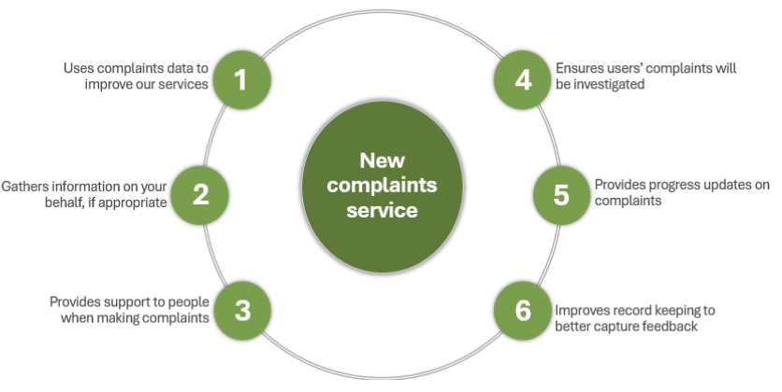

Key elements of the complaints service

A senior departmental officer
The department has appointed a senior departmental officer to oversee the complaints service. They will:
- be impartial and separate from the department’s provider contracts management area
- ensure a holistic approach to complaints management
- deliver a twice-yearly report on complaints data to enhance transparency
- seek out opportunities to improve the quality of employment services.

A complaints management team
We have established a new complaints management team. Reporting to the senior departmental officer, the team will:
- support the senior departmental officer carry out their responsibilities
- investigate and manage complex complaints.

A new process for the call centre
Staff within the National Customer Service Line are dedicated to responding to complaints coming through to the NCSL. The NCSL will continue as the main way complaints are received and dedicated staff will:
- handle complaints from people in employment services, employers and the public
- coordinate and improve reporting of complaints
- provide visibility to the senior departmental officer on complaints
- triage complex complaints to the new complaints management team.

A new online complaint form
We have developed an accessible and easy to use online complaints form. This form provides another option for people to submit complaints, in addition to our current telephone and postal contact options.

Enhancing transparency and leveraging data to improve system performance
Complaints data will be used to inform a complete picture on how employment services are performing. We will use this information to inform ongoing employment services reform and continual improvement to delivering employment services. Complaints data will focus on people’s experiences and will capture a holistic picture of complaints. This includes complaints from employers and members of the public regarding their experiences.
Additionally, we will share complaints data with the public every 6 months from 2025. This will improve transparency and accountability. This publication will report on the source and category of complaints and what it reveals about areas of the employment services system needing focus and attention as part of the ongoing employment services reform process.

