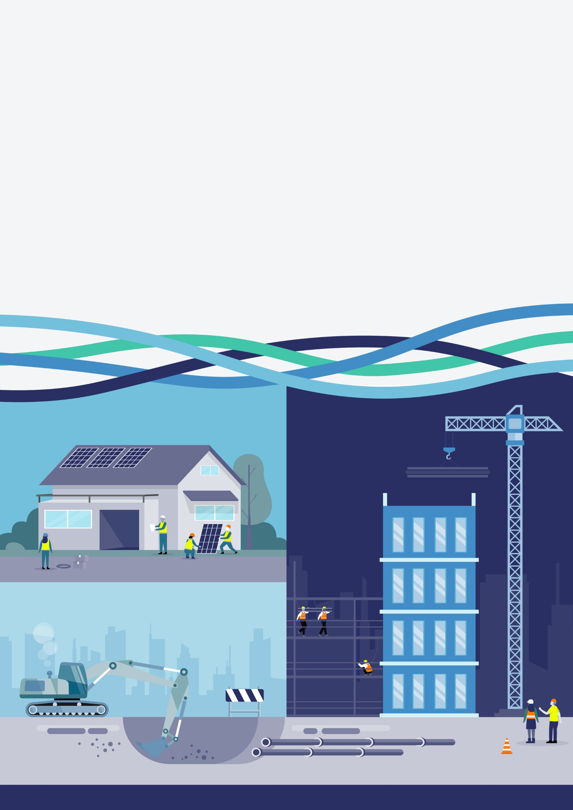
Joint Construction
Industry Charter
  - National Construction Industry Forum
This is a draft. Final content of the Charter will be subject to agreement by all NCIF members

Purpose
Why this Charter, why now
Australia’s building and construction industry is critical to our community and our economy. It delivers the homes we live in, the infrastructure we rely on, and provides the diverse and rewarding careers that support millions of Australians.
The industry is made up of a broad ecosystem of small to large businesses. At its best, the construction industry demonstrates collaboration, expertise and excellence in delivering outcomes that create long-term value for all Australians.
While many parts of the industry demonstrate strong performance and leadership, the industry faces persistent, systemic challenges that affect workers, businesses, governments, consumers, and the broader community.
Safety outcomes can be inadequately prioritised when faced with financial pressure and compressed timeframes, in an industry where work is inherently high-risk. Culture is damaged by instances of criminality, coercion, bullying, and harassment, as well as adversarial practices that erode trust, wellbeing, and participation across the workforce. Productivity is constrained by inefficiencies, outdated practices, skills shortages, limited collaboration and a lack of diversity that impacts the industry’s capacity to meet future demand. Sustainability is jeopardised by fragile supply chains, unstable business models, and ongoing exposure to economic, environmental and geopolitical risks.
There is a shared recognition that the industry can work better for everyone.
The Blueprint for the Future, developed by the National Construction Industry Forum (NCIF), sets a clear direction for change. It identifies what a thriving construction industry looks like, and the conditions needed to achieve it, framed around four interdependent threads: safety, culture, productivity and sustainability, where progress in one reinforces the others. The Blueprint reflects a collective commitment by industry, unions and governments to lift performance and deliver better outcomes for everyone who relies on the industry.

Vision for the future
The NCIF’s vision is of a construction industry that works for everyone.
An industry where people are safe at work, treated with respect and supported by strong and inclusive workplace culture. A financially sustainable industry that delivers high-quality projects on time and on budget, supported by fair risk allocation, transparent commercial practices and investment in skills and innovation. This vision includes a clear expectation that unlawful behaviour, intimidation, harassment and violence have no place in the industry, and that issues are resolved early, fairly and constructively.

What is the Charter
The Charter translates the Blueprint into action. It is a unifying framework, developed by the NCIF, for leaders and participants in industry, unions and government to support better decisions, improve alignment of stakeholders and strengthen collaboration.
The NCIF envisions the Charter, like the Blueprint, to be a living document that will evolve over time in response to the construction industry’s changing needs.
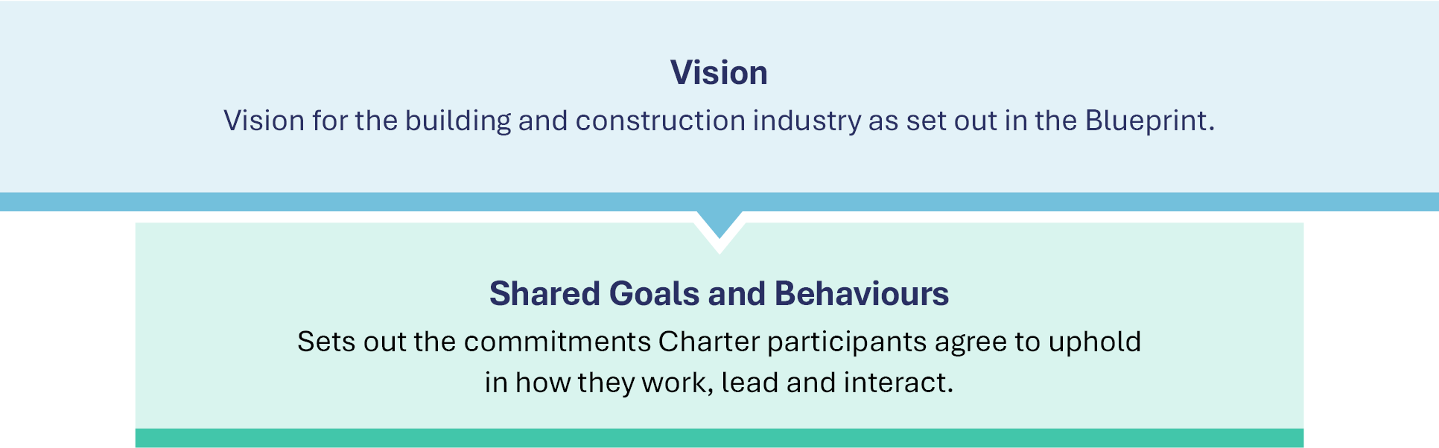
Together, these elements set an industry benchmark for best-practice behaviour, culture and performance, and are intended to guide decision‑making, shape behaviour in boardrooms and on sites, and support early resolution of issues.
The Charter provides a shared reference for defining and demonstrating value across the industry. It supports participants to align decisions and behaviours with agreed expectations, demonstrate their commitment to acting in good faith and evidence performance against those expectations over time.
The shared goals and expected behaviours outlined in this Charter do not replace other obligations. For example, existing work health and safety obligations and all other applicable legislation and regulations.

Who and how does it apply
Everyone that operates in the industry has a role to play in improving it. For change to be embedded in the industry, leaders and participants should demonstrate ‘what good looks like’ by modelling high standards of behaviour, as outlined in the Charter. It is intended to apply consistently across industry, unions and government, while recognising that roles and responsibilities differ.
The Charter is intended to be actively used, not simply endorsed.
- At an industry level, it provides a common reference point for leadership, advocacy and reform.
- At the government and regulator level, it should inform policy, regulatory and enforcement settings, and procurement and delivery practices, to actively shape commercial behaviour and the operating environment, and drive system-wide improvement.
- At an organisation and association level, it should be embedded into policies, procurement practices, leadership expectations and workforce engagement.
- At a project or site level, it should shape how work is planned and delivered, how people are treated and how issues are addressed as they arise.
- At an individual level, it should actively guide everyday decisions and behaviours, from employers to workers.
Pilot projects and companion materials, including self-assessment tools and project lifecycle good-practice guidance, may be developed by the NCIF to support adoption, build capability, and demonstrate the benefits of Charter‑aligned practices.
The Charter is underpinned by a commitment to meaningful consultation and engagement, recognising that better outcomes are achieved when decisions are informed by the experience and perspectives of workers, businesses and their representatives.
Success will be measured over time through improvements against the four Blueprint threads at the industry, organisational, and project or site levels.

Why adopt the Charter
The Charter provides a shared pathway to improve safety, culture, productivity and sustainability, and to ensure the benefits of progress are widely shared. For businesses, the Charter offers better project outcomes, employee engagement, industrial harmony and profitability. For workers and unions, it offers safer and more secure careers with greater flexibility, clearer career pathways and more inclusive workplaces. For governments, private sector clients and the community it offers quality delivery, value for money, and stronger social and economic outcomes.
Above all, the Charter offers the opportunity to reset how the industry works together, moving from fragmentation and conflict toward collaboration and shared success.

Safety
Vision: A healthy, safe and secure work environment for all

Goal 1: Foster a culture of safety
Behaviours:
- Safety is owned by everyone. In line with roles and responsibilities, proactively take steps to contribute to safe work practices and ensure everyone gets home safe.
- Apply safety standards consistently. Ensure safety standards, duties and responsibilities are recognised and understood by all parties before work begins and are upheld consistently for everyone.
- Support and encourage speaking up. Create a culture where anyone can raise concerns without fear, report incidents without barriers, and ensure issues are appropriately addressed.
- Learn from issues and continually improve. Share safety issues and lessons openly, and systematically embed them into planning, work design, and safety risk assessments.
- Act in good faith to support safety outcomes. Safety concerns and rights are used ethically, proportionately and lawfully, and are not misused for industrial purposes, nor are safety obligations ignored.

Goal 2: Plan for safety to prevent harm
Behaviours:
- Prioritise safety across all stages of construction. Ensure work is planned, procured and delivered in a way that supports safe outcomes, including realistic timeframes, appropriate sequencing and clear accountability for safety.
- Plan for and maintain safe and secure workspaces. Prevent unauthorised access and protect workers from external, environmental and site-specific harm.
- Proactively support the safety of a diverse workforce. Recognise that different cohorts may face elevated safety risks and identify and address those risks promptly.
- Provide safe and fit-for-purpose workplaces. Ensure amenities, facilities, equipment and practices are appropriate and safe for the needs of a diverse workforce, including women, LGBTQ+ and people with cultural or religious requirements. Identify and address where adjustments for different workers are needed.
- Take action to prevent unsafe work. Eliminate and minimise risk through good work design and identify and escalate safety risks early. Cease work where there is a reasonable concern of exposure to a serious safety risk arising from an immediate or imminent hazard, until the risk is resolved.

Goal 3: Protect and equally prioritise safety, health and wellbeing
Behaviours:
- Prevent bullying, harassment and violence. Take a prevention-focused approach by proactively identifying and addressing risks before harm occurs. Do not engage in, enable or tolerate any form of bullying, harassment, sexual harassment, discriminatory behaviour or violence.
- Protect mental health and psychosocial safety. Recognise and address risks such as stress, fatigue and harmful behaviours, and support a work environment where people feel safe and informed, support others, and seek help when needed.
- Support wellbeing through good work design and transparency. Maintain predictable and reliable work arrangements that support time for life and adequate time for rest and, where possible, flexible working options. Communicate clearly and early when changes disrupt continuity of work.
- Uphold fit-for-work standards. Support worker wellbeing and fitness for work, and prevent behaviours or situations that impair judgement, reduce capacity or compromise safety or performance, including alcohol or other drugs at work.
- Give psychosocial safety equal importance to physical safety. Commit to and promote behaviours and interactions that are respectful and ethical.

Culture
Vision: Positive, respectful, inclusive, lawful and cooperative

Goal 1: Build constructive, collaborative and positive working relationships
Behaviours:
- Communicate actively and openly across industry and government to support shared outcomes. Share information in a lawful, fair, transparent and timely way to ensure all parties can make informed decisions, build trust and deliver outcomes.
- Engage fairly and in good faith. Approach problem-solving, discussions and decisions honestly, constructively, with a focus on genuine collaboration and mutually beneficial outcomes.
- Be accountable and responsible. Take responsibility for outcomes and commitments to foster trust and support effective delivery.
- Recognise shared achievements and incentivise success. Acknowledge and celebrate success to foster pride in work, reinforce constructive behaviours, and strengthen relationships.

Goal 2: Treat all people with respect and promote inclusive workplaces
Behaviours:
- Lead with integrity and treat all people with respect. Demonstrate integrity, fairness, and respect at all levels and act professionally towards everyone, regardless of role, background or association.
- Foster inclusive workplaces where everyone is welcome. Model and champion inclusivity at all levels by valuing diversity and calling out exclusionary behaviour.
- Support full and equitable participation. Recognise and respond to the needs of a diverse workforce, acknowledging that different groups face different structural and cultural barriers to participation.
- Respond promptly to inappropriate behaviour. Do not engage in, enable or tolerate inappropriate or disrespectful behaviour. Raise, report and address concerns in a timely, fair and appropriate manner to maintain safe and respectful working environments.
- Respect freedom of association. Recognise and uphold the right of employees, contractors and employers to join or not join a registered employee organisation or registered employer organisation.

Goal 3: Maintain lawfulness and integrity in the industry
Behaviours:
- Set and model clear expectations for ethical conduct. Reinforce lawful, transparent and accountable behaviour and ensure these standards are consistently upheld and enforced through leadership, procurement, regulation and oversight.
- Work with fit-and-proper individuals and entities. Ensure parties demonstrate integrity and meet ethical, legal and financial standards before and throughout any engagements. All engagements must be legitimate, lawful and transparent.
- Proactively manage conflicts of interest. Identify and address actual, perceived or potential conflicts of interest in a timely and transparent manner to protect the integrity of decisions.
- Prevent and respond to intimidation, corruption and unlawful behaviour. Adopt a prevention-focused, zero-tolerance approach. Do not engage in, enable or tolerate threats, coercion, corrupt conduct, or any unlawful activity.
- Uphold lawful and ethical work practices. Prevent worker exploitation, non-compliance with workplace laws, sham contracting, and the use of workers, contractors and labour hire providers who are not appropriately authorised, qualified or compliant with applicable requirements.
- Report misconduct promptly and safely. Ensure all parties are supported to safely escalate suspected corruption, criminal activity, or unethical behaviour through appropriate internal and external channels without delay and protect whistleblowers from adverse action.

Productivity
Vision: High quality, on time, on budget, through greater investment and innovation

Goal 1: Deliver quality outcomes on time and on budget
Behaviours:
- Plan and commit to delivery certainty. Set clear, realistic and fair commitments and plan work to achieve consistent quality, reliable schedules and effective cost control across all stages.
- Coordinate delivery across the full lifecycle. Define and agree roles, responsibilities, and decision points so work is sequenced and integrated from concept through to completion.
- Act early to identify and address delivery risks. Identify, escalate and resolve risks to time, cost and quality through transparent and collaborative action, avoiding unnecessary or inequitable transfer of risk to other parties.

Goal 2: Build capability and improve capacity
Behaviours:
- Invest in capability to improve capacity. Identify and develop the right skills, systems and workforce capabilities to lift productivity and support sustainable growth.
- Actively remove barriers to equal participation. Design and improve policies, systems and workforce practices to remove barriers to entry, participation and career progression, enabling more people to contribute.
- Invest in innovation. Enhance productivity and performance through the ethical and responsible adoption of new practices and advanced technologies, including artificial intelligence.
- Embed continuous improvement into everyday delivery. Identify effective practice and areas for improvement and apply insights consistently to current and future projects.
- Promote pipeline transparency to support stability, workforce and capacity planning. Provide clear and timely information on future project pipelines to support realistic workforce planning, skills development, and capability investment.

Goal 3: Invest in relationships to enable efficient and reliable delivery
Behaviours:
- Share appropriate information to support delivery. Share information, issues and decisions openly, lawfully and early to support early risk identification, increase certainty, and maintain delivery momentum.
- Prioritise long-term relationships to improve outcomes. Build and sustain constructive relationships with suppliers and industry partners to proactively develop supply chains to enable investment in skills and capabilities.
- Manage disputes through agreed processes. Use agreed consultation and dispute resolution processes to manage issues constructively, fairly, and consistently, supporting positive working relationships and continuity of work.
- Engage in genuine bargaining and negotiation. Bargain constructively, transparently, lawfully, in good faith and free from coercion to achieve mutual gains, productivity and genuine agreement between parties, including in enterprise bargaining.

Sustainability
Vision: Optimal economic, social and workplace outcomes

Goal 1: Build financial strength and market confidence
Behaviours:
- Ensure ethical, transparent and fair tendering. Respect and protect intellectual property, provide all participants with a fair opportunity to compete and ensure pricing reflects the true scope of works, program, site conditions and associated risks or uncertainties.
- Ensure fair and ethical contracting. Contract in good faith, allocate risk fairly and ensure contracts reflect the true scope, program, site conditions and known risks. Ensure contractors and subcontractors are selected using transparent, fair and appropriate criteria.
- Prioritise value over lowest cost. Make decisions that focus on quality, safety, capability, reliable delivery, and social, environmental and economic benefits rather than lowest-cost options.
- Grow local supply chains and support industry development. Support local markets and suppliers to build local capability and improve resilience.
- Allocate and price risk fairly. Ensure risk is allocated across the contractual chain using the best available evidence. Use shared mechanisms and apply fair relief where risks cannot be quantified or insured.
- Maintain timely, fair and transparent payment practices. Ensure fair and reasonable wages and conditions, and that payments are made on time and in full across the supply chain.

Goal 2: Invest in the workforce of today and tomorrow
Behaviours:
- Recruit and retain diverse talent. Attract people from diverse backgrounds through inclusive recruitment practices and reduced barriers to entry, participation and retention.
- Recognise and value skills. Ensure skills, capabilities and experience are appropriately and consistently recognised and valued, so individuals are placed effectively, rewarded fairly and enabled to contribute fully across roles and career stages.
- Invest in early career training and development. Build a skilled, confident workforce through structured training, mentoring and practical learning, supported by supervision, feedback and pastoral care, particularly for apprentices and trainees.
- Support lifelong learning. Uplift skills and knowledge at all career stages so the workforce remains capable, adaptable and future-ready.
- Champion people-focused work practices. Support contemporary ways of working, including flexibility, and promote the efficient use of resources to improve productivity, wellbeing and long-term workforce resilience.
- Promote stable work practices. Support employment practices that build long-term workforce capability and stability, prioritising direct employment where possible.

Goal 3: Shape a construction industry that is trusted, respected, and regarded for excellence
Behaviours:
- Deliver reliable and ethical community value. Make decisions that foster trust, strengthen public confidence and reflect responsible stewardship of public and private investment.
- Be an industry of choice. Build pride in the industry by recognising excellence, sharing success and strengthening the credibility of construction as a career of choice.
- Uphold high standards of professionalism. Ensure leadership, behaviours and skills reflect accountability, continuous improvement and a shared commitment to consistently high standards of practice.

