2026 Basin Plan Review Indigenous Cultural and Intellectual Property (ICIP) Submission Template

Instructions
This Basin Plan Review Indigenous Cultural and Intellectual Property (ICIP) submission template (the submission template) is to be completed for all email and postal submissions containing ICIP material.
It is presented in three parts:
- Coversheet: this is to be completed to include information about the submission you wish to make.
- Part A: this is where you can provide your submission. You may like to provide a free standing response and/ or consider the questions we have asked in the Discussion Paper.
- Part B: this contains more detailed information, terms and conditions relating to the provision of your submission. A privacy notice is provided in this section of the template which addresses the collection and use of personal information consistent with the Australian Privacy Principles and the Privacy Act 1988 (Cth) (the Privacy Act).
If you need assistance, you can:
- use the Contact Us form at mdba.gov.au/enquiry
- call 1800 230 067 (Monday to Friday, 8.30 am to 5.00 pm AEST).

Information about publication
Please be aware that the Water Act 2007 (Cth) (the Water Act) requires that the MDBA publishes all submissions which are received unless you specifically request that your submission (or a part of your submission) is treated confidentially.
- Non confidential submissions will be published and will be freely accessible online through the MDBA’s website.
- If you advise that your submission or part of your submission is confidential, the submission or the confidential part of your submission (as the case may be), will not be published on the MDBA’s website. The confidential part/s will be redacted before the submission is published.

Coversheet
These questions help us understand who is making a submission, and if required, to contact you about your submission. They are also intended provide us with information about whether your submission or part of your submission is confidential.
We will not publish the details provided in this coversheet page on the MDBA’s website, unless it has been included in your submission (Part A).
PLEASE NOTE: Those questions marked with a red asterisk * are mandatory as they contain information needed to support consideration of submissions which are received.
*Are you submitting as an individual or on behalf of an organisation?
☐ Individual - refers to any contributor who is making a submission from their own experience, perspective or research.
☐ Organisation - may include peak bodies, community groups, government agencies/departments, private organisations, academia or any other group of stakeholders.

QUESTIONS FOR INDIVIDUALS
Please provide your first and last name.
(If you wish to submit anonymously or using a pseudonym please complete accordingly)
First name: Click or tap here to enter text. Last name: Click or tap here to enter text.
Which Australian state or territory do you live in?
☐ Queensland ☐ New South Wales ☐ Australian Capital Territory
☐ Victoria ☐ South Australia ☐ Northern Territory
☐ Western Australia ☐ Tasmania ☐ Other (please specify): Click or tap here to enter text.
Please provide your postcode and suburb you live in.
Click or tap here to enter text.
Do you identify as Aboriginal and/or Torres Strait Islander or First Nations?
☐ Yes ☐ No ☐ Prefer not to say
If you choose to, please indicate which Nation you identify with.
Click or tap here to enter text.

QUESTIONS FOR ORGANISATIONS
*Please enter the full name of the organisation you are submitting on behalf of.
Click or tap here to enter text.
Please select the option that best describes your organisation.
(Select one only)
☐ Community and not-for-profit ☐ Traditional Owner, Aboriginal or First Nations
☐ Environmental groups ☐ Industry and business
☐ Government (local, state/territory, federal) ☐ Peak bodies and associations
☐ Research and academic institutions ☐ Other (please specify): Click or tap here to enter text.

GENERAL QUESTIONS
What sector do you, or your organisation, primarily associate with?
(Select one only)
☐ Irrigated agriculture ☐ Community and regional development
☐ Dryland agriculture ☐ Recreation
☐ Environment and conservation ☐ Traditional Owner, Aboriginal or First Nations
☐ Government ☐ Research and academia
☐ Other (please specify): Click or tap here to enter text.
*Please provide a valid email address.
(The MDBA may contact you about your submission. This email will be used to share your submission back to you and notify you when the ‘what we heard’ report and the Basin Plan Review report are published)
Click or tap here to enter text.

CONFIDENTIALITY AND PUBLICATION
*Please indicate how and if you want your submission published.
(Note: The MDBA may disclose confidential submissions if required or authorised by law)
☐ Option 1 – My submission is not confidential – Public
☐ Option 2 – My submission is not confidential but I wish to remain anonymous – Public and anonymous
☐ Option 3 – My submission is partly confidential – Public with redactions
☐ Option 4 – My submission is confidential – Not public
*Is the whole of your submission (including any supporting evidence or documentation) confidential?
☐ Yes ☐ No
*Is part of your submission (including any supporting evidence or documentation) confidential?
☐ Yes ☐ No
If you answered YES to the above, please let us know which sections, content or supporting documentation are confidential.
Click or tap here to enter text.
*Please provide a published name.
(This will appear with your submission when it is published, unless you have specified that your submission is confidential)
Click or tap here to enter text.
PRIVACY, TERMS AND CONDITIONS
*I have read and understood the Privacy Collection Notice in Part B.
☐ Yes
*I have read, understood and accept the terms and conditions in Part B.
(The MDBA may not be able to accept your submission unless you have confirmed your acceptance of the terms and conditions)
☐ Yes

PART A: Your submission
This section lets you make a submission on any aspect of the Basin Plan Review. You may choose to address the Discussion Paper feedback questions if you would like.
You have the option of providing your submission by completing the sections below and / or by way of separate attachment(s).
Where you are providing your submission in a separate document, we ask that you complete the section below to include its title. We ask that the same approach is taken for any supporting documentation or evidence.

Free text submission
I wish to provide the following submission in connection with the Basin Plan Review:
(Please complete the text box below to add your submission or, where you wish to provide it in a separate document, to note the title of that document)
Click or tap here to enter text.
I wish to provide the following supporting documentation or evidence:
(Please complete the text box below to provide your supporting documentation or evidence. If possible, please include a brief description of the supporting documentation or evidence at the top and if providing it in a separate document(s), to note the title of that document(s))
Click or tap here to enter text.

Discussion Paper feedback questions
Question 1: What do you think of the issues and options presented in the 2026 Basin Plan Review Discussion Paper?
Click or tap here to enter text.
Question 2: Are there other issues and options that should be considered?
Click or tap here to enter text.
Question 3: What do you see as the priorities and why?
Click or tap here to enter text.

Next steps

Email
Email your completed submission template and any attachments to BPRSubmissions@mdba.gov.au with ‘BPR Submission’ in the subject line. The preferred file formats for attachments are PDF, Word, Excel, TXT, MP3, MOV, WAV, JPEG, or PNG or CSV. Ensure attachments are less than 20MB in total.

Post
Post your completed submission template and any attachments to:
Basin Plan Review Submissions
Murray–Darling Basin Authority
GPO Box 1801
Canberra City
ACT 2601
If you have provided a valid email address a receipt will be sent to your nominated email address and will include your reference number. You may wish to keep a copy of your submission in case we cannot contact you.

Part B: ICIP and Privacy

Privacy collection notice
The MDBA respects your right to privacy and confidentiality, and complies with the Australian Privacy Principles in the Privacy Act.
The Privacy Act regulates how:
- we collect, use, disclose and store personal information including sensitive information; and
- you can access and correct records containing your personal information.

Your personal information
The MDBA is collecting your personal information to deliver the review of the Basin Plan (Basin Plan Review) as required under section 50 of the Water Act and the associated public consultation process required under section 51 of the Water Act. The MDBA will collect your personal information including through third parties contracted to support the Basin Plan Review.
Your personal information is collected by the MDBA when you make your submission. We may also collect your personal information from a third party if the circumstances make it unreasonable or impracticable to collect the information directly from you.
Any third party contracted to support the Basin Plan Review is contractually obligated to act in a manner consistent with the Privacy Act.

Including third party personal information in your submission
If you intend to include personal information of a person/s other than yourself in a submission, you should make sure the person is aware of this and has agreed to the inclusion of their information.

Why is your personal information being collected?

Basin Plan Review
Your personal information (including sensitive personal information) is being collected for the purpose of the Basin Plan Review, through this public consultation and submission process. Collection of your personal information (including sensitive personal information) for the purposes of the Basin Plan Review is authorised under section 51 of the Water Act.

Other reviews in connection with the Murray–Darling Basin
Your personal information (including sensitive personal information) is also being collected for the purposes of:
- supporting the Water Act Review, including consideration of the management of Basin water resources. A review of the Water Act is required to be conducted under section 253 of the Water Act; and
- the Menindee Review, initiated by the Basin Officials Committee. This is a review of the operation and management of the Menindee Lakes system, which is managed by the MDBA on behalf of the Australian Government, the New South Wales, Victorian and South Australian governments; and
- other reviews, studies or projects the MDBA (including in conjunction with other Basin governments) carries out in performance of its functions, powers, or obligations,
which are referred to in this notice and the Indigenous Cultural and Intellectual Property Consent Agreement , as the Other Reviews.

How will your personal information be used and disclosed?

Basin Plan Review
Personal information which is collected will be used to inform the MDBA of your views on the Basin Plan Review. We may contact you to clarify parts of your submission. Your submission will be recorded, reviewed, grouped into themes, and used in the preparation of summaries and reports. Thematic grouping and the preparation of summaries may use generative Artificial Intelligence in a closed system.
Cloud-based technology provided by Converlens Pty Ltd (Converlens) is used to collect and host your submission. The recording and processing will involve disclosure to third parties contracted by the MDBA to support delivery of the Basin Plan Review, including Converlens.
Converlens collects personal information in compliance with the Privacy Act and stores data securely in Australia. Find out more about how Converlens manages consultation data in their Privacy Policy at converlens.com/legal/privacy-policy/.
Any personal information included in a submission about you, and/ or persons other than you, will be published on mdba.gov.au, as required under section 51 of the Water Act, unless you make a request to treat your submission, or part of your submission, as confidential. You can choose to have your submission published anonymously or under a pseudonym. We may redact parts of published submissions, in certain circumstances.

Other Reviews
Your personal information may be disclosed to, and used by, the MDBA and Basin governments for the purposes of the Other Reviews described above. This includes the Australian Government Department of Climate Change, Energy, the Environment and Water for purposes of the Water Act Review. Where we disclose this information to other Basin governments, we expect those governments to notify you about their collection, use and disclosure of your information for the purposes of the Other Reviews as required under the Privacy Act.
Your personal information may also be disclosed where you have agreed or where it is otherwise permitted, including where it is required or authorised by or under an Australian law, court, or tribunal order.

What would happen if your personal information was not collected?
Submitting your views on the Basin Plan Review is voluntary. You can choose not to provide your personal information, but the MDBA cannot accept your submission online and will not be able to contact you to discuss or clarify your submission if submitted by other channels.
In circumstances where you are unable to deal with us anonymously, or through the use of a pseudonym, we will ask you to identify yourself to enable us to carry out our functions and activities.

Overseas disclosure of your personal information
The MDBA uses servers located in Australia, but because submissions are published on our website, they are accessible online including to overseas recipients. The provider, Converlens, may disclose personal information to overseas recipients and we recommend you read the relevant privacy policies accessible via the link below.

Access to and correction of your personal information
The MDBA’s Privacy Policy (mdba.gov.au/privacy) and Converlens’ Privacy Policy (converlens.com/legal/privacy-policy/) have information about how you can access and correct your personal information.

Complaints
The MDBA and Converlens privacy policies provide information about making a complaint about a breach of the Australian Privacy Principles and how complaints are dealt with.

Contact us
A copy of the MDBA Privacy Policy can be found at mdba.gov.au/privacy or you can request a copy via email to privacy@mdba.gov.au or call the MDBA Privacy Officer on (02) 6279 0100.

Indigenous Cultural and Intellectual Property Consent Agreement

Purpose of this agreement
Through this consent agreement, you are agreeing to the MDBA gathering and using your Indigenous Cultural and Intellectual Property (ICIP) (Your Content) for the Permitted Purpose and any Additional Permitted Purpose you agree to. This agreement also sets out the MDBA’s commitments to you, regarding Your Content.
This consent agreement does not change ownership of Your Content or limit your ability to use or share Your Content for any other purpose you choose.
This consent agreement governs the MDBA’s use of Your Content.

Key terms
- Your Content: this submission on the Basin Plan Review, handwritten or electronically submitted through this submission template.

- Your Consent: the completion of this agreement will form the basis of Your Consent.
- Gathered through: the completion of this submission template and the submission of Your Content.
- Permitted Purpose: to inform the review of the Murray–Darling Basin Plan through public submission on the Basin Plan Review, to inform the ‘what we heard’ report and the Basin Plan Review report.
- Additional Permitted Purpose: this refers to the additional ongoing initiatives for which the Australian Government is seeking Your Consent for the use of Your Content, currently the Water Act Review and/ or Menindee Review. You will be able to choose if you would like to provide this consent below.
- Publication Selection: the confidentiality and publication options you chose in the Coversheet above, which determines if and how Your Content will be published.

Basin Plan Review submission process
Under section 51 of the Water Act, the MDBA is required to:
- consider any submission it receives in response to the invitation to members of the public to make a submission to the MDBA on the Basin Plan Review.
- publish all submissions it receives on the Basin Plan Review, unless the submitter has specifically requested the submission, or particular part of the submission, is treated confidentially.
The MDBA has implemented arrangements to ensure submissions are managed and considered in a consistent way.
The MDBA will be collating all submissions through Converlens to enable streamlined management, security and consideration of submissions.
The MDBA will be using contracted third parties to support the initial gathering and triage of submissions to support consideration of submissions.

The MDBA may also use artificial intelligence (AI) in a closed system to support tasks enabling the consideration, evaluation and processing of your submission, which may include:
- campaign clustering to triage high-volume identical submissions
- identifying themes and supporting tagging
- preparing summaries of submission content, and
- any other use of generative AI functionality.

Consent
By consenting, you acknowledge and agree with the below statements.
- Agree to comply with any requirements set out in the Basin Plan Review Submission Guidelines supporting the consultation process and available at getinvolved.mdba.gov.au/2026basinplanreview.
- Agree to share Your Content with the MDBA for the Permitted Purpose (Basin Plan Review).
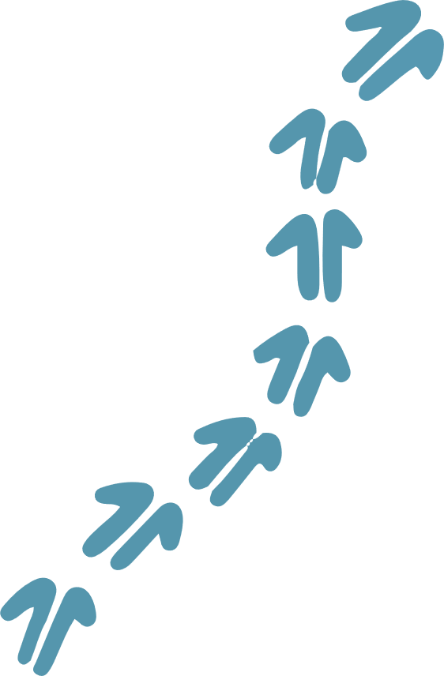
- Consent to the MDBA doing the following with Your Content:
  - using and reproducing Your Content.
  - communicating Your Content.
  - collating Your Content in a way that is consistent with this consent agreement;
  - adapting and modifying Your Content, to support accessibility and publication requirements, and the preparation of redacted versions.
  - sharing Your Content with third parties:
    - for the Permitted Purpose to support triaging, management and analysis, including through the use AI as described above. The MDBA will be responsible for ensuring all contracted third parties will comply with the terms of this consent agreement and the MDBA’s ICIP Policy.
    - for Additional Permitted Purposes (if you consent) on terms consistent with Your Consent.
Your Consent is subject to the MDBA complying with its ICIP Policy (as updated from time to time) and this consent agreement in connection with Your Content.

If you are unsure of any of the above or have any questions about this consent agreement, call us on 1800 230 067.
Note: If Your Content is published (as per your selection in the Publication Selection), it will be publicly available. Its use by other persons may be outside of the MDBA’s control. The MDBA will use a Traditional Custodians Notice to advise anyone who wants to reproduce, re-use or redistribute Your Content for any purpose that they are required to seek your permission.
*Do you consent to the use of Your Content for the Permitted Purpose as outlined above?
☐ Yes

Expiration of and withdrawing consent
By submitting Your Content as part of this submissions process, you are agreeing with the below conditions on your ICIP content.
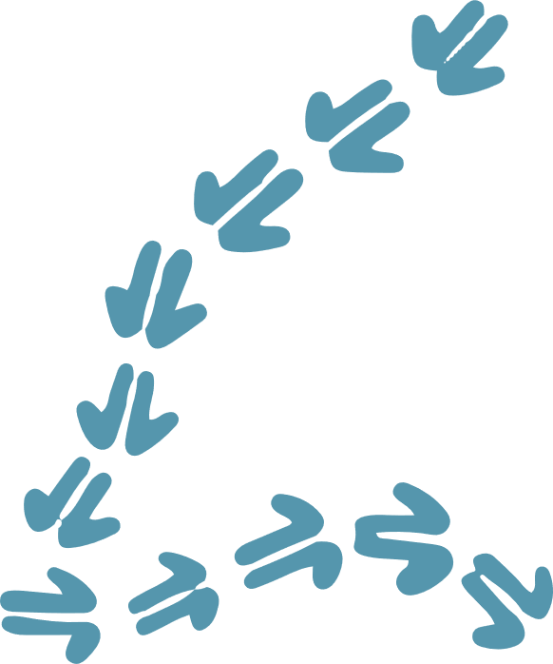
- The MDBA will have Your Consent to use Your Content in perpetuity (no end date) for the Permitted Purpose.
- Your Consent may be withdrawn at any time, by sending an email to first.nations@mdba.gov.au.
Where materials have already been published, it may not be possible to retract, amend, or remove them. The MDBA commits to removing Your Content from any digital or future print publications if you withdraw Your Consent.
*Do you agree with the conditions on expiration of and withdrawing Your Consent as outlined above?
☐ Yes

Additional Permitted Purposes
The Australian Government is continuously seeking feedback and input from individuals and organisations across the Murray–Darling Basin’s vast network of communities.
To support the ongoing work of the Australian Government, we are seeking Your Consent to use Your Content for other key pieces of work currently underway (Additional Permitted Purposes).
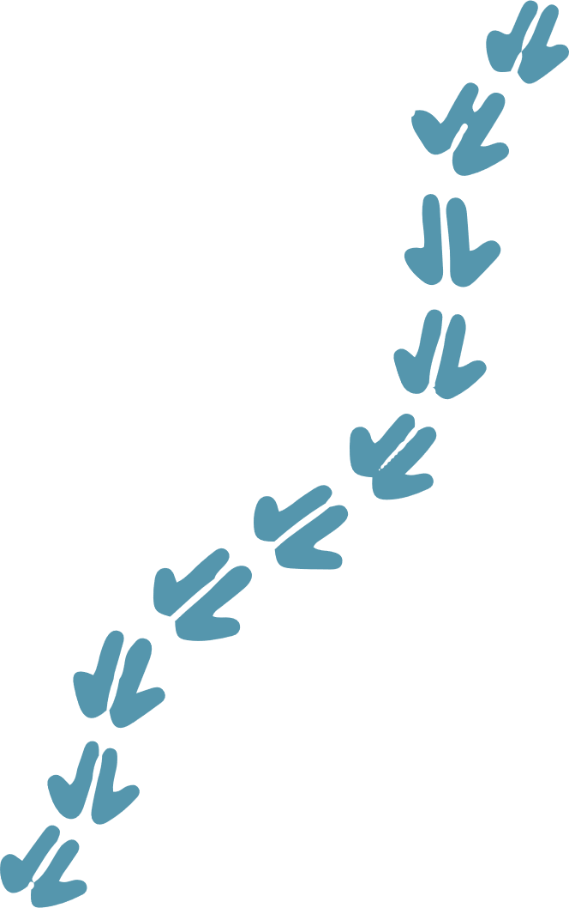
Note: this is entirely optional. If you do not agree to the use of your Content for any Additional Permitted Purpose, we will only use Your Content for the purposes of the Basin Plan Review (Permitted Purpose).
The Additional Permitted Purposes are described below.

Water Act Review
The Water Act provides the legislative framework for ensuring that the Basin is managed in the national interest. Under section 253 of the Water Act, the operation of the Water Act and the extent to which the objects of the Water Act have been achieved is required to be reviewed before the end of 2027 (the Water Act Review).
The Water Act Review must also identify opportunities under the Water Act to promote the principles set out in the United Nations Declaration on the Rights of Indigenous Peoples (UNDRIP).
The terms of reference for the Water Act Review are determined by the Australian Government Minister for Water in consultation with the state and territory governments. The independent review is being supported by the Commonwealth Department of Climate Change, Energy, the Environment and Water.
Your Content will inform the design of the public consultation for the Water Act Review, and the Water Act Review report.

Menindee Review
The Menindee Review aims to establish shared objectives and outcomes for the future of the Menindee Lakes and the way in which they are managed to balance the water needs of the environment, agriculture, and local community amid increasing climate pressures.
The Menindee Review is being conducted in multiple stages and will consider the operation of the Menindee Lakes system including:
- examining the suitability and performance of current water management arrangements currently in place for the system
- exploring opportunities for both improved operating rules and procedures
- exploring opportunities for new or improved infrastructure
- the implication of such changes on local and River Murray communities.
The terms of reference for the Menindee Review were agreed by the Basin Officials Committee (BOC) in 2024. The review is managed by the MDBA on behalf of New South Wales, Victorian, South Australian and Australian governments (the joint governments).
Your Content will inform the Menindee Review – by establishing a shared vision for the future management of the Menindee Lakes system and informing a ‘what we heard’ report. The information will also be used to develop pre-feasibility level options to be further investigated and considered by the joint governments in the next stage of the project. Your Content will also inform the ongoing operation and management of Menindee Lakes by the MDBA and joint governments.

Consent for Additional Permitted Purpose
Please select the Additional Permitted Purpose you consent to us sharing Your Content for.
(Select all that apply)
☐ Water Act Review ☐ Menindee Review

Cultural sensitivities
*Are there any cultural sensitivities in your submission?
(Select all that apply)
☐ Ceremonial knowledge ☐ No Cultural sensitivities
☐ Cultural sites or locations ☐ Other (please specify): Click or tap here to enter text.
☐ Secret Sacred The MDBA does not seek information about secret sacred material, sites or knowledge. Please do not share.

Men’s or Women’s only knowledge
*Please indicate if any of the information in Your Content is Men's only or Women's only knowledge.
(Only complete if you selected ‘Ceremonial knowledge’, ‘Secret Sacred’, ‘Cultural sires or locations’, or ‘Other’ above)
☐ Men's only knowledge ☐ Women's only knowledge ☐ Neither
Note: If you plan to provide both Men's and Women's only knowledge you will need to make separate submissions for each.

Receiving a copy of Your Content
Consistent with the Indigenous Data Sovereignty Principles, the MDBA will provide you with a copy of Your Content via email for your records and use at the completion of this submission template.
Please make sure the email address you provided in the Cover Sheet above is correct as this is the address we will use to send you Your Content.

End of ICIP Consent Agreement
Thank you for sharing Your Content with the MDBA. The submission you provide to the MDBA will help shape the recommendations of the Basin Plan Review report. If you have chosen to provide consent for an Additional Permitted Purpose your submission will also inform those initiatives.

