DRAFT Code of Practice

MONTH year

Disclaimer
Safe Work Australia is an Australian Government statutory agency established in 2009. Safe Work Australia includes Members from the Commonwealth, and each state and territory, Members representing the interests of workers and Members representing the interests of employers.
Safe Work Australia works with the Commonwealth, state and territory governments to improve work health and safety and workers’ compensation arrangements. Safe Work Australia is a national policy body, not a regulator of work health and safety. The Commonwealth, states and territories have responsibility for regulating and enforcing work health and safety laws in their jurisdiction.
Creative Commons
With the exception of the Safe Work Australia logo, this copyright work is licensed under a Creative Commons Attribution 4.0 International licence. To view a copy of this licence, visit creativecommons.org/licenses In essence, you are free to copy, communicate and adapt the work, even commercially, as long as you attribute the work to Safe Work Australia and abide by the other licence terms.
Contact information
Safe Work Australia | mailto:info@swa.gov.au | www.swa.gov.au

Contents
Foreword 4
1. Introduction 5
1.1 What is fatigue? 5
1.2 How fatigue causes harm 6
1.3 WHS duties to manage fatigue risks 9
2. Risk management process 12
2.1 Leadership and management commitment 13
2.2 Consulting throughout the risk management process 14
3. Identify hazards 16
3.1 Risk of workers becoming fatigued 16
3.2 Health and safety risk from fatigue 19
3.3 How to identify fatigue-related hazards 20
4. Assess the risks 24
4.1 When should you assess the risks? 24
4.2 How to assess the risks 24
5. Control the risks 26
5.1 Combination of control measures 26
5.2 Preventing fatigue 26
5.3 Managing health and safety risks from fatigue 31
5.4 Fatigue duties shared with workers 33
5.5 Other persons 35
5.6 Implementing control measures 36
6. Maintain and review control measures 38
7. Record keeping 40
Appendix A – Resources 41
Appendix B – Risk management chart 43
Appendix C – Case Studies (example only – to be updated) 48

Foreword
This Code of Practice on managing fatigue risks at work is an approved code of practice under section 274 of the Work Health and Safety Act (the WHS Act).
An approved code of practice provides practical guidance on how to achieve the standards of work health and safety required under the WHS Act and the Work Health and Safety Regulations (the WHS Regulations), and effective ways to identify and manage risks.
A code of practice can assist anyone who has a duty of care in the circumstances described in the code of practice. Following an approved code of practice will assist the duty holder to achieve compliance with the health and safety duties in the WHS Act and WHS Regulations, in relation to the subject matter of the code of practice. Like regulations, codes of practice deal with particular issues and may not cover all relevant hazards or risks. The health and safety duties require duty holders to consider all risks associated with work, not only those for which regulations and codes of practice exist.
Codes of practice are admissible in court proceedings under the WHS Act and WHS Regulations. Courts may regard a code of practice as evidence of what is known about a hazard, risk, risk assessment or risk control and may rely on the code in determining what is reasonably practicable in the circumstances to which the code of practice relates. For further information see the Interpretive Guideline: The meaning of ‘reasonably practicable’.
Compliance with the WHS Act and WHS Regulations may be achieved by following another method if it provides an equivalent or higher standard of work health and safety than the code.
An inspector may refer to an approved code of practice when issuing an improvement or prohibition notice.
Scope and application
This Code is intended to be read by a person conducting a business or undertaking (PCBU). It provides practical guidance to PCBUs on how to manage health and safety risks related to fatigue at work.
This Code may be a useful reference for other persons interested in the duties under the WHS Act and WHS Regulations.
This Code applies to the performance of work and to all workplaces covered by the WHS Act.
How to use this Code of Practice
This Code includes references to the legal requirements under the WHS Act and WHS Regulations. These are included for convenience only and should not be relied on in place of the full text of the WHS Act or WHS Regulations. The words ‘must’, ‘requires’ or ‘mandatory’ indicate a legal requirement exists and must be complied with.
The word ‘should’ is used in this Code to indicate a recommended course of action, while ‘may’ is used to indicate an optional course of action.
    - Introduction
      - What is fatigue?
Fatigue is an acute and/or ongoing state that leads to physical, mental or emotional exhaustion. Fatigue can not only prevent people from functioning safely, it can also have long-term health effects.
In a work context, fatigue is more than feeling tired and drowsy. It can be:
- physical – that is, pronounced physical exhaustion and reduced ability to engage in physical activities (e.g. manual labour)
- mental – that is, pronounced mental exhaustion and reduced ability to engage in mental or cognitive activities (e.g. making decisions)
- emotional – that is, pronounced emotional exhaustion and reduced ability to engage in emotional activities (e.g. empathising with or caring for others), or
- a combination of any of these.
Fatigue can be caused by a range of hazards broadly grouped as:
- Working hours and shift design – working long hours, working during some or all of the natural time for sleep or not allowing sufficient opportunity for sleep or rest.
- Tasks, equipment or environments – an imbalance between the demands of a worker’s job, and the personal and work resources available to support a person to manage these demands.
- Individual – individual characteristics impacting sleep and recovery causing workers to become fatigued.
In this Code, shift is used broadly to describe a period of work, including both standard day shifts and shift work. Shift work is used to describe non-standard patterns of work such as working at night or extended periods.
      - How fatigue causes harm
Figure 1 Fatigue risk chart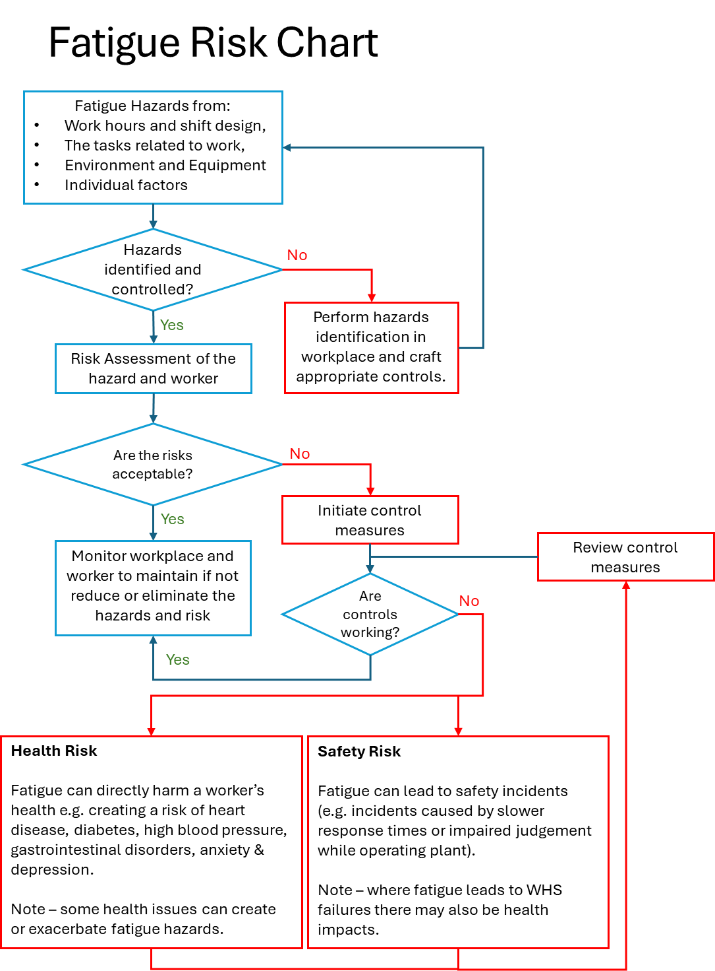
Fatigue hazards
Generated by:
- work hours and shift design,
- the tasks, equipment and environment at work, and
- individual factors.
If risk not controlled or safety systems fail
Risk of workers becoming fatigued
Health Risks
Fatigue can directly harm a worker’s health e.g. creating a risk of heart disease, diabetes, high blood pressure, gastrointestinal disorders, anxiety & depression.
Note – some health issues can create or exacerbate fatigue hazards.
Safety Risks
Fatigue can lead to safety incidents (e.g. incidents caused by slower response times or impaired judgement while operating plant).
Note – where fatigue leads to WHS failures there may also be health impacts.
If not controlled
Health risk of fatigue
Fatigue can directly harm workers’ physical and psychological health, for example it has been shown to cause:
- heart disease
- musculoskeletal disorders
- diabetes
- high blood pressure
- gastrointestinal disorders
- reduced fertility
- anxiety
- depression
- negative impacts on existing health issues (e.g. mental health conditions, asthma, epilepsy or diabetes), and
- link with some cancers.
Shift work, particularly long hours and night shift work, is also associated with poorer general wellbeing, creating conflicts between work and family or other commitments, limiting opportunity for physical activity and is associated with increased risk of the health issues and chronic diseases listed above.
You must eliminate or minimise the risk of workers or others becoming fatigued, not just manage the risks arising from fatigued workers or others (e.g. from having slower response rates and inhibited decision-making abilities).
Broader health, safety and wellbeing
For physical and mental health, adults generally require:
- 7 or more hours sleep a night (or each 24 hour period)
- 2.5-5 hours of moderate intensity exercise or 1.25-2.5 hours vigorous exercise a week
- a healthy, balanced diet, and
- regular social interaction.
While much of this may be beyond a PCBU’s control and duties under WHS laws, shifts or work that prevent a healthy lifestyle can have broad health and wellbeing impacts.
In Australia working beyond 39 hours per week has been shown to lead to a decline in mental and physical health.
The World Health Organization and International Labour Organization have found working 55 or more hours per week is a serious health hazard. It is associated with an estimated 35% higher risk of a stroke and a 17% higher risk of dying from ischemic heart disease, compared to working 35-40 hours a week.
Workers may also be at risk where they are fatigued from work and then do tasks outside of work where fatigue-related errors can result in injury. For example, using power tools, cooking or driving.
Safey risks from fatigue-related incidents
In addition to the health risks, fatigue can increase the risk of injury and other harm. This risk of fatigue-related incidents occurs when:
- it reduces workers capacity (e.g. fatigued workers have slower reaction times, reduced alertness, strength, coordination and capability to communicate, impaired memory, concentration and judgement, and can have micro sleeps), and
- health and safety depends on workers’ performance (e.g. there are inadequate systems in place to prevent workers making fatigue-related errors or to protect workers and others from the consequences of those errors).
Fatigue impacts workers’ coordination, response times and cognitive abilities. Studies have shown that being awake for 17 hours has similar effect on cognitive and motor performance as having a blood alcohol content of 0.05% and being awake for 24 hours is similar to having a blood alcohol content of 0.10%.
Safety incidents from fatigue may include, but is not limited to:
- loss of control while operating fixed or mobile plant, including vehicles or vessels
- errors in following health and safety procedures and the use of PPE
- errors while providing medical care
- errors from professionals, such as engineers or technicians
- slipping while operating plant or tools or falling when performing tasks requiring balance and coordination such as when working at heights
- lapses in attention or missing something while doing tasks requiring a high level of concentration such as monitoring children on an excursion, or
- slips, trips, falls or poor posture leading to musculoskeletal disorders.
      - WHS duties to manage fatigue risks
WHS Act section 19
Primary duty of care
A PCBU must ensure, so far as is reasonably practicable, workers and other persons are not exposed to risks to their physical and psychological health and safety, including the risk from fatigue. A PCBU must eliminate health and safety risks at work, or if that is not reasonably practicable, minimise these risks so far as is reasonably practicable.
This duty includes ensuring, so far as is reasonably practicable:
- the provision and maintenance of work environment without risks to health and safety
- the provision and maintenance of safe plant and structures
- the provision and maintenance of safe systems of work
- the safe use, handling and storage of plant, structures and substances
- the provision of adequate facilities for the welfare of workers including ensuring access to those facilities
- the provision of any information, training, instruction or supervision that is necessary to protect all persons from risks to their health and safety arising from work carried out
- the provision of work health safety systems to address worker feedback on fatigue from work or from factors that may affect safety and health at work
- that the health of workers and the conditions at the workplace are monitored for the purpose of preventing illness or injury of workers arising from the conduct of the business or undertaking.
Workers are ‘at work’ if they are doing work, even if it is outside paid working hours. For example, if workers are working late or you contact them after hours with a work question then they are ‘at work’ and you must manage the risk of fatigue. This is particularly important for night workers or workers working from home, if their sleep is broken as they are often unable to return to sleep.
This duty extends to ensuring so far as is reasonably practicable, that the health and safety of other persons is not put at risk from work carried out. For example, the risk to patients if hospital staff are fatigued or the risk to students from excessive workloads.
Psychosocial risks
WHS Regulations Division 11
Psychosocial risks
Psychosocial hazards are hazards that:
- arise from or in relation to:
  - the design or management of work
  - the working environment
  - use of a plant at a workplace, or
  - workplace interactions or behaviours; and
- may cause psychological and physical harm.
The WHS Regulations require PCBUs to apply the risk management process to psychosocial risks and to consider specific matters when determining the control measures to implement.
Hazardous manual tasks
WHS Regulations Part 4.2
Hazardous manual tasks
A hazardous manual task is a task requiring a person to lift, lower, push, pull, carry or otherwise move, hold or restrain any person, animal or thing involving one or more of the following:
- repetitive or sustained force
- high or sudden force
- repetitive movement
- sustained or awkward posture, or
- exposure to vibration and other hazards.
These hazards directly stress the body and can lead to an injury.
A PCBU must manage risks to health and safety relating to a musculoskeletal disorder associated with a hazardous manual task.
The WHS Regulations require PCBUs to apply the risk management process to these risks and to consider specific matters when determining the control measures to implement.
Inter-relation between fatigue, psychosocial hazards and hazardous manual tasks
Work which is physically and/or psychologically demanding increases the risk of fatigue. For example, jobs requiring intense concentration or heavy lifting can create a risk of fatigue, even when a worker has had good sleep and hasn’t worked a long shift.
Fatigue can also increase psychosocial and musculoskeletal risks.
Fatigue can negatively impact workers’ speed and accuracy of work, communication, mood, patience, and pro-social behaviours. This can create or increase psychosocial hazards such as:
- high work demands (e.g. from decreased efficiency and fatigue-related errors)
- poor support (e.g. lack of patience and time for other workers; decreased empathy)
- harmful behaviours (e.g. rudeness, incivility and bullying).
Physical fatigue may begin to damage tired muscles causing musculoskeletal injury. Fatigued workers may also be more likely to move awkwardly, hold awkward postures or forget to use or incorrectly use tools to assist with manual tasks. Fatigue can reduce workers’ ability to maintain their balance when challenged (e.g. walking on uneven paths, using force to perform their job), identifying any potential slip, trip and fall hazards in their path and responding in time to avoid these hazards.
For more information on these risks see the Code of Practice: Managing psychosocial hazards at work and the Code of Practice: Hazardous manual tasks.
Other relevant duties
Other relevant duties under WHS laws are set out throughout this Code of Practice. See Leadership and management commitment, Consulting with workers, Consulting, cooperating and coordinating activities with other duty holders, Managing the risk of workers coming to work fatigued, Other persons, Information, training, instruction and supervision and incident response.
Most WHS duties apply to the workplace, however incident notification is required for any incident arising out of the conduct of the business or undertaking. For example, a fatigued worker causing a car accident on their way home may be notifiable if the fatigue arose out of the conduct of the business or undertaking.
If you have management or control of a workplace or you design, manufacture, import, supply, install, construct or commission plant, structures or substances you will have additional duties under WHS laws.
WHS laws do not operate in isolation and other laws may also apply. For example, industrial relations, criminal, anti-discrimination, privacy and workers’ compensation laws. Some industries may also have fatigue specific legal requirements including the heavy vehicle, rail, civil aviation, offshore oil and gas, mining and maritime industries.
    - Risk management process
To meet your duties to ensure health and safety, you must eliminate or minimise fatigue and its associated risks so far as is reasonably practicable. To achieve this, just as for any other hazard, you can apply the risk management process described in the Code of Practice: How to manage work health and safety risks.
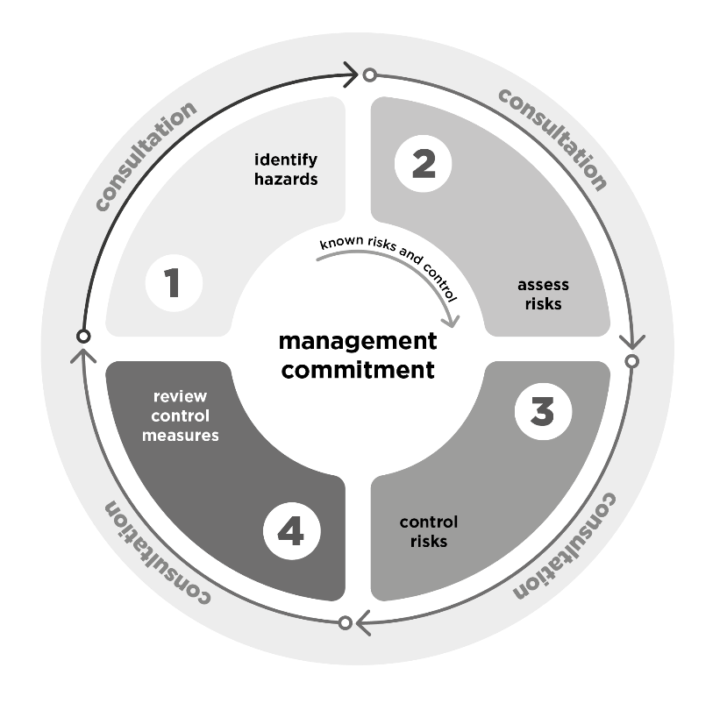
The risk management process involves four steps:
- Identify hazards - find out what could cause harm (Chapter 3).
- Assess risks, if necessary - this step may not be necessary if the risks and controls are known (Chapter 4).
- Control risks - implement the most effective control measures that are reasonably practicable in the circumstances and ensure they remain effective over time. This means:
  - you must eliminate risks, if reasonably practicable to do so
  - if it is not reasonably practicable to eliminate the risks, implement the most effective control measures to minimise the risks so far as is reasonably practicable in the circumstances, and
  - ensure those control measures remain effective over time (Chapter 5).
- Maintain and review control measures to ensure they are effective, used correctly and working as planned and make changes as required (Chapter 6).
Risk management is a proactive process that helps you respond to change and facilitate continuous improvement in your business. It should be planned, systematic and cover all reasonably foreseeable hazards and associated risks. If control measures are not working effectively, you should repeat the risk management process. In the event of an injury or incident at work, the risk assessment process is essential in identifying whether different or additional measures need to be taken to prevent a recurrence of the injury or incident.
The risk management process may be implemented in different ways depending on the size and nature of your business or undertaking. Larger businesses and those in sectors where workers are exposed to more or higher risks are likely to need more complex, sophisticated risk management and consultation processes to meet their WHS duties. For example, hospitals, law firms, primary industry and construction sites will likely need more sophisticated processes than a small café which opens limited hours.
Before you start the process:
- explain the process
- get commitment and engagement from senior leaders and managers
- identify who needs to be involved, for example managers, workers, Health and Safety Representatives (HSRs), subject matter experts, and human resources or scheduling personnel, and
- decide how the process and its outcomes will be recorded and communicated.
      - Leadership and management commitment
Genuine commitment by the PCBU, officers, and other organisational leaders is essential. These leaders, through their governance arrangements and resourcing decisions, actively shape the organisation and the way work is undertaken. These decisions will, directly and indirectly, impact how effectively you can manage fatigue risks.
This commitment can be built by ensuring leaders understand their duties under WHS laws, the risk management process these require, the business case for effectively managing fatigue, and the roles of various organisational leaders (e.g. human resources and WHS managers).
Leaders who are officers under the WHS Act have specific duties.
Officers
WHS Act section 27
Duty of officers
Officers, such as company directors, have a duty to exercise due diligence to ensure the PCBU complies with its duties under the WHS Act and WHS Regulations. This means taking reasonable steps to ensure the business or undertaking has and uses appropriate resources and processes to manage the risks associated with fatigue. For example, ensuring the PCBU has safe systems of work and safe work environments to eliminate or minimise the risk.
For information on officers and their duties see the Interpretive Guideline: The health and safety duty of an officer.
      - Consulting throughout the risk management process
Consulting with workers
WHS Act section 47
Duty to consult workers
WHS Act section 48
Nature of consultation
WHS Act Section 49
When consultation is required
A PCBU must consult, so far as is reasonably practicable, with workers who are (or are likely to be) directly affected by a work health and safety matter. Consultation involves sharing information, giving workers a reasonable opportunity to express views and taking those views into account before making decisions on health and safety matters.
If you and your workers have agreed procedures for consultation, it must be conducted in accordance with those procedures. All consultation must include any HSRs representing your workers. References to consultation with workers in this Code includes consultation with any HSRs.
The definition of ‘worker’ under the WHS Act is broad. In addition to employees, it includes anyone working for the business or undertaking, including contractors and their employees, labour-hire workers, outworkers, apprentices, trainees, work experience students and volunteers.
You must consult with workers when identifying hazards, assessing risks or making decisions about health and safety including what control measures are implemented.
Different workers may be exposed to different fatigue risks and you must consult with all workers who are likely to be directly affected. For example, workers on different shifts or apprentices who have study requirements in addition to work.
Consulting your workers will assist you to identify anything that may put certain workers at greater risk, and whether there are additional reasonably practicable controls you must implement to eliminate or minimise the risks for these workers. This should include any potential barriers you may be able to design your health and safety systems to overcome them, for example providing health and safety information in multiple languages.
Further guidance is available in the Code of Practice: Work health and safety consultation, cooperation and coordination.
Consulting, cooperating and coordinating activities with other duty holders
WHS Act section 16
More than 1 person can have a duty
WHS Act section 46
Duty to consult with other duty holders
More than one person can have the same WHS duty at the same time. This could be because they are involved in the same activities or share the same workplace. The WHS Act requires that where more than one person has a duty for the same matter, each person retains responsibility to meet their duty in relation to the matter and must do so to the extent to which they can influence and control the matter.
Duty holders must consult, cooperate and coordinate activities with all other persons who have a WHS duty in relation to the same matter, so far as is reasonably practicable. Where you share a duty (e.g. a role requires a worker to carry out work for you and another PCBU), each duty holder should:
- exchange information
- find out who is doing what about their respective WHS obligations, and
- work together in a cooperative and coordinated way so risks are eliminated or minimised.
Consulting, cooperating and coordinating with other duty holders can help you more easily and effectively control risks, and assist each of you to comply with your duty.
Shared duties
For example, where a business is providing on-hire workers for shift work, both the labour hire and host businesses have a duty of care to the workers. The businesses must consult, cooperate and coordinate to identify whether fatigue may be a potential hazard and consider issues such as the mental and physical demands of the job, shift rosters and working hours. The labour-hire business must consider the cumulative effect of fatigue arising from all the different workplaces the worker is sent to and agree on arrangements to manage the risks of fatigue with each business. Further guidance is available in the Code of Practice: Work health and safety consultation, cooperation and coordination.
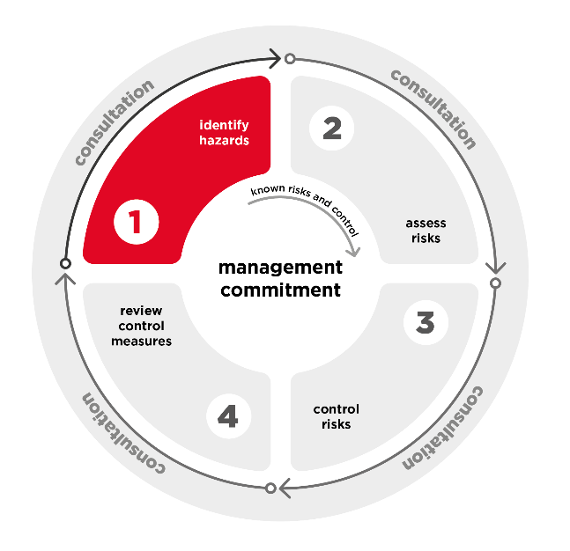
    - Identify hazards
The first step in the risk management process is to identify hazards. This involves identifying the aspects of work and situations that could potentially harm your workers or others at your workplace and why these may be occurring. This step should also assist PCBUs to identify where and when workers are exposed to fatigue risks, and if controls are not adequately eliminating or minimising risks from known hazards.
Fatigue risks can be separated into the risk of a worker becoming fatigued and the health and safety risks that arise once a worker is fatigued.
Workers are likely to be exposed to a combination of hazards and in most circumstances, it will be this combination of hazards which together cause harm. For example, harm is more likely when workers are exposed to long hours, poor conditions and high job demands, and the exposure is repeated, prolonged or severe. However, harm can also be caused by a single hazard or instance such as if workers are exposed to very high demands and irregular shifts during an emergency response.
Some hazards may be constantly present, while others arise sporadically. For example, construction work may be more physically demanding in summer due to the heat or a government department may experience higher work demands during budget time.
      - Risk of workers becoming fatigued
Hazards that create a risk of fatigue
Below are examples of hazards that contribute to the risk of workers becoming fatigued. Some can cause fatigue on their own, but in many circumstances, it will be a combination of hazards together that cause fatigue. Fatigue can be caused by a single instance of exposure to these hazards or over time with repeated or prolonged exposure.
The list and the examples of each hazard are not exhaustive.
Hazard |  | Examples
Work hours and shift design
Long hours |  | - working long hours over a week  - working long hours in a shift  - working ‘double shifts’  - working long hours at night or performing demanding or safety critical work  - on call work in addition to regular shifts
Irregular hours |  | - working in an on call or as need arises capacity beyond a normal work day  - rotating shifts (particularly backwards or slow rotations)  - working remotely for blocks of time (e.g. fly in fly out or drive in drive out work)  - less than 24 hours’ notice is given before shifts reducing ability to plan sleep  - shift start or finish time is changed at short notice  - frequent unplanned overtime
Insufficient breaks during work |  | - regular breaks are not provided  - breaks are tightly scheduled or workers do not have any control over when they take breaks  - workers don’t have access to flexible, regular comfort breaks
Insufficient breaks between periods of work |  | - working more than 5 days in a row  - not having at least one full day off per week  - not having at least two consecutive nights sleep between shift blocks – to allow adequate sleep recovery  - where extended commute times reduces sleep opportunity  - having less than 12 hours between shifts  - shift design that doesn’t allow free days for family/social interaction (e.g. not having regular free weekends or consecutive days off)  - workers don’t have opportunities to use leave entitlements
Work that disrupts circadian rhythm |  | - doing night work, particularly between 2am and 6am  - doing more than 3 successive night shifts  - travelling between midnight and 6am  - when less than 24 hours’ notice is given before night work
Tasks, equipment or environments
High physical job demands |  | - physically demanding, challenging or tiring work  - time pressures or fast paced work  - new tasks where workers haven’t built the necessary fitness  - prolonged sedentary work  - lack of tools and resources to perform work  - inefficient work systems resulting in increased job demands
High emotional job demands |  | - responding to distressing or traumatic situations  - managing heightened emotions of others in the workplace  - providing support or empathy  - suppressing emotions  - displaying false emotions  - new tasks where difficult situations may be unexpected or more distressing than a worker expects
High or low cognitive (or mental) job demands |  | - complex tasks or work that exceeds workers’ capacity and competency  - sustained concentration or vigilance  - work where fatigue-related errors may have high risks  - poorly designed or integrated technology  - tasks with little or no margin for error  - absence of systems to prevent individual errors  - repeatedly or rapidly switching tasks  - insufficient time for the number or volume of tasks  - repetitive tasks  - rapid or prolonged organisational change  - new tasks or technology the worker is learning  - monotonous work or passive monitoring tasks
Exposure to other psychosocial hazards |  | - poor support from leadership or co-workers, increased demand where there are inadequate workers for a task, or tools or equipment aren’t available  - low job control, workers are prevented from varying task intensity, changing tasks or controlling the pace of their work  - remote or isolated work which may require significant travel time or limit support from other workers  - other psychosocial hazards, e.g. poor reward and recognition and exposure to violence
Poor physical work environment |  | - extremes of heat or cold  - high noise levels  - poor lighting  - exposure to hazardous substances  - exposure to vibration and ergonomic hazards  - limited access to healthy food options or facilities to store and heat healthy food options
Poor accommodation |  | - worker accommodation that doesn’t allow for sleep and recovery (e.g. appropriate temperature for sleep and light blocked out for night shift workers sleeping during daylight hours)  - worker accommodation requiring significant travel to the workplace
Individual (both work and non-work)
Sleep amount and quality | - time since last sleep  - influence of alcohol and drugs on amount and quality of sleep  - age, health and fitness (e.g. sleep disorders)  - dietary factors (e.g. quality and time of meals)
Fitness for work | - limited experience (e.g. new or young workers learning tasks)  - new to shiftwork  - fitness for work (e.g. general health and fitness)  - recent illness/injury
Sleep opportunity | - second jobs  - caring responsibilities  - extended commutes between work and home  - sleep environment
Workplace barriers | - perception fatigue can’t be managed without detriment to business or career (e.g. sole traders and apprentices)  - barriers to understanding health and safety information (e.g. literacy or language)  - barriers to raising health and safety issues (e.g. power imbalances or psychosocial hazards such as bullying)  - working to multiple PCBUs (e.g. labour hire workers or contractors)

      - Health and safety risk from fatigue
Fatigue reduces workers’ reaction times, alertness, strength, coordination, ability to communicate, memory, concentration, patience and judgement. Fatigued workers may also have elevated blood pressure, fall asleep or have micro sleeps. Where safety relies on workers’ performance this can lead to safety incidents and harm.
The health and safety risk from fatigue is greatest where:
- workers are doing hazardous work (e.g. working at heights, operating plant, working with hazardous chemicals, doing electrical work)
- systems to control risks from harmful workplace interactions and behaviours such as harassment or violence and aggression are insufficient
- there are insufficient systems in place to prevent fatigue-related errors (e.g. relying on workers to maintain vigilance, memorise information or perform manual calculations without checks), or
- there are insufficient systems to protect workers from fatigue-related errors.
Sometimes workers may arrive to work already fatigued and safety systems should account for some fatigue.
      - How to identify fatigue-related hazards
PCBUs should use a variety of sources to identify hazards. In the context of fatigue, ensure you identify both:
- hazards likely to cause fatigue, and
- the health and safety risk from fatigued workers and others.
You can seek information on fatigue-related hazards from:
- considering planned work
- workers through:
  - consultation
  - surveys and tools
  - having a reporting mechanism and encouraging reporting
- workplace inspection and observation
- reviewing available records and analysing data
- seeking information from reliable sources, and
- monitoring the health of workers and conditions at the workplace.
You should look for trends across these information sources. As well as identifying common hazards, ensure your process identifies hazards for less common but serious incidents, such as working long hours in response to an emergency.
Consider planned work
Consider planned work to identify the fatigue risks it may create. Including:
- work hours and shift design
- tasks, equipment and environments
- the systems of work and processes
- individual factors (e.g. new workers for a project may be inexperienced)
- safety risk exacerbated by fatigue (e.g. driving).
There are tools available which support work planning and can assist to prevent fatigue.
Ensure you consider foreseeable issues impacting on fatigue risks. For example, delays, interruptions or additional work which may result in changes to work hours, additional workers or changes to job demands.
Information from workers
You must consult your workers when identifying hazards at the workplace. For example, consulting your workers to understand where fatigue hazards arise in their work and what creates those hazards (see also part 2.2 of this Code of Practice). However, there are other ways of seeking information from your workers which you may choose to use in addition to consultation, such as surveys and hazard reporting.
Surveys or other tools which collect data from workers have the advantage of proactively seeking information from workers who may not otherwise report feeling fatigued. Tools can capture information to better understand the hazard, such as the work demands, complexity and activity levels which contribute to fatigue. Fatigue self-assessment tools can assist overcome challenges with workers correctly identifying their own fatigue level. You can design surveys to provide workers with anonymity or to target areas of work where you are concerned there may be a problem. For example, you could use surveys to identify whether workers feel fatigued undertaking particular tasks or shifts.
You should have a mechanism for reporting WHS matters and encourage workers to report fatigue related incidents, hazards that may give rise to fatigue and any risks that fatigue may create. Your reporting mechanism should protect workers’ privacy and allow for anonymous reporting where possible. Your reporting mechanism should suit your business size and circumstances and be proportional to the risks in your business.
Burnout
The World Health Organization (WHO) explains that burnout is not a medical condition but rather an occupational phenomenon. WHO defines burnout as a syndrome conceptualised as resulting from chronic workplace stress that has not been successfully managed. It is characterized by three dimensions:
feelings of energy depletion or exhaustion
increased mental distance from one’s job, or feelings of negativism or cynicism related to one's job, and
reduced professional efficacy.
Burn-out refers specifically to phenomena in the occupational context and should not be applied to describe experiences in other areas of life.
Burn-out and fatigue are different, however fatigue may contribute to burnout and a fatigued worker may describe feeling ‘burnt out’. This should not be ignored or overlooked when identifying fatigue risks.
Workplace inspection and observation
A workplace ‘walk-through’ inspection is a useful way of identifying hazards.
Fatigue related hazards may be identified by observing the:
- workplace (e.g. are there poor workplace conditions which may contribute to fatigue such as poor support or lack of resources)
- work and how work is performed in practice (e.g. is the work physically, cognitively or emotionally demanding, is work delayed, do certain tasks result in frequent mistakes), and
- workers.
Ensure the inspection considers all elements of the workplace such as vehicles.
Signs workers may be fatigued include:
- excessive yawning or falling asleep at work
- increased blink rate
- reduced alertness
- noticeably reduced capacity to engage in effective interpersonal communication
- impaired decision-making and judgement
- reduced hand-eye coordination, reaction time or slow reflexes, and
- reduced ability to process information.
Not all hazards are ‘visible’ so a walk-through should not be used in isolation.
Workers may also have symptoms that are not obvious to others (e.g. feeling drowsy, headaches, difficulty concentrating, blurred or impaired vision, need for extended sleep on days off).
Review available records and data analysis
Review relevant information and records which may include:
- records of hours worked including any differences between rostered and actual hours worked, shift swaps, and any records of shift schedules which were redone because of fatigue or working hour requirements
- records of injuries, incidents or workers’ compensation (e.g. incident investigation reports)
- worker complaints – including non-WHS compliance (e.g. an industrial relations grievance regarding hours of work may indicate a fatigue related hazard)
- investigations or audit records
- reports from workplace inspections (e.g. HSR or safety officer walk arounds)
- staffing including number of unfilled positions
- work systems, policies, governance arrangements and procedures
- duty statements and performance agreements
- data on leave usage, including sick, annual and long service leave
- absenteeism, turnover data and exit interviews, and
- Health and Safety Committee (HSC) meeting records.
You should ensure you are collecting and maintaining records in a form that covers all workers and can be used to help you understand patterns and WHS risks at work. For example, only being able to access records of hours worked in relation to individual personnel files, or through accessing individual entry/exit swipe times, would limit your ability to identify risks in a timely way.
Seek information from reliable sources
Information and advice about fatigue hazards and risks relevant to particular industries and work activities are available from the work health and safety regulator, other safety regulator where applicable, industry associations, unions, technical specialists (e.g. human factors specialists or ergonomists), similar workplaces and safety consultants. Advice is particularly helpful in complex or high risk situations.
Monitoring
WHS Act section 19
Primary duty of care
PCBUs must ensure, so far as is reasonably practicable, that the health of workers and conditions at the workplace are monitored for the purpose of preventing illness or injury of workers arising from the conduct of the business or undertaking. For example:
- monitor the workplace conditions to minimise fatigue (e.g. workstations are well lit and temperature is comfortable)
- if sleeping facilities are provided at the workplace (e.g. for on-call emergency workers or crews on vessels) regularly check the facilities (e.g. air conditioners, blinds) to ensure the conditions remain suitable for sleep, or
- if workers are driving long distances install equipment to monitor fatigue (e.g. in-vehicle eye-monitoring and reporting systems).
Any risks to health and safety from workplace monitoring must also be managed. For example, only check sleeping facilities when they are not in use to minimise the risk of sexual or gender-based harassment.
Look for trends
You may be able to identify trends from the information you collect. Trends may show certain tasks have more hazards associated with them, or some hazards are more common in certain roles. Trends may show workers on a particular task, shift or area are exposed to more hazards than in other areas. This can inform your risk assessment.
You can improve your trend analysis by:
- using multiple sources of data or information
- consulting workers to check any assumptions and get more context, and
- reviewing data and information over time – this can help show any changes over time and help identify any periods of increased risk.
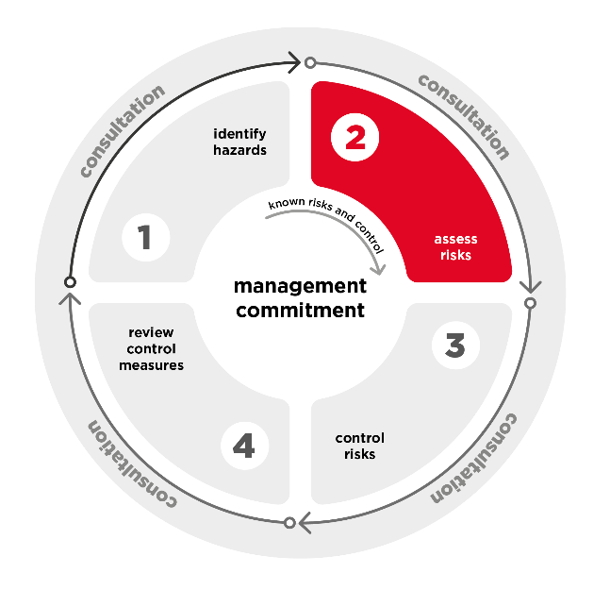
    - Assess the risks
      - When should you assess the risks?
Assessing the risks will help you determine what is reasonably practicable to control them.
However, if you already know what the risks are and how to control them effectively, you can implement the controls without undertaking a risk assessment and then check to confirm these have been effective.
Further information on risk assessments is available in the Code of Practice: How to manage work health and safety risks.
      - How to assess the risks
When assessing risks, you must do so in consultation with workers and their HSRs if you have them. To fully understand fatigue related risks:
- Consider the duration, frequency and severity of exposure to fatigue hazards and how fatigue hazards may interact or combine. This will provide an understanding of the risk of workers becoming fatigued and being exposed to the health risks of fatigue.
- Consider the likelihood and consequences of harm from fatigue related incidents. This will provide an understanding of the safety risk from fatigued workers.
Risk of workers becoming fatigued
Considering duration, frequency and severity generally provides a clearer understanding of the risk from cumulative or chronic risks such as the long-term health risks from fatigue. It is specifically required for psychosocial hazards and hazardous manual tasks.
- Duration – how long is the worker exposed to the hazards or risks?
- Frequency – how often is the worker exposed to the hazards or risks?
- Severity – how severe are the hazards and the workers’ exposures?
Risks increase the longer, more often and more severely workers are exposed to hazards and risks. For example, the risk of fatigue from long hours increases the more often a worker works long hours and the longer the hours are, or the risk of harm from high job demands increases the more severe the exposure.
Fatigue hazards combine and interact to change or increase the risk. For example,
- if a worker is exposed to physically demanding work in high temperatures and long hours, the risk of fatigue is increased
- managing psychosocial risks well may help to reduce the of fatigue from a long shift. and
- unplanned overtime added to a day shift extending it into the early evening will have a lower fatigue risk than an evening shift that is extended after midnight.
Safety risk from fatigue-related incidents
Considering likelihood and consequences may be more useful where there is an immediate risk from an incident.
- Likelihood – how likely is it that someone will be harmed?
- Consequences – how severe could the harm be?
You should consider the likelihood and consequences of the full range of harms. For example, the risk for a fatigued driver could range from shutting their hand in the door resulting in soft tissue injuries to driving off the road resulting in fatal injuries.
Fatigue related hazards should not be considered in isolation. Workers and others may be exposed to more than one fatigue related hazard at any time and hazards can interact or combine to create new or higher risks.

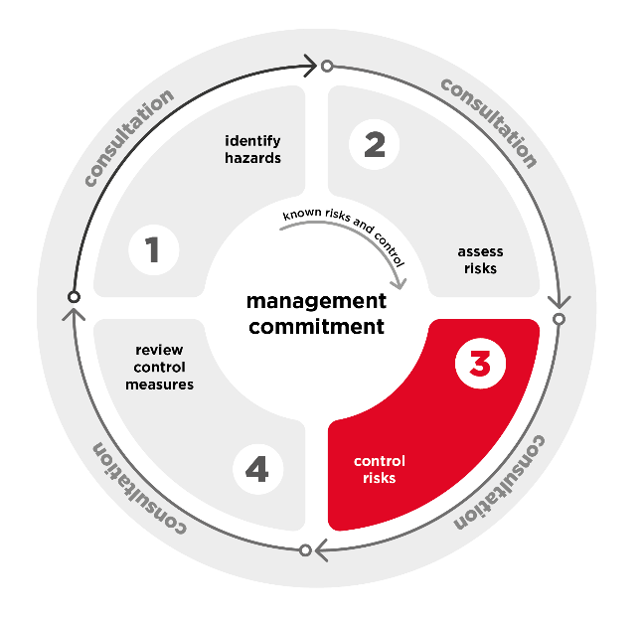
    - Control the risks
You must eliminate risks to health and safety if it is reasonably practicable to do so. If it is not reasonably practicable to eliminate the risks, you must minimise risks so far as is reasonably practicable.
You must consult with workers, and any HSRs, when making decisions about ways to eliminate or minimise risks.
      - Combination of control measures
You will likely need to implement a combination of control measures.
The best combination of control measures will be tailored to your organisation’s size, type and work activities to manage risks during both everyday operations and emergencies.
It is important to control the risk for each fatigue hazard. For example, only changing shift patterns will not manage the risk of fatigue from high cognitive job demands.
You may need to balance different risks and check whether your control measures introduce new risks.
      - Preventing fatigue
Preventing workers from becoming fatigued is the most effective way of controlling the risk as it eliminates or minimises both the health and the safety risks from fatigue.
Work hours and shift design
There is no single shift design suited to all workplaces, however there are common principles you can apply in designing shifts to minimise fatigue, including:
- minimising long or irregular hours
- minimising circadian disruption, and
- ensuring sufficient breaks both during and between shifts.
Shift design can be supported by scheduling software, such as technology leveraging bio-mathematical models. Such software can enhance the quality of data used to develop appropriate schedules and help manage irregular operations. Software can also be used to monitor some fatigue risk during shifts, and support analysis of fatigue impact on incidents. Like all technology, the use of this software requires appropriate human interpretation.
Worker agreement to work high risk shifts
The duty on the PCBU is not removed by hours set in employment contracts, enterprise agreements or awards or a worker’s preference for certain shift patterns, for social reasons, their willingness to work extra hours or to come to work when fatigued. It is also not mitigated by the renumeration provided and WHS duties are owed whenever workers are working even if they are not being paid.
Minimise long hours
The risks that workers will become fatigued increases the longer workers are at work. This can be managed by minimising long hours, in particular ensuring workers do not work long hours over a week or long hours over a day.
However, the safe shift length will depend on other fatigue related hazards present. For example, risk is higher for night shifts, very demanding work and where safety is dependent on workers being alert (e.g. driving or operating machinery). Where there is a high risk of or from fatigue (e.g. night shifts or doing demanding or safety critical work) consider restricting shifts to no more than 8 hours and avoid overtime allocation.
Minimise irregular hours
Minimising irregular hours reduces the risks of workers becoming fatigued. While it may not be reasonably practicable to eliminate irregular hours, (e.g. where on call arrangements are used to avoid other fatigue related hazards) risks of irregular hours must still be managed, so far as is reasonably practicable. For example, by:
- setting rosters early to ensure workers can plan personal time and adjust sleep patterns, particularly if transitioning to or from the night shift
- minimising last minute changes to rosters particularly within 24 hours of a shift to ensure workers have adequate sleep opportunity before shifts
- minimising the use of on call rosters and allow workers flexibility over nominating for additional shifts
- developing contingencies for unplanned absences to minimise calling workers in at short notice
- providing workers with more control over their shifts to allow for personal responsibilities and leisure time
- scheduling shifts in a forward rotation when transitioning workers between day and night shifts, and
- minimising workers exposure to other fatigue related hazards and managing the risks that may arise from fatigue.
Minimise circadian disruption
Minimising work hours that disrupt workers’ circadian rhythm or body clock is an important part of preventing fatigue. Where it is reasonably practicable, work should not commence before 6am and should end no later than 10pm. The risk of fatigue increases after 10pm but is particularly high between 2am and 6am.
Where it is not reasonably practicable to schedule work for after 6am or before 10pm, minimise the risk. For example:
- schedule non-urgent tasks during the day and only do essential tasks overnight (e.g. a veterinary hospital provides emergency care overnight but delays non-urgent tasks such as paperwork or scheduled care to day shifts)
- don’t roster workers for more than three successive night shifts
- minimise workers doing night shifts while still ensuring enough workers for safety (e.g. to minimise the risk of violence and aggression)
- minimise the length of night shifts.
- ensure workers can adjust to night work (e.g. providing at least 24 hours’ notice and using a forward shift rotation)
- encourage workers to have a strategic nap in the afternoon before the first night shift
- minimise other fatigue related hazards, and
- minimise the risks from fatigue – in particular, avoiding tasks where there is a high risk from individual mistakes during low body clock periods (e.g. driving).
Provide sufficient breaks while at work
The risk of fatigue can be minimised by providing workers with sufficient breaks while they are at work. At a minimum, workers should have a 30-minute break every five hours. More frequent breaks may be required when other fatigue related hazards are present. For example, construction and maintenance workers doing physically demanding work, outside in the heat should have more frequent breaks.
Avoid disruptions to breaks such as workers being ‘on call’ during break time.
As well as formal breaks, workers should also have access to flexible and regular comfort breaks (e.g. to get water, use the toilet or stretch).
You can support workers to take breaks by increasing workers control over their breaks, and ensuring workers feel safe and able to access breaks.
Schedule sufficient breaks between periods of work
The risks of fatigue can be minimised by ensuring workers have sufficient breaks between periods of work. For example, scheduling work to ensure workers:
- provide opportunity for ‘down time’ as well as sufficient sleep opportunity
- do not work more than 5 days in row
- have at least one full day off per week
- have at least two consecutive nights of sleep opportunity between shift blocks
- do not have less than 12 hours between shifts
- have free weekends at least every three weeks
- have opportunities to use leave entitlements, and
- are not also exposed to other fatigue related hazards and that the risks arising from fatigue are managed.
You can provide workers with information on the importance of sleep and tips on how to make maximum use of sleep opportunities.
Breaks between periods of work should be a complete break allowing workers to disconnect and rest wherever possible. Eligible employees also have the right to refuse employer or third-party contact outside of working hours under industrial relations laws. Information on Right to Disconnect is available from the Fair Work Ombudsman.
Task, equipment and environment
Tasks a worker undertakes, the equipment used and the work environment can create a risk of fatigue even where shifts have been designed to minimise the risk from working hours and times.
These hazards (listed in Chapter 3) can be eliminated or minimised by:
- managing psychosocial hazards that contribute to fatigue, particularly high job demands – see the Code of Practice: Managing psychosocial risks at work
- managing the risks from hazardous manual tasks that contribute to fatigue - see the Code of Practice: Hazardous manual tasks
- managing risks from the work environment contributing to fatigue – see the Code of Practice: Managing the work environment and facilities
- minimising the duration, frequency and/or severity of workers’ exposure to hazards that cause fatigue.
Specific examples of control measures for hazards arising from the task, equipment and environment are listed below.
Task
- Identify any unnecessary work which can be removed.
- Set realistic deadlines and scheduling work to minimise high physical and cognitive demands.
- Schedule hard or complex tasks early in the shift and avoid these tasks when energy and concentration may be low (e.g. between 12-4am and post lunch 2-4:30pm).
- Allow workers flexibility to vary their task intensity (e.g. if work is machine or computer paced workers should be able to vary the speed of the work throughout the shift).
- Roster sufficient workers for the expected workload and have processes to address unexpected peaks in workload (e.g. calling on additional worker, deferring non-essential tasks or referring work to other PCBUs).
- Rotate workers through physically, cognitively or emotionally demanding tasks (e.g. rotate workers through tasks such as providing bad news).
- Ensure workers have appropriate training, skills and experience for the task.
- Avoid interruptions or the requirement for workers to rapidly switch tasks (e.g. provide a quiet space for tasks requiring concentration).
Equipment
- Provide tools and equipment to assist with tasks, (e.g. lifting equipment or software).
- Ensure tools are stored close to the location work is undertaken.
- Select equipment which minimises hazards such as noise and vibration.
Environment
- Set the temperature to match the work being done (e.g. cooler where workers are performing more physical tasks) or schedule outdoor tasks to suit the temperature (e.g. avoiding extremes of heat and cold).
- Ensuring the workplace is well lit, particularly during night shifts.
- Ensure workers have access to healthy food or the facilities to store and heat healthy food options.
- Minimise loud noise such as machinery but where reasonable allow workers to listen to music, the radio or podcasts to assist with alertness.
Accommodation
PCBU owned and managed accommodation
WHS Act section 19(4)
Primary duty of care
If you provide accommodation for workers and own or manage the accommodation you must, so far as is reasonably practicable, maintain the premises so that the worker occupying it is not exposed to health and safety risks. This includes both physical and psychosocial risks such as fatigue.
For example, accommodation for workers working in regional or remote areas, sleeping onboard vessels, or for workers who are on call during sleeping hours.
Accommodation should support workers to get adequate sleep, rest and recovery. For example, to ensure worker can get adequate sleep, accommodation should:
- be close to the workplace to minimise the need for travel and maximise sleep opportunity
- have sleeping quarters shielded from noise, light and vibration
- have adequate lighting, heating, cooling and ventilation
- be lockable, with safe entry and exit, and
- be regularly cleaned and have rubbish collected.
Other accommodation
Workers may need to stay in accommodation you don’t own or manage. For example, in a hotel while travelling for work. In these cases, you must still ensure the health and safety of workers while they are at work, so far as is reasonably practicable. The same considerations as listed for accommodation you own or manage apply to third party accommodation, however what is reasonably practicable to manage the risk may be different. For example, it may not be reasonably practicable to shield sleeping quarters from noise, however you may be able to select a hotel in a quiet area, particularly where a worker needs to sleep during the day.
Managing risks for individual workers
It may be reasonably practicable to accommodate the needs of an individual worker to prevent harm where you are aware of those needs. These changes may include, but are not limited to, flexible working arrangements, adjusting workplace policies, changing workload and work hours, the nature of work, the work environment, or support and supervision.
For example, consulting with a worker returning to work after injury and offering a temporary change to shorter shifts while they recover.
      - Managing health and safety risks from fatigue
While preventing fatigue should be the first priority, it may not always be reasonably practicable. Even where you have effective strategies in place to minimise fatigue there may be a risk from hazards outside your control.
You must eliminate or minimise the risks from fatigue (e.g. the risk of fatigue related incidents).
For some work, errors or slower response rates from fatigued workers will pose little immediate risk (e.g. jobs where quality of work may suffer but not create a WHS risk) for others the consequences can be catastrophic (e.g. bus drivers). The higher the risk from fatigue, the more you need to do to identify and control the risks.
Stimulants
Many workers will drink coffee, tea, soft drinks or energy drinks to make them feel awake. However, PCBUs should not rely on stimulants as a control measure for fatigue.
Stimulants such as caffeine can temporarily reduce feelings of fatigue and may reduce fatigue-related errors for a short time, but as the effects wear off fatigue can worsen. Stimulants also disrupt sleep so may increase fatigue over time. It may also have long term impacts.
Some stimulants affect workers’ ability to perceive and process risk. Inappropriate use of these stimulants can increase risk taking behaviour.
Monitoring, early intervention and recovery
Having a system to monitor worker fatigue as well as procedures for intervening when workers are fatigued, provides the opportunity to intervene and address the risk before an incident occurs. If a risk is identified the underlying hazards should be addressed as well as the immediate risk.
Monitoring can include a mechanism for workers to self-assess and report fatigue. However, this will not be effective if there are barriers to self-reporting including punitive treatment of workers and no review process to look at possible scheduling impacts on the worker.
Many of the control measures to prevent fatigue can also be used to help workers recover once they are fatigued. For example, providing adequate time between shifts to recover, increasing breaks and minimising job demands.
It may be reasonably practicable to provide some of these control measures to workers to use at their discretion, such as flexibility to take short breaks, adjust the temperature or change the pace of their work. Additional control measures may be reasonably practicable to apply once you identify that a worker is fatigued. For example, providing additional breaks.
Napping at work
Workplace napping may temporarily reduce fatigue and improve alertness and performance. Napping can be used in response to unanticipated fatigue risk, however should not be required or routinely used as a control measure.
Napping can create sleep inertia where a worker will wake up temporarily inhibited (tired, groggy or disoriented). To prevent sleep inertia from creating a safety risk:
- no more than 40 minutes should be spent trying to nap, and
- workers should wake up at least 10 minutes prior to returning to work to allow time to recover from sleep inertia.
Where workplace napping is used as a control for fatigue workers should be provided with a suitable space (e.g. quiet, temperature controlled and away from customers, clients or patients).
Naps can be provided during a shift or at the conclusion of a shift to reduce the fatigue risk during the worker’s commute.
Have systems in place to prevent workers making fatigue-related errors
A system of work which relies on workers not making errors is particularly vulnerable to fatigue. Administrative WHS control measures and personal protective equipment rely on human behaviour. They can be forgotten, overlooked or applied incorrectly, particularly by fatigued workers.
If it is reasonably practicable, eliminating the potential for fatigue-related error that carries a WHS risks will significantly reduce the risks arising from fatigue. For example, automating tasks to prevent errors. Where risks can’t be eliminated, applying more effective and reliable control measures (engineering, isolation or substitution controls) will significantly reduce the risk.
Often it will not be reasonably practicable to eliminate all potential errors. But the risk to health and safety of errors must then be minimised so far as is reasonably practicable. For example,
- change tasks or processes that result in frequent errors (e.g. engineers using computer software to calculate safety-critical load ratings instead of doing this manually)
- introduce systems to prevent errors (e.g. have reminders and written notes instead of relying on workers’ memory)
- schedule tasks during low risk periods to minimise the risk of errors (e.g. not at the end of a long shift)
- redesign the workplace to remove slip and trip hazards (e.g. remove objects a fatigued worker needs to navigate over or around)
- assign tasks to workers who are less likely to be fatigued (e.g. have worked fewer hours or on less fatiguing tasks)
- assign tasks to workers who have the right skills and experience to do the task who may be less likely to make mistakes, and
- train newer or inexperienced workers and supervise them while they gain experience.
Have systems in place to protect workers and others from the consequences of fatigue-related errors
If fatigue-related errors may still occur, have systems in place to protect workers and others from the risks they create. For example:
- providing work vehicles with active safety features
- introduce systems to double check for mistakes
- reduce workplace noise or other hazardous workplace conditions so that mistakes in wearing PPE will have less severe consequences
- ensure plant is guarded so even if workers slip, they will not be injured, and
- fit plant with safety trigger mechanisms if operator is incapacitated (dead man switches).
This is particularly important when fatigue-related errors may have high consequences for example, in healthcare, construction or plant operations.
Incident response
Responding promptly and effectively to incidents can minimise the harm caused.
The WHS Regulations set specific requirements on emergency plans and first aid. For information see the Code of Practice: First aid in the workplace and Code of Practice: Managing the work environment and facilities.
In the event of a notifiable incident (death, serious injury or illness or dangerous incident) arising out of the conduct of the business or undertaking, you need to notify your WHS regulator. You may also need to notify other authorities such as the police or industry-specific regulator.
Notification requirements are not limited to incidents that occur at the workplace, or while working. A notifiable incident must be notified to the WHS Regulator if it arises out of the conduct of the business or undertaking, irrespective of where the harm occurs. For example, if a worker is seriously injured in a car accident on the way home from night shift that occurred due to work-related fatigue.
For information see the Incident notification information sheet.
      - Fatigue duties shared with workers
Managing the risk of fatigue is a shared duty where both the PCBU and workers have opportunities to control the risk.
WHS Act section 28
Duties of workers
Workers must take reasonable care for their own health and safety and to not adversely affect the health and safety of other persons. Workers must comply with reasonable health and safety instructions, as far as they are reasonably able, and cooperate with reasonable health and safety policies or procedures that have been notified to workers.
Worker duties
It may be reasonable for workers to ensure they do not come to work fatigued by having sufficient rest and sleep (e.g. avoiding staying up late before an early shift). If that is not reasonable (such as where fatigue is outside a worker’s control), that workers follow a process to notify someone and minimise the risk of incidents. Even where fatigue related actions or omissions do not carry safety risks, workers should advise the PCBU/supervisor if fatigue risks are severe, frequent or prolonged to prevent harm to their health.
If workers are fatigued, they must take reasonable care for their own safety and not adversely affect the health and safety of other persons. This may mean notifying the PCBU of fatigue or where they have control over their task, rescheduling tasks that carry risks from fatigue to a time when they are not fatigued.
Workers must comply with reasonable health and safety instructions, as far as they are reasonably able, and cooperate with reasonable health and safety policies or procedures that have been notified to workers. For example, workers must follow any reasonable health and safety policies on fitness for work or second jobs.
PCBU and worker duties exist concurrently. Worker duties in relation to fatigue do not diminish a PCBU’s duty to identify and manage fatigue risks. Controls that rely on workers self-identifying and reporting fatigue may not be effective on their own.
A system of work which relies on workers never being fatigued and always showing up to work well rested is not a safe system of work. However, in workplaces where there is a high risk of fatigue or fatigue may create serious risks, it may be reasonable to ensure policies address fitness for work and provide a mechanism for workers to self-report fatigue and be provided with alternative duties. These policies may be incorporated as part of your WHS policies; employment contracts; enterprise agreements; leave, shift, overtime, travel and outside employment policies and other policies.
Policies on fitness for work and second jobs can ensure workers understand what is expected of them and how they can minimise fatigue risks.
WHS policies are not stand-alone documents and will need to be reflected in other places such as employment contracts, travel arrangements, project schedules and IT system (i.e. shift scheduling software). To be effective workers need to know what will happen to them if they report fatigue and managers need to ensure reports are dealt with appropriately.
Second job policies should not limit workers to working less than standard full-time hours regardless of the number of jobs they have. It is important you manage the risks of fatigue for all workers and do not provide a lower safety standard for part time or casual workers.
In addition to designing shifts to minimise fatigue, you can reduce the risk of workers coming to work fatigued by:
- provide information to workers about how to manage fatigue (e.g. how to transition on and off the night shift).
- providing notice of shifts particularly any long, irregular or night shifts, and
- increasing workers control over their shifts.
You should be respectful of workers privacy if you need to collect personal information to manage the risk of fatigue. Consider what information is actually needed and ensure you treat any information you gather appropriately and in accordance with relevant privacy laws.
      - Other persons
PCBUs must ensure, so far as is reasonably practicable, that the health and safety of other persons is not at risk from work carried out as part of the conduct of the business or undertaking.
Other persons at the workplace also have WHS duties. This means you can give reasonable instructions to address fatigue risks, and under WHS laws they must follow them.
What is reasonably practicable to manage a risk to other persons may be different to what is reasonably practicable to manage a risk for workers. In part, because in most situations other persons are unlikely to be exposed to the risk of fatigue from work carried out over long periods of time and so are not at risk of chronic consequences of fatigue. For example, a night construction worker will be at risk of long-term consequences of fatigue but a resident near a construction site is unlikely to be exposed to disruption over the long term.
Other persons can be at risk of harm both from becoming fatigued and from fatigue related incidents either because they are fatigued or because workers are fatigued.
Managing fatigue risk for workers will also in many circumstances manage the risks to other persons. For example, a fatigued bus driver can create a risk to their passengers and other road users, managing the risk to the driver will also manage the risk to others.
You may need to manage fatigue risks to other persons directly. For example:
- universities setting realistic workloads for students and supporting timetabling arrangements that allow students to balance work shifts in a way that minimises the risks of fatigue, or
- self-driving tour operators requiring tourists to arrive the night before their tour commences, scheduling regular breaks and limiting the driving hours each day.
In managing the risks of others becoming fatigued you should consider:
- if there are fatigue related hazards you can reasonably foresee (e.g. travel time or the time of day you undertake an activity; adult students having to work in addition to their study load), and
- if lack of experience or skill with a task or activity is likely to increase fatigue risks.
Higher risks could arise because other persons are at greater of becoming fatigued (e.g. customers doing a hiking tour are unlikely to be as fit as tour guides) or because they are at higher risk once they are fatigued (e.g. they are more likely to make mistakes because they are unfamiliar with a task).
WHS Act section 29
Duties of other persons at the workplace
Other persons at the workplace must take reasonable care for their own health and safety and must take reasonable care not to adversely affect other people’s health and safety. They must comply, so far as they are reasonably able, with reasonable instructions given by the PCBU to allow them to comply with the WHS Act and WHS Regulations. For example, tourists on a self-drive tour may be instructed by the tour operator to arrive the night before their tour to minimise fatigue.
      - Implementing control measures
PCBUs should test control measures and ensure you have provided any necessary information, training or instruction to workers before they rely on the control measure. You should also supervise work to ensure control measures are effective.
You may need to implement temporary control measures to address an immediate risk. For example, if you need to recruit workers to cover additional shifts you may need to reduce the scope of work or hours of operation until you have the additional workers.
Test control measures
Testing control measures (e.g. having a trial period for new rosters) allows you to ensure they are suitable for your workplace, operate as intended and do not introduce new risks.
You should allow enough time for your workers to adjust to changes (e.g. new work processes or schedules) before assessing the effectiveness of control measures. At this stage, you should frequently check with your workers on how they think the improvements are working and supervise workers to ensure controls are implemented effectively. For example, to ensure workers are not working additional non-scheduled hours.
Information, training, instruction and supervision
WHS Act section 19
Primary duty of care
WHS Regulation 39
Provision of information, training and instruction
As you are planning to implement control measures, you must consider what information, training, instruction or supervision is required to ensure the control measures are effective.
Training must be suitable and adequate, having regard to:
- the nature of the work to be carried out
- the associated fatigue hazards and risks, and
- the control measures to be implemented.
Training about fatigue and relevant workplace policies should be arranged so it is available to all workers on all shifts. You may need to provide additional training to managers, workers who assign shifts and any others who have key role in ensuring control measures are implemented and effective. For example, it is insufficient to tell workers to make sure shift schedules are safe. You should also:
- train supervisors and shift managers on how to schedule low risk shifts
- where work hours are flexible (e.g. workers do additional unplanned hours), train managers and supervisors on how to identify and manage fatigue risk (e.g. setting shorter hours following a period of longer hours)
- provide information on what to do if there are issues such as how to escalate scheduling if there are insufficient workers on the roster to ensure shifts can be safely schedule, and
- provide sufficient supervision to ensure shift rosters are safe.
Training should require workers to demonstrate they are competent in performing the task. It is not sufficient to simply tell a worker about the procedure and ask them to acknowledge they understand and can perform it. Training may include formal training courses, in-house training or on the job training.
Information, training and instruction must be provided in a form all workers can understand, for example training may need to be provided in other languages. Information and instruction may also need to be provided to others who enter the workplace, such as customers or visitors.
The level of supervision required will depend on the risks and the experience of the workers involved. High levels of supervision are necessary where inexperienced workers are expected to follow new procedures or carry out difficult and safety critical tasks.
Workplace policies
Workplace policies can provide important information and help ensure everyone involved understands the business or undertaking’s processes for managing fatigue. Policies alone should not be relied on to manage the risk of fatigue, but they can detail responsibilities and help set clear expectations. For example, setting out any expectations around fitness for work, second jobs, and any processes for ensuring additional hours are safe.
You may have separate policies or one policy that covers several WHS issues.
WHS policies are not stand-alone documents and will need to be reflected in other places such as employment contracts, travel arrangements and project schedules.
Where you have policies relating to fatigue, these must be developed in consultation with your workers and any HSRs. All workers must be made aware of the policies and what is expected of them.
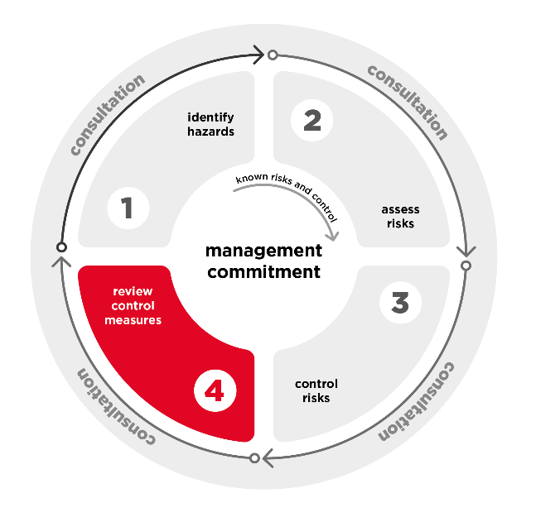
    - Maintain and review control measures
Maintain control measures and review the effectiveness to ensure they are working as planned.
Maintaining control measures means ensuring they are fit for purpose, suitable for the nature and duration of the work; and set up and used correctly. You should decide what maintenance a control measure will require when you implement the control and establish a schedule for routine checks and maintenance.
As the PCBU you must review and modify or replace a control measure if it is not working effectively. Reviewing control measures should be done regularly, and must be done:
- when the control measure is not eliminating or minimising the risks so far as is reasonably practicable
- before a change at the workplace that is likely to give rise to a new or different health and safety risk that the control measure may not effectively control
- if a new hazard or risk is identified
- if the results of consultation indicate a review is necessary, or
- if an HSR requests a review because they reasonably believe one of the above has occurred and it has not been adequately reviewed already.
Reports, complaints (including informal complaints) or grievances from workers may identify new hazards or risks that are not adequately controlled and should trigger a review. These do not have to be raised in a WHS context to be a WHS issue for example, an industrial relations grievance regarding hours of work may indicate that the risks of fatigue are not being managed so far as is reasonably practicable.
Common review methods include inspecting the workplace, consultation, and analysing records and data. You can use the same methods as in the initial hazard identification step to check control measures. You must also consult your workers and their HSRs.
The person reviewing your control measures should have the authority and resources to conduct the review thoroughly and be empowered to recommend changes where necessary. Questions to consider may include:
- Are control measures working effectively, without creating new risks?
- Have workers reported feeling fatigued or are they showing signs of fatigue or other harm?
- Have all fatigue related hazards and risks been identified?
- Have risks changed or are they different to what you previously assessed?
- Are workers actively involved in the risk management process?
- Are workers openly raising health and safety concerns and reporting problems promptly?
- Has instruction and training been provided to all relevant workers?
- Are there any upcoming changes that are likely to result in a worker being exposed to new or different fatigue risks?
- Are new control measures available that might better control the risks?
- Have risks been eliminated or minimised as far as is reasonably practicable?
If the effectiveness of the control measures is in doubt, go back through the risk management steps, review your information and make further decisions about control measures.
    - Record keeping
You should identify the records you need to identify fatigue related risks and keep these in a format you can use to easily identify the risk. For example, records of working hours, breaks and travel. Identifying how you will use the information in your risk management process and designing your systems to make this information easily accessible can save time and money later.
You should also record your risk management process and the outcomes, including your consultation with workers. This allows you to demonstrate you have met your work health and safety duties and will assist you when you need to monitor or review the hazards you have identified and controls you have put in place.
Your records may include the outcomes of consultation, the hazards you identified, how you assessed the risks, the control measures implemented, and the training provided.
You should select a method of recording the risk management process and outcomes to suit your circumstances. For example, you can use a risk register such as the one in the Code of Practice: How to manage work health and safety risks.
It is also useful to have a record of the processes used to investigate and resolve issues. You could choose to include only high-level information in the general risk register where you are concerned about the need to maintain confidentiality.
A work health and safety inspector may ask to see a copy of records relating to WHS if they visit your workplace. If you do not have a written record, you will need to demonstrate by other means how you have met your duties.

Appendix A – Resources
WHS Regulators
New South Wales: SafeWork NSW
Victoria: WorkSafe Victoria
Queensland: Workplace Health and Safety Queensland
South Australia: SafeWork SA
Western Australia: WorkSafe WA
Tasmania: WorkSafe Tasmania
Northern Territory: NT WorkSafe
Australian Capital Territory: WorkSafe ACT
Commonwealth: Comcare
Other Safety Regulators
Australian Maritime Safety Authority (AMSA)
Civil Aviation Safety Authority (CASA)
National Offshore Petroleum Safety and Environmental Management Authority (NOPSEMA)
Office of the National Rail Safety Regulator (ONRSR)
National Heavy Vehicle Regulator (NHVR)
Fair Work Commission
The Fair Work Commission is Australia’s national workplace relations tribunal and registered organisations regulator.
Phone: 1300 799 675
Website: fwc.gov.au
Fair Work Ombudsman
The Fair Work Ombudsman is Australia’s national workplace relations regulator. It provides employees and employers with information and advice about workplace entitlements and obligations.
The Fair Work Ombudsman can provide general information about protections.
Phone: 13 13 94
Website: fairwork.gov.au
Workers’ compensation
If a worker sustains a physical or mental injury from fatigue requiring medical attention or time off work, they may be able to access worker’s compensation.
New South Wales: NSW State Insurance Regulatory Authority
Victoria: WorkSafe Victoria
Queensland: WorkCover Queensland
South Australia: ReturnToWork SA
Western Australia: WorkCover WA
Tasmania: WorkSafe Tasmania
Northern Territory: NT WorkSafe
Australian Capital Territory: WorkSafe ACT
Commonwealth: Comcare

Appendix B – Risk management chart
Step 1: Hazard identification | Step 2: Risk Assessment | Step 3 Risk Control
Identify potential hazards and risks at the workplace. Examples are listed below however, you must consider these in the context of your workplace or industry. | To assist risk assessment, a general level of risk for each hazard is indicated along arrow guides. In assessing risk consider interaction between hazards and how that could influence the level of risk. Also take into account specific workplace/industry circumstances. | You must eliminate of minimise the risk so far as is reasonably practicable. Examples of control measures are included below and in Chapter 5 of this Code.

Step 1: Hazard identification | Step 2: Risk Assessment |  |  | Step 3 Risk Control
Hazard | General Risk indicator |  |  | Control measures
Work hours and shift design |  |  |  | The most appropriate control measures should be implemented for the identified hazard. Control measures may include:
Long hours | 35-40 hours (per week)  7-8 hours (per shift) | 48 hours (per week)  10 hours (per shift) | 55 hours (per week)  13 hours (per shift)  Safety crucial work performed at night  Double shifts | - Monitor actual time worked against the allocated roster and identify if excessive hours are being worked.  - Plan into work schedules enough workers and other resources to do the job without placing excessive demands on workers.  - Ensure workers have and take adequate and regular breaks so they can rest, eat and rehydrate.  - Structure shifts and work plans so demands are highest towards the middle of the shift and decrease towards the end.  - Use forward rotation roster systems (day-evening-night).  - Avoid overtime allocations after afternoon or night shifts.  - Consider sleep opportunity and recovery in instances where workers are required to work on call after a normal shift or on days off.  - Schedule safety critical work outside low body clock periods (i.e. between 2am and 6am).  - Have opportunities for workers to use leave entitlements.  - Avoid quick shift changeovers such as finishing at 11am and starting again at 7am the next day.  - Allocate shift and night workers consecutive days off to allow for at least two full nights rest including some weekends.  - Encourage workers to have a strategic nap in the afternoon before the first night shift.  - Design working hours and rosters to allow for good quality sleep and enough recovery time between workdays or shifts for travelling, eating, washing and sleeping.
Irregular hours | Work hours are regular and infrequently change | Forward rotating shift  Short rotating shifts  Occasional unplanned overtime  Frequent changes to shifts with more than 24-hours’ notice | Regularly working in an on call or as need arises capacity beyond a normal workday  Backwards rotating shifts  Slow rotating shifts  Fly-in fly-out work (or other remote work for short periods)  Less than 24-hours’ notice before start or end time for shift is changed  Frequent unplanned overtime
Insufficient breaks during work | Regular breaks provided and encouraged | Infrequent breaks  Tightly scheduled breaks with little control when breaks can be taken | No breaks
Insufficient breaks between periods of work | Adequate time for sleep, travel, meals, etc  16 hours between shifts | Working more than 5 days in a row  14 hours between shifts | Inadequate time for sleep, travel, meals etc  Working more than 7 days in a row  Less than 12 hours between shifts  Not having at least two consecutive nights sleep between shift blocks  Extended commute times
Work that disrupts circadian rhythm | Day shift | Afternoon shift  Night shifts rostered well in advance to allow time to adjust sleep patterns | Night shift  Work between 2am and 6am – especially safety critical work or traveling  Doing more than 3 successive night shifts  Less than 24 hours’ notice is given before night work
Tasks, equipment or environments |  |  |  | The most appropriate control measures should be implemented for the identified hazard. Control measures may include:
High physical job demands | Minimal physically demanding work | Prolonged sedentary work  Short periods of physically demanding work | Highly physically demanding work  New tasks where workers haven’t built the necessary fitness  Lack of tools and resources necessary | - Install fit for purpose plant machinery and equipment for use at the workplace.  - Redesign jobs to limit periods of excessive cognitive (mental), emotional or physical demands.  - Identify and the causes of high emotional demands.  - Rotate workers through physically, cognitively or emotionally demanding tasks.  - Roster sufficient workers for the expected workload and have processes to address unexpected peaks in workload.  - Schedule hard or complex tasks early in the shift to avoid lower energy and concentration periods later in shifts.  - Plan tasks to remove unnecessary work.  - Provide equipment and/or technology to assist with tasks.  - Match workers skills and experience to the tasks allocated.  - Avoid physically demanding work during periods of extreme temperature.  - Design the workplace to protect workers from extremes of heat and cold (e.g. provide shade and shelter from wind and rain). Install heating and cooling if needed.  - Provide additional breaks if working in extremes of temperature.  - Select and install fit for purpose machinery (low noise and vibration).  - Ensure the workplace and surroundings are well lit, safe and secure.  - Ensure accommodation is quiet, dark (particularly when workers sleeping during the day) and allows for sleep and recovery.
High emotional job demands | Work-related causes of high emotional demand identified and addressed | Workers rotated through emotionally demanding tasks | Prolonged exposure to high emotional demands (e.g. responding to distressing or traumatic situations or managing heightened emotions of others in the workplace)
High or low cognitive (or mental) job demands | Varied task demands within the worker’s skills and experience | Some variation in tasks but long periods of concentration required. | High concentration work, with high demands over an extended period of time  Work where errors may have high risks  Insufficient time for the number or volume of tasks  New tasks or technology the worker is learning  Monotonous work or passive monitoring tasks
Exposure to other psychosocial hazards | Psychosocial hazards identified and effectively controlled | Occasional exposure to psychosocial hazards | Regular, prolonged or severe exposure to hazards such as poor support, high job demands, low job control, remote or isolated work (or other psychosocial hazards).
Poor physical work environment | Well-designed physical work environment | Short exposures to loud noise, extreme temperatures or vibration  Prolonged exposure to low level noise | Prolonged exposure to loud noise, extreme temperatures, vibration or lighting  Exposure to hazardous substances  Lack of access to healthy food options or facilities to store and heat health food options
Poor accommodation | Accommodation provided close to the workplace and allows for reasonable sleep | Longer travel time between workplace and accommodation but transport and drivers provided (e.g. bus) | Worker accommodation that doesn’t allow for sleep and recovery  Worker accommodation requires significant travel to and from the workplace
Individual (both work and non-work) |  |  |  | The most appropriate control measures should be implemented for the identified hazard. Control measures may include:
Sleep amount and quality | Awake for less than 16 hours  8 hours sleep in 24 hours | Awake for over 17 hours | Awake for 24 hours  6 hours sleep or less in 24 hours  Poor quality sleep (e.g. influenced by health conditions, dietary factors or alcohol or drugs) | - Consult workers and designing shift rosters that enable workers to meet work and personal commitments.  - Set clear expectations on readiness for work policy.  - Implement flexible working arrangements to accommodate the individual needs of workers.  - Give additional support or supervision to workers who are new or returning to work after a period of extended absence.  - Implement a systematic approach to providing workers with accessible WHS information.  - Provide information to workers about how to manage fatigue (e.g. how to transition on and off the night shift).  - Give notice of shifts - particularly any long, irregular or night shifts to allow works to plan their sleep and other responsibilities.  - Promote healthy diet by providing facilities to cook or heat healthy meals and appropriate breaks to eat them.
Fitness for work | Experienced workers  Fit and healthy workers | Inexperienced worker but with good supervision and support | Worker has limited experience and support  Worker is new to shiftwork  Poor diet  Recent illness/injury
Sleep opportunity | Adequate time to rest and sleep | Out of work responsibilities occasionally impact sleep | Significant out of work responsibilities impacting sleep time  Extended commutes between work and home sleep environment
Workplace barriers | Accessible options to understand health and safety information and to raise health and safety concerns are provided | Ad hoc approach to ensuring safety information is accessible and supporting workers to raise safety issues | Significant barriers to understanding health and safety information  Significant barriers to raising health and safety issues

Appendix C – Case Studies
These case studies provide examples of ways to manage the risk of fatigue in various industries.

Case study: Health
Situation | Hazards/Risks | Outcome
After a medication administration error, a large city hospital conducted an investigation. During the investigation, they discover the nurse who made the error had worked more than 240 hours that month. The nurse worked many long shifts, some were for 10 hours at night and some were for 12 hours in the day. The nurse had been required to work a number of night shifts at short notice to fill in for absent staff. The unit manager had not been able to call on agency staff or casuals because of budget constraints. For the entire month, the nurse did not get two days off in a row. The shifts the nurse worked over the month were often on a backward rotation. | The investigation revealed there were no effective risk controls for fatigue:  - there was no monitoring of the rosters staff actually worked  - many shifts were scheduled in a backward rotation  - often the rosters didn’t provide enough recovery time between shifts  - some rosters meant staff did not get two consecutive days off a week  - shifts were often varied at short notice and  - no consideration was given to actual acquired sleep of staff and the amount of opportunity staff had to sleep between shifts. | The fatigue risk control measures the hospital implemented included:  - a safe hours policy which included clear guidelines on how to develop schedules minimising the risk of fatigue (including a maximum number of night shifts which could be worked in a roster cycle, minimum number of days off in a roster cycle and minimum hours break between shifts)  - a forward-rotating rostering system  - a roster-monitoring system which included checking rosters actually worked against the planned rosters every month  - budget allocation for agency staff to cover unplanned absences, and  - supervisor and staff training on the new rostering system.

Case study: Fly-in Fly-out construction
Situation | Hazards/Risks | Outcome
A company utilising fly-in fly-out working arrangements to construct facilities for a mining site in a remote area.  Before commencing work, they identify fatigue is likely to be a risk during the construction phase.  They conduct a risk assessment in consultation with their workers and based on their previous experience. | The risk assessment identifies the following hazards:  - some previously trailed shift designs created fatigue risks from long working hours  - long commutes from the nearest airport to site  - seasonal weather conditions mean some work will be conducted in hot and humid conditions  - nuisance and excessive noise on site can disturb or disrupt sleep routines  - ineffective window treatments in worker accommodation can prevent sleeping during daylight hours (if needed)  - poorly scheduled cleaning activities can disrupt sleep  - where alcohol is available on site its use can increase fatigue | The company implements the following control measures to minimise fatigue risks:  - minimising the use of night shifts by identifying where tasks can be accomplished in other ways  - designing work schedules to minimise fatigue, including fly-in and fly-out days  - utilising buses to transport workers between the airport and site so workers aren’t required to drive  - planning work to minimise outdoor work during extreme weather and if it is necessary schedule additional breaks  - minimising sleep disturbances by locating worker accommodation away from communal areas and scheduling cleaning or other noisy activities for times workers aren’t sleeping  - proving accommodation with comfortable beds, sound proofing, air conditioning and blackout curtains  - limiting the availability of alcohol on site, and  - promote good sleep hygiene practices among workers.

Case study: Manufacturing
Situation | Hazards/Risks | Outcome
A manufacturing company runs its operations 24 hours a day, with three shifts, morning, afternoon, and evening. All shifts are permanently allocated to three sets of workers. The night shift is carried out by staff provided through a labour hire company. There is no limit placed on the number of consecutive nights contractors can work and there are fewer staff rostered to work at night than in the day. The night shift includes minimal maintenance staff.  The manufacturing company did not think it had a risk of fatigue until it undertook a health and safety review of injuries, near misses and incidents. They consulted the labour hire company and its workers in as part of the review, which revealed a disproportionate number of injuries, near misses and incidents during the night shift. | The review highlighted the following fatigue hazards:  - no limits on the number of hours which could be worked  - no monitoring of hours actually worked  - the continuous night shift roster did not provide enough recovery time for workers, and  - consistent night shifts meant the night workers rarely got good quality sleep. | The review recommended the following control measures be implemented:  - only operate the lower-risk production lines at night  - give the night supervisors and night maintenance staff permission to shut down the production line when necessary  - implement an organisation-wide fatigue management system to manage and monitor the number of weekly hours worked by each worker  - place a limit of 7 consecutive days and no more than 4 consecutive night shifts  - establish an agreement with labour hire company to set limit on working hours of contractors, and  - provide workers a minimum of six days off every month.

Case study: Hospitality
Situation | Hazards/Risks | Outcome
A chef at a busy local restaurant has been forced to take time off with a second-degree burn acquired during a shift.  When asked what caused the incident, they couldn't give an answer, stating "they guess they were just having a clumsy moment and not concentrating properly ".  This is the second time in a month a worker has been absent due to injury and has prompted a full review of work safety.  Many kitchen staff work purely nightshifts, often not finishing until midnight. | A walkthrough observation of the workplace revealed multiple hazards leading to increased risks of and from fatigue:  - Repetitive motions (such as cutting or dicing) with inadequately sharpened knives are causing high physical fatigue.  - Long hours, at night, without sufficient breaks due to demands in busy periods.  - Excess heat from the stoves without sufficient ventilation, and kitchen layout meaning prep staff work next to hot machinery, causing further fatigue.  - Cognitive load (multitasking, handling multiple orders).  - Managers are stressed and tired from constant time pressures and interactions with staff are often strained or rude. | New systems to implemented to limit fatigue in the restaurant:  - Rostering staff so workers can take scheduled rest breaks.  - Ensure plant and equipment are adequate, functional, and without risk of physical injury (sharp knives, functional dishwasher and safer induction stovetops).  - Separate work areas to limit exposure to hazards.  - Ensure rosters allow at least 12 hours of rest in between shifts, and that there's at least one free weekend every three weeks.  - Change rosters so workers work a maximum of three-night shifts in a row.  - Increase support from senior chefs, cultivate a culture of reporting hazards.

Case study: Warehousing
Situation | Hazards/Risks | Outcome
Daintree Warehousing has received more complaints of incorrect items delivered to customers. They investigate to figure out why this is happening.  Workers manually collect the items from the warehouse shelves then box them to be shipped.  They receive their order through an app, informing them of what item to collect one at a time. KPIs and other targets are tracked through this software, which workers complain are unrealistically high.  It is physically demanding work, with workers lifting hundreds of boxes over a ten-hour shift, with some boxes requiring special lifting equipment. The investigation notes the equipment is being underused. | Key fatigue hazards and risks identified:  - Workers have no control of the order they collect items in, leading to longer walking distances and time in-between collecting items.  - Excessive surveillance through the app is leading workers to feel pressured to work faster creating high job demands and causing mental fatigue.  - Repeated heavy lifting causing physical fatigue, increasing the risk of physical injury.  - The isles are too narrow for the plant to be used correctly, leading more workers to lift boxes manually increasing their physical fatigue. | The review recommended the following risk control measures be implemented:  - Modify the app so workers can see all upcoming tasks and select multiple within a safe limit for carrying or collection in their trolly  - Modify the app to remove the perception of constant monitoring, instead only flagging where workers are struggling.  - Ensure equipment is fit for purpose and minimises physical exertion.  - Ensure training is comprehensive to complete tasks involving heavy machinery, and time is allocated within the task to complete it safely.

Case study: Small Accounting firm
Situation | Hazards/Risks | Outcome
During tax season, the workload of an inner-city accounting firm expands significantly. In previous years, the workers expressed concerns about being overworked and 'burnt out' during this period and clients complained about the quality of the work being done. The company wants to address the problem before this year’s tax season.  Last year, the employees worked many overtime hours both in-office and at home to meet their deadlines, with double the number of portfolios being managed compared to non-tax season.  The office is next to a loud construction site operating during the working day.  Overtime pay has been floated as an option, but workers are hesitant for this to be the only control for their fatigue. | Key hazards and risks identified:  - High work demand with tight deadlines.  - Repetitive work requiring close concentration that is mentally taxing.  - Employees feel obliged to be online as much as possible outside of their contracted hours, feeling that if they took sick leave or didn’t work long hours, they be making the situation worse for their colleagues.  - Due to the high workload, many workers reported missing their scheduled lunch breaks.  - Outdated technology creates more mental effort and frustration.  - Aggression from customers waiting on their tax returns.  - Noise from the construction site creating a poor physical work environment. | The review recommended the following risk control measures be implemented:  - Increase monitoring and record keeping of workers hours to better understand and manage worker fatigue.  - Hire casual staff to help with the increased demand.  - Updating accounting software to support workers completing tasks efficiently.  - Increasing job control to allow workers to complete smaller, less urgent tasks in times of less demand, as well as halting repetition of tasks.  - Clearly setting expectations that overtime, whether paid or not, is not a requirement and will only be used where there is a specific need identified not for business as usual tasks. While supporting flexibility, setting some limits on additional hours or times of work, particularly at times that could disrupt good sleep or when extended hours are likely to lead to inefficiencies.  - Consult with the construction site to identify when high noise tasks are being completed and allow employees to work from home on those days.  - Manage worker leave to ensure maximum staffing levels during periods of peak demand.

Case study: Emergency Services
Situation | Hazards/Risks | Outcome
At the peak of the bushfire season a strike team of five trucks is sent to an area four hours from their own station to assist with a large fire.  The team are split between day and night shifts working either four-day shifts or three-night shifts. The shifts are 12-hours long, including travel to and from a staging area at a community hall which is also used for meals and sleep.  The community hall is used as a staging area for other emergency and support services and is therefore quite noisy and busy. A number of other strike teams are in the same situation.  The safety coordinator becomes concerned the strike teams are not getting the amount of quality rest and sleep time they need to avoid fatigue. The co-ordinator conducts a risk assessment in consultation with the teams to identify the hazards and implement control measures addressing fatigue. | Key fatigue hazards identified:  - harsh environment caused by extreme heat, smoke and fire  - travel time was not adequately accounted for in shift arrangements  - the common rest area is noisy  - firefighting is physically demanding work and requires a high level of vigilance to be maintained, and  - not enough recovery time provided. | The following control measures are implemented:  - shift lengths are modified in consultation with workers to reduce fatigue  - crew leaders on the fire ground monitor their crews for fatigue  - teams alternate between active fighting and asset protection tasks  - teams are provided breaks during their shift in a cool, shaded location  - more suitable accommodation is provided; where there is no motel accommodation a base camp is set up away from the main staging area  - buses are provided for transport to and from staging area and the meals and accommodation locations, and  - once the fire is contained, the number of teams working at night is reduced.

Case study: HR investigation
Situation | Hazards/Risks | Outcome
The human resources department receives a complaint after a minor accident in a work vehicle. The complaint is made by a member of the public and suggests the worker was not paying attention at the time of the accident.  They talk to the worker’s manager and are told the worker has been arriving to work late, talking rudely to their colleagues and making regular minor errors in their work. | The human resources manager thinks there may be an underlying fatigue risk so starts a WHS investigation focussing on whether there are underlying hazards that have not been identified or the risk controlled so far as is reasonably practicable.  The investigation identifies:  - Standard shifts in the worker’s area are:  - 10 hours from 8am-6pm  - 4 days on and 4 days off  - on call duties overnight for every second shift block.  - Workers are regularly tasked with jobs towards the end of their shift and required to work unplanned overtime.  - There has been high staff turnover leaving the area which is now at two thirds of its full staffing level. Workers in the area are covering additional duties and some tasks identified as requiring two workers for safety are being done by a single worker.  - At the time of the accident the worker was on the last day of their shift block, had worked 9 hours that day and 12 hours the day before. | The review recommended the following risk control measures be implemented:  - Jobs received within the last hour of shifts are assigned to the designated on-call workers to allow workers to better plan around when overtime may be required.  - On-call workers who are called out overnight or required to work more than 2 hours of overtime are given either later starts or time off the following day off to recover.  - Recruitment for the area is prioritised, and non-essential tasks postponed until the additional staff are available.  The human resources manager discusses the circumstances around the accident and the worker’s prior behaviour with the worker’s manager.  They decide fatigue may have contributed to both and an investigation into whether the worker has breached the organisation’s code-of-conduct is not warranted.  The worker’s manager discusses the issues identified with worker and they agree to monitor the workers’ work and behaviour to see if the changes address these issues.

WHS laws use the term plant to describe machinery, equipment, appliances, containers, implements and tools, any part of those things or anything fitted or connected to those things.
Both work and non-work fatigue hazards can contribute to the risk of fatigue at work and should be considered as part of your risk management process.

