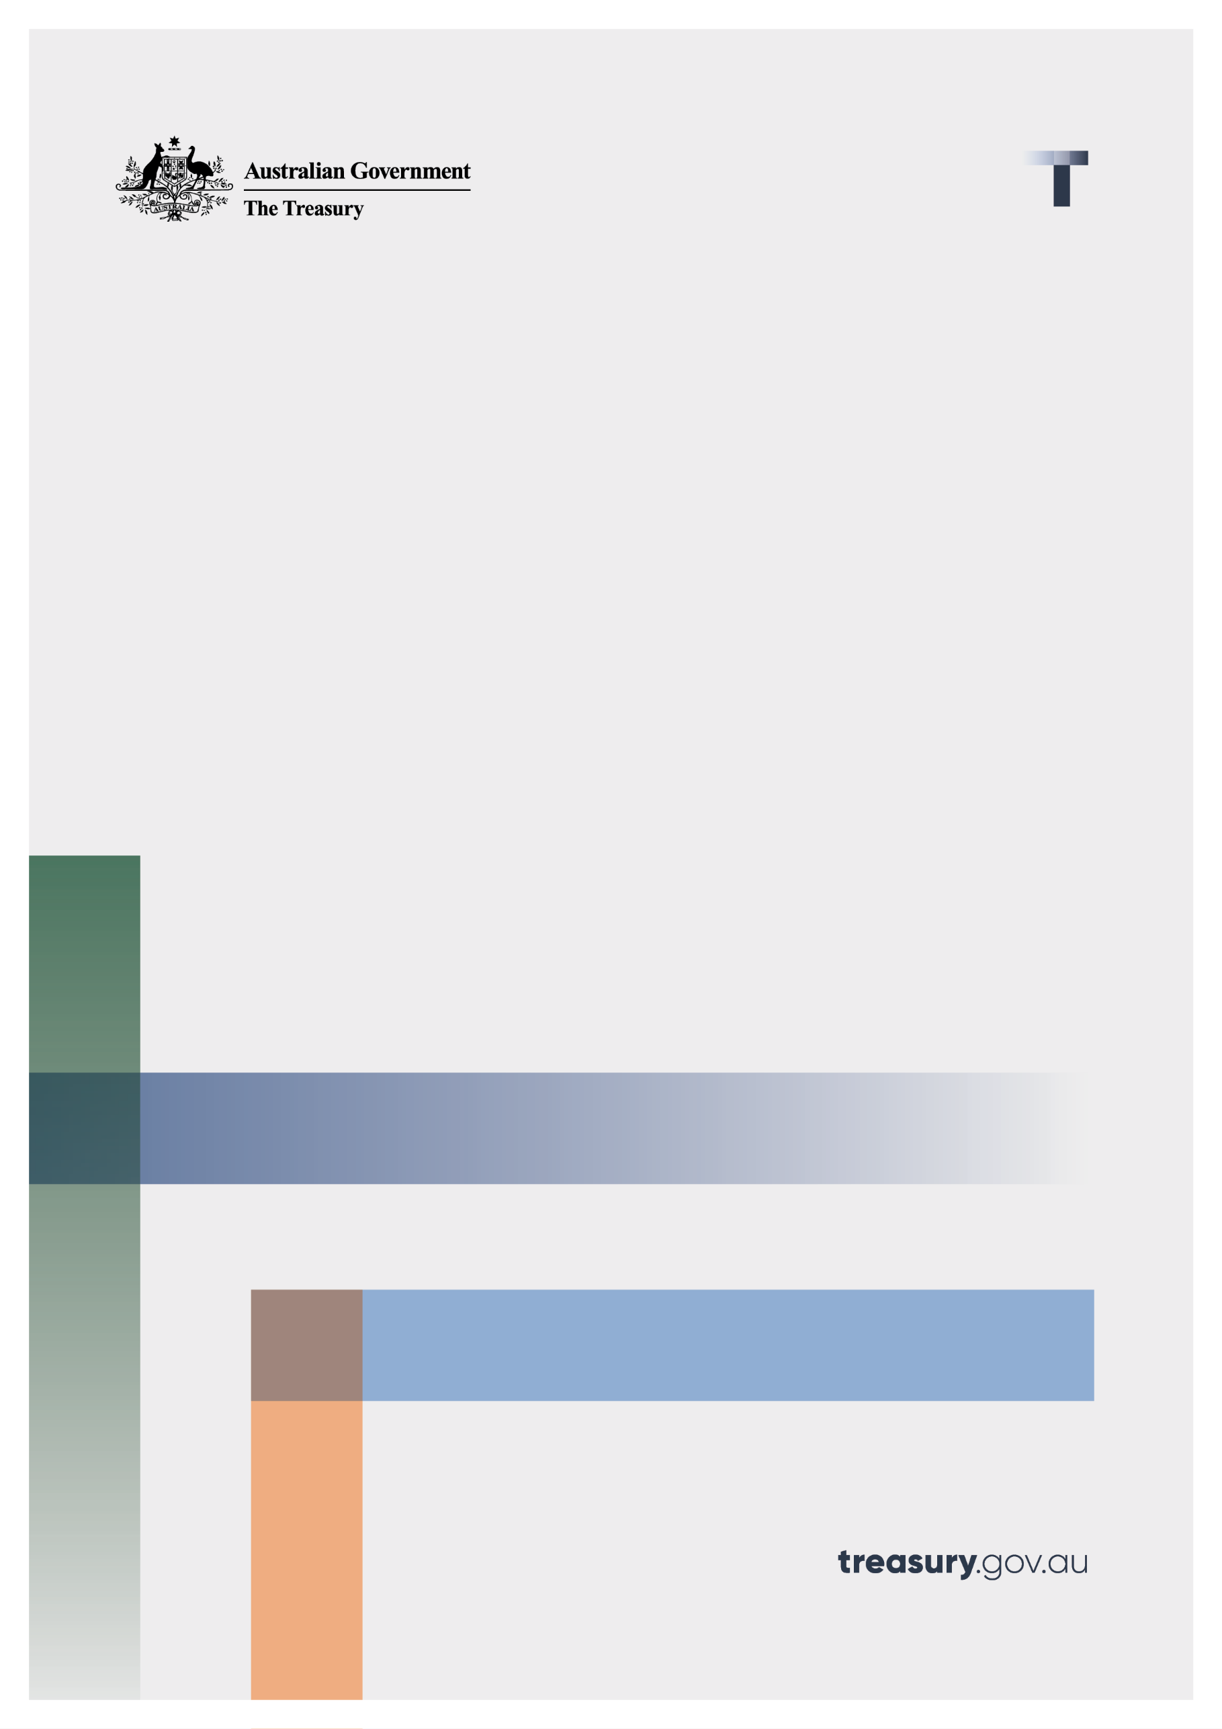

Giving fund reforms: distribution rate and smoothing

Consultation paper

June 2025

© Commonwealth of Australia 2025

This publication is available for your use under a [Creative Commons Attribution 4.0 International](https://creativecommons.org/licenses/by/4.0/) licence, with the exception of the Commonwealth Coat of Arms, the Treasury logo, photographs, images, third party materials, materials protected by a trademark, signatures and where otherwise stated. The full licence terms are available from [creativecommons.org/licenses/by/4.0/legalcode](http://creativecommons.org/licenses/by/4.0/legalcode).

Creative Commons attribution licence 3.0 icon. 

Use of Treasury material under a [Creative Commons Attribution 4.0 International](https://creativecommons.org/licenses/by/4.0/) licence requires you to attribute the work (but not in any way that suggests that the Treasury endorses you or your use of the work).

**Treasury material used ‘as supplied’.**

Provided you have not modified or transformed Treasury material in any way including, for example, by changing the Treasury text; calculating percentage changes; graphing or charting data; or deriving new statistics from published Treasury statistics – then Treasury prefers the following attribution:

Source:The Commonwealth of Australia.

**Derivative material**

If you have modified or transformed Treasury material, or derived new material from those of the Treasury in any way, then Treasury prefers the following attribution:

Based on Commonwealth of Australia data.

**Use of the Coat of Arms**

The terms under which the Coat of Arms can be used are set out on the Department of the Prime Minister and Cabinet website (see [www.pmc.gov.au/government/commonwealth-coat-arms](http://www.pmc.gov.au/government/commonwealth-coat-arms)).

**Other uses**

Enquiries regarding this licence and any other use of this document are welcome at:

Manager  
Media and Speeches Unit  
The Treasury  
Langton Crescent   
Parkes ACT 2600  
Email: [media@treasury.gov.au](mailto:media@treasury.gov.au)

In the spirit of reconciliation, the Treasury acknowledges the Traditional Custodians of country throughout Australia and their connections to land, sea and community. We pay our respect to their Elders past and present and extend that respect to all Aboriginal and Torres Strait Islander peoples.

# Contents

Contents ii

Consultation Process 1

Request for feedback and comments 1

Giving fund reform: distribution rate and smoothing 2

Background 2

Purpose 2

Issues for discussion 3

Principles for setting the distribution rate for giving funds 3

Practical considerations for setting the minimum annual distribution rate 4

Principles for smoothing distributions 7

Appendix: the hypothetical giving fund 10

# Consultation Process

## Request for feedback and comments

Interested parties are invited to lodge a written submission addressing the discussion questions which can be found through the paper.

Electronic lodgement is preferred. For accessibility reasons, please submit responses sent via email in a Word or RTF format. An additional PDF version may also be submitted. Submissions may be made through the Treasury website or by email or post using the details below.

If you would like part of your submission to remain in confidence, you should provide this information marked as such in a separate attachment. A request made under the *Freedom of Information Act 1982* (Cth) for a submission marked ‘confidential’ to be made available will be determined in accordance with that Act.

|  |  |
| --- | --- |
| Email | charitiesconsultation@treasury.gov.au |
| Mail | Director, Not-for-profits Unit  Personal and Indirect Tax and Charities Division  The Treasury  Langton Crescent  PARKES  ACT  2600 |
| Enquiries | Enquiries can be initially directed to charitiesconsultation@treasury.gov.au |

The principles outlined in this paper have not received Government approval and are not yet law. As a consequence, this paper is merely a guide as to how the principles might operate.

# Giving fund reform: distribution rate and smoothing

## Background

A giving fund – currently described in tax law as an ancillary fund – is a trust set up and maintained solely for the purpose of providing money, property or benefits to deductible gift recipients (DGRs). Although a giving fund is also a DGR, it does not undertake its own charitable work. Instead, it acts as an intermediary between donors and DGRs that do undertake such work.[1]

Two types of giving fund exist, private giving funds (PGFs) and public giving funds (PuGFs).[2] PuGFs must ask for donations from the public. PGFs are restricted in their ability to receive donations from people other than their founders or relatives, associates and employees of the founders. As at 3 March 2025, 3,707 giving funds exist: 2,292 PGFs and 1,415 PuGFs.

Giving funds encourage philanthropy by allowing donors to receive an upfront income tax deduction for gifts that are distributed over time to item 1 DGRs. To ensure giving funds meet their philanthropic goal, guidelines made under the *Taxation Administration Act 1953* require funds to make a minimum distribution each financial year to item 1 DGRs. A distribution is the provision of money, property or benefits such as concessional loans and loan guarantees.

For PuGFs the minimum distribution is $8,800 or 4 per cent of the fund’s net asset value at the end of the previous year, whichever is greater. For PGFs the minimum distribution is the greater of $11,000 or 5 per cent of the fund’s net asset value. PuGFs are not required to make the minimum distribution in the year of establishment, nor in the following four years. PGFs are not required to make the minimum distribution in the year of establishment.

## Purpose

On 5 December 2024, the government announced[3] it would improve the support provided to charities through giving funds by:

* aligning and increasing the minimum annual distribution rate for public and private funds,
* allowing funds to smooth their minimum annual distributions over three years, and
* renaming ancillary funds in the tax law to giving funds to reflect their role in giving to charities.

The increased distribution rate will not apply for five years after amendments are made to the ministerial guidelines. This allows funds to adjust their investment strategy, if necessary, in response to the new rate.

These changes respond to recommendations 8.1 and 8.2 of the Productivity Commission’s *Future foundations for giving* report.[4] They will maximise the benefits available to item 1 DGRs they support in return for the tax benefit received by the donor.

The government seeks feedback on a suitable value for the minimum distribution rate and the principles that will apply to distribution smoothing.

## Issues for discussion

### Principles for setting the distribution rate for giving funds

The Productivity Commission set out three principles for consideration when deciding the minimum annual distribution rate:

* The purpose of giving funds is charitable. Investments are made to maximise the benefits available to item 1 DGRs, not to maximise investment returns.
* There should be no guarantee that funds can exist in perpetuity in the absence of additional gifts to the fund. However, the distribution rate should not be set so high that it encourages high‑risk investment strategies by trustees seeking to maintain the value of a fund.
* Distributions should reflect the funding needs of item 1 DGRs, which will include short‑term as well as longer‑term requirements.

The Commission did not give a preferred minimum annual distribution rate. Instead, it suggested a rate between 5 and 8 per cent is appropriate. It recommended aligning the distribution rate for PGFs and PuGFS and providing five years notice before any new distribution rate applies.

The government broadly agrees with the Commission’s principles and suggested range of rates.

However, the government also notes giving funds exist to encourage philanthropy. If a donor is discouraged from creating a giving fund, there is no guarantee that the donor would simply donate the same amount directly to item 1 DGRs. In setting the minimum annual distribution rate, the government seeks to strike a balance between maximising benefits to DGRs and encouraging new giving funds.

|  |
| --- |
| Questions   1. Are these considerations appropriate in setting the minimum annual distribution rate? 2. Should the five‑year transition period apply only to giving funds that exist at the time the distribution rate changes, or to all giving funds? 3. What other considerations, if any, should the government consider in setting the minimum annual distribution rate? |

When giving funds were established in the tax law in their current form, a principle was that the benefit to item 1 DGRs should be greater than if the government had provided, by way of grant, a benefit to DGRs equivalent to the revenue foregone through the donor’s tax deduction.[5]

If a gift is made directly to an item 1 DGR, the up-front monetary benefit to the DGR is greater than the value of the tax deduction to the donor. Further, the initial benefit is received by the DGR at around the same time as the donor receives the benefit of the tax deduction.

When a gift is made to a giving fund, the donor receives the benefit of the tax deduction for the income year in which the gift is made. DGRs receive a benefit later. It might be some years before the value of distributions received by DGRs exceeds the value of the tax deduction received by the donor. The Productivity Commission noted this as one factor to consider when setting the distribution rate. A more detailed analysis of the value of donations according to time preferences of DGRs, and how this is affected by the distribution rate, is set out below.

### Practical considerations for setting the minimum annual distribution rate

Increasing the minimum distribution rate could affect more PGFs than PuGFs. Not only do more PGFs exist, Productivity Commission analysis of ATO data shows, for 2020‑21, the majority of PuGFs distributed well above the minimum required. In contrast, a majority of PGFs distributed around or below the minimum required, although a quarter are distributing at rates above 10 per cent. Chart 1 shows the results of the Productivity Commission’s analysis.

Chart 1: Percentage of giving funds making distributions at various distributions rates 2020‑21

|  |  |
| --- | --- |
| This chart shows the percentage of private ancillary funds making annual distributions at various rates in 2020-21. Twenty five per cent of private funds made distributions above 10 per cent while 49 per cent made distributions between 5 and 6 per cent. | This chart shows the percentage of public ancillary funds making annual distributions at various rates in 2020-21. Forty nine per cent of public funds made distributions above 10 per cent while 17 per cent made distributions of between 4 and 5 per cent. |

Source: Productivity Commission *Future foundations for giving* report*.*

Given the likely greater effect on PGFs, this section considers how an increase in the minimum rate would affect the operation of a hypothetical PGF. The PGF is seeded with a gift of $1 million in 1979‑1980 and receves no subsequent gifts.

While the concept of a giving fund did not exist in 1979‑80, this financial year has been chosen to enable a longer‑term evaluation of giving fund growth and distributions using real‑world rates of return on investment. It includes the effect of changes in economic conditions, such as the 1982‑83 and 1990‑91 recessions, the 2008‑09 global financial crisis and the COVID‑19 pandemic.

The appendix provides further detail on the assumptions behind this fund, including its asset allocation and rates of return.

Chart 2 shows, in constant 1979-80 dollars, the cumulative distributions made by this fund, and changes in its asset value, for the current minimum ditribution rate of 5 per cent and higher rates of 6, 7 and 8 per cent.

Chart 2: Giving fund asset value at June 30 and cumulative value of distributions made in constant 1979-80 dollars

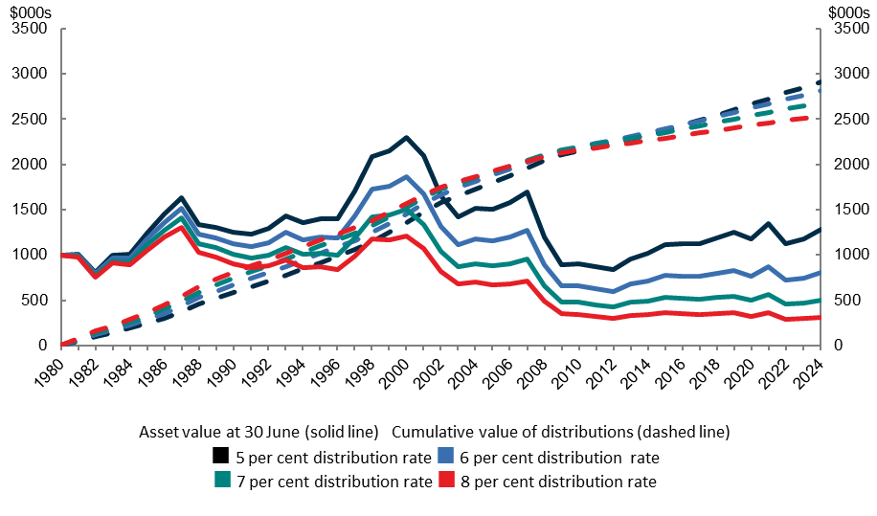

The higher distribution rates see aggregate distributions to DGRs maximised over the short term. In the longer term, distributions are maximised when the distribution rate is set at its current rate of 5 per cent. The 5 per cent distribution rate is also the only scenario in which the real value of the intial $1 million gift is retained, if perpetual operation of a fund is considered important. This suggests benefts to DGRs in the future are also maximised with the lowest distribution rate.

Using the current highest marginal personal income tax rate of 47 percent (inclusive of the Medicare levy)[6], the benefit of the $470,000 tax deduction to the donor is distributed to DGRs within seven to nine years. This time will be shorter where the donor faces a lower marginal tax rate.

However, looking at the real value of fund value and distributions ignores the opportunity cost to DGRs of having assets in giving funds rather than with DGRs to use for their purposes. Some DGRs prefer to receive larger distributions from giving funds to allow them to perform activities now. Other DGRs, including those yet to be established, might prefer giving funds build or maintain a corpus to provide certainity of funding in the future. Still others will prefer a mix of immediate and long‑term funding.

Community preferences on the distribution of benefits now, in return for the donor’s tax deduction, versus building a corpus for later distribution will similarly vary.

Using discount rates allows analysis of the value of distributions that takes into account these time preferences. With any such analysis, the choice of discount rate is important. The larger the discount rate, the higher the value is placed on giving funds making distributions now. To be clear, the discount rates explored below are for analytical purposes only and will not be applied to real-world minimum distribution rates.

In its philanthropy report, the Productivity Commission suggests use of the social discount rate[7]. It further noted disagreement exists on what this rate is. A 2010 Productivity Commission research paper suggests a real social discount rate of 8 per cent, but other sources cited in the philanthropy report prefer real rates between 4 per cent and 15 per cent.

Chart 3 replicates Chart 2, but with a real discount rate of 8 per cent applied to distributions and asset values. The benefit to DGRs is maximised with a minimum annual distribution rate of 8 per cent. Because the discounted value of fund assets is much lower in the future, the benefit of preserving assets is negated.

Chart 3: Giving fund asset value at June 30 and cumulative value of distributions made with 8 per cent real discount rate applied

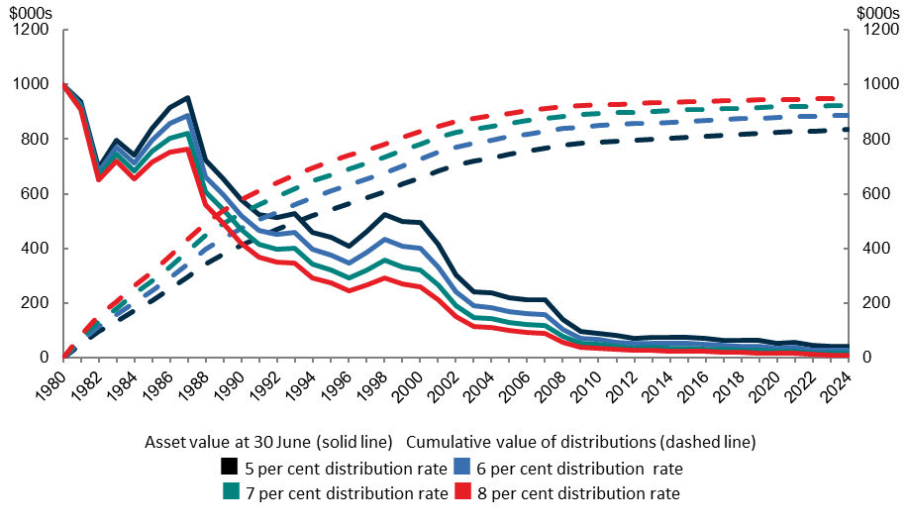

With 26,285 item 1 DGRs[8] eligible to receive distributions from giving funds,the choice of a discount rate will not reflect the preferences of all DGRs. To illustrate how differing preferences – and thus discount rates – influence the calculated value of benefits provided to DGRs, Chart 4 replicates Chart 3 but using real discount rates of 4 and 15 per cent.

With a real discount rate of 4 per cent, the value of distributions to DGRs for all distribution rates converges in the time period considered in this analysis. The benefit of the higher distribution rate is more pronounced for a 15 per cent real discount rate. When the discount rate is higher, the value of the donor’s tax deduction is distributed to DGRs sooner when the distribution rate is higher.

Chart 4: Giving fund asset value at June 30 and cumulative value of distributions made with 4 per cent (LHS) and 15 per cent (RHS) real discount rates applied

|  |  |
| --- | --- |
| This chart shows the changes in asset value and cumulative distributions over 24 years for a hypothetical giving fund. Data is shown for annual distribute rates of 5, 6, 7 and 8 per cent. A real discount rate of 4 per cent is applied. Cumulative distributions for all annual distribution rates converge in the longer-term. Asset value in the long-term is maximised for the 5 per cent annual distribution rate. | This chart shows the changes in asset value and cumulative distributions over 24 years for a hypothetical giving fund. Data is shown for annual distribute rates of 5, 6, 7 and 8 per cent. A real discount rate of 15 per cent is applied. The long-term asset value converges to zero in the longer-term for all distribution rates. The cumulative value of distributions is maximised with the 8 per cent annual distribution rate. |
|  | |

|  |
| --- |
| Questions   1. In setting the minimum annual distribution rate, is it appropriate to consider the time preferences of DGRs and the community? 2. Is your preference for DGRs to receive distributions sooner (implying use of a higher discount rate), later (a lower discount rate) or no preference? 3. To what extent should the wishes of donors to operate a fund in perpetuity be balanced against preferences of DGRs? 4. Do you have a view on how increasing the distribution rate would affect the willingness of donors to set up giving funds? 5. Given all considerations, do you have a view on what the appropriate minimum annual distribution rate should be? |

### Principles for smoothing distributions

The government has agreed to allow giving funds to smooth distributions over a three‑year period. Under smoothing, a giving fund’s obligation is to make distributions across the three years whose value is equal to the sum of the minimum distributions calculated for each year in the period.

For example, suppose the value of a giving fund’s minimum distributions were $100,000 in year one, $120,000 in year two and $100,000 in year three. A giving fund could meet its requirement by distributing $300,000 in one year and $10,000 in each of the other two years.

This allows funds the flexibility to meet the funding needs of DGRs with, for example, infrastructure projects or social investment programs.

To ensure deductible gifts held in giving funds continue to flow to DGRs, the government proposes adhering to the following principles when amending the guidelines to allow smoothing:

* Smoothing may occur only over discrete three-year periods. The guidelines will not allow rolling periods.
  + If rolling three-year periods are allowed, a large distribution in one year could offset lower distributions in more than two other years. Item 1 DGRs might then receive less funding than they would have if the giving fund had made the minimum distribution each year.
  + Over the three‑year period, a fund may distribute more than the minimum required. Any distribution over and above the minimum may not be used to offset a below minimum distribution outside the period.
* The minimum distribution calculated for each year in the smoothing period will use the minimum annual distribution rate specified in the giving fund guidelines. There will be no ability to seek a reduction in the minimum distribution rate for any year of the smoothing period.
* In deciding whether a fund has met its distribution requirement, nominal values of minimum annual distributions and distributions made will be used.
  + This approach is administratively simpler than if real and/or discounted values are used.
* A giving fund will not need approval from the Commissioner of Taxation to smooth distributions. However, it will need to inform the Commissioner before or in the first year of the period of its intention and the reasons for smoothing distributions.
  + This approach reduces administration costs while ensuring the Commissioner may accurately assess a fund’s compliance with the guidelines.
* At the end of the smoothing period, the Commissioner will have the power to direct a fund to rectify any shortfall in distributions. The Commissioner will be able to impose administrative penalties on the trustee of a fund if the trustee does not rectify the shortfall.
  + This is consistent with the Commissioner’s existing ability to direct a giving fund to rectify a shortfall in its annual distribution.

|  |
| --- |
| Questions   1. Are these principles reasonable? If you don’t agree with one or more of them, please provide reasons. 2. Should the Commissioner of Taxation have the ability, following notification by a giving fund of its intention to smooth distributions, to direct the fund to instead make the required minimum distribution in each year? (A fund would be able to object to a direction.) 3. If the Commissioner is given the power to direct a fund to instead make the minimum annual distribution, what factors should the Commissioner be required to take into account before giving the direction? Examples are the fund’s reasons for smoothing, past compliance with minimum distribution requirements and the ability of the fund to make a distribution larger than the minimum in a year. 4. Should a giving fund be able to access distribution smoothing if it has never previously made a distribution? For example, a PuGF that is not required to and, in fact, has not made a distribution in the four years following its establishment might want to smooth distributions over the first three years in which it is required to make distributions. 5. Are there other principles for smoothing that should be reflected in the guidelines? |

## Appendix: the hypothetical giving fund

The hypothetical PGF discussed in this discussion paper has the following asset allocation:

| Asset class | Percentage allocation |
| --- | --- |
| Australian shares | 25 |
| US shares | 20 |
| Other international shares | 15 |
| Australian property | 20 |
| Australian bonds | 10 |
| Cash | 10 |

It is assumed the fund makes only the minimum required annual distribution each year, the distribution is cash or equivalents, and that the distribution is made on July 1 in the relevant financial year. This removes the distribution from the calculation of asset returns in that year. The fund is assumed to have no liabilities.

The value of each asset class is reduced by the distribution percentage. Treasury acknowledges this scenario is artificial, in that in any given year certain assets might not be liquidated to make the fund’s distribution.

An administration fee of 1.056 per cent of asset value is deducted from the fund’s assets each year. This value is the maximum administration fee permitted to be charged by a licensed trustee company when acting as trustee of a charitable trust. Real world administration fees might be lower.

The investment returns are calculated from the annual percentage return as of June 30 taken from the [Vanguard Investments website](https://austreasury.sharepoint.com/sites/nfp-function/pcpi/insights.vanguard.com.au/static/asset-class/app.html), accessed 29 January 2025.[9] Dividends are assumed to be reinvested.

The analysis ignores the effect of refundable franking credits for giving funds that are charities.

Constant 1979‑80 dollars calculation used CPI data for the June quarter from the December 2024 quarter release of the data series *Percentage change from corresponding quarter of previous year; all groups CPI; Australia*.[10]

1. The latter DGRs are known as ‘item 1’ DGRs as they are described in item 1 of the table at section 30‑15 of the *Income Tax Assessment Act 1997*. For a similar reason, giving funds are known as ‘item 2’ DGRs.
2. These are described in the tax law as public ancillary funds and private ancillary funds. The government plans to amend the names in the tax law.
3. The government’s announcement is [available on the Treasury website](https://ministers.treasury.gov.au/ministers/andrew-leigh-2022/media-releases/supporting-philanthropic-giving).
4. The *Future foundations for giving* report is [available on the Productivity Commission website](https://www.pc.gov.au/inquiries/completed/philanthropy/report).
5. The principles for giving funds are set out in a [2008 discussion paper available on the Treasury website](https://treasury.gov.au/consultation/improving-the-integrity-of-prescribed-private-funds).
6. The highest marginal tax rate in 1979‑80, the year the hypothetical fund was established, was 61.5 per cent. As noted, the purpose of setting that year as the start date of the fund is to allow an analysis of real-world investment returns, not the tax settings as they existed then.
7. *Future foundations for giving* report, page 285.
8. As at 3 March 2025. This represents the total number of entities endorsed as an item 1 DGR, endorsed for the operation of one or more funds, authorities or institutions that are item 1 DGRs, or both.
9. Treasury’s use of this data does not imply endorsement.
10. This data is available in Tables 1 and 2 of the [CPI data downloads available on the Australian Bureau of Statistics website](https://www.abs.gov.au/statistics/economy/price-indexes-and-inflation/consumer-price-index-australia/dec-quarter-2024) (accessed 10 February 2025).