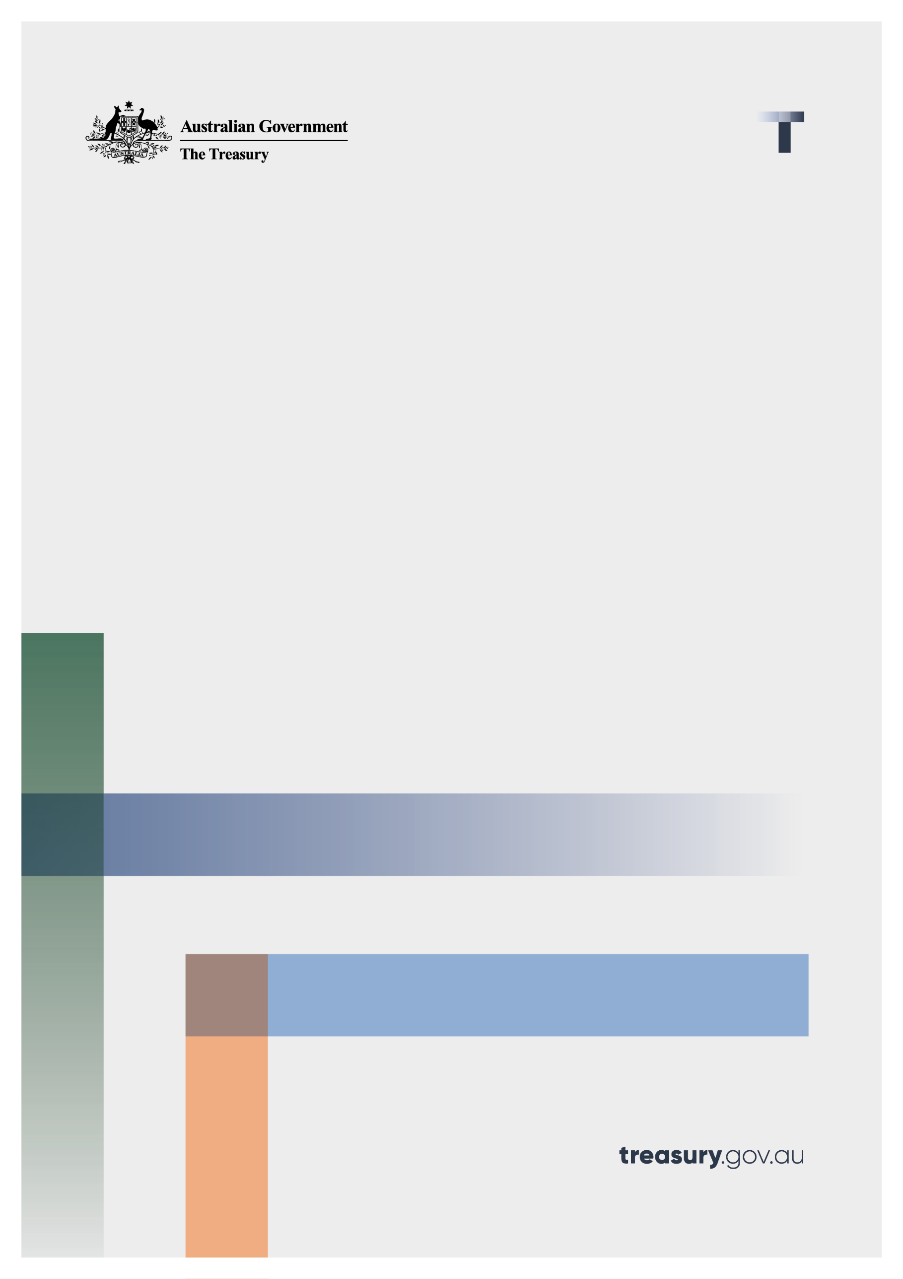

Internal Dispute Resolution under the Scams Prevention Framework
  - Position paper
May 2026

© Commonwealth of Australia 2026
This publication is available for your use under a Creative Commons Attribution 4.0 International licence, with the exception of the Commonwealth Coat of Arms, the Treasury logo, photographs, images, third party materials, materials protected by a trademark, signatures and where otherwise stated. The full licence terms are available from creativecommons.org/licenses/by/4.0/legalcode.
Use of Treasury material under a Creative Commons Attribution 4.0 International licence requires you to attribute the work (but not in any way that suggests that the Treasury endorses you or your use of the work).
Treasury material used ‘as supplied’.
Provided you have not modified or transformed Treasury material in any way including, for example, by changing the Treasury text; calculating percentage changes; graphing or charting data; or deriving new statistics from published Treasury statistics – then Treasury prefers the following attribution:
Source: The Commonwealth of Australia.
Derivative material
If you have modified or transformed Treasury material, or derived new material from those of the Treasury in any way, then Treasury prefers the following attribution:
Based on Commonwealth of Australia data.
Use of the Coat of Arms
The terms under which the Coat of Arms can be used are set out on the Department of the Prime Minister and Cabinet website (see www.pmc.gov.au/government/commonwealth-coat-arms).
Other uses
Enquiries regarding this licence and any other use of this document are welcome at:
Manager
Media and Speeches Unit
The Treasury
Langton Crescent
Parkes ACT 2600
Email: media@treasury.gov.au
In the spirit of reconciliation, the Treasury acknowledges the Traditional Custodians of country throughout Australia and their connections to land, sea and community. We pay our respect to their Elders past and present and extend that respect to all Aboriginal and Torres Strait Islander peoples.

Contents
Contents ii
Internal Dispute Resolution under the Scams Prevention Framework 1
Background 1
Purpose 1
Policy objectives 1
Proposed policy settings 2
Entities will be required to cooperate at the IDR stage 2
Efficient and proportionate handling of complaints 2
Entities will share liability equally where they have breached obligations under the SPF 3
Clear SPF obligations will support consistent and predictable AFCA outcomes 4

Internal Dispute Resolution under the Scams Prevention Framework

Background
- The Scams Prevention Framework (SPF) will require all regulated entities to have accessible and transparent internal dispute resolution (IDR) processes in place to manage scam complaints.
- The Australian Government has released exposure draft SPF codes and rules, which sets out certain obligations relating to IDR, including the timing and contents of a statement of compliance.
- A single scam complaint may involve several regulated entities across different sectors, each of which may have played a role at different stages of the scam.
- This creates a level of complexity not typically present in existing IDR frameworks, which are generally designed to assess disputes involving a single entity.
- The IDR process under the SPF will need to accommodate multi-party complaints, whereby each entity will need to assess their own compliance against the SPF and come to a shared view on how to settle a complaint with the consumer.
- The government has been conducting targeted consultation with key industry stakeholders and consumer groups to settle the outstanding IDR requirements under the SPF.
- The policy settings in this paper have been informed by these consultations and will be reflected in the final SPF codes and rules.

Purpose
- This paper sets out the government’s position on the policy settings for IDR under the SPF.
- It is intended to provide clarity to industry stakeholders and consumers on how scam complaints should be handled at the IDR stage and the principles that will be reflected in the final SPF rules and codes.

Policy objectives
The IDR settings under the SPF have been guided by the following policy objectives:
- Efficiency: Disputes should be resolved in a timely and streamlined manner to minimise delay, duplication and unnecessary cost for both regulated entities and consumers.
- Proportionality: IDR processes should be proportionate to the value of the loss, ensuring responses are appropriate without imposing unnecessary burden on either consumers or regulated entities.
- Fairness: Complaints should be handled impartially and consistently, giving consumers a genuine opportunity to be heard while ensuring outcomes are just and unbiased.
- Accountability: All regulated entities involved in a scam should engage in transparent decision-making and contribute to resolving complaints and preventing harm.
- Prevention first: IDR settings should complement the overall intent of the SPF, which is to prevent scams from impacting consumers in the first place.

Proposed policy settings

Entities will be required to cooperate at the IDR stage
- The exposure draft sector code obligations require regulated entities to cooperate with one another in the handling of scam complaints at the IDR stage.
- The intent is to make sure that all entities:
  - engage constructively with each other when responding to complaints,
  - share relevant information where appropriate, and
  - support timely resolution of complaints.
- The government understands several industry participants are cooperating to develop a centralised IDR model to coordinate scam complaints made under the SPF involving more than one entity.
- The government welcomes this initiative and intends for code obligations to complement these arrangements. While not all entities may wish to sign up to the centralised IDR model, all entities will be required to cooperate with other entities at the IDR stage. A centralised IDR model therefore will likely represent an efficient solution for entities that receive a high-volume of scam complaints.

Efficient and proportionate handling of complaints
- Ministerial Guidance set out in the SPF rules will make it clear that investigations and complaints handling at IDR should be proportionate to the value and complexity of the scam loss.
- IDR investigation and complaint handling can be costly. It would be highly inefficient for dispute resolution costs to exceed the value of the loss.
- Ministerial Guidance will support:
  - lower value complaints to be resolved through streamlined processes, which may include simplified or automated assessments, and
  - higher value or more complex complaints to have more detailed investigation.
- While lower-value complaints can be resolved through streamlined processes, there will still be cases where the IDR process is not proportionate to value of the loss.
- That is why it would be appropriate to automatically reimburse scam victims for verified scam losses below $3,000.
  - The majority of scam complaints lodged in Australia involve losses under $3,000, despite accounting for a small fraction of total scam losses.
- As a guide, where a scam involves multiple regulated entities from multiple regulated sectors, reimbursement could be split equally.
- Reimbursing low-value scam complaints provides a proportionate and efficient process to support quick resolution and minimise the cost of investigating complaints. It will also help reduce the load on IDR and external dispute resolution (EDR) systems.
- This expectation will be set out as Ministerial Guidance in the SPF rules.

Entities will share liability equally where they have breached obligations under the SPF
- While Ministerial Guidance will make it clear that entities should reimburse consumers for scam losses under $3,000, entities will be liable for losses where they have breached their obligations under the SPF for all values of scam losses.
- Where more than one regulated entity has breached its obligations under the SPF, liability should be shared equally between those breaching entities.
  - While entities will be required to coordinate their response to the consumer, each entity will be responsible for directly reimbursing consumers for any losses the entity is liable for.
- This will be set out as liability apportionment guidelines in the SPF Rules.
- An equal apportionment approach provides a streamlined and simple assessment of liability and helps avoid protracted disputes about relative fault or causation. It also supports faster resolution of complaints.
- The liability apportionment guidelines will allow for entities to make a case to adjust liability apportionment in exceptional circumstances, such as cases where there is unanimous agreement that one entity played a more significant role in the scam chain.
  - The guidelines will advise that any deviations from the default apportionment settings should only be done where there is agreement by relevant entities involved in the scam.
- The liability apportionment guidelines will not support consideration of the role of non-regulated entities.
  - Entities are ultimately responsible for their own compliance against the SPF.
  - Any consideration of non-regulated entities will have the effect of shifting liability to consumers despite an admission by a regulated entity that it did not meet its obligation under the SPF.

Clear SPF obligations will support consistent and predictable AFCA outcomes
- Consumers will always have the right to escalate a complaint to EDR if they are unsatisfied with the outcome reached at IDR.
- The Australian Financial Complaints Authority’s (AFCA) decision-making will be guided by an assessment of SPF Code obligations, which, under the primary law, operates as the primary benchmark for assessing compliance with the SPF.
- AFCA will also consider whether entities had regard to IDR guidelines set out in the SPF rules.
- Currently, AFCA is assessing scam complaints in the absence of any scam specific legislation.
- Once operational, the SPF will provide a clear framework to support consistent and transparent AFCA determinations with the SPF taking priority over other applicable frameworks (e.g. ePayments Code). It is expected that at IDR, the same framework priority order would be applied.
- Over time, this will be reinforced as published AFCA decisions build a body of decisions against these benchmarks, further improving transparency and confidence in the dispute resolution system.

Section 58BZE of the Competition and Consumer Act 2010 requires regulated entities to have regard to any process prescribed by the SPF rules for undertaking internal dispute resolution or any guidelines prescribed by the SPF rules for apportioning liability arising from a complaint.

