AIME Champion Herbert Mathewson Award
Given to TMS members annually
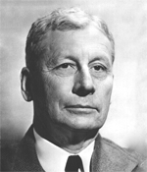
Administered by AIME Member Society, TMS, the AIME Champion Herbert Mathewson Award was established in 1950 to recognize a paper, or series of closely related papers with at least one common author, which represents the most notable contribution to metallurgical science in the award period. A group of Yale alumni provided funds raised to AIME to establish an award in Mr. Mathewson’s name. Additional donations were added to the fund, and AIME renamed the Institute of Metals Division annual award the Mathewson Award and added a gold medal to the engraved certificate, which had been given since 1934.
Champion Herbert Mathewson was born in 1881 in Essex, CT. From Yale University he received a Ph.B. and later an honorary D.Sc. From Gottingen University he received an M.A. and Ph.D. From 1904 to 1906 he was Austin Fellow of M.I.T. where he was successively Assistant Instructor in Chemistry, 1902-1904, and Instructor in 1906-1907.
From 1907 to 1950 he was on the Faculty at Yale University, serving as Instructor, Assistant Professor, and Professor of Metallurgy and Metallography. He was Emeritus Professor following that. At various times Dr. Mathewson was Metallurgical Consultant for the New Jersey Zinc Co., the Scovil Manufacturing Co., the Chase Copper and Brass Co., and the Bell Telephone Laboratories.
He was active on many technical committees of chemical and engineering societies. From 1941-1947, he was a member of the Nonferrous Metallurgical Advisory Board of the U. S. Ordnance Department, operating at the Frankford Arsenal. He was author of numerous publications on constitution and plastic deformation of metals and alloys and Editor of Modern Uses of Nonferrous Metals, published by AIME.
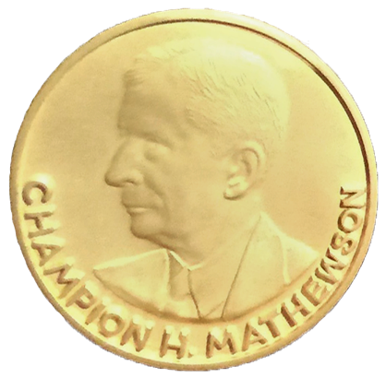
Dr. Mathewson received the Gold Medal of the American Society for Metals. AIME also honored him in 1932 with the James Douglas Gold Medal. He was Institute of Metals Division Lecturer in 1928, Chairman of the Institute of Metals Division in 1932, and President of AIME in 1943. That year he was also Campbell Memorial Lecturer for the American Society for Metals. He was presented AIME Honorary Membership in 1958 as a pioneer of modern physical metallurgy in this country, who laid much of the foundation of our understanding of the working and annealing of metals. His impact on the science, both through his own work and even more through his students who now occupy key positions in industry and universities, can scarcely he overestimated. For his contributions and his influence, he may well be regarded as the Dean of American metallurgists.
To nominate someone for the AIME Champion Herbert Mathewson, visit the TMS awards webpages at https://www.tms.org/portal/PROFESSIONAL_DEVELOPMENT/Honors___Awards/Past_Recipients/portal/Professional_Development/Honors___Awards/Past_Recipients.aspx?hkey=d575f8c2-00be-46fe-860d-fec3c0e3f31e.

