Please Note* If you have accessed your 1098-T form in Bison before, you are not required to grant consent again. You should see the picture below, and you will CLICK: on 2021.

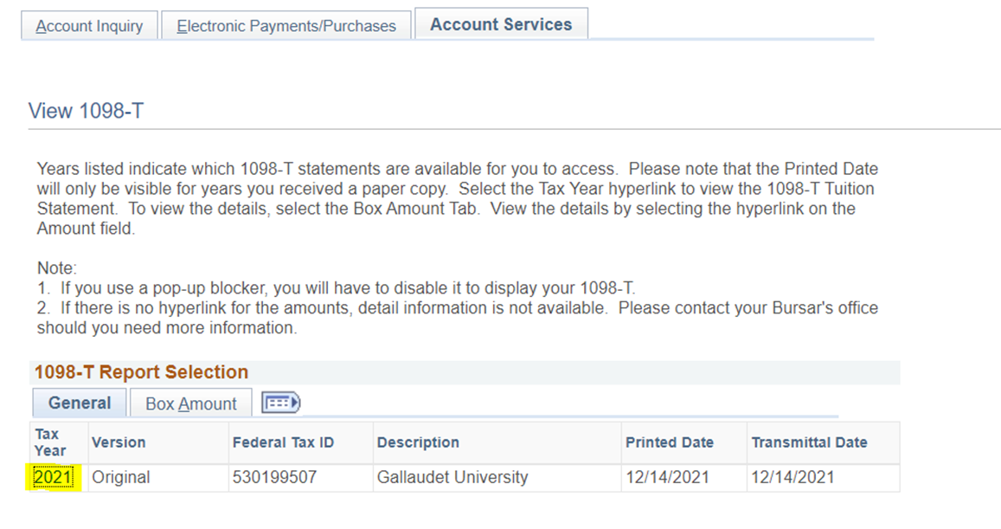

Log into Bison (Campus Solutions)
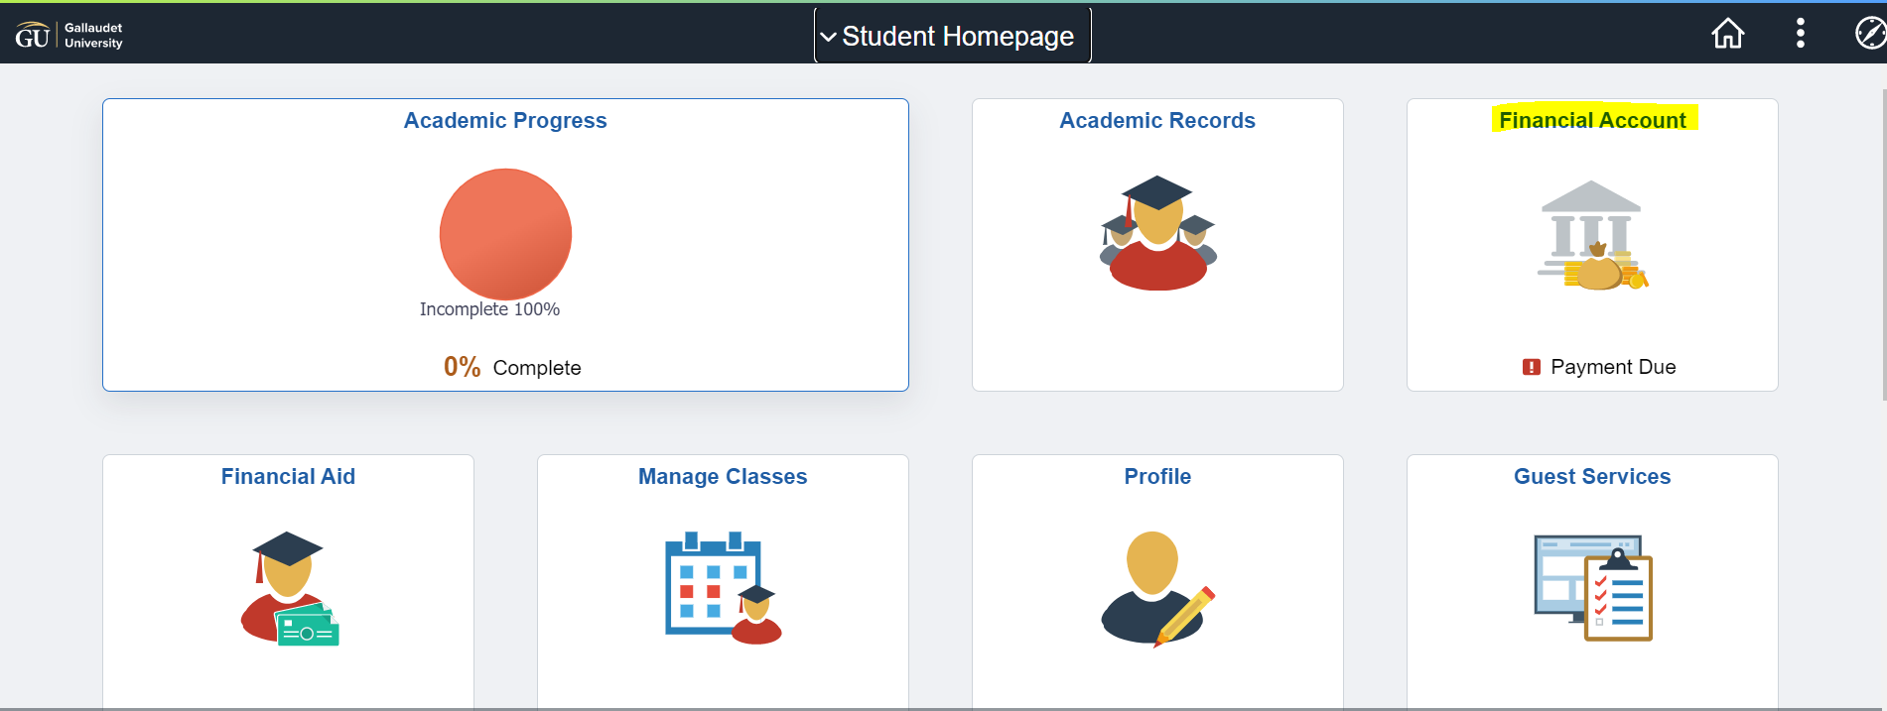
Click on “FINANCIAL ACCOUNT”

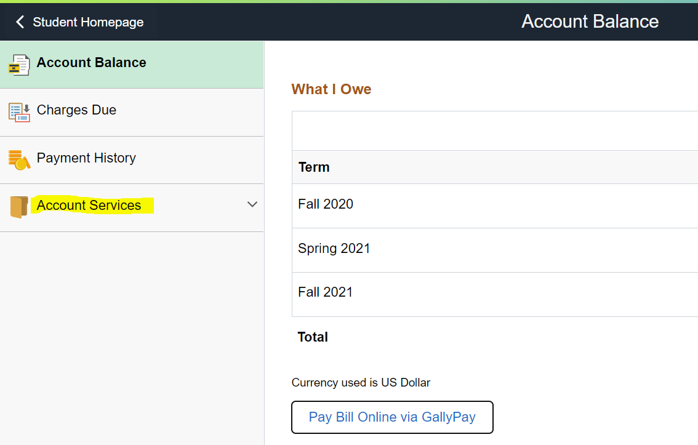
Click on “ACCOUNT SERVICES”

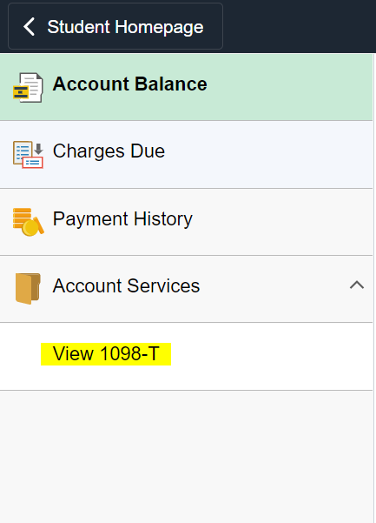
Click on “VIEW 1098-T”

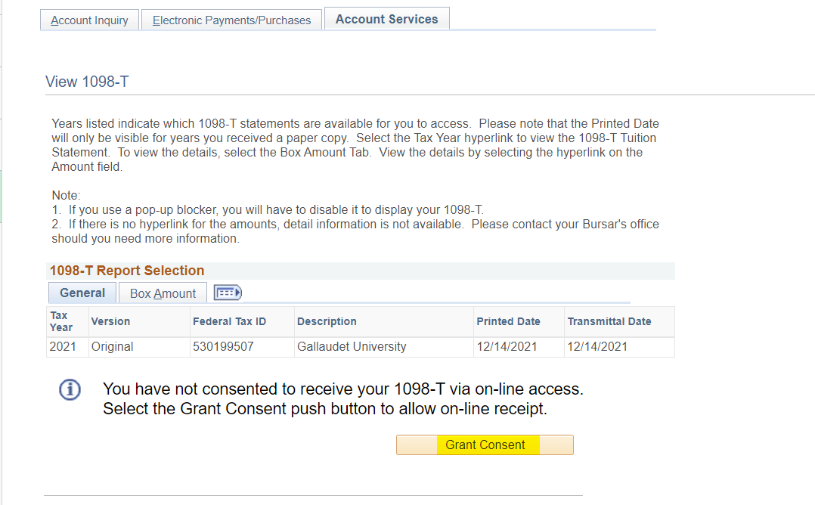
Before you can access your 1098-T form, you must “GRANT CONSENT
Click on “GRANT CONSENT”

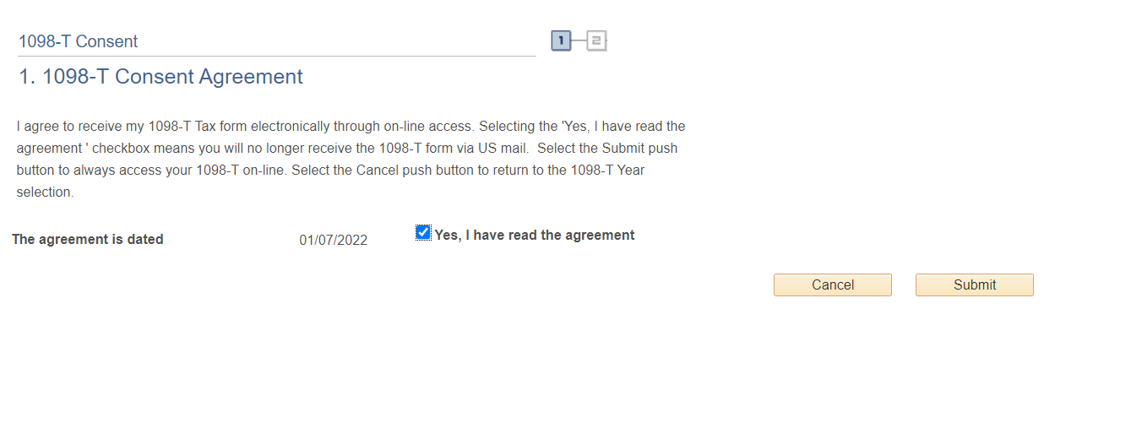
Click “YES, I HAVE READ THE AGREEMENT” a CHECK should appear.
Click “SUBMIT”

Once consent has been granted, you will be able to view your form. Click on “2021” and your 1098-T will be available in BISON.

