

|  |
| --- |
| **ޕޮއިންޓް ޓު ޕޮއިންޓް ފައިބަރ ކަނެކްޓިވިޓީ ޚިދުމަތް ފޯރުކޮށްދިނުމާއި ގުޅޭގޮތުން ދެވޭ އިތުރު މަޢުލޫމާތު** |

|  |  |
| --- | --- |
| ޕޮއިންޓް ޓު ޕޮއިންޓް ފައިބަރ ކަނެކްޓިވިޓީ ޚިދުމަތް ހޯދުން | **ޕްރޮޖެކްޓްގެ ނަން:** |
| W-026/2019/38 | **ޕްރޮޖެކްޓްގެ ނަންބަރު:** |
| (A)AD-2019/246 ގެ އެމެންޑްމެންޓް | **އިޢުލާން ނަންބަރ:** |
| 16 އޮކްޓޯބަރ 2019 | **އިޢުލާން ތާރީޚް:** |
| 23 އޮކްޓޯބަރ 2019 | **އެމެންޑްމެންޓް ގެނެވުނު ތާރީޚް:** |

**އިލެކްޝަންސް ކޮމިޝަން**

މާލެ، ދިވެހިރާއްޖެ

**އެނެކްސް-2 (ރިކުއަރމަންޓް)**

**Introduction**

Election commission of Maldives (herein referred as ECM) invites vendors to submit proposal for “Point to Point Fiber Connectivity”. ECM requires consulting services to complete all components of this project including installation, testing, configuration and implementation.

**Purpose**

1. The purpose behind issuing this RFP is to provide information for technical and commercial bids from the eligible bidders for the above purpose.

**Scope of Work**

1. Installation of Single Mode 6 Core Fiber Optic cable between Elections Center (Baa Jamaaluddin School, Nikagas Magu, Malé) and Elections HQ (Third Floor, Port Complex Building, Hilaalee Magu, Malé).

***Additional Information: Below please find the drawing***

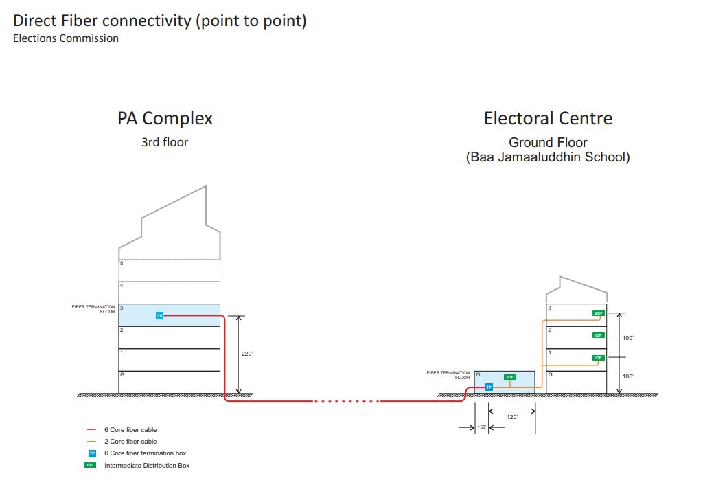

**Fiber Specification**

|  |  |
| --- | --- |
| Cable Type | Single-Armored Outdoor |
| Inner/Outer Jacket | PE(Black) |
| Armor Layer | Corrugated Steel Tape |
| Cable Diameter | 8.0mm |
| Tensile Strength (long/short term) | 500/1000N |
| Bending Radius (long/short term) | 10D/20D (mm) |
| Fiber Count | 6 Fibers |
| Fiber Type | Singlemode G.652D |
| Strength Member Material | Steel Wire |
| Cable Weight | 109kg/km |
| Crush Load (long/short term) | 300/1000 (N/100mm) |
| Operating/Storage Temperature | -40 to +60°C |

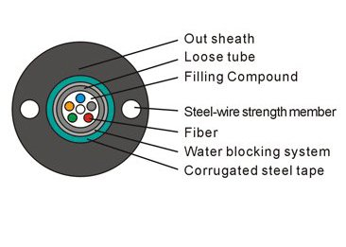

**Fiber Connection Specification (Interface)**

|  |  |
| --- | --- |
| Interface | LC Duplex |
| Max Data Rate | 10.3125Gbps |
| Wavelength | 1310nm |
| Form Type | SFP+ |
| Protocols | MSA Compliant |
| Max Cable Distance | 10km |