INVITATION FOR PROPOSAL

Services/Goods Required:

Requirement for IASL Seaplane Hanger Overhead Crane Service.
Date and time for information session of the Project: 17th January 2020 (11:00 Hrs.)
Note that site visit is a must and details of the site visit will be shared with the parties attending the information session. Once site visit has been concluded, we will share the date and time for the proposal submission.

Instructions for visiting site

- For site visit a security pass will be required for the persons interested in visiting the site. The company will facilitate the security pass upon request. To obtain the security pass, interested persons must submit (email) their ID copies (For foreigner’s visa card) to procurement.admin@iasl.aero /mohamed.ziyau@iasl.aero prior to one day of the site visiting date.

- After submission of the necessary documents to procurement.admin@iasl.aero / mohamed.ziyau@iasl.aero, the interested persons must contact and coordinate with the below mentioned Projects Coordinator to accompany them to the installation site.

- Site visit is compulsory. Hence proposals will be accepted only from parties who completes the site visit.

Contact Information:

Name: Ali Waheedh
Position: Manager
Telephone: 3024 751
Mobile No.: 9194848
Email: a.waheed@iasl.aero / admin.maintenance@iasl.aero / projects.maitenance@iasl.aero

Eligible Vendors

The Vendor must submit relevant documents as per clause (s) of this document.

- Vendor must be a Maldivian firm or individual providing such services as attachment.

- The vendor shall furnish the following documentary evidence.

  - All information provided will be subjected to verification by IASL. Submission of incomplete or unsigned forms will result in rejection of the proposal as non-responsive.

  - The project estimate and rates must be quoted in Maldivian Rufiyaa inclusive of all taxes and clearing charges.

  - A detail BOQ (Bill of Quantities) must be submitted along with the proposal.

  - Company registration certificate

  - GST registration certificate

  - Proposal must remain valid for a period of 60 days.

- REJECTION AND DISQUALIFICATION OF PROPOSAL
- If any of the documents mentioned under Eligible Vendors is missing in the proposal the company has the right to reject or request for a resubmission

*******************

Appendix A

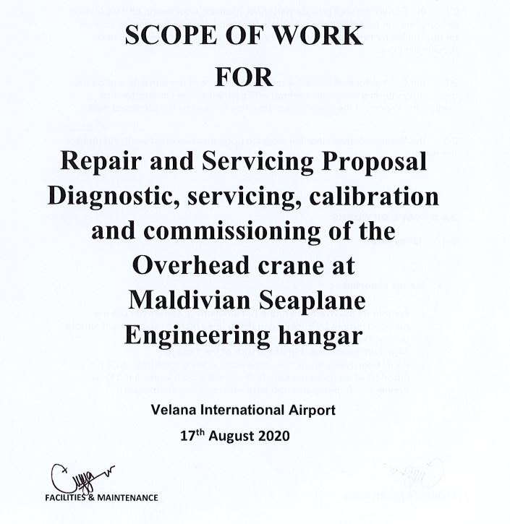

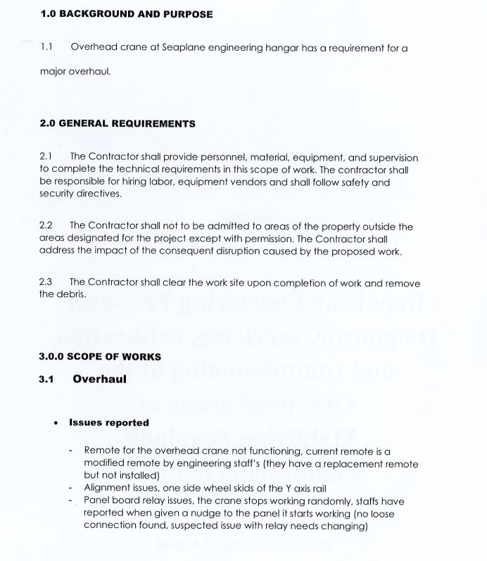

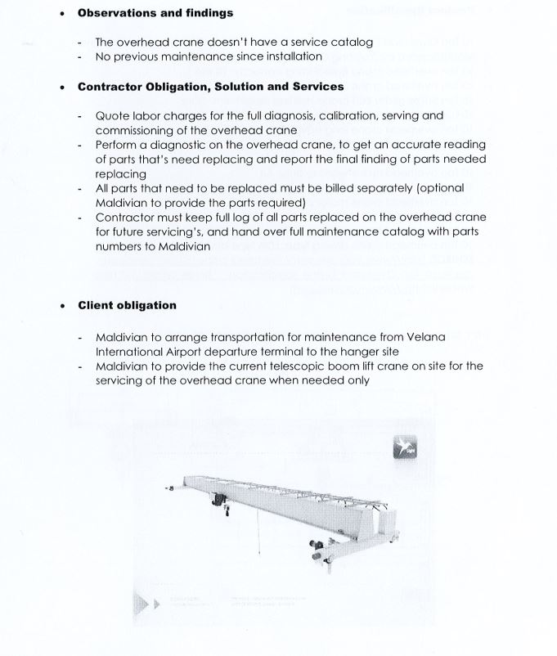

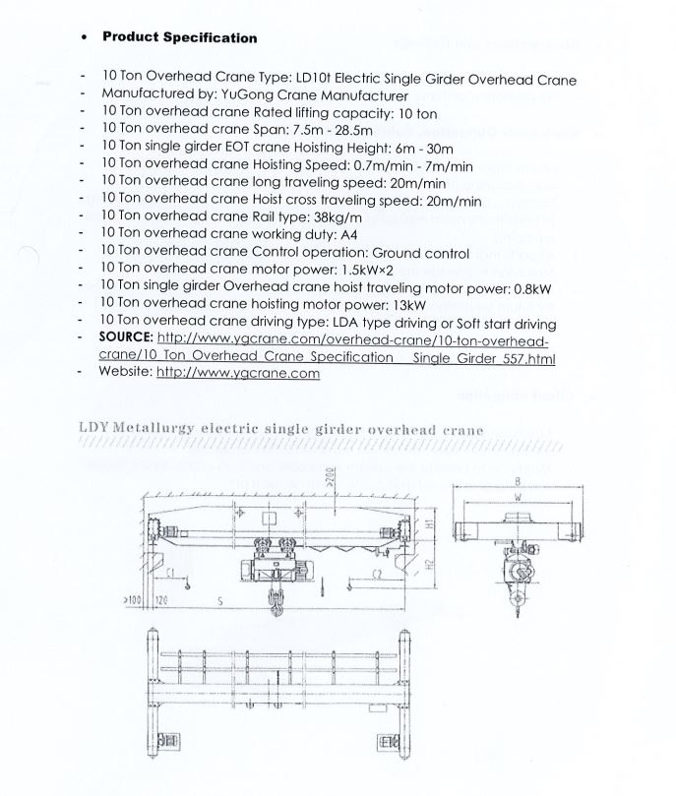

Proposal Documentation Check List

Proposal

Company Profile

Proposal Cover Letter

Disclaimer Letter

Memorandum and Articles of Association

Company Registration Certificate

GST Registration Certificate

Audited Financial Statements

Reference of past experience and work completion letter or certificates

Detail BOQ (Bill of Quantities) of the Proposal

Project Delivery Period

Required
Not Required

