TERMS OF REFERENCE
(IUL)438-WMPC/438/2021/10

Consultancy Service on Retainer basis for Engineering Drawings and Bill of Quantities for Island Resource Recovery Centres (IRRCs)

- OBJECTIVE

The Ministry of Environment is seeking for consultancy for Engineering Drawings and respective Bill of Quantities for the Establishment of Island Resource Recovery Centres (IRRCs).

- SCOPE AND DELIVERABLES

The scope of the works to be undertaken through the consultancy services include the following:

- Provide layout for 14 Island Resource Recovery Centres (IRRCs) in line with the concept provided
- Provide complete engineering drawings of 14 IRRCs including the plumbing and electrical networks in line with the concept provided
- Provide detailed cost estimate and BOQ and rate analysis for all drawings provided

**Note: It is of note that the set of deliverables stated would not be more than 14 units (meaning 14 Island Resource Recovery Centres)

- TECHNICAL DETAIL OF THE PROJECT

Layout for each island should be completed as per the concept in Annex 3 of this Terms of Reference within approved land allocated for construction of IRRCs on the respective islands.

Each detailed design, cost estimate and BOQ and rate analysis set is to be provided for each island upon approval of the layout within a maximum of 15 calendar days.

The agreement will be on a retainer basis for a duration of 6 months.

Payment will be given for each set of layout, design work, detailed cost estimate, BOQ and rate analysis upon completion and approval by the Waste Management and Pollution Control Department of the Ministry of Environment.

Consultants are expected to work closely with the Waste Management and Pollution Control Department of the Ministry of Environment. All drafts should be shared with the department and approval is required prior to finalizing the designs.

- QUALIFICATION AND EXPERIENCE OF THE CONSULTANT(S)

The individual consultants that apply or the consultant(s) that are proposed by firms should meet the following minimum criteria:

- Minimum undergraduate degree in the field of Civil Engineering or Architecture
- Minimum 2 years of experience in a relevant field

- EVALUATION CRITERIA

The consultant(s) should meet the minimum qualification and experience standards stated in part (4) of this document to be considered eligible for the work.

All eligible consultants will be scored according to the price proposed using the Financial Proposal Format provided in Annex 1 of this document.

For evaluation purposes the score of each financial proposal will be calculated as follows:

(Lowest Price Bid × 100)/(Price of Bid Being Evaluated)

- Submission Requirements

All applicants must submit the following documents required to demonstrate their capacity and experience to carry out the services stated in the TOR:
- Proposal with a minimum 90 days validity
- Completed Form-2: Financial Breakdown Form – Financial proposal should include GST (if applicable) and rate per design package must be indicated separately.
- Completed Form-4: Letter of Commitment
- Completed Form-1: Experience for works done by consultant with valid reference letters of works carried out
- Copies of academic qualifications

For consultants / individual applicants:
- CV
- Reference letters of works carried out
- Copy of national identity card and contacts details.
- Copy of tax registration (if applicable)
- Sole Proprietorship certificate

For companies/partnerships/institutions
- Completed Form-3: Team Composition and Task Assignment
- CV of consultants
- Copy of business registration, copy of tax registration, contacts details (name, designation & contact number) of a liaising official

Note:
All the standard forms should be included (i.e. no standard contents deleted, no reservations added)
Proposal should be strictly for the full scope of requirements (i.e. partial offer is not allowed)
There should be no exceptional conditions stated that are unacceptable to MoEn

- SUBMISSION OF BIDS

Address for submission of bids is:
Procurement Section
Ministry of Environment
Green Building
Handhuvaree Hingun, Maafannu
Male', Republic of Maldives
Tel: +960 3018300

Deadline for submission of bids is:
Date: 27th January 2021
Time: 1100 Hours local time

- OPENING OF BIDS

The bids shall be opened at the following address:
Ministry of Environment
Green Building
Handhuvaree Hingun, Maafannu
Male', Republic of Maldives

Date and time of opening:
Date: 27th January 2021
Time: 1100 Hours local time

Late bids will not be accepted.

Annex 1: Standard Forms

FORM-1: EXPERIENCE

The form should be filled for each experience work completed by the consultants/individuals. Valid reference letters for each work should be provided.

1. | Name of work:
2. | Role of Consultant in the work:
3. | Client:
4. | Type of output:
5. | Overall Concept:
6. | Date of contract:
7. | Date of work completion:

FORM-2: FINANCIAL BREAKDOWN

A. | Tier | Tier 1 | Tier 2 |  |  | Tier 3
B. | Sub-Tier | 1C | 2A | 2B | 2C | 3A
C. | No. of Islands Requiring Design Package in Sub-Tier | 2 | 3 | 3 | 3 | 3
D. | Land Area of IRRC for Sub-Tier (sqft) | 13,200 | 13,200 | 13,200 | 9,700 | 6,800
E. | Unit Price for Design Package for Each Sub-Tier (MVR)
F. | Total Price for Design Package for Each Tier (C×E)
G. | Total for All 14 Design Packages (MVR)
H. | GST
I. | Total with GST (MVR)

Note:
The total contract price should be quoted inclusive of Goods and Services Tax (GST) as per the GST Legislation and Circulars.
Price must be quoted in Maldivian Rufiyaa (MVR).

FORM-3: TEAM COMPOSITION AND TASK ASSIGNMENT

Name of Staff | Position Assigned | Task Assigned

FORM-4: Letter of Commitment

[ Date]
[Company/Partnership/Institute Name]
[Road Name]
Male’
Maldives

Re: Consultancy Service on Retainer basis for Engineering Drawings and Bill of Quantities for Island Resource Recovery Centers (IRRCs). Ref: (IUL)438-WMPC/438/2021/10

Dear Sir/Madam,

I/We am/are writing to confirm my/our availability to provide services for the for the Ministry of Environment (insert date).

I/We undertake, if this proposal is accepted, to complete and deliver the whole of the services assigned to me in the scope of services.

I/We undertake, if this proposal is accepted upon receipt of the Ministry of Environment’s notice, to commence performance of the services with due expedition and without delay.

Yours sincerely,
Name:
Passport /ID card No:
Date:
Signator:
Annex 2: Evaluation of Proposals

Criteria for Preliminary Examination of Proposals | Document pre-check  - Proposal with a minimum 90 days validity  - Completed Form-2: Financial Breakdown Form – Financial proposal should include GST (if applicable) and rate per design package must be indicated separately.  - Completed Form-4: Letter of Commitment  - Completed Form-1: Experience for works done by consultant with valid reference letters of works carried out  - Copy(ies) academic qualification(s)  For consultants / individual applicants:  - CV  - Reference letters of works carried out  - Copy of national identity card and contacts details.  - Copy of tax registration (if applicable)  - Sole Proprietorship certificate  For companies/partnerships/institutions  - Completed Form-3: Team Composition and Task Assignment  - CV of consultants  - Copy of business registration, copy of tax registration, contacts details (name, designation & contact number) of a liaising official
Criteria for Essential Eligibility or Qualification of key personnel | Refer to Section 4 (QUALIFICATION AND EXPERIENCE OF THE CONSULTANT(S)) of this TOR
Note:
1. If proponents do not meet any of the above listed criteria, their proposal may not be considered for further evaluation.
2. Proponents meeting above listed criteria are required to submit evidences (details / documents) in support – otherwise proposal may be disqualified.
Financial Evaluation of Proposals | For evaluation purposes the score of each eligible consultants’ financial proposal will be calculated as follows:  (Lowest Price Bid × 100)/(Price of Bid Being Evaluated)

Annex 3

1. Tier Based Distribution of Islands

For strategic planning purposes of island level provisions for resource recovery and management, all the islands of the Maldives are divided into tiers based on the following factors:
- Resident population projection up to the year 2030
- Agricultural activities
- Guest house and tourism activities
- Land area of the island

The facilities for each island are to be provided under the tier wise distribution. For each tier, the size of the Island Resource Recovery Centre (IRRC), the organic waste management methodology and equipment and vehicles to be provided has been standardized as shown in Table 1 below. Tier 1A and 1B are areas where Regional Resource Management Facilities are to be provided and hence the details are not included within the tier system.

Table 1: Tiers for Islands and Planned Facilities
Tier | Tier 1 | Tier 2 (Anaerobic) |  |  | Tier 3 (Aerobic)
Sub-Tier | 1C | 2A | 2B | 2C | 3A
Resident Population 2030 Projection | 4000 to 20000 | 2500 to 4000 | 1500 to 2500 | 900 to 1500 | 450 to 900
Organic waste management Methodology | Anaerobic Digestion |  |  |  | Aerobic Composting
No. of Islands in the sub Tier | 2 | 3 | 3 | 3 | 3
Land Area of IRRC (sqft) | 13,200 | 13,200 | 13,200 | 9,700 | 6,800
Est. Size of Compost Pad |  |  |  |  | 35
Est. Area for Anaerobic Digestion | 100 | 90 | 90 | 90

2. Design Concept for Island Recovery Centres

The concept for the establishment if Island Resource Recovery Centres (IRRC) at all inhabited islands has been prepared based on the past experience and lessons learned by the Government of the Republic of Maldives in conducting waste management projects at islands as well as regional level.

A sample concept for Tier 2C islands with a land area of 9,700 sqft (30m by 30m plot size) is provided in Figure 1 below.

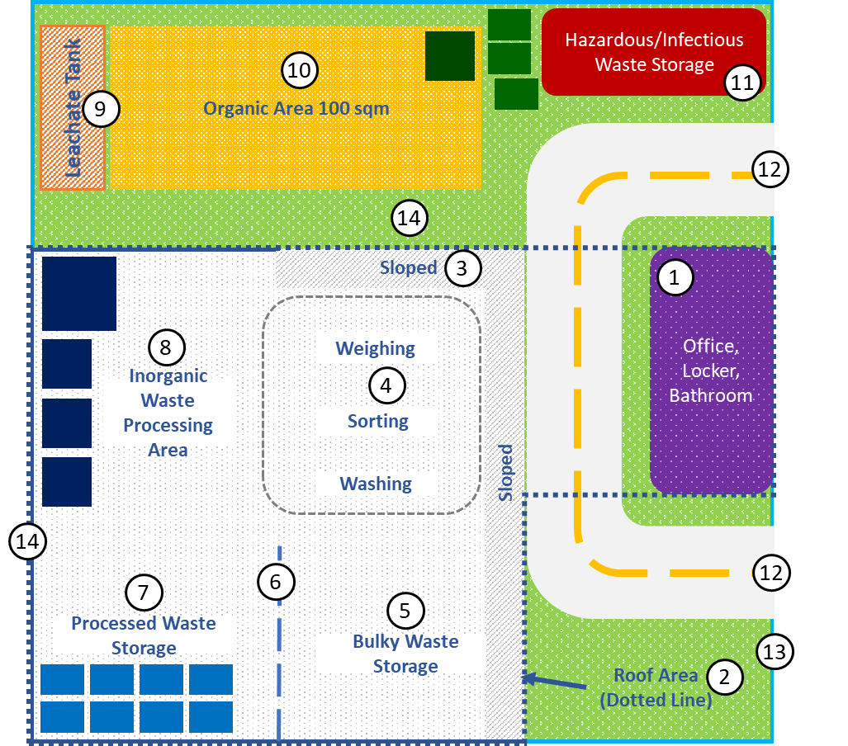
Figure 1: Example for a layout of the standard design concept for IRRCs created for Tier 2C for a land area of 9,700 sqft

The main points to highlight within the current infrastructure concept of the IRRCs are listed in Table 2 with numbers in reference to Figure 1.

Table 2: main points to highlight within the current infrastructure concept of the IRRCs

No. | Feature | Details to consider in design
1 | Office/Admin Building | - Include an administrative building with office space, locker facilities and at least one-bathroom facility with shower.  - The wastewater should be routed to a septic tank of adequate capacity or connected to the island sewer system if available.  - The building must be located near the entry way to allow for use as a guard house in addition to office space  - The corners of the building are to be rounded
2 | Warehouse Area and Roofing | - Single story warehouse with roof height 4-6 m  - Structure must be compatible for rooftop solar panel installation  - Allow leachate and wastewater from operation and maintenance processes to be conveyed to a septic tank of adequate size
3 | Entry way to warehouse | - Slope the entry to paved area to allow for entry and parking of collection vehicle within the warehouse area as well as moving of wheelie bins through the centre
4 | Weighing/Sorting/Washing Area | - Keep the weighing area at focus/centre of the entire facility when designing to allow for better flow within the facility
5 | Bulky Waste Storage Area | - Bulky waste storage area should not be placed too far inside the sheltered warehouse area to allow easier access for loading/unloading and resale of items
6 | Partition Walls | - Focus on modularity and have an open concept  - Have minimum walls in processing area  - If walls are necessary inside facility use movable partitions
7 | Processed Waste Storage Area | - Enable storage of waste in movable closed containers
8 | Inorganic Waste Processing Area | - Have electrical outlets installed in factory style that can be moved
9 | Leachate Tank | - Allow leachate and wastewater from operation and maintenance processes within the inorganic area as well as organic waste processing area to be conveyed to a septic tank of adequate size  - The slope of the slab should be designed to allow this
10 | Organic Waste Processing Area | - Concrete slab should be provided with adequate slope for flow of water to the leachate tank  - Allow leachate and wastewater from operation and maintenance processes to be conveyed to a septic tank of adequate size
11 | Hazardous and Infectious Waste Storage | - Allow hazardous and infectious waste to be stored in a separate area that is sheltered, away from processing and office space with direct access for collection vehicles
12 | Gate and road access | - A lockable metal gate should be provided at each exit/entry  - Each exit/entry should be 4m wide  - Roads should be paved and 4m wide and provided with adequate turn around radius at the turns
13 | Fence | - Walls with fence should be provided around the facility
14 | Grounds | - Paved area should be reduced to only the necessary areas with the remaining left as bare ground for landscaping  - Design should be created to minimise clearance of existing coconut palms and trees within the land plot as far as possible
15 | Ventilation | - There should be adequate ventilation provided within the warehouse area as well as the office building  - Fans should be provided within the warehouse area to ensure flow of air

2.1. Electricity Requirements

All IRRCs are to be equipped with solar panels to increase the share of renewable energy utilized within the operational power required for the centre. Additionally, if the IRRC is located far from the existing electricity grid of the island, a generator of adequate capacity should be provided to the IRRC with regard to the best feasible option in terms of environmental and socio-economic aspects. If the electricity grid of the island is close enough to the IRRC and the connection to the grid is feasible, this option will be preferred over provision of a generator.

In addition to the electricity outlets within the office, electricity outlets must be provided for the weighing/sorting/washing area, the inorganic waste processing area as well as outdoor outlets for the organic waste sorting area.

2.2. Water Requirements

All IRRCs are to be equipped with water that is fit for the following purposes:
- Potable for human consumption
- Bathroom and washing facilities
- Washing and maintenance of vehicles and equipment
- Washing and maintenance of the facility floor
- All operational processes that require water

Irrespective of availability of water supply on the island, rain water harvesting facilities must be provided at all IRRCs with adequate storage capacity installed.

In addition to the taps in bathroom facilities, water taps must be included at each processing area:
  - Organics processing area
  - Weight/Sorting/Washing area
  - Processing area

2.3. Special Design Provisions for IRRCs

On the occasion of shortage of land for the establishment of an IRRC at an island of the Maldives, the principles of the design concept are to be implemented as far as possible within the available land.

Special design provisions for the temporary storage and extraction of all waste generated on the island will be needed for islands that do not have space for the management of organic waste. Such situations need to be discussed in detail before and throughout the entire design process.

2.4. Considerations Within Design
i. Working Site
- The site should be kept clean during the construction work period and should be thoroughly cleaned once the works are completed.
- Works should be carried out on site in a safe manner to all the workers on site and the people living in the vicinity of site.
- Disturbance to the neighborhood should be kept to a minimum.
- Electricity and water supply to the site, during construction period, should be provided by the contractor.
- Modifications to the environment outside of the developmental footprint should be avoided, and the work should be carried out with minimum environmental damage. Furthermore, all aspects of environmental and social safeguard best practices should be respected during the construction, including mobilizations and demobilization as well
ii. Site Clearance
- The working site needs to be cleared of vegetation and waste if required according to the instruction of the council.
- The working site needs to be cleared of any construction waste or debris within the demobilization process before handover of the land.
iii. Concrete
- Cement conforming to BS12 standards should be used for all concrete, masonry and plastering works. The cement intended for use should be fresh and should not have any traces of hardened cement in the bag.
- All concrete works should be done using one brand of cement
- Sand and aggregate used for concrete works should be well graded.
- Concrete should be mixed in the ratio 1:2:3 which are 1 part cement, 2 parts sand and 3 parts aggregate.
- All foundations should be cast on a lean concrete layer. The lean concrete should be placed on well compacted ground.
- Concrete should be mixed using a concrete mixer. Concrete should not be mixed by hand. When pouring concrete into the formwork, the mix should be compacted using a mechanical vibrator.
- Aggregate used for concrete works should not be larger than 20mm.
- Sand and aggregate used for concrete works should be clear from dust, mud and other debris.
- All reinforcement bars used for the concrete works should be free from rust and grease that could weaken the bonding between the reinforcement bar and the concrete. Care should be taken to use continuous bars rather than short segments joined by laps.
iv. Masonry Works
- All masonry work should be done using Cement confirming to BS12 standards.
- Masonry blocks should be made from mortar mixed at 1:5 ratio with 1 part cement to 5 part sand.
- Average size of sand particles should not exceed 5mm.
v. Plastering Works
- All plastering work should be done using Cement confirming to BS12 standards.
- Plaster mix should be made from imported or local sand white sand sourced from a permitted borrow area. The sand should be free from organic matter and other debris.
- Plaster mix should be made by mixing Cement and Sand at a ratio of 1:3 with 1 part Cement to 3 part Sand.
- Average size of sand particles should not exceed 5mm.
vi. Structural Steel work
- All steel pipes obtained for the work should be new pipes and free from rust.
- Thickness of pipes should not be less than 2.5mm.
- All weld joints should be treated to limit/minimize rusting and corrosion.
- All metal components within the structure should be painted with marine grade paint.
vii. Electrical works
- All materials used for electrical wiring should comply with Utility Regulatory Authority’s standards.
iix. Roofing works
- All materials used for roofing work should be newly purchased for the project.
- All screws or bolts used for roof fixing should be G.I or Zinc finish screws.

