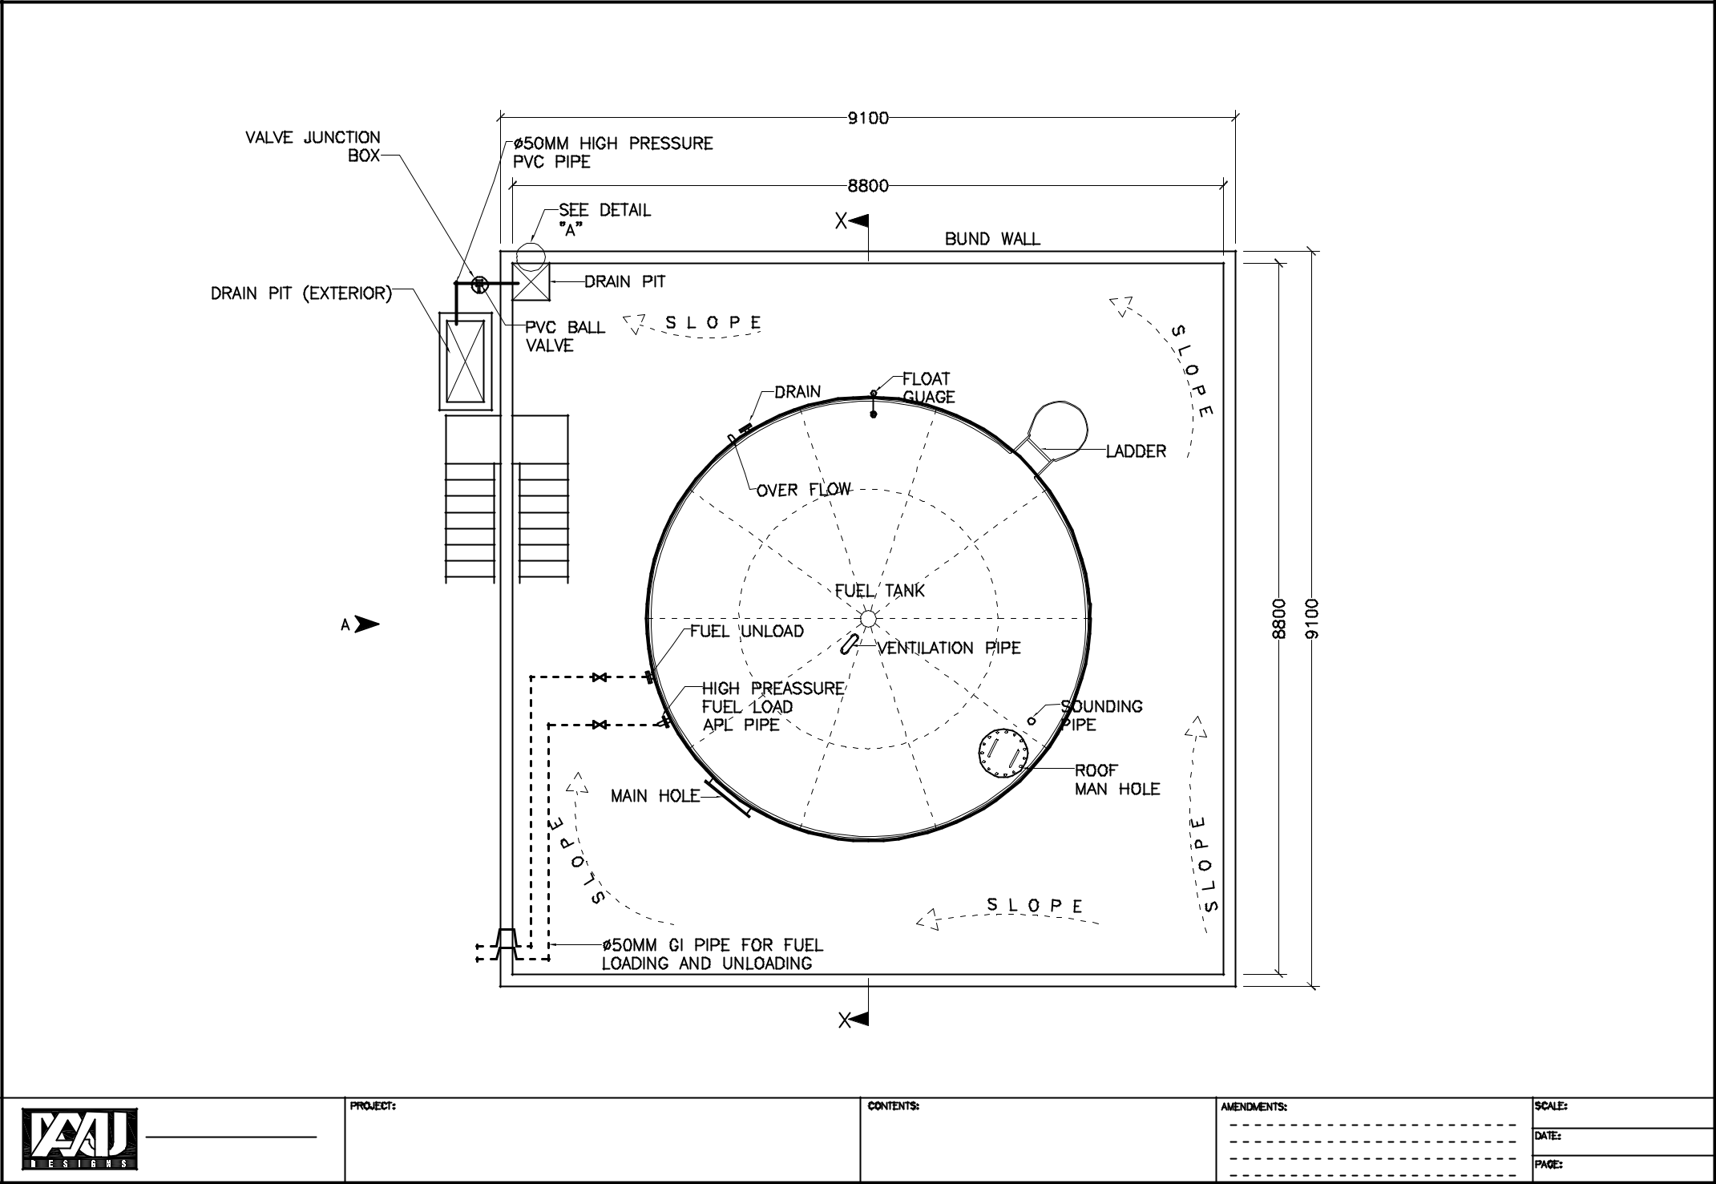

AMJ Design pvt.Ltd. |  | 115,000 |  | Storage Tank |  | 1:75
Ma.Alamaage, Dhevina Magu, Maldives. |  | 115,000 |  | Storage Tank | FLOOR LAYOUT PLAN | 02-01-2021
Phone | : 3345514 | Ra. Ungoofaaru |  |  | FLOOR LAYOUT PLAN | 02-01-2021
Fax | : 3328272 |  |  |  |  | 01 of 11
E-mail | : sales@amjdesigns.com |  |  |  |  | 01 of 11
 |  |  | Liter | Fuel |  | 01 of 11

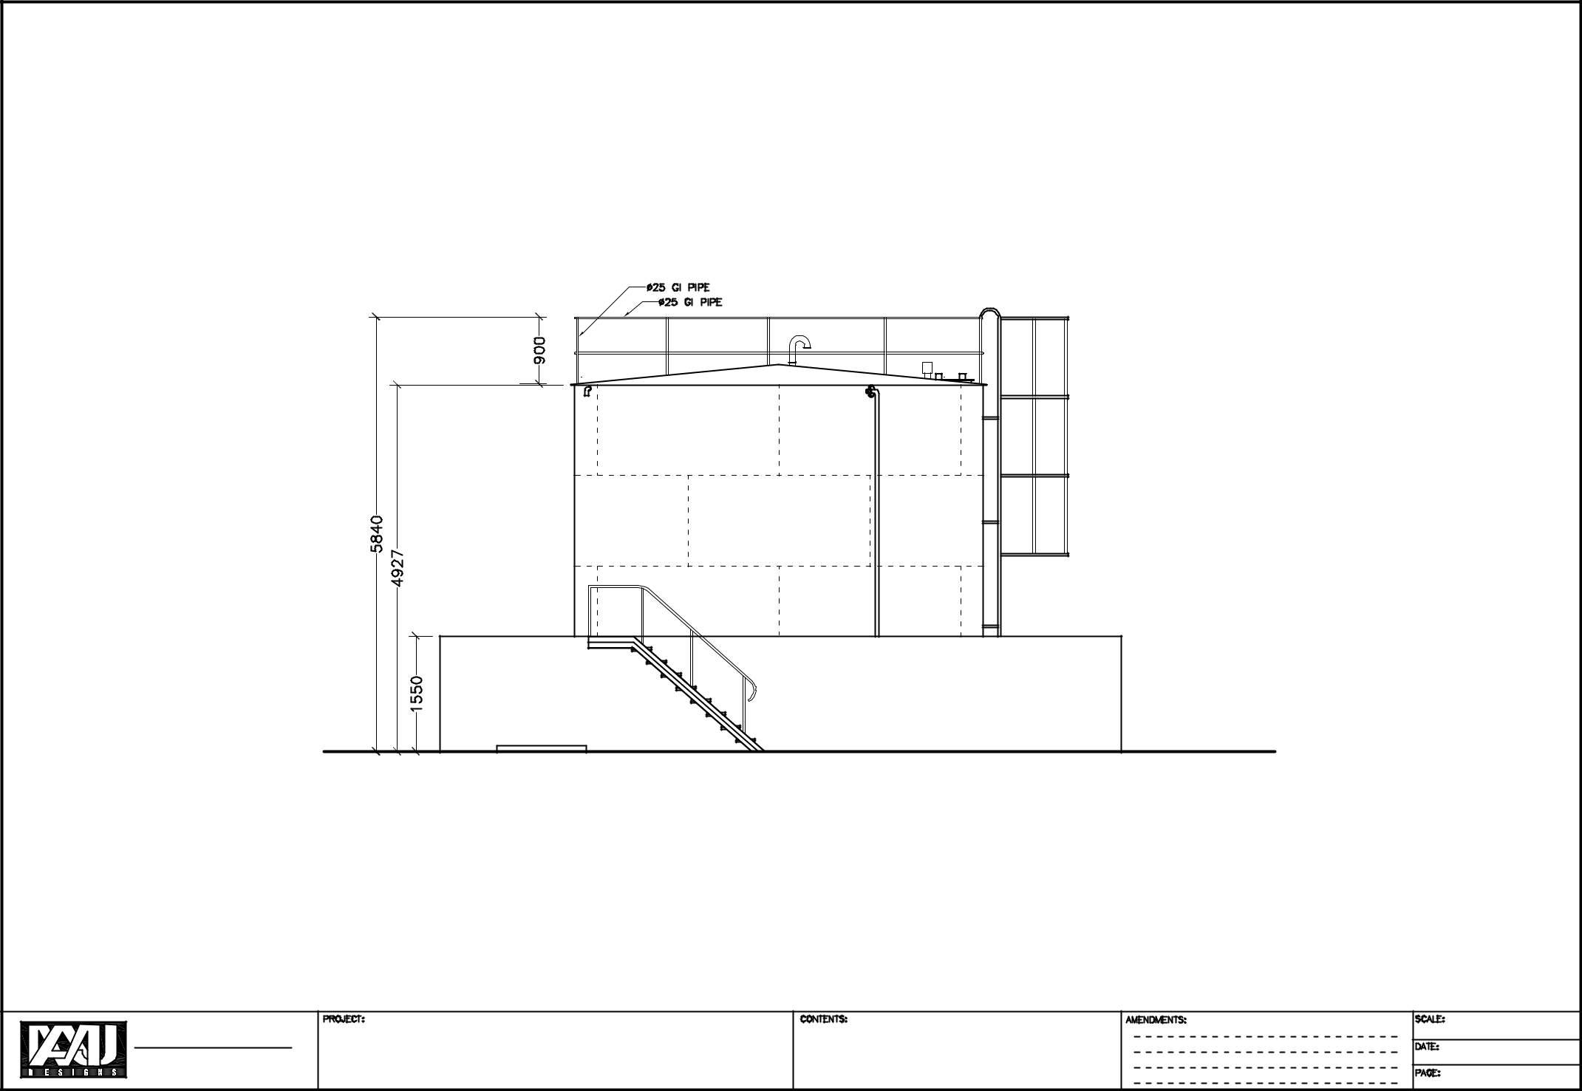

AMJ Design pvt.Ltd. |  | 115,000 |  | Storage Tank |  | 1:75
Ma.Alamaage, Dhevina Magu, Maldives. |  | 115,000 |  | Storage Tank | FRONT ELEVATION | 02-01-2021
Phone | : 3345514 | Ra. Ungoofaaru |  |  | FRONT ELEVATION | 02-01-2021
Fax | : 3328272 |  |  |  |  | 02 of 11
E-mail | : sales@amjdesigns.com |  |  |  |  | 02 of 11
 |  |  | Liter | Fuel |  | 02 of 11

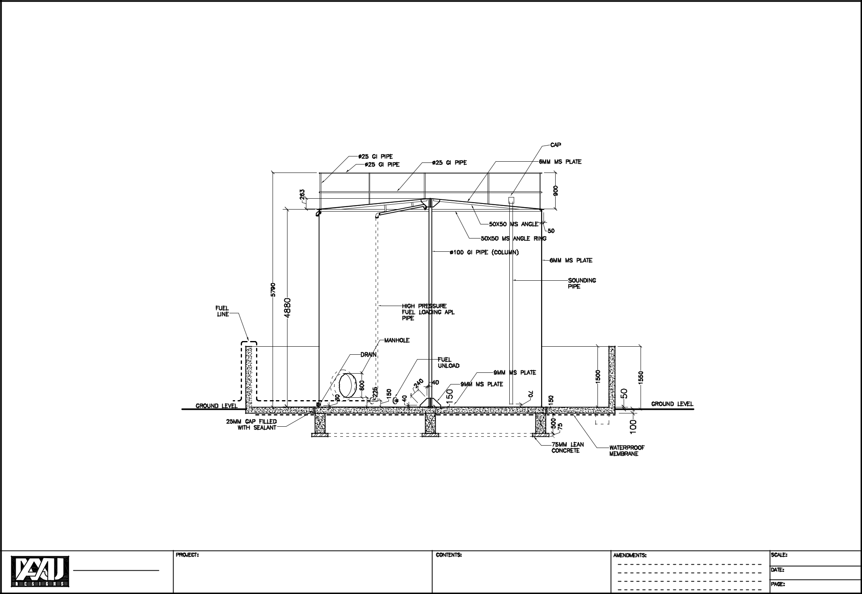

AMJ Design pvt.Ltd. |  | 115,000 |  | Storage Tank |  | 1:75
Ma.Alamaage, Dhevina Magu, Maldives. |  | 115,000 |  | Storage Tank | SECTION X-X | 02-01-2021
Phone | : 3345514 | Ra. Ungoofaaru |  |  | SECTION X-X | 02-01-2021
Fax | : 3328272 |  |  |  |  | 03 of 11
E-mail | : sales@amjdesigns.com |  |  |  |  | 03 of 11
 |  |  | Liter | Fuel |  | 03 of 11

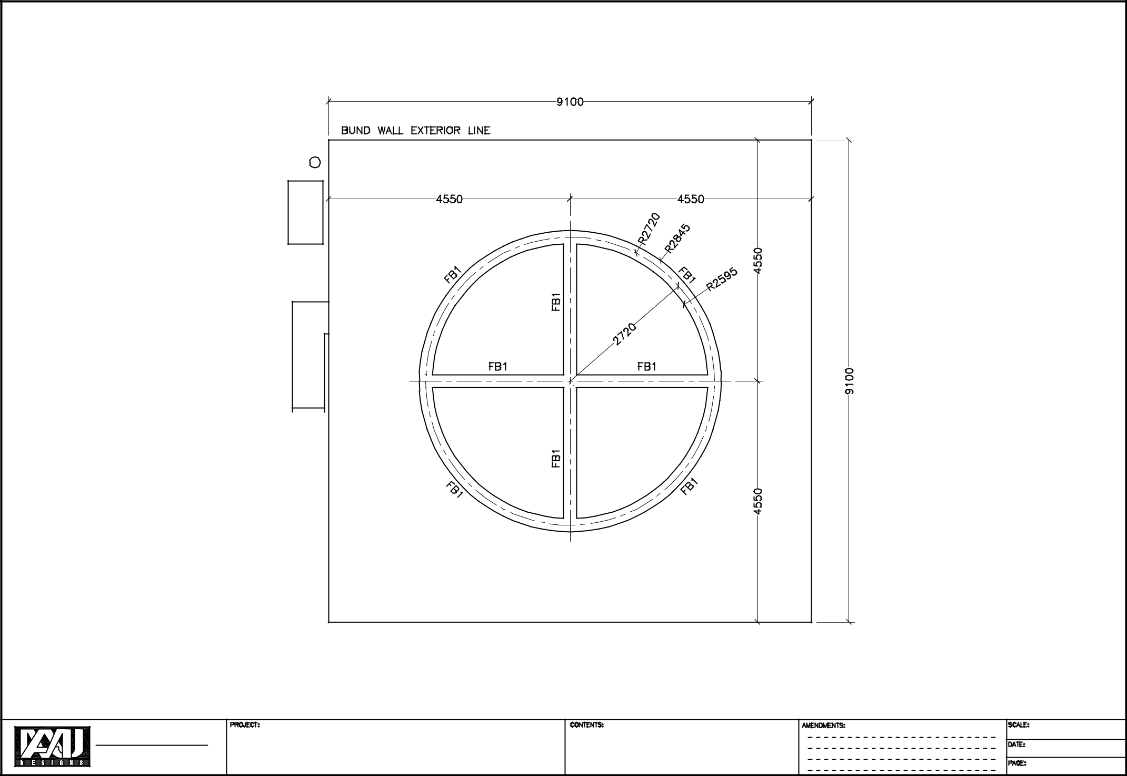

AMJ Design pvt.Ltd. |  | 115,000 |  | Storage Tank |  | 1:75
Ma.Alamaage, Dhevina Magu, Maldives. |  | 115,000 |  | Storage Tank | FOUNDATION PLAN | 02-01-2021
Phone | : 3345514 | Ra. Ungoofaaru |  |  | FOUNDATION PLAN | 02-01-2021
Fax | : 3328272 |  |  |  |  | 04 of 11
E-mail | : sales@amjdesigns.com |  |  |  |  | 04 of 11
 |  |  | Liter | Fuel |  | 04 of 11

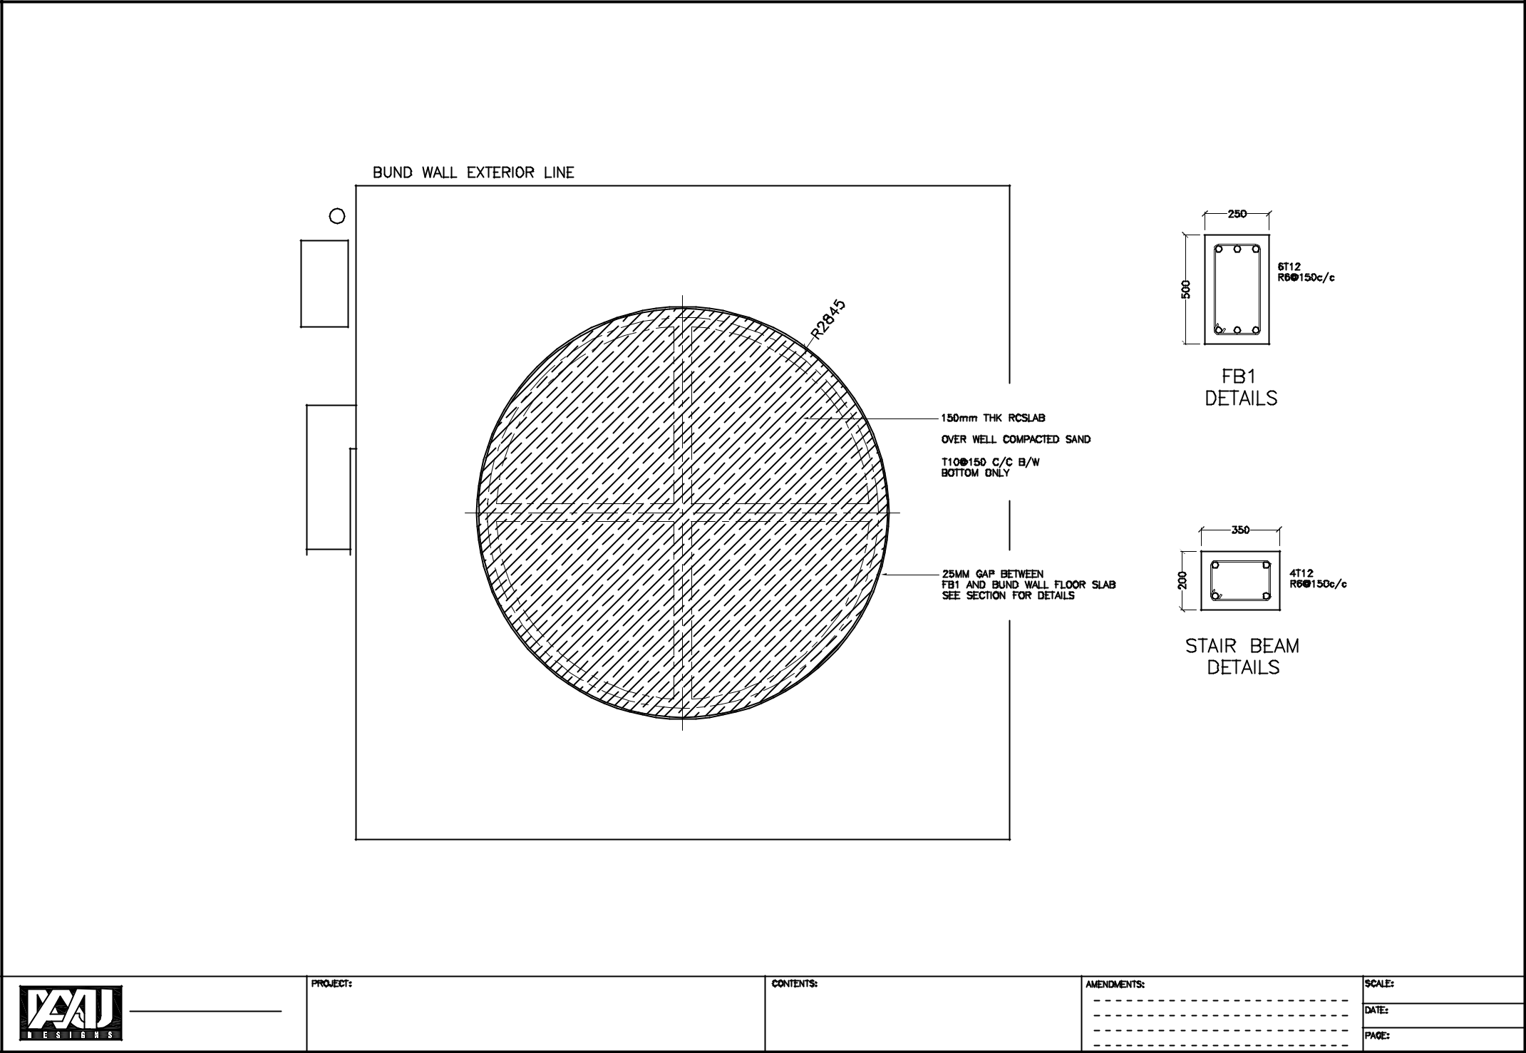

AMJ Design pvt.Ltd. |  | 115,000 |  | Storage Tank |  | 1:75
Ma.Alamaage, Dhevina Magu, Maldives. |  | 115,000 |  | Storage Tank | FOUNDATION SLAB | 02-01-2021
Phone | : 3345514 | Ra. Ungoofaaru |  |  | FOUNDATION SLAB | 02-01-2021
Fax | : 3328272 |  |  |  |  | 05 of 11
E-mail | : sales@amjdesigns.com |  |  |  |  | 05 of 11
 |  |  | Liter | Fuel |  | 05 of 11

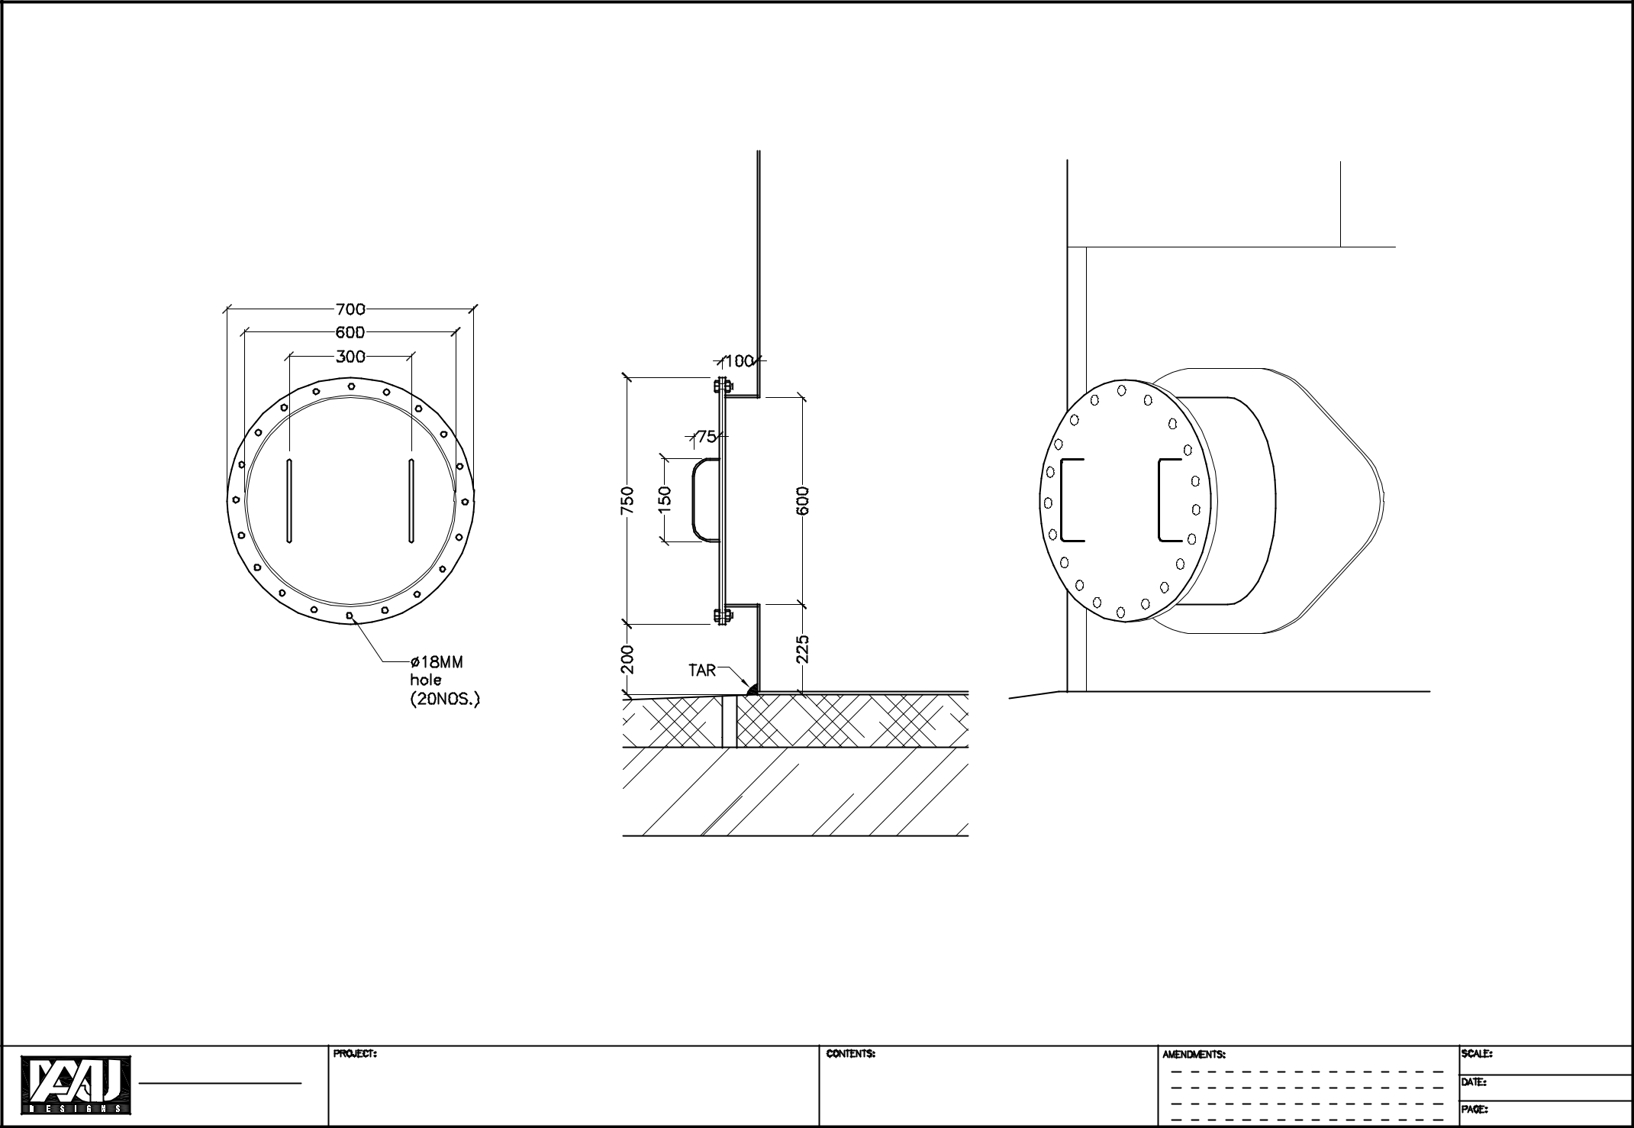

AMJ Design pvt.Ltd. |  | 115,000 |  | Storage Tank |  | 1:50
Ma.Alamaage, Dhevina Magu, Maldives. |  | 115,000 |  | Storage Tank | MAN HOLE | 02-01-2021
Phone | : 3345514 | Ra. Ungoofaaru |  |  | MAN HOLE | 02-01-2021
Fax | : 3328272 |  |  |  |  | 06 of 11
E-mail | : sales@amjdesigns.com |  |  |  |  | 06 of 11
 |  |  | Liter | Fuel |  | 06 of 11

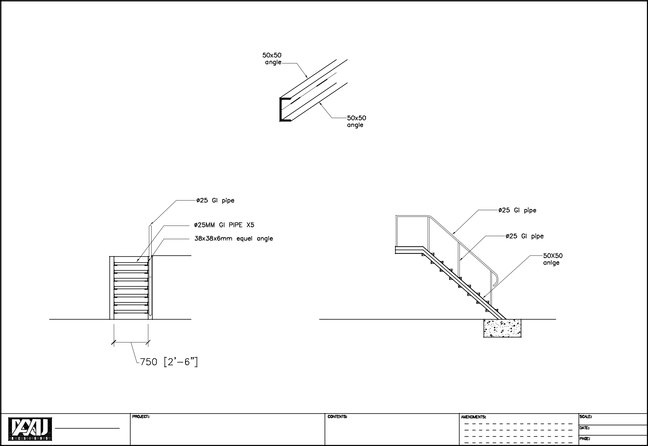

AMJ Design pvt.Ltd. |  | 115,000 |  | Storage Tank |  | 1:50
Ma.Alamaage, Dhevina Magu, Maldives. |  | 115,000 |  | Storage Tank | STAIRS | 02-01-2021
Phone | : 3345514 | Ra. Ungoofaaru |  |  | STAIRS | 02-01-2021
Fax | : 3328272 |  |  |  |  | 07 of 11
E-mail | : sales@amjdesigns.com |  |  |  |  | 07 of 11
 |  |  | Liter | Fuel |  | 07 of 11

AMJ Design pvt.Ltd.

Ma.Alamaage, Dhevina Magu, Maldives.

Phone : 3345514

Fax : 3328272

E-mail : sales@amjdesigns.com

115,000 L F Storage Tank
Ra._{iter}Ungoofaaru_{uel}

INNER LADDER DETAILS
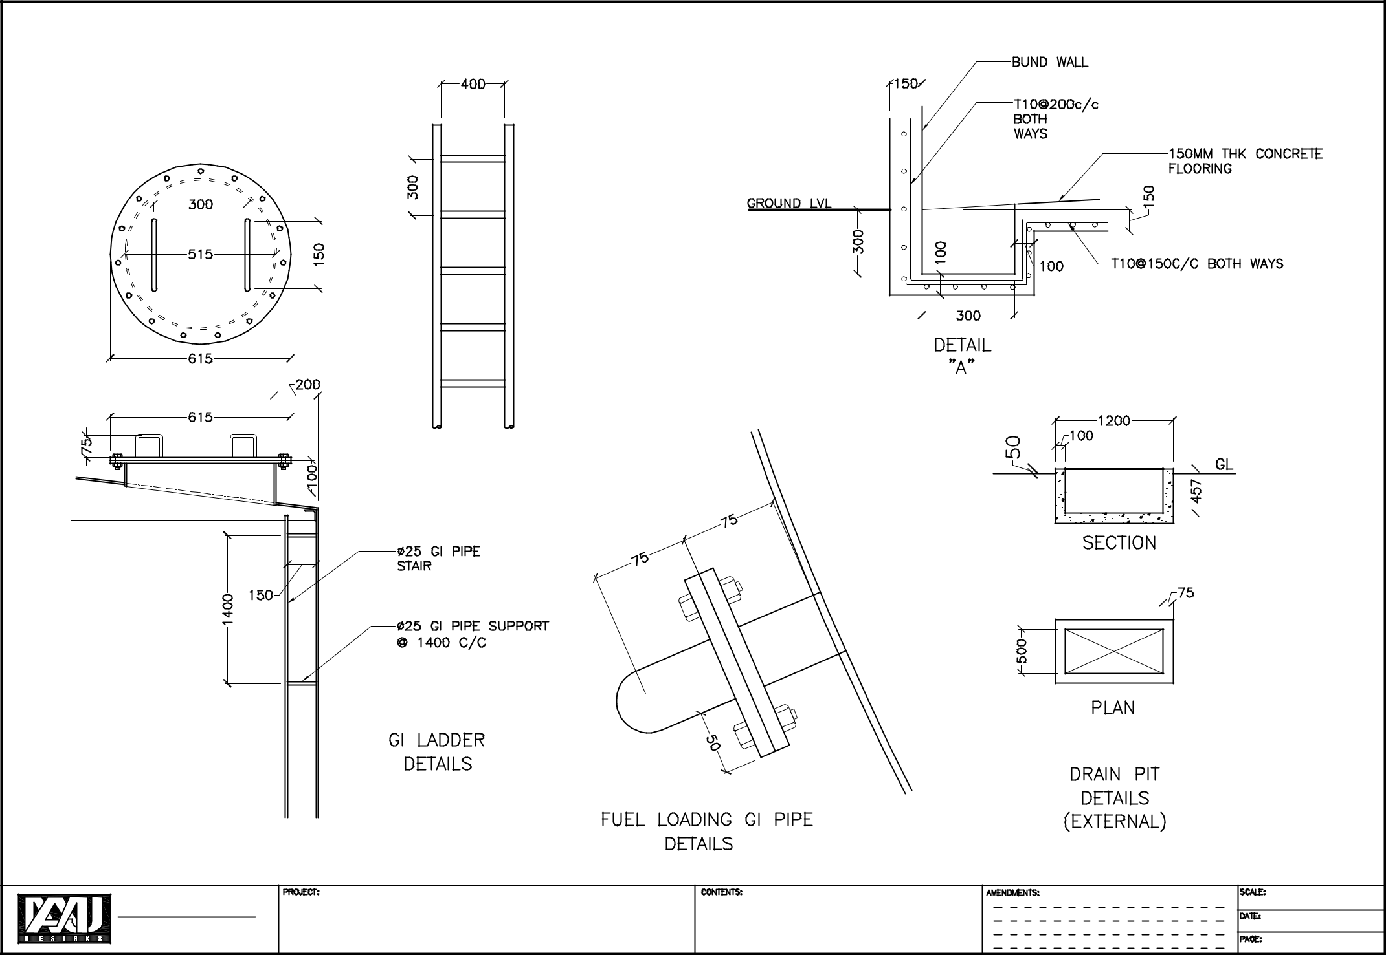

DRAIN PIT DETAILS

FUEL LOADING PIPE

1:50

02-01-2021

08 of 11
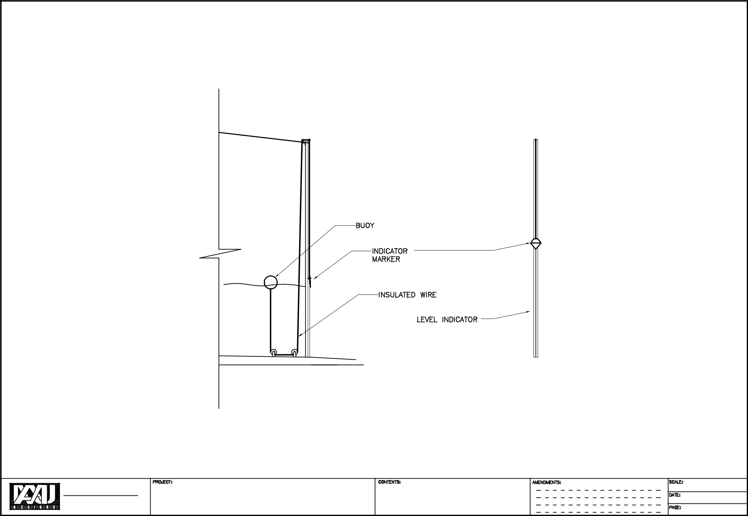

AMJ Design pvt.Ltd. |  | 115,000 |  | Storage Tank |  | 1:50
Ma.Alamaage, Dhevina Magu, Maldives. |  | 115,000 |  | Storage Tank | LEVEL INDICATOR | 02-01-2021
Phone | : 3345514 | Ra. Ungoofaaru |  |  | LEVEL INDICATOR | 02-01-2021
Fax | : 3328272 |  |  |  |  | 09 of 11
E-mail | : sales@amjdesigns.com |  |  |  |  | 09 of 11
 |  |  | Liter | Fuel |  | 09 of 11

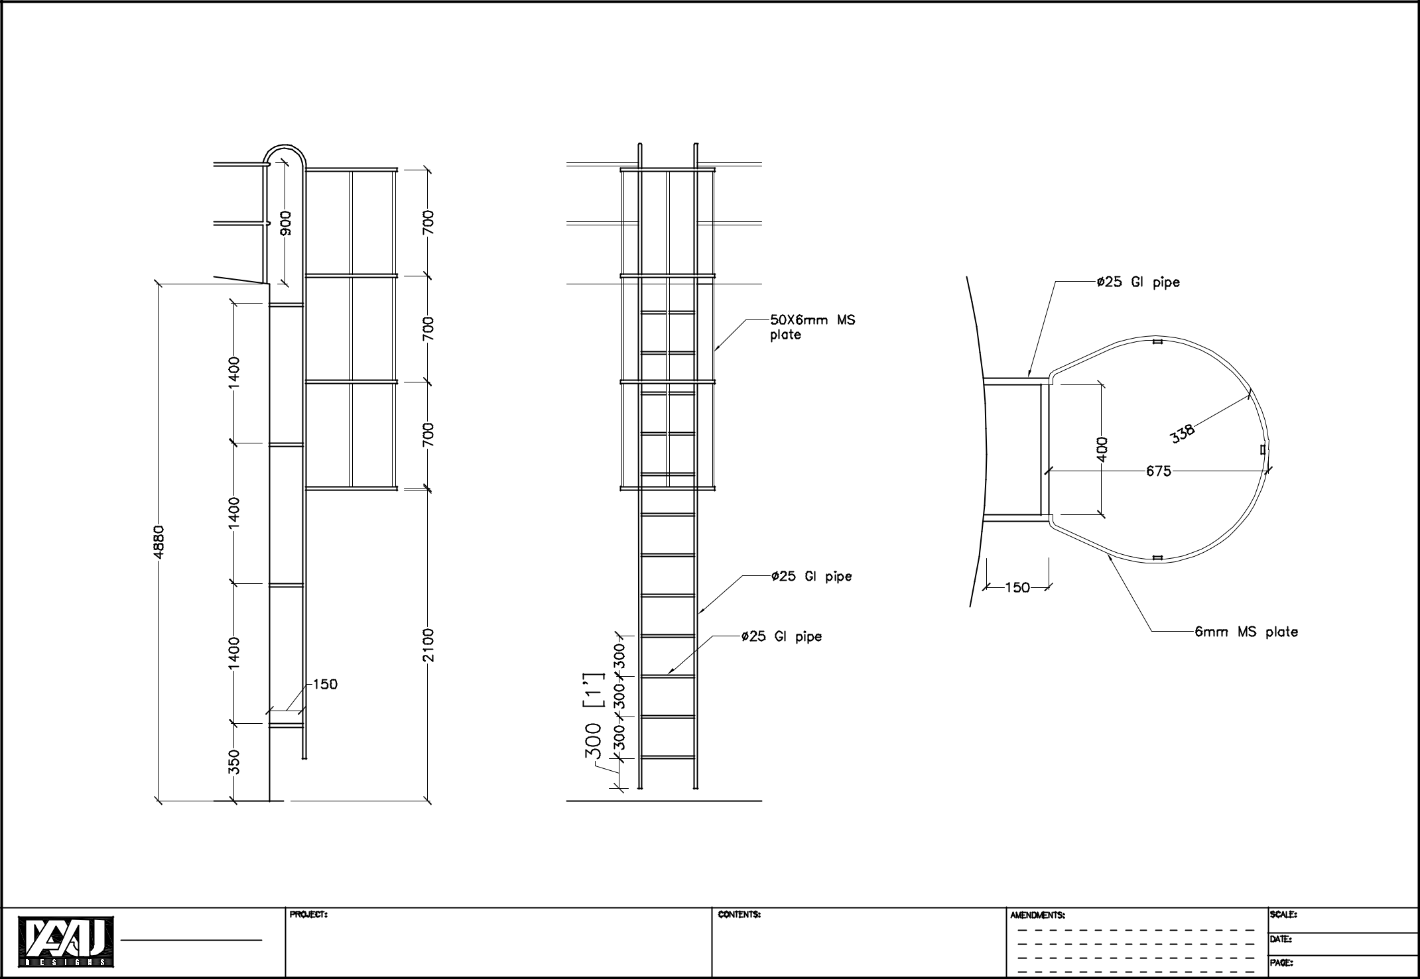

AMJ Design pvt.Ltd. |  | 115,000 |  | Storage Tank |  | 1:50
Ma.Alamaage, Dhevina Magu, Maldives. |  | 115,000 |  | Storage Tank | OUTTER LADDER | 02-01-2021
Phone | : 3345514 | Ra. Ungoofaaru |  |  | OUTTER LADDER | 02-01-2021
Fax | : 3328272 |  |  |  |  | 10 of 11
E-mail | : sales@amjdesigns.com |  |  |  |  | 10 of 11
 |  |  | Liter | Fuel |  | 10 of 11

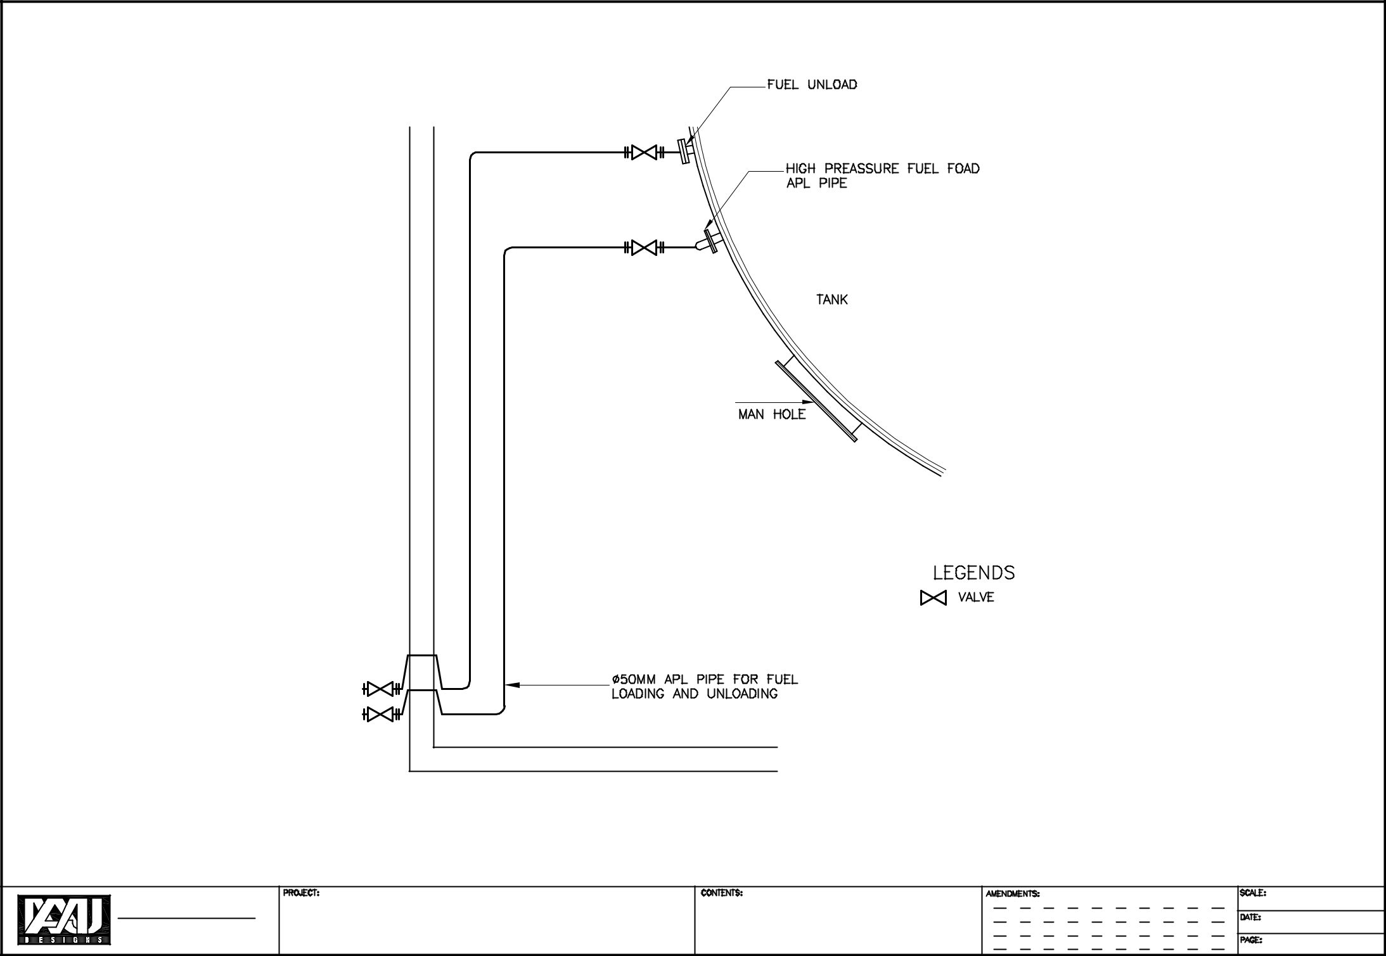

AMJ Design pvt.Ltd. |  | 115,000 |  | Storage Tank |  | NTS
Ma.Alamaage, Dhevina Magu, Maldives. |  | 115,000 |  | Storage Tank | FUEL PIPE CONNECTIONS | 02-01-2021
Phone | : 3345514 | Ra. Ungoofaaru |  |  | FUEL PIPE CONNECTIONS | 02-01-2021
Fax | : 3328272 |  |  |  |  | 11 of 11
E-mail | : sales@amjdesigns.com |  |  |  |  | 11 of 11
 |  |  | Liter | Fuel |  | 11 of 11

