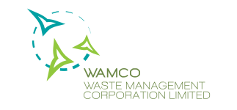

Waste Disposal Form

Request Date: / /

DETAILS OF PARTY REQUESTING FOR SERVICE

Name of Individual / Company / Resort / Island Department

Address

Email Address

Telephone Number and Fax Number

H.DH. Kulhudhuffushi

S.Hulhumeedhoo

DETAILS OF VESSEL/ VEHICLE

Name of Vessel/ Vehicle

Registry Number

Name of Captain/ Driver

National ID Card Number

Length of the Vessel / Vehicle

Tonnage

Name of Company Location of WAMCO

Industrial Village/Malé

Telephone Number and Fax Number

K. Thilafushi

Hulhumalé

Vilimalé

R. Vandhoo

Fuvahmulah

S.Hithadhoo

PARTICULARS OF WASTE (SEGREGATED)

Green Waste

Plastic

Wood

Glass

Paper/Cardboard

ELV

Electronic Waste

C&D

Other

*ELV: End of Life C&D: Construction and Demolition waste

**Note 1. The following waste types are not accepted at the Facility**

1. **Hazardous chemical waste**
2. **Liquid or semi-liquid sewage and septic waste**

**Note 2: Please send the original along with a copy of the same with the boat captain or driver.**

V.2

Sales Receipt / Estimate Number

AUTHORIZED PERSON OF REQUESTING PARTY

Name

Telephone Number and Fax Number

Designation

Payment basis: Cash Credit (Prior arrangement needed)

*Any alterations on the form will not be accepted Signature and Stamp

**---------------------To be filled by official of Waste Management Corporation---------------------**

Name

Date Received

Time Received

Signature and Stamp