**­Seattle University Bannerwood Park A-Z Guide**

**1790 Richards Rd, Bellevue, WA 98005**

**Seattle U Baseball**

Last Updated: March 1st, 2023

The following A-Z Guide is for all Seattle University Baseball games held at Bannerwood Park. We hope this guide helps you as you prepare for your visit to Seattle University Baseball and the Bannerwood Park.

**ACCESIBILITY ACCOMODATIONS**

Below is a list of disability services currently offered at Bannerwood Park. Feel free to reach out to the Ticket Office at 206-398-4678 to help make arrangements prior to your visit if you have any special needs, questions or concerns regarding our services.

*Accessible Parking for Guests with Disabilities*

Bannerwood Park has accessible parking spaces located near the main entrance of the ballpark.

*Accessible Drop-Off/Pick-Up*

Should the accessible spaces fill on game day, guests may be dropped off near the main entrance to the ballpark. Please be aware of any pedestrians who are waiting in line or walking up to the ballpark when dropping patrons off.

*Accessible Pedestrian Route & Entrance*

Access from the parking lot to the main entrance of Bannerwood Park is accessible.

*Accessible Restrooms for Guests with Disabilities*

Restrooms are located near the concessions stand behind home plate. Both male and female restrooms are accessible.

*Gender Neutral Accessible Restroom*

There is no dedicated gender-neutral restroom at Bannerwood Park. Any patrons who seek accommodation may speak with the Game Manager.

*Seating for Guests with Disabilities*

A limited number of accessible seats are available for guests with disabilities at Bannerwood Park. Guests may reach out to the Ticket Office ahead of game day at 206-398-4678 to request accommodations. Accessible seating will be filled on a first come, first-serve basis.

*Emergency Evacuation*

If an emergency evacuation arises, staff will be available to persons with disabilities who request assistance in exiting the venue. The primary accessible exits are the gates located outside the 1st and 3rd base stands as welll as the main entrance behind home plate. Please follow the direction of the Public Address announcer and venue video board.

**ANIMALS**

Animals or pets are prohibited at Bannerwood Park with the exception of trained service animals and service animals in training for guests with disabilities. Service animals must be kept on a leash or in a harness at all times.

**BAG POLICY**

All bags permitted at Bannerwood Park are subject to search. Seattle University reserves the right to deny anyone or anything from entering the venue. For the safety of all in attendance bags that are denied entry to the venue should be returned to your vehicle, bags may not be left unattended outside the venue. Unattended bags will be dealt with in a manner deemed appropriate by the Game Manager.

**BANNER/SIGNAGE POLICY**

Seattle U Athletics reserves the right to prohibit or remove any banner or sign. Signs that obstruct the view of other fans, obscures stadium signage, can be considered an advertisement, or is determined to be obscene, vulgar, indecent, inappropriate, or derogatory are strictly prohibited.

**CAMERA POLICY**

Cameras are permitted for personal use only. Professional cameras and cameras with telephoto or detachable lenses longer than the width of the camera are prohibited. Flash photography, video cameras, monopods, and tripods are also prohibited. Seattle University Athletics reserves the right to ask guests to put cameras or video equipment away. All media must be credentialed via Seattle U Athletic Communications.

**CONCESSIONS**

Concessions are located behind home plate between the restrooms. Concessions at Bannerwood Park are cash free. Debit /credit cards are the only accepted form of payment.

**CANCELED/POSTPONED EVENTS**

For the most up-to-date information of postponed/canceled games please follow us on Twitter @GoSeattleU and our respective team accounts.

**DRIVING DIRECTIONS**

Bannerwood Park, home to the Seattle University Baseball team is located approximately 10 miles from campus. Bannerwood Park is located at 1790 Richards Road, Bellevue, WA, 98005. Bannerwood park is located 1 mile north of I-90 and just east of the I-90/I-405 intersection. You may access the park by taking the Factoria exit off I-90, or by taking Exit 12 off I-405.

**EMERGENCY PROCEDURES**

SEE SOMETHING, SAY SOMETHING - if you notice or become aware of any suspicious, concerning, or unusual activity both inside and outside the venue please report the activity to the nearest event staff member. In the event of an emergency please follow the directions of the PA announcer, event staff, and emergency responders. Once seated, please locate the nearest exit and an alternate exit in case of an emergency. Always designate a predetermined location both inside and outside the venue to meet friends and family in case you are separated or in the event of an emergency.

**FAN CODE OF CONDUCT**

Seattle University is committed to creating a safe, comfortable, and enjoyable environment for all guests. It is expected that all guests conduct themselves in an appropriate manner at all times before, during, and after the competition. We expect all fans to treat other guests, players, coaches, and officials with courtesy. To ensure a fun, safe, family atmosphere please refrain from:

* + Interfering with others ability to enjoy the game
  + Using/displaying foul or abusive language or gestures
  + Being or appearing to be intoxicated
  + Failing to produce a ticket upon request
  + Entering the competition or restricted access areas
  + Smoking except in designated areas (Seattle U is a tobacco free campus)
  + Throwing objects onto the competition area or within the venue
  + Otherwise being disorderly

Guests found to be in violation of the Fan Code of Conduct may be asked to leave the venue. You may report fans in violation of the Code to the nearest working staff member.

**FOUL BALLS**

Batted balls may leave the field of play at any time, Guests should be aware at all times during the game.

We kindly ask that any balls that leave the playing field and either exit the ballpark or land in the seating area are returned to Athletics staff. Balls may be returned to the concessions stand in exchange for Double Bubble.

**GATES OPEN**

Gates open ninety (90) minutes prior to event start. All entry takes place at the home plate entrance to Bannerwood Park.

**LOST AND FOUND**

All guests looking to claim, or report lost items during an event should find the nearest Event Staff. All lost and found items not picked up prior to the end of the game will be available for pick-up with Seattle U athletics staff no earlier than the following business day. Staff may be contacted the next business day at 206-296-6400. All unclaimed items will be disposed of after (30) days.

**PARKING MAP**

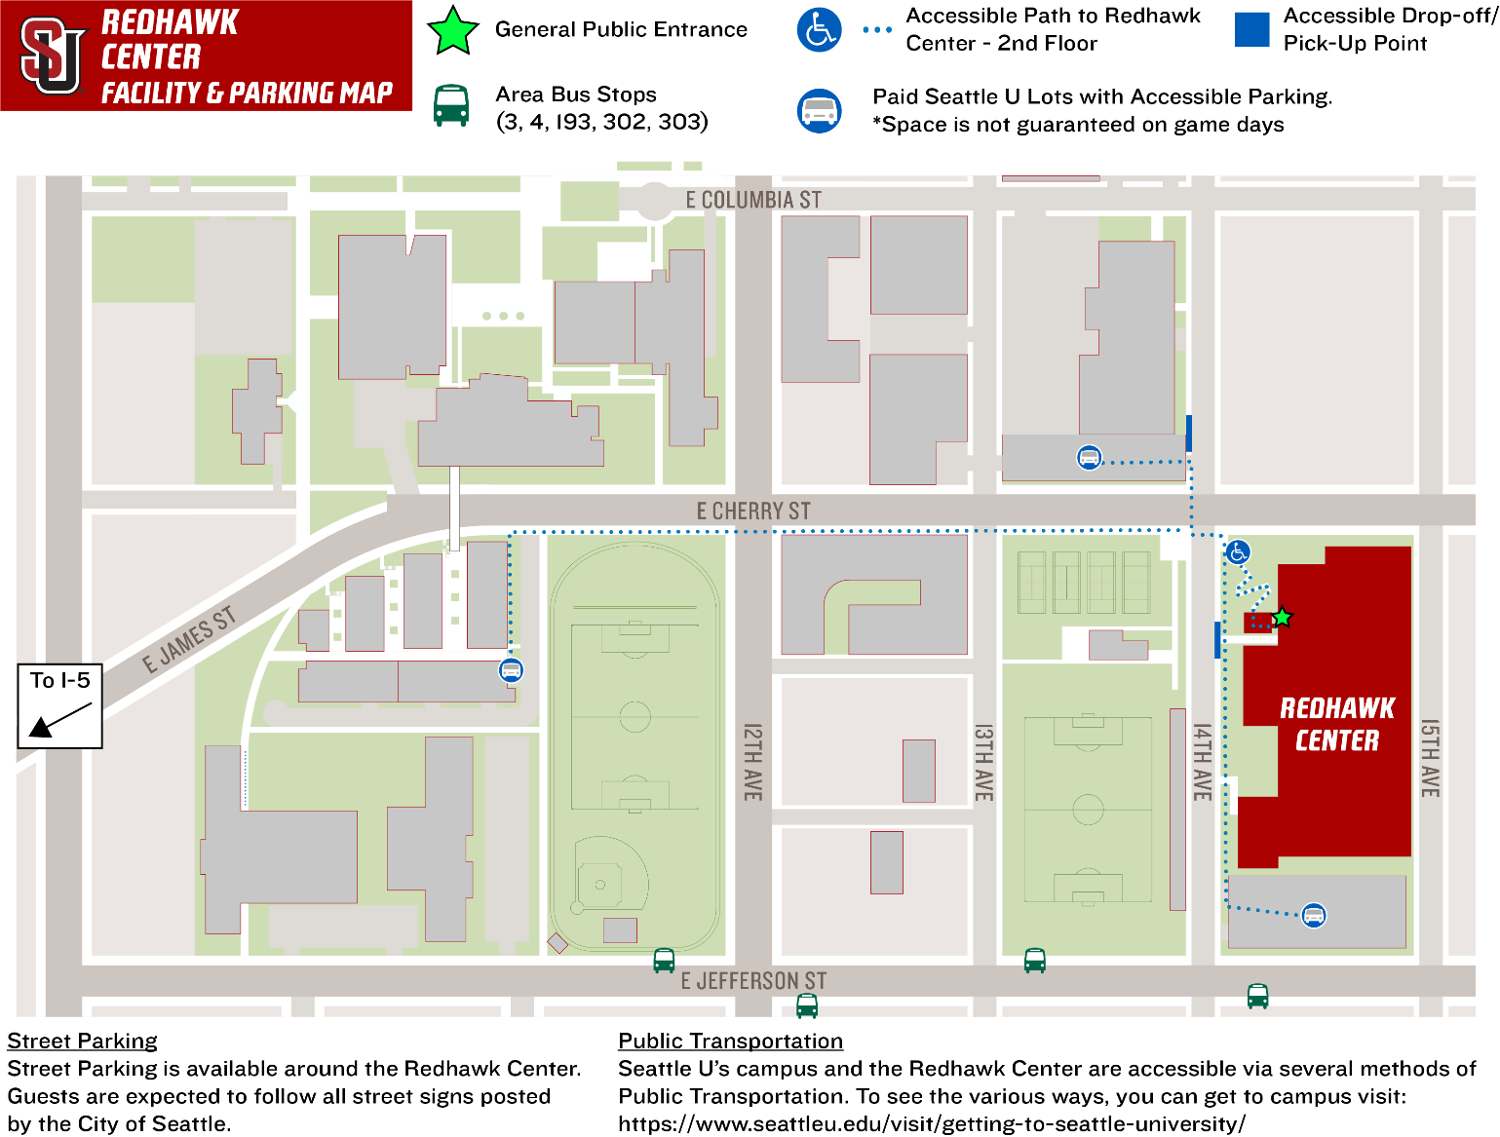

**PARKING & TAILGATING**

Parking for games located is directly outside of Bannerwood Park. Guests may park in any available space. Spaces may be blocked by cones for team buses, please respect any spaces that are reserved for specific use.

*Tailgating*

Tailgating is allowed outside of Bannerwood Park. The City of Bellevue asks that all tailgating take place either within the single space occupied by your vehicle, or in the grassy area on the West side of the parking lot. Tailgates that block use of the drive line will be asked to relocate to an approved location.

**PROHIBITED ITEMS**

All guests and personal items are subject to search prior to entering Bannerwood Park. For the safety and game day experience of all fans, the following items are prohibited from entering:

* + Alcoholic beverages
  + Animals (except for service animals)
  + Balloons, balls, and frisbees
  + Coolers and containers
  + Drones and Unmanned Aircraft Systems (UAS)
  + Fireworks
  + Hazardous Materials
  + Hover-boards, Scooters & Bicycles
  + Laser pointers
  + Professional Cameras
  + Selfie stick
  + Weapons of any kind

**RE-ENTRY**

Re-entry is permitted at Bannerwood Park. Guests wishing to depart and re-enter the venue must scan out and scan back in for access. Guests may be asked to show their valid game ticket at any time they enter the venue.

**RESTROOMS**

Restrooms are located near the concessions stand behind home plate.

**STROLLERS**

There is no designated storage location for strollers. It is not the responsibility of event staff to monitor unattended items. Guests are encouraged to leave strollers in their vehicle.

**SUSTAINABILITY**

Seattle University encourages all guests to reduce, reuse, and recycle. For more information on Seattle U’s commitment to sustainability visit [HERE](https://www.seattleu.edu/cejs/campus-sustainability/).

**TICKETING**

Tickets are required for admission to Bannerwood Park. For more information regarding tickets sales please visit our Ticketing Home Page [HERE](https://goseattleu.com/sports/2019/12/19/tickets.aspx) or call the Seattle University Ticket Office at (206) 398-GOSU (4678) or email [seattleutickets@seattleu.edu](mailto:seattleutickets@seattleu.edu).

*Children*

Children ages three (3) and older must have a ticket to enter a Seattle University Athletics ticketed event. Children ages two (2) and under are granted complimentary admission to all Seattle University Athletics events with the understanding they sit on the lap of an adult and do not disturb other guests.

*Faculty/Staff*

All Seattle University benefits-eligible faculty and staff receive two (2) complimentary tickets for all regular-season baseball games. Tickets are subject to availability and may be claimed at the following [LINK](https://goseattleu.com/sports/2020/1/7/faculty-staff.aspx).

*Students*

All Seattle University undergraduate, graduate and law students receive complimentary admission to all regular-season Seattle University athletics contests. Student seating at all venues is general admission, available on a first-come, first-served basis. Tickets are subject to availability and may be claimed at the following [LINK](https://goseattleu.com/sports/2020/1/7/students.aspx).