
PRESS RELEASE
Jan 2025
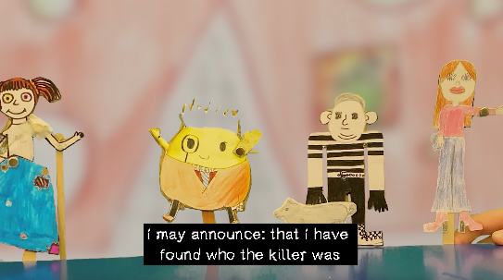
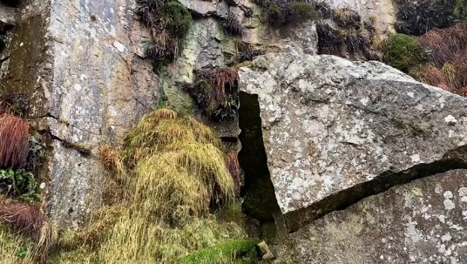
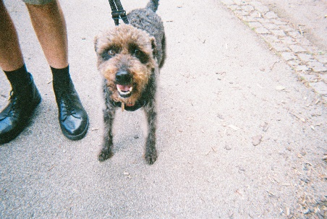

Harbour House celebrates artwork made by local artists and community members in their upcoming community programme exhibition

Exhibition: 25 Jan - 22 Feb 2025
Curator Tours: Weds 5 Feb, 12pm-1pm & Fri 14 Feb 4pm-5pm
Closing Event: Sat 22 Feb 2025 (PM)

Harbour House is excited to announce The Bird and the Rhino exhibition showcasing artworks created by local community members. The exhibition features collaborations between community groups from Kingsbridge Community Primary School, Kingsbridge Community College, and participants of the Kingsbridge Love Your Park event in 2024 as part of Harbour House’s community engagement programme, alongside works by the Devon-based artists who facilitated those projects; Ellie Robinson-Carter, Sam Machell and Jodie Saunders.

As part of Harbour House’s ongoing community engagement programme, the exhibition highlights the impact of free workshops and events offered throughout the year. These initiatives are aimed at making art and movement practices accessible to all, reaching underserved community groups across Devon. Some workshops are open to the public, while others are tailored for specific community groups, fostering creativity and collaboration in the local setting.

The title of the exhibition is inspired by the mutually beneficial relationship between Oxpecker birds and rhinos. Oxpeckers' main source of food are insects and bugs, and are often seen sitting on rhinos’ backs, eating the insects that live on the rhino, helping them keep clean; the rhino offers a constant supply of food. As rhinos have bad eyesight, the birds also work to help protect them from predators like lions or hyenas. When the Oxpeckers see the predators they make lots of noise which alerts the rhinos to the danger.

The Bird and the rhino highlights the collaborative nature of the socially engaged projects programmed by Harbour House, where artists and participants inspire and learn from each other. Like the Oxpecker and the rhino, these projects demonstrate the power of mutual support, fostering creativity and connections within communities.

Featured Projects:
Sam Machell and Kingsbridge Community Primary School:
Sam Machell, an artist known for exploring political and ecological themes through storytelling, led a series of workshops at Kingsbridge Community Primary School. Working with a group of students in years 5 & 6, Sam guided them through an improvisational, collective approach to storytelling, resulting in the creation of the film The Creative Common: The Fateful Feast at Castle Froglington. The exhibition also includes Machell’s film Dinner Machine: Depictions of an Altered Beast. The project showcases the boundless creativity and imagination of the students.

Ellie Robinson-Carter and Love Your Park
Ellie Robinson-Carter specialises in using creative practices to support individuals with dementia and intergenerational groups. Her Photobook Project invites participants to document their experiences through photography, fostering empathy and connection. At the Love Your Park event, participants created images based on themes such as flowers, animals and nature. The exhibition displays photobooks with images by participants from this event alongside etchings by Robinson-Carter, offering a moving visual record of the participants’ connection to the natural world.

Jodie Saunders and Kingsbridge Community College
Jodie Saunders explores ‘Tentacular Listening’- listening as an attentive, embodied and essential way of being. Working with year 12 students from Kingsbridge Community College, Jodie guided them through the creation of the film Crepuscular Creatures, which explores the diversity of local nature at dawn and dusk. They used these, and recordings from the BBC Natural History Collection Unit sound archive to create a soundtrack for the moving image piece. The exhibition features the students’ film, created over a ten-month period, alongside Jodie’s audio piece Foggintor.

Events:
Curator Tours
Dr Beth Richards, Harbour House’s Education and Engagement Curator, will lead 2 x guided tours of the exhibition, offering insights to the different works and the community engagement programme.
- Weds 5 Feb, 12pm-1pm
- Fri 14 Feb 4pm-5pm

Exhibition Details:
- Title: Community Programme Exhibition: The Bird and the Rhino
- Location: Harbour House Ground Floor Gallery
- Dates: Sat 25 Jan - Sat 22 Feb 2025
- Curator tours: Weds 5 Feb, 12pm-1pm & Fri 14 Feb 4pm-5pm
- Closing event: Sat 22 Feb 2025

>>ENDS<<
NOTES TO EDITORS
ADDITIONAL INFORMATION

About the Partners:
Love your park
Love Your Park is a community event run by Kingsbridge Town Council, part of the National Love Parks week which happens annually. The event takes place at The Recreation Ground in Kingsbridge. Love Your Park is a celebration of everything the Green Flag award winning Recreation Ground has to offer, and is a community event with something for everyone.

Kingsbridge Community College
Kingsbridge Community College are passionate about learning and ensuring that their learners thrive and grow amidst our beautiful surroundings here in South Devon. They have high aspirations for every student and they strive to ensure that students are able to achieve their full potential through a clear focus on learning and achievement in a supportive environment. They recognise the benefits an excellent education brings and encourage their students to be ambitious and bold in their learning journey and to make the most of every opportunity. They are justifiably proud of our community, and routinely seek excellence in all that they do.
Website: www.kingsbridgecollege.org.uk

Kingsbridge Community Primary School
Kingsbridge Community Primary School is guided by their key values of community, aspiration, respect and equity. Their core purpose is to care for and champion all the children in our community to enable them to be the best that they can be. They have a warm and friendly atmosphere and a wonderful environment in which to learn. KCPS are proud of their school, their curriculum, and they are always delighted to welcome visitors.
Website: www.kingsbridgeprimary.co.uk

About the Artists:
Sam Machell:
Sam Machell uses writing, performance and visual storytelling to explore political, philosophical and ecological anxiety. In 2020, he was writer in residence for Rame Projects, reflecting on their summer program from the perspective of a three-headed chimera (a fire-breathing monster with a lion's head, a goat's body, and a serpent's tail). He has had writing published by CLOAK, Expat Press, surfaces.cx and Back Patio Press. With Colin le Duc as the Sand Gardeners, his experimental videogame work has been exhibited internationally and featured in publications such as PC Gamer and Kotaku. Recent exhibitions include In Spite of Bad Weather (2023) at The Arts Institute, and The Tale of the Tattoo’d Pig (2023), held in an empty shopfront in Plymouth and made possible by Meanwhile Use.
Website: neutralspaces.co/browniecove/

Ellie Robinson-Carter:
Ellie Robinson-Carter is a specialist in using creative practice to enable people with dementia and intergenerational groups to connect to themselves and others, fostering empathy, building belonging and challenging disconnection in our society. Ellie has completed international residencies and projects with Run Tomo Japan, Humanitas Deventer and Alzheimer Bulgaria, as well across the UK including Butterflies (Hull), Talk Dementia (London) and Budding Friends (Exeter). In 2021 she was awarded a place on The Multiplier with The Cares Family and in 2022 was selected for the prestigious Starling Fellowship with Giving Tuesday. Alongside this, she teaches on the MSc Dementia at University of Hull and is Creative Spaces Project Manager at Sensory Trust.
Website: ellierobinson-carter.com

Jodie Saunders:
Jodie Saunders explores ‘Tentacular Listening’ - listening as an attentive, embodied and essential way of being. Past projects have investigated feminist sonic histories/stories - as in Lyneham Collection (2020) & invisible:indivisible (2022). 'In the Mind's Ear' (2021) asked questions around underwater listening and the effects of human-generated sound on underwater beings. In 'Tentacular Listening' (2022), she collaborated with Emma Somerville in a BSL conversation exploring listening and vibration.
Website: https://jodiesaunders.org

About Harbour House
Harbour House is a contemporary art, movement and wellbeing centre in Kingsbridge, South Devon. Our mission is simple: to enrich the lives of the people of our town and surrounding communities through art, creativity, movement and wellbeing practices. We achieve this through an inspiring and inclusive programme of exhibitions, performances and educational activities that invite everyone to participate. We also provide flexible spaces dedicated to mindfulness, movement and yoga. Join us as we explore, create, move and thrive together.

Links
Harbour House Website: https://harbourhouse.org.uk/
Harbour House Eventbrite: https://www.eventbrite.com/o/harbour-house-68065898243
Harbour House Instagram: https://www.instagram.com/harbour.house.art.wellbeing/
Dropbox Promotional Images:

For further information/images or interview requests please contact:
Elaine Sinclair (Assistant Curator and Communications Manager at Harbour House)
Tel: 01548 854708 | Email: elaine@harbourhouse.org.uk
Harbour House, The Promenade, Kingsbridge, TQ7 1JD

