**Hamilton City Council | Te Kaunihera o Kirikiriroa  
Disability Policy Action Plan  
2022 – 2025**

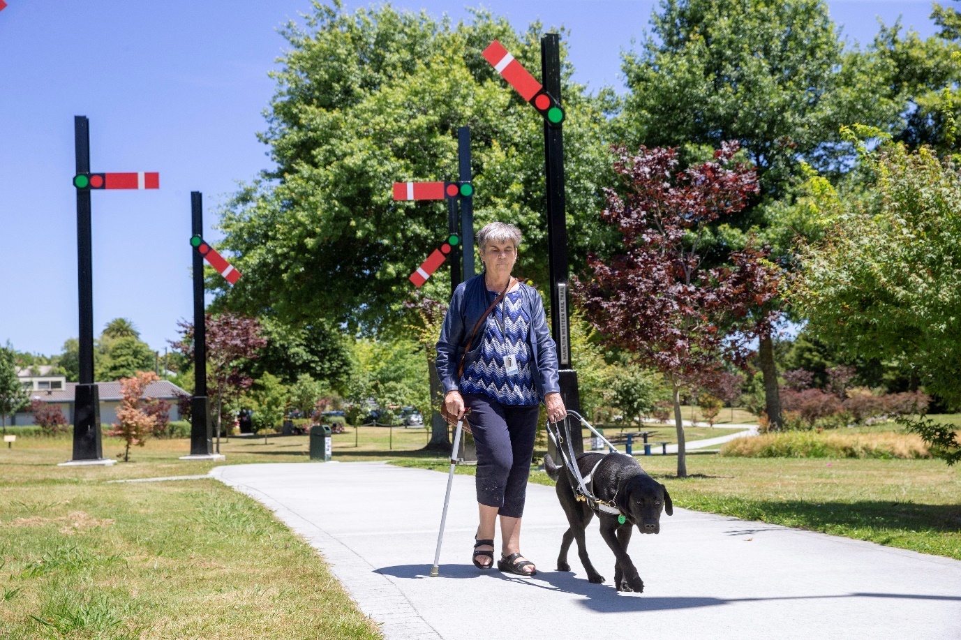

This action plan will implement Council’s Disability Policy. It will ensure that Council operates and manages all its infrastructure, facilities and services in a way that gives all people equity of access, inclusion and opportunity. The action plan will be monitored and reported on annually with support from the Disability Advisory Forum and reviewed every three years alongside the disability community.

Actions will continue to be developed and updated in collaboration with our community. This action plan also supports and assists in achieving the vision of Council’s Community and Social Development Strategy.

**Summary of goals**

**Goal 1:**Council develops effective, mutually beneficial partnerships with stakeholders to inform and progress outcomes.

**Goal 2:**  
Funding and decision making around accessibility is enabled by quality data and audits so everyone can experience Council events, facilities and destinations.

**Goal 3:**

Council services will be responsive to the diverse needs of disabled people.

**Goal 4:**People can get around the city independently and safely.

**Goal 5:**The whole community can enjoy fair opportunities to play.

**Goal 6:**Council projects embed the principles of universal design, so every new-build community facility project is accessible to everyone.

**Goal 7:**Hamilton City Council is an enabling employer that benefits from the skills and perspectives of a diverse workforce.

**Goal 8:**Barriers to civic life and democratic participation are removed through better physical access and improved Governance and communication processes.

**Goal 9:**Council communications are produced and distributed in accessible and effective formats, enabling participation, engagement and preparedness.

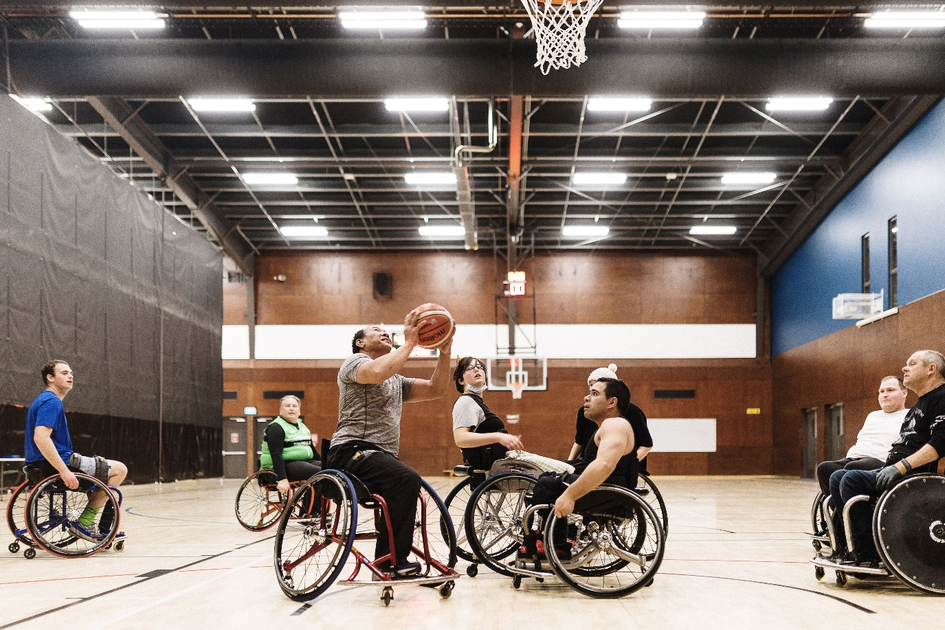

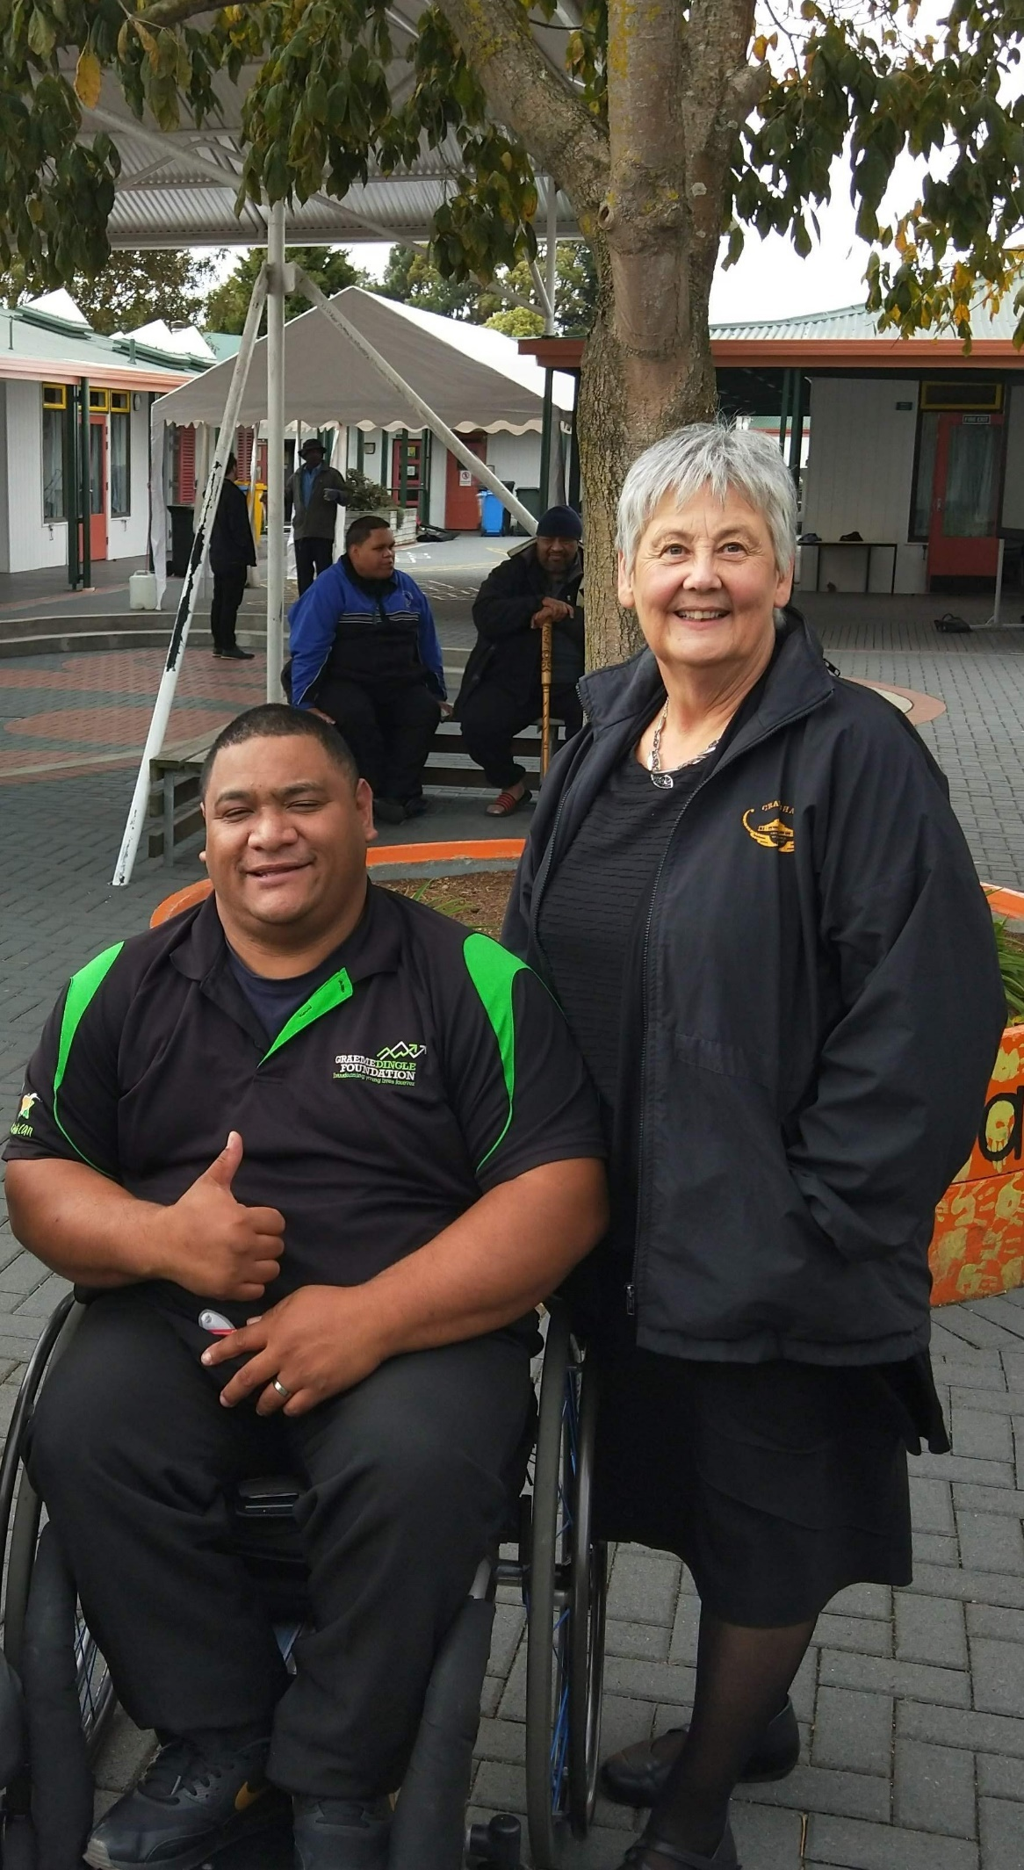

**Goal 1:**  
Council develops effective, mutually beneficial partnerships with stakeholders to inform and progress outcomes.

**New action - Disability Advisory Forum:**

Council will work with the Disabled People’s Forum and the Community1 to create a diverse group of representatives to input into decisions.

Outcomes:

* Better connections with disabled community
* Informed decision making
* Issues affecting the disabled community areeffectively prioritised.
* Better awareness of key challenges and opportunities for solutions.

Led by: Community and Social Development  
Timing: To be established by December 2022, meetings held every two months.

**New action – Engagement project:**

Large engagement project to identify and promote issues highlighted by individuals from the disability community, with a focus on previously under-represented groups.

Outcomes:

* Improved relationships and communication channels
* Wider input to decision making.

Led by: Community and Social Development, Disabled People’s Forum (external), Community (external)  
Timing: 2024

**Current action – Capacity building:**

Work with the disability sector (community leaders and service providers) to grow the capacity of the local disability community.

Outcomes:

* Community-led development
* Stronger partnerships.

Led by: Community and Social Development, Disability Advisory Forum, Community (external)  
Timing: Long term, priorities reviewed every six months

**New action – Disability Strategy:**

Staff will work with a wide range of partners including community organisations, rights holders and government organisations to co-design a citywide disability strategy.

Outcomes:

* Citywide approach to enabling better lives.
* Aspirations and priorities of the disabled community are captured.
* Issues affecting the disabled community are prioritised through Long Term Plan (LTP) processes.

Led by: Community and Social Development, Disability Advisory Forum, Disabled Persons Assembly (external), Disabled People’s Forum (external), Community (external)  
Timing: 2024

**New action – Lifemark rating:**

Assess impact and application of the Lifemark rating incentive. This rating provides developers with a discount on consent fees if their build is adaptable, safe and usable.

Outcomes:

* Good understanding of the costs, risk and benefits of recently implemented Lifemark rating.

Led by: Planning guidance, Community and Social Development   
Timing: 2025

**Current action – Community feedback surveys:**

Community surveys are developed and reviewed to include accessibility perspectives. Feedback is responded to.

Outcomes:

* Council decision-making processes actively seek an accessibility perspective where relevant.
* Issues affecting the disabled community are prioritised.

Led by: Community and Social Development, Communications and Engagement  
Timing: Long term, process reviewed annually

**New action – Accessibility in non-council development:**

Investigate opportunities for influencing non-council development through planning tools including the district plan and consenting.

Outcomes:

* Citywide approach to enabling better lives
* Understanding of gaps and opportunities.

Led by: Growth, planning guidance  
Timing: 2023 – 2025

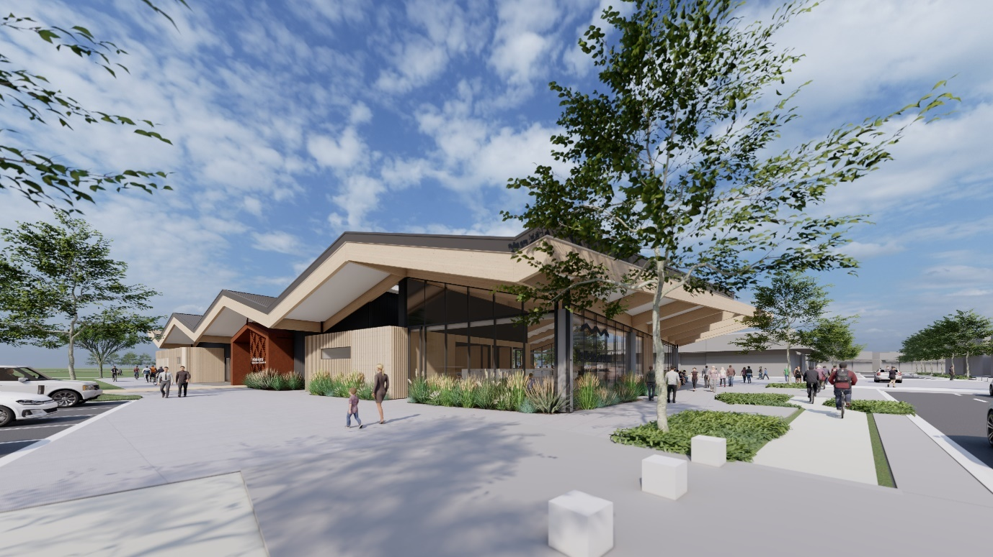

**Goal 2:**Funding and decision making around accessibility is enabled by good quality data and audits so everyone can fully experience Council events, facilities and destinations.

**Current action – Major community facility audits:**

A minimum of two comprehensive accessibility audits of major council owned facilities and/or destinations annually.

Outcomes:

* Information for decision making/proposals.

Led by: Waikato Museum, Hamilton Pools, Hamilton Gardens, Hamilton Libraries, Parks and Recreation unit, Hamilton Zoo, H3 venues, Transport unit.

Timing: Long term, minimum two per year

**New action – Minor community facility audits:**

Council will carry out at least three accessibility audits per year on smaller community facilities (parks, playgrounds etc).

Outcomes:

* Information for decision making/proposals.

Led by: Parks and Recreation unit  
Timing: Initiation in 2023, minimum three per year

**New action – Asset management planning:**

Accessibility will factor into Council’s Asset Management planning and processes to provide processes for costings for Annual Plan and Long Term Plan proposals.

Outcomes:

* A Council-wide approach to ensuring the disability policy is considered in relevant aspects of asset management.

Led by: Asset management leadership group  
Timing: Initiated, 2023

**New action – Data collection programme:**

Data collection is undertaken to inform investment. Programme includes a stocktake of accessibility audits and benchmarking against other local authorities.

**Outcomes:**

* More robust data available for informed decision making.
* Understanding of gaps and opportunities.
* Council wide approach to making the city more accessible.

Led by: Community and Social Development  
Timing: 2024

**New action – Accessible toilets and changing places network planning:**

Required upgrades to toilet network identified for 2023/2024 LTP proposal.

Outcomes:

* Information for decision making/proposals
* Accessibility improved through work programmes.

Led by: Parks and recreation unit  
Timing: 2023 – 2024

**Current action – Accessible paths at community services and destinations:**

Upgrade paths at community services and destinations to increase accessibility.

Outcomes:

* More people enjoy the full benefits of Council facilities
* A more varied range of accessible experiences.

Led by: Hamilton Zoo, Hamilton Gardens, Parks and Recreation unit, Hamilton Libraries, H3 venues  
Timing: Long term (incorporated into audits and asset management plans for inclusion in long term plan considerations).

**New action – Target setting:**

Project to establish baseline data and work with community to create future targets and goals.

Outcomes:

* Meaningful targets and goals are established.
* Success is measured accurately
* Data is available for LTP.

Led by: Community and Social Development, Disability Advisory Forum  
Timing: 2023 – 2024

**New action – Accessible signage at community services and destinations:**

Signage upgraded through renewal process to include accessible formats e.g. large print, pictures, and New Zealand Sign Language.

Outcomes:

* Better customer experience at council facilities.

Led by: Hamilton Zoo, Hamilton Gardens, Parks and Recreation unit, Hamilton Libraries, Hamilton Pools, H3 venues  
Timing: Long term (incorporated into audits and asset management plans for inclusion in long term plan considerations).

**New action – Online information platform:**

Information about accessibility for Council facilities, events and services is easily accessible online, available through an easy-to-use platform. Information allows for planning, improving awareness, and promoting accessible recreation options.

Outcomes:

* The whole community is enabled to access the city’s destinations.
* A more varied range of accessible experiences for the whole community.
* Users can plan their trips around accessibility options.

Led by: Community and Social Development, Communications and Engagement   
Timing: 2023 – 2024

**New action – Two-way information sharing:**

Improvements in accessible information sharing between Council and the community so it’s easier to move between Council and its facilities.

Outcomes:

* The whole community are enabled to access the city’s destinations.
* Council and community benefit through information sharing.

Led by: GIS, City Safe, Transport unit, Communications and Engagement  
Timing: Long term process reviewed annually

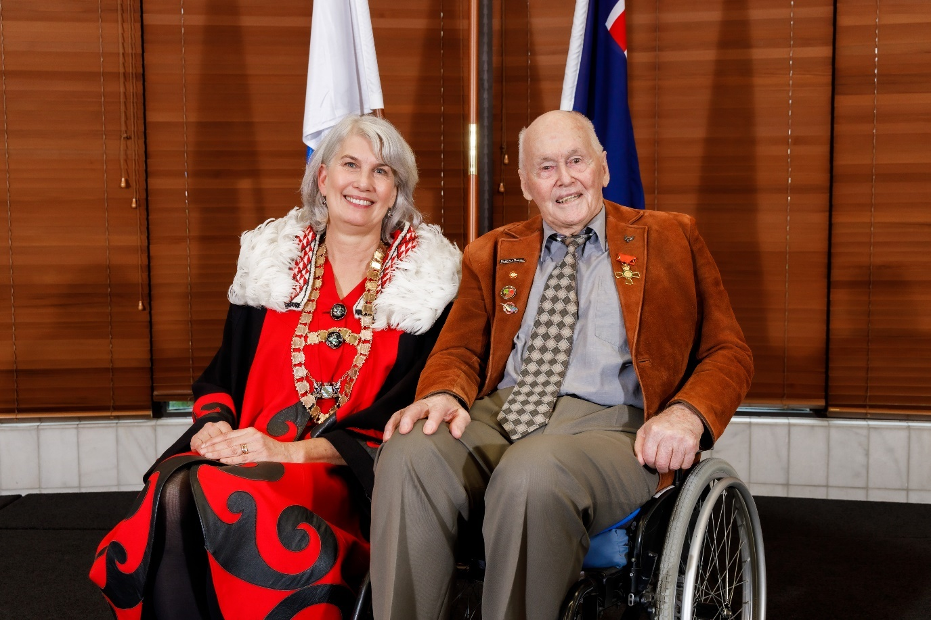

**Goal 3:**Council services will be responsive to the diverse needs of disabled people.

**Current action – Education:**

Induction of new staff will include disability training, and frontline staff will have regular disability training.

Outcomes:

* Better customer experience.
* Customers can engage with Council in a range of ways and be heard.
* Better organisational knowledge and awareness of disability issues.
* Benefits to organisational culture.

Led by: People and Culture  
Timing: Long term, priorities reviewed every six months

**New action – Assisted waste service:**

Review of new waste management service to explore the value of the assisted service.

Outcomes:

* Better customer service from council services
* More efficient waste management systems.

Led by: Waste Management  
Timing: 2024

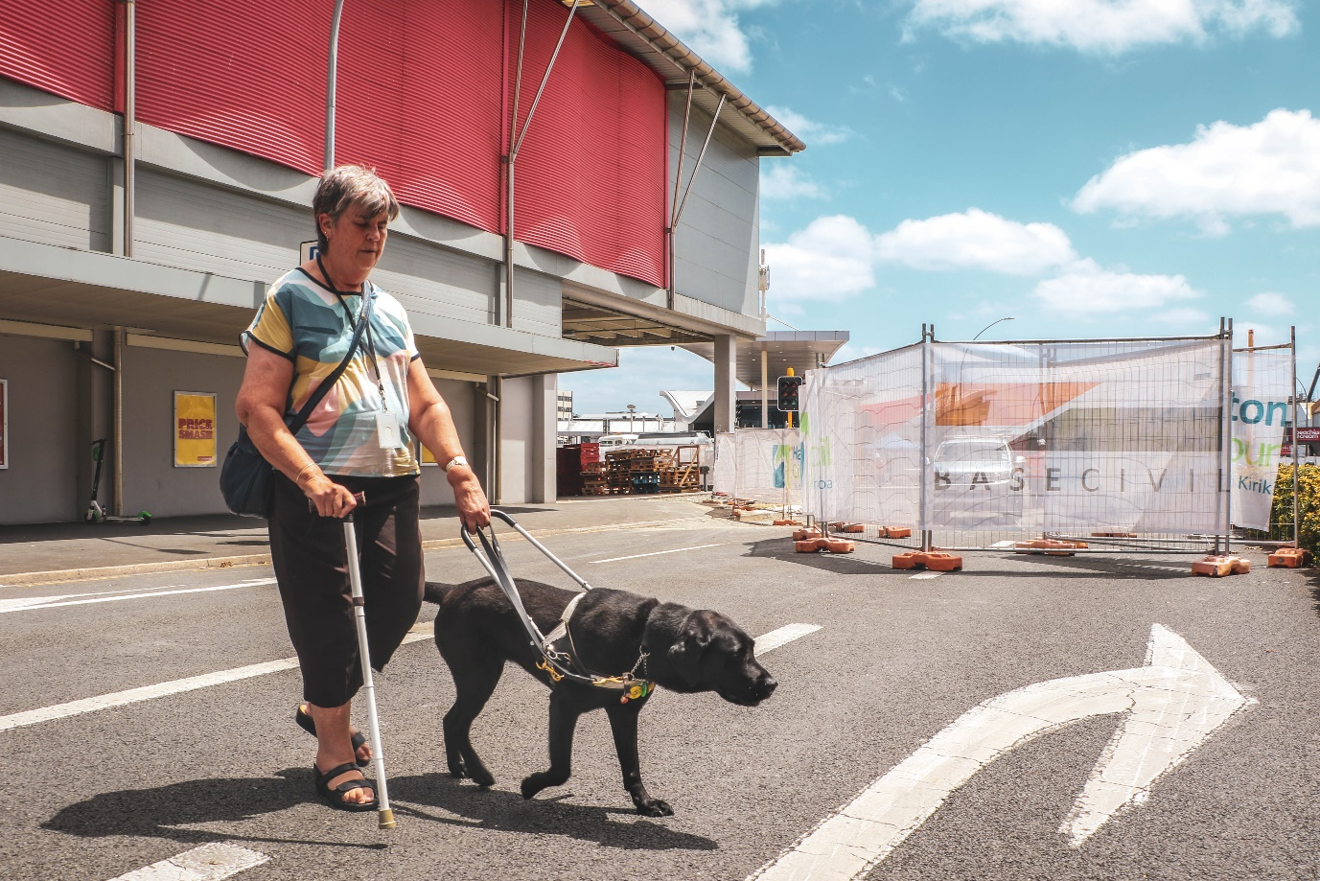

**Goal 4:**  
People can get around the city independently and safely.

**Current action – Audit of transport network:**

Audits will be completed on Council’s transport network including neighbourhood accessibility audits and project safety audits (including a focus on pedestrians).

Outcomes:

* Information for decision making/proposals
* Accessibility improved through work programmes.

Led by: Transport unit  
Timing: Long term, process reviewed annually

**New action – Community access mapping:**

Barriers identified through community input into a co-designed map of access issues, focusing on a key topic every six months.

Outcomes:

* Information for decision making/proposals
* Issues affecting disabled community are prioritised effectively.

Led by: Community (external), Community and Social Development  
Timing: 2024 – 2025

**Current action – Public transport:**

Partner with Regional Council to improve public transport accessibility. Focus on improved transportation options and removing barriers to use.

Outcomes:

* Greater uptake for public transport services and community facilities.
* Greater independence and quality of life for transport users.

Led by: Transport unit, Waikato Regional Council (external)  
Timing: Long term, results reviewed annually

**Current action – Crossings:**

Upgraded to provide safer options in key locations, community facilities and public transport routes.

Outcomes:

* Greater uptake for public transport services and community facilities.
* Greater independence and quality of life for transport users.

Led by: Transport unit, Waikato Regional Council (external)  
Timing: Long term, results reviewed annually

**Current action – Footpath programme:**

Footpath programmes to renew and maintain footpaths to an accessible standard.

Outcomes:

* Safer pedestrian access
* Improved level of services

Led by: Transport unit, Waikato Regional Council (external)  
Timing: Long term, results reviewed annually

**New action – Mobility carpark review:**

Review of current mobility carparks (including an audit).

Outcomes:

* Information for decision making/proposals
* Better parking options for permit holders.

Led by: Transport unit, CCS Disability Action (external)   
Timing: 2023 -2025

**New action – Illegal parking monitoring:**

Information Systems solution introduced in partnership with NZParking to ensure appropriate usage of mobility carparks.

Outcomes:

* Better parking options for permit holders.

Led by: Transport unit, NZParking (external)  
Timing: 2023 -2025

**New action – Regional Infrastructure Technical Specifications (RITS) review:**

Review RITS to update these to reflect best practice.

Outcomes:

* Information for decision making/proposals.
* Staff are given the ability to positively influence outcomes from the design stage.

Led by: Transport unit, Community and Social Development, Smart Access (external)  
Timing: From 2025 onwards

**New action – Accessible streets regulatory package:**

Advocate for the progression of the Accessible Streets Regulatory Package through Central Government.

Outcomes:

* Better accessibility standards for streets nationally.

Led by: Transport unit, Disability Advisor  
Timing: 2023 – 2025

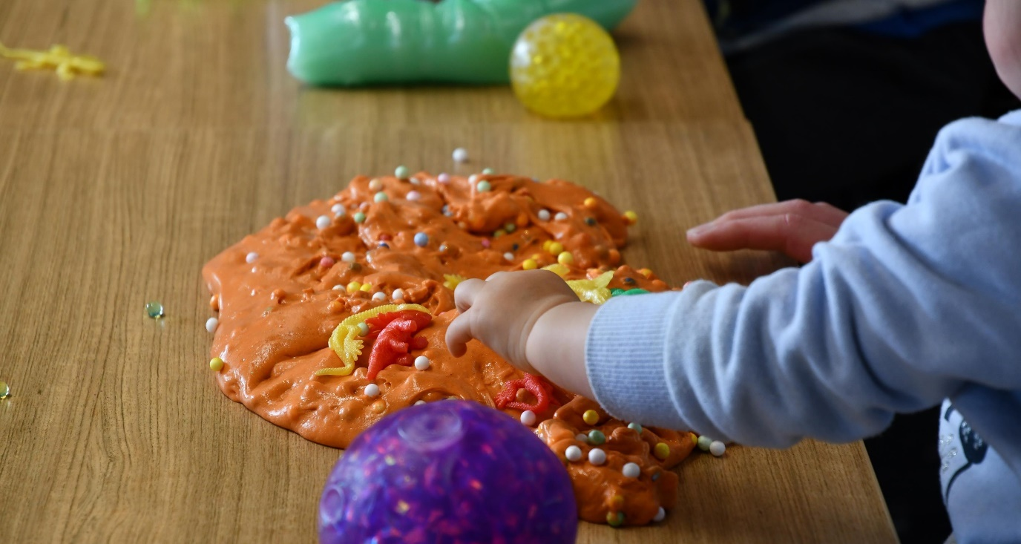

**Goal 5:**

The whole community can enjoy fair opportunities to play.

**New action – Informal play in the city:**

New informal/pop-up play opportunities in the central city consider accessibility in their design and installation.

Outcomes:

* A more varied range of accessible experiences for the whole community
* Better experience for customers

Led by: Central city programme team, Sport Waikato (external)  
Timing: 2024 – 2025

**Current action – Future playgrounds:**

All future playgrounds will include assets, access and equipment that is universally accessible/inclusive.

Outcomes:

* Accessible activity options for tamariki
* Better experience for customers.

Led by: Parks and recreation unit  
Timing: Long term (incorporated into audits and asset management plans for inclusion in long term plan considerations).

**New action – Upgrades to existing parks and playgrounds:**

Options to improve accessibility of current neighbourhood parks and playgrounds are considered in the 2023/2033 LTP discussions.

Outcomes:

* Information for decision making/proposals
* Better experience for customers.

Led by: Parks and recreation team  
Timing: 2023 – 2024

**New action – Inclusive programme trials:**

Pilot programmes will be created at council facilities to encourage and enable access to a wide range of activities for our community.

Outcomes:

* Accessible activity options for our community
* Better understanding of community demand and ability to fine tune future programmes.

Led by: Hamilton Pools, Hamilton Zoo, Hamilton Libraries, Waikato Museum.  
Timing: 2023 - Hamilton Pools trial, 2024 – Hamilton Libraries trial, 2025 – Hamilton Zoo and Waikato Museum trial

**New action – Halberg programme to improve accessible recreation for youth:**

Halberg Foundation will work with Council to ensure parks, public spaces, club rooms and its facilities are fully accessible to 5-12 year old tamariki/rangatahi with physical impairments, by funding equipment or person support.

Outcomes:

* Accessible activity options for tamariki and rangatahi.
* Better experience for customers.

Led by: Community and Social Development, Halberg Foundation (external), Parks and Recreation unit.  
Timing: initiation in 2023

**New action – Trail rider:**

Staff will work with Halberg Foundation to explore provision of a loan trail Rider bike that would allow disabled people to use the river walks, gardens, Council open spaces and zoo more independently.

Outcomes:

* Better experience for customers
* A more varied range of accessible experiences for the whole community.

Led by: Community and Social Development, Halberg Foundation (external), Parks and Recreation unit, Hamilton Gardens, Hamilton Zoo  
Timing: 2023 – 2024

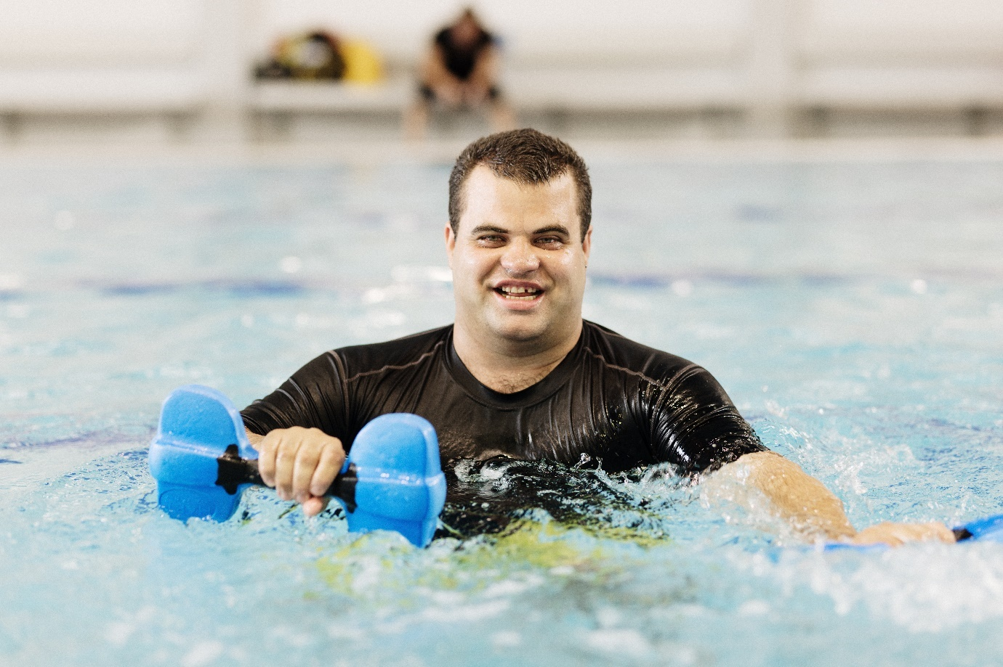

**Goal 6:**Council projects embed the principles of universal design, so every new-build community facility project is accessible to everyone.

**New action – Capital project planning:**

Universal design considerations are embedded into all Council project planning templates for new builds and renewals.

Outcomes:

* A Council wide approach to ensuring that the disability policy is considered through every stage of the planning and renewal process.

Led by: Programme Management Office  
Timing: 2023

**New action – Rototuna Library:**

Rototuna Library will be built based on codesigned and universal design principles.

Outcomes:

* Accessible activity options for our community
* Better experience for every customer.

Led by: Community Programme Office  
Timing: 2023 – 2025

**New action – Celebrating Age Centre**

Investigations into the replacement of the Celebrating Age Centre, which will include opportunities for a fully accessible community space.

Outcomes:

* Better experience for every customer.

Led by: Community Programme Office  
Timing: 2024

**New action – Accessible toilets and changing places at Rototuna:**

Accessible toilets and changing spaces will be installed at Rototuna Village.

Outcomes:

* Accessible activity options for our community
* Better experience for every customer.

Led by: Community Programme Office  
Timing: 2023 – 2025

**Current action – Transport Centre:**

Advisory group support to review the designs, undertake audits, and provide feedback. Centre has been designed using Universal Design Principles.

Outcome:

* Information for decision making/proposals
* Wider input to decision making.

Led by: Transport unit, Waikato Regional Council (external)  
Timing: 2024 - 2025

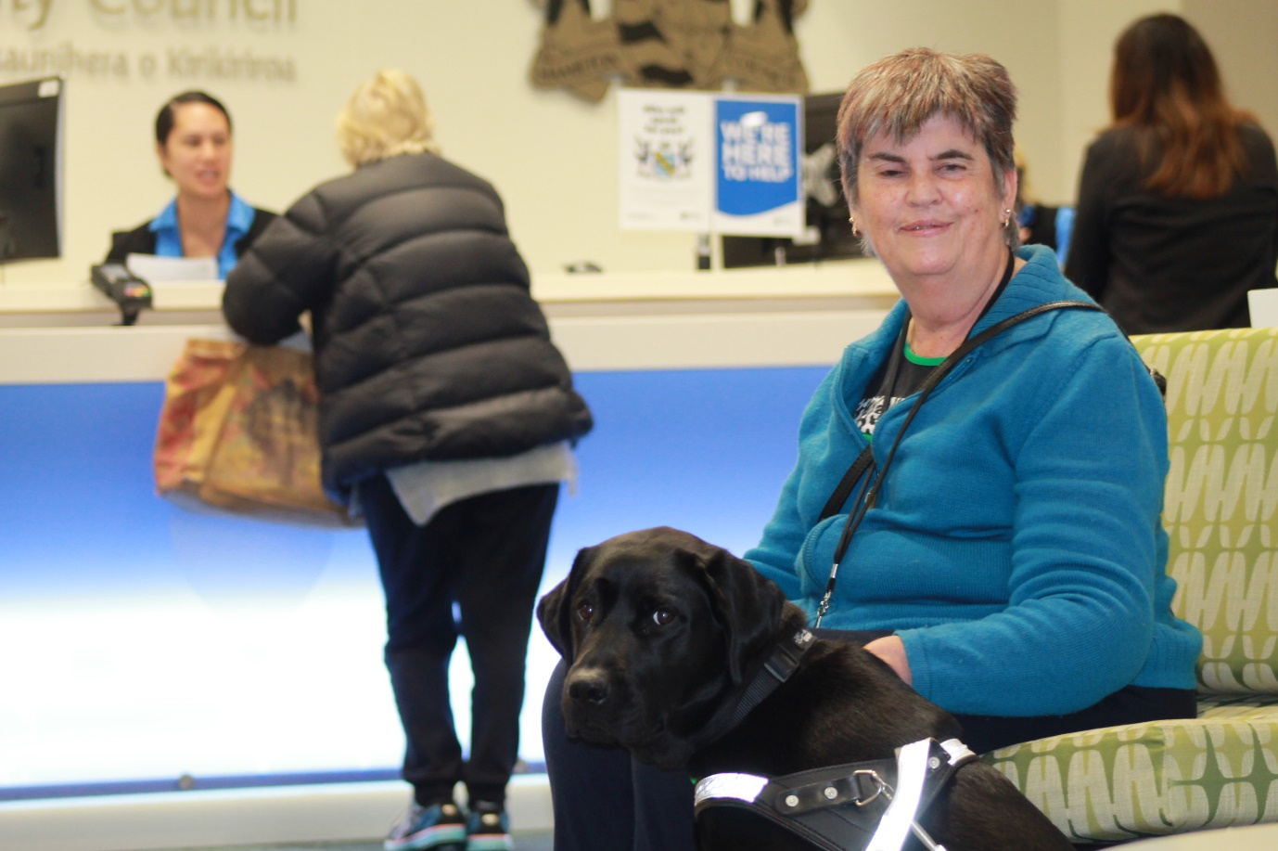

**Goal 7:**

Hamilton City Council is an enabling employer that benefits from the skills and perspectives of a diverse workforce.

**Current action – Recruitment:**

The Council’s recruiting processes will be reviewed annually to ensure barriers to employment are removed

Outcomes:

* A more inclusive, diverse workplace
* A work force that benefits from the strengths of an enabling environment.

Led by: People and Culture  
Timing: Long term, reviewed annually

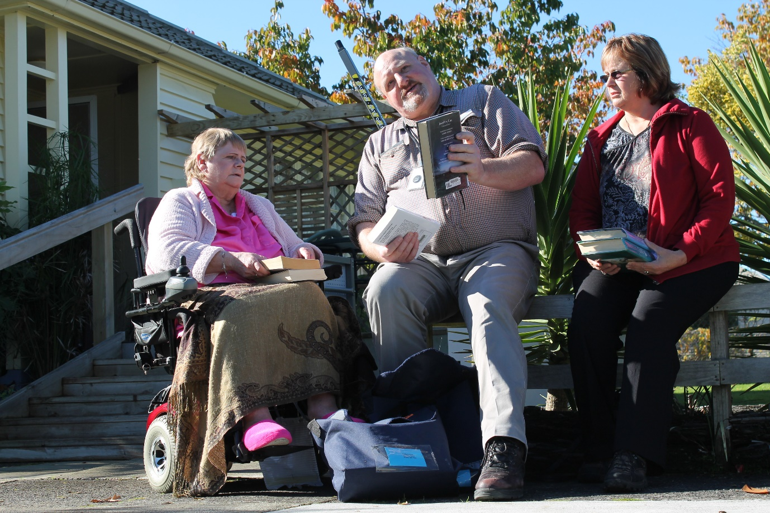

**Goal 8:**Removal of barriers to civic life and democratic participation through improved physical access, Governance and communication process

**New action – Chamber upgrade 2023/24:**

Accessibility will be prioritised through the use of technology and equipment upgrades,

Outcomes:

* A fair and democratic space that is accessible and welcoming to everyone.

Led by: Governance  
Timing: 2024 – 2025

**Current action – Accessible governance processes:**

Ensure governance processes are inclusive and accessible, enabling the whole community to:

* Respond to surveys in any way they choose
* Participate in public forums and meetings with appropriate support
* Make sure all aspects of meetings are accessible.

Outcomes:

* The city benefits from a more diverse range of voices
* The whole community has greater opportunity to participate in civic life.

Led by: Governance team, Communication and Engagement team, Disabled Persons Assembly (external)  
Timing: Long term, reviewed annually

**New action – Report writing:**

Report writers/authorisers will be trained in including accessibility implications in Council reports.

Outcomes:

* Council decision-making is consistently informed by the disability perspective, specific to the decision.

Led by: Strategy team, Policy team, Community and Social Development team, Governance team.  
Timing: 2023 – training developed, 2024 – training implemented

**New action – Report writing:**

Guidelines are developed that ensure Council documents are fully accessible.

Outcomes:

* The whole community has greater opportunity to participate in civic life and democratic processes

Led by: Communications and Engagement team  
Timing: 2023

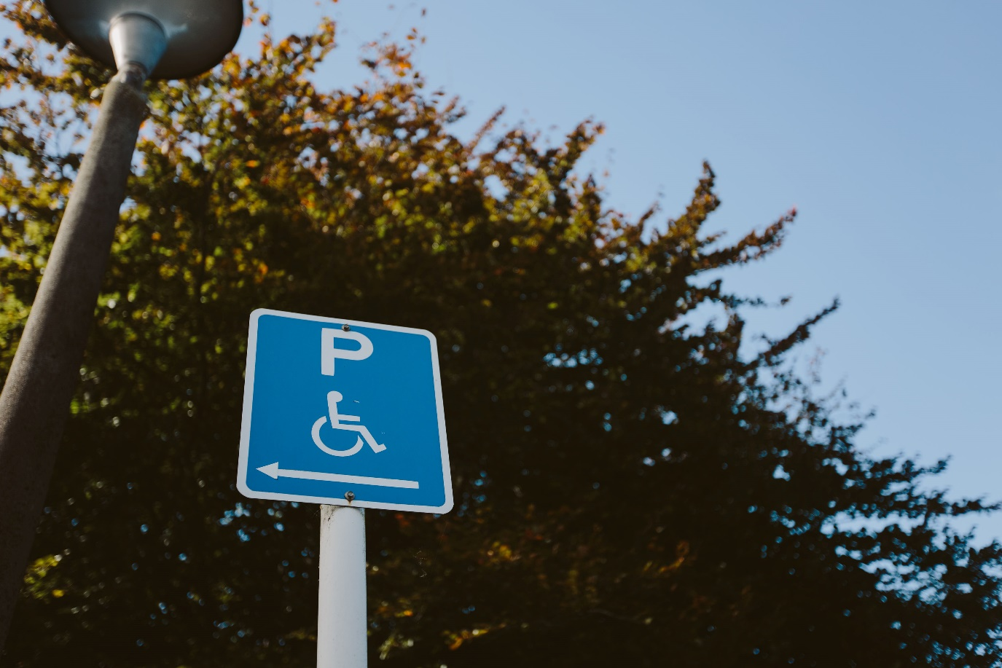

**Goal 9:**Council communications are produced and distributed in accessible and effective formats, enabling participation, engagement and preparedness.

**New action – Emergency/immediate communications:**

Hamilton City Council will partner with Waikato Regional Council and Waikato District Health Board to ensure emergency processes respond to the needs of the disabled community.

This would include resources and web development with information prioritising the disabled community.

Outcomes:

* People are better able to manage their needs during an emergency.
* Emergency services can be more responsive when required.

Led by: Waikato Regional Council, Waikato DHB, Emergency Management, Communication and Engagement team, community organisations (external).  
Timing: 2023 – 2025

**New action – Information sharing guidelines:**

Guidelines are developed to consider when New Zealand Sign Language and screen reader friendly formats are recommended for communication campaigns.

Outcomes:

* Council and community benefit through information sharing.

Led by: Communication and Engagement team, Community and Social Development team  
Timing: 2024

**New action – Communication audits:**

Communication audit to be undertaken for all Council communication for a week (randomly selected) annually to test application of the Document Accessibility Guidelines.

Outcomes:

* Information for decision making/proposals.

Led by: Communication and Engagement team  
Timing: From 2024 onwards

**Council would like to thank our wonderful delivery partners, helping us to shape an accessible Hamilton Kirikiriroa:**

* PVINZ
* Life Unlimited
* Disabled Persons Assembly
* Wordsworth Sign Language Interpreters
* My Life, My Voice
* Eye Films
* Halberg Foundation
* Blind Low Vision
* Lifemark
* CCS Disability Action Including All People