CORONAVIRUS - STAFF and VOLUNTEER

HEALTH RISK ASSESSMENT FORM

May 2021 (Version 17)
Introduction

It is important that UHP is aware of any factors that might put you at higher risk of serious illness if you were to be infected with coronavirus, so that appropriate adjustments can be considered to mitigate this risk. Risk factors that can affect an individual’s vulnerability to coronavirus include increased age, high body mass index, underlying health conditions and ethnicity (such as colleagues from minority ethnic backgrounds). Vaccination represents a protective factor but individual risk will also depend heavily on the level of cases amongst the community at large and amongst colleagues.

It is acknowledged that a number of different versions of this document have been provided throughout the pandemic. This is both due to the changing knowledge base and also the changing levels of virus within the community. It is not necessary to repeat the risk assessment for all members of staff and volunteers, especially if this will not change how they work, but line managers should ensure that all staff and volunteers have had at least one coronavirus risk assessment since the start of the pandemic.

This updated version (May 2021 v17) should be used for risk assessments from the date of publication onwards. It continues to use the COVID-age calculation (detailed below) to predict an individual’s vulnerability of developing serious illness if infected with coronavirus. This COVID-age calculation has NOT changed since the previous (December 2020) version of this document but there are two important developments: It gives advice on the change in risk following vaccination and it includes tables taking into account changes in the prevalence of COVID in the community. It is not an exact tool and it does not cover every possible situation – so if there are any concerns that it does not reflect an individual’s risk - then further discussion with Occupational Health is recommended. This is particularly the case for vaccination: There are a number of conditions which can affect the strength of the response to the vaccine and if the protection from the vaccine is being used to allow a wider range of work it would be prudent to seek advice to confirm what level of risk reduction should be expected.

This document is primarily designed to identify the level of vulnerability for an individual, should they become infected with coronavirus. Reducing the risk of an individual actually becoming infected with coronavirus in the workplace is also dealt with using the Team Risk Assessment Guidance, in which controls are put into place to reduce potential exposure (including barriers, social distancing, patient and staff swabbing and PPE). The Team Risk Assessment must also be taken into account when considering the overall risk to an individual and the adjustments that might be required.

What has changed?
- Lockdown measures being progressively eased over the next few weeks / months
- Formal Shielding pausing on 01 April 2021
- COVID levels in the community remain low and relatively stable but may increase as lockdown is eased or if new variants emerge locally
- COVID cases amongst UHP staff are very low
- Working from home is still advised unless this is not reasonable for your role
- The COVID vaccine is now being rolled out to high priority patient groups and most staff have now had both doses
- Guidance on coming to work for those at higher risk after lockdown

The Government’s new advice from the 1st April for those who have been identified as Clinically Extremely Vulnerable (CEV) states that they should continue to work from home where possible but, if they cannot work from home, it may be possible for them to return to the workplace, where it is safe for them to do so and following a review of their Covid-19 Risk Assessment.

Since the first lockdown in March, we have learnt a great deal more about the risks caused by health conditions and how these are influenced by other factors such as ethnicity and age. This has resulted in the development of better-informed risk scoring systems such as the COVID-age guidance (from ALAMA) on which this Coronavirus risk assessment tool is based. Using this system, some individuals who had previously received shielding letters have subsequently been advised that they are not in the highest risk category and for a few others, even though they have never received a “shielding” letter, the Trust’s Coronavirus risk assessment scoring system puts them in the highest risk category (“Very High Risk”).

We still believe that the Trust’s risk assessment process and the ALAMA COVID-age risk assessment, on which it is based, represent the best available assessment of risk and our advice would be to continue to follow the Trust’s risk assessment guide. We recognise that individuals may have differing tolerance of the risk from Coronavirus and differing drivers for continuing to come in to work but, if you are in the “very high risk” category you should continue to work from home if possible. If it is not possible or if there are strong reasons to continue coming in to work you should have a further conversation with your line manager, guided by this document and the advice in the Change to Shielding Guidance from 1st April - links here:
- Guidance for Managers
- Guidance for Staff

Only if both you and your line manager are happy that your risk can be managed to a safe level should you be coming in to work and in this situation a hybrid model of mixed home and hospital working should be considered.

COVID Vaccination

Many staff/volunteers have now had both doses of the vaccine and the evidence is that this gives good protection from COVID and especially from severe COVID. The protection builds progressively over the 3 weeks after the vaccine was given. The level of protection afforded by the vaccine may be reduced in some with certain underlying conditions (such as immunosuppression or renal failure) and by certain medications although even a reduced level of protection is very important in this situation.

The government has still not endorsed any options for adjusting risk assessment following vaccination however; the revised ALAMA advice (which is aimed specifically at the working age population and on which our risk assessment is based) suggests that for most people vaccination or previous infection is equivalent to a reduction in COVID age of 18 years which, in most cases will move a previously infected/vaccinated individual down by one category of vulnerability – for example, from ‘high’ to ‘moderate’. It is important to note that some groups, particularly those with conditions which reduce immunity or who are taking medications which affect immunity, this benefit is likely to be lower. In such cases or if there is any doubt, advice from your treating specialist, GP and / or occupational health should be sought.

Similar benefit is likely to be obtained for those who have had previous infection. In both cases this situation could change depending on the development of new variants.

No one should be moved out of the very high risk group on the basis of their vaccination status or previous COVID infection without OH advice being obtained.

How to use this form

It is crucial that we ensure every colleague has had a Coronavirus Risk Assessment undertaken and that these are up to date and reflect the latest circumstances. Where these were undertaken some time ago, it may be necessary to review and refresh the Risk Assessment particularly if one of the of the older risk assessment tools was used.

This up-to-date Risk Assessment Tool is recommended, in particular, for those who have previously fallen into the moderate or higher risk categories using the previous July 2020 tool (as a new risk category assignment may now be appropriate), or for consideration where there has been a change in underlying health or for staff deploying into a new role.

This risk assessment should be carried out in conjunction with the Team Risk Assessment Guidance here, which helps identify steps to reduce risk in the workplace more generally, and thereby the likelihood that staff will be exposed to the virus. There is further advice on the Government and HSE Websites.

This form is designed such that the employee’s personal medical history is considered using an online tool (please see section 2, Page 5 below). Only the COVID-age adjustment scores (modifiers) need be transferred to the risk assessment form, not written details of the medical history itself. The risk assessment form must still be stored confidentially and in full compliance with the Data Protection Act (DPA) as informed by GDPR 2018. There is no obligation for individuals to share details of their medical history with their line manager. If they, or their line manager are concerned that the risk assessment does not reflect their actual risk, further advice should be sought as below.

There will be cases where it is not clear which risk group (Appendix 1) an individual falls into, particularly if they have received conflicting advice from elsewhere. Individuals with serious conditions may benefit from specific occupational guidance via the Occupational Health Advice Line (plh-tr.occhealthadvice@nhs.net ). The OH team will be able to address the issues in a confidential environment and offer an opinion without the need to share personal details with the line manager. Please complete the risk assessment below before doing so.

Line managers should document the results of the risk assessment on Appendix 3 and be prepared to review it regularly, particularly if there are changes in job role or operational demands, and also as the levels of coronavirus change within the community. Any adjustments that are required as a result of the risk assessment should be recorded in the work adjustment assessment grid at Appendix 3.

Advice on Risk Assessment:

Risk assessments will be undertaken by line managers.

It is not possible to avoid all risk and the aim of the risk assessment is to avoid unacceptably high risk activities and to bring down risk in other areas as far as reasonably practicable but it is not to try and avoid any possible risk. Most people will be able to continue working normally but it is still important to consider how you could reduce their risk.

If you feel an individual is unable to work safely in their normal place of work and there are no good options for working in a modified way then you should refer the case to the HR Control Inbox, plh-tr.hrcontrolcentre@nhs.net who can help to consider options for temporary redeployment.

Exceptional Cases
There will be some cases where the level of risk is exceptional. Such cases might include those with severe degrees of immunosuppression or whose health and ability to maintain normal function is very limited such as those with severely impaired lung or liver function or those in the later stages of chronic neurological diseases. If you suspect this to be the case or if the individual is on immunosuppressant medication or “biologics” seek advice from the Occupational Health Advice Line (plh-tr.occhealthadvice@nhs.net ).
Pregnancy
Pregnant women of any gestation should not be required to continue working if this is not supported by a risk assessment. Pregnant women are considered ‘clinically vulnerable’ or in some cases ‘clinically extremely vulnerable’ to coronavirus (COVID-19), and therefore require special consideration. See https://www.gov.uk/government/publications/coronavirus-covid-19-advice-for-pregnant-employees/coronavirus-covid-19-advice-for-pregnant-employees for further information.

The latest government guidance is that pregnant healthcare workers with no significant underlying health conditions should only continue to work in direct patient-facing roles if they are under 28 weeks’ gestation and if this follows a risk assessment that recommends they can continue working, subject to modification of the working environment or deployment to suitable alternative duties.

For pregnant women from 28 weeks’ gestation, or for those with significant underlying conditions such as heart or lung disease at any gestation, a more precautionary approach is advised. Women in this category should be recommended to stay at home and identify with their line management what work they may be able to undertake from home where this is possible; where this is not possible, consideration can be given to a return to work in a low risk environment following the Trust guidance for “very high risk individuals” and following an updated pregnancy risk assessment.

Appendix 1 now includes separate guidance for pregnant women.
Guidance to Staff with Vulnerable or Pregnant Individuals in their household / family
The new national guidance may cause concern for those with vulnerable family members at home.
Our recommendation is to discuss these issues with your line manager and use this risk assessment document as a guide to reduce your own risk, which in turn will help to protect those at home. It is important for managers to consider all factors and to support those with particularly vulnerable household/family members taking into consideration the operational demands of the workplace alongside the presented vulnerabilities.
Further guidance can be found at https://www.gov.uk/government/publications/coronavirus-covid-19-providing-unpaid-care/guidance-for-those-who-provide-unpaid-care-to-friends-or-family .
Covid-19 Medical Risk Assessment Questionnaire V.3 (May 2021 update)
Based on the ALAMA COVID-Age Medical Risk Assessment (https://alama.org.uk/covid-19-medical-risk-assessment/)
Please complete sections 1-4:
Section 1
Name:

Date of birth: |  | Employer: | UHPT
Email address: |  | Telephone number:
Job title/role: | Volunteer | Area where you volunteer:
Manager name: | Elizabeth Pollard | Manager email: | Elizabeth.pollard@nhs.net
Section 2:
Please now go to https://alama.org.uk/covid-19-medical-risk-assessment/ and calculate the COVID age using the online calculator. Detailed Guidance on how to complete the COVID age can be found in Appendix 2 below. Results of calculation should be entered below:
Covid Individual Risk Factor | Insert Modifier *  (taken from COVID age calculator)
Age (please insert actual age):
Sex | 0 / -5
Ethnicity
Body Mass Index (BMI)
Vaccination or previous infection - please read the advice above and in the ALAMA guide under “ACCOUNTING FOR SPECIFIC IMMUNITY” before applying any adjustment. (-18 or as advised by OH)
Additional modifiers - insert additional modifiers (numbers only) from other health conditions, if present
Total COVID-age (given by online calculator)
*The modifier is the COVID age adjustment for a variety of underlying risk factors, such as age, sex, BMI and medical conditions. Appendix 2 offers guidance on how to complete the COVID age. The table above is designed to form a record of your scores which can be referred to in future. There is no need to list the underlying medical conditions – just the associated modifiers (numbers only). The website will calculate the final score for you.
Section 3:
Covid Vulnerability Group, based on calculation |  |  | Please tick:
Vulnerability group selected after discussion with the employee:  (See Appendix 1) | Very high | Covid Age > 80
 | High | Covid Age 70 to 80
 | Moderate | Covid Age 50 to 69
 | Low | Covid Age < 50

Section 4:
The above COVID age calculation and risk assessment should now be discussed by line manager and employee together, and the below questions considered:
A. Do you have any other conditions or factors that may affect your vulnerability to COVID, not considered above?  e.g. Are you immunosuppressed by medication that is not covered by the COVID age calculator, such as high dose steroids or biologics? |  | Yes/ No  If Yes, please indicate disease or medication including the dose  If pregnant, see guidance on page 2 and undertake pregnancy risk assessment.
B. Do you feel that your COVID vulnerability group does not accurately reflect your risk relating to your underlying health conditions? |  | Yes/ No
C. Did you receive a shielding letter for a condition not covered by Health Risk factors in the COVID age calculation? |  | Yes/ No  If Yes, for what condition?
If you have answered ‘Yes’ to any of questions A to C above and you do not feel that this has been adequately resolved by discussion with your line manager, then please arrange for this assessment to be escalated for review by the Occupational Health Advice Line (plh-tr.occhealthadvice@nhs.net) . We will call you if further information is required.

To be completed by assessor

Final COVID Vulnerability Level | Very High / High / Moderate / Low
Work Adjustment Grid completed? | Yes / No  (Any adjustments required as a result of the risk assessment should be recorded in the work adjustment assessment grid at Appendix 3)
Additional comments by employee?

Further review required? | Yes/ No If Yes, please indicate date:
Name of assessor: |  | Signature of assessor:
Date of assessment: |  | Signature of volunteer:
Your questionnaire is now completed. Thank you for your assistance.

Appendix 1: Suggested workplace recommendations according to risk matrix
Vulnerability level | COVID Prevalence locally less than 100/ 100,000/week | COVID Prevalence locally between 100 and 200 / 100,000/week
Very High  Relative Risk or  Covid-age over 80 (Adjusted for immunity) | Ideally work from home  Not to work in rooms, wards, accommodation buildings or vehicles in close proximity to people with confirmed or suspected Covid-19 or where effective PPE / social distancing cannot be maintained.  Only undertake medium risk activities such as healthcare or face-to-face contacts with high number of different contacts if essential.  Where clinical work, care work and working closely with others is essential, risks must be managed reasonably and effectively. Working only with patients or clients who have tested COVID-negative may be an example of reasonable risk-management.  Work in low risk environments such as COVID secure offices with good ventilation and low risk of breach of social distancing / hygiene | Ideally work from home.  Not to work in rooms, wards, accommodation buildings or vehicles in close proximity to people with confirmed or suspected Covid-19 or where effective PPE / social distancing cannot be maintained  Not to undertake medium risk activities such as healthcare or face-to-face contacts with high number of different contacts if essential.  Where clinical work, care work and working closely with others is essential, risks must be managed reasonably and effectively. Working only with patients or clients who have tested COVID-negative may be an example of reasonable risk-management.  Only work in low risk environments such as COVID secure offices with good ventilation and low risk of breach of social distancing / hygiene if unavoidable.  Consider risks of travel to and from work.
High  Relative Risk or  Covid-age 70 to 80 | Not to work in rooms, wards, accommodation buildings or vehicles in close proximity to people with confirmed or suspected Covid-19 or where effective PPE / social distancing cannot be maintained.  Only undertake medium risk activities such as healthcare or face-to-face contacts with high number of different contacts if necessary and where testing of patients and staff and/or provision of controls (e.g. screens, PPE) are effective in managing the risk.  Work in low risk environments such as COVID secure offices with good ventilation and low risk of breach of social distancing / hygiene | Not to work in rooms, wards, accommodation buildings or vehicles in close proximity to people with confirmed or suspected Covid-19 or where effective PPE / social distancing cannot be maintained.  Only undertake medium risk activities such as healthcare or face-to-face contacts with high number of different contacts if essential and where testing of patients and staff and/or provision of controls (e.g. screens, PPE) are effective in managing the risk.  Some individuals in essential roles may be asked to accept a higher risk and agree to do so where this can be justified.  Work in low risk environments such as COVID secure offices with good ventilation and low risk of breach of social distancing / hygiene  Consider risks of travel to work and whether lower risk work is available.
Moderate  Relative Risk or  Covid-age 50-69 | Only work in rooms, wards, accommodation buildings or vehicles in close proximity to people with confirmed or suspected Covid-19 if necessary and where effective PPE / social distancing can be maintained.  Work in medium other areas such as healthcare or face-to-face contacts with high number of different contacts where there are no reasonably practicable means of reducing the risk further and in low risk environments such as COVID secure offices with good ventilation. | Only work in rooms, wards, accommodation buildings or vehicles in close proximity to people with confirmed or suspected Covid-19 if necessary and where effective PPE / social distancing can be maintained.  Only undertake medium risk activities such as healthcare or face-to-face contacts with high number of different contacts if necessary and where testing of patients and staff and/or provision of controls (e.g. screens, PPE) are effective in managing the risk.  Work in low risk environments such as COVID secure offices with good ventilation and low risk of breach of social distancing / hygiene
Low  Relative Risk or  Covid-age < 50 | Work in all areas | Work in all areas
Pregnancy | Current advice is to minimise the risk to pregnant women, while allowing them to choose whether to attend work and what role to undertake at work. Risk should be reduced as far as reasonably practicable.  Pregnant healthcare workers should only continue to work in direct patient-facing roles if they are under 28 weeks gestation and if this follows a risk assessment that recommends they can continue working, subject to modification of the working environment or deployment to suitable alternative duties.  After 28 weeks gestation (or in mothers from the more at-risk groups listed opposite) then a more precautionary approach is recommended – see Page 3 of this guidance.
Definitions
Necessary | Implies that the task is necessary for that role and that there is no way of reducing the risk further including by adjusting duties within the team.
Essential | Implies that the task is essential to maintain healthcare services ; that it cannot be done by anyone else and that there is no way of reducing the risk further..

Appendix 2: Guidance on using the ALAMA COVID 19 Medical Risk Assessment Guidance
The ALAMA website now contains a COVID age calculator which can be used to calculate an individual’s vulnerability to coronavirus. Details of underlying health conditions are required in order to complete the calculation.
- Click on the link https://alama.org.uk/covid-19-medical-risk-assessment/

- On first use it is recommended that the user reads through the summary on how to assess a worker’s vulnerability.

- Scroll down to the COVID age calculator:
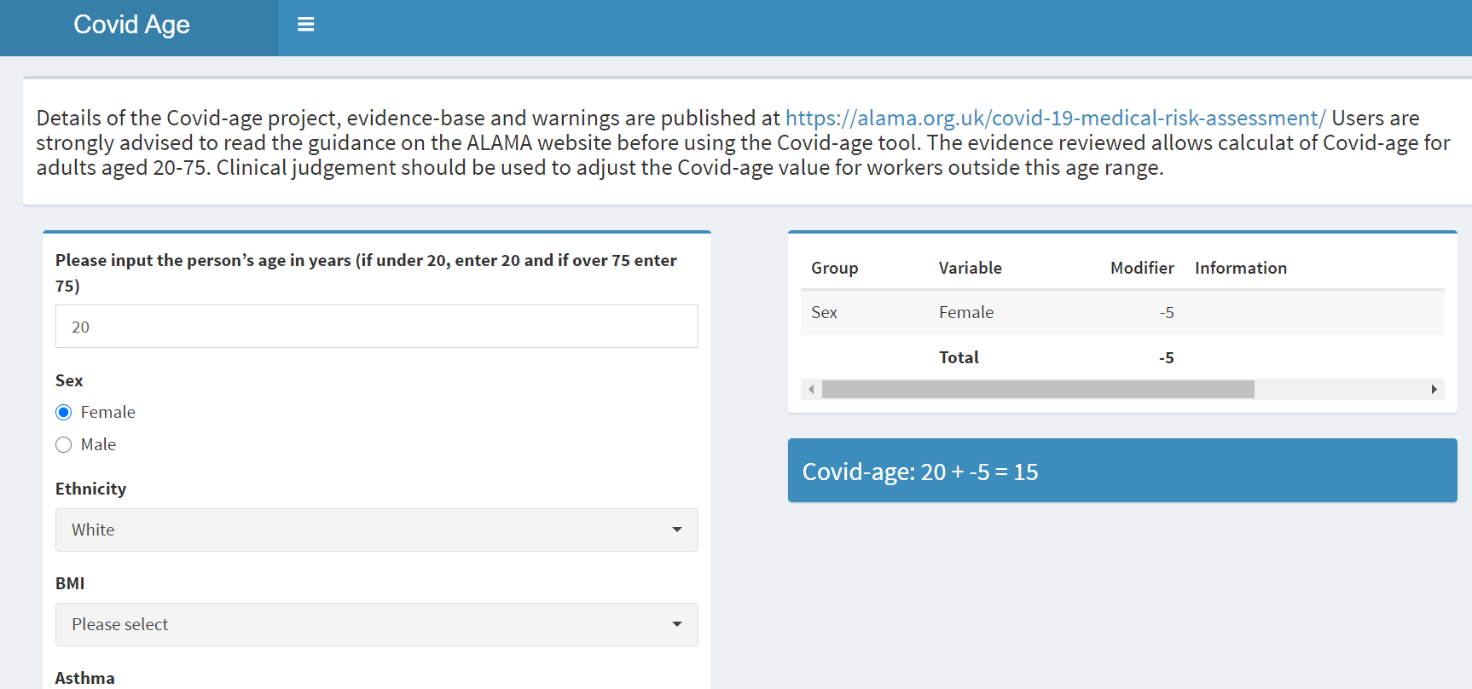

- Insert details of employee’s age, ethnicity and BMI.

As you insert information, the right-hand box will compute a modifier (age adjuster) based on the information given and the age of the person, which in turn will give a COVID age. BMI can be calculated via www.nhs.uk/live-well/healthy-weight/bmi-calculator if unknown.

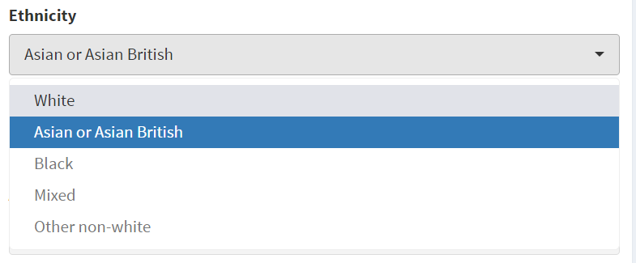
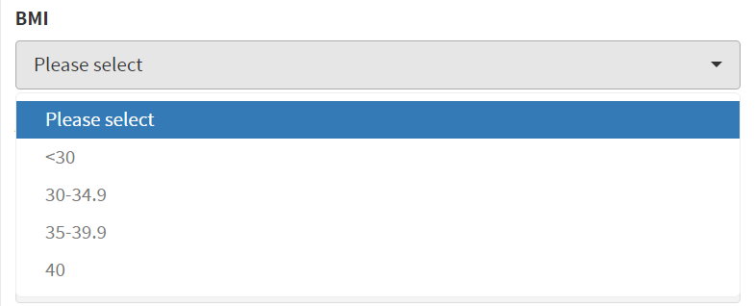

- Asthma: Select appropriate choice for asthma.
  - Mild asthma: No requirement for oral steroids (prednisolone) for asthma in past 12 months.
  - Severe asthma: Required oral steroids (prednisolone) for asthma in past 12 months.
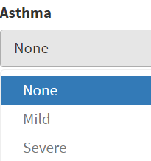
- Diabetes: Select appropriate choice.

Some people may know their latest HBA1c result (taken as a blood test) however many won’t. If unknown, select the ‘unknown HBA1c option’ for either Type 1 (usually requires insulin), or Type 2 (doesn’t usually require insulin). Note there is an option for diabetes that has been diagnosed within 1 year which should be selected if appropriate.

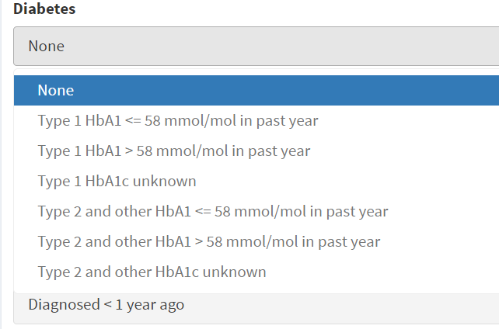

- Additional Medical Conditions

Now move on to the remaining medical conditions, making sure you also consider the ‘Other Conditions’ dropdown menu which includes the below:
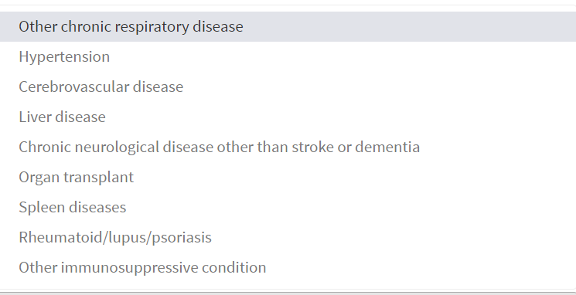

If you are uncertain what illnesses may be included within a condition, then selecting something on the left hand side will often highlight further guidance in the right hand box, as below:

‘Chronic Neurological Disease’ selected from left hand side:
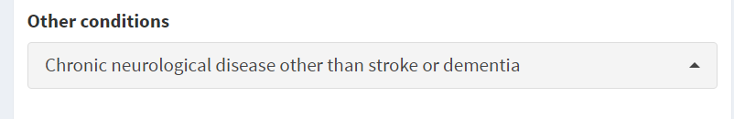

Further guidance appears in right hand side scoring box, as below:

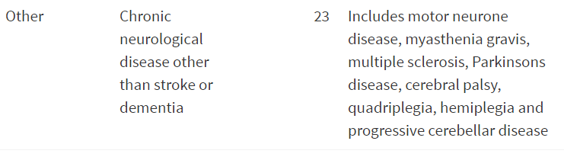

- Review the summary box on the right, and check it contains the correct information. (It can be very easy to select an option in order to read the guidance and then forget to de-select it). Example for a 40 year old lady given below:

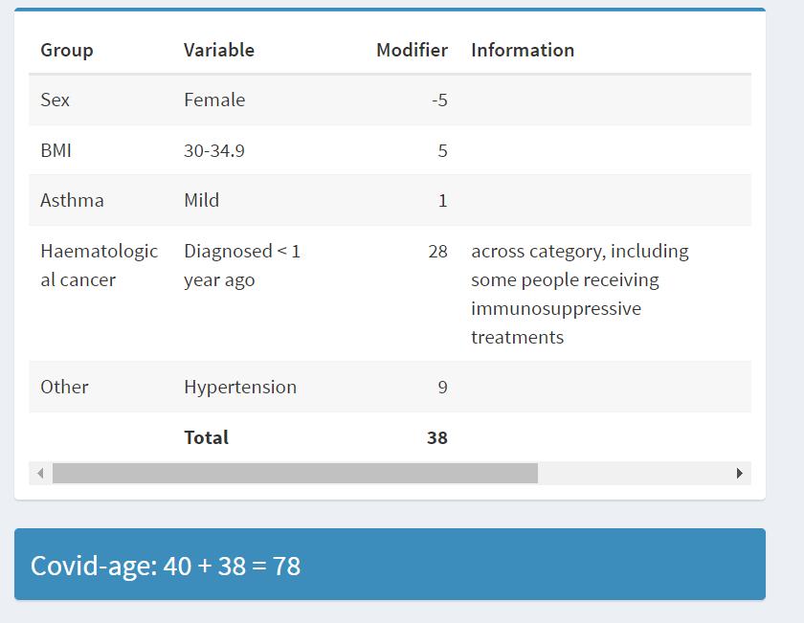

- Transfer the final COVID-age (78 in example above) to the staff risk assessment form. The example calculation above would look like this on the final document:
Covid Individual Risk Factor | Insert Modifier *  (taken from COVID age calculator)
Age (please insert actual age): | 40
Sex | -5
Ethnicity | 0
Body Mass Index (BMI) | 5
Additional modifiers (insert additional modifiers from other health conditions, if present) | 1
 | 28
 | 9
Total COVID-age (given by online calculator) | 78

- Calculator not working - if for any reason the COVID calculator tool is not working, then the age-adjusted modifiers can be found in the tables below the tool on the ALAMA website (see below). Identify the person’s true age and then scroll down, taking note of any added years according to the risk factors on the left hand column. Theses years (modifiers) can then be added to the table on the risk assessment document and totalled for a final COVID age.
Note that the COVID calculator can ‘grey out’ if unused for a period of time. Please refresh your screen to restore the tool.

Manual COVID age calculation tables:
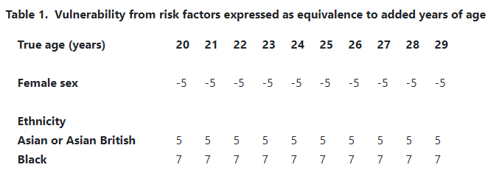
Appendix 3: WORK ADJUSTMENT ASSESSMENT GRID – Examples in Red Italics (please delete)

Employee Name: | Manager Name: | Meeting Date:
Job Title: | Service Area:
Identified health condition(s): | - Increased risk from COVID-19
Impact of health condition(s) on ability to undertake job:

Adjustment(s) recommendation(s) to be considered: | Impact of adjustment | Has adjustment been implemented?  Yes / No  If not, why not? | Implementation Date | Review Date | Impact on sickness absence/return to work/ability to remain at work?

Is there any adjustment/any other support I have not discussed with you that you consider would support you in your role? | None raised at this meeting
Detail any other alternatives considered by service to support employee | - Further advice sought from OH&WB on any other adjustments to relieve/minimise MSK symptoms & help e/ee to remain at work;  - Permanent reduction in hours being considered

Manager’s signature/ job title……………………….………………………..………………… Date: …………………….

Employee’s signature……………………………………………………………………….…….Date: …………………….

