Volunteer Role Description
Mass Vaccination Shuttle Bus Service
Do you have a passion for caring for people? Could you support us in our fight against the COVID pandemic? Would you like to be at the forefront of our ground-breaking programme of vaccinations?

Why we need your help

Mass vaccination is underway at Derriford and a dedicated Vaccination Hub has been set up in the Post Graduate Medical Centre, at the rear of the hospital.

Unfortunately not all of our elderly patients, who are being offered the vaccination as a priority, are able to make their own way from their outpatient appointments to the Hub.

We are looking for a team of volunteers to drive the small shuttle bus from outpatients areas to the Hub (see photo below).

What will I do?
Following training, and using a mobile telephone which will be provided, you will be contacted to collect patients from the entrance of our outpatients clinics and drive them, in our new covid-secure electric shuttle bus, the short distance to the Vaccination Hub. Helping to maintaining flow to and from the hub will be a key aspect for this role, to help prevent overcrowding while patients are attending the hub for their vaccination.

You will then you will be asked to return patients to the main entrance or one of the car parks, following their vaccination.

You’ll be based in the Mobility Centre in the Disabled Car Park and specific tasks include:
- Using wipes provided, wipe seats after each use.
- Ensure the mobile phone is charged (a charging point/socket is available in the Mobility Centre)
- Ensure the Shuttle Bus is plugged in to re-charge at the end of the day or when not in use
- Ensure the Mobility Centre is locked when unoccupied
- You’ll encourage hand sanitising and social distancing at all times

What we won’t ask you to do

- You won’t be asked to help passengers on and off the bus. This will be the responsibility of the person accompanying the patient, or a trained member of staff.
- You won’t be asked to take the shuttle bus off the Derriford site
- You will not be required to escort patients into the Vaccination Hub
- You will not be expected to take a patient in the passenger seat of bus, next to the driver’s seat.

What you will gain from this role
You will play a vital part in ensuring the more vulnerable members of our community are able to receive their covid-19 vaccination at the earliest opportunity.
You’ll meet new people every time you attend, and help them in a positive way.
You’ll be able to keep fit and active and be part of the team in a busy hospital environment.
We will offer you
- Training to drive the shuttle bus safely
- Personal protective equipment (ppe)
- A hi-viz jacket and waterproof trousers
- Support from your point of contact and patient transport team
- Supplies of wipes and hand sanitiser, as well as the means to dispose of these appropriately
- A covid-secure vehicle, with the driver/passenger seats screened off from the rest of the bus
We will ask you to
- Be reliable and committed
- Be willing to undertake training provided
- Be a courteous and helpful representative of the hospital
- Wear your identity badge and lanyard (if you have one) at all times
Location
Derriford Hospital, Plymouth
Days and times required
Monday to Friday
8am-4.30pm (times to suit)
Points of contact
Patient Services Manager (for rota and day-to-day enquiries)
Patient Transport Link (for shuttle bus enquiries)

Other requirements
Applicants must have held a clean driving licence for a minimum of 3 years.
Health: Those considered at an increased risk of severe illness or those caring for vulnerable adults should not apply to carry out this role.
Application requirements: A standard Disclosure & Barring Service check, formal volunteer registration
For more information or if you have any questions regarding this role, please contact
plh-tr.volunteerenquiry@nhs.net

Covid Rating: Green
Mitigation:
- Volunteers must check in with a member of staff in the Deployment Hub, inside the main entrance, on arrival and check out when leaving. Their attendance is recorded for ‘track and trace’ purposes.
- Volunteers are provided with appropriate personal protective equipment (PPE)
- A face mask and gloves must be worn while volunteering on hospital premises
- Volunteers are advised to maintain an appropriate social distance from staff and patients, including in lifts and stairwells
- Volunteers will not be asked to escort patients or visitors into the Vaccination Hub
- Hand sanitiser is available and volunteers are instructed when to use this
- Wipes are available to use on equipment used such as the mobile phone and buggy seats.
- Generally appropriate for: volunteers who fall within the low and moderate Alama (covid age) assessment rating but in certain circumstances it may be possible to include volunteers who fall into the higher risk Alama category

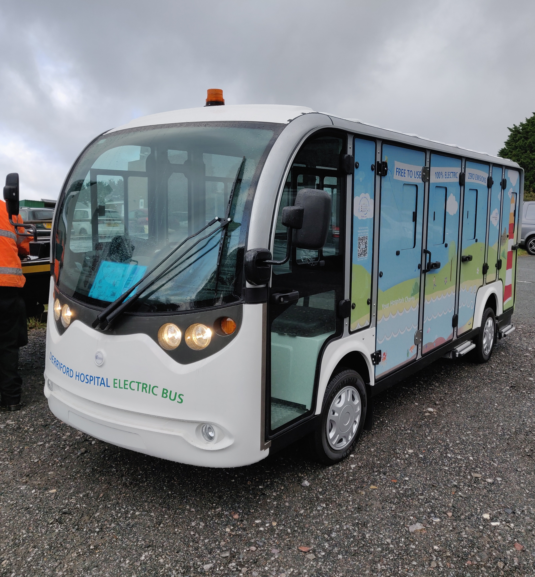
Here is DEB, the Derriford Electric Bus, shortly after delivery (prior to covid compliance)

