Description: C:\DOCUME~1\Jacksoll\LOCALS~1\Temp\XPgrpwise\52D69A30TCSPO710016A726E1655C1\IMAGE.png

**VOLUNTEER MANUAL**

**Telephone Support Volunteers following a patient discharge**

**from Royal Cornwall Hospital Trust (RCHT)**

|  |  |
| --- | --- |
|  |  |

|  |  |
| --- | --- |
| Section No | **Table of Contents** |
| 1 | Welcome & Introduction |
| 2 | Background |
| 3 | Role of the Telephone Support Volunteer |
| 4 | Expectations   * what you can expect from us * what we expect from you * what is involved |
| 5 | RequiredTraining   * safeguarding * data protection * other training |
| 6 | Telephone calls   * initial process * telephone calls |
| 7 | Issues / Concerns Arising from Telephone Calls |
| 8 | Further Support Services   * Pastoral care remove this here as not mentioned within text * Wards & departments information We haven’t added this information * Specific tools |
| 9 | Reports & Statistics   * telephone reports * statistics & updating spreadsheets? Could leave these subheadings out |
| 10 | Appendices : Helpful Information & Tools |

**1. Welcome / Introduction**

You will be part of a Discharge Support Project which is a simple and effective initiative that positively contributes to patient mental health and emotional wellbeing at a time that is, for some, very anxious. You as a volunteer will be contributing to the health and wellbeing of our patients by demonstrating that the Royal Cornwall Hospital Trust cares about them.

This project wholeheartedly embraces the Trust values demonstrating Brilliant Care, Brilliant People, Brilliant Improvement and Brilliant Patient Communication, values which we would look to demonstrate with care and compassion.

Through this project you will provide a friendly telephone support service from your home across the county for adult patients being discharged from the Royal Cornwall (Treliske), West Cornwall and St Michael’s Hospitals.

The feedback from the telephone calls help inform RCHT staff to know that what they are doing is really appreciated by patients and their relatives and to report any concerns if expressed.

This manual explains this volunteer role which was created in 2020 - we hope that the contents will support you with key elements and information to help you and we would like to take this opportunity to thank you in advance for your contribution within our volunteering team.

**2. Background**

This project arose from the COVID19 Pandemic review of services which led to the development of a Going Home Pack (nutritional groceries plus toilet rolls) (Appendix 1). The pack was funded by RCHT Charity.

Packs continue to be provided as a gift to frail, elderly, or vulnerable patients at their point of discharge. A compliment slip in the bag informs the patient that ‘*We would love to hear how you are getting on and one of our volunteers will give you a call in a few days just to say ‘Hello’* . This project has now developed and offered to patients on discharge either with a Going Home Bag or after more than a 72 hour stay at RCHT.

Volunteers are home based, provided with the discharged patient contact details and make a one-off *“hello, how are you”* phone call to provide a listening ear and check on the welfare of the discharged patient. If, necessary, the Volunteer will signpost to local services as appropriate, e.g. Volunteer Cornwall, GP Surgery, etc. Where a concern has been flagged, the volunteer discusses this with their Volunteer Coordinator. This contact has been well received by patients.

**3. Role of the Telephone Support Volunteer**

What is needed by the volunteer to carry out the role:

Should be add as first bullet Read and sign the role description (Appendix 2)

1. A phone, preferably with a call plan of free calls. Speak to Voluntary services office staff if you have concerns about this.
2. NHS email address as patient names and phone numbers cannot be sent via personal email messages for data protection General Data Protection Regulation (GDPR)– this can be set up for you, if necessary.
3. Computer laptop, iPad or similar.
4. Familiarisation with the IQVIA reporting system (an online tool to gather data and describe experiences about healthcare); this focuses on both the positive and less positive aspects of the patient experience following their recent discharge.) the manual and relevant paperwork. **NB** The IQVIA online form, which is very easy to use, is a live electronic record; please do not enter information to practice using it. See Appendix 3 for the current IQVIA data fields that are used.

What is involved:

* Set aside some time each week to make phone calls to an agreed number of patients. When new in the role you may wish to only phone 2 patients per week then we suggest you set an agreed limit, for example 4 or 6 patients per week to phone. We expect volunteers to be unavailable from time to time - just let us know in advance, if possible, so that we can leave you off the list for that particular time.
* Record any reasonable expenses that you incur – for phone calls you will need to submit the phone bill as evidence. Inform the Voluntary Services Team if expenses are high.

Read and agree the role description, which is a 2-page document. (Appendix 2)

* Obtain feedback from patients via phone conversation and their experiences when in hospital including discharge planning and if appropriate the Going Home bag.
* Enquire about the level of support that the patient has at home, whether they live alone or not, and that they have someone to shop and cook for them as needed, run errands etc.
* Fill in a short online report form, using IQVIA (Appendix 3). This data is managed by the RCHT Patient experience group and is available for staff to see electronically.
* Identify any issues and flag them to your Coordinator.
* e.g are you worried that a patient has not got help at home?
* e.g are you concerned that there may be a safeguarding issue, perhaps the patient is describing a relative friend or carer is stealing from them?
* Seek support and be supported as this role involves volunteering from home. Do not hesitate to contact your Coordinator for support and to chat through the situation.

**4. Expectations**

* ***What you can expect from us***
* The Volunteer Office will email you the Telephone Support Volunteers manual.
* The Volunteer Office will email you a Role Description for you to look through and sign and return to the Volunteer Office, electronically or by hand/post.
* The volunteer office can advise on links to any training and support that you may need to ensure that you have an enjoyable and rewarding experience as a Telephone Support Volunteer.
* There are guidelines in the manual (see Appendix 4) provided to assist you with a structure for the phone calls (especially helpful if you are new to the role and until you are a little more experienced with what information is required).
* You will be sent a link to the IQVIA form to save on your computer/iPad or equivalent, for use after each phone conversation.
* You will be given a Coordinator who will liaise with you about the calls you need to be make and support you in your role. Keep in regular contact with the Coordinator with any concerns, however minor you may think they are.

***NB*** If you require help setting up please do not be afraid to ask your coordinator or the Cornwall Information Technology Services (CITS) Helpline 01209 881717

* ***What we expect from you***
* To attend an RCHT induction session and other team meetings as required
* To undertake RCHT mandatory training on an annual basis, or as required
* Make the allocated telephone calls within 3-5 working days of receiving notification of the patient(s) to call.
* Please let your coordinator know when calls have been made.
* If you are not available to make the calls, it is especially important that you let your Coordinator know as soon as possible

**What is involved:**

* Make a *“how are you call”* on your phone to the discharged patient using the WITHELD (141 preceding the number) function on your phone.
* Encourage and signpost the patient to make contact if necessary, with their
* GP;
* Carer;
* Volunteer Cornwall
* Relative
* Check with the patient if the information they have supplied can be shared (without use of names) and indicate this within the tick box at the end of the IQVIA form, if their permission is gained.
* Complete the online IQVIA form and submit it following each phone call.

**VERY IMPORTANT - PLEASE NOTE**

You will be receiving patient names and telephone numbers via email; you must ONLY USE your NHS email address for email communication of these details.

Please ensure that you delete all emails relating to patient information after you have made the call and is no longer required by you.

**5. Required Training**

This includes:

* **Safeguarding/Data Protection**

You will have attended a short session at the initial Corporate Induction, and further mandatory training as required.

* **Other Training**

If you feel that other training would be beneficial, please let us know – we can look at trying to accommodate your requests, either individually or as part of a team meetings, for example `Handling Difficult Situations’.

**6. Telephone Calls**

* **Initial Process**
* You will be sent an email by your Volunteer Coordinator with the details of the patient(s) to call. Name / phone number and usually with other information of date of birth, discharge ward and date of discharge.
* **Telephone Calls**
* On receipt of the patient’s details, you will telephone WITHELD NUMBER the patient (at a time suitable for you, usually between the hours of 9.00 and 16.00 hours
* Introduce yourself and explain why you are calling
* Check to ensure that it is the right person and that they are willing to talk
* Emphasise that this is a friendly call to say hello following their recent hospital stay, refer to the compliment slip (see Appendix 1) they received
* Explain that you will give written feedback following the call but that it will be anonymous, and ask whether they are happy for their comments to be shared more widely, again with no mention of their name.
* Keep the conversation informal, using `open questions’ as much as possible, but try to cover the following points:
  + Communication between staff and patients/families at discharge
  + Discharge – how efficient was the process?
  + Have they encountered any problems since discharge?
* The above points are contained within the IQVIA electronic form, which you need to fill in “online” after the telephone call.

**7. Issues / Concerns Arising following the telephone call**

If you encounter a difficult or challenging situation during the telephone call, it is particularly important that you report the details to your Volunteer Coordinator as soon as possible, for your own support and to ensure appropriate actions are taken.

Contact the Volunteer Coordinator by phone (see their email for number) only in an emergency (e,g, safe guarding) and you cannot contact your Coordinator should you contact the Volunteer Services Office (01872 253737). They will know who else needs to be involved and if a concern needs to be escalated and logged.

Remember we want your time with Voluntary Services to offer enjoyable and valuable experiences and the Team will make every effort to support you at all times.

**8. Further Support Services**

We have also attached two tools which some people find helpful - one as an aide memoir to help with communication skills and the other for use when reflecting on a situation:

* the LEAPS Framework for Communication Skills for guidance (Appendix 5)
* Gibb’s Reflective Model – Appendix 6

Pastoral care is mentioned in this section in the contents page and its not mentioned here,

**9. Reports & Statistics**

The Patient Experience Team and Quality Improvement Team are able to provide reports and statistics, as required, to inform the clinical areas of the work that we do.

**10. Appendices**

4 Aide Memorie and Guidelines when making a Discharge Follow up Call

3 IQVIA Information

1. Going Home Bags poster / List of Going Home Bag contents / Compliment Slip wording

5 LEAPS Model for Communication Skills Adapted from Thompson, G. (2009, 2nd ed): *Verbal Judo. The gentle art of persuasion,* Harper Collins

6 Gibbs Model of Reflection (Gibbs, G. (1988) Learning by Doing: A guide to teaching and learning methods. Further Education Unit. Oxford Polytechnic: Oxford.

7 Flowchart

2. Role description

**APPENDICES**

Appendix 4

**Aide and Guidelines for when making a Discharge Follow up Call**

Call the patient between 09.00 -16.00

Introduce yourself “Hello I am (your name) a volunteer from Royal Cornwall Hospital Trust. I am calling to say hello following your recent discharge from hospital. Do you have a few minutes to speak to me ?” If YES, say “ Thank you”

I believe you went home on (date of discharge) how is everything now you are home?

Continue with general enquiries e.g.

* + How are you doing today?
  + Have you any one at home with you?
  + Are you managing to get around the house ok?
  + How are you feeling today?
  + Have you managed to speak to any of your friends or family?
  + What is a typical day like for you? Do you enjoy reading or watching TV?
  + Are you managing to prepare your meals?
  + Do you have all the medication you need?
  + Are you able to get out to the garden for some fresh air?
  + Other prompts may be added as appropriate.

Listen without interrupting and repeat what has been said to check you understand.

* 1. Use phrases such as I understand …empathize
  2. Please be yourself
  3. If they speak of medical problems, check that they know how to contact their GP surgery as they are there to support them.
  4. If the discharged patient has a package of care- contact numbers will be in their Care Plan Folder in their home and they should be encouraged to use that.
  5. For help with shopping or medication collection pass on the details of Volunteer Cornwall via [requestforhelp@volunteercornwall.org.uk](mailto:requestforhelp@volunteercornwall.org.uk) or Telephone 01872 266988
  6. ?? remove this bullet

Once the call is over please complete the IQVIA form

If there is **no reply** please leave a message giving your name and that you are a volunteer from RCHT. Say you are calling to say Hello following your recent discharge. I will try calling you again later/ another time, my number will be withheld.

If they answer and say NO …OK would you like me to call you back? It may be an inconvenient time for them e.g. nurse or carer visiting (depending on response arrange another time or thank patient and note no further contact)

Appendix 3

**IQVIA Information**

The form is designed to act as prompts to nurture a conversation and help it to flow as opposed to a survey with specific questions to be answered. If, while having the conversation, answers can be attributed to the question prompts this will help us in reporting but this is not essential.

Before making the call to the patient, click on the link below – the green section at the top and demographic data at the bottom can be filled out before the conversation has started:

<https://www.oc-meridian.com/RCHT/survey/DischargedPtExpSurvey>

All green sections **ARE** mandatory; you will not be able to submit the record if this section isn’t filled out.

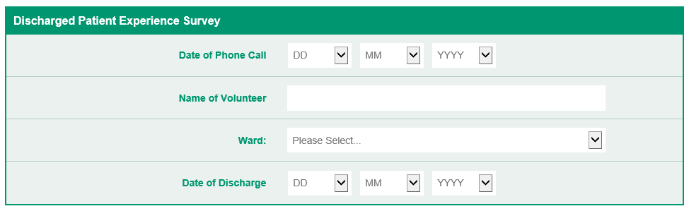

Enter your name here

Select ward the patient was discharged from using the dropdown menu

Select date from dropdown

Select date from dropdown

All blue sections are **NOT** mandatory. These can be filled out as you see fit using the free text boxes to note down key information from the phone call. The questions have purely been included to act as prompts for the conversation. If you can answer the questions from the conversation this will mean we have more quantitative data for the wards – it is not vital that these questions are asked verbatim.

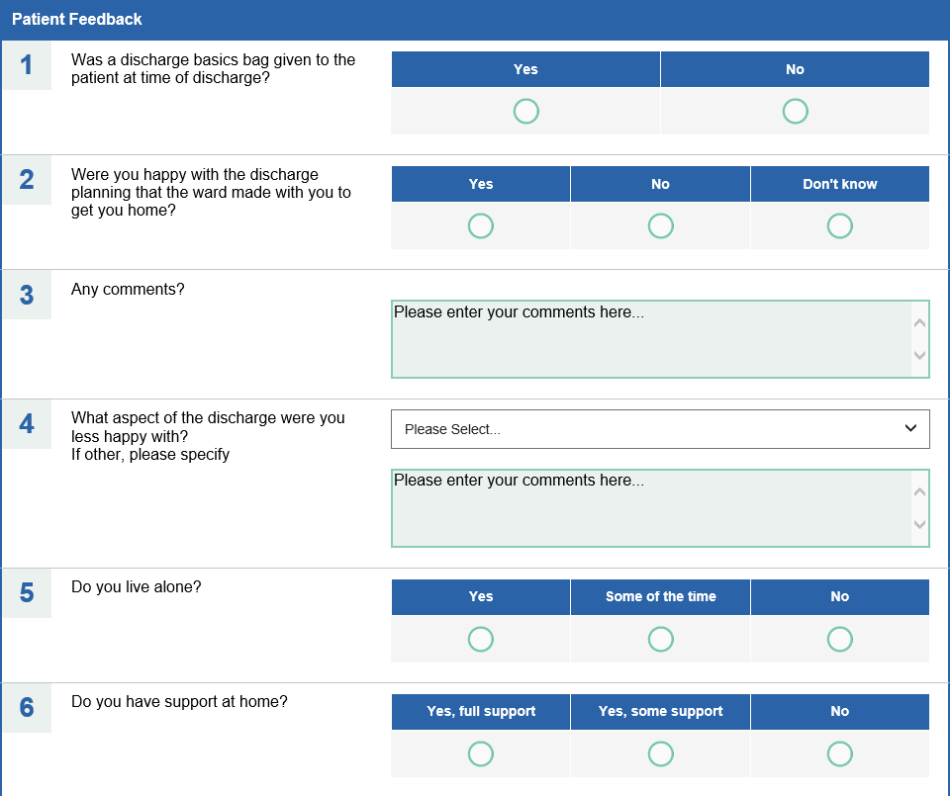

Use free text boxes to record key parts of the conversation

Free text boxes expand to record lots of information

Select the best option from dropdown menus; if the patient has multiple answers, use the free text box to document this

**Demographic Data**

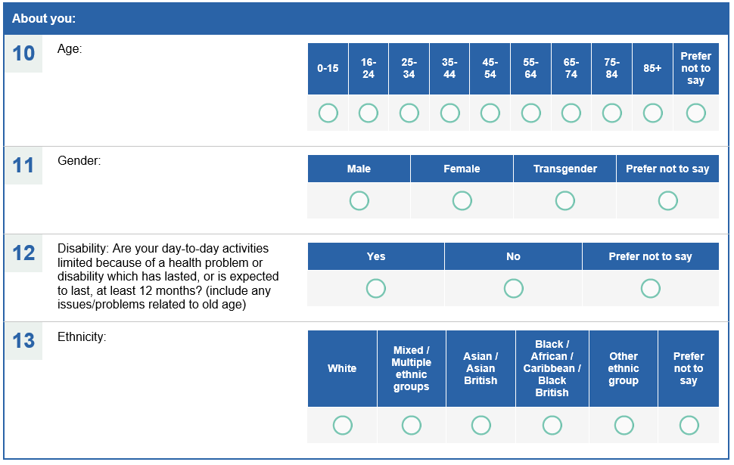

Appendix 1

**Information about Going Home Bags**.

|  |  |
| --- | --- |
|  | **Going Home Bag Pack**  **Contents**  Pack of Cup a Soup x 2  3 x packs of crackers  Jam portions x 6  Tea x 10  Coffee x 5  Hot Chocolate sachets x 2  Sugar sachets x 10  Milk - UHT Carton  2 x Tubs of Rice pudding  2 x packs of cereal  2 x packs of 3 biscuits either custard cream or bourbon  Toilet Rolls x 2 |

**Going Home Bag Compliment Slip** – *put in the Going Home Bag*

We would like you to accept this gift from us funded by the RCH Charity following your discharge from the Hospital.

We would love to hear how you are getting on following your discharge and one of our volunteers will give you a call in a few days just to say “Hello”!

Please note the number will be withheld.

Royal Cornwall Hospitals NHS Trust

**Appendix 5**

**LEAPS**

**Framework for all Communication Skills**

|  |  |
| --- | --- |
| **L**isten | Demonstrate you are listening on a telephone  – how do you do this?   * paraphrase * ask open questions (why what how)   **Note**: the letters of `listen’ also spell ***silent***!!!  It is sometimes better to be silent and listen, rather than interrupting and making assumptions, e.g. finishing off ***their*** sentences in ***your*** head, trying to give advice. |
| **E**mpathise | Try to understand how the other person feels   * talking with the person ***adult-to-adult*** (at the same level), as opposed to parent-to-child (Transactional Analysis) * level of transaction may have a direct effect on resulting response /behaviour |
| **A**sk | Don’t be afraid to ask what is wrong!   * behaviour may be an attempt to get acknowledgement or attention * to ***ask*** can open valuable lines of communication, encouraging adult-to-adult dialogue |
| **P**araphrase | It can be helpful to repeat back bits of what you have heard   * this is a good way of demonstrating that you have listened to what has been said * also, a good way of getting the person to listen to you (checking that you have heard and understood correctly what has been said) |
| **S**ummarise | Ensure the person is clear about what is/happens next   * it is important check whether there is anything else they want to ask, or to add |

Adapted from Thompson, G. (2009, 2nd ed): *Verbal Judo. The gentle art of persuasion,* Harper Collins

**Appendix 6**

**Gibbs Model of Reflection (1988)**

Gibbs, G. (1988) Learning by Doing: A guide to teaching and learning methods. Further Education Unit. Oxford Polytechnic: Oxford.

This would be better turned to landscape view I think

Appendix 7



**Appendix 2**

**ROLE DESCRIPTION**

**Discharge Support Volunteer**

**Royal Cornwall Hospital**

1. **Role Overview**

Our Telephone Discharge Follow Up Volunteers provide a friendly telephone follow up call to patients on discharge from RCHT. Patients have either been discharged to their own home after more than a 72 hour stay or meet the criteria for a Going Home Bag.

This is currently a home-based role.

You will play an integral role in supporting a positive experience of discharge and empathy and a listening ear now the patient is at home.

1. **What’s the commitment?**

We ask that you make a commitment of approximately 3 hours during each week, Monday to Friday.

You will need to treat all information and calls in **Confidence** –

It is important that you use your NHS Email at all times**.**

Please ensure that contact details are deleted from your email account.

To make the service safe for everyone please do not arrange to visit your telephone contact or exchange any personal contact details with them including social media accounts.

1. **What’s involved?**

Our aim is to support the discharge process with a friendly call now the patient is home.

* During the week you receive an email from your Volunteer Coordinator with patient contact number/s
* Call the patient between 9.00-16.00- please ensure that you withhold your number, (just dial 141 before the telephone number you want to call).
* Introduce yourself **(***suggested opening- Hello I am (your name) a volunteer from Royal Cornwall Hospital Trust. I am calling to say hello following your recent discharge from hospital.)*
* Ask open questions- e.g. *What, where, when, How are you doing today? Have you managed to talk to any of your Friends or family*?
* Take care with phrases such as “*I understand*”. If the person sounds angry, acknowledge – e.g. “*it must be hard*”.
* Please be yourself and be a listening ear.
* If you have concerns please speak to your Volunteer Coordinator or sign post the patient to specific health, social and voluntary organisations out in the community.
* Once the call is over please complete the IQVIA on line form
* Confirm with your Coordinator that the call/s have been made.

1. **How will we support you?**

* Induction and on-going training as appropriate
* Support from a Voluntary Services Co-ordinator
* Invitations to attend Voluntary Service training, events and awards.

1. **What we expect from you:**

* *Reliability* – please give as much notice as possible (ideally 24 hours) if you cannot volunteer when expected.
* *Safety* – follow RCHT’s rules and procedures.
* *Involvement* - participate in relevant induction, training programmes and supervision.
* *Be a Team player* - respect reasonable directions and instructions.
* *Live RCHT values* –be courteous and respectful everyone.

1. **General**

This role description is a working document. The needs of the service may alter and the role of the Volunteer may therefore need to be adjusted. However, Volunteers will be involved in any changes suggested. If you as a Volunteer have comments to make on the role, or you have suggestions for additional tasks, please speak to your Voluntary Services Coordinator.

For insurance purposes, it is essential that Volunteer’s ‘work’ within the existing role description.

*I have read the role description and fully understand what is expected of me whilst I am a Volunteer at RCHT.*

*Signed by _______________________________________________*

*Print Name_______________________________________________*

*Date___________________________________*

*Please retain one copy for your records and one copy to be returned to Voluntary Services*

Voluntary Services Office, 1st Floor, Tower Block, Royal Cornwall Hospital Truro, Cornwall TR1 3LJ

Tel: 01872 253737 you missed out a number

https://www.oc-meridian.com/CDN/images/loadingGrid.gif  
Loading questionnaire please wait...

Top of Form