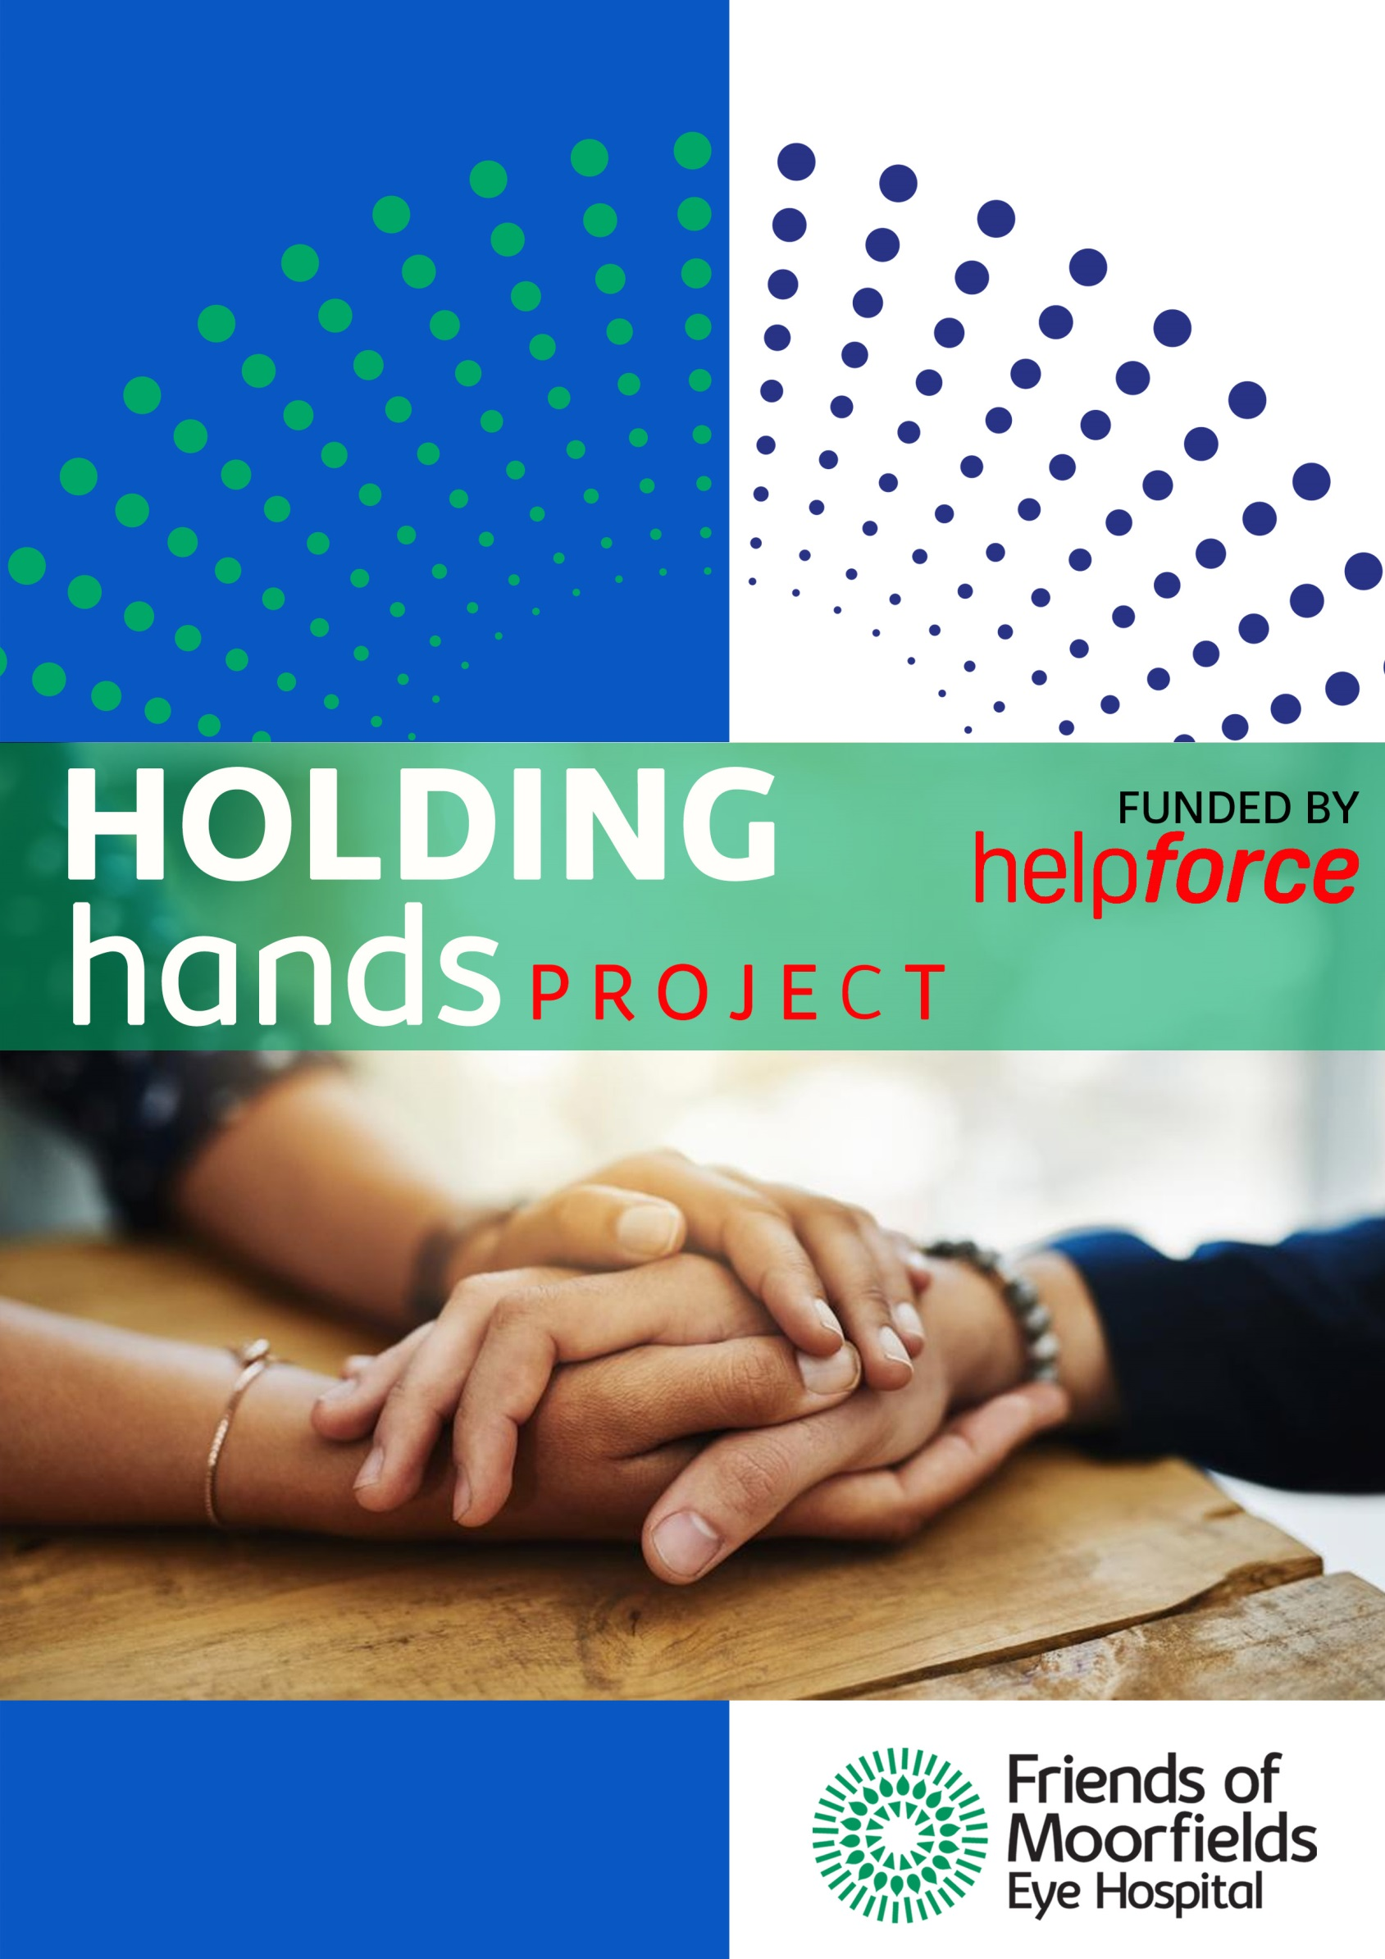



**Welcome to Moorfields NHS Foundation Trust**

Tracy Luckett

Director of Nursing and Allied Health Professions

Moorfields Eye Hospital NHS Foundation Trust

162, City Road

London

EC1V 2PD

Direct line 0207 566 2282

Theatre Manager – Phil Chadwick

Anaesthetic Lead - Kwasi Adzika

Surgical Lead - Vacant

Practice Educator – Cecilia Tribunal

Friends of Moorfields Volunteer Service Manager (Lead on Hand-Holding) – Natalia Tomashpolskaya

**Operating Theatres**

**Operating list times-**

• Morning lists 08:30 to 13:00

• Afternoon lists 13:30 to 18:00

• All Day lists 08:30 to 18:00

• Evening lists 18.00 to 20.30

• Weekend lists 09.00 to 17.30

Staff will provide and maintain a safe and protective environment for patients, personnel and others when undergoing surgery in CR theatres.

Friends of Moorfields Office contact number 02072511240

What to do if you are sick: please call Natalia at the office as soon as possible.

**Theatre Induction Checklist**

This section should be completed before starting in a hand-holding role. Each item in the list should be ticked by the volunteer when they feel comfortable with the information provided.

I understand the layout of the office or clinic area I will normally be working in, and I know where to find the things I need.

☐

In the event of a fire or other emergency, I know how to raise the alarm, evacuate the building and where to assemble safely.

☐

I understand the local health and safety procedures of my work area.

☐

I have been shown around the building(s) I will be working in and identified where toilets, canteens, break rooms and other relevant places are located.

☐

I understand my volunteering hours and work rotation schedule (if applicable).

☐

If I have an “on call” element to my role, I understand the arrangements and schedule.

☐

I understand the arrangements for break times and lunch in my department.

☐

If I am unable to attend volunteering due to sickness or other unavoidable circumstances, I know when and how to report my absence.

☐

I understand to inform in advance about my leave or absence and who to contact.

☐

I understand the expectations regarding appearance, uniform and personal hygiene.

☐

I understand that as a hand-holding volunteer I will be wearing a full suit of scrubs, theatre shoes and hat. I will also be wearing a mask (worn based on the procedure and the proximity from the sterile field).

☐

I understand that I will wash hands before and after every patient.

☐

I understand that I should wear disposable gloves If I have bleeding or breaking of skin on my hands. I will also need to report this to my volunteer manager.

☐

I understand the role of the volunteer hand-holder. I have a copy of my Job Description to keep track of these.

☐

I understand the standards I will be expected to demonstrate in my role.

☐

I understand the key documents and policies, standard procedures and methods, and scopes of responsibility of my role (do’s and don’ts below).

☐

I have been introduced to the key people in the department or trust who I need to know.

☐

I understand how to use key equipment within the department and have received or booked any additional training I need.

☐

I have a Moorfields Identification card, and relevant keys and security codes (if appropriate) for the buildings and areas where I will be working.

☐

I have been shown how to use the telephone system, how to access external lines and the number to call in an emergency.

☐

**A few Do’s and Don’ts from the Clinical Team:**

* Do Introduce yourself to the patients in waiting area gently; making them aware of your presence if required, allowing them to come and ask you for help and support, please don’t be forceful;
* Do Feel free to talk at length to patients in waiting areas but not in operating theatre, the surgeon will require the patient to be quiet in most cases;
* Please actively listen to the suggestions of the team as per where you need to be located in relation to each patient, this will depend on equipment used and the eye;
* Please don’t touch anything clinical, anything in blue drape (it is sterile!), no microscope, trolleys or instruments or bars;
* Please be aware of touching any body areas like chest that might feel private to the patient (you may be able to adjust a blanket for them if they indicate they require this)
* Please refrain from talking to medical team about your personal matter or condition;
* Please refrain from asking questions about the patient’s surgery, or anaesthesia. (E.g. is there normally that much blood?)
* If you need to leave please do (In case you feel queasy);
* Please maintain confidentiality about what the patient has undergone;
* Please don’t comment on the surgery or anaesthesia to the patient even after the procedure  (I’m concerned if they say ‘I haven’t seen it done that way’ for example it could perceived negatively by the patient);

We expect to receive on-going feedback from the medical team which might expand this list further (the project is in evolution)

**The Moorfields Way**

*The Moorfields Way* is the common language we have created so that everyone at the trust can appreciate the positive actions and attitudes of their colleagues and challenge inappropriate staff behaviours when they arise.

Our commitment to each other, and to our patients, are that we will be **caring**, so people feel listened to and valued, **organised**, so we don’t waste people’s time, **excellent**, so people feel confident that we will deliver a first class professional service, and **inclusive**, so people feel informed, involved, and part of a team.

If we, as a trust, are able to role model commitments described by *The Moorfields Way*, and the behaviours that underpin them, we will be successful in delivering excellent health care to patients and a positive working environment for our colleagues. The commitments and descriptive behavioural framework can be found at the end of this document.

It is your responsibility to ensure you act and behave in line with the behavioural expectations described in *The Moorfields Way* and encourage your colleagues to do the same. Your manager should positively role model these behaviours and be accountable for the attitudes and actions of their team. In the event that the conduct of a colleague is unacceptable, you can expect your line manager to use the Disciplinary Policy to take action over unsatisfactory conduct.

If you have any questions about *The Moorfields Way* please contact the Learning & Development team via email (development.support@moorfields.nhs.uk).

|  |  |
| --- | --- |
| **Useful Ophthalmic terminology (for general interest only, VOLUNTEERS ARE NOT EXPECTED TO KNOW THIS)** | |
| **Ophthalmic Term** | **Definition** |
| Accommodation | The ability of the lens to change shape to allow focussing of objects near and far |
| Amblyopia | Reduction of vision in an eye that appears normal |
| Anterior chamber | The space behind the cornea, in front of the iris filled with aqueous |
| Aqueous | Clear fluid in that fills the anterior and posterior chambers |
| Astigmatism | A refractive problem due to the irregularity in the cornea |
| Aphakia | An eye which has had its lens removed |
| Binocular vision | The ability of to use both eyes to see see one image |
| Blepharitis | Inflammation of the eye lid margin |
| Cataract | Opacity of the lens |
| Chalazion | Inflammation of a meibomian gland |
| Chemosis | Swelling of the conjunctiva |
| Conjunctivitis | Inflammation of the conjunctiva |
| Dacroycystitis | Inflammation of the lacrimal sac |
| Dendritic ulcer | An ulcer on the cornea caused by the herpes simplex virus, looks like a tree branch |
| Entropion | In turning eyelid |
| Ectropion | Out turning eyelid |
| Enucleation | The surgical removal of an eye |
| Epiphera | Watering of the eye |
| Eviseration | Removal of the contents of the eye leaving the sclera behind |
| Extenteration | Removal of all the contents of the orbit including the eyeball and the eye lids |
| Floaters | Pieces of vitreous that break off |
| Fundus | The posterior part of the eye, which can be viewed with an ophthalmoscope |
| Glaucoma | Abnormally increased intra ocular eye pressure with damage to the optic nerve |
| Hyphaema | Blood in the anterior chamber |
| Hyopyion | Pus in the anterior chamber |
| Injection | Redness of the eye |
| Iritis | Inflammation of the iris |
| Keratitis | Inflammation of the cornea |
| Keratoplasty | Corneal graft |
| Keratoconus | Abnormal cone shape to the cornea |
| Lacrimation | Excessive production of tears |
| Miosis | Constriction of the pupil |
| Mydriasis | Dilation of the pupil |
| Myopia | Short-sightedness |
| Nystagmus | An involuntary rapid movement of the eye ball |
| Photophobia | Abnormal light sensitivity |
| Presbyopia | Reduced accommodation powers due to advancing in age |
| Proptosis | Term used when the eyeball is prominent |
| Retinal detachment | The separation of the retina from the choroid |
| Ptosis | Drooping eyelid |
| Strabismus | A manifest deviation of the eyes |

|  |  |
| --- | --- |
| **Acceptable Ophthalmic abbreviations that may be used in patient’s documentation (this is just for information, you are not expected to know this)**  **Abbreviation** | **Full term** |
| AAU | Acute anterior uveitis |
| AC | Anterior chamber |
| ALT | Argon laser trabeculoplasty |
| ARMD | Age Related Macular Degeneration |
| AS | Anterior segment |
| BE | Both eyes |
| BP | Blood Pressure |
| BRAO | Branch retinal artery occlusion |
| BRVO | Branch retinal vein occlusion |
| BSV | Binocular single vision |
| BUT | Break up time of tear film |
| CCT | Central corneal thickness |
| CD | Cup disc ratio |
| CF | Count fingers |
| CL | Contact lens |
| CMO | Cystoid macular oedema |
| CMV | Cytomegalovirus |
| CRAO | Central retinal artery occlusion |
| CRP | C-reactive protein |
| CWS | Cotton wool spot |
| D | Dioptre |
| DCG | Dacrocystogram |
| Dx | Drug history |
| ECCE | Extra Capsular cataract extraction |
| EUA | Examination under anaesthetic |

**Uniform and Dress Code Policy attached.**