

# JOB DESCRIPTION

**POST:** Macmillan Volunteer Service Co-ordinator

**LOCATION:** Belfast Trust

**BAND:** 5

**REPORTS TO:** Volunteer Co-ordinator Manager

**RESPONSIBLE TO:** Senior Manager

**Job Summary / Main Purpose**

The post holder will be responsible for co-ordinating the volunteer services across the Belfast Health and Social Care Trust, ensuring that volunteers complement the delivery of core Trust Services. The post holder will support the Volunteer Co-ordinator Manager providing the effective recruitment, retention, and support of volunteers across all sites. The post holder will principally, but not exclusively, support the development of volunteer services and roles that will complement services providing care to people living with cancer across both acute and community services. The post holder will work in partnership with other key stakeholders including Macmillan Cancer Support Services.

## Main Duties / Responsibilities

For each of the following, the postholder will;

* To promote recognition and value for volunteering and in Health and Social Care.
* To assist in the continued implementation of the Trust Volunteer strategy. This will include the implementation of policies and procedures to ensure volunteers are supported by the principles of equality and diversity.
* Plan, coordinate and monitor the activities undertaken by volunteers on particular sites or within service groups.
* Review established role descriptions and develop new roles for volunteers, ensuring they are fit for purpose, meet the needs of patients and clients whilst ensuring they complement the core services of the Trust.
* Participate in the safe and effective recruitment and selection of volunteers ensuring placements areas have adequate support form clinical supervisors
* Carry out regular placement reviews and support meetings with volunteers throughout the Trust, adhering to Trust policy.
* Support Trust staff to ensure volunteers are involved and utilised effectively.
* Coordinate, in conjunction with administrative support, all relevant AccessNI and Occupational Health checks for prospective volunteers.
* Assist with the maintenance of appropriate records adhering to data protection guidance and policy.
* Identify required training needs for volunteers; work with key stakeholders in providing appropriate training.
* Work with other key stakeholders including other Health and Social Care organisations, private, public and voluntary organisations.
* Actively engage with Macmillan Cancer Support to contribute expertise and experiences and to support the Macmillan strategy.
* Support the Volunteer Coordinator Manager in the delivery of volunteer induction programmes and training. Assist in the organisation of meetings and recognition events as appropriate.
* Assist the Volunteer Coordinator Manager in the promotion of volunteering opportunities within the Trust both internally and with the use of external partners.
* Assist the Volunteer Coordinator Manager to raise the profile and awareness of volunteering amongst trust staff.
* Contribute to the development of the annual volunteer services management plan.
* Collate relevant information on volunteers and volunteer activity within the Trust ensuring records and database information is accurate and updated in a timely manner.
* Provide regular progress reports to Macmillan regarding specific Macmillan volunteer roles and participate in annual progress reviews with the Macmillan Partnership Quality Lead.
* Keep up-to-date with changes in policies and legislation relevant to the role such as Recruitment and Selection, Data Protection etc. ensuring compliance with these and all Trust Policies at all times.
* Provide appropriate written reports for the volunteer services manager as required.
* Ensure that any volunteer roles specific to Macmillan services adheres to Macmillan Quality Standards Framework.
* Contribute to the Trust’s overall governance strategy in accordance with the Public Sector values, codes of conduct and accountability.
* Work within the volunteer services budgetary restraints, providing advice on the cost of planned projects and consultations.
* Ensure that volunteers are aware of the Trust’s policies and procedures in relation to claiming expenses, ensuring these are processed effectively.
* Such other duties as appropriate.

**People Management**

* Ensure effective utilisation of staff resources within areas of responsibility to ensure maximum outcomes.
* Participate in the recruitment and selection of relevant staff.
* Participate in staff induction, training and other learning as required.
* Contribute to effective team working.
* Act as a mentor as required.

**General Responsibilities**

Employees of the Trust are required to promote and support the mission and vision of the service for which they are responsible and:

* At all times provide a caring service and to treat those with whom they come into contact in a courteous and respectful manner.
* The post holder will promote and support effective team working, fostering a culture of openness and transparency. The post holder will ensure that they take all concerns raised with them seriously and act in accordance with Belfast Trust’s Whistleblowing Policy and their professional code of conduct, where applicable.
* Demonstrate their commitment by their regular attendance and the efficient completion of all tasks allocated to them.
* Comply with the Trust’s Smoke Free Policy.
* Carry out their duties and responsibilities in compliance with the Health and Safety Policies and Statutory Regulations.
* Adhere to Equality and Good Relations duties throughout the course of their employment.
* Ensure the ongoing confidence of the public in-service provision.
* Maintain high standards of personal accountability.
* Comply with the HPSS Code of Conduct.

**Information Governance**

All employees of Belfast Health & Social Care Trust are legally responsible for all records held, created or used as part of their business within the Belfast Health and Social Care Trust, including patient/client, corporate and administrative records whether paper based or electronic and also including e-mails.  All such records are public records and are accessible to the general public, with limited exceptions, under the Freedom of Information Act 2000, the Environment Regulations 2004, the General Data Protection Regulation (GDPR) and the Data Protection Act 2018. Employees are required to be conversant and to comply with the Belfast Health and Social Care Trust policies on Information Governance including for example the ICT Security Policy, Data Protection Policy and Records Management Policy and to seek advice if in doubt.

**For further information on how we use your personal data within HR, please refer to the Privacy Notice available on the HUB or Your HR**

**Environmental Cleaning Strategy**

The Trusts Environmental Cleaning Strategy recognizes the key principle that “Cleanliness matters is everyone’s responsibility, not just the cleaners” Whilst there are staff employed who are responsible for cleaning services, all Trust staff have a responsibility to ensure a clean, comfortable, safe environment for patients, clients, residents, visitors, staff and members of the general public.

**Infection Prevention and Control**

The Belfast Trust is committed to reducing Healthcare associated infections (HCAIs) and all staff have a part to play in making this happen. Staff must comply with all policies in relation to Infection Prevention and Control and with ongoing reduction strategies. Standard Infection Prevention and Control Precautions must be used at all times to ensure the safety of patients and staff.

This includes:-

* Cleaning hands either with soap and water or a hand sanitiser at the appropriate times (WHO ‘5 moments’);
* Using the correct ‘7 step’ hand hygiene technique;
* Being ‘bare below the elbows’ when in a clinical environment;
* Following Trust policies and the Regional Infection Control Manual (found on intranet);
* Wearing the correct Personal Protective Equipment (PPE);
* Ensuring correct handling and disposal of waste (including sharps)  and laundry;
* Ensuring all medical devices (equipment) are decontaminated appropriately i.e. cleaned, disinfected and/or sterilised;
* Ensuring compliance with High Impact Interventions.

**Personal Public Involvement**

Staff members are expected to involve patients, clients, carers and the wider community were relevant, in developing, planning and delivering our services in a meaningful and effective way, as part of the Trust’s ongoing commitment to Personal Public Involvement (PPI).

Please use the link below to access the PPI standards leaflet for further information.

<http://www.publichealth.hscni.net/sites/default/files/PPI_leaflet.pdf>

***Clause: This job description is not meant to be definitive and may be amended to meet the changing needs of the Belfast Health and Social Care Trust.***



### PERSONNEL SPECIFICATION

**JOB TITLE / BAND:** Macmillan Volunteer Service Co-ordinator / Band 5

**DEPT / DIRECTORATE:** Volunteer Services, Nursing & User Experience

**Notes to applicants:**

1. *You must clearly demonstrate on your application form under each question, how you meet the required criteria as failure to do so may result in you not being shortlisted. You should clearly demonstrate this for both the essential and desirable criteria.*
2. *Shortlisting will be carried out on the basis of the essential criteria set out below, using the information provided by you on your application form. Please note the Trust reserves the right to use any desirable criteria outlined below at shortlisting. You must clearly demonstrate on your application form how you meet the desirable criteria.*
3. *Proof of qualifications and/or professional registration will be required if an offer of employment is made – if you are unable to provide this, the offer may be withdrawn.*

|  |  |  |
| --- | --- | --- |
| **ESSENTIAL CRITERIA** | | |
| The following are **ESSENTIAL** criteria which will initially be measured at shortlisting stage although may also be further explored during the interview/selection stage.  You should therefore make it clear on your application form whether or not you meet these criteria. Failure to do so may result in you not being shortlisted. The stage in the process when the criteria will be measured is stated below. | | |
| **Factor** | **Criteria** | **Method of Assessment** |
| **Experience**  **Qualifications**  **Registration** | * A university degree or equivalent qualification and one year’s relevant experience in an administrative and/or human resources environment.   **OR**   * A minimum of 4 years’ relevant experience in an administrative and/or human resources environment. | Shortlisting by Application Form |
| **Other (e.g. Driving etc.)** | * Hold a valid full UK driving license and have access to a car on appointment.   *Where disability prohibits driving, this criteria will be waived if the applicant is able to organise suitable alternative arrangements.* | Shortlisting by Application Form |
| **Knowledge**  **Skills**  **Abilities** | * Demonstrate understanding and knowledge of issues relating to volunteering in general and associated with Health & Social Care * Demonstrate effective communication skills and the ability to influence. * Demonstrate the ability to work effectively as part of a team. * Illustrate an ability to develop and deliver training. * Experience in working with Microsoft office products including MS Excel. * Demonstrate the ability to use own initiative. * Flexibility to work in a changing environment | Shortlisting by Application Form  ***And / Or***  Interview |

**NOTE:**

Where educational/professional qualifications form part of the criteria you will be required, if shortlisted for interview, to produce original certificates *and* one photocopy of same issued by the appropriate authority. Only those certificates relevant to the shortlisting criteria should be produced. If educational certificates are not available an original letter *and* photocopy of same detailing examination results from your school or college will be accepted as an alternative.

If successful you will be required to produce documentary evidence that you are legally entitled to live and work in the United Kingdom. This documentation can be a P45, Payslip, National Insurance Card or a Birth Certificate confirming birth in the United Kingdom or the Republic of Ireland. *Failure to produce evidence will result in a non-appointment*.

Where a post involves working in regulated activity with vulnerable groups, post holders will be required to register with the Independent Safeguarding Authority.

**HSC Values**

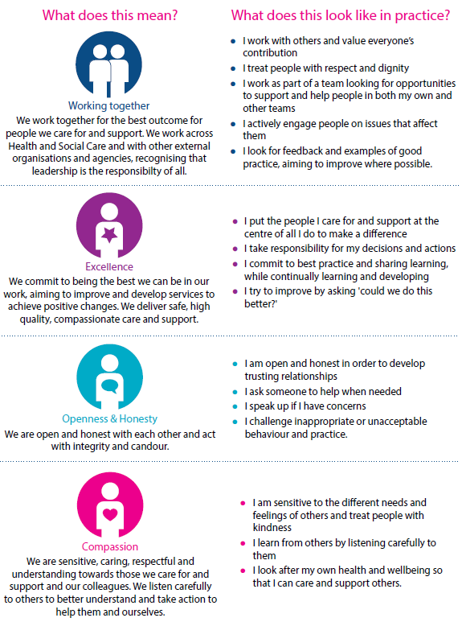Whilst employees will be expected to portray all the values, particular attention is drawn to the following values for this role