COVID-19 Vaccination Program – Volunteers’ Induction, agreement and confirmation

Thank you for stepping up to help in these extremely strange and challenging times. To ensure we all remain safe, compliant, and indemnified from an insurance and health & safety point of view, it is necessary to ask you to complete this induction process before making your application.
At the end of this short training document and information note you will be asked to certify that you have completed all the online reading below as required to take up this volunteering role and that you have read and will comply with the volunteer agreement, also in this document.

3 tasks to complete, all in this document:
- Read the Health and Safety briefs
- Read the volunteer agreement
- Click to confirm you have read, understood and agree.

Thank you again for volunteering. Every individual contribution matters

Health & Safety Knowledge.
Please read the 3 Health and Safety info-sheets below. There is no assessment.

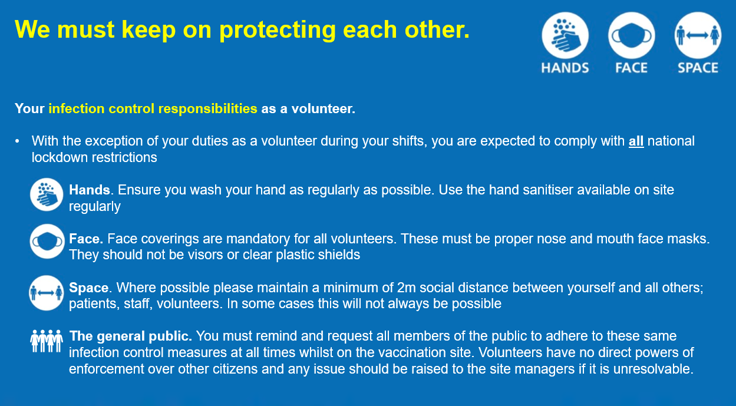

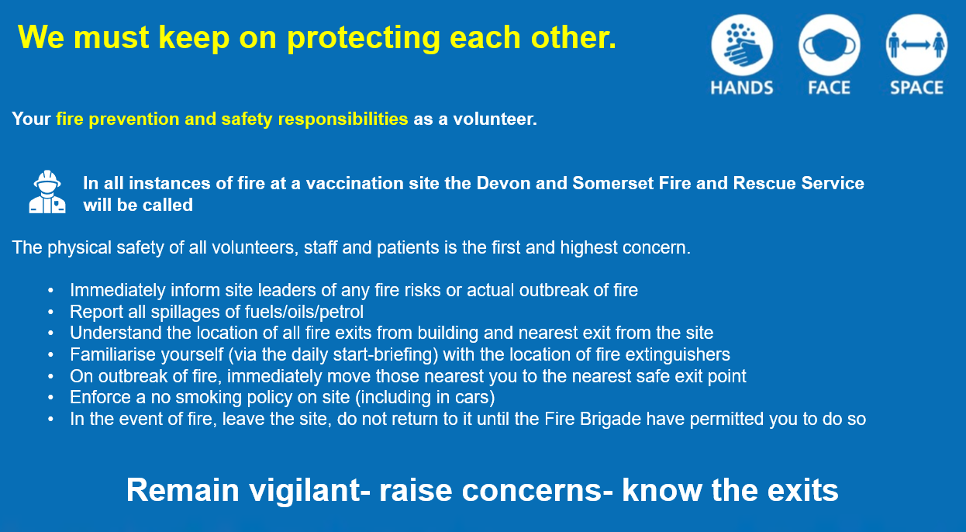

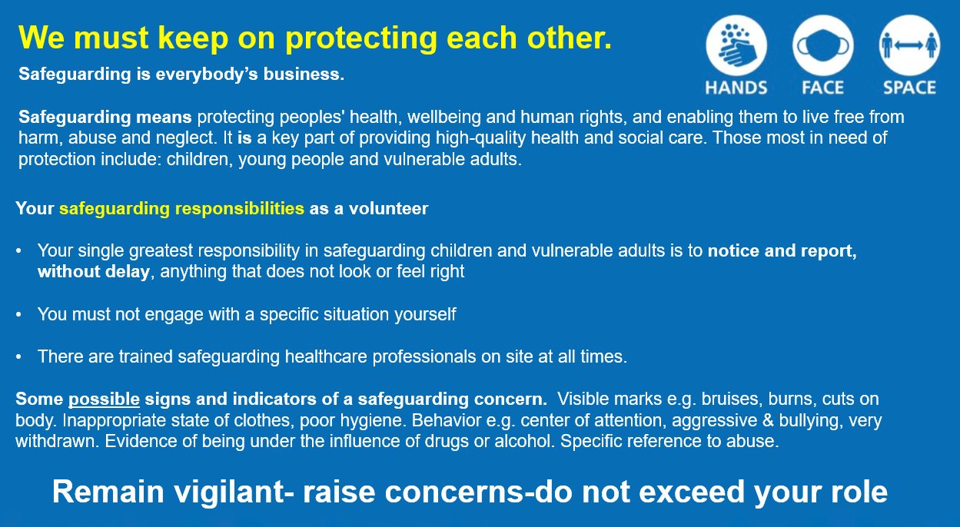

You are not expected to know this information by heart, there are operations managers running the sites and clinical leaders running the vaccinations. What is important is being aware of the key warning signs and more importantly, telling someone if you see something that does not look right.

Identity Check- on the day
Please be aware you will need to bring a form of photo ID with you as these will be checked at the beginning of each shift; A Passport or UK driving licence

Health Assessment – Self Certification Form
The purpose of this assessment is to ensure you are able to fulfil the various duties as a Volunteer Marshal. This self-certification protects everyone onsite; staff, volunteers, visitor and patients.
By clicking the confirmation at the end of this document, you are certifying that the 6 statements below are accurate in your personal case.
- I certify that I do not have any health conditions which may affect my ability to fulfil the duties expected of me as a Volunteer Marshall? (see note for detail)
- I certify that I do not have any health condition which may be affected by or made worse by the post offered? (see note for detail)
- I certify that I do not have any health condition or lifestyle issue which may put me or others at risk at work. (see note for detail)
- I certify that I am aged between 18-69? (older age groups are still deemed to be at greater risk from COVID-19)
- I certify that I do not require any adjustments, adaptions or support in order for me to be able to fulfil the duties of the post offered apart from general training and induction?
- I certify that I have not worked in, or returned from West Africa or from any country with Viral Haemorrhagic Fever in the last 21 days? e.g. Ebola
NB: Questions 1- 3 refer to any physical, psychological, mental or emotional health condition or lifestyle issue which may affect you or others and/or may be made worse by the post offered and/or which may require advice, adjustments, adaptions and/or support. Examples are:
A severe allergy, Problems with the skin on your hands or forearms, Neck, back and/or joint pain, Chronic fatigue syndrome, Diabetes, Epilepsy, Mental Health problems, Infectious disease, Alcohol and/or Drug misuse, any on-going/ long term condition / surgery for which you may require further treatment, Internal devices e.g. pacemakers, internal defibrillator, A contamination incident (blood, splash or bite) for which you are being treated or have been recently cleared.
Any of the above may not exclude you from volunteering although we will need to speak with you so we are able to assess what adjustments we may reasonably make to ensure your safety and that of your colleagues on site.

SCROLL DOWN FOR THE VOLUNTEER AGREEMENT AND CONFIRMATION

Volunteer Agreement for Covid-19 Vaccination Programme
Thank you for offering to provide your services as a volunteer marshall to assist with the national Covid-19 Vaccination Programme.
The Trust identified above is the Lead Provider locally supporting the national Covid-19 Vaccination Programme and covers the whole of Devon including the mass vaccination sites in Exeter and Plymouth. This letter sets out our expectations on you as a volunteer participating in the national Covid-19 Vaccination Programme.
- Volunteer role
Your duties as a volunteer marshall are set out in the volunteer role description provided to you by your voluntary body or online.
You will be notified of available volunteer shifts in advance, and where you have committed to undertaking a particular volunteer shift, it is important that you notify your voluntary body as soon as possible if, for any reason, you become unable to perform that shift.
You are expected to perform your role to the best of your ability and to follow the procedures and standards, including health and safety, infection prevention and control and equal opportunities in place with the Lead Provider, and any other procedures operated by the vaccination site to which you are deployed as are notified to you as part of your orientation with the vaccination site provider.
You will comply with our data protection policy and patient confidentiality policies and procedures as notified to you on your initial on-boarding with us as the Lead Provider. You acknowledge that as the Lead Provider we will process certain information about you, including information shared by your voluntary body.
- Induction and training
Location-specific orientation and induction will be provided for each local vaccination site you volunteer to support.
You will be asked to report to the shift team leader at the local vaccination site where you have volunteered, and any concerns should be raised with them in the first instance.
You will have completed the Health and Safety knowledge element by reading the information in this note on Infection Prevention, Fire Safety and Adult/Child Safeguarding and confirming by clicking the link below.
- Insurance
We, as the Lead Provider will provide adequate insurance cover for your activities as a volunteer marshall while you are undertaking voluntary work approved and authorised under the national volunteer scheme, providing that you are complying with any instructions given at the local vaccination site. This does not include personal accident cover.
- Confidentiality
You are expected to keep all information about the programme confidential, and not to discuss or disclose any aspect of your volunteering experience with any other person at any time.
In the course of undertaking voluntary work as part of the Covid-19 Vaccination Programme, you may have access to confidential information relating to us, as the Lead Provider, the vaccination provider delivering the vaccination site where you have been deployed, as well as information about staff and patients working or attending the vaccination site.
You are asked not to make any public statements or comments about your volunteering role, or the procedures and practices in place as part of the Covid-19 Vaccination Programme, given the sensitive nature of your role and the programme. You are not permitted to take photographs or video recordings during your volunteer shift.
These restrictions are to protect patients and ensure the smooth and efficient running of the sites, but are not designed to prevent you from disclosing confidential information where it is required by law.
- Status
This agreement is binding in honour only, is not intended to be a legally binding contract between us and may be cancelled at any time at the discretion of the Lead Provider, or any local vaccination provider with whom you are deployed. Neither of us intends any employment relationship to be created either now or at any time in the future.

By following this link to our application form I certify that I have completed all the online reading above as required to take up this volunteering role. Furthermore, I will declare anything applicable from the self-certification health assessment. I also accept I acknowledge that I agree to the conditions on which you are invited to participate as a volunteer with us as the Lead Provider and your agreement to comply with these principles.

