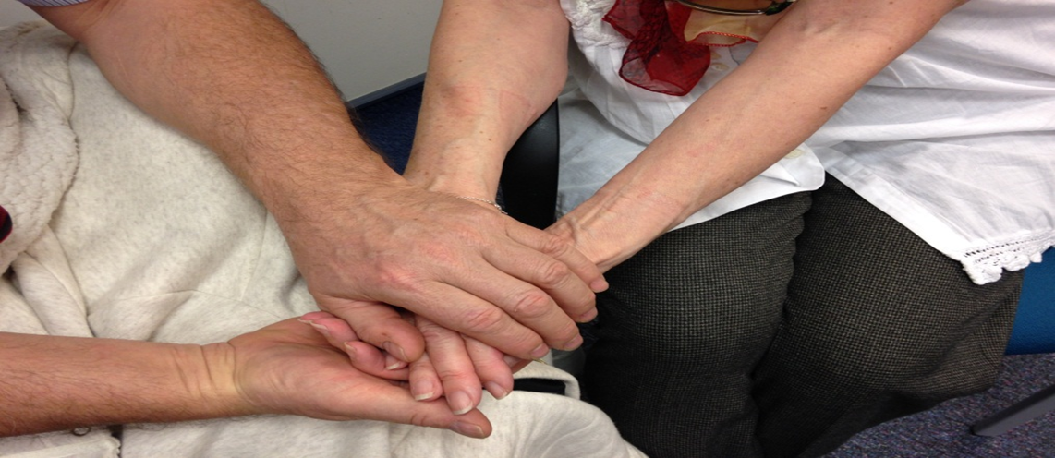


The Palliative Care Volunteer Training Programme

Palliative Care Volunteer Training Programme

Introduction
Welcome to the Palliative Care Volunteer Training Programme!

This programme has been designed specifically for people, like yourself who are interested in becoming a Palliative Care Volunteer at the Trust. The course will provide you with the opportunity to explore the important considerations when caring for a dying patient and their families and prepares you for your role as a Palliative Care Volunteer.
The programme is a two way process; helping you to decide whether you wish to progress and become a volunteer and providing us the opportunity to get to know you and assess your suitability for this specific role.
This course uses different methods to facilitate learning:
• Three Study sessions delivered by experienced facilitators from the Academic Palliative and End of Life Care Centre.
• Completion of a designated workbook between the study sessions to consolidate your learning.
The workbook will take you through a number of learning activities and allow you to record your thoughts and feelings. The workbook is an integral part of the course and as such you will be guided to complete different sections and exercises before you attend the next session. The relevant sections to be completed will be illustrated with the following icon in the Training programme

• Completion of a reflective journal providing the opportunity to reflect on your learning and to explore the feelings evoked by the programme content.

Before attending the session Please ensure that you have read and completed Sections 1 & 2 in your workbook.
Day One
Thursday 13.06.19
Seminar 2 Education Department
Royal Liverpool Hospital
Learning Outcomes:
By the end of today’s session you:
- Will have an awareness of how the programme will run and what you will need to do to complete the course.
- Will understand the group boundaries which will be agreed to keep this a safe place for you to learn and participate
- Will learn about reflection and the importance of reflection in this role
- Have an opportunity to explore your personal experiences of death and dying and begin to explore the influence and impact they have had on your motivations to volunteer
- Will meet some our Palliative care volunteers and hear about their experiences
Programme:
13:30 Coffee and introductions
13.45 Overview of the Training Programme
13:50 Hopes and Fears
14:05 Ground rules for the group
14:15 Introduction to Reflection
14:30 Personal experiences of death and dying
15:00 Group feedback
15:20 Coffee
15:30 Outline of the Palliative Care Volunteer Role
15:45 Summary of learning
15:50 Workbook preparation for next session
16:00 Close
Before attending the next session please ensure that you have completed section 3 & 4 in your workbook
Day Two
Friday 21.06.18 Ward 2017, Education Centre, Royal Liverpool Hospital
Learning Outcomes:
By the end of today’s session you:
- Will have an understanding of loss and the diverse ways that people respond to loss
- Will be able to understand a personal definition of spirituality and develop strategies of how to respond to signs of spiritual distress and questioning.
- Will be aware of the importance of presence and how to communicate presence to dying patients
- Will be able to reflect on your own styles of coping and how you might cope with the emotional content of the Volunteering role.
Programme:
09:30 Welcome
09:35 Reflections on session one and reflection on workbook exercise
10:00 Exploring the impact of loss- “Little losses” exercise
10:15 Responding to spiritual issues in context of your role as a Volunteer
10:45 Coffee
11:00 communicating presence- Hand holding exercise
11.20 How do we cope? - An exploration of coping strategies
11:35 Summary of learning

12:00 Workbook preparation for next session
Before attending the next session please ensure that you have completed section 5 in your workbook
12:15 Close
Day Three
Thursday 27.06.18
Seminar 3 Education Department
Royal Liverpool Hospital

Learning Outcomes:
By the end of today’s session you:
- Will learn about some of the practical aspects of the Volunteer role and volunteering in the Trust
- Will develop an understanding of how to respond to difficult questions that patients/families may ask you.
- Will understand what will happen next in the process of your application to become a Palliative Care Volunteer

Programme:
13:30 Welcome
13:35 Reflections on session two and workbook exercise
13:45 Practical Aspects of the CODV Role- Entering and leaving a dying patient’s room
14:15 Challenging scenarios
15:00 Coffee
15:15 Role Boundaries
15:30 Meeting Palliative Care Volunteers

16:00 Next Steps
16:15 Complete Training Evaluations
16:30 Presentation of Attendance Certificates
17:00 Close

