Kingston Hospital Volunteering Strategy 2020 – 2023
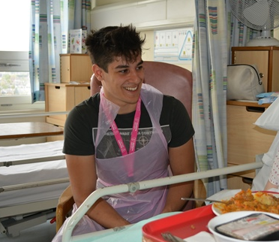
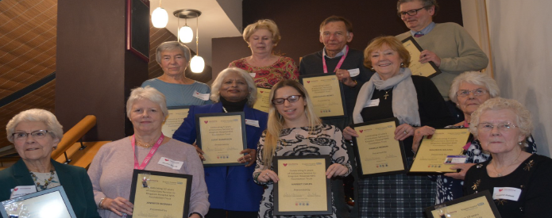
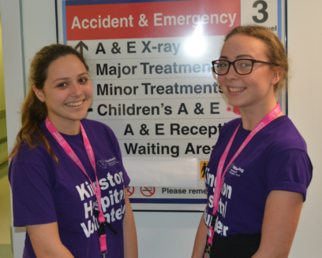
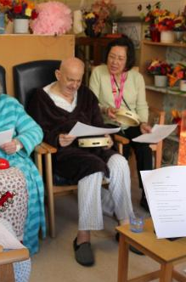
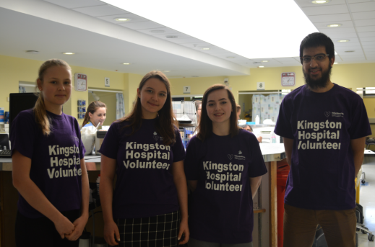
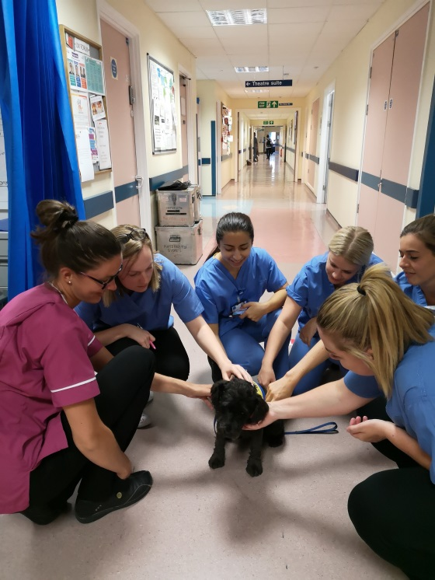

“You’re an angel. I’m so grateful. I’m not sure what I would have done without you.” Patient to a Discharge Support Volunteer, 2020.
“I love you all, I love the team, we don’t use you enough.” Lead Discharge Coordinator.
“one of the most rewarding and memorable experiences for this past year – I will never forget this.” Gemma, Dining Companion 2020
- Introduction
Volunteering at Kingston Hospital is all about enhancing the care that we provide. Every day volunteering provides us with amazing stories of kindness and commitment that change patients’ lives for the better.
In March 2020, Volunteering as we knew it was stepped down as a safety measure for volunteers, our staff and patients during the Coronavirus Pandemic. This has resulted in a radical re-think about how volunteering can function at the Trust. The sector for volunteering in health has changed dramatically, with new schemes such as the NHS Responders making it simple and convenient to volunteer meaningfully in communities. As the world has shifted to connecting online, so too must our volunteering offer.
Some things have not changed. At Kingston Hospital, Volunteering is about high impact. Volunteering is a fundamental part of the Trust’s improvement culture. As such, there is also huge scope for creativity and innovation with volunteering entering a virtual world where timeliness and convenience is everything.
With over 330 volunteers (and a further 300 in the recruitment pipeline at this time) the Trust is in a unique position to mobilise this force for good.
Beyond the numbers of volunteers, this Strategy will increase the impact that volunteering can have on patients, staff, volunteers and the Trust overall. The futuristic model for volunteering that has been necessitated by Covid-19 will increase the accessibility of volunteering to a wide range of people, ensuring that people who want to give their time can do so without discrimination. It will also introduce levels of engagement to ensure that within our volunteering offer, there genuinely is something for everyone who wants to give of their time, on and offline. It will also increase the satisfaction of our volunteers across a hospital culture that is welcoming and inclusive of them.
- A vision for volunteering 2020 - 2023
A KHFT Volunteering culture and community that improves health and wellbeing for patients, staff, carers, visitors, volunteers and communities and enhances the way we deliver outstanding health care.
- The aims of the Volunteering Strategy 2020 - 2023
The aims of our strategy are:
  - To align Volunteering with Trust priorities for patient care and respond to these as they change.

  - To enable all staff to recognise and value the opportunities that working in partnership with Volunteers can bring and the impact this can have.

  - To ensure that volunteers’ experience is rewarding and that volunteering enriches the lives and opportunities of the individuals and communities, groups and partner organisations who volunteer.

  - To deliver a safe, accessible and inclusive experience of volunteering both on and off-line that enhances volunteer wellbeing and that of our patients.

  - To deliver a high quality Volunteering programme that draws on evolving national best practice and develops our reputation as national leaders of hospital volunteering and volunteering solutions across our role in integrated care.

- Strategic Objectives of the Volunteering Strategy 2020 – 2023

  - Respond to Trust Priorities: We will look at the Quality Priorities and Strategic Objectives for Kingston Hospital and devise volunteering roles and programmes that respond to these.

  - Staff recognise the value of volunteers and impact they can have: We will develop the skills and capability of staff to value and support volunteers. This will include training of staff and mentoring from the Volunteering Team.

  - Maintain a thriving volunteer function: We will ensure that volunteering is championed at all levels of the organisation, enabling a well-resourced and effective Volunteering Team which ensures that volunteers are well trained and supported and perform roles and services in areas that are proven to impact on patients’ experience.

  - Increase accessibility of volunteering: We will enable young people and people from diverse backgrounds to volunteer and to recognise volunteers as the potential future NHS workforce. We will ensure that through the evolution of virtual volunteering, those without access or confidence to use IT are supported to participate, either through direct support or identifying alternative ways to utilise their time.

  - Quality and reputation: We will continually evaluate and learn from the performance of the volunteering programme.

- What volunteers will be involved in

As and when Infection Control measures allow, we will involve volunteers to deliver the results we know that volunteering can provide for patient experience. Where traditional hospital-based volunteering cannot take place, we will always look for a virtual solution – via digital platforms, telephone and simple pen and paper.

  - Enhancing our administrative systems in order to improve how we communicate with patients and the efficiency of services. Responsive to requests from staff, volunteers will continue to be placed in meaningful administrative support roles.

  - Drawing on the skills of volunteers in our holistic approach to the delivery of dementia care. We will widen patient participation in ‘Active Days and Calm Nights’ and promote the use of music therapeutically with skilled volunteer musicians and confident Dementia Volunteers both on and offline. Volunteers will recognise and support the needs of carers within a dedicated new service.

  - Enhance supported mealtimes through volunteers. We will double the number of Dining Companions as well as expand the number of corporate (staff) Dining Companions to include a micro-volunteering ask of just 15 minutes once per fortnight to support wards at the beginning of the meal service.

  - Collaborating with clinical teams to enhance the care we provide. The spectrum of roles that support planned and unplanned care will continue to grow. We will welcome partnership opportunities, such as the Macmillan Cancer Support Service delivered through volunteers at first on wards and now, remotely. Volunteering roles such as ‘Gentle Movement’ will translate online with volunteers coaching patients to exercise via digital platforms e.g. A Touch Away. The Discharge Support Service will continue to optimise telephone support, increasing the connectedness of patients discharged home to the support and services available in their local community and voluntary sector.

  - Cancer Services. Volunteers will continue their good work in Cancer Services. If and when possible, volunteers will lead the provision of Complementary Therapies under the management and governance of the Macmillan Cancer Information & Support Centre. Volunteering will also remain a flag-ship part of the welcome we make to visitors to the Sir William Rous Unit, optimising video and other digital content to remain present for patients, even during the foot-fall restrictions of Covid-19.

  - Wayfinding. As and when it is possible to return, we will increase the number of Volunteers Welcoming at the Trust, stationing them in Outpatients, Main Entrance, REU, Physiotherapy, Day Surgery and as an integral part of the Emergency Department role. In the meantime, we will utilise video and other online content to begin the volunteering welcome for visitors of the hospital website and screens in hospital waiting areas.

  - Fostering human connections in spiritual and emotional crisis – with over 30 volunteers reflecting all faiths and those of humanistic faith, volunteers are integral to the way the Chaplaincy offers spiritual and pastoral care across the Hospital. Whilst there are no chaplaincy volunteers active at present through Covid-19, we will scope and develop new ways for volunteers to connect with patients. An established cohort of Pets as Therapy Volunteers, both on and offline as feasible, will continue to bring delight and joy across the full range of services.

  - Patient and carer voice as a powerful agent for change and improvement. We will proactively support volunteers to get involved in the spectrum of Patient & Public Involvement. They will support the PPI Strategy by enabling people to complete the Friends & Family Test (FFT) as a common aspect of Volunteering roles both on and offline.

- What’s new 2020 – 2023
6.1 Bereavement Support - We will partner with Spiritual & Pastoral Care and the Bereavement Service to scope the role of volunteers to provide virtual outreach and community based support to families after bereavement.
6.2 Carers’ Support - In addition to harnessing both technology and creative initiative to deliver therapeutic activities virtually, we will scope the role of volunteers to support carers’ of people affected by dementia through a Carers’ Discharge Support model.
6.3 Community based volunteering - We will extend the Discharge Support Service to patients accessing the Emergency Department and extend care into the patients’ home to include a home settling in service alongside the virtual offer of telephone based support, connecting patients with services and support in their communities through a social prescribing model.
6.4 End of Life Care - In line with ‘recognition of dying’ quality priority, volunteers will guide patients nearing end of life through the development of Advance Care Plans (ACP); in partnership with experts in the field including Princess Alice Hospice and Marie Curie, skilled volunteers will sit alongside patients during the final days and hours of life where this is feasible so that “no one dies alone” at Kingston Hospital.
6.5 Handholding – In the event that volunteering on-site is restored with the approval of Infection Control, with 100% patients reporting that ‘hand holding’ reduced their anxiety about Phacoemulsification in REU Theatres, this role will be explored for other surgical or invasive procedures.
6.6 Peer-to-Peer - With strong evidence in support of ‘Peer to Peer’ Breast Feeding Support, we will develop an in-house service optimising first digital, and if appropriate face to face methods, and scope the provision of complementary therapies for women in pregnancy and in the hours and days post-delivery.
- How we will deliver the volunteering programme

  - Recruitment – We can anticipate a minimum of 300 new volunteers per year, bringing the anticipated total to approximately 900 by 2023. With youth volunteering high on the national agenda and accessibility paramount to a diverse and inclusive volunteer community, we will provide bespoke volunteering packages e.g. Summer placements for young people, and schemes with custom support in place to embrace people with additional needs or social disadvantage into volunteering.

  - Reward & retention – we continue to celebrate our volunteers with a minimum of two awards events, virtual or otherwise, per year. We will introduce a bi-annual Volunteering Conference where social distancing allows, or alternative such as a series of webinars to showcase the impact that volunteers make. It will form one way in which we consult volunteers so that their voice is a powerful change agent for quality improvement in both volunteering, and Trust services.

With effective staff engagement, volunteers will be expected, welcomed into teams, creatively thanked and their views actively sought and followed-up.

  - Learning and development – we will explore e-learning from trusted and accredited providers including HelpForce Learning Partners Open University and e-learning for healthcare (Health Education England). Volunteer training will be modular and accessible with volunteers able to move seamlessly between roles by accruing a training ‘passport’ into multiple-held roles. We will collaborate with the SW London Recruitment Hub to explore and implement pathways into employment in accordance with the local NHS People Plan action plan.

  - Support and supervision - Buddying and mentorship will be a core feature of volunteer learning and development with experienced volunteers sharing expertise and building confidence with new volunteers across all roles. Peer Support Volunteers will provide consistent virtual outreach support to volunteers. Professional and clinical supervision will be provided for roles that require this, including the Chaplaincy Volunteers and volunteers involved in End of Life with methods such as MS Teams adopted to keep footfall to the Hospital low.

  - Staff engagement – There is a relational need to nurture greater trust between staff and volunteers. Each volunteering service will have a named clinical lead who will define the volunteering activity within a Service Level Agreement and cascade to staff teams. An online Volunteering Leadership & Management Masterclass and mentorship package is available and will be rolled out across the staff cohort. We will optimise hospital communications, National Volunteering Week, HelpForce Champions, Volunteering and staff awards, Trust Induction and themed events such NHS Change Day (October) to promote volunteering across the Trust and ensure that volunteer management is an accessible and highly regarded skills-set amongst staff.

  - Evaluation – A Theory of Change sets out the outcomes and impact of volunteering at the Trust. This will be evidenced through case studies and step changes in emotional support, ability to cope at home post hospital discharge and patient satisfaction at mealtimes. Success will also be measured through a cultural shift in which staff report feeling well supported to work alongside volunteers, and volunteers feel included in teams and services. Volunteering will be integrated into clinical settings and volunteers visible at multi-disciplinary events such as Schwartz Rounds and other virtual support platforms. Volunteering will enhance life opportunities with volunteers gaining study opportunities and employment.

  - Community partnerships – mirroring integrated healthcare systems, we will support Community Partnerships with local and national charities and community organisations to reach patients with their own services earlier in their patient journey. A strategic delivery group will be established, drawing on the expertise and networks of universities, voluntary sector and other community partners to create an open-door to partnership working through volunteering.

  - Volunteers’ voice – volunteers are a phenomenal source of insight and inspiration for the quality improvement of health services in big ways and small. We will ensure the volunteers’ voice is integrated across the range of ways that patients and the public can give us feedback. With all volunteers as Trust members from August 2020, volunteering is a pipeline for Governor recruitment. By strengthening volunteer reward and retention we will increase the number of forums available for volunteers to tell their stories as agents for change and the mechanisms by which the Trust is listening and responding.

- Volunteer governance and leadership
8.1 Representation and Champions - There will be a named Non-Executive Director and named Governor with responsibility for volunteering within their portfolio. They will provide leadership, guidance and support to the Volunteering Team and network of staff champions across the Trust who manage volunteers and are instigating the cultural shift towards a workforce that is inclusive of and responsive to volunteers.
8.2 Executive Management Committee – EMC works collectively at the highest levels of leadership within the Trust to oversee and co-ordinate effective operational management so that strategic objectives and priorities are delivered and statutory duties are achieved in accordance with the Trust’s overall vision and values. To provide leadership of innovation and improvement in safe and effective quality of care provided for patients, and to ensure that strong governance, risk management and compliance arrangements are in place and provide sufficient assurance to the Board.
8.3 Patient Experience Committee – The PEC is a formal committee reporting to the Quality Assurance Committee. Its role is to provide strategic leadership volunteering and have oversight of the range of volunteering activity across the Trust with a view to strengthening it. There are no specific volunteer representatives on PEC and this will be addressed.
8.4 Head of Volunteering – The Head of Volunteering is responsible for promoting the volunteering strategy and its culture of volunteering across the hospital and supporting staff to work alongside volunteers in the delivery of outstanding care. He or she provides leadership to the Volunteering Service Team and their portfolio of programmes and services, develop innovation in volunteering and ensure that the existing and prospective communities of volunteers are nurtured and supported.
8.5 Volunteering Service Team – The Volunteering Service Team is a high performing team with exceptionally high levels of Belbin ‘Company Worker’, and notable strengths in ‘Completer Finisher’ and ‘Team Worker’. Our Team Charter describes a driven team, passionate about volunteering who will maintain business as usual and operationally track performance. As the volunteer cohort grows exponentially, further resource for the Volunteering Service Team will be explored.
9. How we will track our progress
9.1 Better Impact – A brand new database for 2020 with the capabilities to track the time that volunteers give to the hospital as well as communicate effectively with volunteers.
9.2 Formal reporting on progress at the PEC – We will set out our priorities, the progress we have made, the challenges faced and how we plan to overcome these in quarterly reports to the PEC and annual reports to the Executive Management Committee and onwards to the Board.
9.3 Indicators of success – case studies will be collected quarterly to demonstrate the impact of volunteering on:
- Better patient experiences of mealtimes – Dining Companions’ volunteering improves patient experiences of mealtimes
- Increased access to emotional support – evidence from across volunteering roles how volunteers can bring kindness, support and make a substantial difference to the way we support the emotional ramifications of a hospital admission or visit.
- Personal development of volunteers – volunteers going on to gain study opportunities and employment as the future NHS workforce.
We will proactively monitor the following:
- Reduced anxiety about going home from hospital – the Volunteer Discharge Support Service will monitor the change in patients’ reported anxiety about how they will cope at home at the point of discharge, and the change six weeks later.
- Increased overall patient experience – the Friends & Family Test will monitor the correlation in overall patient experience between those hospital in-patients who had access to a volunteer during their hospital stay, compared with those who do not.
- Increased % (<85%) volunteers who feel they have made a difference to patient experience
- The overall diversity of the volunteer community will be measured, maintained and improved.
- We will be proactive in overseeing offers of support and involvement to people over the age of 70 to ensure that this demographic is not isolated out of volunteering through a shift towards online engagement.

- Conclusion
Volunteering is already a much valued part of Trust culture however this strategy demonstrates that there is still scope for ambition and further impact. Whilst the national drivers such as the NHS Long Term Plan set the national pace and resource for hospital based volunteering, we do it also because we have the evidence that volunteering makes a difference, as well as the firm belief that involving volunteers is the right thing to do.
The Volunteering Strategy presents a vision and plan for an inclusive culture of volunteering whereby volunteers are integrated into clinical teams and we are clear about what volunteering is, where it can enhance care, as well as where the boundaries lie.
To succeed, we need to create a Trust-wide culture of volunteering whereby clinical and volunteering staff work in partnership to harness the time and talents of volunteers. This work has already begun, with pockets of excellence with volunteers participating in team ‘huddles’ as well as providing detailed feedback to clinicians following online interventions. This is welcomed by staff at all levels and meaningful in the management of patient care. Volunteering, when managed well can enhance team morale and through the course of this strategy, this potential for the wellbeing of patients, staff and volunteers themselves will be realised.
Whilst Volunteering is time given freely, it is not a free resource and the work of the Volunteering Team is mission-critical to the success of the Strategy. This strategy will seek out the resource and champions at all levels of the Trust to ensure that Volunteering remains high on the Trust agenda and is universally valued and supported.

Appendix 1: Theory of Change – Volunteering Strategy 2020 - 2023

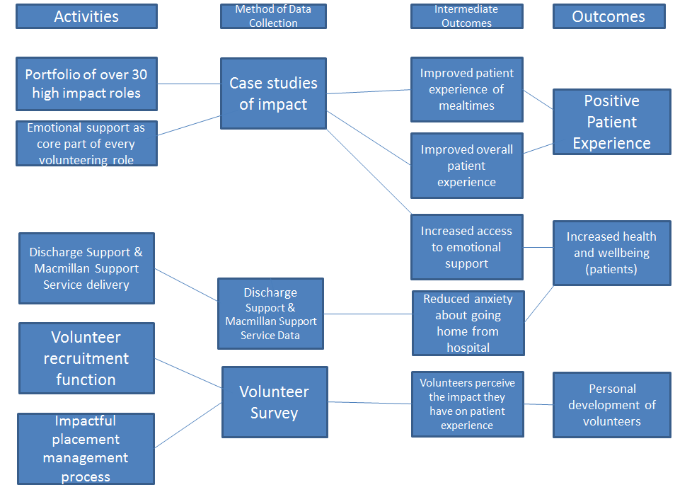

Appendix 2: A Volunteering Team Charter 2020
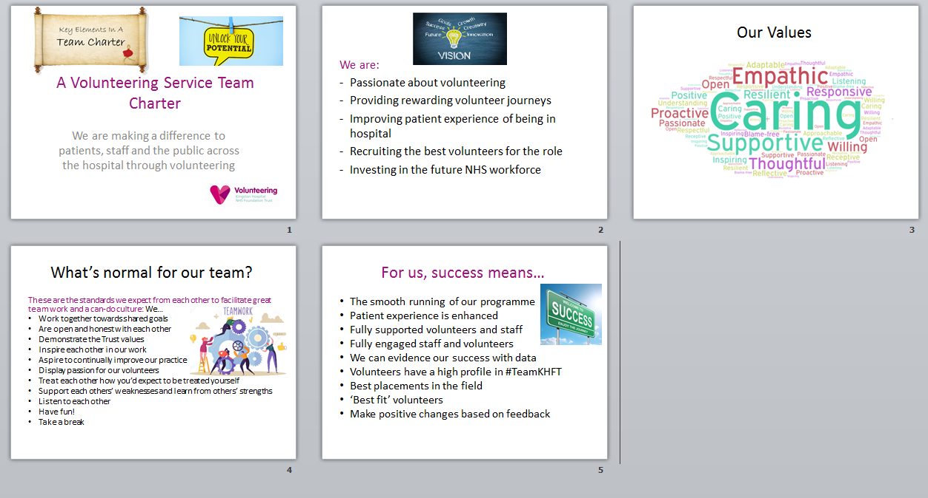

Theory Of Change, Volunteering 2020 – 2023 Appendix 1
Volunteering Team Charter 2020 – Appendix 2

