**VOLUNTEERING**

Welcome Back!



**Important information for returning volunteers**

Dear Volunteer

Welcome back to Derriford! It’s been quite a while since you were last here as a volunteer and we’ve missed you!

First of all, we would like to thank you for your patience and loyalty while we’ve worked through the challenges which have arisen as a result of the Covid-19 pandemic, which saw almost all our volunteer services ‘paused’ for several months.

As we begin to reintroduce volunteers we do so cautiously, mindful the pandemic is not yet over. For this reason, a number of our volunteer roles involving close and/or regular patient contact are unavailable for the time being, but we have worked alongside staff to develop new, meaningful volunteer roles and we’re delighted you’ve agreed to carry out one of these.

**Before you return**

Before returning to volunteer, you must read and complete the following:

1. **Read and sign the Supplementary Agreement,** recognising the changes which have taken place within the hospital since you last volunteered.
2. **Completed a covid-age risk assessment**
3. **Received a role description**, including a covid-rating, for the voluntary work you are now carrying out

The completed Supplementary Agreement and covid-age risk assessment, which you will have received when you offered to help in your new role, must be returned to your Volunteer Co-ordinator before you re-join. This will ensure our records are up-to-date. You are welcome to keep a copy (either electronically or paper) for yourself.

**How we have changed volunteering to help keep you safe**

To offer you assurance the role you’re now undertaking is as safe as possible, we have taken the following steps:

1. 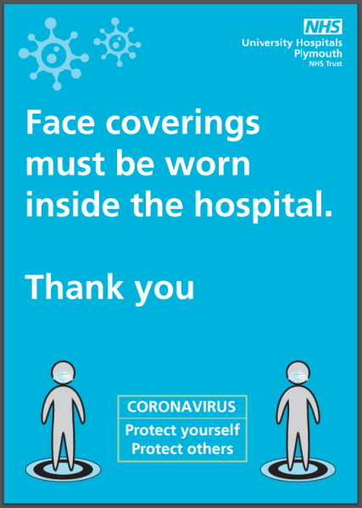**Revised our volunteer roles**, drawn up new role descriptions and risk rated them either Red, Amber or Green in respect of covid-19.

Red means this role is not yet considered appropriate or safe for volunteers to undertake eg. on a ward where a volunteer would be likely to visit different patients and/or carry out tasks which would involve close or sustained contact, such as shopping or helping with meals.

Amber means the role is not without some risk, but mitigation such as the use of personal protective equipment (ppe), hand sanitising and distancing may enable participation by volunteers in a low or medium-low risk category according to their covid-age assessment.

Green means the role is generally considered lower-risk and is likely to be appropriate for the majority of volunteers to undertake, depending on the outcome of their covid-age assessment and personal preference.

1. **Asked you to undertake a covid-age assessment**. The result of your covid-age assessment (your ‘covid age’) has placed you in the Red, Amber/Yellow or Green banding and this has helped us to offer you a suitable volunteer role.
2. **Ensured you have a named contact**, and contact details for your volunteer role. This person, or one of their colleagues, will give you a local induction to your new/revised role and arrange for any specific training you need.
3. **Arranged for you to have the necessary personal protective equipment** for your role which will be the same as a member of staff undertaking an equivalent role.

**How things have changed in the hospital**

You may not have visited Derriford for several months so you’ll no doubt see a number of changes. Some of these are easy to spot, such as signs and notices; others will require you to behave differently.

Here are some of the changes which you’ll need to be aware of:

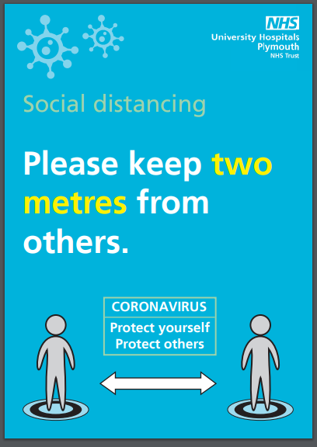

**Distancing**

Following government guidelines we ask everyone coming in to the hospital to maintain a 2m distance whenever possible. When this isn’t possible, you must remain at least 1m apart **and** wear your face covering.

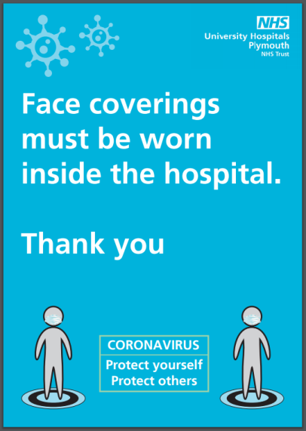**Face Coverings**

Unless there are specific reasons why you are unable to wear a face covering, these are compulsory within the hospital building, including retail/food outlets (unless eating). If you volunteer in an office or department which has been passed as ‘covid-secure’ and you are part of that team, you may be able to remove your face covering while you are in this area, but please check first with your volunteer supervisor.

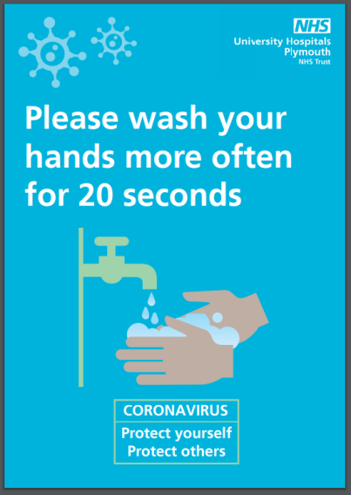**Handwashing**

Hand sanitising stations are available to use at all main entrances and hand sanitiser and wipes are provided throughout the hospital. Thorough hand washing with soap and water on a regular basis is also recommended.

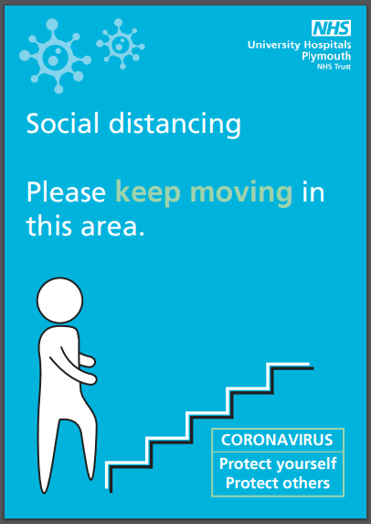

**Using the Lifts and Stairs**

For the time being our lifts can accommodate a maximum of 4 people, standing on the signs on the floor of the lift, to ensure sufficient space between occupants. If you can use the stairs this will often be quicker.

When taking the stairs, please try to keep to the left and avoid stopping to chat with anyone en route. Please also avoid stopping in the space between floors if you can.

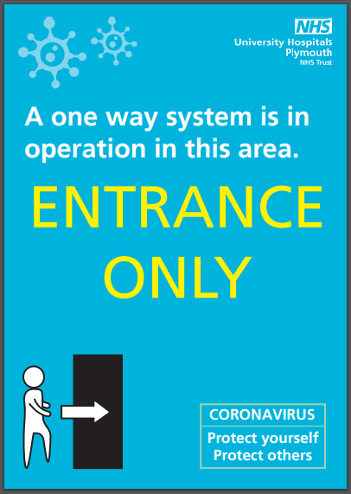

**One Way Systems**

Some areas may now operate a one-way system for entering and leaving. Please be aware of this, especially if you have been used to a particular ward or department pre-covid.

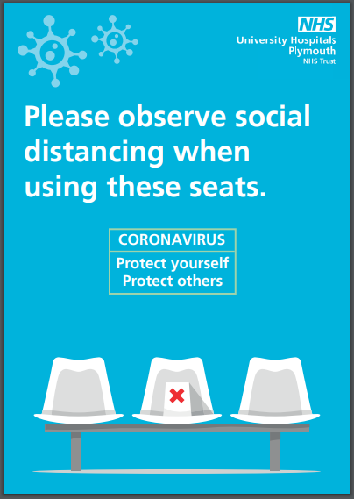

**Seating in Corridors**

You may notice some of the seat pads, or seats themselves, have been removed. This is deliberate (they haven’t been vandalised!) to ensure an appropriate distance can be maintained.

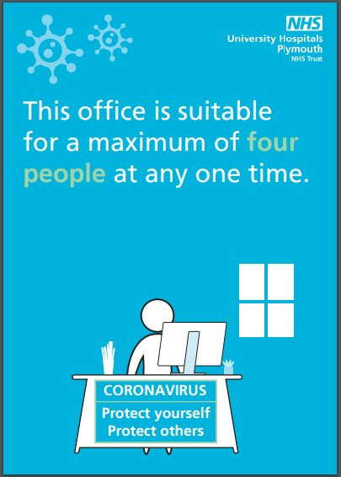

**Going into Offices**

Unless you are part of the ‘team’ in a particular office (see ‘Face Coverings’ above), you must wear your face covering in all office areas and maintain an appropriate social distance. Many offices display posters stating how many people should occupy the space at any one time. Please be aware of this, and wait outside if asked to do so.

**Toilet Facilities**

Toilets and shower rooms continue to be cleaned on a regular basis throughout the day. One difference you may encounter is the reintroduction of paper towels to dry your hands, instead of using the air dryer.

**Visitors**

Most ward visiting remains suspended with the exception of visiting for patients at the end of life and for parents and carers in women’s and children’s areas. There are also some special circumstances in which visitors can attend at the discretion of the ward manager. You’ll therefore see fewer visitors in the hospital at this time.

**Accessing Wards**

It is unlikely you will be able to access wards, unless your volunteer role is one which you will be carrying out in a ward environment in which case you will have been given instructions how to do this.

**Support Available For You**

The last few months have been difficult for everyone and we want to support you as best we can during this time. If you have any questions or concerns please don’t hesitate to speak to your volunteer supervisor or one of the Voluntary Services Team.

**UHP Support Hub**

Our Human Resources Team has created a virtual Support Hub, drawing together a range of resources and materials to help staff and volunteers during the coronavirus pandemic. The Hub is designed to help you find information quickly to support your health and wellbeing. There are four areas within the Support Hub which each contain more information and further links to advice and guidance on the different Psychological, Practical, Physical and Professional support available to you.

Some of the resources, such as the centralised absence reporting line, are only applicable to staff, but as a volunteer, you are welcome to use the Hub and the information it provides. Here is a link to access the Hub: <https://www.plymouthhospitals.nhs.uk/covid19-support>

**Flu Vaccine**

We’re pleased to offer a flu vaccine to all our volunteers. If you don’t qualify for a free vaccine via your GP, you’re invited to attend a Flu Vaccination session organised by our Occupational Health Team. Please ask your volunteer supervisor or one of the Voluntary Services Team for details of dates and venues. When you attend please take your volunteer identity badge with you.

**Government Guidelines**

If you would like to be reminded about what the latest government guidelines/regulations are with regard to coronavirus and social interaction, you can do so here:

<https://www.gov.uk/government/publications/coronavirus-outbreak-faqs-what-you-can-and-cant-do/coronavirus-outbreak-faqs-what-you-can-and-cant-do>

**General Information about Coronavirus**

**Symptoms**

The main symptoms of coronavirus are:

* high temperature – this means you feel hot to touch on your chest or back (you do not need to take your temperature)
* new, continuous cough – this means coughing a lot for more than an hour, or 3 or more coughing episodes in 24 hours (if you usually have a cough, it may be worse than usual)
* loss or change to your sense of smell or taste – this means you've noticed you cannot smell or taste anything, or things smell or taste different to normal

Most people with coronavirus have at least one of these symptoms.

**What to do if you have symptoms**

Do not volunteer but please ensure you let your volunteer supervisor know.

NHS 111 has an online coronavirus service which will advise you if you need medical help and let you know what to do.

Do not go to a GP surgery, pharmacy or hospital. Call 111 if you need to speak to someone.

Get a test. Anyone with coronavirus symptoms can get a test. You can find out more by following this link: <https://www.gov.uk/get-coronavirus-test>

Like the common cold, coronavirus infection usually occurs through close contact with a person with novel coronavirus via cough and sneezes or hand contact. A person can also catch the virus by touching contaminated surfaces if they do not wash their hands.

You can learn more about COVID-19 here: [www.nhs.uk/conditions/coronavirus-covid-19/](http://www.nhs.uk/conditions/coronavirus-covid-19/)