

**Palliative Care Volunteer Training Programme**

**Workbook**

Section 1: General Information 3

Section 2: A ‘Good Death’ 5

Is there ever such a thing as a 'good death'? 7

Section 3: communication 11

Section 4: SPRITUALITY 18

Section 5: summary 22

# Section 1: General Information

Welcome to the Palliative Care Volunteer Training Programme

**Introduction to the Course**

Patients who are in the last hours or days of their life, their relatives and carers need care and support from skilled healthcare staff. At this difficult time, they need to have their needs and wishes considered and to be treated with dignity and respect (LACDP, 2015 Francis, 2013; Neuberger, 2013). In order to provide the best care for dying patients, healthcare staff need both technical knowledge and clinical skill in assessing and adapting care to the rapidly changing needs of both the patient and their family. Crucially, they also need excellent communication skills to support patients and families with care and compassion as well as preventing unnecessary misunderstandings.

Patients who are dying will come into contact with a wide range of health care professionals and volunteers therefore nearly all staff and volunteers need training appropriate to their role.

This course aims to provide such training for volunteers who are supporting dying patients and their families. It will help them to improve their skills and competencies in this important area of care.

**What does the course involve?**

This course uses different methods to facilitate learning:

* Three Study sessions delivered by experienced facilitators from the Academic Palliative and End of Life Care Centre.
* Completion of a designated workbook between the study sessions to consolidate your learning.

The workbook will take you through a number of learning activities and allow you to record your thoughts and feelings. The workbook is an integral part of the course and as such you should complete it before you attend the next session.

* The completion of a reflective journal providing the opportunity to reflect on your learning and to explore the feelings evoked by the programme content.



**What do you want to get out of the course?**

**In the space below, tell us what you would like to gain from doing this course.**

Click here to enter text.

# Section 2: A ‘Good Death’

There are many, many factors that contribute to a death being perceived as the best that it could be or a terrible experience. However, it is recognised that a good death is often achieved if the best care is given. International and national evidence identifies 10 key elements of care that are necessary for achieving the best care possible. These are:

* Recognition that the patient is dying- this may be a complex decision and it is made by the multi-disciplinary team who are caring for the patient.
* Good communication with the patient (where possible) and always with family and loved ones

Spiritual care

* Anticipatory prescribing for symptoms- this means that the medications that may be needed to treat common symptoms such as pain or breathlessness can be provided without delay.
* Review of clinical interventions in the patient’s best interests – this means looking at all the treatments and medications that a person is having and deciding which are important to keep the patient comfortable. It may be decided that some are no longer necessary and may cause added discomfort at this time.
* Review of the person’s hydration status, this means that the medical team will decide whether the team need to start or stop clinically assisted hydration (fluids given in a drip)
* Review of nutritional status, this means that the medical team will decide whether to start or stop clinically assisted nutrition.

Full discussion of the care plan with the patient and relative or carer

* Regular reassessment of the patient to ensure that they are comfortable and not in any distress
* Dignified and respectful care after death

We would like you to think about and describe in the space below what a good death is from your point of view. You may wish to draw on your personal experiences of caring for a dying person as well as your own views and beliefs.

Click here to enter text.

After you have written down your thoughts, read the article below that was published on the Telegraph online in June 2014. This article was written by Ann Munro who has been a palliative care psychotherapist for 30 years and also works as a clinical ethicist, dealing with ethical dilemmas at the end of life. She was involved in Channel 4’s series, [My Last Summer,](http://www.channel4.com/programmes/my-last-summer) which was broadcast in June 2014



# Is there ever such a thing as a 'good death'?

By Ann Munro, Palliative care psychotherapist

Posted 8:00am BST 04 Jun 2014

Is there such a thing as a 'good death'? Certainly, there are situations at the end of life where things are calm and gentle and symptom-free, and where those involved understand exactly what is happening.

But the popular conception of a good death, as so often depicted onscreen, where families exchange meaningful sentiments and sunlight bathes the room, is unrealistic. So is death without sadness. We can hope for the absence of pain, of throwing up, of shouting and confusion, and of fear. But there will be no absence of sadness. Sadness and death are inseparable partners.

All deaths are different, and affected by a unique set of factors, some of them personal, some medical. I would never presume to give people definitive advice on preparing for their own death.

The following are merely suggestions drawn from experience, from which you can take as much or little as you need. Any attempt to give advice to help people face death can sound glib and hopelessly inadequate for such a challenging and individual situation – but a little preparation goes a long way.

**1. Draw up a plan.** Just as you would draw up a birthing plan, creating one for the other end of life is also a useful exercise. What is really important to you? Where do you want to be looked after? What is the next best alternative? Do you want lots of medications, or do you want to be as meds-free as possible? What other measures do you want taken? Who do you want to be there?

As with a birthing plan, this is only a guideline, and may well go out of the window. But to have it as a starting point is useful for the patient, their loved ones, and the medical team. Sometimes doctors struggle to stop treating patients and allow them to get on with dying, so it’s helpful if you can give a steer on when enough is enough.

Drawing up such a plan is, of course, not easy. Most people struggle, because to do so means to admit, to themselves and to others, the reality of their situation. It means looking death in the eye, and many people, especially and understandably the young, find this extremely difficult to do. If you feel strongly, write it down.

**2. Tie up loose ends.** While you are able to, you need to look after any situations that will upset you if you fail to do so. You don’t want to be spending your last days regretting your inaction, whether it’s to do with domestic stuff or personal matters. If you want to reconcile with someone with whom you have fallen out, pick up the phone. I often see people reconciling with estranged loved ones at the very, very end of their life, and I often have heard 'l wish l‘d done this sooner'.

If a relationship is so important that you need to reconcile in your last days, surely it was worth salvaging weeks, months or even years before, when there was still time to enjoy it.

**3. Appoint a key supporter.** Pick someone you love and trust to be your key supporter. This person is almost like your care manager. They must be aware of the details of your plan, of your hopes and requirements. The inevitable truth is that you are not going to be dealing with one kindly doctor, one nurse, but with a host of medical staff of varying degrees of seniority, many of whom will almost certainly be run off their feet.

This person must be your advocate and communicator with the medical staff, particularly if you reach a stage where it is difficult for you to make, or communicate, your decisions. Pick someone who will also be honest with you as and when the need arises.

It is also useful to appoint someone (possibly not the same person) to communicate with the rest of the family. There are always people who want to be kept informed, and having one person to do this simplifies and streamlines the whole process.

**4. Take care of finances.** It seems crass to be thinking about financial matters at a time of such heightened emotion, but the last thing you want is to be worrying about money at the very end. Money matters can quickly become very hard. I’ve often seen carers get in such a muddle about money, and worrying about whether they can afford to travel to hospital, that they can’t look after their own emotional needs, or those of their dying loved one.

Plan ahead how you will manage your finances. Don’t wait for things to go wrong. And if you need help, make an appointment with an adviser, or someone from your bank.

**5. On the subject of money, if you’ve got it, use it.** '**Bucket lists**' are for the well. However, as cancer patient Stephen Sutton recently showed,

It is a sad and ugly fact of life and death that money really helps with the basics. Dying can take a long time – and the money for parachute jumps might be more helpful to buy support and additional care, and help expedite certain aspects of your plan. Services work, but sometimes they use up time that you may not have.



Stephen Sutton created a bucket list of 46 'weird and wonderful' things he wanted to achieve before dying – but they didn't all involve spending huge amounts of money

**6. Communicate with each other.** Death involves so much emotion, exhaustion and strain; it is very easy for wires to get crossed that need untangling. Often the dying person feels they can’t keep on fighting any more but, especially if they are young, they may feel that giving up would mean letting their loved ones down.

At the same time, unbeknown to them, their partner might be feeling exhausted watching their loved one suffering. They might be at their wits’ end, living on a shoestring, balancing all sorts of responsibilities, and still being at hospital morning and night. If everyone can communicate honestly and openly, it can prevent a lot of needless agony. Sometimes this needs some help to be able to talk openly, to be given the room to ask – is it OK to stop?

Communication applies across the board. Try to be honest even with those you would like to protect, like your parents or your children. Try and be upfront about the issues, as gently as possible. I’ve seen the most painful, confused circumstances where people, out of the very best of intentions, have tried to keep the truth from those close to them. It leads to needless isolation, pain and muddles with medics and can prevent the relief of asking honest question and getting honest answers. And on that point ...

**7. Fight the fear.** Fear can play such a big part in people’s end of life experience. Dying removes control of our bodies, and we become physically and emotionally dependent on others which can be the most frustrating, frightening and humiliating experience. Patients describe it as a sheet of plate glass between themselves and the rest of the world – isolating and airless. We want answers: Why me? Why now? When will it happen?

Sometimes there aren’t any. Give your fears an airing. Talk to someone, whether it is someone close to you, or an impartial medical professional. Try someone else if that person struggles to listen and reassure. Sometimes it is the fear of fear itself that is the most destructive. We can elect to stay in the present and focus on what today brings rather than mourn our lost tomorrows.

**8. Be prepared to change your mind about location.** Often people say that they will prefer to die at home, in familiar, comfortable surroundings. But, as time moves on patients often change their mind and want to be somewhere where medical help is very readily available. Have the confidence to do this, if it’s what you want.

For some people getting to know the hospice day- and outreach nursing services is a way into thinking about what realistic options are available. People often talk of feeling ‘safe’ in hospices. Everyone knows their job. They are used to being around death, and they have the time and the ability to engage with the patient’s family both before and after death. However, depending on where you live into the country, your age, illness and dependency, your access to a hospice may be different.

Around 60 per cent of people still die in hospitals, and with an older, frailer population living alone some distance from working relatives and support, hospices remain a small and scarce resource. Dying in a complex busy hospital environment presents a different challenge to staff and to patients’ families.

It is hard, despite the best intentions, to provide the same level of care, privacy and continuity that a hospice offers, and in some ways it is an unfair comparison. I have seen examples of both the very best and the very worst of care in hospitals.



**What are your thoughts about this article? How does it compare with your views?**

**Please write these in the space below.**

Click here to enter text.

# Section 3: communication

Communication is a vital component of all healthcare.

Research shows us that good communication can significantly improve health outcomes for patients. Communication lies at the heart of health care delivery and can alleviate the anxiety and distress associated with ill health.

Effective communication is particularly important when caring for patients who are nearing the end of their life. It is essential that communication is a proactive, two way process with health care staff actively and sensitively eliciting and listening to the views and concerns of people who are dying and their family and friends, and not waiting to be asked questions. All health care staff need to develop skills that enable them to communicate in a sensitive and respectful manner which not only takes into consideration what the dying person and those important to them want, but also acknowledges what they may feel able to talk about at any particular time point.

Healthcare professions need to show they are as interested in concerns about psychological, social and spiritual issues as they are in physical problems. They need to talk to patients and their families in a proactive way that makes it clear that it is alright to disclose any concerns, not just those of a physical nature.

This allows problems to be more accurately identified and will help patients to understand their care and be involved in decisions that need to be made. Hopefully, this will not only lead to patients and their families being satisfied with the care and support they are getting and minimise any distress, and also increase the wellbeing of the healthcare professionals caring for them.

Health care staff must continually assess the condition of the patient and respond accordingly to adapt care, taking the needs and wishes of the patient and family into account.

If the patient is likely to die soon, this should be clearly and sensitively communicated to the patient (if conscious). The same communication must take place with those important to the patient and others involved in that patient’s care. Discussion should acknowledge any uncertainty about the prognosis, and provide opportunity for any questions to be asked.

It is important that the patient and their loved ones understand why it is thought that death may be imminent but also understand that uncertainties exist at this time. It should also be made clear that if the patient’s condition should change, the care and treatment will be reviewed and changed as necessary.

This is an important and complex process. In order to achieve this level of care, health care professionals must make time to talk with dying patients and their families.

**As a Palliative Care Volunteer, compassionate communication skills will be a key component of your role.**

**How do we communicate?**

Communication consists of a mixture of elements - non-verbal (body language), para linguistic (how we say things) and verbal (what we say). The use of these elements can vary. For example, it has been estimated that when communicating feelings and attitudes, only 7% of this communication is verbal, 38% of the message is in how we say things and 55% is transmitted non-verbally by our facial expression.



**Thinking about body language, list the different ways we can communicate non-verbally in the space below.**

Click here to enter text.



**Thinking about what we say, list the different aspects of verbal communication that may encourage patients to talk to us in the space below.**

Click here to enter text.



**Again, thinking about what we say, list the different aspects of verbal communication that may discourage patients from talking to us in the space below.**

**Aspects which encourage communication include:**

Listening

Acknowledging what is being said

Encouraging - ‘Can you tell me a bit more about that?’

Using open questions

Picking up cues

Reflecting back words or phrases

Clarifying what is being said

Being empathic

**Non-Verbal Communication includes**:

Personal Space – how far away or near to the person we are

Touch

Eye contact

Facial Expression

Hand gestures

Head movements

Posture – how we are sitting or standing

**Aspects which discourage communication include**:

Changing the subject

Giving information instead of listening

Using leading or multiple questions

Normalising the situation or feelings - ‘It’s normal to feel like that?’

Changing the focus

Giving premature or false reassurance

Every contact we make with patients and their families should demonstrate a high level of compassionate care.

NHS, England defines compassionate care as;

“ The way in which we relate to other human beings when they are vulnerable. It has to be nurtured and supported. It involvsnotcing another person’s vulnerability, experiencing an emotional reaction to this and acting in someway with the person in a way that it is meaningful for people. It is defined by te people who give and receive it, and therefore interpersonal processes that capture what it means to people are an important element of its promotion.”

 **Can you think of a time in your life when you have received compassionate care?**

**What was it that the person/s did that made you feel that it was compassionate?**

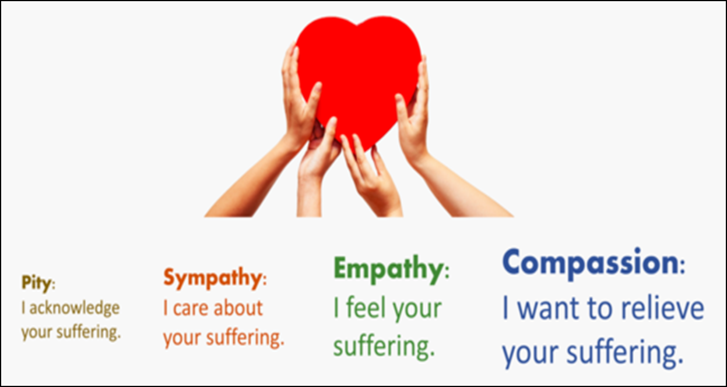

Perhaps the best way that we can demonstrate compassion in a way that is appropriate and meaningful to an individual is by;

* Listening carefully and attentively.
* Allowing the person time to speak, without rushing in
* Acknowledging the feelings expressed
* Never judging the person.
* Never assuming that you know how the person feels even if you have had a similar experience yourself.
* **Trying**, to understand how a person might be feeling

**Remember!**

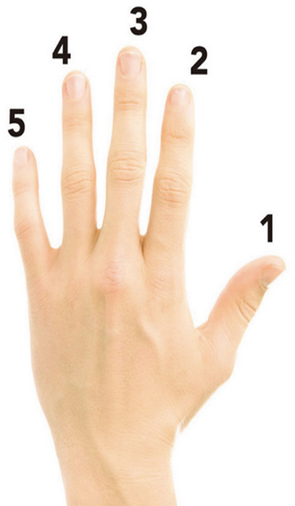

**4**

**1**

**3**

**5**

**2**

1. Acknowledge the question / emotion / situation
2. Don’t run away!
3. Clarify exactly what is being asked / the situation
4. Gather enough information to include what action the person needs or wants
5. Be Honest …………and tell them exactly what you are going to do next

**Section 4: SPRITUALITY**

Spirituality can be defined in many ways and often means different things to different people. It is a broad term and usually relates to what is important to an individual, their thoughts and feelings about their own being and purpose. Sometimes spirituality can be based on a person’s philosophies, rather than established faiths. Faith and religion refers to particular beliefs, rituals and practices, this can be very significant to a person’s spiritual life.

As a person nears the end of their life, spirituality can be very important sometimes they may develop new spiritual beliefs or reconsider their beliefs completely.

**Being aware of a person’s spiritual needs is an important part of your role as a Palliative Care Volunteer.**



**Reflect about the concept of spirituality and what it means to you, try to write a personal definition and notice the feelings and thoughts this evokes.**

Spiritual pain can occur when a person is struggling to find a sense of meaning or purpose. A person might experience spiritual pain as they struggle to make sense out of what is happening to them, searching for a reason why or rooted in their own emotional or spiritual needs. Sometimes a person may reflect on their life and begin to question or challenge past events and experiences. This process can be painful and protracted and may leave the person struggling with difficult questions about life and its meaning.

Emotionally this can be a very difficult time with people experiencing a range of feelings including fear, guilt, regret and anxiety. This period in a person’s life may trigger a need to settle unresolved issues with family and friends and often a sense of sadness about leaving their family or loved ones. Some people may experience a process of detaching from the world and getting ready for a next stage – whatever they believe that to be.

It is important to understand that emotional and spiritual pain is not the same as depression.

The person may say things that indicate that they are experiencing a loss of meaning or purpose in life, such as:

• Why is this happening to me?

• I feel so hopeless. What’s the point?

• I don’t know who I am any more.

• I don’t want to be a burden to my family.

• I need to make amends for things I have done in the past.

Sometimes a person’s spiritual pain may be expressed through their behaviour or actions this may include a fear of being alone, refusing to engage or accept help and support.

**What can I do as a Palliative Care volunteer?**

The most important thing that you can do is listen and be present with the person. Remember sometimes patients may find it easier to speak to you as a volunteer, than confide in their family or friends. Remain open and engaged, do not judge the person or dismiss what they. Always try to understand and accommodate your patient’s beliefs, without imposing your own.

Do not rush to give reassurance, remember allowing a person to talk openly about their feelings is really therapeutic. You cannot take away their pain but allowing them to share their fears and concerns can help to alleviate their sense of isolation and allow them to develop their own sense and meaning

Questions about life and its meaning are profound, so don’t feel like you always need to have an answer. Leave room for listening, thoughtfulness and stillness.

Remember if you have any concerns for the patient always talk to the Ward Team who are caring for them. The Multi- Disciplinary Palliative Care team are highly trained and specialised to support patients and their families. In addition the ward team can access support from the Chaplaincy Team and representatives from the main faith groups.

The following poem was written by a woman called Marilyn Shaw, she wrote the poem after her child died as a way to explain to her friends and family how best to support her in her grief.

It very powerfully demonstrates the importance of being present, listening to a person and showing empathy and compassion.

***Just be there.***

*I only want you to be there*

*To listen, to understand, to share*

*To accept my sadness and to show me that you care*

*And give me the freedom to cry out with despair.*

*Please don’t try to change the way I feel*

*Or take my grief away,*

*It’s the only feeling I have left.*

Marilyn Shaw

(“Enduring, Sharing, Loving” Darton, Longman & Todd)



**Think about a time when you have supported someone in your life. Perhaps they have had bereavement or were struggling to adjust to a difficult or distressing situation. Think about how you supported them and anything that was difficult or challenging, has this section made you think about the situation in a different way and would you do anything differently?**

Section 5: summary

You have now had a chance to look at and think about what constitutes a good death and how we can effectively, empathetically communicate with patients and families. You have also learnt about spirituality and explored why this may be of importance to patients nearing the end of life and how you, as a volunteer might support them.

Thank you for taking the time and effort to complete this work book. We hope that you have found this training interesting and informative and that it will prepare you for your role as a Palliative Care Volunteer.

**Please look back over the previous sections of the workbook and your reflections following sessions 1 & 2 and then highlight the 3 most important things that you have learnt or you will take from this training programme.**

**List the items in the space below together with any issues that you are uncertain about or where you require additional information or input. This will be discussed at the final session.**