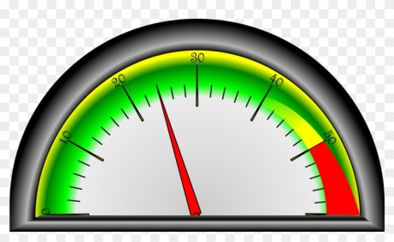**Tasking Volunteer Activity**

|  |  |  |
| --- | --- | --- |
|  | | **Number of** |
| How many steps did you take? | |  |
| How many TTO’s did you take? | |  |
| How many telephone calls did you take? Or Make? | |  |
| **How many patient’ contacts were completed during this Task** | | |
| ✓ | Number of patients escorted/accompanied |  |
| ✓ | Helped with Refreshments |  |
| ✓ | Befriended |  |
| ✓ | Other Task (please advise):  __________________________________________  __________________________________________ |  |

**This form helps us to measure the impact of our Responder Service.**

**Thank you**

Office Use: Input by ___________ Date: __/__/2021

|  |
| --- |
| **If you would like to give feedback, we can use this to help us make improvements and evaluate our Volunteer Responder Service** |
| What did you like about this task? |
| Was there anything you didn’t like about this task? |
| Was there anything you think could have been better?  Such as instructions (did you have enough information to carry out this tasks efficiently) |
| Did you feel confident in being able to carry out this task? Please give details if you were not  YES 🞐   No 🞐 |
| Did you feel that you were helping free staff time? Provide details if you wish |
| Did you find the patients were comfortable with your support? Provide details if you wish |
| Would you like to complete this Task again?    YES 🞐    No 🞐   Provide details here if you wish |