**2020 Green Building Award**

**Sustainable San Mateo County and the American Institute of Architects San Mateo County Chapter (AIASMC) are sponsoring the 18th Annual Green Building Award.**

This award is given to a project that promotes green, sustainable design and construction. It also supports environmentally-friendly design in architecture and recognizes the architects, builders, and owners of these green buildings in San Mateo County.

The Green Building Award is open to any building constructed or remodeled within the last five years and located in San Mateo County. Remodels and additions are also eligible to apply for the award. To apply for the award, your project must have completed its final inspection by Friday December 6, 2019. Previous submittals may apply if their original projects have had additional substantial green improvements.

The Green Building Award winner will be selected by an independent panel of recognized professionals in the disciplines of green and sustainable construction. **The award will** **be presented at the Sustainable San Mateo County Awards Dinner on** **Thursday April 2, 2020 in the Bayview Dining Room at the College of San Mateo.**

**Applications must be received by Sunday December 8, 2019 by midnight.**

**For more information, visit** [**www.sustainablesanmateo.org**](http://www.sustainablesanmateo.org/home/awards/green-building-awards/)

Please email applications to [advocate@sustainablesanmateo.org](mailto:advocate@sustainablesanmateo.org) or by mail to:

Sustainable San Mateo County (SSMC)

ATTN: Green Building Awards

2955 Campus Drive #110

San Mateo, CA 94403

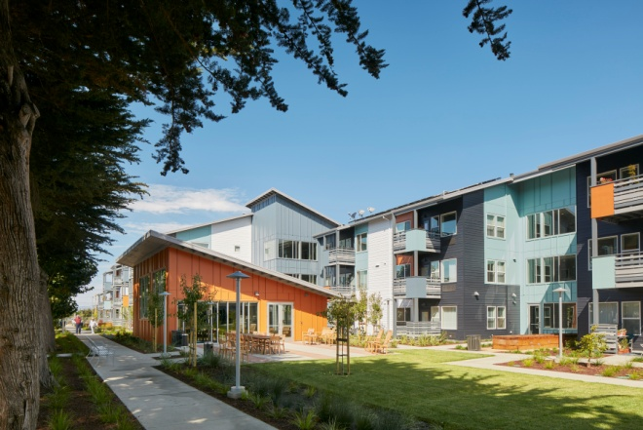

**2020 Green Building Award Application**

**Required Submittals**

* Site Plan with North Arrow. Remodel Projects must submit “before” and “after” photographs.
* Floor Plans
* CD or USB drive with images (include notable features, as appropriate). Submitted documentation will not be returned. By submitting the application you are authorizing full rights to use the materials for any Sustainable San Mateo County promotional materials.
* On a separate piece of paper, address how this project has incorporated the environmental performance criteria listed on the following page.

**Optional Submittals**

* Energy Bill (before and after if remodel)
* Water Bill (before and after if remodel)
* Green Building Rating System Results (LEED, CHIPS, Build it Green, etc.)
* Construction & Demolition Diversion Rate
* Energy Performance Ratings
* Percent on-site renewable energy generation
* Amount of salvaged, recycled or sustainably harvested material used

**The following section must be completed:**

Site Size (square footage) _____________________

Building Size (square footage)__________________

Type of Project: ___New ___Remodel ___Both (_____% new _____% remodel)

Building Occupancy date___________________________

Type of Building ___Commercial ___Residential ___Multi-Family Residence

___School, Government or Institution ___Other

Project Name___________________________________________________________

Project Address ________________________________________________________

Project Start Date _______________________________________________________

Person Submitting the Application­­__________________________________________

Address ______________________________________________________________

Phone _________________________ Email ­­­­­­­­­­________________________________

Architect_______________________________________________________________

Address ______________________________________________________________

Phone _________________________ Email ­­­­­­­­­­________________________________

Builder ________________________________________________________________

Address ______________________________________________________________

Phone _________________________ Email ­­­­­­­­­­________________________________

Owner ________________________________________________________________

Address ______________________________________________________________

Phone _________________________ Email ­­­­­­­­­­________________________________

Owner/CEO Signature ___________________________________________________

**Environmental Performance Criteria**

In 1000 words or less, on a separate piece of paper, please describe how your project addresses each of these environmental objectives. Guiding questions are listed under each objective, however, these do not need to be answered explicitly. Each section will be weighted differently so please highlight the best features of your project and allocate space accordingly.

1. **Energy Conservation and Efficiency (30 points)**

What measures were taken to reduce energy usage?

If the project generates energy, approximately how much of the energy needs are supplied?

Did you set an energy usage goal at the beginning of the project? Did you reach your goal?

Were you striving for a Zero Net Energy or Zero Energy Ready building?

How close to ZNE is your building?

1. **Materials and Resources (20 points)**

How was construction and demolition debris reduced, reused or recycled?

How was the need for virgin resources minimized (both present and future)? How does the project utilize rapidly renewable or sustainably managed material?

1. **Footprint and Community Impact (15 points)**

How does the project decrease its impact on the surrounding natural environment and community?

How does the location of the site minimize development and vehicle travel?

How does the project use materials that decrease associated energy and water?

1. **Indoor Air Quality (15 points)**

What measures were taken to protect indoor air quality?

How were the connections between the outdoors and indoors made?

1. **Water Conservation and Management (10 points)**

How does the project reduce water usage?

How does the project manage and/or reuse stormwater on site?

1. **Innovation and Design (5 points)**

What whole-systems approaches were utilized to ensure the components work together?

What sustainable design principles were utilized to improve environmental performance?

1. **Presentation and Other Considerations (5 points) (**No response required.)