**Executive Summary**

**SUNY Jefferson Community College On-site Energy Manager Project 2019**

**Background**

In February of 2019 Jefferson Community College began a one-year commitment to provide a one-half time FTE On-site Energy Manager position in partnership with NYSERDA under project code OsEM17-C, (PON 3710). The project was initiated to continue the work started in NYSERDA REV Grant (PON 3438) for an energy study of campus facilities that was completed in 2018. The College was still using outside consultants, Trane Service and A&E firms to provide guidance on energy savings projects but lacked time to drill down to the micro-level controls in the Trane building automation system that runs its facilities.

**Goals**

The goals of this project were to develop a long-term energy management plan that would achieve measurable operational savings, maximize building efficiencies, reduce the College’s carbon footprint, promote sustainability and raise awareness among students, faculty, staff and the local community. A 7% reduction in energy use intensity measured in BTU/SF was targeted as an achievable metric.

**Method**

The OsEM collected baseline and ongoing data logs on all equipment to view operating trends for comparative purposes. These were used to identify problems and help take corrective actions. An regularly updated “work list” was created so JCC Staff and Trane Technicians could prioritize repairs and update BAS programming. A cross functional energy team consisting of the OsEM, JCC Administration, Trane Energy Group and the college’s A&E firm met on a regular basis to help guide the project.

**Energy Savings Results**

The energy use data from the project was evaluated by the Trane Energy Group. The results from FY 18-19 vs. FY19-20 showed an overall (electric and natural gas) improvement of 14.81% using the ENPI EXCEL application for utility regression analysis. This is twice the original project goal of a 7% reduction.

**Greenhouse Gas Mitigation**

JCC is a signatory of the American College and University Presidents Climate Commitment and has a goal of eventually achieving a “net-zero” campus. CO2 emissions are tracked annually. In 2018 Scope 1 Emissions (Natural Gas) were 658 MTCO2e and Scope 2 Emissions (Electricity) were 483 MTCO2e for a total of 1,173 MTCO2e. This project mitigated 271 MTCO2e, a 23% reduction for Scopes 1 and 2.

**Financial Savings Results**

A straight line comparison shows an estimated overall yearly savings of $68,782.42 from FY 18-19 to FY 19-20. This is a 28 % reduction in direct operating expense. The cost / payback analysis showed that the $58,948 OsEM cost measured against the savings achieved resulted in a ten-month payback.

**Summary**

The NYSERDA OsEM Grant for Jefferson Community College was an unqualified success from energy reduction, greenhouse gas mitigation and cost savings standpoints. Over 1,300 man-hours were invested over the 1-year course of the project. The overall results exceeded project goals. The results are easily measurable, verifiable and the methodology used is easily transferrable to other institutions. All reports and supporting data are available to the public upon request. Funding from NYSERDA and technical input from Trane Energy were critical to this project’s success.

# SUNY Jefferson Community College - NYSERDA OsEM Case Study

**Introduction**

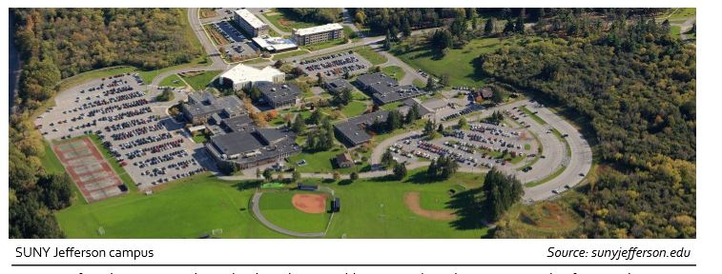Jefferson Community College is two-year College located in Watertown, New York, the county seat of the College’s sponsor, Jefferson County. The College was chartered in 1961 and was initially accredited by the Middle States Association in 1969. The campus footprint is 285,297 square feet with 9 buildings of various uses including administrative, library, academic, support facilities, day care and a residence hall.

**JCC’s Commitment to Leadership and Environmental Excellence**

The College has been recognized for signifying leadership among its peers and demonstrated their commitment to clean energy by joining the REV Campus Challenge in 2015. As a first mover, JCC was very excited about this opportunity to continue to meet their financial, environmental, academic, and community goals through clean energy solutions.

JCC is a signatory of the American College and University Presidents Climate Commitment and maintains active membership in the SUNY Sustainability Coalition (NYCSHE), NYS Association for Reduction, Reuse and Recycling (NYSAR3), NNY Chapter of US Green Building Council and is recognized as a “Tree Campus USA member” listed with Arborday.org

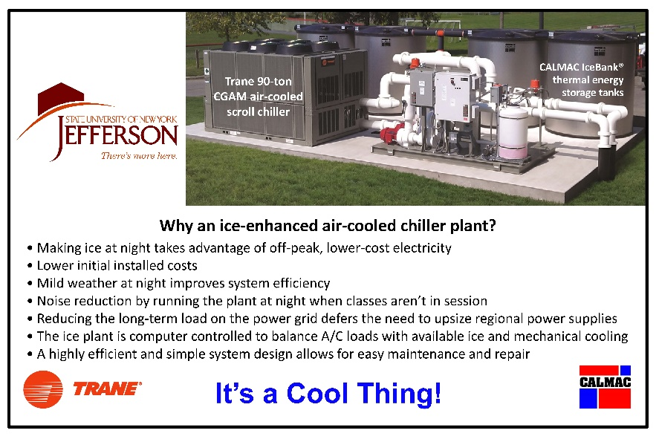

**Innovation for Sustainability**

JCC has made excellent progress

in reducing its energy use over the past ten years. Of special note is the reduction of electrical demand. The campus overall has gone from high peaks of over 700 KW to a current average level of just over 450 KW despite adding over 30,000 square feet of new buildings. This success is the due to the use of off-peak chiller plants with ice storage, LED lighting, improved HVAC systems and upgrades to the computerized energy management system. Trane Corp. has been an

partner and team member in these efforts helping JCC find innovative solutions to energy management.

**Project Development:**

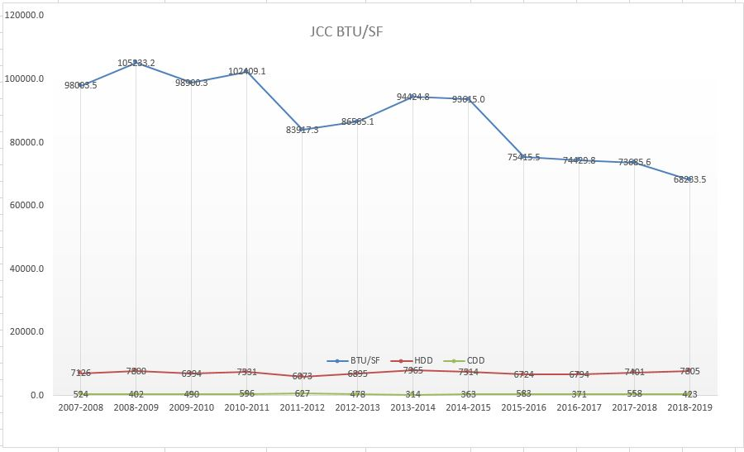In 2012 the Governor issued Executive Order 88 which required state owned or managed facilities to reduce average source energy use intensity by at least 20% from a baseline of 2010-2011. While Community Colleges were not mandated in this same way, SUNY Jefferson Community College recognized its responsibility as a member of the SUNY system to take action in a similar manner. Using the current Facilities Master Plan, a concerted effort was made to improve the energy efficiency of campus buildings through envelope improvements, HVAC upgrades and energy management systems improvements. By FY 2018 the College had reduced energy use (BTU/SF) by 14% despite having added over 32,000 square feet from new construction during that time. (Table Below)

**The REV Campus Challenge:**

in 2017 the College was awarded $52,528 through the NYSERDA REV Grant program (PON 3438) for an energy study of campus facilities. The project was done in partnership with Trane and the project deliverables were received in 2018 - 2019. The information received included:

* Review of existing energy data in order to establish a baseline
* Detailed site survey (ASHRAE level 1 and level 2) of the buildings
* Energy Conservation Measure (ECM) Analysis
* Recommendations for ECM Implementation
* Inventory of all mechanical systems components
* Inspection of building envelopes including thermal imaging
* Retro-commissioning of the Building Automation Systems

**The OsEM Opportunity**:

The timing of 2018 OsEM program was ideal and represented a once in a lifetime opportunity for the college. It provided a perfect segue for an on-site energy manager to utilize the information gathered in the just completed REV Grant energy study to create a Campus Energy Management Plan. After meeting with college administration it was clear to all that this was a very appropriate project to pursue. The College applied for the grant and began assembling an Energy Management Team consisting of JCC Staff, Trane consultants, and principals from the college’s A&E firm. NYSERDA approved the funding of up to $48,412 and project was launched in April of 2019.

**Goals for Measurable Economic and Environmental Benefit**

The goals of this project were to develop a long-term energy management plan that would achieve measurable operational savings, maximize building efficiencies, reduce the College’s carbon footprint, promote sustainability and raise awareness among students, faculty, staff and the local community. A 7% reduction in energy use intensity measured in BTU/SF was targeted as an achievable metric. That target was exceeded in every month of the OsEM project and overall energy use was reduced by 14.81% over the course of the project with a total dollar savings of $68,782.42.

**Verification of Goals for OsEM Project**

The team turned to the Trane Energy Management Group for the final analysis of the one-year project results using the ENPI EXCEL application for utility regression analysis. This tool showed an overall (electric and natural gas) improvement of 14.81% This is twice the original project goal of a 7% reduction. Of interest are the notes regarding the report findings (below) from the overall electrical and natural gas models derived, especially that campus electrical use is more driven by occupancy than weather. This would explain why ECM-7 (Revise Building Schedules - described later) has been a big driver in the success of this OsEM project. The scatter plots below clearly show that the actual energy use over the past two years in total MMBTU vs predicted modeling is lower. This is direct proof that the NYSERDA Campus Energy Study done in 2018 and OsEM Grant in 2019 have been very worthwhile.

Trane Energy - April 6, 2020 (Excerpted)

(We) use the ENPI EXCEL application for the utility regression analysis. This EXCEL application tool is the “recognized” tool for NYS baseline comparisons to determine improvement under the NYS greenhouse gas reduction targets.

“…*The tool is producing a very good regression for natural gas on your campus but there is not a good regression for kWh because of the extent of occupancy controls, scheduling, heat pumps and ice storage for cooling. This is a good thing, showing the electric consumption is occupant use driven more significantly than being temperature dependent….”.*

Comparing FY18-19 with FY19-20 shows an overall (electric and natural gas) improvement of 14.81%.

With FY08-09 as the baseline the overall (electric and natural gas) improvement is 27.29%.

Bruce A Brown, P.E., LEED AP O&M - Trane Energy Group

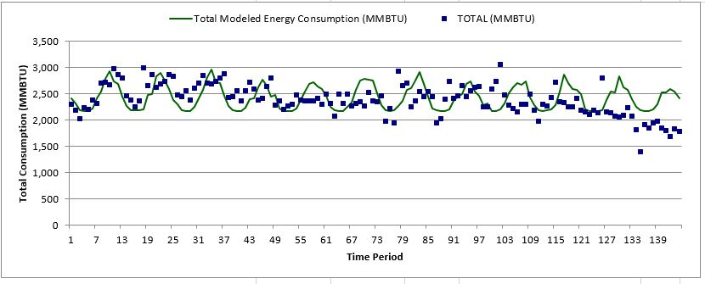

**JCC OsEM Project - Modeled vs Actual 2008-2020**

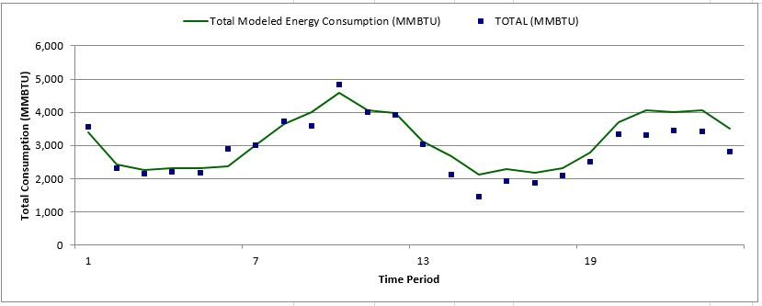

**JCC OsEM Project - Modeled vs Actual 18-19 to 19-20**

**Greenhouse Gas**

An important side consideration to this project was greenhouse gas reduction. The ENPI EXCEL application is designed to measure this (below) and the avoided CO2 Emissions for 18-19 vs 19-20 shows a total of 271 Metric Tons/Year. JCC is a signatory of the American College and University Presidents Climate Commitment and has a goal of eventually achieving a “net-zero” campus. CO2 emissions are tracked annually by the Facilities Department. In 2018 Scope 1 Emissions (Natural Gas) were 658 MTCO2e and Scope 2 Emissions (Electricity) were 483 MTCO2e for a total of 1,173 MTCO2e. This project has resulted in a 23% reduction of monitored GHG Scopes 1 and 2 which represents very significant progress towards the college’s long-term goals. (271 / 1,173 = 23%)

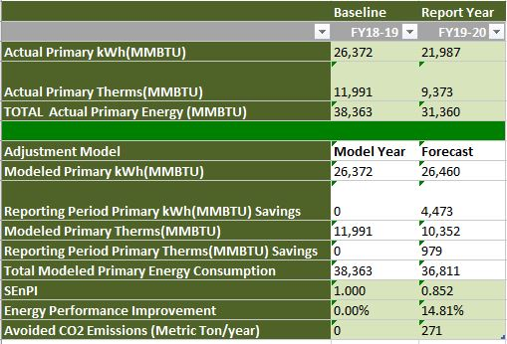

**OsEM Project - SEP Results 18-19 vs 19-20**

**Cost Benefit Analysis**

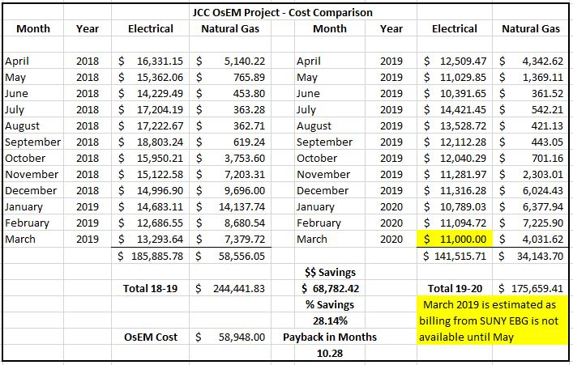The bottom line cost savings is of interest as well. A straight line comparison (not adjusted for degree days) shows an estimated overall yearly savings of $68,782.42 from FY 18-19 to FY 19-20*. This is a 28 % reduction in direct operating expense. While this project’s success or failure has been evaluated on the basis of BTU/SF reduction to date, there is a significant matching dollar savings. * This number is estimated as March billing from SUNY Energy Buying Group is not available until May 2020.

**2019-2020 Cost Comparison**

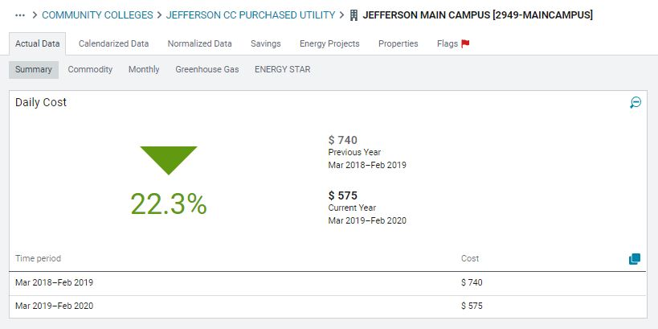SUNY Energy CAP Data also backs up the overall savings data from the project. (example below) This tool looks at all utilities for the main campus based on the actual bills and data submitted and shows a significant reduction in operational costs for JCC utilities.

**Daily Cost of Purchased Utilities - Daily Comparison from SUNY Energy CAP**

**Low Cost / No Cost Energy Conservation Measures that can be Adopted by Others**

(JCC - Cost of electricity: $.075 per kWh - Cost of Natural Gas: $.75 per Therm)

A summary of these energy conservation measures is attached as OsEMProjectSummary_Q4

ECM 1: Replace HPS Lamps in Quad with LED: National Grid Rebate Program 10 LED lamps for annual savings of 10,950 kWh savings at .075 = $821.00

ECM 2: Replace Theater House lights with LED: National Grid Rebate Program - 54 LED Lamps for annual savings of 21,063 kWh at .075 = $1,579.00

ECM 3: Install CO2 Sensors in B-1: In-house ECM to reduce outside air cycles. Electrical - 7% savings of 103,008 = 7,000 x .075 = $525.00 Natural Gas - 10% savings of 1,639 = 164 x .75 = $123.00

ECM 4: Cooling Tower Controls in B-2: In-house ECM to reduce electrical and gas use. Electrical - 2% savings of 336,919 = 6,738 x .075 = $505.35. Natural Gas - 1% savings of 16,352 = 154.5 x .75 = 115.50

ECM 5: Raise the cooling minimum from 70* F to 72* F to decrease electrical use in summer.

ECM 6: Lower the heating maximum from 74*F to 72* F to decrease natural gas use in winter.

Calculating conservatively at 1% savings per degree change the campus-wide savings for these ECM’s should be 2% for heating (natural gas) a reduction of 2,445 Therms at $.75 = $ 1,834.00 and 2% for cooling (electricity) a reduction of 51,618 kWh at .075 = $ 3,871.00.

ECM 7: Adjust building run time schedules for occupied/unoccupied operations to the actual class schedules by semester. For the summer, overall campus-wide equipment run times were reduced by approximately 50%. Calculating conservatively at a 1% reduction the campus-wide savings for this ECM should be 1% for heating (natural gas) a reduction of 1,222 Therms at $.75 = $ 917.00 and 1% for cooling (electricity) a reduction of 25,809 kWh at .075 = $ 1,935.00.

ECM 8: Lower minimum air flow settings at VAV boxes. After consultation with the design engineer it was felt that minimum setting could be reduced to from 50% to 20% of Max flow. This will help to reduce air handler loads but the actual savings will be hard to quantify. This change will mainly affect Building 5 (Gregor) and Building 15 (CLC). For estimating purposes a .5% electrical savings from reduced fan speeds will be used. Building 5 - 673 kWh x $.075 = $50.54 and Building 15 - 1304 kWh x $.075 = $97.82, a total of 1,977 kWh and a total cost savings of $ 148.00.

ECM 9: Change heat pump fan from continuous mode to duty-cycling mode in Building 6. AHU-1 supplies 100% outside air to building spaces so the heat pump fans are not needed for ventilation and air exchange. 344 days / year. 34 HP x 99 Hours Week x 49 weeks = 164934 fan HP / hours / year x .7457 conversion factor = 122991 kWh / year x .075 per kWh = $9224 cost / year x .5 = $4612 / year. 122991 kWh x .5 = 61495 kWh savings year.

ECM 10: Program changes to allow the outside air dampers to open only when CO2 levels become too high. It was found that the original program was not set up correctly and that units were bringing in too much unconditioned outside air and exhausting conditioned air when it was not necessary. This is similar to ECM 3 for Building 1. Expected savings would be 7% electrical = 260859 x .07 = 18260 kWh x .075 = $1,369 per year and 10% natural gas = 10216 x .10 = 1021 therms x .75 = $766.

ECM 11: Removed old exterior wall packs and replaced with LED. A total of eight units were replaced. The existing 42v watt units were changed to 20 watt equivalent fixtures. 4,380 annual hours x 22 watts savings = 700,880 watts annual reduction = 700.8 x $.075 = $52.56 dollars annually.

ECM 12: Program changes to air handlers in Buildings 1, 5, and 15 so that minimum amounts of unconditioned air are brought in and mixed air damper controls are loop tuned. For this report the conservative estimated savings will be a 2% electrical savings for Building 15. = 260859 x .02 = 5217 kWh x .075 = $391 per year and 1% natural gas = 10216 x .01 = 102 therms x .75 = $76. TOTAL $467

ECM 13 - Facilities staff repaired or replaced door weather stripping campus wide. Estimated .001% savings. 2580 kWh x .075 = $193.57 and 122 Therms x $.75 = 91.71 TOTAL $285.28

ECM 14: Replace existing rest room lighting in Buildings 2 and 3 with LED. The existing 32 watt units were changed to 22 watt equivalent fixtures. Estimated 4,242 annual hours per fixture at 10 watts savings times 10 fixtures = 4,242 x 10 x 10 = 424,200 watts annual reduction /1,000 =4,242 kWh x $.075 = $318.00 dollars annually.

ECM 15 - CO2 Sensors Building 5 . Trane estimates (attached) that this ECM will save 12,012 = kWh x .075 = $900.90 per year and 3,463 Therms x $.75 = $2,597 for a total $3,498.15 dollars annually. This measure is being considered for the Green Initiative Grant funding. Status - not installed yet.

ECM 16 - Heat pump day/night control via BAS in Building 2. Trane estimates (attached) that this ECM will save 60,824 = kWh x .075 = $4,561 per year and 4,813 Therms x $.75 = $609.75 for a total $5,170. This measure is being considered for the Green Initiative Grant funding. Status - not installed yet.

ECM 17 - LED Retrofit - Campus Wide. An initial study done in 2017 by Potentia Management Group indicated that a turn-key project would save 169,977 kWh per year. At $.075 per kWh it =$12,748.00 annual savings. When factored against a $139,764.00 implementation cost after utility incentives were applied the payback was approximately 11 years which was not acceptable. At the team meeting in February an alternative of doing this project in-house and only incurring materials cost was discussed. It was felt that could easily reduce costs by 50% and make it financially viable. This ECM is being considered for the Green Initiative Grant funding. Status - not installed yet.

**Post-Project Continuation of Superior Practices Learned**

The College plans to continue the OsEM position by re-allocating existing staff resources post-project and re-assigning the work activities developed during the past year. This may be the most significant ECM that has been found to date in terms of long-term energy conservation at zero cost. Staff hours are “sunk costs” and many of the routine tasks established can be performed by staff in existing positions. The most important tasks for these future efforts identified so far include:

* Daily routine checks of alarms, spaces and equipment via BAS - HVAC Technicians
* Review of trend logs on a systematic basis each season - Director
* Weekly energy use trend log data gathered for all building electrical meters - Director
* Schedule adjustments on a weekly basis to manage building occupied times - HVAC Technicians
* Schedule adjustments on a semester basis to adjust for changes in use - HVAC Technicians
* Regular comparisons of current energy use trends with Energy CAP - Director
* Updating BAS, HVAC and mechanical systems “to do” work lists - Energy Team
* Preventative maintenance on equipment to be scheduled in AIM - Director
* Monthly meetings between the campus staff and the Trane energy team - All
* Investigate possible new and innovative ECM projects - Team
* Enhance Employee and Community Awareness - EverGREEN Committee
* Improve O&M Procedures and Preventative Maintenance: Team
* Continued training for Facilities Staff - Director

This list of post-project practices is readily transferrable to any facility that desires to enact low cost/no cost measures that will improve energy and operating efficiencies.

**Cross Functional Energy Team**

This project was made possible by having multiple partners as the backbone of the Energy Team. They were aided by JCC Facilities Staff personnel, outside specialty contractors, JCC Department Heads and consultants as appropriate. In addition, an important part of this project was collaboration with partners at Onondaga Community College, Cayuga Community College and Tompkins Cortland Community College with the intent to jointly share data, strategies and findings from each institution.

Mr. Dan Dupee - JCC Vice President for Administration - Administrative Oversite

Mr. Bruce Alexander - JCC Director of Administrative Services - OsEM

Mr. Terry Kinneer - JCC Building Maintenance Mechanic 1 (HVAC)

Mr. Ray Side - JCC Building Maintenance Mechanic (HVAC)

Mr. Jeff McKenna PE - Bernier Carr and Associates

Mr. Joe Edick PE - Bernier Carr and Associates

Mr. Matt Pinczes - Trane Energy Performance

Mr. Bruce Brown PE - Trane Energy Engineer

Mr. Jerry Warren - Trane Service Department

Mr. Dave Taylor - Trane Sales Department

Mr. Adam DeSio - NYSERDA Project Representative

**NYSERDA Funding**

None of these efforts would have been possible without NYSERDA funding most of the expenses. JCC was tasked with a 25% share of costs as part of the awards. The OsEM project was initiated to continue the work started in NYSERDA REV Grant (PON 3438) - Energy Study of Campus Facilities. That project was in its final phase of retro-commissioning the building automation systems when the OsEM PON became available. JCC worked closely with NYSERDA Staff During the application process to ensure that the submittal would meet all project requirements.

**JCC EverGREEN Committee for Campus Sustainability**

<https://sunyjefferson.edu/about/campus-community/sustainability.php>

The EverGREEN Committee was established in 2009 to provide the campus with programs, resources and information to help raise the awareness of the importance of sustainability in conserving and protecting the natural resources that our lives are dependent upon. The committee coordinates activities such as Earth week, Arbor Day, community garden, trash cleanup, and Tree Campus USA. The committee planned to begin an Energy Awareness campaign in the Spring of 2020 but the current nationwide health crisis has closed campus. That campaign will be re-started after campus re-opens.

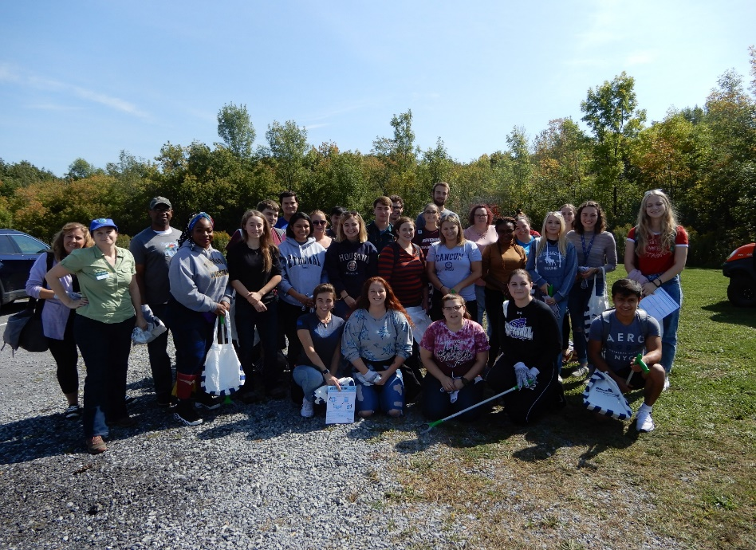The committee tries to promote student involvement in its many sustainability efforts as well as encouraging eco-friendly curriculum offerings. The success of the OsEM project will be used as a base for future energy conservation outreach.

**Left - JCC students participate in the annual Black River Trash Bash 2019**

**NYSERDA OsEM Grant Project Summary**:

**Overall Results**

**14.81% Reduction in Energy Use**

**28% Reduction in Energy Costs**

**23% Reduction in CO2 Emissions**

The NYSERDA OsEM Grant for Jefferson Community College was a success and exceeded the target goal of an overall 7% savings in energy use intensity. Project preparation and data collection actually began prior to the 2019 April grant award. The College set up a new server in February 2019 so that BAS trend logs could be saved for analysis. Data logs on equipment were updated on a regular basis and there is now a good set of operating trends that can be used for comparative purposes in the future.

Project highlights include.

* Cross Functional Energy Team was organized
* Trane retro-commissioning and maintenance of major equipment
* Alerton retro-commissioning and maintenance of major equipment
* JCC subscribed to SUNY AIM database for O&M and PM work orders
* JCC subscribed to SUNY Energy CAP to log and monitor utility use and costs
* Trend log collection has provided a 1 year baseline for future comparisons
* Energy Awareness campaign to be done by the JCC EverGREEN Committee
* O&M Procedures and Preventative Maintenance plans updated
* Updated Facilities Master Planning with data gathered from REV and OsEM Grants
* Additional training for Facilities Staff on the Trane and Alerton BAS
* Walk-through audits performed in all facilities
* Low cost / no cost Energy Conservation Measures implemented
* NYS Green Revolving Loan Fund (GRLF) made available for community colleges
* OsEM operating procedures drafted to guide ongoing energy management efforts
* OsEM hours for the project totaled 986
* Other - team hours for the project totaled 355
* Continuation of OsEM role moving forward
* Sharing of data with partners and other institutions

Respectfully Submitted;

Bruce Alexander LEED AP - Director of Administrative Services

SUNY Jefferson Community College

4/10/2020

