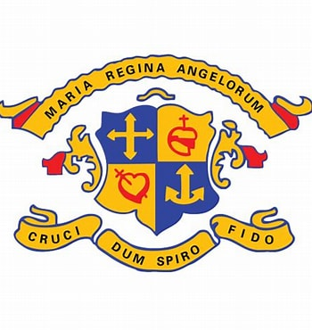

Loreto P.S. Dalkey

DATE | EVENT | AUTHORITY
March 2021 | Policy Creation | Principal
March 2021 | Ratified | BOM
October 2025 | Reviewed | BOM, Staff and PA
Next Review: October 2027

Custody/ Separation Policy

The Staff of Loreto Primary School, Dalkey, realise that children in our school may come from different family circumstances. We encourage parents experiencing separation to come and speak confidentially to the teachers and/or Principal. It is our aim to handle such matters with sensitivity and compassion, and ultimately, our primary concern is for the well-being and overall development of the child.

Guiding Principles
- Child-Centred Approach: The child’s safety, emotional wellbeing, and educational continuity are paramount.
- Equality and Fairness: Both parents are treated equally unless a court order specifies otherwise.
- Transparency and Communication: Clear, respectful communication between school and families is essential.

When a child spends time in two homes, it is requested that the school be provided with both sets of emergency/contact numbers. Regarding the collection of children from school - it is requested that the school be informed of any changes in collection arrangements by note. It is the school policy to offer the option of separate parent/teacher meetings, if so desired.

Legal Framework and Compliance
This policy reflects the most recent legislative and procedural updates, including:
- Children First Act 2015 and Children First National Guidance 2017
- Child Protection Procedures for Schools 2025
- Family Courts Act 2024 – establishing specialist family law courts
- Children and Family Relationships Act 2015
- Article 42A.4.2° of the Irish Constitution – right of children to be heard in custody proceedings

Policy Procedures
A. Custody and Guardianship Documentation
- Parents must provide certified copies of court orders or custody agreements.
- A solicitor’s letter is not sufficient to restrict access or rights.
- In the absence of legal documentation, both parents are considered equal guardians.

B. Communication and School Engagement
- Both parents may receive school reports, through Aladdin Connect and attend meetings, unless legally restricted.
- Where a child resides equally with both parents, communications will be sent to both, once the school has been made aware of the situation.
- Requests for separate parent-teacher meetings will be accommodated with sensitivity.

C. Collection and Access Protocols
- The school must be informed in writing of any changes to collection arrangements.
- Emergency contact details for both households must be provided.
- If there is a concern about abduction or unauthorised removal, a court order must be presented.

D. Staff Training and Support
- All staff will receive mandatory child protection training under Circular 0041/2025.
- The Designated Liaison Person (DLP) and Deputy DLP received additional training October 2025.
- Staff will be supported in managing sensitive custody situations with discretion and care.

Wellbeing and Civil Rights Considerations
A. Child Wellbeing
- Custody arrangements should prioritise emotional stability, routine, and safe relationships.
- The school will monitor for signs of distress and liaise with Tusla if concerns arise.
- Children’s voices will be respected, in line with constitutional rights and best practice.

B. Parental Rights
- Both parents have the right to be involved in their child’s education unless restricted by law.
- The school will not take sides in disputes and will act only on legal documentation.

C. Staff Protection
- Staff will be protected from undue pressure or involvement in family disputes.
- Any threats or inappropriate behaviour will be reported to the relevant authorities.

Best Practice Recommendations
- Trauma-Informed Approach: Staff will be trained to recognise and respond to trauma in children affected by separation.
- Safe Custody Exchanges: If custody exchanges occur on school grounds, they must be conducted in a safe, neutral environment.
- Support Services: Families will be referred to mediation, counselling, or legal support where appropriate (e.g., Barnardos, Springboard, Rainbows Ireland, Tusla).

It is assumed that when we wish to communicate with parents regarding their child, the parent who is contacted (i.e. the parent with whom the child principally resides) will inform the other parent of meetings, arrangements etc. where appropriate. Special requests for separate communication may be accommodated.

- Regarding notes, school communication via schoolbags, school reports etc, it is assumed that the parent with whom the child principally resides will keep the other parent informed.

- In the case of married parents, the school cannot be asked to withhold a child from either parent in the absence of a custody arrangement.

- In the case of unmarried parents, the natural father has no custody or guardianship rights unless a court grants those rights to him. The onus is on the father to produce evidence of a court order in the case of a dispute regarding the collection of a child during or after school.

The staff of Loreto Primary School, Dalkey, will endeavour to deal sensitively and compassionately with children experiencing separation.

Reviewed and Ratified:


_______________________ Date: 20/10/2025
Caroline McNicholas
Chairperson B.O.M.

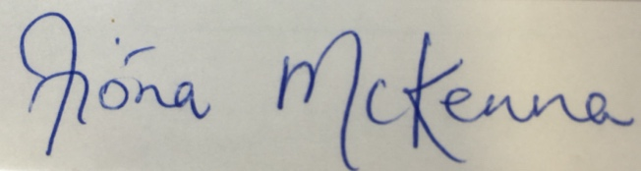
_________________________ Date: 20/10/2025
Fióna McKenna
Principal.

