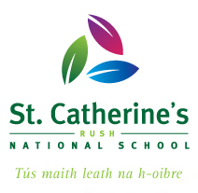
Junior Infant Information Booklet 2026
Fáilte romhat agus roimh do pháiste.
This Booklet is a guide to helping your child as they start their exciting journey through school.
Before Your Child Starts School
Starting school will be a big change in the life of your child. We have put together this booklet as a general guide. We trust you will find it helpful and that your child will be happy in St Catherine’s.
Parents and teachers take special care to ensure that the transition from home to school is as smooth as possible. If your child’s first experience of school is one of happy involvement a very good foundation will have been laid for fruitful school years ahead.
Ensure your child can be as independent as possible - physically, emotionally and socially. If they can look after themselves, they will feel secure and confident and settle in readily.
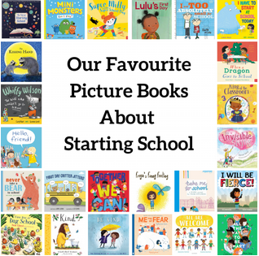
https://ivyslibrary.com

Preparing for School – Life Skills
Can I?
Put on, fasten and take off my coat by myself?  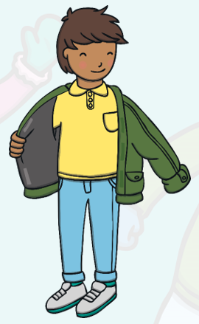  Put on and take off my shoes by myself? | Can I hang up my coat on a coat hook? 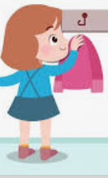  Can I find my name on the coat hooks in the classroom?
Can I use the toilet by myself?   | Do I know how to wash my hands properly?  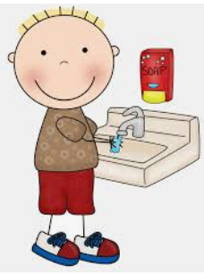
Can I open and close my lunchbox and drink by myself?  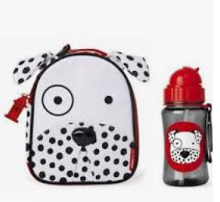  Can I tidy away my lunch things and clean my desk? | Can I use a hanky? Can I cough into my sleeve? 

Things that need to be done before starting school:
- Put your child's name on everything - jumpers, track-suit tops, jackets, t-shirts, lunch box and drink containers and school bags (big enough to hold an A4 folder).
- St. Catherine’s NS uniform consists of:
  - Grey tracksuit with our school crest and a white t-shirt
  - Grey school shorts for warm weather
  - Grey Trousers/Skirt, White Shirt/Blouse, Burgundy Jumper/Cardigan.
- Either of the above is acceptable as uniform.
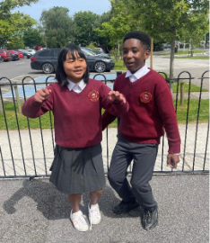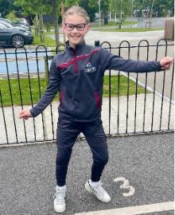

- The school tracksuit is available to purchase from:
  - O’Farrell Schoolwear, Unit 2, N1 Business Park, Swords, Co. Dublin.
  - Website: www.ofarrellschoolwear.com

- The children need to wear the school tracksuit and runners on PE days. You will be told which days are PE days in early September. Velcro straps on shoes and runners are easier for the child and teacher to use.
- Be able to recognise their name on all their belongings and in print around the classroom.

Preparing for School – Social and Emotional Skills
Can I?
Share toys and take turns in games?  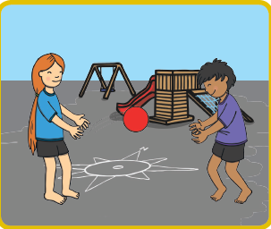 | Stand in line calmly?  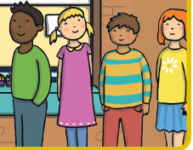
Tidy up and put games and activities away.  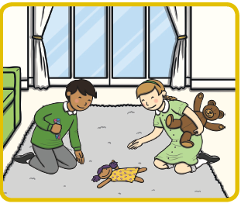 | Listen carefully.  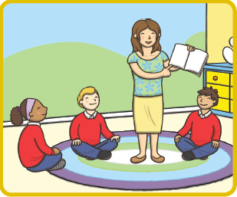

Our School Values
Talk to your children about the 5 core values in St Catherine’s, all school rules are built around these values. We use these 5 words when we talk to children about their behaviour.
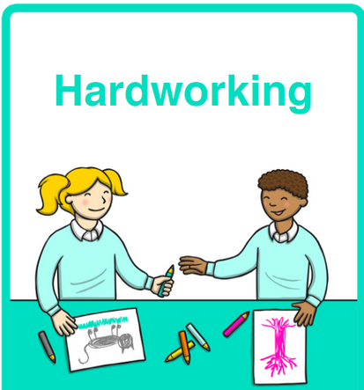 | We work hard in school.  - We listen carefully.  - We work and play the way our teacher asks us to.  - We keep trying even when it is hard. We say, ‘I can’t do it yet, but I will get there’.
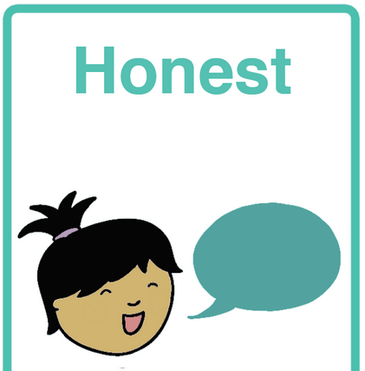 | We are honest in school.  - We tell our teacher when something is difficult and ask for help.  - We tell our teacher if we are upset or sad so s/he can help us sort it out.  - We tell the truth when we are asked about something that happened.
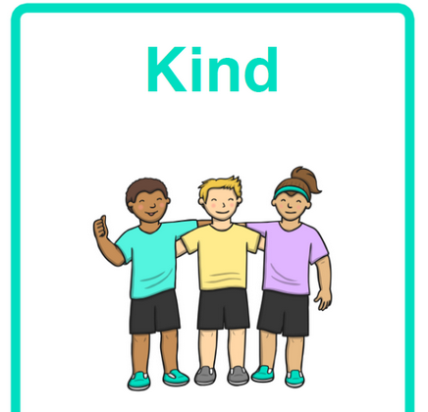 | We are kind in school.  - We play nicely together using kind words, kind hands and kind feet.  - We give each other compliments.  - We share and let other people take turns.  - We say, ‘hard luck!’ if someone loses a game and ‘well done!’ to the winner if we lose a game.
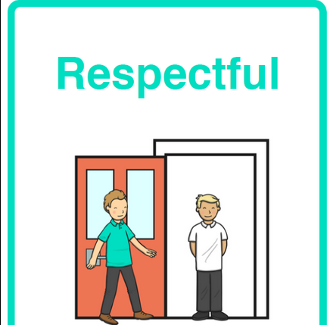 | We are respectful in school.  We respect people:  - We greet others and respond to greetings.  - We give other children space, and we allow others to go ahead of us.  - We say ‘please’ and ‘thank you’ and use our manners.  - We listen to our teacher when they call our name.  We respect property:  - We are careful with our classroom resources (toys, games, crayons, pencils)  - We tidy away the things when we are finished using them.  - We take care of our own property.
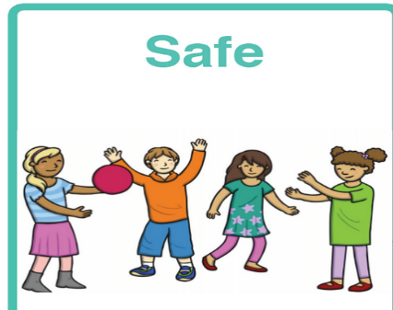 | We are safe in school.  - We walk calmly in the classroom and on the corridors.  - We look where we are going (in the direction we are walking).  - We use safe hands and safe feet.  - We are careful with furniture and equipment.  - We sit properly on our chairs.

Preparing for School – Getting ready for learning
Teachers and parents are partners in a child’s education. We have included some ideas for the home, which should stimulate the child’s interest and nurture their desire to know more.
Children are natural learners. They are curious and have an eagerness to know more about everything, themselves, others and the world around them. They learn fast when they are ready and their interest is aroused. The first year in school is mainly about settling in, making friends, feeling happy, learning how to learn and getting used to the school routine.
Rates of progress of children can vary greatly, children move at their own pace.
Children are helped to get ready for learning by:
- Ensuring they get enough sleep (10 hours a night)
- Developing their oral language and expression.
- Sharpening their senses.
- Developing physical co-ordination.
- Extending their concentration span and encouraging them to listen attentively.
- Learning through play.
- Co-operating with the teacher and other children.
- Performing tasks by themselves.
- Working and sharing with others.

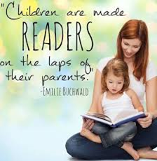  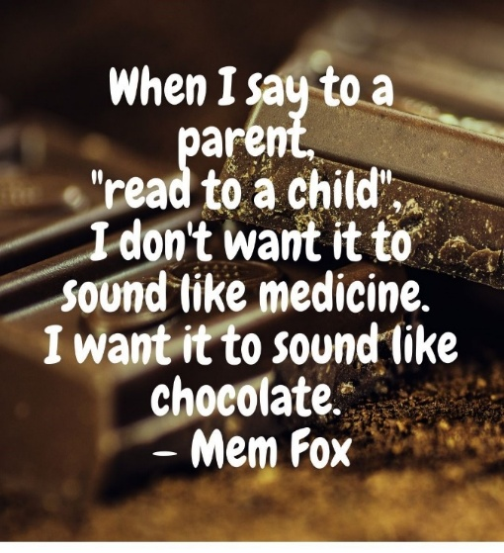 | - Inspire a love of reading…have a reading corner in your home and a selection of books that you buy or borrow from the library. Have a mixture of storybooks and factual books.  - Let your children see you read and talk to them about what you are reading – children will read if it is something the adults they look up to do. It is especially important for boys to see the men in their house reading.  - Read, read, read with your child every day, read bedtime stories every evening.  - Let the child choose, it’s ok to read a favourite book over and over again!  - While reading ask them to predict what will happen next and make connections to the story.  - Ask them their favourite part of the story or what they thought about the book.  - Talk about the characters ask what type of person each character is (kind, unkind, gentle, hardworking)  - Find interesting words in the book and talk about what they mean.  - Help them to notice how the book is opened, to identify the front and back cover, where the writing starts and that we read it left to right.  - Start to recognise some letters in the words in the story (e.g. letters in their own name). Comment on punctuation (I have to say this as a question because I see a question mark at the end).  - Notice words that rhyme.
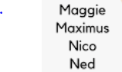 | Help your child to practice talking about them/herself (name, physical description of themselves, family, likes/dislikes, favourite book/game, pets, where they live...)  Practice recognising his/her name and finding the name on a list (they do not need to be able to write their names yet!).
My teddy    Grandad’s car   | Get your child to practise describing objects according to the following 7 prompts:  - number  - colour  - shape  - size  - texture  6. position (where)  7. doing (what)  For example,  - ‘He has two arms, two legs and one nose’  - he has a brown body and a red dickie bow’  - ‘His ears are round’  - ‘Teddy is small’  - ‘His fur is fluffy, his feet feel rough’  - ‘He is on the couch between Mammy and me’  - ‘Teddy is reading a book with us’
 | Help your child to practise describing feelings, for example.  She’s happy/delighted/over the moon.  He’s angry/frustrated
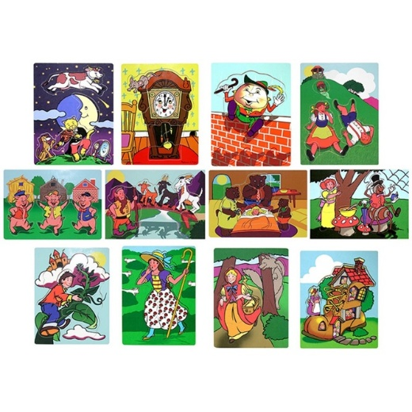 | It would be helpful if your child knows (understands and can recite) the following nursery rhymes:  - Twinkle, Twinkle Little Star  - Incy, Wincy Spider  - Jack and Jill  - Humpty Dumpty  And the following Fairytales:  - Little Red Riding Hood  - The Three Little Pigs  - Goldilocks and the Three Bears  - The Billy Goats Gruff
Vocabulary   | It is important that your child learns lots of new words every week. How many words they know is a big predictor of success in literacy. For example, check that the child knows.  - The names of items in the kitchen (bread knife, colander, dinner plate, side plate, pizza cutter etc) and in the other rooms of the house.  - The names of some trees, birds and common plants and animals  - Vocabulary for school (secretary, caretaker, principal, deputy principal, desk, SNA (Special Needs Assistant), intercom, basket, press/cupboard, interactive board.  - Vocabulary of learning: book cover, author, illustrator, take out your..., tick the box, circle the red crayon, match two, draw a line to, line up.  - Talk about all the new words you come across in books or out and about (sign, traffic lights, supermarket shelf...)
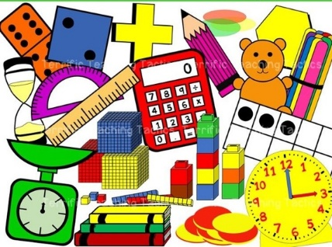 | - Build your child’s Maths concepts through play.  - Complete jigsaws and floor puzzles. Play games with dice.  - Talk about movement when on swings and slide – speed, push, pull.  - Set up a water play area with jugs, funnels, items that float and sink.  - Counting forwards – one, two, three, four, five while hopping/jumping/skipping  - Counting backwards – five, four, three, two, one  - One-to-one-correspondence (counting out three spoons/toys while touching each item as you count)  - Role-play area e.g. set up a shop to become familiar with coins and money.  - Colours and Shapes (square, rectangle, triangle, circle) - notice colours/shapes around the house/in the environment  - Matching/Sorting - objects of the same size/colour/texture/shape etc  - Identify patterns in leaves, toys. Make patterns with blocks/Lego  - Maths and Me
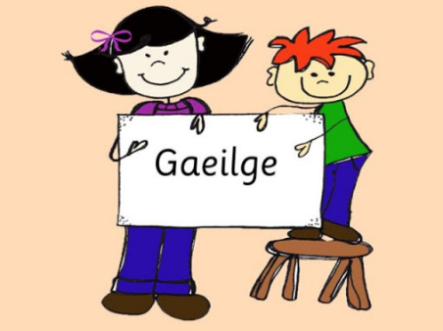 | - Encourage a positive attitude towards Gaeilge with your child.  - If they learn new words at school, encourage their use at home.  - Start to learn some words/phrases in Irish.  - Bua na Cainte  - https://youtu.be/heA91pd0fVs  - https://youtu.be/4jUO1bmbIug

Other Areas of the Curriculum
Drama, Music and Visual Arts give the chid an imaginative and creative vocabulary that allows them to express themselves in new and interesting ways. They help the child to understand their emotions and feelings and the world around them.
The SESE curriculum covers Science, History and Geography. These subjects open up the wider world to the children. In P.E. the child develops skills for movement and sport as well as learning to have a healthy body.
The SPHE curriculum deals with the child’s social, personal and health education. Moral and social aspects are also covered through the school day e.g. kindness to others, sharing with them, saying we are sorry.
The children become aware of God and bible stories as well as learn prayers during Religion.

Play
Play is central to learning in Junior Infants within the new Primary Curriculum. It is recognised as a powerful way children learn best—through active, meaningful, and enjoyable experiences.
Through a balance of child-led and teacher-guided play, children develop key skills such as language, social interaction, problem-solving, and creativity. Play-based learning is active, enjoyable, and inclusive, allowing all children to learn at their own pace. It is integrated across all areas of learning, making it a vital part of children’s early educational experiences.
Here are common types of play areas you can include in a Junior Infants classroom:
- Role Play / Dramatic Play Area
(e.g. home corner, shop, doctor’s surgery)
- Construction Area
(blocks, Lego, building materials)
- Small World Play Area
(farm sets, dolls, animals, cars, train tracks)
- Creative / Art Area
(drawing, painting, cutting, sticking)
- Sand and Water Area
(exploration and sensory play)
- Language and Literacy Area
(books, storytelling, puppets, writing materials)
- Maths Play Area
(counting games, puzzles, sorting and matching)
- Playdough / Sensory Area
(playdough, clay, tactile materials)
- Outdoor Play Area
(physical play, nature exploration, large equipment)
These areas support different types of learning and help children develop a range of skills through play.
New Primary School Curriculum
The Primary School Curriculum is changing in Ireland. Information for parents can be found here. https://ncca.ie/en/primary/resources-for-parents
If your first language is not English the information is also available in all the languages spoken in Ireland (e.g. Polish, Latvian, Lithuanian, Russian etc).

Spoken Language
It is important that the child’s ability to talk is as advanced as possible. It is through speech that a child communicates their thoughts and feelings, their needs and desires, curiosity and wonder. If they cannot express these in words, they will tend to remain silent and will often withdraw from the learning activity of the class. This may be the first sign for support being needed. Much attention is given to language development in the first years of school.

You can help
- Talk to your child naturally and casually about things of interest that you or he may be doing-at home, in the shop, in the car, etc. Remember that all the time he is absorbing the language they hear about them. It takes them a while to make it their own and to use it for their own needs.
- Try to make time to listen when they want to tell you something that is important to them. But don’t always make them the centre of attention.
- Answer their genuine questions with patience and in an adequate way. Always nurture their sense of curiosity and wonder.
- Introduce them gently to the ideas of Why? How? When? Where? If... etc. These demand more advanced language structures.
- They will have their own favourite stories and rhymes that he never tires of hearing. Repeat them over and over again and gradually get them to tell them to you.
First Steps in Reading
Ability to read is the foundation for all future progress. Learning to read is a gradual process and a lot of preparatory work must be done before a child becomes a more independent reader. Children get ready for reading over an extended period. Reading is something to be enjoyed.
You Can Help
- Join the local library and allow them to pick books.
- Make sure your child sees you reading (especially important for boys to see the adult men in their lives reading)
- Have attractive colourful books in the home. Include a mixture of fiction and non-fiction books.
- Read them a variety of stories from time to time. They will get to associate these wonderful tales with books and reading.
- Convey to them that books are precious things to be minded and handled carefully.
- Look at the pictures with them and talk about what they say.
- Read them nursery rhymes. They will learn them naturally, no need to push them.
- Above all, don’t push with early reading. You may turn the child against it for evermore.
- Sing the alphabet song with your child, so that they know about letters and perhaps what each one looks like.
- Tell your child stories.
Getting Ready for Writing
Your child can make shapes on a page. They will learn to hold the pencil properly and make regular shapes. Their hand and finger muscles are developing at this stage.
You Can Help
- Notice letters in words in stories and in print in the environment.
- Your child is not expected to be able to write or read before starting school. It would be helpful if they are able to recognise the letters in their own name.
- They must develop the ability to get the hand and eye working together. This is very important. Get them manipulating toys like: Jigsaws, Lego, beads to thread etc.
- Playdough to make their own shapes.
- A colouring book and thick crayons
- Sheets of paper that he can cut up with a safe scissors.
- Try and ensure he holds a pencil correctly from the start. It will be difficult to change later.
- Left-handedness, if that is their natural inclination, will be encouraged and supported.

The First Day
The child’s first day at school is remembered for the rest of their life. Tell them about school beforehand as a happy place where there will be a big welcome for them and they will meet new friends.
Coming into school
When you arrive at the classroom, be as relaxed as you can. They will meet the teacher and the other children and will be shown their place. Assure them you will be back to collect them, wish them goodbye and leave as soon as you can. Your child will take their cue from you. If you are relaxed and cheerful leaving, your child will be reassured.

Going Home
Be sure to collect them /her on time. Children can become very upset if they feel they are forgotten. The children will be brought to the school gates at home time. If somebody else will be collecting your child, please inform the teacher in advance. We cannot let a child go home with somebody we have not been informed about.

Important dates 2026
- Monday 31st August – Friday 4th September school starts at 9.30 until 12.00 to ease the child into the school routine.
- Monday 7th – Friday 11th September (Hot Lunch Commences) , school will be from 9:00 -12:30
- Monday 14th September onwards a full school day 9:00 - 13:40
On Monday 31stof August and Tuesday 1st September you may accompany your child to the classroom.
From the 2nd – 4th of September you may accompany your child to the school door.
From the 7th of September pupils will walk from the school gates to the class themselves. SNAs and teachers will be on hand to help any pupil that needs it.
Children will be walked out to the gate by their teacher at the end of the school day and parents will collect their child at the gate.
An Upset Child
Despite the best efforts of both teacher and parents a small number of children will still become upset. If your child happens to be one of them don’t panic.
- Trust the teacher. They are experienced and resourceful and are used to coping with all kinds of problems.
- Try not to show any outward signs of your own distress. Sometimes the parents are more upset than the child.
- Say “goodbye, see you soon” and leave. The teacher will distract them with activities more easily when you are not around. Even if a child is upset you should insist that they stay and see how much fun it can be.

As Time Goes on
School begins at 9.00 a.m. In the mornings the children will be met at the gate by the principal and children will walk in by themselves.
Junior Infants must be collected every day by an adult. For reasons of child safety inform the teacher who will normally collect the child. If you cannot collect the child each day, introduce the collector/minder to the class teacher. We cannot let children leave with adults we do not know.
If there is any change in collecting your child, we must be informed. If you are going to be late, please call the school.
Children need plenty of rest after the effort and excitement of a day at school. Children in infant classes should be sleeping 10 hours per night so please ensure that they get to bed early and has a good night’s sleep.
Listen to your child if they want to tell you things and continue to show interest in their daily adventures.
If their progress is different do not compare them with other children. Working with the teacher in support of your child will ease their learning.
They may not be a model of perfection all the time. Have patience with shortcomings and praise for achievements.

After School Care
There is after-school care, run by Smarty Pants (www.smartypants.ie ), where children may wait for older brothers and sisters. There is a fee for this service and numbers are limited. Please contact Michelle in Smarty Pants for further information.

Lunches
We have hot school meals in St Catherine’s NS. This is fully funded by the Department of Social Protection, and there is no charge to parents. The company awarded the contract for St Catherine's is The Lunchbag, you can explore their website here: https://www.thelunchbag.ie/
Your child will be given a letter to bring home to you which will contain a unique code.
When you receive that letter, download the Lunchbag App and set it up for your child with the unique code. You will then be asked to input any allergens or dietary requirements.
You can then select meals for your child for the week starting Monday 7th September. Please note that orders require 48 hours notice.
All children will be given a plastic 'waste box' which the hot meal fits into. They place their meal into this box while eating. They close the top of the waste box and bring it home to show their parents anything they have not eaten. The waste is disposed of in your brown bin at home. All labels and forks etc are fully compostable. It is very important that the child brings the waste box back into school the next day.
On days when the class is away from school for any reason, we can order a cold lunch pack option. No individual choices can be made on these days.
Please note that if you do not wish to take part in this scheme you must opt out by sending an email to secretary@stcatherinesns.ie.
A fruit bowl will be available in the classroom containing satsumas and small apples. They will be replenished daily. Children can eat these at break-time.
Children must continue to bring in their own healthy drinks.
We have a healthy eating policy. Only give your child something you feel they can easily manage to eat. Please peel and cut fruit and vegetables.
https://www.stcatherinesns.ie/page/Policies/54533/Index.html
If your child has dietary requirements, inform the teacher. Please no bars etc. that contain nuts. Some children have nut allergies.
Suggestion:
SNACK – fruit, yogurt, or vegetable- what your child can eat in about 5 minutes.


Home-School Contact
It is very important to give your contact numbers as well as alternative contacts to the school. If a child becomes ill or has an accident at school, we need to contact parents. Inform the school if your phone number or your address changes.

Check the schoolbag every day as there may be notes, homework and uneaten lunches in it. Most notes are sent via Aladdin or by email so ensure that the school has your email address and please check the Aladdin app and your e-mails regularly. We may also send texts to your mobile.

Homework
After the first few weeks, the children will be given some learning or reading work to practice at home. It is very important to do this little bit of oral work each day. As the year progresses, they will be given books and some written work for 5 – 10 minutes. To become familiar with the national curriculum you can log onto http://www.ncca.ie
Homework will be posted to Aladdin.ie
We expect you to have full participation in your child’s learning. You can do this by ensuring you help your child with after schoolwork (sounds, reading, colouring, etc.) as well as participating in classroom activities when requested. There may also be meetings during the school year that you will be expected to attend.

Useful links for learning at home
Here's how you can access the programmes we use in school. Simply click the link or scan the code on other devices and start practicing.
Gaeilge | Numeracy | Literacy and Numeracy
Bua Na Cainte JI-6th class  https://app.buaathome.ie/  No passwords or specific logins just select the class level you are in and practice at home.   | Maths and Me  https://mathsandme.edcolearning.ie/home/  No passwords or specific logins just select the class level you are in and practice at home.   | IXL JI-6th Class  https://ie.ixl.com/signin/stcatherines  Our school’s online platform to practice literacy and Numeracy skills at home and in school, 365 days a year. Logins and codes are unique to each child.  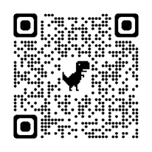

Illnesses and Accidents
Let the school know if your child has dietary requirements or a health issue, we need to be aware of.
If your child has an infectious illness, keep them at home until the doctor says they can return.
There can be toilet accidents from time to time. We usually change wet clothes but on other occasions we call for parents, as the child may be upset and uncomfortable. Please keep a change of underwear, trousers and socks in your child’s bag in case of toilet accidents.
Head lice happen unfortunately in all schools. Check for head lice. Inform the school if your child has head lice and we will send out notes for all parents in the class.

Meeting the Teacher
If there is a quick issue you wish to discuss, talk to the teacher in the mornings and at home time. Otherwise make an appointment to meet the teacher.
Tell the teacher if something is upsetting your child. It can easily be sorted out when caught early. Sometimes it is only children playing and learning to get along, but we all need to be aware.
All visitors to the school must report to and sign in at the school office. Do not go to the classroom before signing in at the school office
Absences
You will be given a list of closures for holidays for the school year. Keep this list in a prominent place in the house.
Your child will miss days from school due to illness and other urgent reasons. We are obliged to report to (TÚSLA) when a child is absent 20 days and note if we are concerned about attendance. Please use Aladdin.ie to let us know why your child is absent from school.
Take holidays when the school is closed.

Getting along with each other
Social skills are very important. We always encourage good manners, with everyone being courteous to fellow students and teachers. Encourage your child to play and mix with other children. If your child experiences anything upsetting on the playground, remind them that the first thing they should do is tell the teacher on duty.
Please read our code of behaviour carefully. Code of behaviour
Enjoy the Experience
There are lots of ideas and suggestions in this booklet for you to help your child begin school and learning. We hope your child has a happy learning experience in St Catherine’s. We will work together to help your child reach their full potential in a positive learning environment.
Website: www.stcatherinesns.ie
Email: secretary@stcatherinesns.ie Tel: 01 843 8266
Aladdin: www.aladdin.ie
Get involved with the parents' association: Parents' Association | St. Catherine's National School
You will be given an access code for Aladdin once the children start school. This is where communication with the class teacher and homework will be posted.

