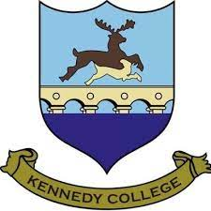
2nd Year Tour- Manchester April 2027
Tour cost: €418
Included in your Tour Price:
Flights
- Dublin/Manchester return on scheduled airline services.
- Ryanair advance check in and assigned seating fee.
- One small item of hand luggage (40x30x20cm).
Coaching
- Exclusive use of coach for the duration of your tour (within EU drivers' regulations).
Accommodation & Meals
- 1 night B&B hostel accommodation in Manchester (tourist tax applies).
- 1 evening meal served at the hostel.
Activities
- Entrance to Alton Towers (subject to availability).
- Tour of Old Trafford Stadium.
Also Included
- Fully comprehensive insurance cover.
Flight Details:
Date | Depart | Arrive
Wednesday 14th April 2027 | Dublin: 07:30am | Manchester : 08:30am
Thursday 15th April 2027 | Manchester: 22:45pm | Dublin : 23:45pm
Please note that the above tour price is based on these flights at their current availability. Flight availability is subject to change at any time, therefore early booking is advisable in order to avoid any increases in fare.
If you wish for your child to be included in this tour, please complete the space below and return it to the office by 29th May 2026.

Student Name:___________________________________________________________________
Parent Name:____________________________________________________________________
Parent Email:_____________________________________________________________________

