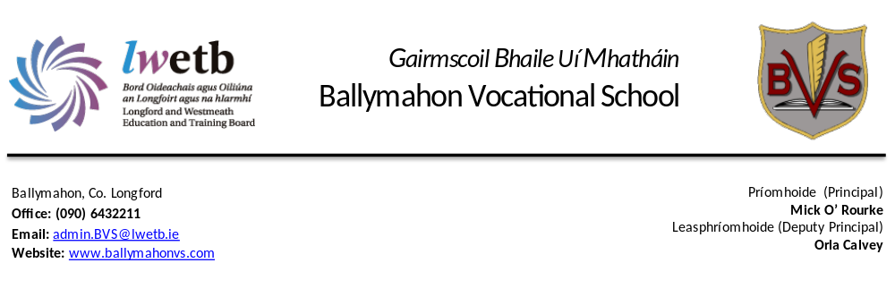
Ballymahon Vocational School

Relationships & Sexuality Education
Policy

January
2026

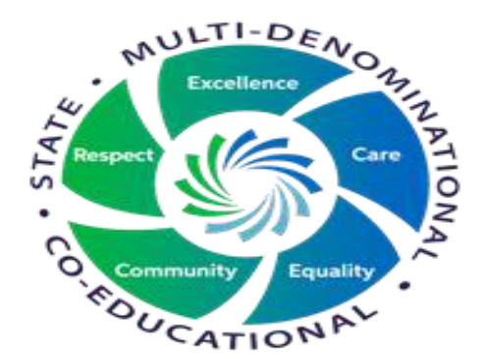

School Mission & Aims
To create and maintain a caring and efficient learning environment founded on trust and co-operation, so that, to the best of our ability, we can prepare our students for their examinations and enable them to reach their full potential as individuals and students.
Based on our mission statement, our general aims are:
- To provide a caring, safe and respectful space where students learn and teachers teach. In a collaborative classroom environment where co-operation is fostered
- To provide a broad-based curriculum which seeks to meet the needs and abilities of each individual student.
- To foster and develop each student’s skills, knowledge and self-esteem as well as his/her enthusiasm for learning.
- To help students to develop skills for future life and for responsible citizenship.

Definition of RSE
Relationships and Sexuality Education (RSE) is a structured, developmental, and lifelong educational process that enables young people to acquire knowledge, understanding, skills, and values regarding their sexual identity, relationships, and intimacy. It is a key component of the Social, Personal, and Health Education (SPHE) curriculum.

Course Objectives
The Relationships and Sexuality Education (RSE) program is designed to provide young people with comprehensive, age-appropriate information and skills to develop healthy, positive, and responsible attitudes toward themselves and their relationships. It is a developmental process integrated into the Social, Personal and Health Education (SPHE) curriculum over the 5/6 years of their secondary education.
- focusing on personal development and identity
- developing self-esteem
- understanding sexuality in a moral, social, and spiritual framework
- building self-worth
- fostering respectful relationships and recognising unhealthy relationships
- understand sexual health
- developing decision-making skills
- promoting positive attitudes towards self and others

Topics Covered
Includes but not limited to, puberty, reproduction and fertility, contraception, sexually transmitted infections, consent, healthy friendships, peer pressure, different types of relationships, sexual orientation, and abuse/harassment, coercion and sexuality and the media

Age-Appropriate Learning
Content and resources are tailored for both Junior Cycle (exploring development, emotions , responsibility towards others) and Senior Cycle ( deeper understanding of consent, contemporary issues , the law and consequences , the workplace). Lessons are planned in advance with the age and stage of the students in focus, monitored and regularly reviewed.

Safe & Open Environment
A key goal is to provide a safe classroom setting for students to discuss sensitive topics, often through hypothetical questions and case studies with skilled teachers. Students are not asked direct or personal questions and develop an understanding of topics through general discussion.
Parental Information
All Parents will be informed prior to the commencement of the RSE module via TYRO. They will be directed to this policy and can make informed decisions based on the content. If they wish to withdraw their child from the RSE module they will have to make arrangements to supervise their child during this time.
Timetabling
RSE will be given a minimum of 6 classes in every school year from first to sixth, including TY. More time may be spent on a topic and any interruption to teaching plans can be compensated for in such a way, at the discretion of the teacher.

Cross-Curricular Links
Art-Projects may be on LGBTI+ theme
English- Poems novels and songs about relationships and sexuality/ debating
Biology- Reproductive system and genetics
CSPE-Laws around online sexual activity
Geography- human geography and culture

