Kingswood Community College
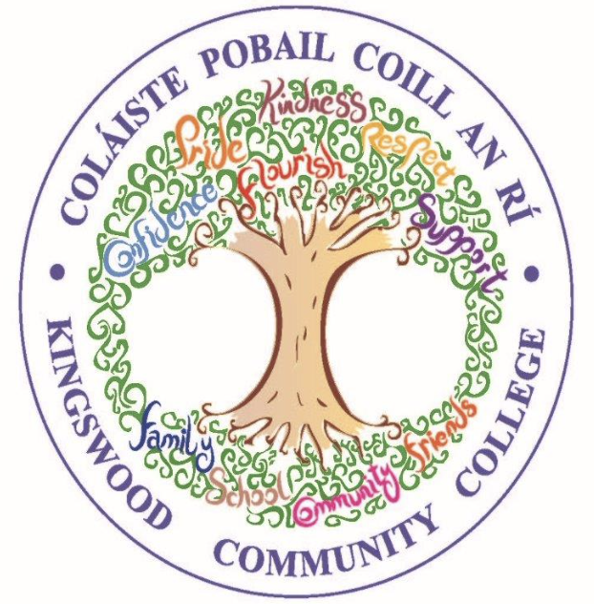

3rd Year 2026/27- Resource List
School journal will be given to students in September.

SUBJECT | Equipment
Mocks fees | School is covering the cost of mock examinations.
Paid through MIT system | Costs for the forthcoming year;  Locker Rental & Maintenance - €20  Insurance - €6.90  Sports & Cultural Fund - €50  Careerfit Psychometric Testing €20  Total - €96.90
English | Retain Copies, Books and Workbooks from 2nd Year  New for 3rd Year:  Exam Papers  2 x A4 Copy (soft back) - 1 to be used as an Assessment copy  Blue, black and red pens.  A4 Display Folder  All 3rd year students to receive ‘Merchant of Venice’ as part of educate.ie bundle  We aim for students to attend a staged version of their Shakespearean play during the year. The date and cost of this will be emailed to parents/guardians if/when it is finalised.
Gaeilge | Retain Books and Workbooks from 2nd Year  New for 3rd Year:  3rd year book included in package purchased in 1st Year  1 x A4 Display Folder  1 x A4 Hard back copy  2 x A4 Aisling Manuscript Copy (soft back) - 1 to be used as an Assessment copy  Black, Blue, Red pen  Exam Papers
Maths  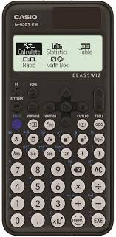 | Retain Books and Workbooks from 2nd Year  New for 3rd Year:  Exam Papers  3rd year book included in package purchased in 1st Year  2 x Project Maths copy book – A4  1 x A4 copy (soft back) to be used as an Assessment copy  1 x Maths Set  1 x Formulae and Tables Book  Scientific Calculator Casio FX-85GT Plus
Science | Retain Books and Workbooks from 2nd Year  New for 3rd Year:  Science hardback manuscript copy with graph paper  2 x A4 Aisling manuscript copy (soft back) - 1 to be used as an Assessment copy  Exam Papers
History | Retain Books and Workbooks from 2nd Year  New for 3rd Year:  2 x A4 Aisling Manuscript Copy (soft back) - 1 to be used as an Assessment copy  (Copies are to be retained from First Year for use until end of 3rd Year )  1 x A4 Display folder  Exam Papers
Geography | Retain Books and Workbooks from 2nd Year  (Copies are to be retained from 1st Year for use until 3rd Year)  New for 3rd Year:  1 x A4 Display folder  1 x 12 pack of colouring pencils  A ruler, rubber and pencil  2 x A4 Aisling Manuscript Copy (soft back) - 1 to be used as an Assessment copy  Exam Papers
French / Spanish | Retain Books and Workbooks from 2ndYear  New for 3rd Year:  3 x A4 Aisling Manuscript Copy (soft back) - 1 to be used as an Assessment copy  Exam Papers
Home Economics | Retain Books and Workbooks from 2nd Year  1 x A4 Manuscript copies (Retain copies from 2nd Year) - 1 to be used as an Assessment copy  1 x A5 Hardback copy  1 x A4 subject display folder - Poly pockets  New for 3rd Year  €3 for materials paid to teacher  Exam Papers
Art  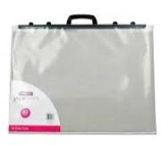 | Exam Papers  A2 plastic portfolio with name clearly on it.  Watercolour paint set  Small Paint brush set with selection of 4/6 brushes (available in Mr. Price)  Good quality eraser  Good quality colouring pencils  Selection of drawing pencils HB, 2b, 4b,6b  2 x A4 Sketchbook copy NOT Spiral or Flip style.  (Example: Mr. Price / Brown cover copy style)  A3 Clear Zip Folder – to hold all equipment.
Graphics   | Exam Papers (Educate)  H Pencil, 2H Pencil  30/60 Set Square  45 Set Square  T- Square  Protractor  Masking Tape  Rubber + Sharpener  Drawing Compass (Good Quality)  1 x A4 copy (soft back) to be used as an Assessment copy
Wood Technology  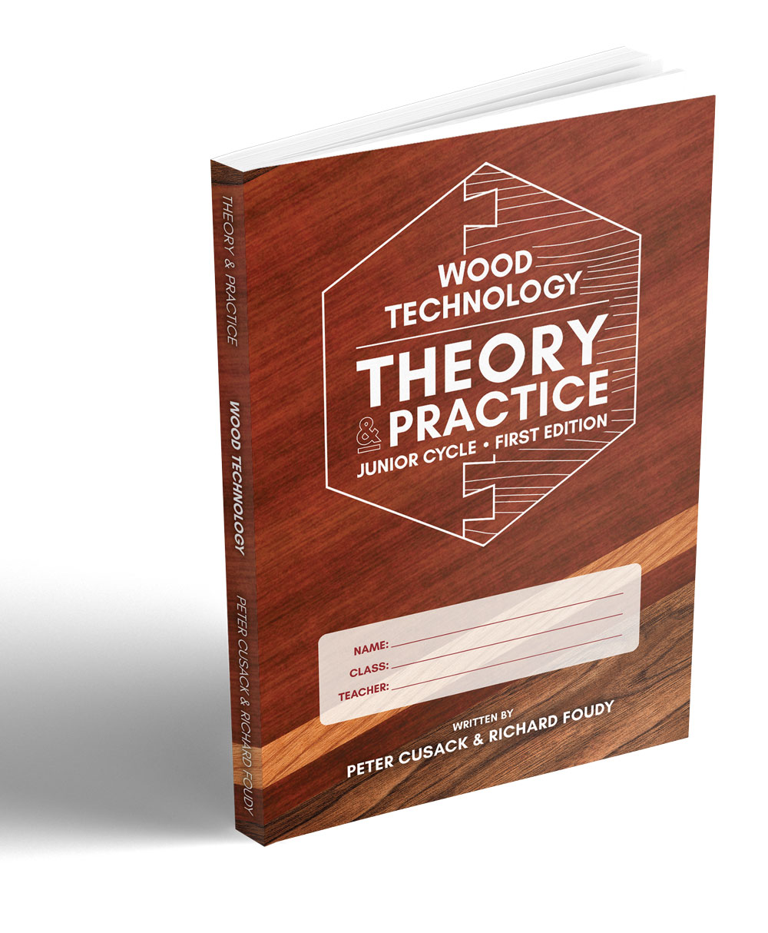 | Retain the following book: Wood Technology Theory and Practice First Edition  A4 Hardback Copy  A4 Softback Copy (Assessment Copy)  Pencils  Colouring Pencils  New: Exam Papers
Applied Technology  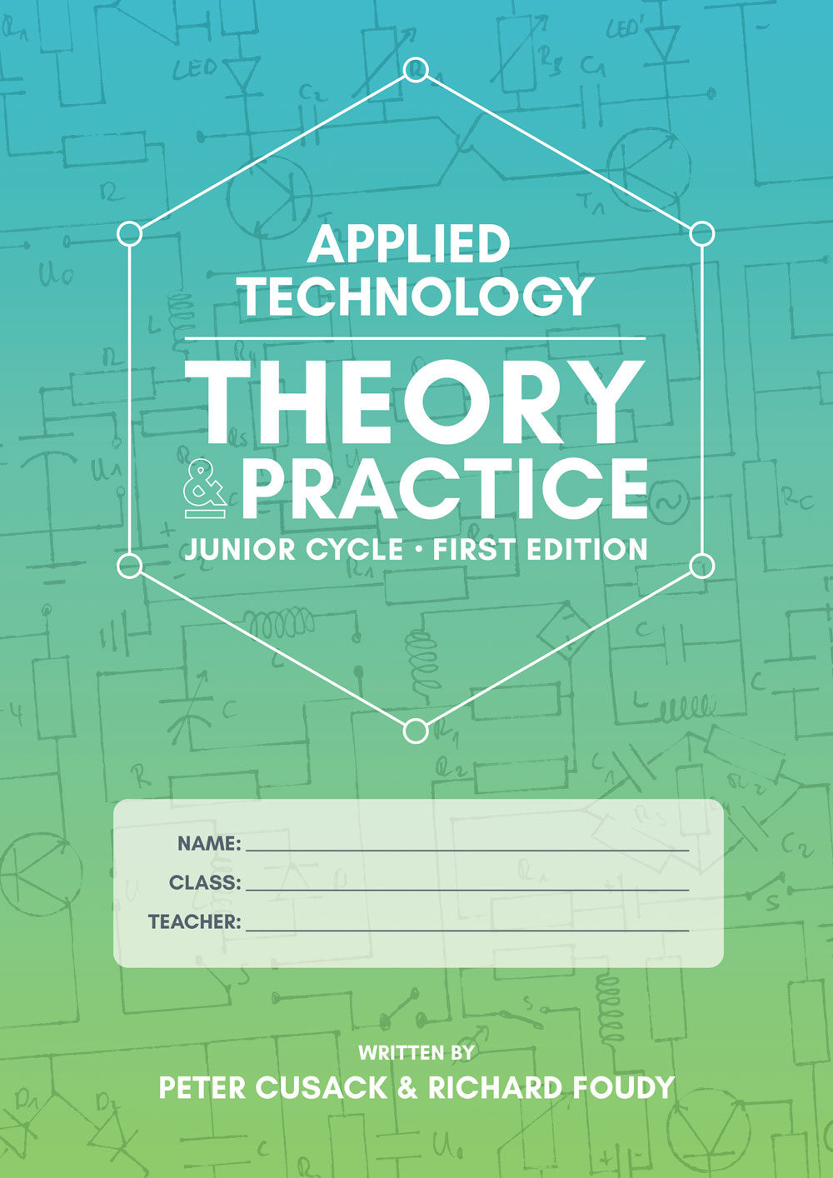 | Retain the following book: Applied Technology Theory and Practice First Edition  A4 Hardback Copy  A4 Softback Copy (Assessment Copy)  Pencils  Colouring Pencils  New: Exam Papers
Music | Retain Book and Composition Portfolio from 2nd year (Maestro)  Music manuscript copy (Retain copy from 2nd Year)  Small music copy (Retain copy from 2nd Year)  Pencil  Folder (Retain from 2nd year)  New: Exam Papers
Business | Retain Books and workbooks from 2nd Year  1 x A4 Hard back copy  2 x A4 Aisling manuscript copy (soft back) - 1 to be used as an Assessment copy  New: Exam Papers
Artistic Performance | Earphones
Philosophy | Copies to be retained from First and Second Year  1 x A4 Aisling manuscript copy (soft back)
Coding | Copies to be retained from First and Second Year  1 x A4 Aisling manuscript copy (soft back)
CSPE | Copies to be retained from First and Second Year  1 x A4 Aisling manuscript copy (soft back)
SPHE | You’ve Got This Book 3  A3 Scrapbook (20 page)
IMBVE | Copies to be retained from First and Second Year  Earphones
Guidance | Retain Reach Plus Junior Cycle Programme  Careerfit Psychometric Testing €20 (Paid through MIT system)
Tutor Class | Kingswood Community College Journal – Supplied by College

Sample of an A4 Manuscript Copy
