
Kingswood Community College
Transition Year 2026/27 – Resource & Booklist

School journal will be given to students in September.

Paid through MIT | 24 hour/7 days a week Compulsory School Insurance- €6.80  Careerfit Psychometric Testing €20
Core Subjects  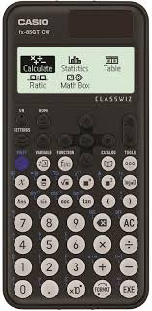   | - 3 x A4 copies  - 2 x A4 Maths Copies  - Assortment of pens, pencils and erasers etc  - Pencil case  - Scientific Calculator Casio FX-85GT Plus  - Maths Set (containing compass, protractor, set square and ruler)  - Highlighters  - Felt tip pens  - A4 Display folder  - Leap card for school trips  2 Class Sets (60 copies) Text and Tests for Transitions Year – Celtic Press
Rotation & Enrichment Modules | 6 x A4 copies
Guidance | Reach Plus Senior Cycle  Careerfit Psychometric Testing €20 (Paid through MIT system)

SENIOR CYCLE JUMPER AND TRACKSUIT – Available to order online at
https://schoolwearhouse.ie/

The Schoolwearhouse, Unit D7 Ballymount Cross Industrial Estate, Ballymount, Dublin 24.

