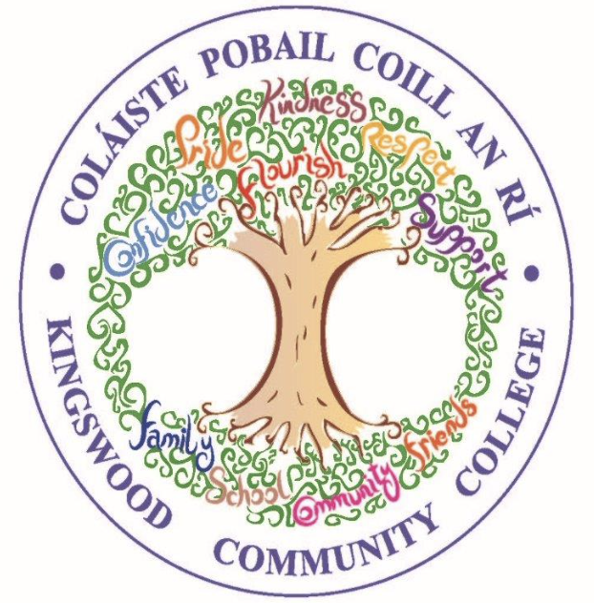
Kingswood Community College
2nd Year 2026/27 - Resource List

SUBJECT | Equipment
Paid through MIT system | Costs for the forthcoming year;  Locker Rental & Maintenance - €20  Workshops - €15  Insurance - €6.90  Sports & Cultural Fund - €50  Total - €91.90
English  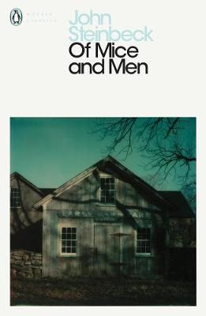  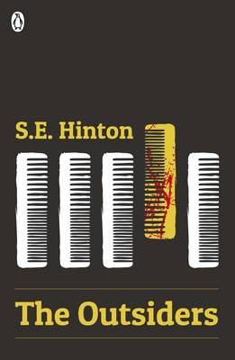 | Retain Copies, Books & Workbooks from 1st Year.  New for 2nd Year:  3 x A4 Copy (soft back) - 1 to be used as an Assessment copy  Blue, black and red pens.  1 x pocket folder  ‘Of Mice & Men’ by John Steinbeck -  ‘The Outsiders’ by S. E. Hinton-
Gaeilge | Retain Copies & Books from 1st Year.  Retain 2nd Year Book included in package purchased in 1st Year.  New for 2nd Year:  1 x A4 Display Folder  2 x A4 Aisling Manuscript Copy (soft back) - 1 to be used as an Assessment copy  1 x A4 Hard back copy  Black, Blue and Red pen
Maths  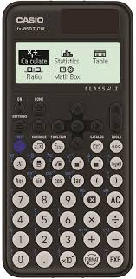  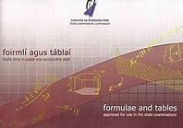 | Retain Copies & Books from 1st Year.  Retain 2nd Year Book included in package purchased in 1st Year.  Retain the following stationery from 1st Year:  1 x Maths Set  1 x Formulae and Tables Book  Scientific Calculator Casio FX-85GT Plus  New for 2nd Year:  2x A4 Project Maths copy Book  1 x A4 copy (soft back) to be used as an Assessment copy
Science | Retain Books and Workbooks from 1st Year.  New for 2nd Year:  A4 Science hardback manuscript copy  2 x A4 Aisling manuscript copy (soft back) - 1 to be used as an Assessment copy
History | Retain Books and Workbooks from 1st Year  New for 2nd Year:  2 x A4 Aisling Manuscript Copy (soft back)  (Copies are to be retained from First Year for use until Third Year)  1 x A4 Display folder
Geography | Retain Books and Workbooks from 1st Year  New for 2nd Year:  3 x A4 Aisling Manuscript Copy (soft back) - 1 to be used as an Assessment copy  (Copies are to be retained from First Year for use until Third Year)  1 x A4 Display folder  1 x 12 pack of colouring pencils  A ruler, rubber and pencil
French | Retain Books and Workbooks from 1st Year  New for 2nd Year:  3 x A4 Aisling Manuscript Copy (soft back) - 1 to be used as an Assessment copy
Spanish | Retain Books and Workbooks from 1st Year  New for 2nd Year:  3 x A4 Aisling Manuscript Copy (soft back) - 1 to be used as an Assessment copy
Art  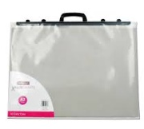 | A2 plastic portfolio with name clearly on it.  Watercolour paint set  Small Paint brush set with selection of 4/6 brushes (available in Mr. Price)  Good quality eraser  Good quality colouring pencils  Selection of drawing pencils HB, 2b, 4b,6b  2 x A4 Sketchbook copy NOT Spiral or Flip style.  (Example: Mr. Price / Brown cover copy style)  A3 Clear Zip Folder – to hold all equipment.
Home Economics | Retain Books and Workbooks from 1st Year  New for 2nd Year:  1 x A4 Aisling Manuscript Copy (soft back) - 1 to be used as an Assessment copy  CBA 1 - textiles equipment will be confirmed before Christmas  1 x A4 Display folder - Poly pockets  €3.00 for materials paid to teacher.
Graphics  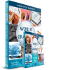 | Retain from 1st Year:  H Pencil, 2H Pencil Qty 2 each  30/60 Set Square  45 Set Square  T- Square  Protractor  Rubber + Sharpener  Masking Tape  Drawing Compass (Good Quality)  1 x A4 copy (soft back) to be used as an Assessment copy  A3 zip folder (To store completed work)
Applied Technology  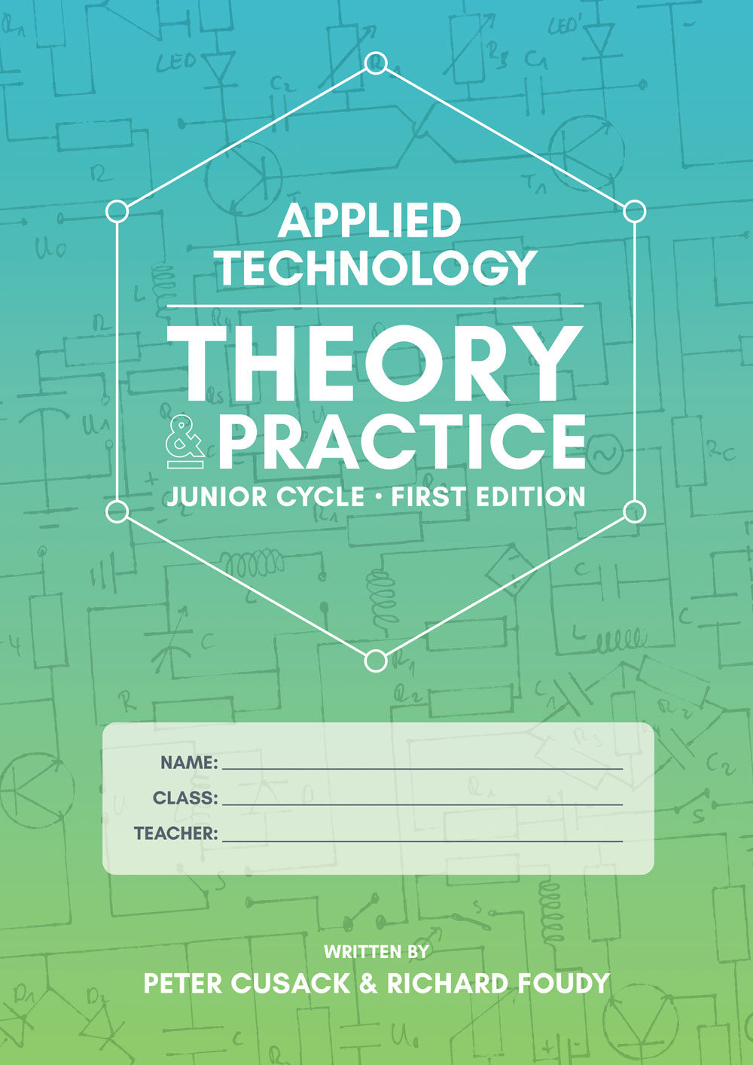 | Retain from first year:  Applied Technology Theory and Practice First Edition  A4 Hardback Copy  A4 Softback Copy (Assessment Copy)  Pencils  Colouring Pencils
Wood Technology  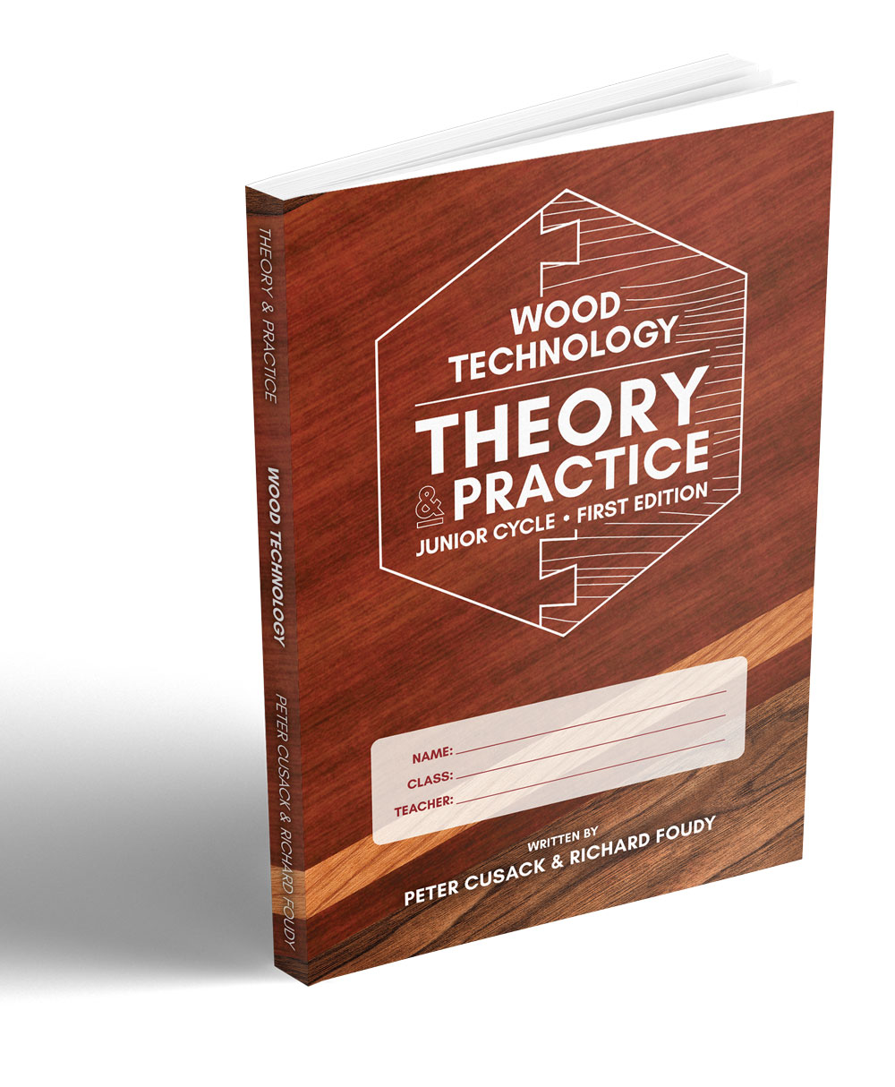 | Retain from first year:  Wood Technology Theory and Practice First Edition  A4 Hardback Copy  A4 Softback Copy (Assessment Copy)  Pencils  Colouring Pencils
Music | Retain Books and Workbooks from 1st Year (Maestro, text book and workbook)  New for 2nd Year:  Music manuscript copy  Pencil  2 x A4 Aisling manuscript copy (soft back) - 1 to be used as an Assessment copy  Music folder/ subject space in general folder  Recorder (retain from first year)
Business | Retain Books and Workbooks from 1st year (Network book)  New for 2nd Year:  1 x A4 Hard back copy  2 x A4 Aisling manuscript copy (soft back) - 1 to be used as an Assessment copy
Artistic Performance | Earphones
CSPE | Retain book  First Year copy to retained.  1 x A4 Aisling manuscript copy (soft back)
SPHE | You’ve Got This Book 2  1 x A3 Scrapbook (20 pages)
Coding | First Year copy to be retained.  1 x A4 Aisling manuscript copy (soft back)
Philosophy | First Year copy to be retained.  1 x A4 Aisling manuscript copy (soft back)
IMBVE | First Year copy to be retained.  Earphones
Guidance | Retain Reach Plus Junior Cycle Programme Book
Tutor Class | Kingswood Community College Journal – Supplied by College

Sample of an A4 Manuscript Copy
