

CSS1

Child Safeguarding Statement and Risk Assessment

For: |  | Limerick School Project NS
At: |  | O’Connell Avenue, Limerick City

This school is a: ☒ primary ☐ post-primary ☐ special school
In accordance with the requirements of the Children First Act 2015, Children First: National Guidance for the Protection and Welfare of Children 2017, the Addendum to Children First (2019) and 2025, Child Protection Procedures for Schools 2025 and Child Safeguarding: A Guide for Policy, Procedure and Practice, 2nd ed. (Tusla, 2024), the board of management has adopted the Child Safeguarding Statement and Risk Assessment set out in this document.
The board of management has adopted and will implement fully and without modification the department's Child Protection Procedures for Schools 2025 as part of this overall Child Safeguarding Statement and Risk Assessment.

Name of the Designated Liaison Person (DLP):
Pamela Ronan

Name of the Deputy Designated Liaison Person (Deputy DLP/DDLP):
Jenni Oakley
In the absence of the DLP, the Deputy DLP shall assume responsibilities of the DLP

Name of Relevant Person
Pamela Ronan
(In schools this person is the DLP)

Relevant Person can be contacted on:
061 412994 | pronan@lsp.ie
Under the Children First Act 2015 Relevant Person means a person who is appointed by a provider of a relevant service to be the first point of contact in respect of the Child Safeguarding Statement. This person is nominated by the board of management to manage and provide oversight of child protection concerns/allegations of child abuse.

Name of Chairperson of the board of management:
Sarah Ryan
In the event that both DLP and DDLP are absent and unavailable, and where there is no staff member formally acting in their role, the chairperson of the board of management assumes the role of DLP.
CSS1 Page 1 of 13
The board of management recognises that child protection and safeguarding permeate all aspects of school life and must be reflected in all of the school's policies, procedures, practices and activities. In all of these, the school will adhere to the following principles of best practice in child protection and welfare. The school will:
☐ Recognise that the protection and welfare of children is of paramount importance, regardless of all other considerations.
☐ Fully comply with its statutory obligations under the Children First Act 2015 and other relevant legislation relating to the protection and welfare of children.
☐ Fully co-operate with the relevant statutory authorities in relation to child protection and welfare matters.
☐ Adopt safe practices to minimise the possibility of harm happening to children and protect members of school personnel from the necessity to take unnecessary risks that may leave themselves open to accusations of child abuse.
☐ Develop a practice of openness with parents and encourage parental involvement in the education of their children.
☐ Fully respect confidentiality requirements as set out in the Child Protection Procedures for Schools 2025 in dealing with child protection matters.
☐ Adhere to the above principles in relation to any vulnerable adult.

Procedures and Measures in Place
Our Child Safeguarding Statement and Risk Assessment has been developed in line with requirements under the Children First Act 2015, the Children First: National Guidance 2017, and Child Safeguarding: A Guide for Policy, Procedure and Practice, 2nd ed. (Tusla, 2024), and the Child Protection Procedures for Schools 2025. In addition to the procedures listed in our risk assessment, the following procedures support our intention to safeguard children while they are availing of our service:
> Procedure for the Management of Allegations of Abuse or Misconduct against School Personnel Relating to a Child Availing of Our Service
~ Where any member of school personnel is the subject of any investigation in respect of any act, omission or circumstance in relation to a child attending the school, the school is required to adhere to the relevant procedures set out in Chapter 7 of the Child Protection Procedures for Schools 2025 and to the relevant agreed disciplinary procedures for school staff which are published on the gov.ie website.

CSS1 Page 2 of 13
> Procedure for the Safe Recruitment and Selection of School Personnel to Work With Children
~ The school is required to adhere to the requirements of the Vetting Act. The selection or recruitment of staff and their suitability to work with children, requires the school to adhere to the statutory vetting requirements of the National Vetting Bureau (Children and Vulnerable Persons) Acts 2012 to 2016, and to the wider duty of care guidance set out in relevant Garda vetting and recruitment circulars published by the Department of Education and Youth and available on the gov.ie website and as outlined in Chapter 10 of the procedures.
~ A written protocol is in place authorising immediate action for cases which require an employee to be immediately absented from school for child safeguarding reasons.
> Procedure for Provision of and Access to Child Safeguarding Training and Information, Including the Identification of the Occurrence of Harm
~ The school provides information and training to members of school personnel in relation to the identification of the occurrence of harm (as defined in the 2015 Act) as follows:
~ The school has provided each member of school personnel, including any new members of school personnel, (employees and volunteers, board of management members, student teachers and those on work experience) with a copy of the school's Child Safeguarding Statement and Risk Assessment.
~ The school ensures that members of school personnel have availed of relevant training and completed child protection training.
~ The school encourages board of management members to avail of any relevant training and complete child protection training.
~ The board of management ensures that records of all staff and board member child protection training are maintained.
> Procedure for the Reporting of Child Protection or Welfare Concerns to Tusla
~ All members of school personnel are required to adhere to the procedures set out in the Child Protection Procedures for Schools 2025, in relation to reporting of child protection concerns to Tusla. Mandated reporting applies to all registered teachers and any other mandated person who may be employed by the school, for example a chaplain or nurse. A full list of those people who are mandated persons is set out in Appendix 1 procedures.
> Procedure for Maintaining a List of the Persons (if any) in the Relevant Service Who Are Mandated Persons
~ There is a procedure in place to maintain a list of mandated persons. Schools may on occasion employ additional staff who are mandated by virtue of their profession. This list will include all registered teachers and identify additional employees that are not registered teachers.
> Procedure for Appointing a Relevant Person (In schools this person is the DLP)
~ There is a procedure in place for appointing a relevant person.
CSS1 Page 3 of 13
The various procedures referred to in this Child Safeguarding Statement and Risk Assessment can be accessed via the school's website, the gov.ie website or will be made available on request by the school.
In accordance with the Children First Act 2015, the Addendum to Children First 2019 and 2025, and the Child Protection Procedures for Schools 2025, the board of management carried out an assessment of any potential for harm to a child while attending the school or participating in school activities. A written assessment setting out the areas of risk identified and the school's procedures for managing those risks is included with the Child Safeguarding Statement.
This statement has been published on the school's website or will be made available on request by the school. It has been provided to all members of school personnel, the parents' association, the patron and parents. A copy of this statement and risk assessment will be made available to Tusla and the department if requested.
This Child Safeguarding Statement and Risk Assessment will be reviewed annually or as soon as practicable after there has been a material change in any matter to which this statement refers.

CSS1 Page 4 of 13

Child Safeguarding Risk Assessment
 | List of School Activities | Risks Identified Against Each School Activity | Procedures/Measures in place to Mitigate Risk
1. | Arrival, dismissal and recreation breaks | Harm through inadequate supervision, inappropriate adult contact or peer abuse. | Supervision rosters, defined duty areas, visitor/collection controls, incident reporting and safeguarding escalation.
2. | Classroom teaching and one-to-one support | Harm by adults or peers; inappropriate contact or failure to recognise concerns. | Staff code of conduct, professional boundaries, appropriate visibility/supervision, induction and reporting procedures.
3. | Toilets, changing and intimate care | Harm through inappropriate contact, inadequate supervision or failure to recognise concerns. | Intimate Care Policy, individual plans, consent, privacy-balanced safe practice and recording.
4. | Additional needs, communication and medical support | Harm arising from increased vulnerability, communication barriers or inappropriate care. | Individual support/care plans, accessible communication, appropriate supervision, staff training and safeguarding reporting.
5. | Medication, first aid and emergency care | Harm through neglect, inappropriate care or failure to recognise/report concerns. | Medication and first-aid procedures, written authorisations, individual emergency plans, trained personnel and secure records.
6. | Behaviour support and crisis situations | Harm through inappropriate physical intervention, punitive practice or inadequate supervision. | Code of Behaviour, current Department guidance, individual plans, staff training, recording and safeguarding escalation.
7. | Bullying, racism and peer relationships | Harm through bullying, discrimination, sexualised behaviour, coercion or peer abuse. | Bí Cineálta procedures, inclusion measures, supervision, pupil reporting routes and child protection reporting procedures.
8. | SPHE, RSE and Stay Safe | Harm not recognised or disclosed because pupils lack age-appropriate safeguarding knowledge. | Whole-school SPHE/RSE planning, Stay Safe delivery, accessible provision, staff preparation and implementation records.
9. | ICT, online learning, AI and digital communication | Harm through grooming, inappropriate content, bullying, recording or unauthorised contact. | Acceptable Use Policy, approved platforms, supervised access, communication boundaries, recording permissions and reporting.
10. | Photographs, video and school communications | Harm through inappropriate recording, sharing or exploitation of children. | Consent/permissions, approved devices and accounts, access controls, publication procedures and safeguarding escalation.

 | List of School Activities | Risks Identified Against Each School Activity | Procedures/Measures in place to Mitigate Risk
11. | Outings, sport, swimming and off-site activities | Harm through inadequate supervision, inappropriate contact or changing arrangements. | Outing-specific safeguarding arrangements, supervision, external-provider responsibilities, privacy and reporting procedures.
12. | Transport and escorts, where applicable | Harm through inadequate supervision, inappropriate contact or unclear handover. | Confirm applicability; provider responsibilities, vetting where required, handover, supervision and reporting arrangements.
13. | External tutors, coaches, volunteers and visitors | Harm by unsuitable or unsupervised adults or inappropriate communication. | Recruitment/vetting requirements, identity checks, visitor controls, safeguarding induction, supervision and reporting.
14. | Recruitment, substitutes and student placements | Harm arising from unsuitable personnel or failure to apply safeguarding requirements. | Statutory vetting, required declarations/undertakings, recruitment checks, induction and immediate-absence protocol.
15. | Fundraising, events and external use of premises | Harm through unclear responsibility, inadequate supervision or unauthorised adult access. | Confirm activities; written responsibilities, safeguarding requirements, access controls, supervision and reporting.
16. | Breakfast, homework or after-school provision, if applicable | Harm through inadequate supervision, unclear provider responsibilities or inappropriate contact. | Confirm applicability and provider; safeguarding responsibility, vetting, handovers, supervision and incident procedures.
17. | Children with particular vulnerabilities | Harm due to discrimination, isolation, communication barriers or failure to respond to concerns. | Inclusive safeguarding, accessible communication, appropriate individual supports, confidentiality and reporting procedures.
18. | Safeguarding governance, reporting and records | Harm not recognised or reported promptly; failure to act on allegations or inappropriate disclosure. | 2025 reporting procedures, DLP/DDLP cover, mandated-person register, training, secure records, CPOR oversight and annual review.
19. | School use of external personnel and community services | Harm through unclear safeguarding responsibilities or inappropriate adult contact. | Verify service agreements, safeguarding responsibilities, vetting where required, supervision and reporting arrangements.
20. | School participation in digital or media projects | Harm through inappropriate recording, publication, contact or disclosure of personal information. | Verify project approval, consent, appropriate supervision, approved systems and safeguarding/data-protection procedures.

CSS1 Page 7 of 13
In accordance with Section 11 of the Children First Act 2015 and with the requirements of Chapter 9 of the Child Protection Procedures for Schools 2025, the following is the written Child Safeguarding Statement and Risk Assessment.
In undertaking this Child Safeguarding Statement and Risk Assessment, the board of management has endeavoured to identify as far as possible the risks of harm that are relevant to this school and to ensure that adequate procedures are in place to manage all risks identified. While it is not possible to foresee and remove all risk of harm, the school has in place the procedures listed in this risk assessment to manage and reduce risk to the greatest possible extent.
This Child Safeguarding Statement and Risk Assessment was reviewed by the board of management on _________________________________ (most recent review date)

Signed:* |  | Date:
Chairperson of the board of management

Signed:* |  | Date:
Principal/Secretary to the board of management

This Child Safeguarding Statement and Risk Assessment is expected to be reviewed again on ________________________________ (expected review date)

* Document to be printed and signed with original signatures
CSS1 Page 12 of 13
Appendix - Location of copies of the Child Protection Procedures and Children First Guidance

The child protection statement and Child friendly poster are located in every classroom and support teacher room as depicted in the picture below. They are also in the main school foyer, the staffroom, outside the Sensory Room and in the school servery area.
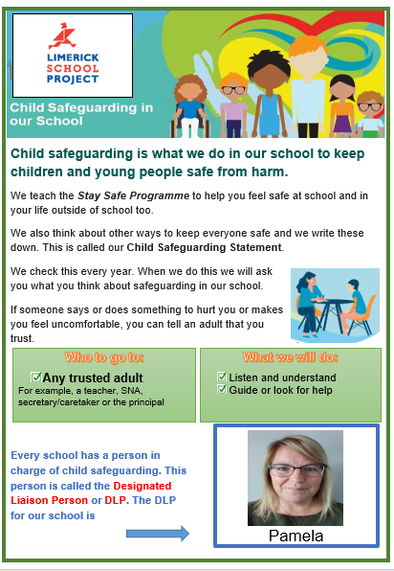

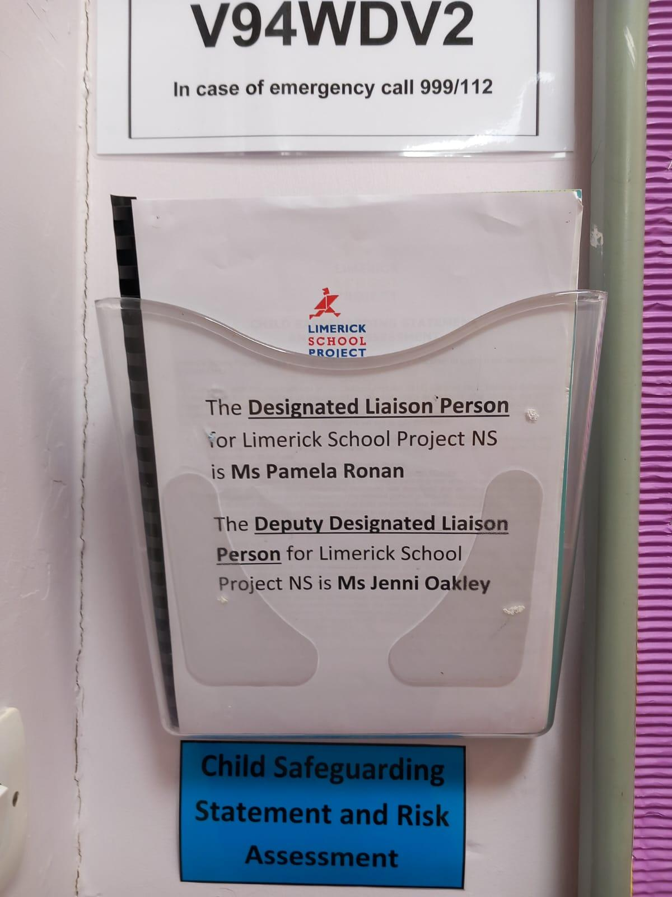

CSS1 Page 13 of 13

