Application Form
  - Church Music Scholarships for the Academic year 2027-2028
  - 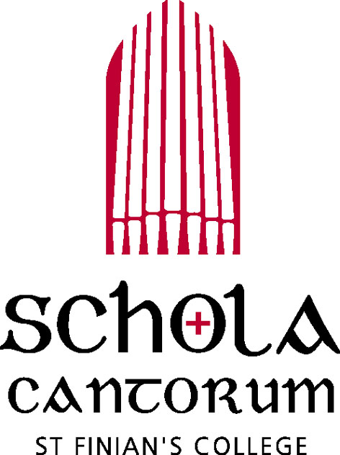
Schola Cantorum
St Finian’s College
Mullingar
Co Westmeath
Tel: 044 - 9342906
e: schola@stfinianscollege.ie

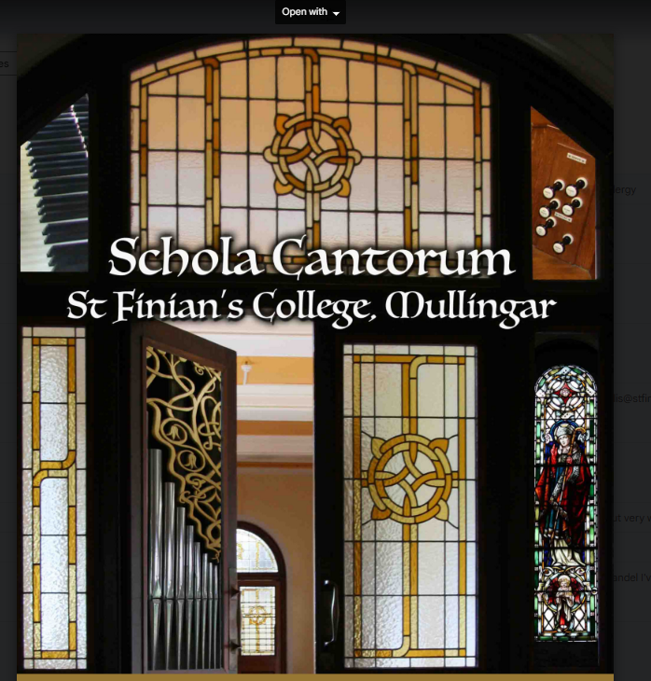
Schola Cantorum Director:
Mr Gerard Lillis

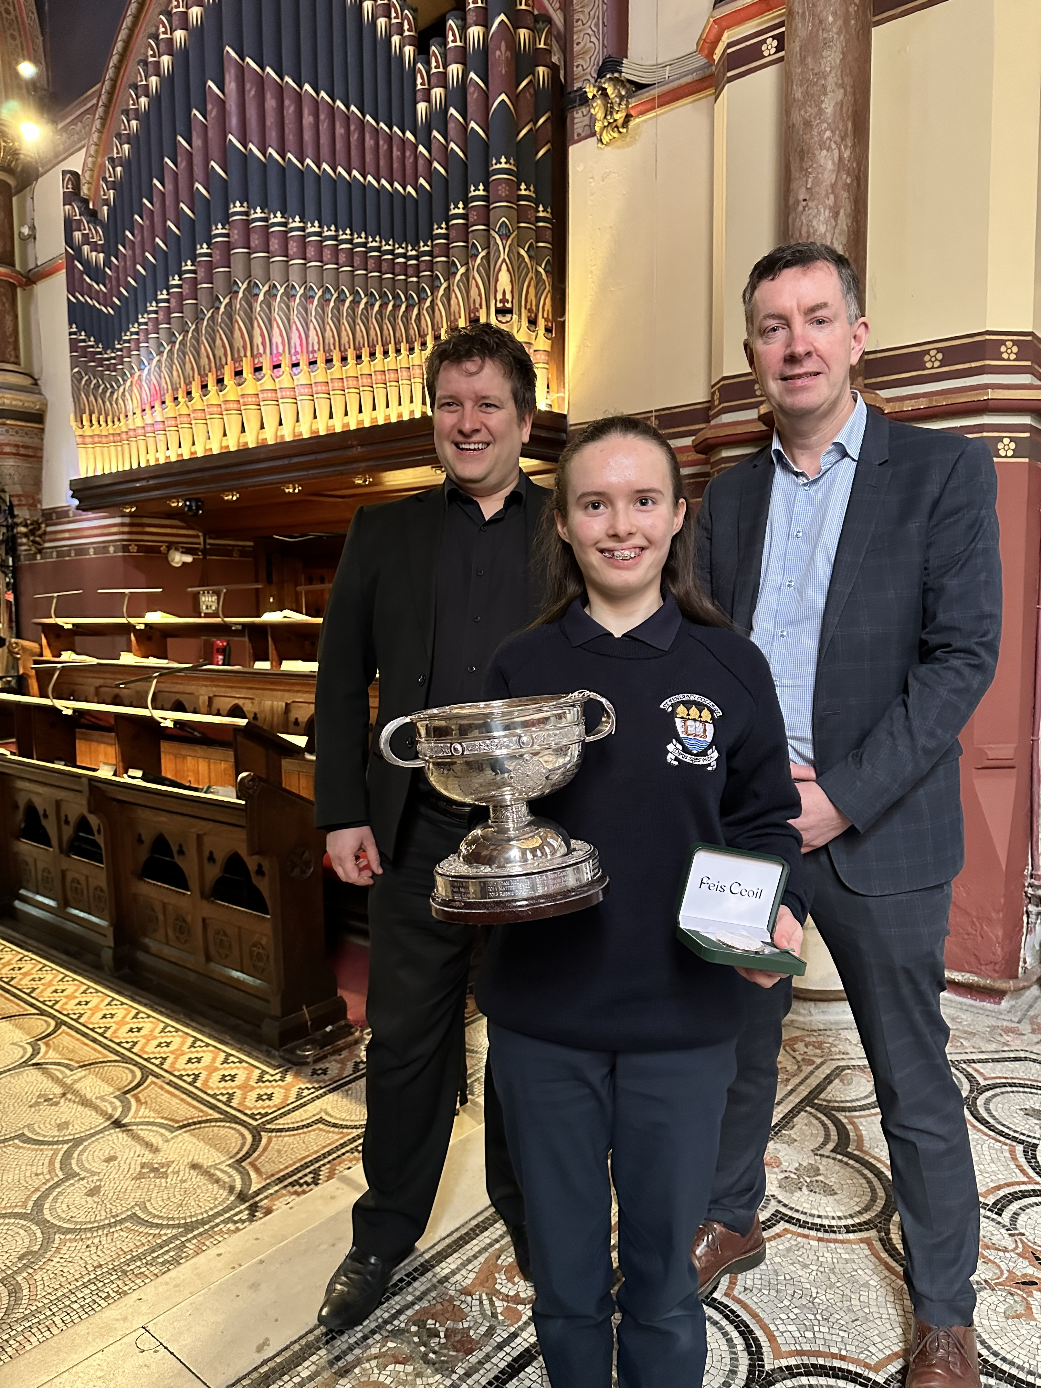Feis Ceoil Awards
Feis Ceoil 2023

Name of candidate:
Date of birth:
Postal Address:
Parent’s/Guardian’s names:
Parent’s Mobile No:
Parent’s Email address:
Music Teacher’s name:
Music Teacher’s mobile No:
Primary School:
School Principal:
Instrument(s) played:
Level/Grade:
Any other information:

Completed Application Forms should be emailed to schola@stfinianscollege.ie
Please attach digital recordings of 2 pieces (at least one which should be on piano/keyboard) and one song. NB: Closing date is Friday 30 October 2026 at 5pm.

